Breast Ultrasound Tumor Segmentation using YOLOv8

Team Members:

Supervised by:

INSTITUTE OF COMPUTER SCIENCES AND INFORMATION TECHNOLOGY
FACULTY OF MANAGEMENT AND COMPUTER SCIENCES
THE UNIVERSITY OF AGRICULTURE, PESHAWAR
KHYBER PAKHTUNKHWA PAKISTAN
INTRODUCTION

1.1 Background
Breast cancer is one of the most common and deadly cancers among women worldwide. According to global health reports, millions of new breast cancer cases are diagnosed each year, and a significant percentage of these cases lead to mortality due to late diagnosis, limited access to screening, or inaccurate interpretation of medical images. Early detection and accurate diagnosis are critical for improving survival rates, guiding treatment options, and reducing the overall burden on healthcare systems.
Medical imaging plays a central role in breast cancer screening and diagnosis. Traditionally, mammography is considered the standard imaging technique for breast cancer screening. However, mammography has limitations, especially for women with dense breast tissue, where tumors can be difficult to distinguish from normal tissue. In such cases, ultrasound imaging is often used as a complementary or alternative modality because it is relatively affordable, portable, non-invasive, and does not involve ionizing radiation.
Despite these advantages, ultrasound images are inherently noisy, low contrast, and highly dependent on the operator’s skill. Radiologists must carefully inspect each image to identify suspicious regions, which is a time-consuming and cognitively demanding process. Inter-observer variability, fatigue, and experience level can also lead to inconsistent or inaccurate diagnoses. These challenges highlight the need for automated, reliable, and efficient computer-aided diagnosis (CAD) systems to support radiologists in clinical decision-making.
Recent advances in deep learning have transformed the field of medical image analysis. Convolutional Neural Networks (CNNs) and transformer-based models have achieved impressive results in various tasks, such as classification, detection, and segmentation. Among these, the YOLO (You Only Look Once) family of models has gained popularity for real-time object detection due to its speed and accuracy. The latest version, YOLOv8, extends these capabilities to include segmentation, making it highly suitable for medical image tasks where both localization and boundary information are important.
In this project, we focus on breast ultrasound tumor segmentation using YOLOv8. Instead of only detecting the presence of a tumor, we aim to segment the exact region of interest (ROI), providing more detailed information for diagnosis, treatment planning, and follow-up monitoring.

1.2 Problem Statement
Early and accurate detection of breast tumors is essential for improving patient outcomes, yet it remains a significant challenge, particularly in low- and middle-income countries where access to experienced radiologists and high-end imaging systems is limited. Ultrasound is widely available and cost-effective, but its interpretation is complex due to:
- Speckle noise and artifacts in images
- Variability in acquisition settings and equipment
- Differences in tumor appearance across patients
- Dependence on the radiologist’s experience and attention
Manual annotation and interpretation of ultrasound images by radiologists are:
- Time-consuming
- Prone to human error and subjectivity
- Difficult to scale for large screening programs
Traditional image processing techniques, such as thresholding or edge detection, often fail to generalize across diverse datasets and cannot robustly handle noise and variations in tumor shape, intensity, and texture.
Therefore, there is a clear need for an intelligent, automated, and robust deep learning-based system that can:
- Detect suspicious breast tumor regions in ultrasound images
- Precisely segment the tumor area
- Work efficiently enough to be integrated into real-time or near real-time workflows
This project addresses the following main problem:
How can we develop a YOLOv8-based deep learning system that accurately detects and segments breast tumors in ultrasound images to support radiologists in clinical diagnosis?

1.3 Aim of the Project
The overall aim of this project is:
To develop an automated breast tumor segmentation system using YOLOv8 on breast ultrasound images, capable of accurately highlighting tumor regions and assisting radiologists in diagnosis.

1.4 Objectives
To achieve the main aim, the following specific objectives are defined:
- Develop a YOLOv8-based segmentation model for detecting and segmenting breast tumors in ultrasound images.
- Collect and prepare a labeled dataset of breast ultrasound images, using a public dataset such as the BUSI (Breast Ultrasound Images) dataset, and preprocess it for YOLOv8 segmentation.
- Train and fine-tune the YOLOv8 segmentation model using appropriate hyperparameters to achieve high performance.
- Evaluate the model using standard metrics such as Precision, Recall, F1-Score, Intersection over Union (IoU), and mean Average Precision (mAP).
- Visualize model predictions using bounding boxes and segmentation masks to qualitatively assess the tumor localization and boundaries.
- Compare predictions with ground truth annotations to analyze strengths, limitations, and potential improvements.
- (Optional) Design a simple user interface (GUI or web app) to demonstrate the model in an interactive, user-friendly way.

1.5 Research Questions
This project seeks to answer the following research questions:
- Can YOLOv8 segmentation be effectively applied to breast ultrasound images for accurate tumor localization and boundary segmentation?
- How does the performance of YOLOv8 on breast ultrasound tumor segmentation compare to traditional or simpler deep learning approaches?
- What are the main challenges in training segmentation models on noisy ultrasound images, and how can they be mitigated through preprocessing or augmentation?
- To what extent can an automated segmentation system reduce the workload and support the decision-making process of radiologists?

1.6 Significance of the Study
The significance of this study can be viewed from multiple perspectives:
Clinical significance:
- Supports radiologists with automated detection and precise segmentation of tumors.
- Can help reduce diagnostic errors and inter-observer variability.
- Offers potential for integration into CAD systems in hospitals, especially in regions with limited expert availability.
Technical significance:
- Demonstrates the application of YOLOv8 segmentation in the domain of ultrasound imaging.
- Explores practical issues such as dataset preparation, class imbalance, and noise handling.
- Provides a pipeline that can be extended to other medical imaging tasks.
Academic significance:
- Serves as a case study for applying state-of-the-art object detection and segmentation models in healthcare.
- Contributes to ongoing research in medical image segmentation and deep learning-based CAD systems.

1.7 Scope of the Project
This project is focused on the segmentation of breast tumors in ultrasound images, and the scope is defined as follows:
- The model will use a publicly available breast ultrasound dataset (e.g., BUSI dataset), which includes images of normal, benign, and malignant cases, along with mask annotations.
- The primary task is tumor segmentation, not classification into benign or malignant.
- The project aims to run training and evaluation on platforms like Google Colab or Kaggle using GPU resources.
- The prototype may include a simple GUI or web interface to upload an image and visualize the segmented tumor region.
Out of Scope:
- Detailed clinical validation in a real hospital environment.
- Full integration with hospital PACS systems or electronic medical record systems.
- Automated diagnosis of tumor type (benign vs malignant) or treatment recommendation.

LITERATURE REVIEW

2.1 Introduction
This chapter reviews existing work related to breast cancer detection, ultrasound imaging, and deep learning-based segmentation methods. The literature review helps identify gaps, justify the choice of YOLOv8, and position this project among existing solutions.

2.2 Breast Cancer Detection and Imaging Modalities
Breast cancer detection commonly involves imaging techniques such as mammography, ultrasound, and MRI. Mammography is widely used for screening but can be less sensitive in women with dense breasts. Ultrasound, on the other hand, is more effective in characterizing cystic versus solid lesions and is widely used as an adjunct tool.
Ultrasound images are generated using high-frequency sound waves, which makes the modality safe and suitable for repeated use. However, due to the presence of speckle noise and the dependence on the operator, the visual interpretation of ultrasound images remains challenging. This complexity motivates the development of automated systems that can reliably detect abnormalities.

2.3 Computer-Aided Diagnosis (CAD) in Breast Ultrasound
Traditional CAD systems rely on handcrafted features such as texture, shape, and intensity, combined with machine learning classifiers like Support Vector Machines (SVM) or Random Forests. These methods often require expert-designed features and do not generalize well to new datasets or imaging conditions.
With the rise of deep learning, especially CNNs, CAD systems have shifted towards end-to-end learning from raw images. Deep learning methods automatically learn relevant features for classification or segmentation, often outperforming handcrafted approaches.
A number of studies have explored CNN-based classification of breast ultrasound images into normal, benign, and malignant categories. However, classification alone does not provide precise information about the tumor boundaries, which are important for treatment planning and volume estimation. This brings attention to segmentation-based approaches.

2.4 Segmentation in Medical Imaging
Segmentation involves partitioning an image into regions of interest, such as tumors or organs. In medical imaging, segmentation helps quantify tumor size, shape, and location. Classical methods include region growing, active contours, and threshold-based techniques, but these are sensitive to noise and image quality.
Deep learning-based architectures, such as U-Net, have become the standard for medical image segmentation. U-Net and its variants use an encoder-decoder structure with skip connections to generate pixel-level segmentation masks. These methods have been successfully applied to segment organs, lesions, and tumors in various modalities.
However, U-Net-based approaches typically do not perform explicit object detection. In contrast, detection-oriented models like YOLO focus on locating objects using bounding boxes. With newer models that support segmentation, it becomes possible to combine detection and segmentation in a single network.

2.5 YOLO Family and YOLOv8 Segmentation
The YOLO family of models was introduced as a real-time object detection framework. Earlier versions such as YOLOv1, YOLOv2, and YOLOv3 focused on bounding box prediction for objects in natural images. Subsequent versions improved performance and efficiency.
YOLOv8, developed by Ultralytics, extends YOLO’s capabilities to multiple tasks, including:
- Object detection
- Instance segmentation
- Classification
The segmentation variant of YOLOv8 predicts both bounding boxes and corresponding masks, making it particularly suitable for tasks where both localization and shape information are required.
Key advantages of YOLOv8 for this project include:
- End-to-end training for detection and segmentation
- High inference speed, suitable for near real-time applications
- Support for custom datasets and flexible configuration through Ultralytics framework

2.6 Breast Ultrasound Datasets
A widely used breast ultrasound dataset is the BUSI dataset created by Al-Dhabyani et al. It consists of ultrasound images labeled as normal, benign, or malignant, with corresponding ground truth masks for lesions. The availability of segmentation masks makes BUSI an excellent candidate for training and evaluating segmentation models.
Using such a dataset ensures that the model is trained on real clinical images and that performance metrics are based on accurate ground truth annotations.

2.7 Research Gap
From the reviewed literature, it is observed that:
- Many works focus on classification rather than detailed segmentation of tumors in ultrasound images.
- A large portion of segmentation work is based on U-Net-like architectures, with fewer studies exploring YOLO-based segmentation for breast ultrasound.
- Real-time or near real-time segmentation has received less attention, especially with models optimized for speed.
Therefore, there is an opportunity to:
- Apply and evaluate YOLOv8 segmentation specifically on breast ultrasound tumor segmentation.
- Build a pipeline that can be adapted for CAD systems where both accuracy and speed are important.

2.8 Summary
This chapter has discussed the role of breast ultrasound imaging, traditional CAD systems, deep learning-based segmentation techniques, and the YOLOv8 framework. The identified research gap supports the motivation behind using YOLOv8 for breast tumor segmentation in this project.

METHODOLOGY

3.1 Overview of the Proposed System
The proposed system is a pipeline that takes breast ultrasound images as input and outputs the same images with tumor regions segmented using masks. The main stages are:
- Dataset collection and preprocessing
- Annotation conversion and dataset preparation for YOLOv8
- Model selection and configuration (YOLOv8-seg)
- Training and validation
- Evaluation and visualization
- (Optional) Deployment via a simple interface

3.2 Dataset Collection and Preparation

3.2.1 Dataset Source
The project will use the Breast Ultrasound Images (BUSI) dataset, which includes:
- Ultrasound images of normal, benign, and malignant cases
- Ground truth masks for tumor regions (for benign and malignant cases)

3.2.2 Preprocessing Steps
The preprocessing will include:
- Image resizing: Resize images to a fixed size compatible with YOLOv8 (e.g., 640 × 640 pixels).
- Normalization: Normalize pixel values to a standard range (e.g., [0, 1] or [0, 255]) as required.
- Noise handling: Apply light denoising or contrast enhancement if needed to improve visibility.
- Annotation formatting: Convert mask annotations into YOLOv8 segmentation format (e.g., polygons or encoded masks).
Tools like Roboflow may be used to manage preprocessing, augmentation, and export in YOLO format.

3.3 Data Annotation and Splitting

3.3.1 Annotation Format
The BUSI dataset provides masks that already indicate tumor regions. These masks will be converted into YOLOv8 segmentation annotations. Each image will have:
- Image file
- Corresponding label file with class and polygon coordinates for the tumor region

3.3.2 Train-Validation-Test Split
The dataset will be split into:
- Training set (e.g., 70%)
- Validation set (e.g., 15%)
- Test set (e.g., 15%)
The split will be done in a way that avoids data leakage (i.e., images from the same patient should ideally be in the same split).

3.4 Data Augmentation
To improve generalization and robustness, various augmentation techniques will be used, such as:
- Horizontal and vertical flips
- Rotation and scaling
- Slight brightness and contrast adjustments
- Random cropping or zooming
These augmentations help the model learn robust features despite noise and variations in real-world ultrasound images.

3.5 Model Architecture: YOLOv8-Seg
The project will use the YOLOv8 segmentation variant (YOLOv8-seg). The architecture consists of:
- A backbone network for feature extraction
- A neck for feature aggregation at multiple scales
- Heads for bounding box prediction, classification, and segmentation mask prediction
We will select a model size (e.g., YOLOv8s-seg or YOLOv8m-seg) based on available computational resources.

3.6 Training Procedure

3.6.1 Hyperparameters
Typical training hyperparameters include:
- Number of epochs (e.g., 100–200)
- Batch size (depending on GPU memory)
- Learning rate (using default YOLOv8 settings or tuned manually)
- Optimizer (e.g., SGD or Adam)

3.6.2 Training Platform
The model will be trained using Google Colab or Kaggle with GPU acceleration. The Ultralytics YOLOv8 library will be used to:
- Load the dataset
- Configure the model
- Start and monitor training

3.7 Evaluation Metrics
The performance of the YOLOv8 segmentation model will be evaluated using metrics such as:
- Precision: Fraction of predicted tumor regions that are correct.
- Recall: Fraction of actual tumor regions that are correctly detected.
- F1-Score: Harmonic mean of precision and recall.
- IoU (Intersection over Union): Measures overlap between predicted and ground truth masks.
- mAP (mean Average Precision): Standard detection metric averaged over IoU thresholds.
These metrics will be computed on the validation and test sets to measure model performance.

3.8 Visualization and Analysis
The model’s predictions will be visualized by overlaying:
- Bounding boxes around detected tumor regions
- Segmentation masks highlighting the tumor boundaries
These visualizations will be compared with ground truth masks to qualitatively assess:
- Accuracy of localization
- Completeness of segmentation
- Failure cases such as missed tumors or false positives

3.9 Tools and Technologies
- Programming Language: Python
- Deep Learning Framework: Ultralytics YOLOv8, PyTorch
- Dataset Management & Augmentation: Roboflow
- Training Platform: Google Colab / Kaggle
- Image Processing: OpenCV
- Evaluation & Visualization: Scikit-learn, Matplotlib
- GUI (Optional): Tkinter or Streamlit

3.10 Flowchart of the System

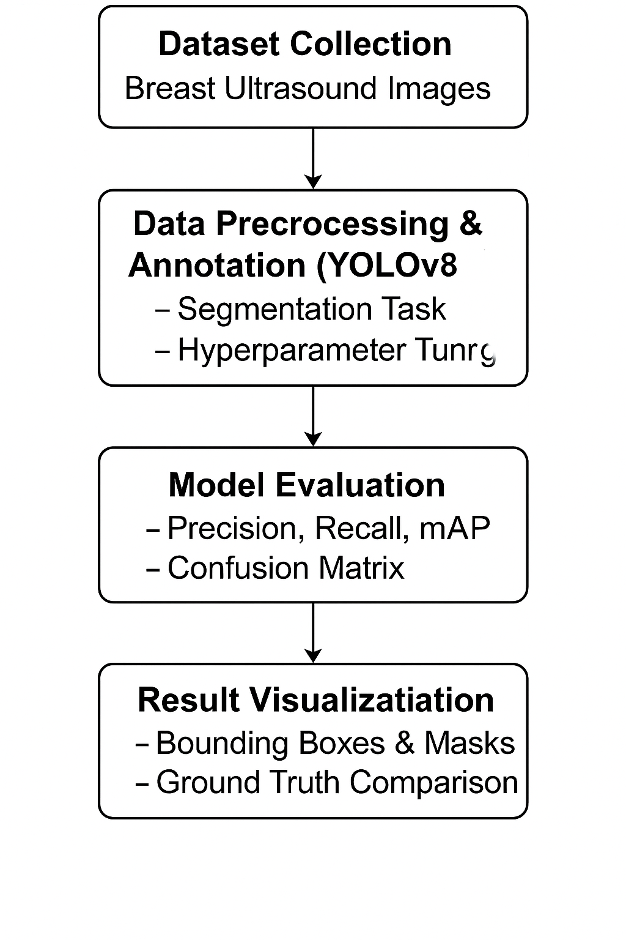

PROJECT PLAN AND TIMELINE

4.1 Work Breakdown
The project is divided into phases:
- Phase 1: Literature Review & Planning
  - Study related work on breast ultrasound analysis and segmentation
  - Review YOLOv8 documentation and examples
  - Finalize dataset and tools
- Phase 2: Dataset Collection & Preparation
  - Download and organize BUSI dataset
  - Preprocess images and masks
  - Convert annotations to YOLOv8 format
  - Split dataset into train/validation/test
- Phase 3: Model Training (YOLOv8)
  - Configure YOLOv8 segmentation model
  - Train model and monitor metrics
  - Apply data augmentation strategies
- Phase 4: Model Evaluation & Fine-Tuning
  - Evaluate model using Precision, Recall, F1, IoU, mAP
  - Analyze failure cases
  - Fine-tune hyperparameters if needed
- Phase 5: Visualization & Interface Development
  - Generate visualization plots and images
  - Develop a simple GUI or web app (optional)
- Phase 6: Final Testing & Report Compilation
  - Test the final prototype
  - Document methodology, results, and conclusions in the final report

4.2 Estimated Timeline
Total duration: approximately 14 weeks, as originally planned:
- Weeks 1–2: Literature Review & Planning
- Weeks 3–4: Dataset Collection & Preparation
- Weeks 5–7: Model Training
- Weeks 8–10: Model Evaluation & Tuning
- Weeks 11–12: Visualization & Interface Development
- Weeks 13–14: Final Testing & Report Writing

EXPECTED RESULTS AND CONTRIBUTIONS

5.1 Expected Outcomes
By the end of the project, we expect to achieve:
- A trained YOLOv8 segmentation model capable of detecting and segmenting breast tumor regions in ultrasound images with high accuracy.
- Visual outputs where tumor regions are clearly highlighted with bounding boxes and segmentation masks.
- A reproducible training and evaluation pipeline that can be used for further research.
- A written project report documenting methodology, experiments, and results.
- (Optional) A prototype GUI or web-based tool for demonstrating the system.

5.2 Potential Impact
If successful, this project can:
- Demonstrate the feasibility of using YOLOv8 for ultrasound-based tumor segmentation.
- Serve as a foundation for future CAD tools for breast cancer screening.
- Be extended to other modalities or diseases with minimal changes to the core pipeline.

CONCLUSION
This proposal presents a plan to design and implement an automated system for breast ultrasound tumor segmentation using YOLOv8. The project addresses a real-world clinical problem: the need for accurate, efficient, and scalable methods to detect and localize breast tumors in ultrasound images.
By leveraging a public dataset (BUSI), modern deep learning techniques, and powerful tools such as YOLOv8 and Roboflow, the project aims to develop a robust segmentation model evaluated with standard metrics and visual analysis. The expected outcome is a practical and extendable pipeline that contributes both academically and technically to the domain of medical image analysis.

REFERENCES
(You can format them in your own style, but these are based on your original list.)
- Al-Dhabyani, W., Gomaa, M., Khaled, H., & Fahmy, A. (2020). Dataset of Breast Ultrasound Images. Data in Brief, 28, 104863.
- Jocher, G., Chaurasia, A., & Qiu, J. (2023). YOLOv8: Ultralytics Object Detection and Segmentation Models. Ultralytics Docs.
- He, K., Zhang, X., Ren, S., & Sun, J. (2016). Deep Residual Learning for Image Recognition. Proceedings of the IEEE Conference on Computer Vision and Pattern Recognition (CVPR).
- Redmon, J., & Farhadi, A. (2018). YOLOv3: An Incremental Improvement. arXiv preprint arXiv:1804.02767.
- Bradski, G. (2000). The OpenCV Library. Dr. Dobb’s Journal of Software Tools.
- Roboflow. (n.d.). Data Labeling and Augmentation Platform. Retrieved from roboflow.com

