**Pandas:**

Pandas(Day 1)

First we import libraries

* Import pandas as pd
* pd.read_cvs(‘data_file.csv) # pd mean pandas librar pd.read_cvs (read the data) (‘data_file) mean name of data file (.csv) mean type of data file

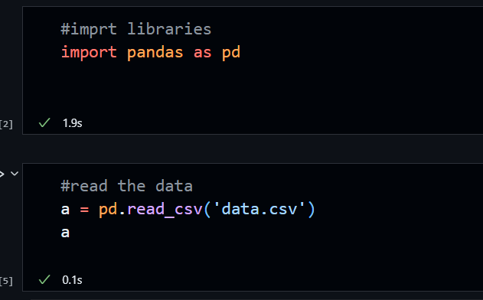

* df.to_excel(‘data_file.xlsx’) #