**MACHUKI ERICK DAUDI**

**P15/1271/2010**

**What is net-snmp,mibBrowser?**

Net-SNMP is a suite of software for using and deploying the Simple Network Management Protocol used for for monitoring the health and welfare of network equipment (eg. routers), computer equipment and even devices like UPSs. it has several applications such as Command-line applications to retrieve information from an SNMP-capable device( snmpget, snmpgetnext).

A mibBrowser is a graphical application tool of net-snmp that allows you to pull out data from SNMP enabled devices such as routers, switches, and servers. and other functionalities

i installed net-snmp in my linux workstation together with net-snmpd;

snmpd:

acts as the central SNMP data repository for a given host. In it's most typical usage, it listens to port 161

* waits for requests to come in and responds to them
* issues notifications ([TRAPs](http://www.net-snmp.org/wiki/index.php/TRAP) and [INFORMs](http://www.net-snmp.org/wiki/index.php/INFORM))
* is capable of performing some [Self Monitoring](http://www.net-snmp.org/wiki/index.php/TUT:DisMan_Monitoring)

using command line based net-snmp was able to :

-SNMPGET

**snmpget** is an SNMP application that uses the SNMP GET request to query for information on a network entity. One or more object identifiers (OIDs) may be given as arguments on the command line

example:

snmpget -v1 -Cf -c public localhost system.sysUpTime system.sysContact.

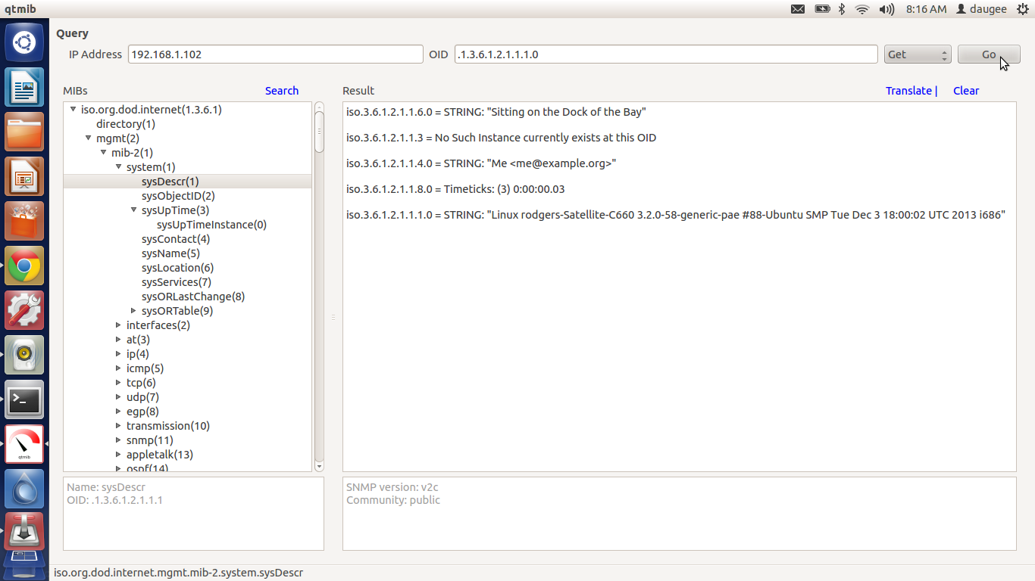

-SNMPWALK

retrieve a subtree of management values using SNMP GETNEXT requests

The command:

snmpwalk -Os -c public -v 1 zeus system

will retrieve all of the variables under system:

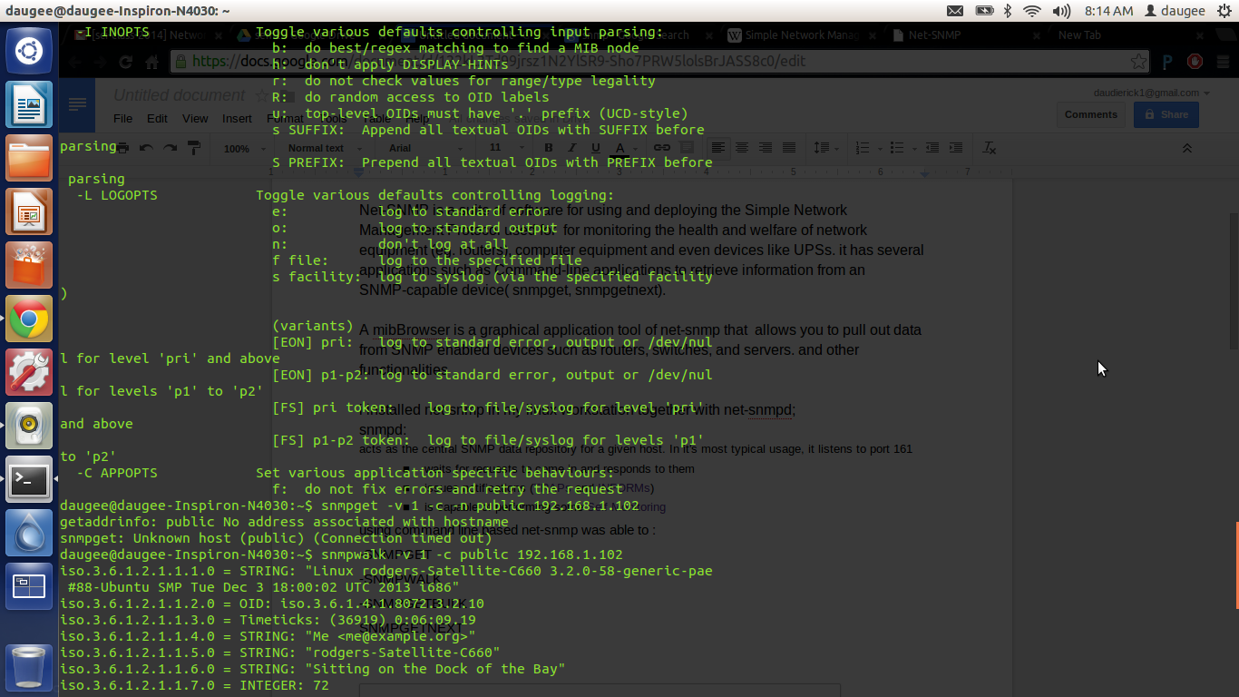

-SNMPGETBULK

Optimized version of *GetNextRequest*. A **manager-to-agent** request for multiple iterations of *GetNextRequest*. Returns a *Response* with multiple variable bindings walked from the variable binding or bindings in the request. PDU specific *non-repeaters* and *max-repetitions* fields are used to control response behavior. *GetBulkRequest* was introduced in SNMPv2.

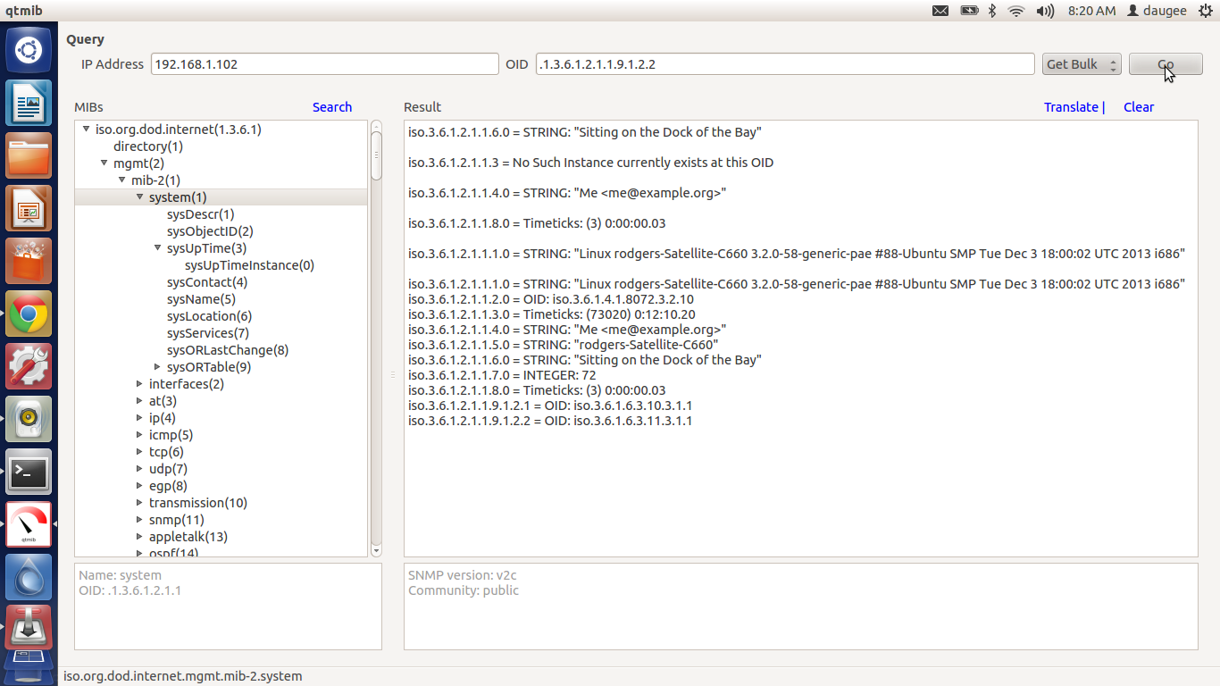

SNMPGETNEXT

A **manager-to-agent** request to discover available variables and their values. Returns a *Response* with variable binding for the lexicographically next variable in the MIB. The entire MIB of an agent can be walked by iterative application of *GetNextRequest* starting at OID 0. Rows of a table can be read by specifying column OIDs in the variable bindings of the request.

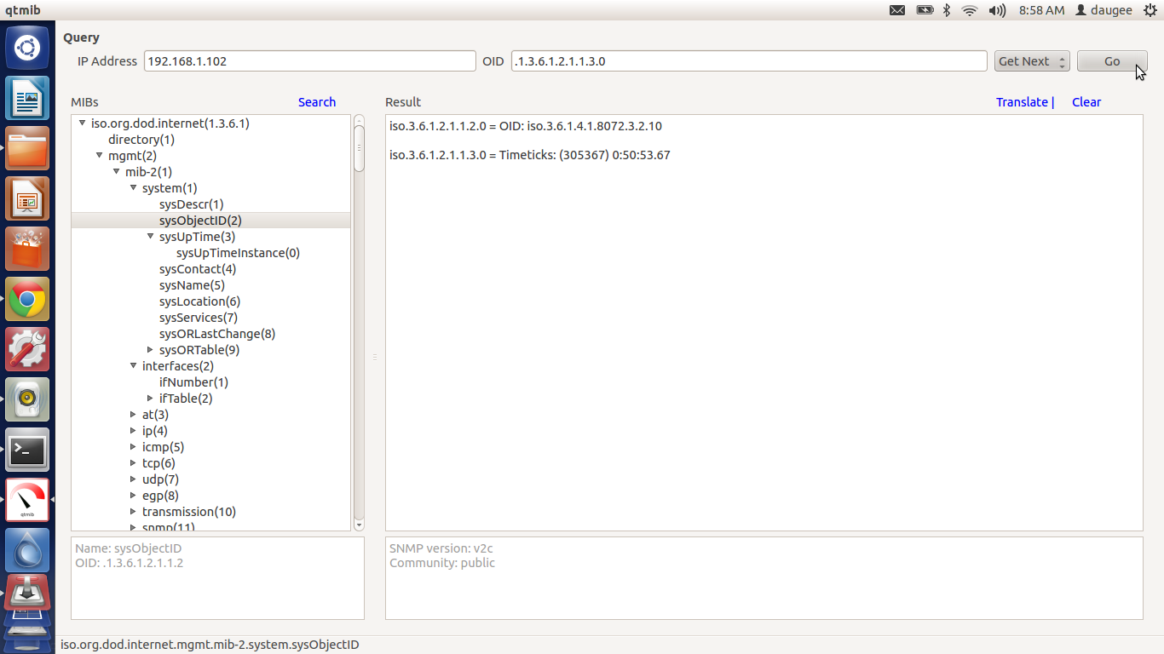

**2. What is mrtg?**

The Multi Router Traffic Grapher, or just simply MRTG, is [free software](http://en.wikipedia.org/wiki/Free_software) for [monitoring](http://en.wikipedia.org/wiki/Network_monitoring) and [measuring](http://en.wikipedia.org/wiki/Network_traffic_measurement) the traffic load on [network](http://en.wikipedia.org/wiki/Computer_network) links. It allows the user to see traffic load on a network over time in graphical form. It uses Simple Network Management Protocol (SNMP) to send requests with two [object identifiers](http://en.wikipedia.org/wiki/Object_identifier) (OIDs) to a device. The device, which must be SNMP-enabled, will have a [management information base](http://en.wikipedia.org/wiki/Management_information_base) (MIB) to look up the OIDs specified. After collecting the information it will send back the raw data encapsulated in an SNMP protocol. MRTG records this data in a log on the client along with previously recorded data for the device. The software then creates an [HTML](http://en.wikipedia.org/wiki/HTML) document from the logs, containing a list of graphs detailing traffic for the selected devices in the server.

**3. What is prtg?**

[PRTG Network Monitor](http://en.wikipedia.org/wiki/PRTG_Network_Monitor) is a server up-time and utilisation, [network monitoring](http://en.wikipedia.org/wiki/Network_monitoring) and [bandwidth usage](http://en.wikipedia.org/wiki/Throughput) software for server infrastructure by [Paessler AG](http://en.wikipedia.org/wiki/Paessler_AG). It can monitor and classify bandwidth usage in a network using [SNMP](http://en.wikipedia.org/wiki/Simple_Network_Management_Protocol), [Packet Sniffing](http://en.wikipedia.org/wiki/Packet_Sniffer) and [Netflow](http://en.wikipedia.org/wiki/Netflow).

**4.Ethereal [common-view]**

Is a [free and open-source](http://en.wikipedia.org/wiki/Free_and_open_source_software) [packet analyzer](http://en.wikipedia.org/wiki/Packet_analyzer). It is used for [network](http://en.wikipedia.org/wiki/Computer_network) troubleshooting, analysis, software and [communications protocol](http://en.wikipedia.org/wiki/Communications_protocol) development, and education

