**Question 1:**

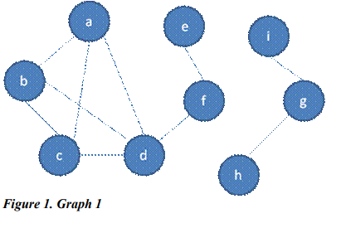

**Adjacency table :**

|  |  |  |  |  |  |  |  |  |  |
| --- | --- | --- | --- | --- | --- | --- | --- | --- | --- |
|  | A | B | C | D | E | F | G | H | I |
| A | 0 | 1 | 1 | 1 | 0 | 0 | 0 | 0 | 0 |
| B | 1 | 0 | 1 | 1 | 0 | 0 | 0 | 0 | 0 |
| C | 1 | 1 | 0 | 1 | 0 | 0 | 0 | 0 | 0 |
| D | 1 | 1 | 1 | 0 | 0 | 1 | 0 | 0 | 0 |
| E | 0 | 0 | 0 | 0 | 0 | 1 | 0 | 0 | 0 |
| F | 0 | 0 | 0 | 1 | 1 | 0 | 0 | 0 | 0 |
| G | 0 | 0 | 0 | 0 | 0 | 0 | 0 | 1 | 1 |
| H | 0 | 0 | 0 | 0 | 0 | 0 | 1 | 0 | 0 |
| I | 0 | 0 | 0 | 0 | 0 | 0 | 1 | 0 | 0 |

🡪 the output of breadth-first traversal from vertex B : B A C D F E G H I

**Question 2:**

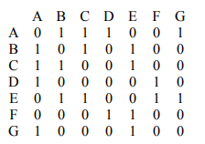

**Graph :**

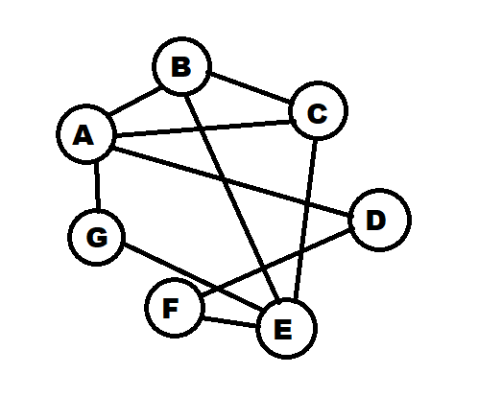

* the output of breadth-first traversal from vertex A : A B C D G E F

**Question 3:**

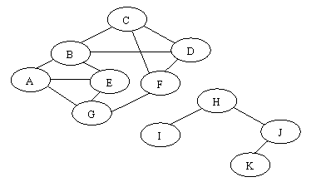

* the output of depth-first traversal from vertex A : A B C D F G E H I J K

**Question 4:** The shortest path from the vertex 1 to the vertex 5 = 6

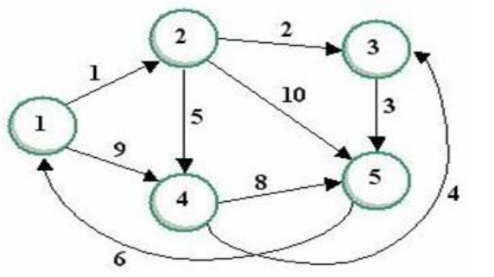

|  |  |  |  |  |  |  |
| --- | --- | --- | --- | --- | --- | --- |
|  |  | **1** | **2** | **3** | **4** | **5** |
| **Step 0** |  | ~ | ~ | ~ | ~ | ~ |
| **Step 1** | **1** | - | 1,1 | - | 9,1 | - |
| **Step 2** | **1,2** | - | - | 3,2 | 6,2 | 11,2 |
| **Step 3** | **1,2,3** | - | - | - | 6,2 | 6,3 |
| **Step 4** | **1,2,3,4** | - | - | - | - | 6,3 |

1 => 2 => 3 => 5

**Question 5:** The label of the vertex 4 is (6) when the shortest path from 1 to 5 is determined.

**Question 6:** The shortest path from the vertex A to the vertex F = 20

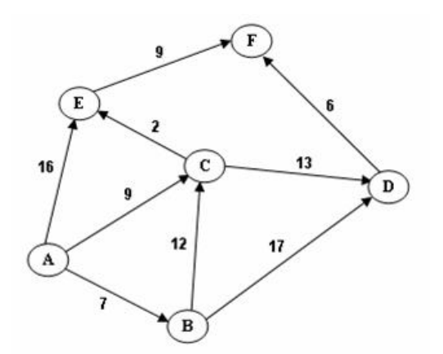

|  |  |  |  |  |  |  |  |
| --- | --- | --- | --- | --- | --- | --- | --- |
|  |  | A | B | C | D | E | F |
| Step 0 |  | ~ | ~ | ~ | ~ | ~ | ~ |
| Step 1 | A | - | 7,A | 9,A | - | 16,A | - |
| Step 2 | A,B | - | - | 9,A | 24,B | 16,A | - |
| Step 3 | A,B,C | - | - | - | 22,C | 11,C | - |
| Step 4 | A,B,C,E | - | - | - | 22,C | - | 20,E |
| Step 5 | A,B,C,E,D | - | - | - | - | - | 20,E |

A => C => E => F

**Question 7:**

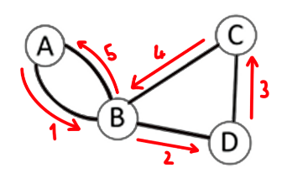

**The graph has e Euler cycle: A-B-C-D-B-A**

**Question 8:**

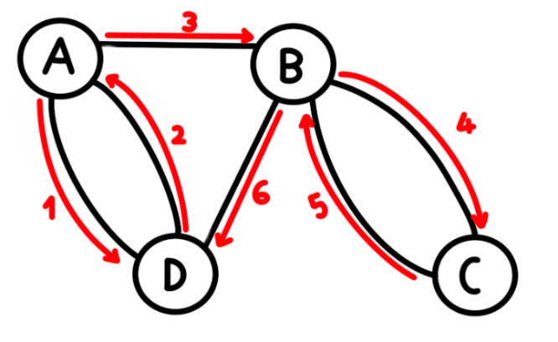

Euler path exists: a -> d -> a -> b -> c -> b -> d

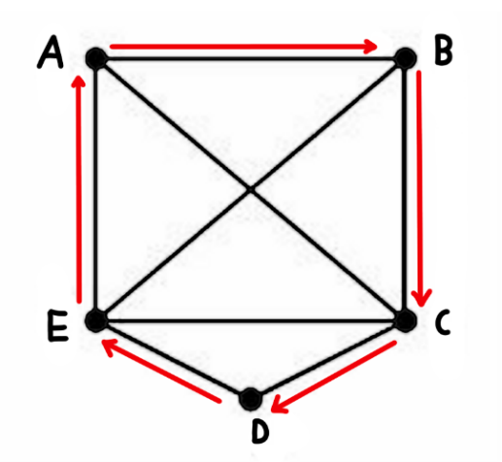**Question 9:**

Hamilton cycle exists: a -> b -> c -> d -> e -> a

**Question 10:**

**C1:**

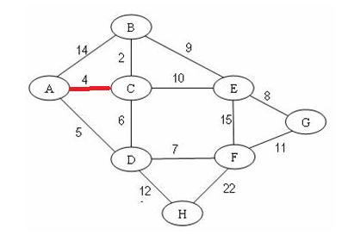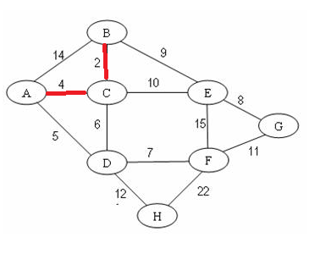

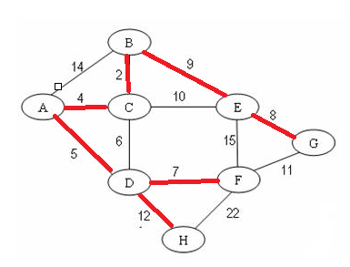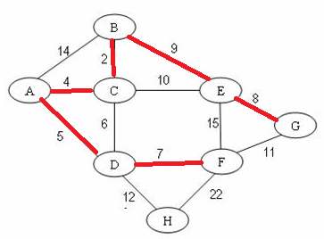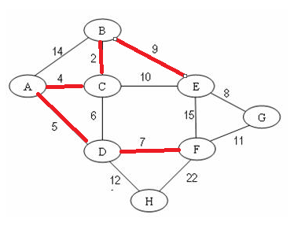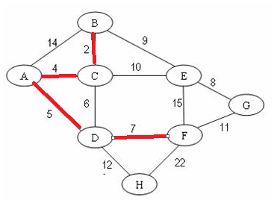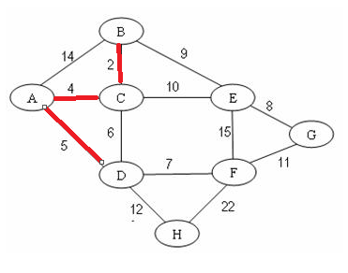

**C2:**

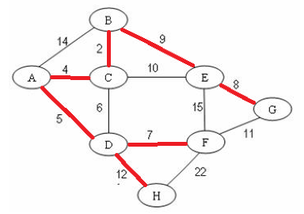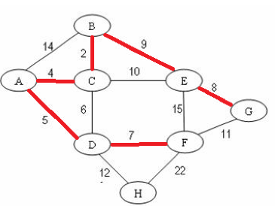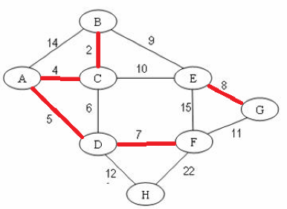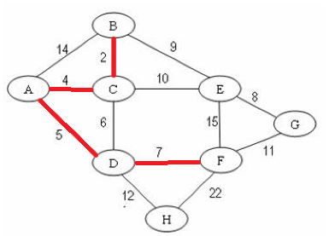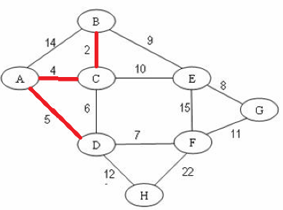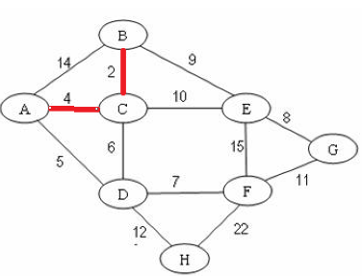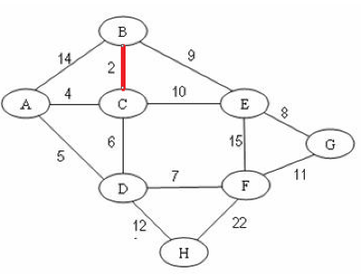

**Question 11:**

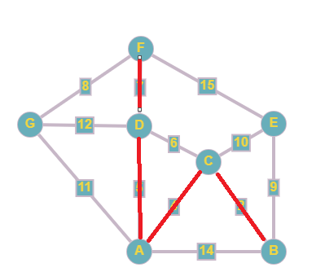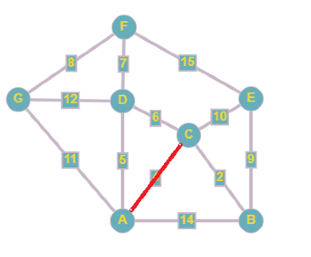**C1:**

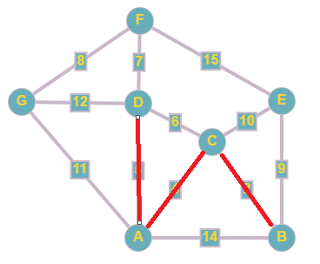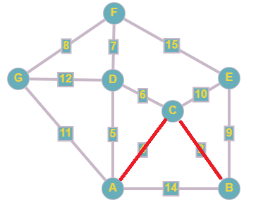

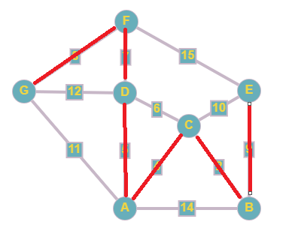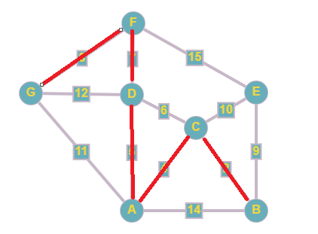

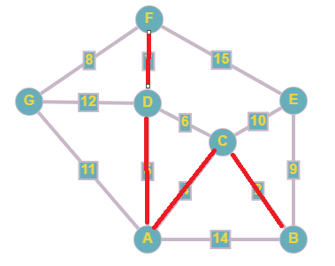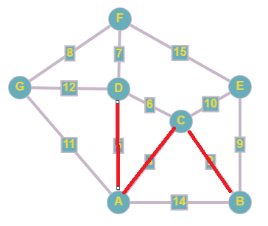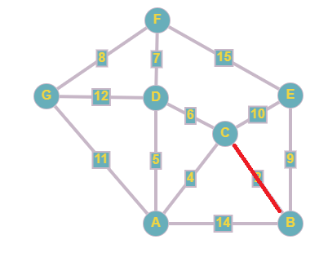**C2:**

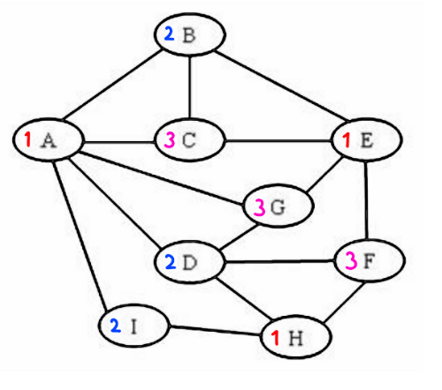**Question 12:**

**>**

Color vertices in the following sequence: A -> B -> C -> D -> E -> F -> G -> H -> I

The color of the vertex H: 1

**Question 1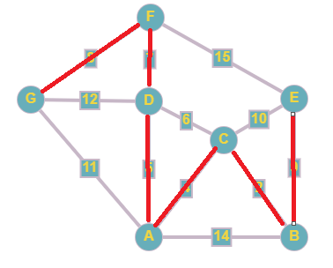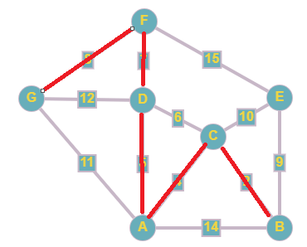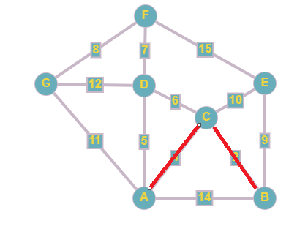3:**

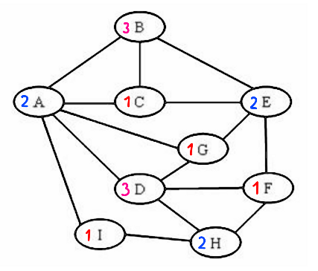

The color of the vertex H: 2

Color vertices in the following sequence: I -> H -> G -> F -> E -> D -> C -> B -> A