1. the output of breadth-first traversal from vertex B : B A C D F E
2. the output of breadth-first traversal from vertex A : A B G C E F D

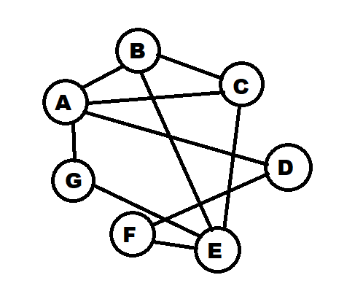

1. the output of depth-first traversal from vertex A : A B C D F G E