Task 1. Generate and insert 200 random rows into the Passengers table.
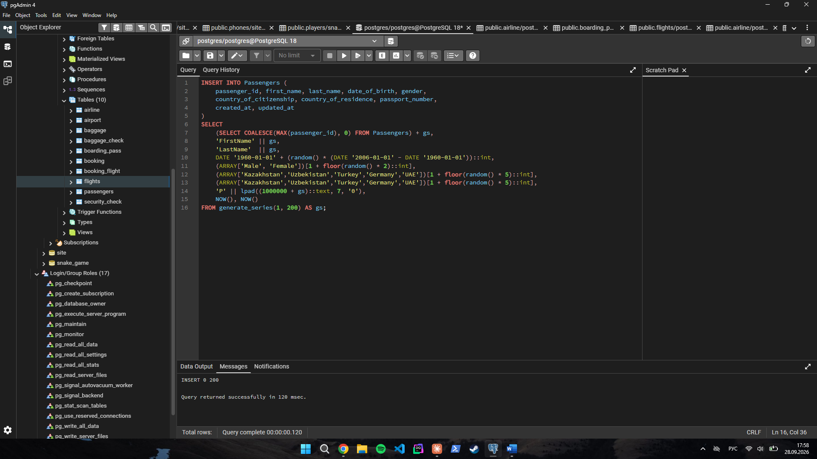
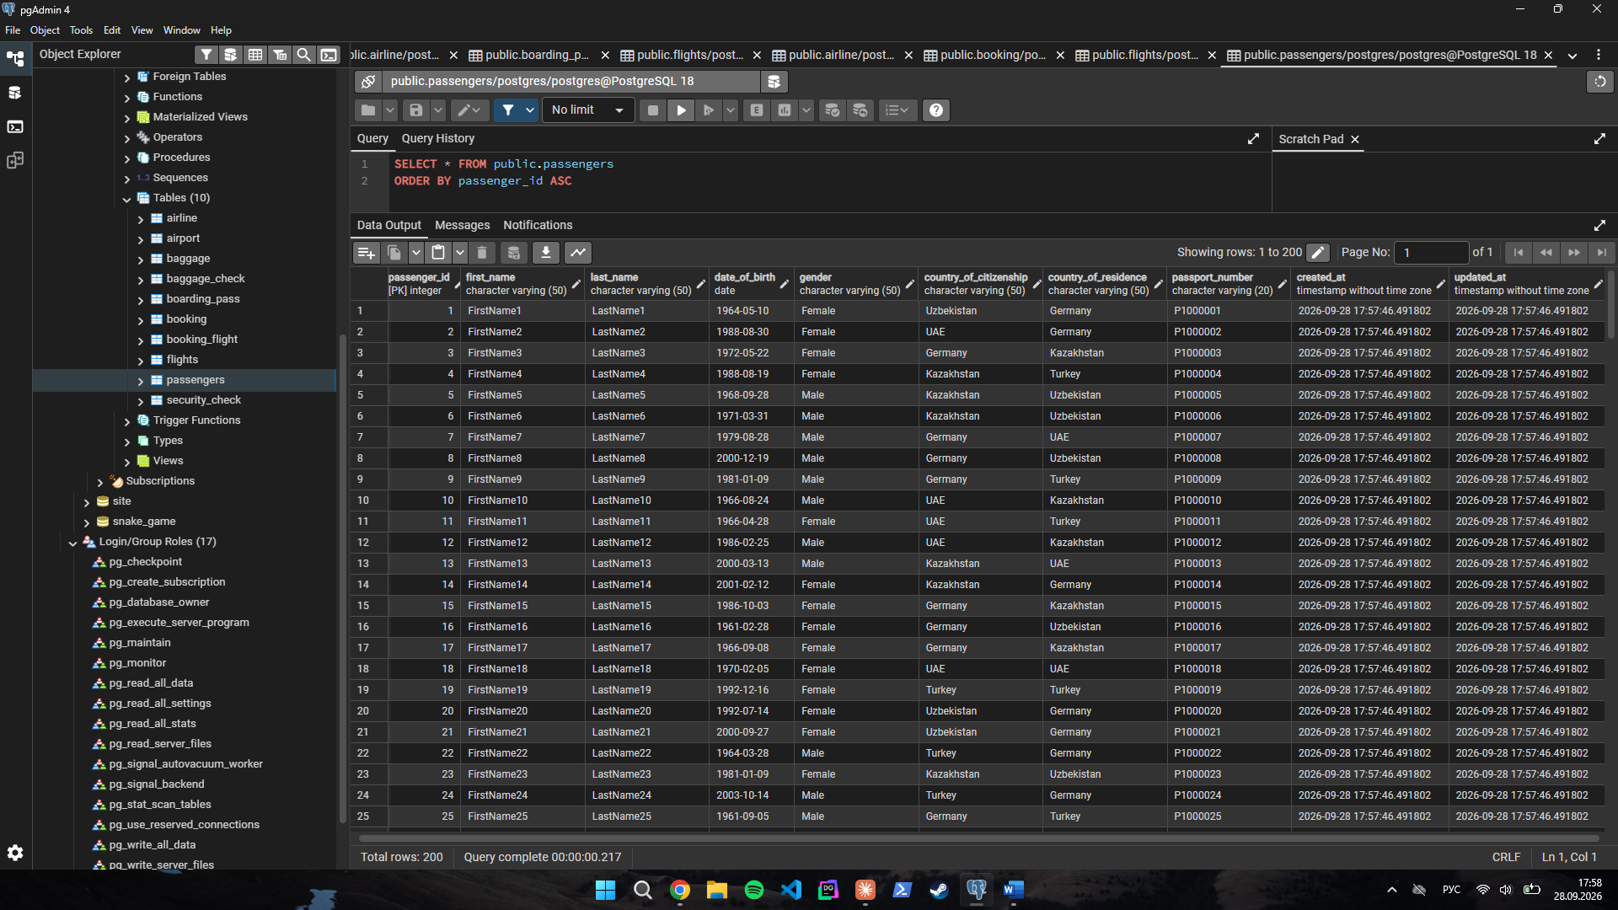
Task 2. Add a new airline "KazAir" based in "Kazakhstan" to the Airline table.
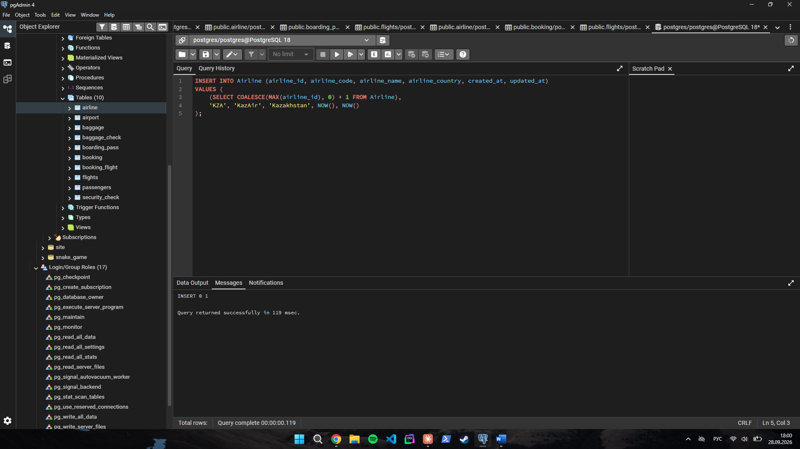
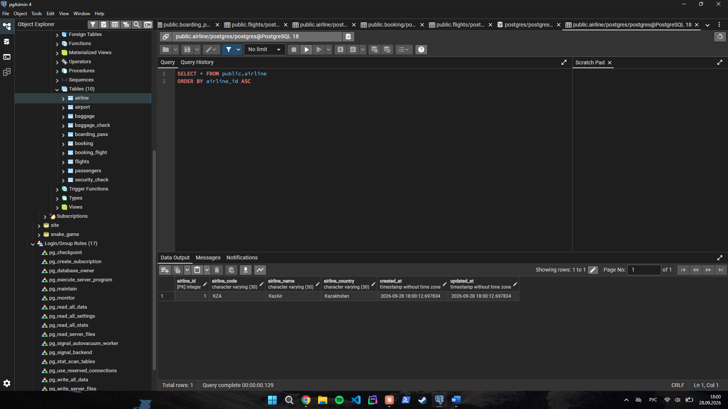
Task 3. Update the airline country of "KazAir" to "Turkey".
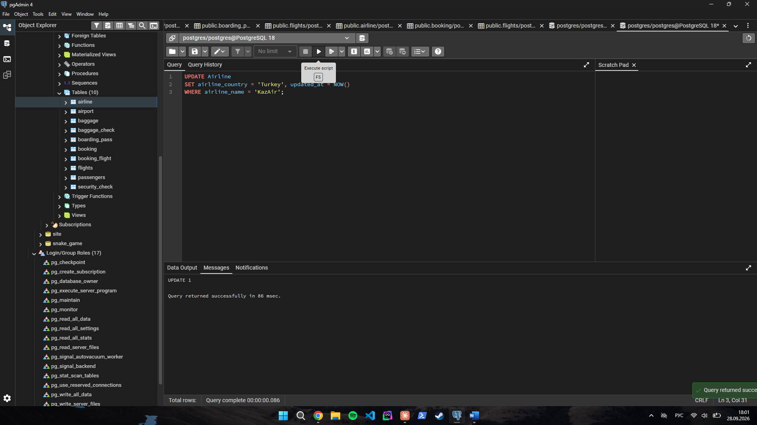
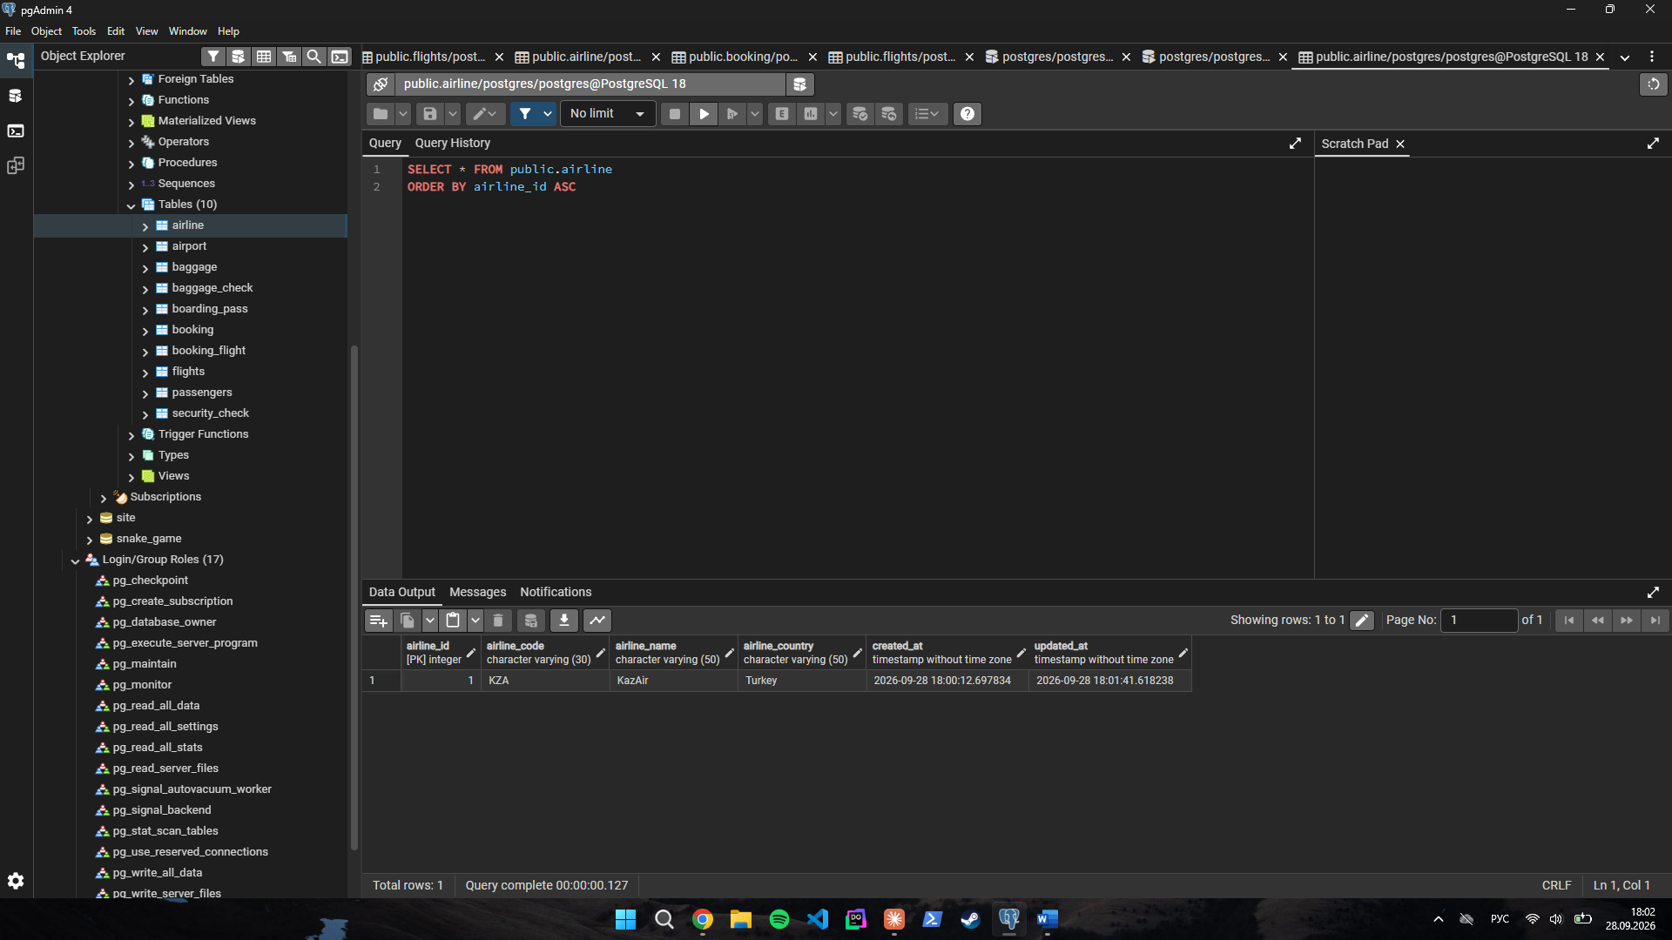
Task 4. Add three airlines at once: "AirEasy" in France, "FlyHigh" in Brazil, and "FlyFly" in Poland.
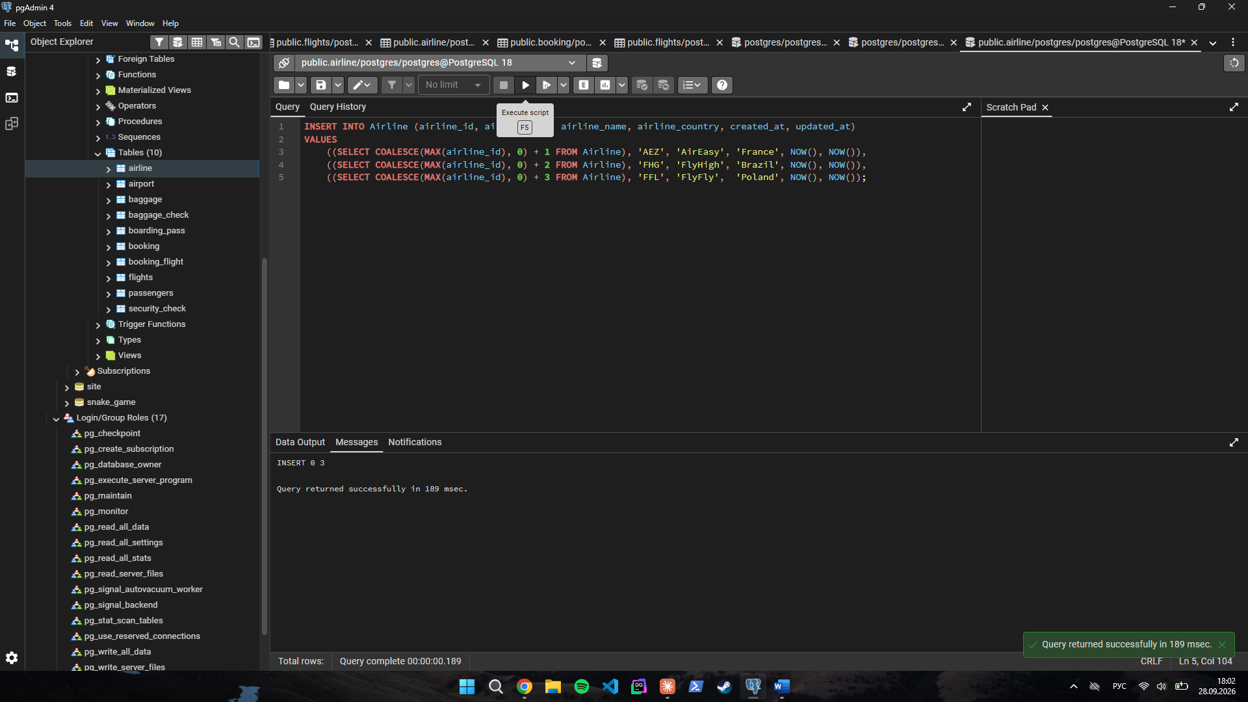
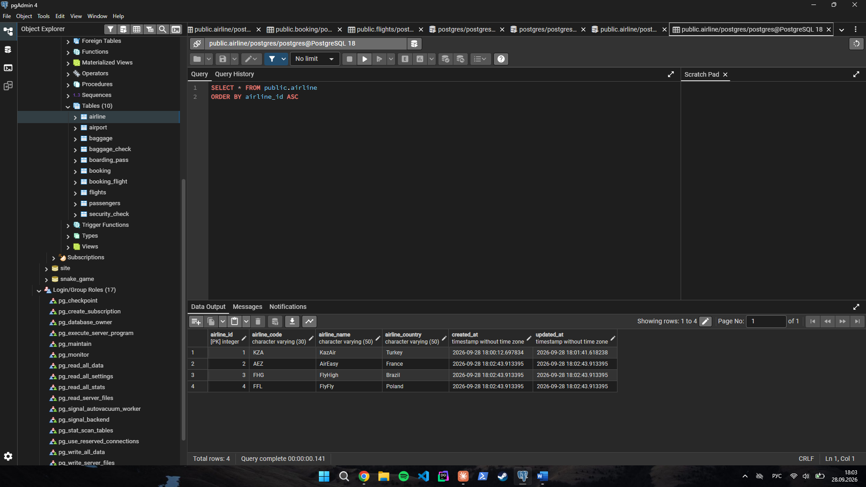
Task 5. Delete all flights (Flights) whose arrival year (sch_arrival_time) is 2024.
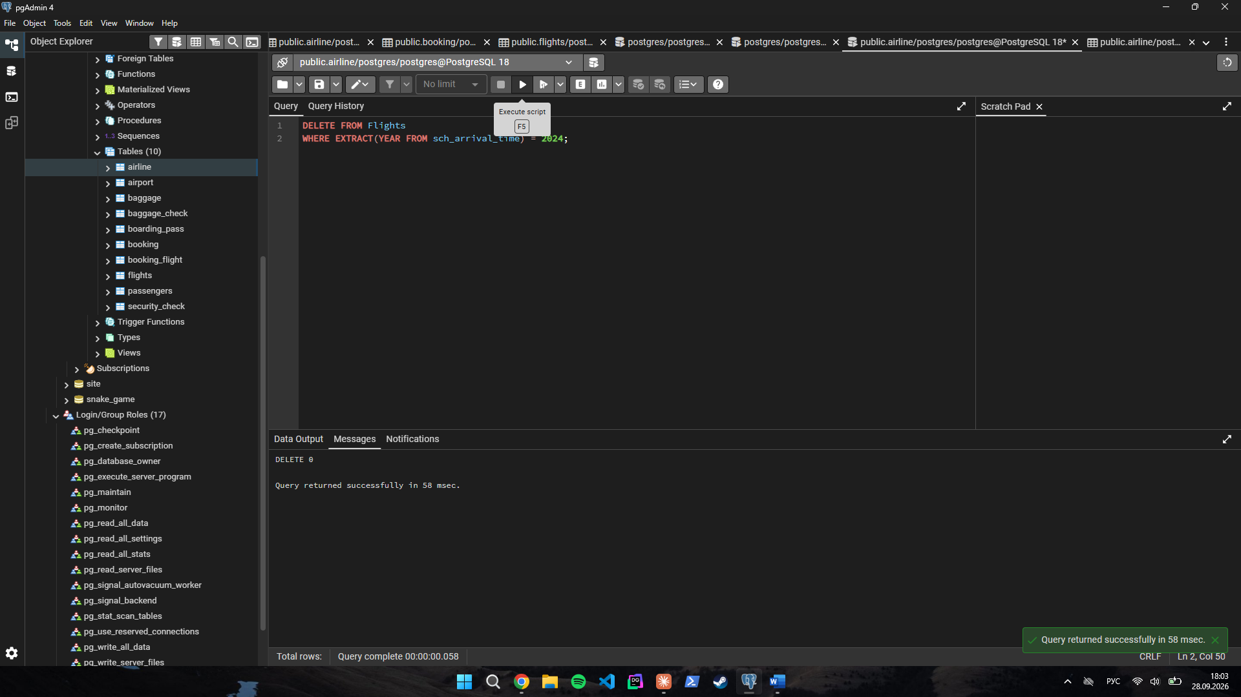
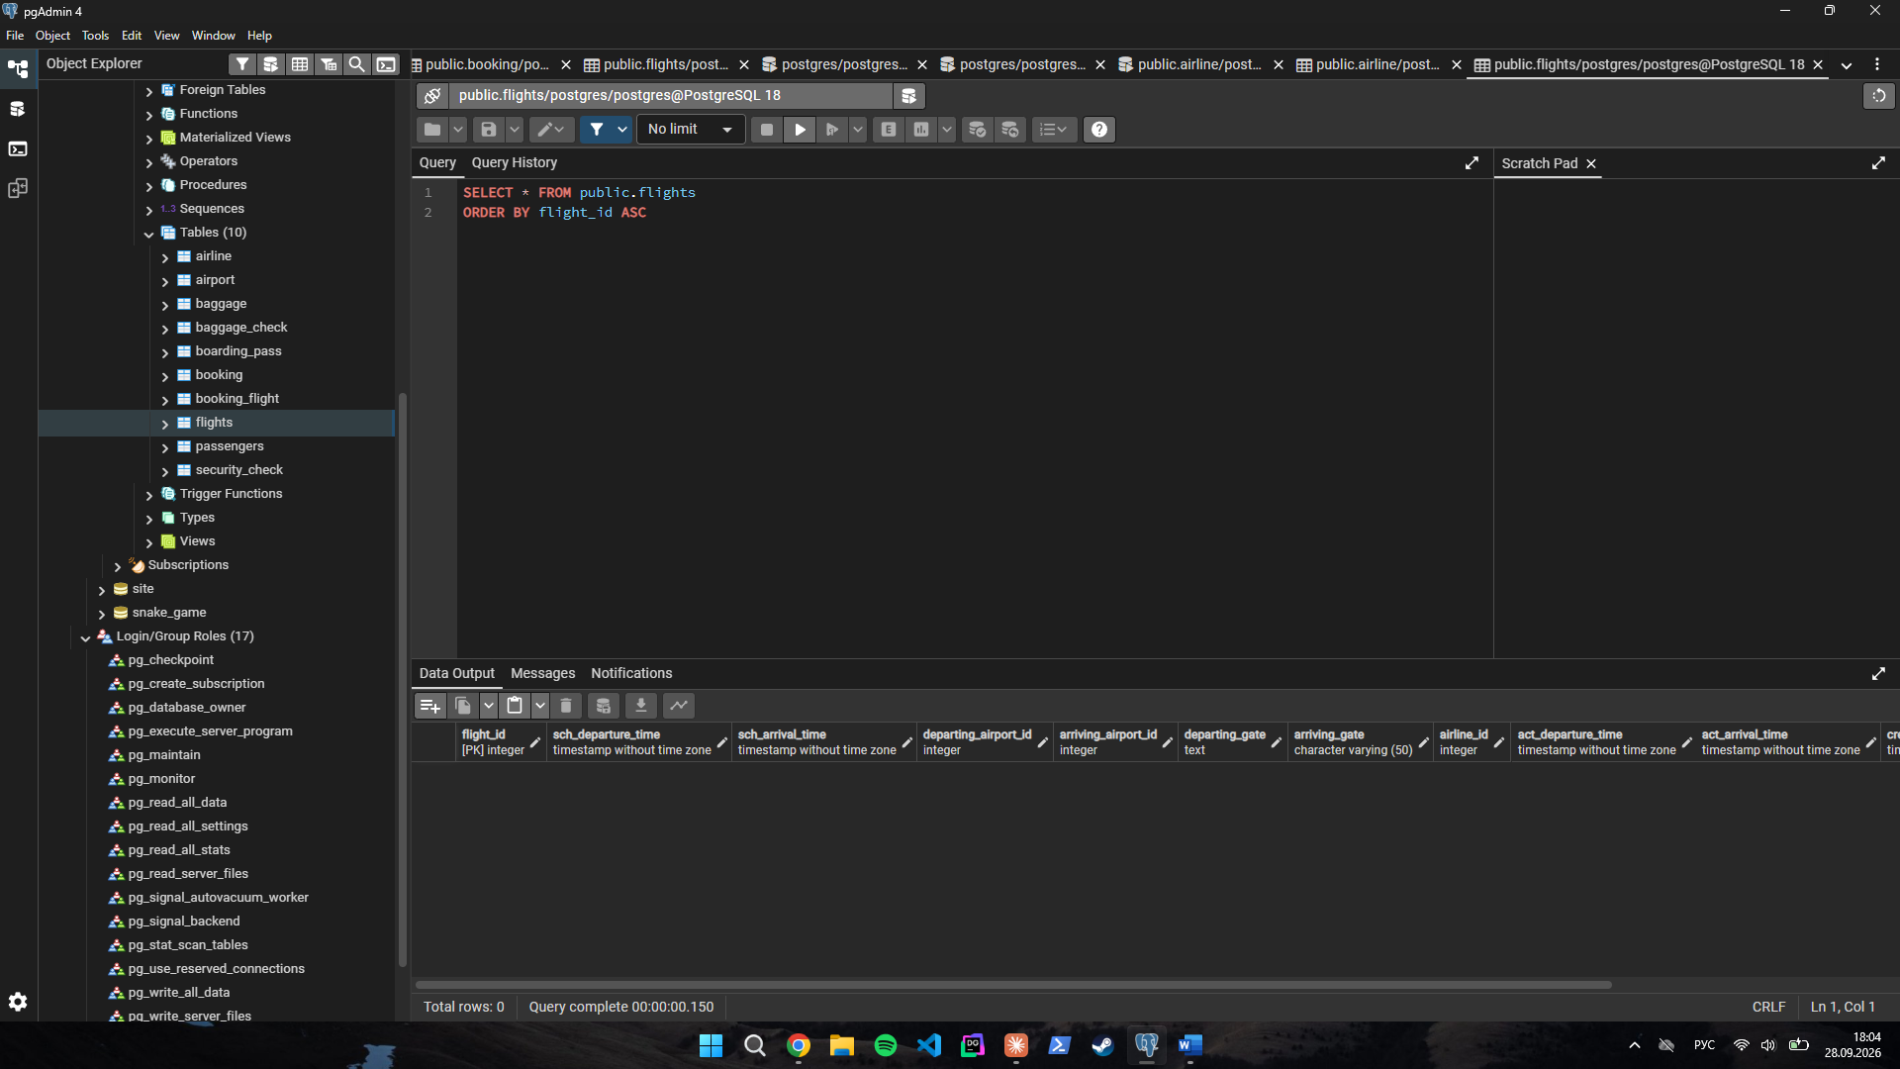
Task 6. Increase the ticket_price of all tickets in the Booking table by 15%.
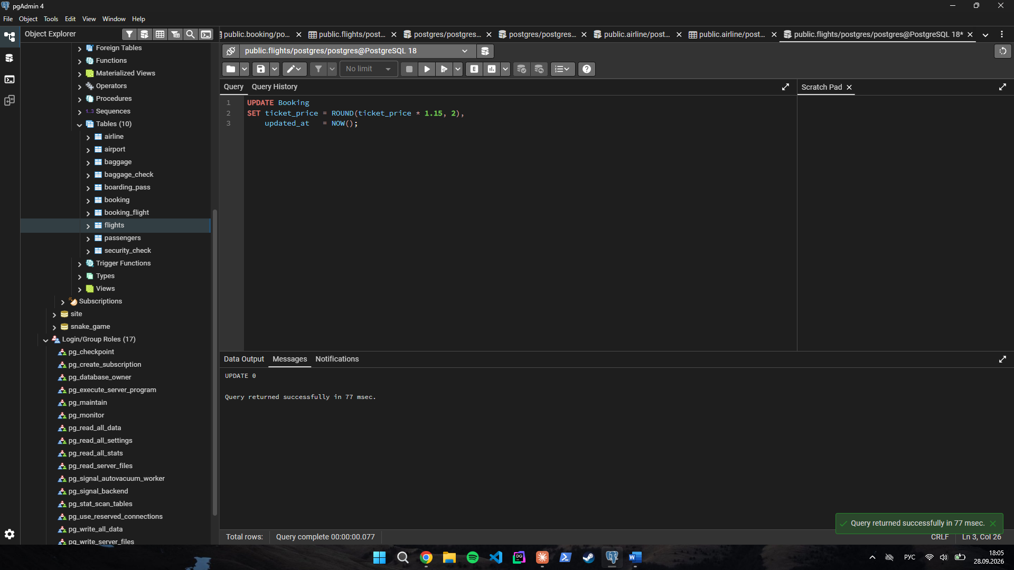
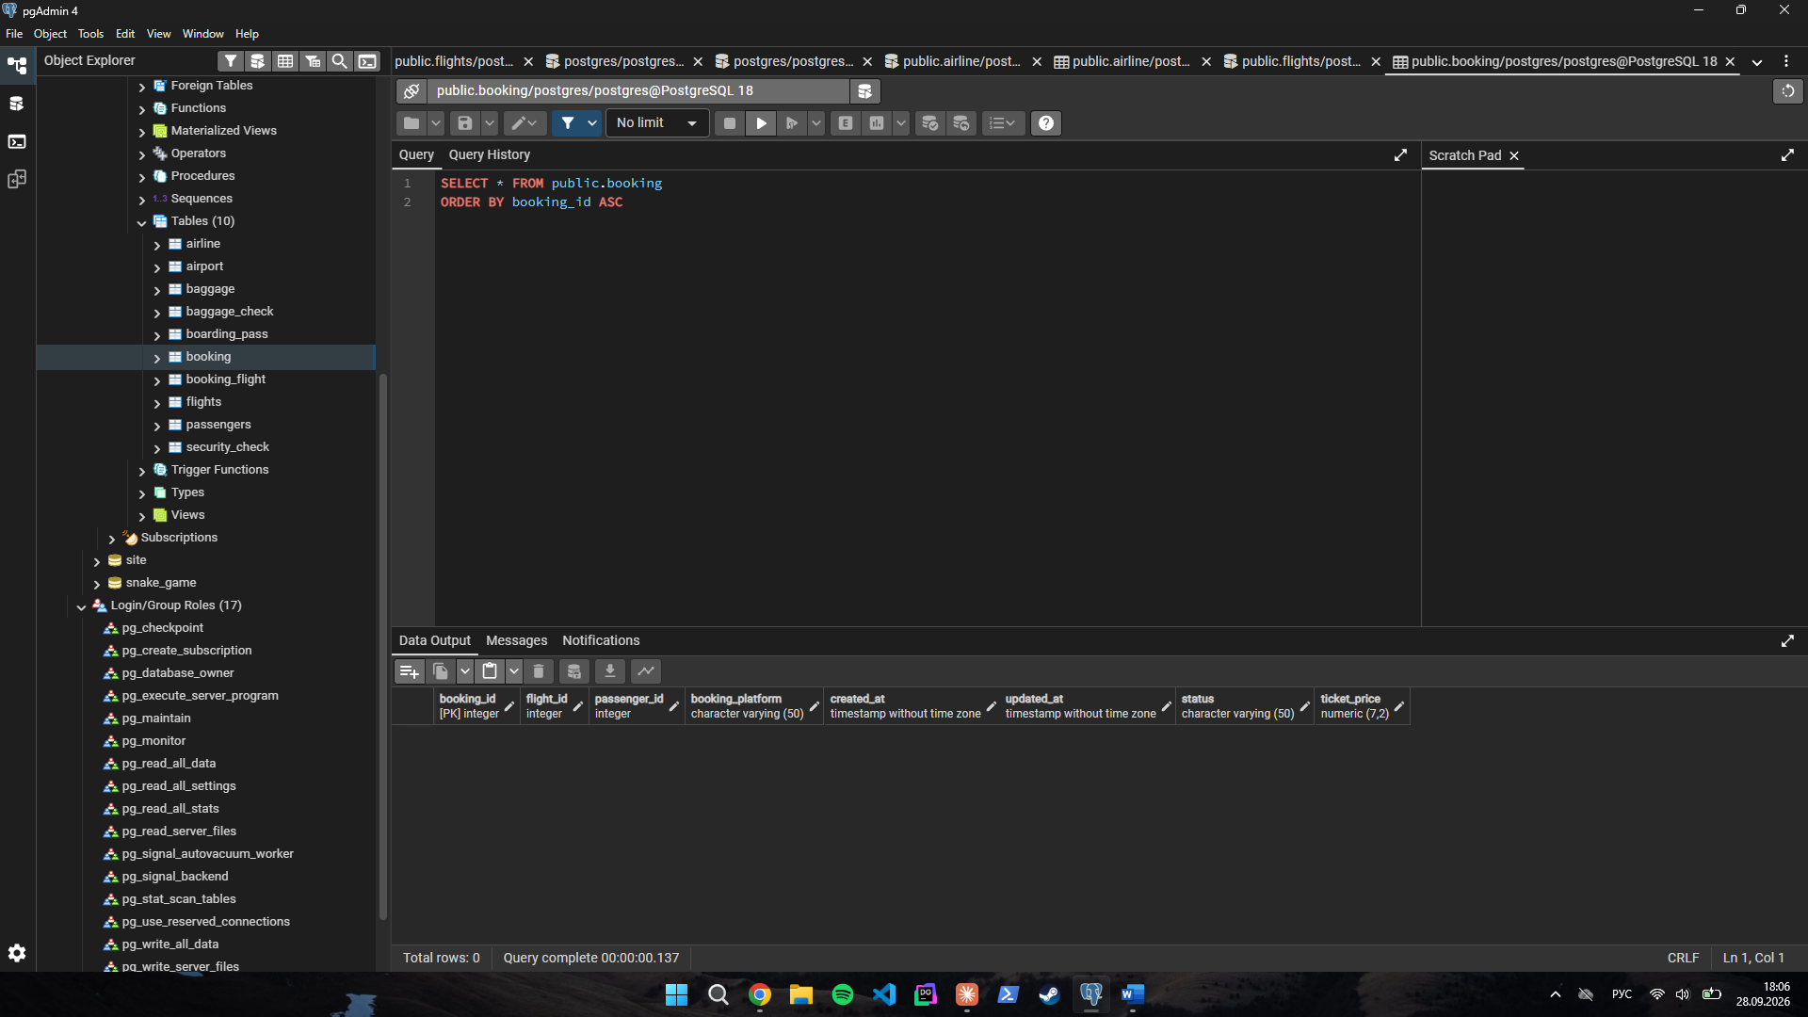
Task 7. Delete all tickets from Booking where ticket_price is less than 10000.
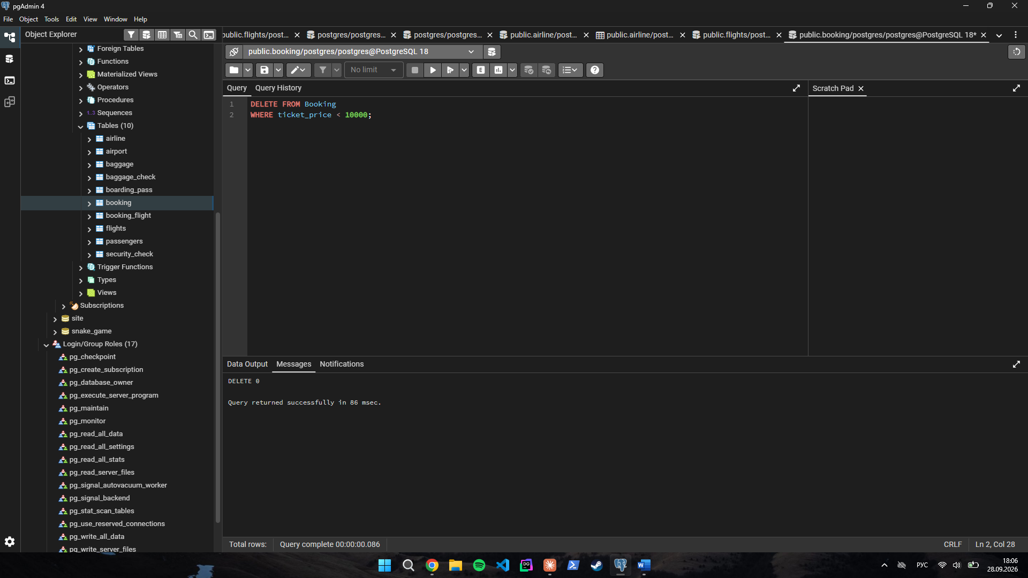
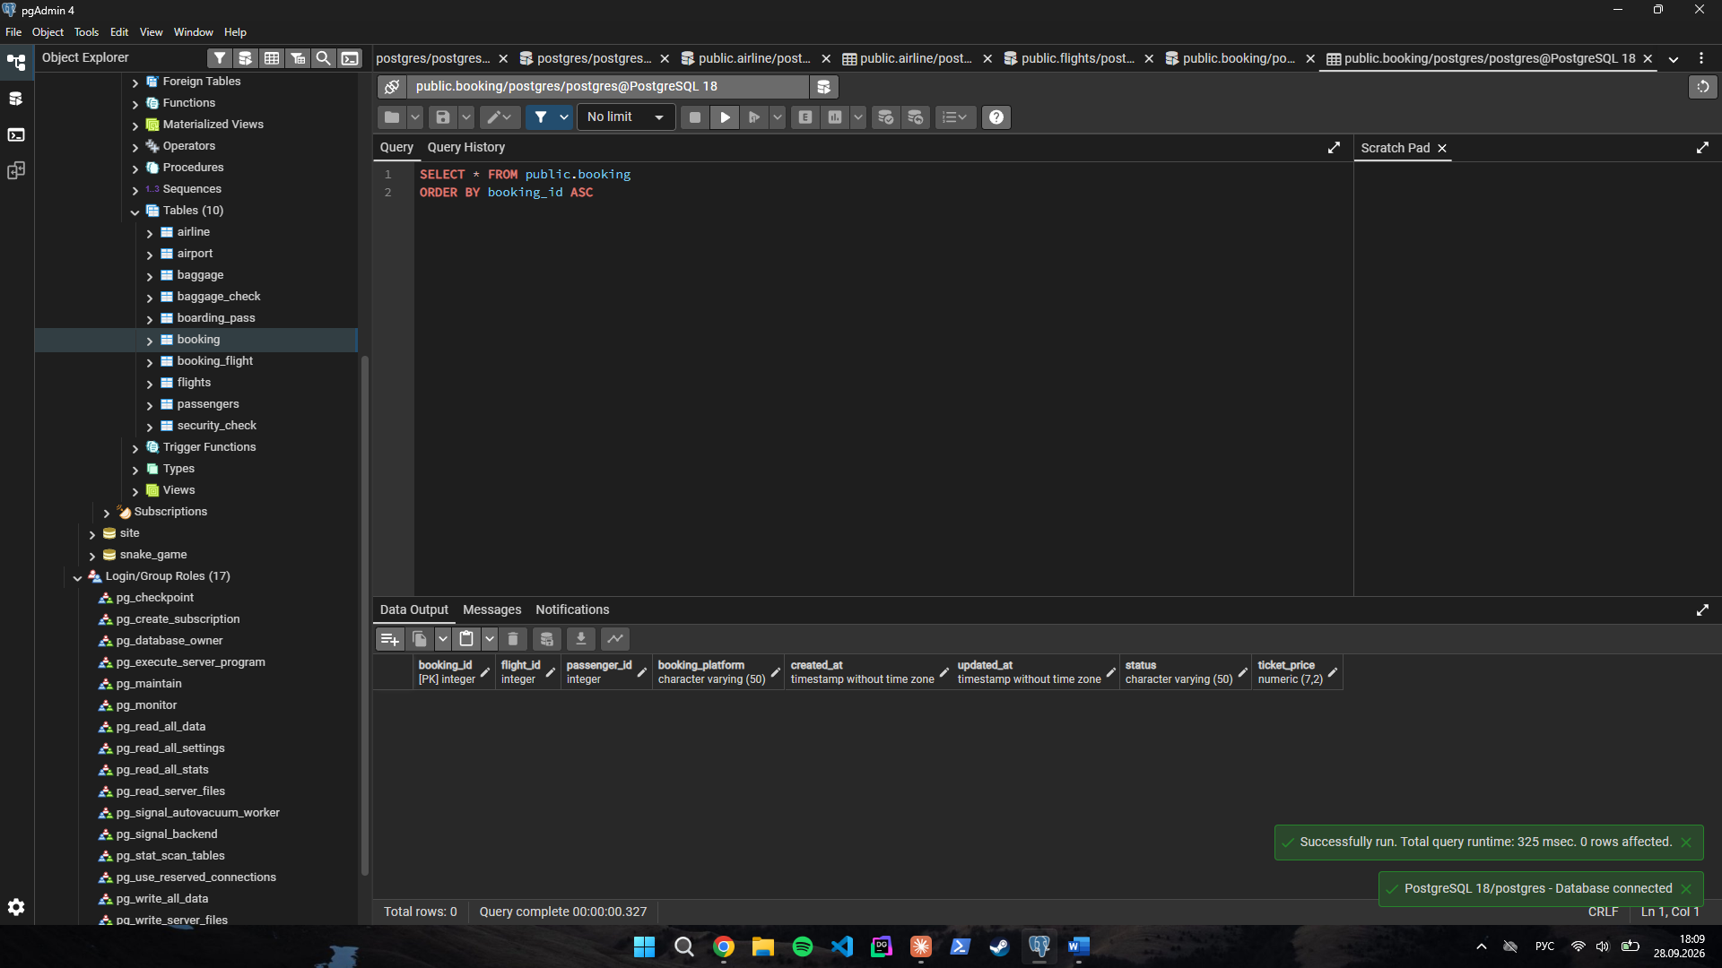
Task 8. Set a default code 'UNK' for any airline in the Airline table where airline_code is missing (NULL).
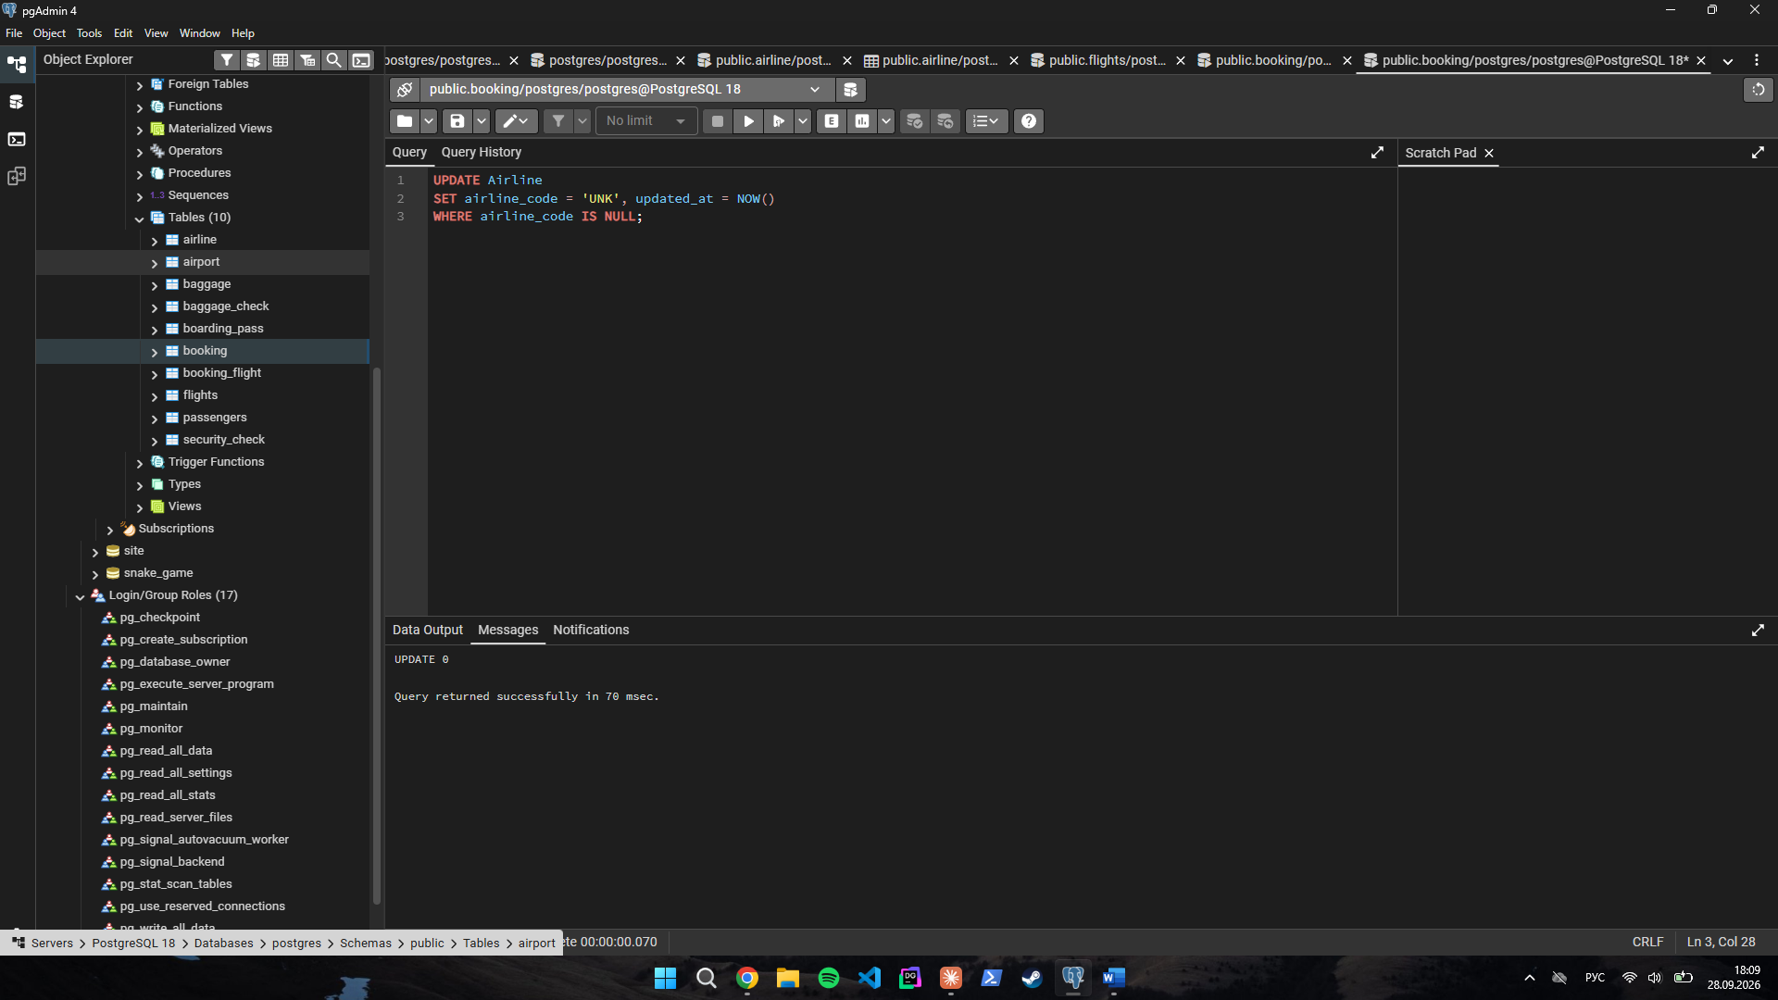
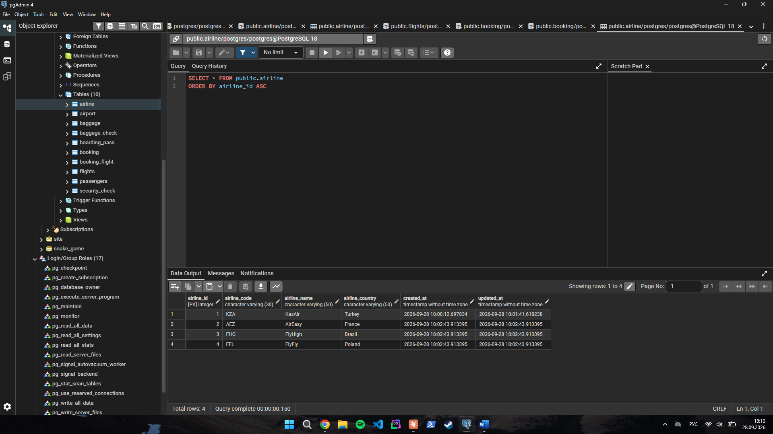
Task 9. Delete all baggage check records (Baggage_check) created before June 1, 2023, whose result is still 'Not checked'.
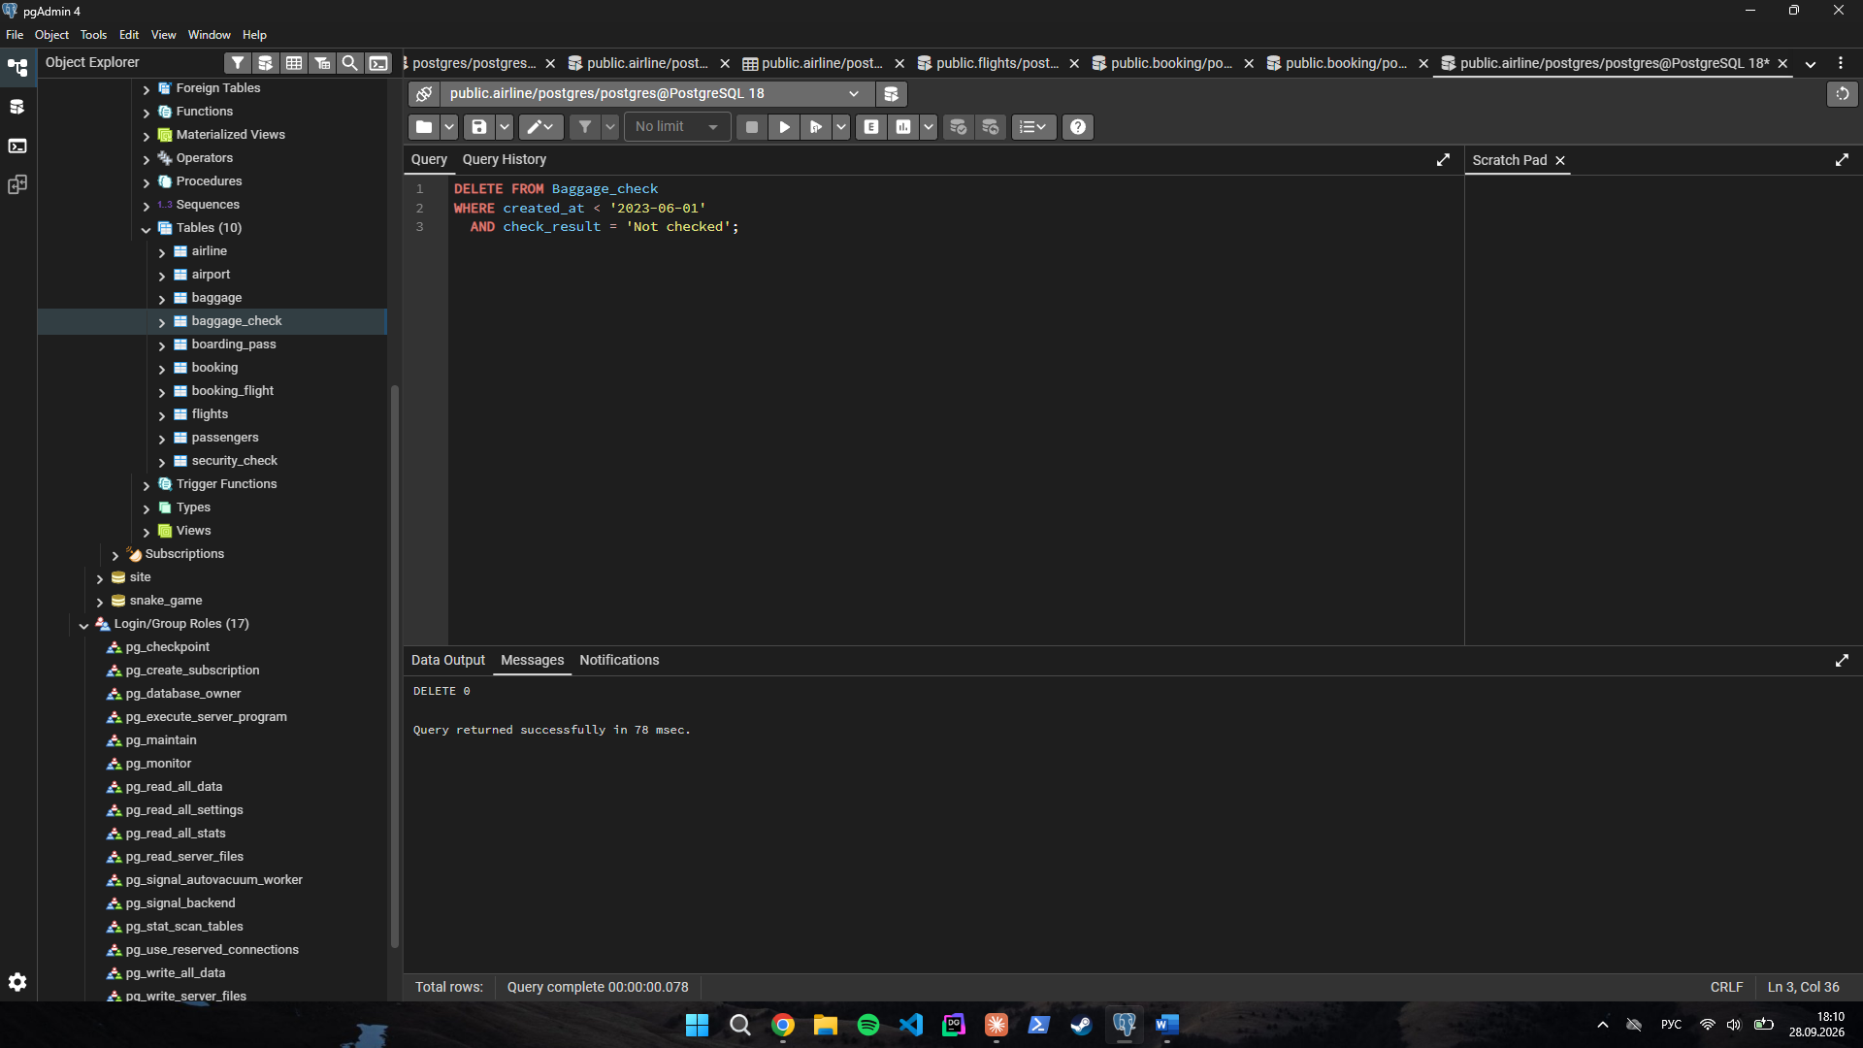
Task 10. Delete all entries from the Airport table where state is missing (NULL) and the city is either 'Mlawe' or 'Kepuh'.
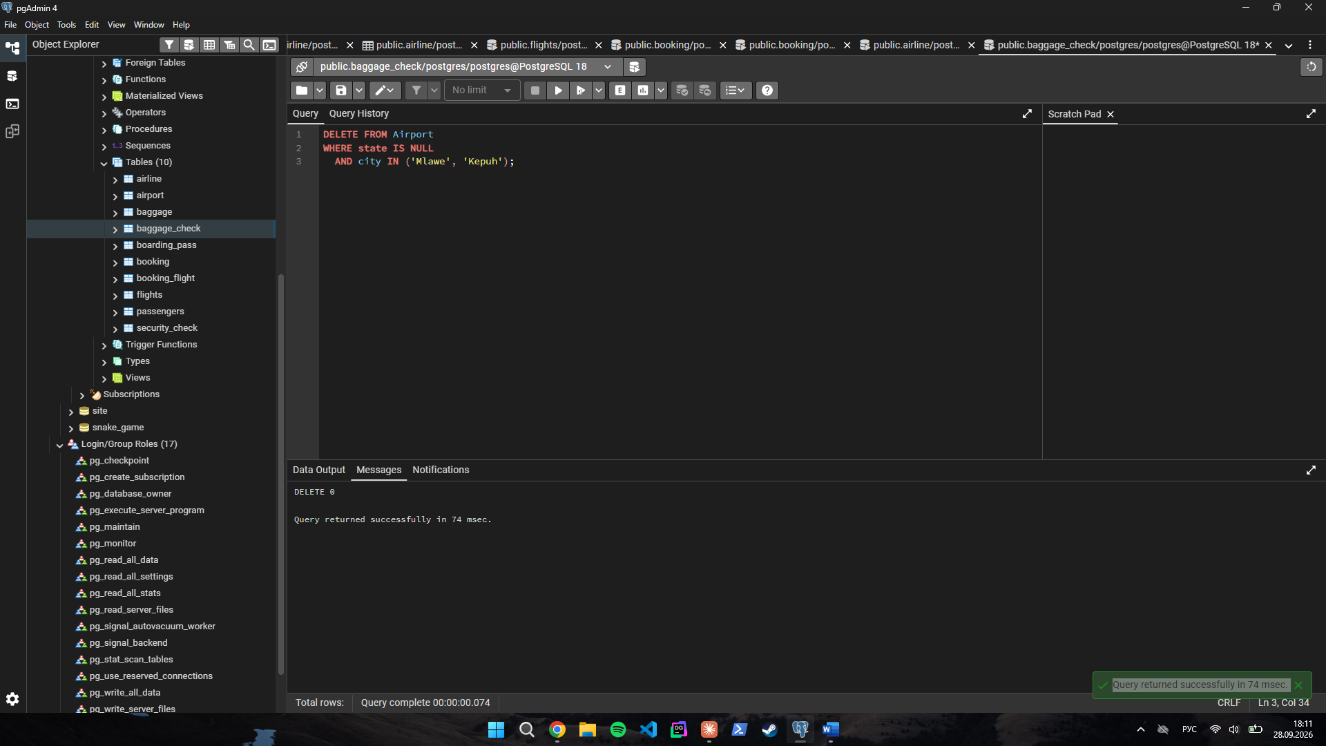
Task 11. Insert a new unchecked baggage inspection record (Baggage_check) and immediately return its newly generated baggage_check_id and created_at timestamp.
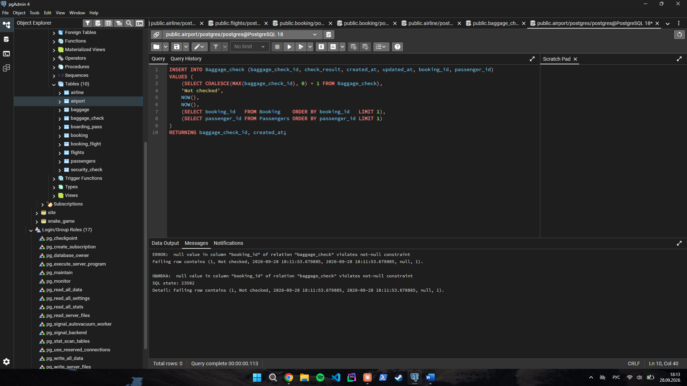
Task 12. Convert all country names (airline_country) in the Airline table to uppercase to ensure data consistency.
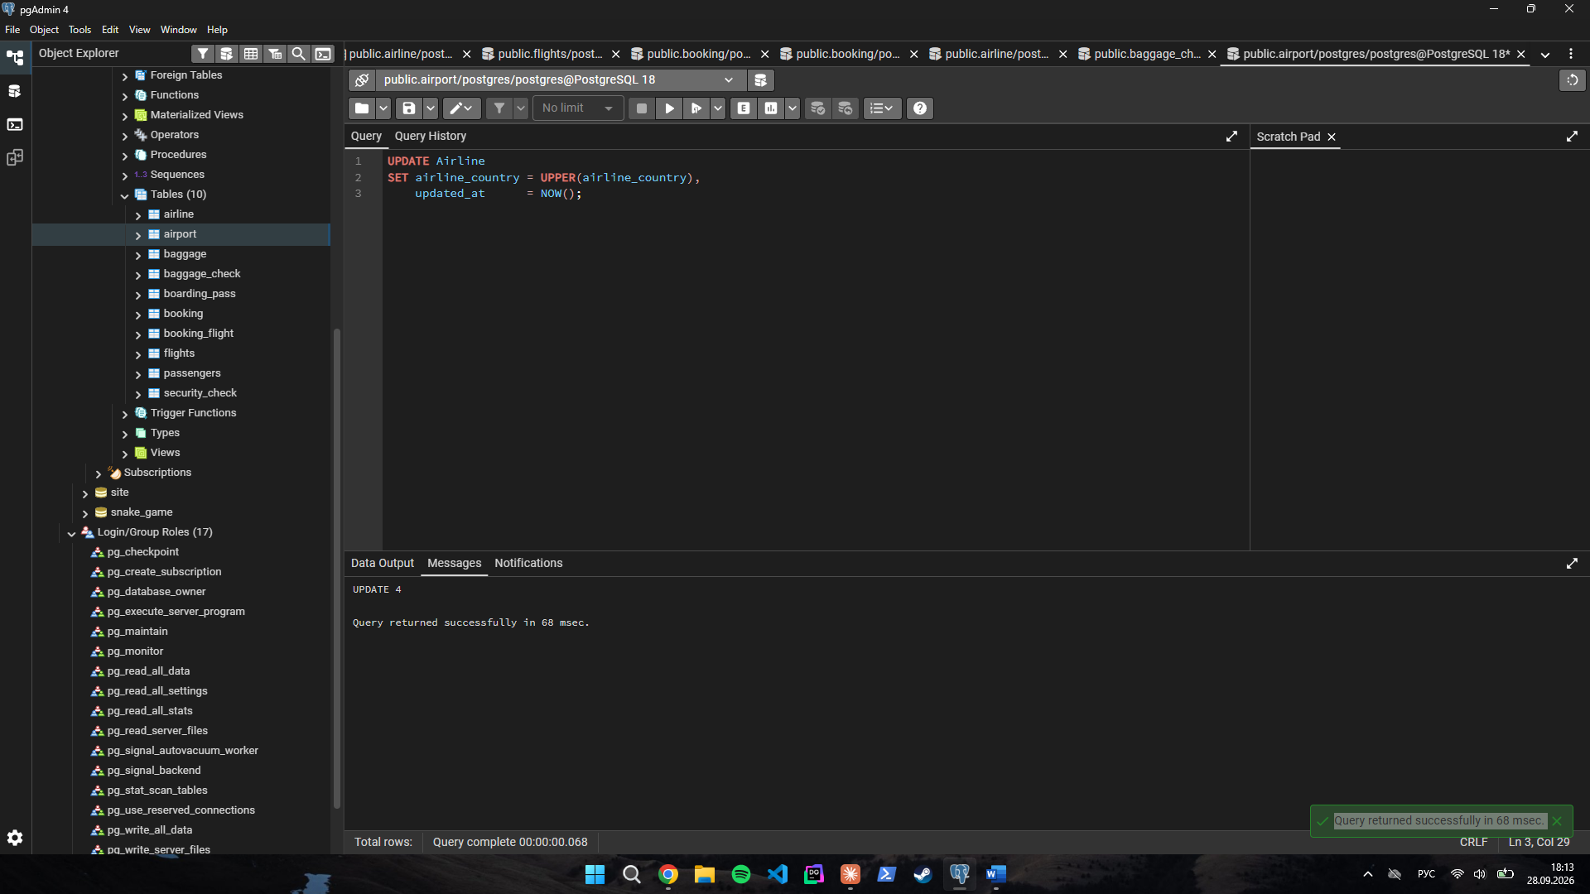
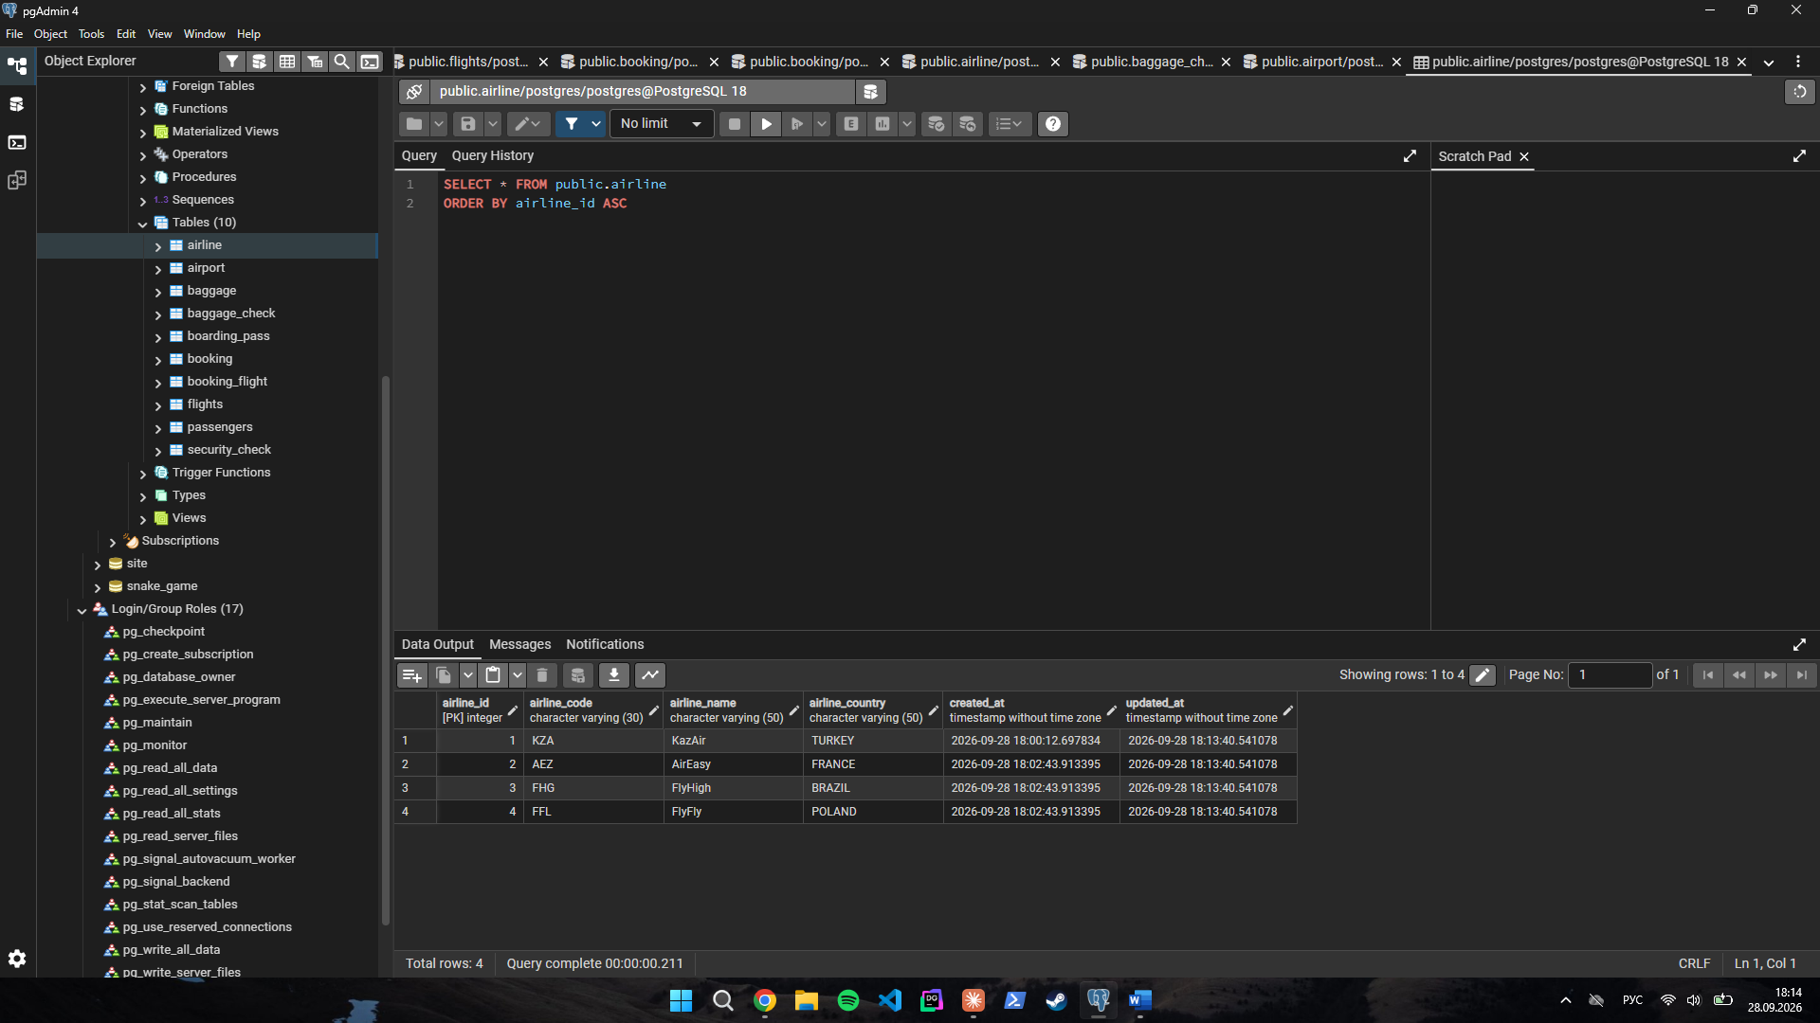
Task 13. Update both the name and country for the airline with airline_id = 5: set the name to 'Global Airways' and the country to 'United Kingdom', while updating updated_at to the current date.
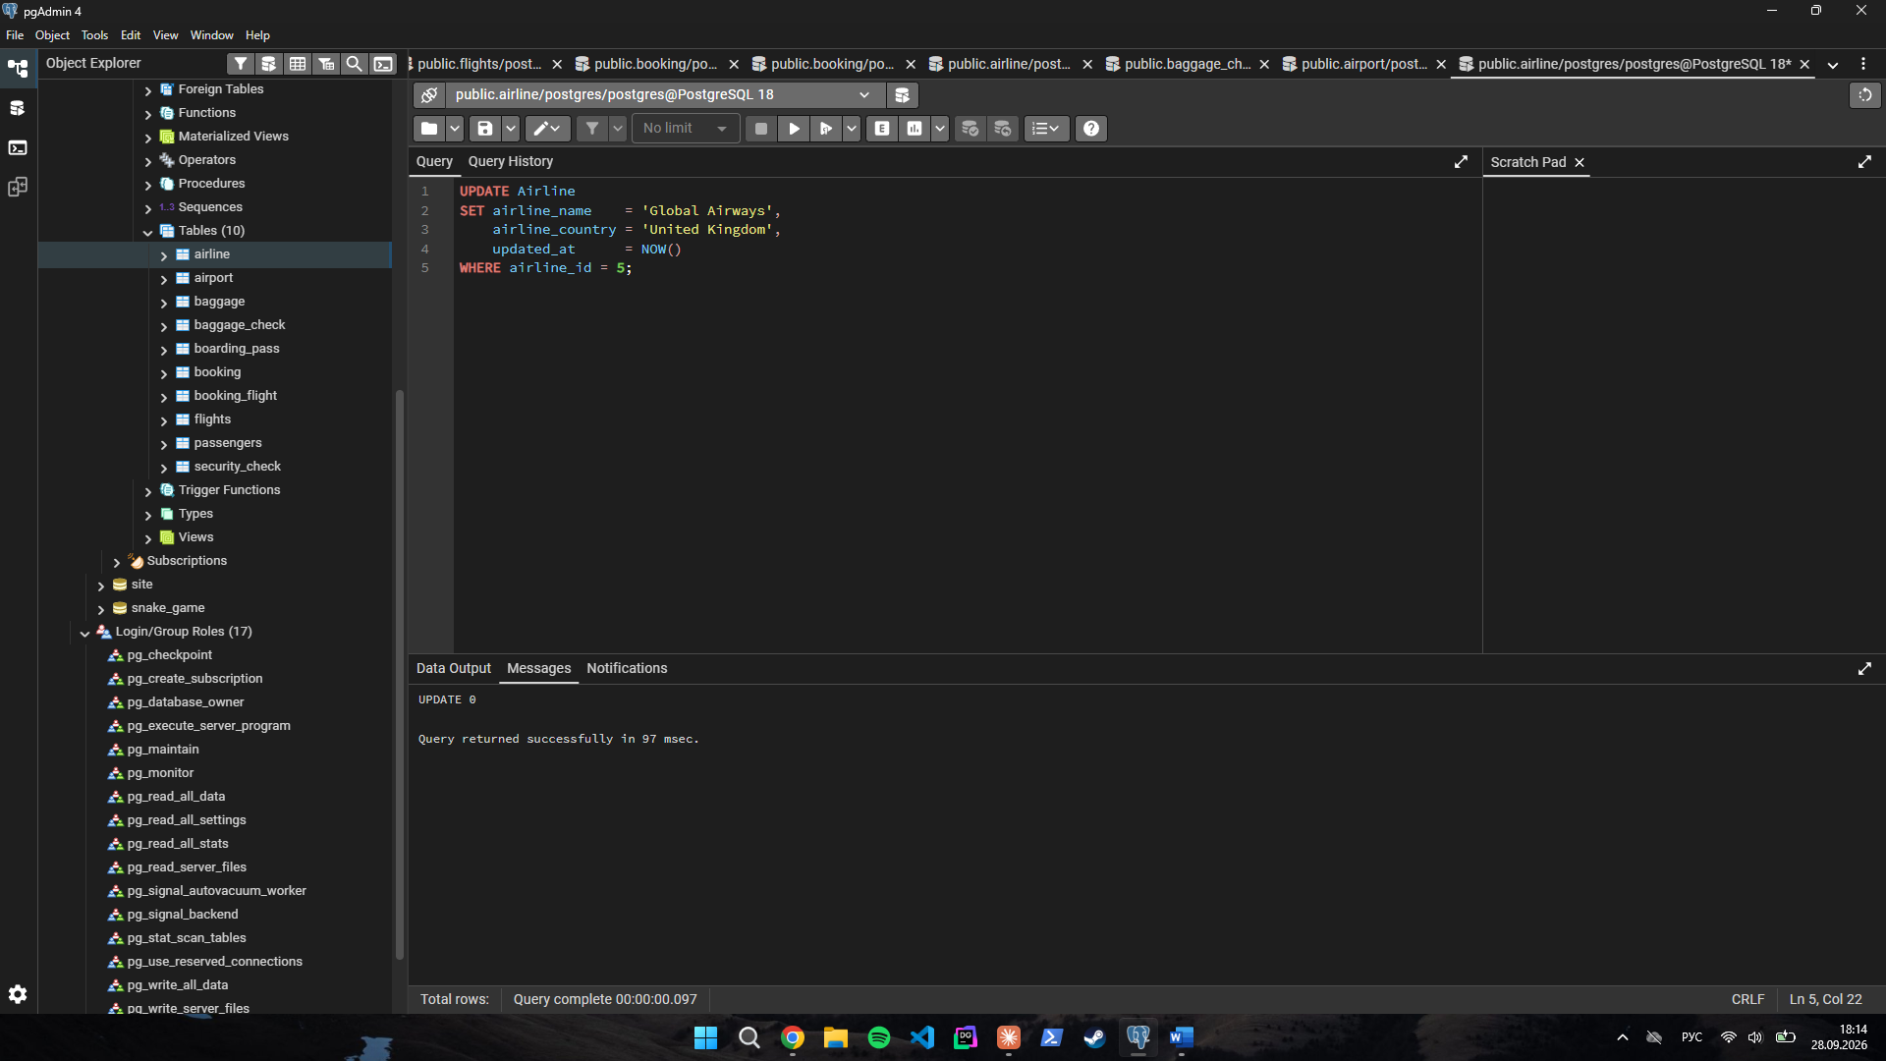
Task 14. Set the state field to 'Capital District' for airports located in specific cities: 'Astana', 'London', and 'Tokyo'.
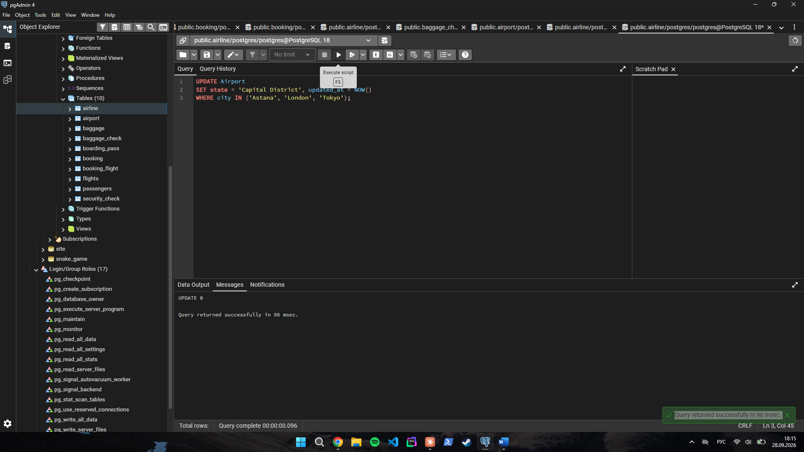
Task 15. Mark all baggage check records (baggage_check) created in March 2024 with a status of 'Not checked' as completed ('Checked').
