Lab5
1 ALTER TABLE passengers
ADD CONSTRAINT chk_passenger_min_age
CHECK (date_of_birth <= CURRENT_DATE - INTERVAL '10 years');
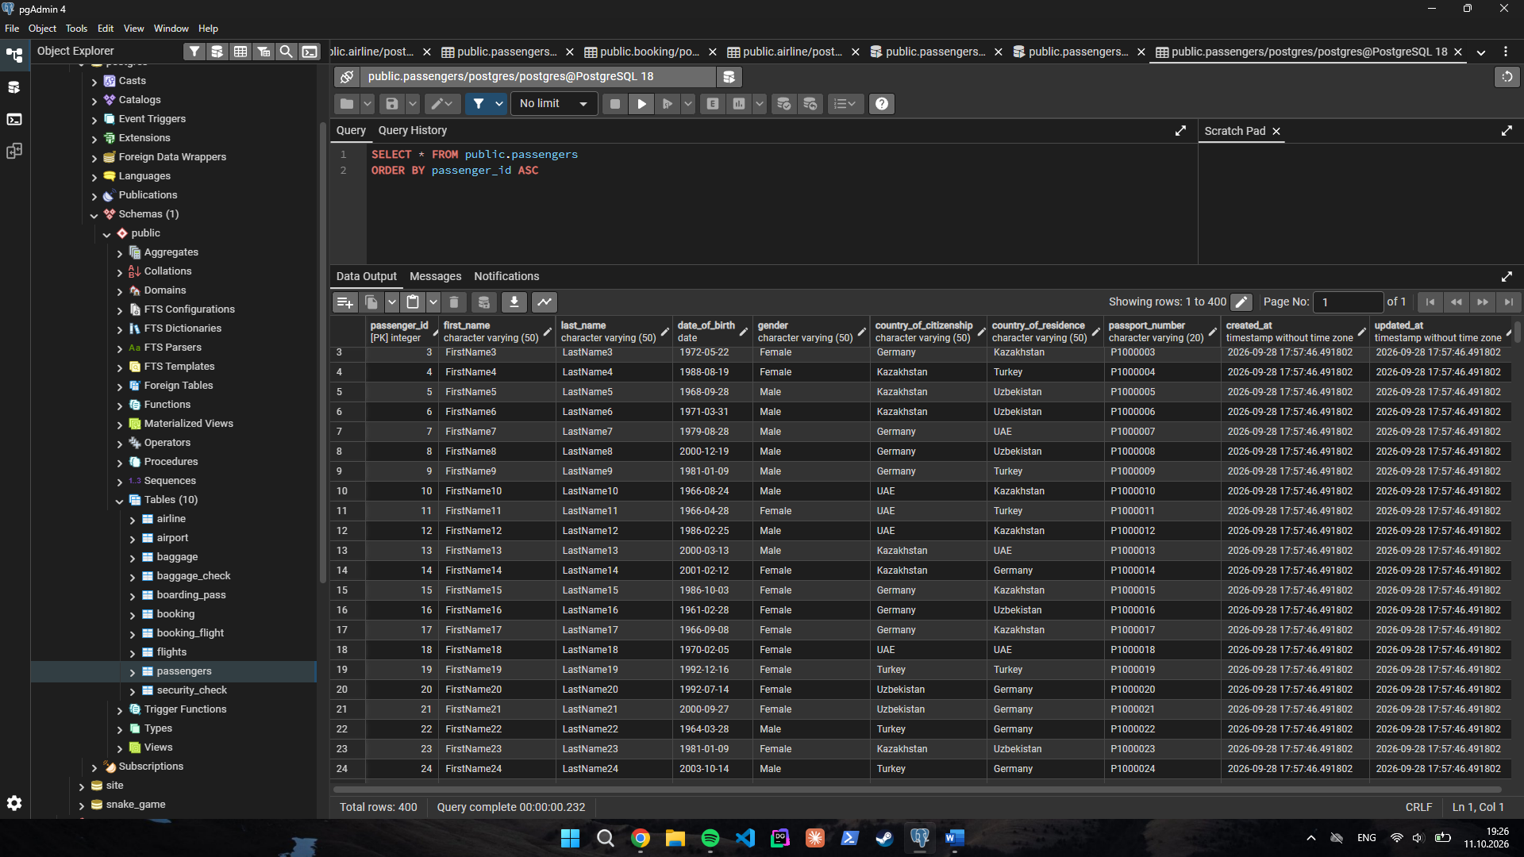

2
ALTER TABLE booking ADD CONSTRAINT chk_booking_ticket_price CHECK (ticket_price >= 0 AND ticket_price <= 50000);
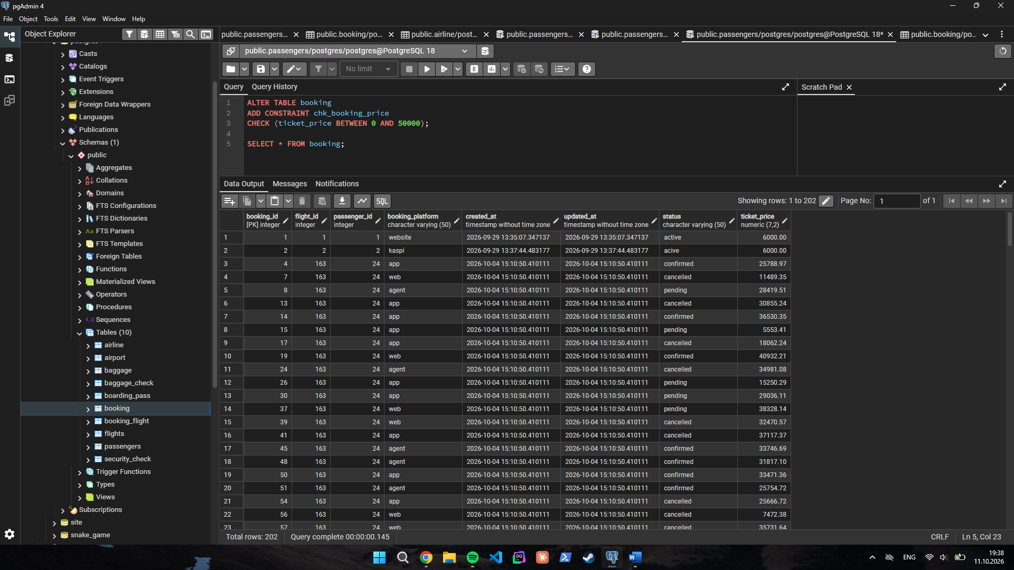

3

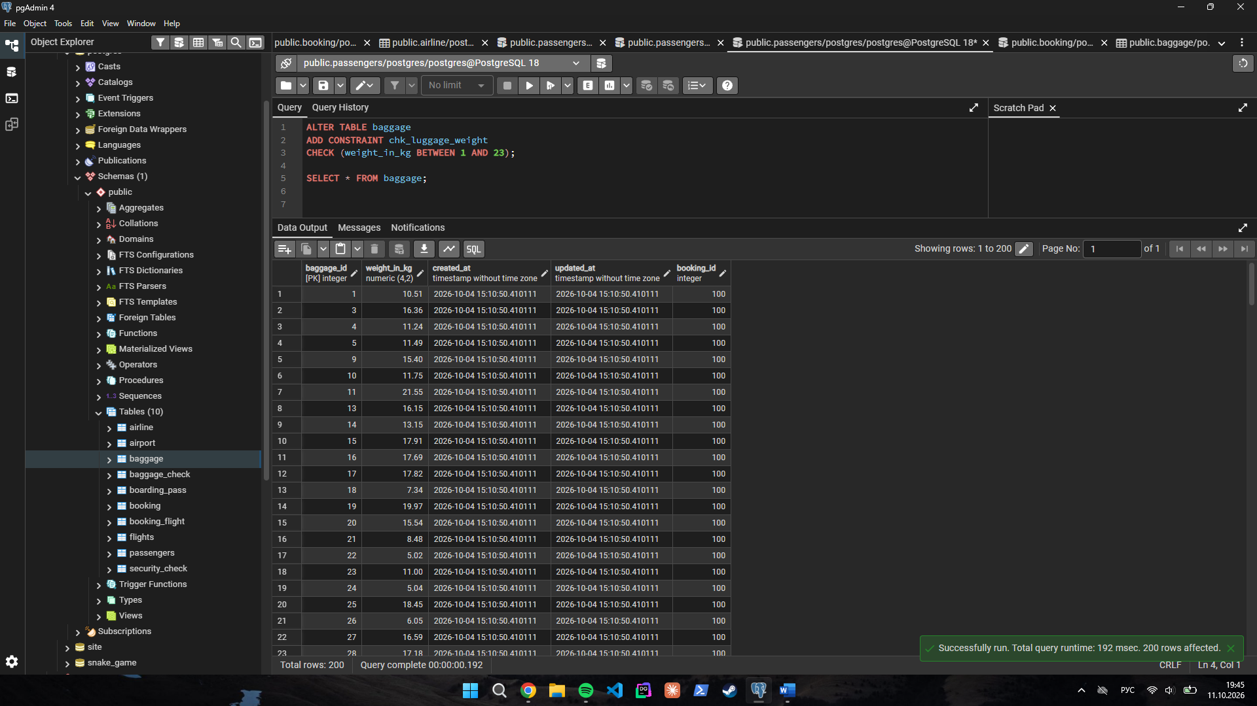

4

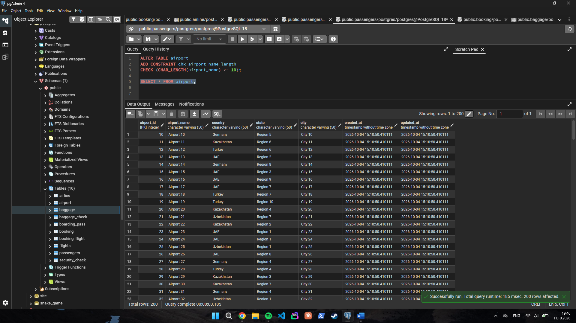

5
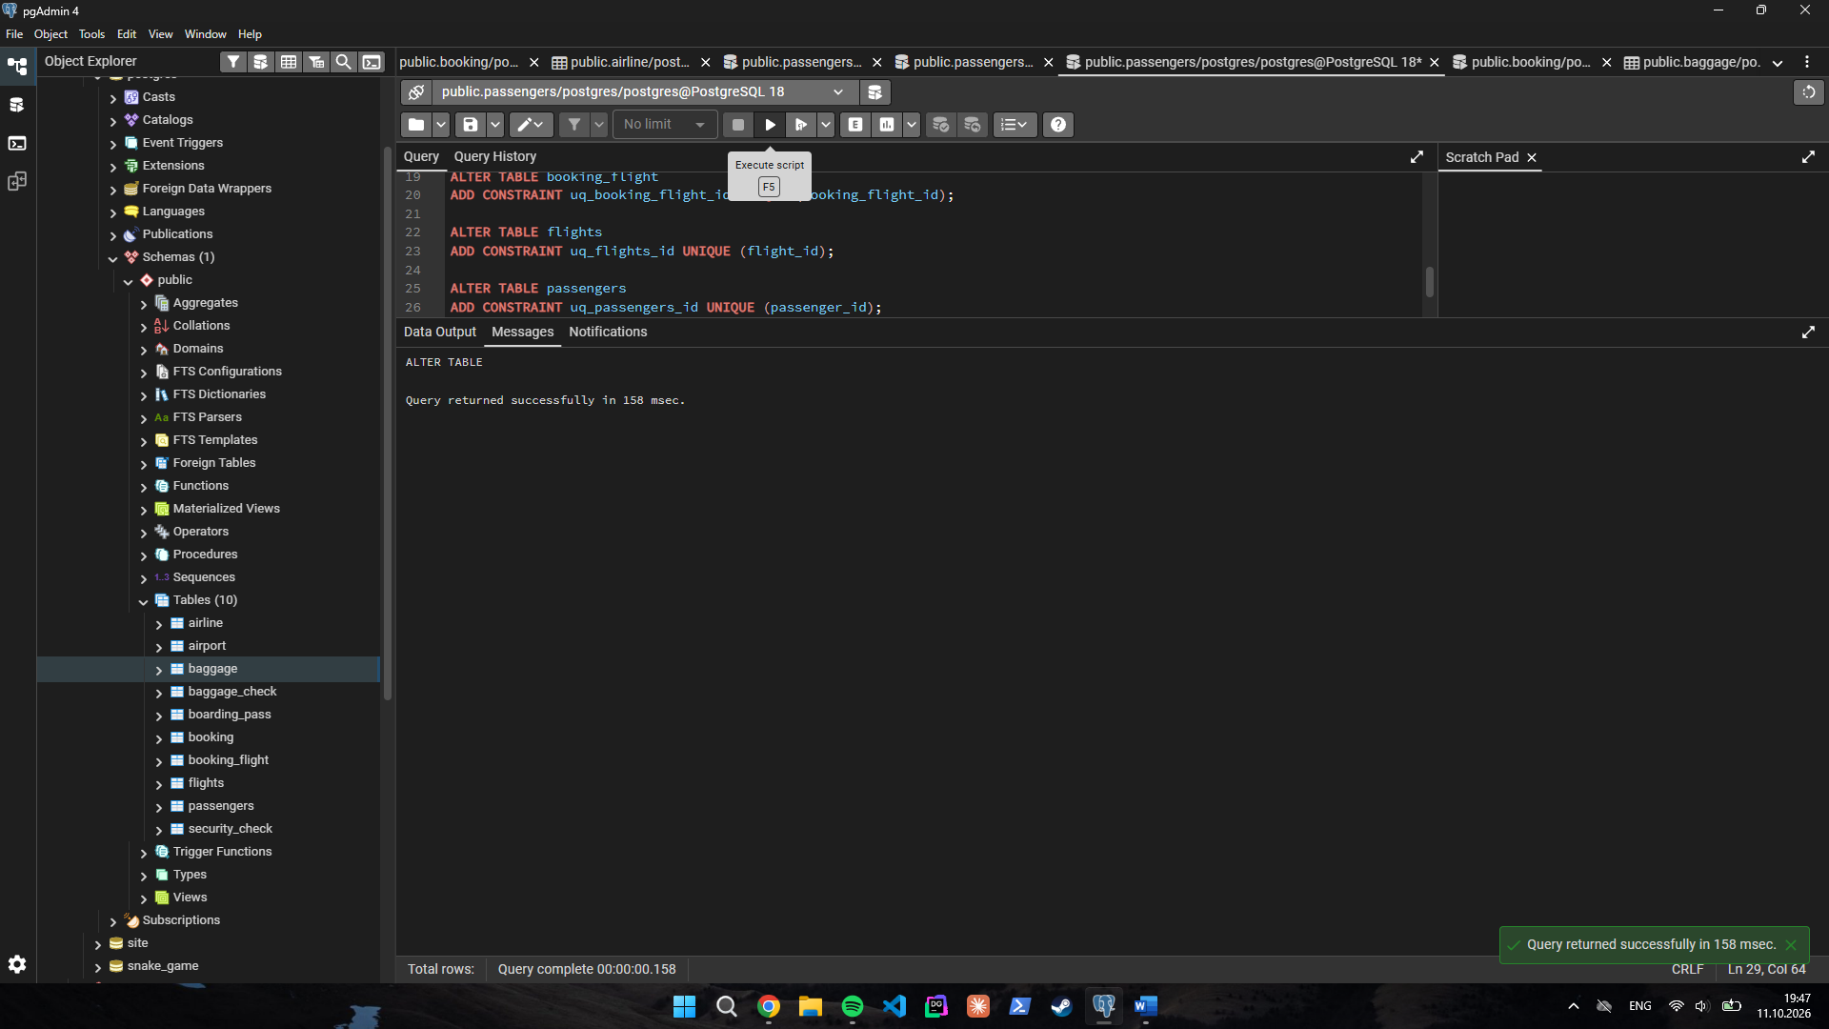

6
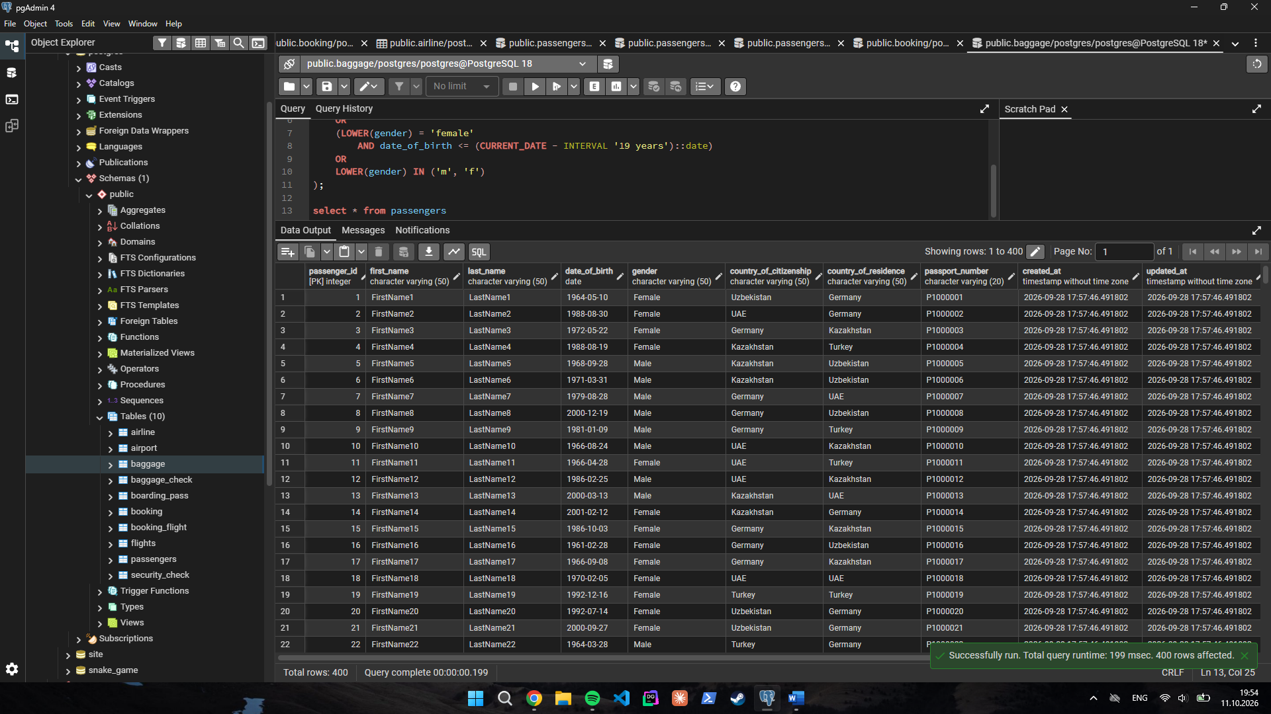
7

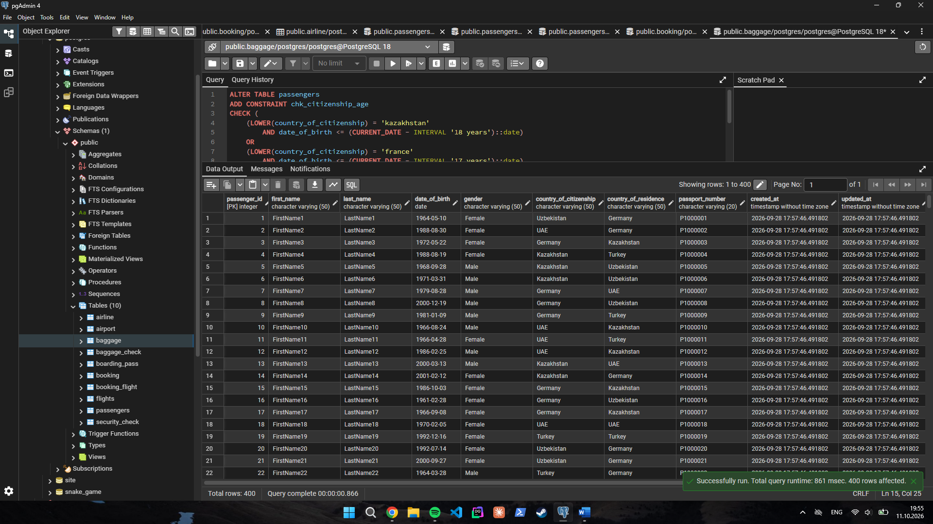

8
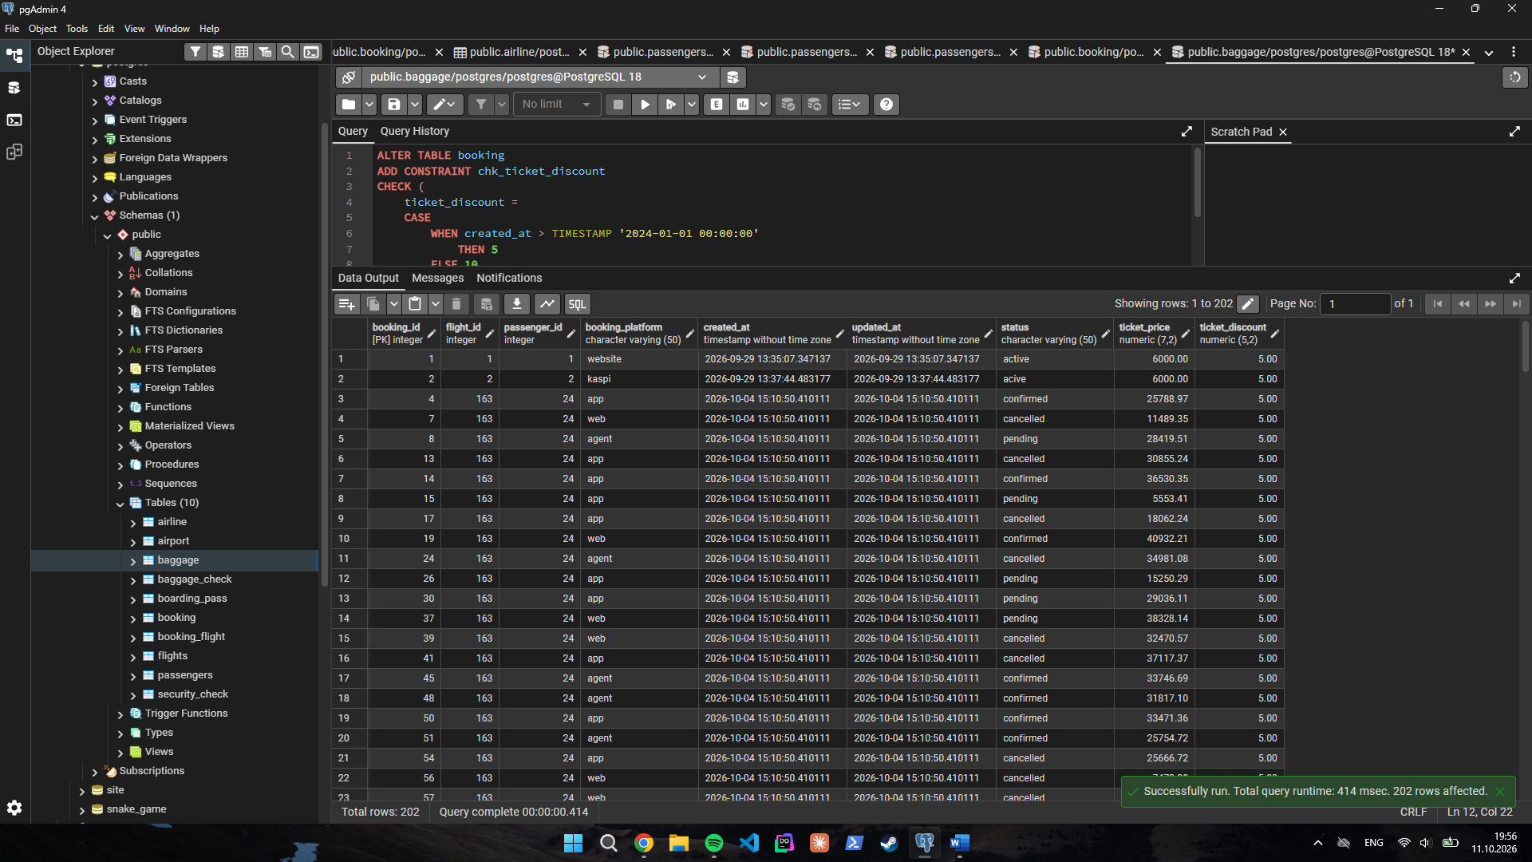

9
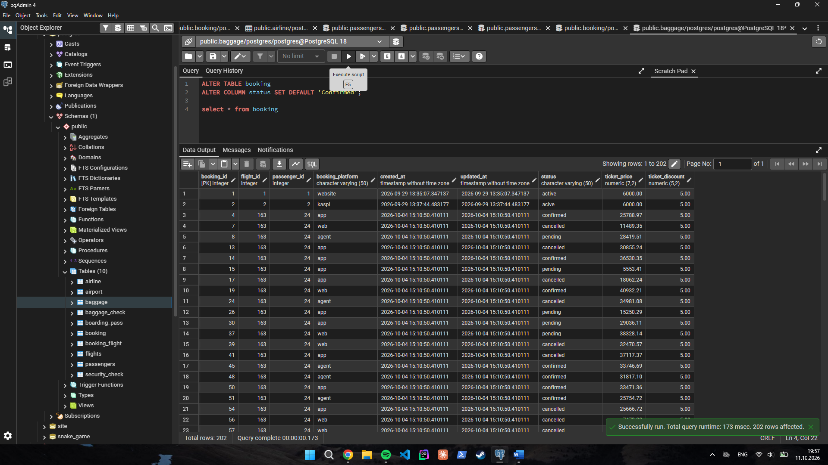

10

