Study Sprint 3 Quest Studio
Software Design Patterns / Final project report

Introduction
Study Sprint is a Java 17 and Swing planner for students managing several courses. Quest Studio expands the planner with a course map, CSV task import and undo for completion changes. The app retains schedules, timed study, the daily mission and report export.
Overview shows level, completed tasks, timed minutes and active streak. The weekly chart switches between XP and timed focus minutes.
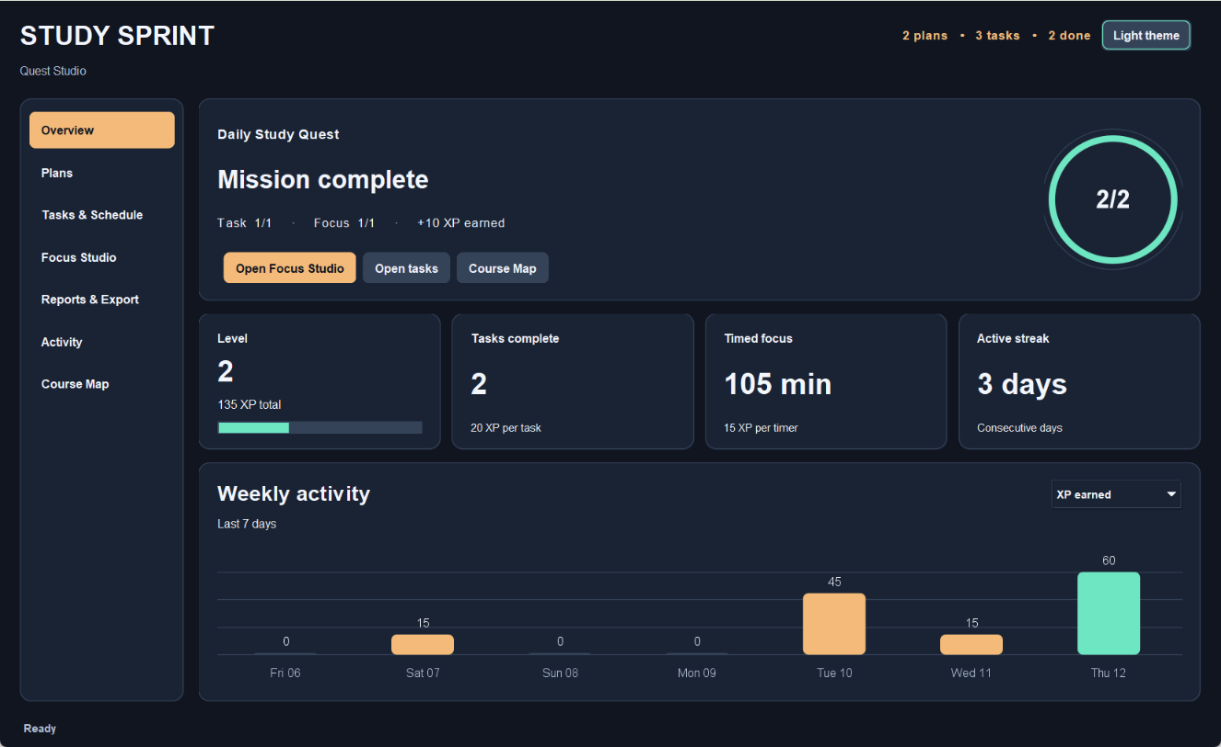
Figure 1. Dark Overview with illustrative local history. The mission is complete and the active streak is three days.

Run the application
Install JDK 17. From the extracted project folder run .\scripts\run.bat on Windows or bash scripts/run.sh on Linux or macOS. Two sample plans, three tasks and one manual session appear on first launch.

User Scenarios
1. Create a study plan with a title and goal. Edit the goal as coursework changes.
2. Add two tasks with distinct estimates and priorities. Compare Priority first and Shortest first in the schedule preview.
3. Complete a task and check Activity for the notification and Overview for the first mission step.
4. Select a task in Focus Studio. Start a one-minute demonstration timer, pause and resume, then select Finish & save at zero. Overview marks the mission complete.
5. Select report sections and export TXT or CSV. Restart with the same data file to verify the saved task, timer and progress.
6. Preview and import the sample task CSV. Inspect the new tasks in Course Map, then use Undo and Redo to demonstrate a reversible completion change.
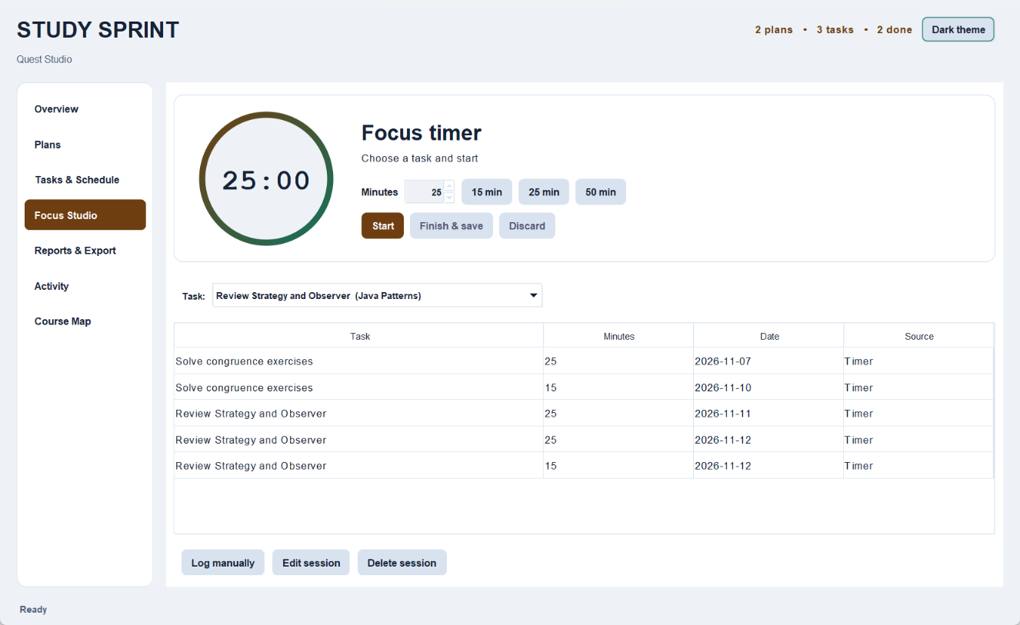
Figure 2. Light Focus Studio screen with the timer dial, 15, 25 and 50 minute presets, and session history.

Architecture and Core Patterns
Swing handles interaction and rendering. StudyPlannerFacade coordinates validation, reports, scheduling and persistent changes. The repository writes a complete snapshot before an event updates the UI. StudyPlan owns tasks, and each FocusSession refers to one StudyTask.
Pattern | Problem | Participants | Demonstration | Student
Builder | Construct validated tasks with several fields. | StudyTask.Builder, StudyTask | Add or edit a task. | ________
Factory Method | Select a formatter through a common export workflow. | ExportService, TextExportService, CsvExportService, ReportFormatter | Export TXT, then CSV. | ________
Decorator | Compose optional report sections. | SummaryComponent, BaseSummary, SummaryDecorator, ProgressSummaryDecorator, FocusSummaryDecorator | Toggle progress and focus in the preview. | ________
Facade | Keep UI actions independent of storage and reports. | PlannerFrame, StudyPlannerFacade, StudyRepository | Save a completed focus timer. | ________
Strategy | Swap scheduling rules at runtime. | SchedulingStrategy, PriorityStrategy, ShortestTaskStrategy | Switch between urgent and short tasks. | ________
Observer | Refresh views after a committed change. | StudyEventHub, StudyEventListener, StudyChangeEvent, PlannerFrame | Complete a task and check Activity and Overview. | ________
Enter each responsible student’s real name before submission.

Persistence
The UTF-8 Properties file stores task completion dates and timed session provenance in the same snapshot as plans and tasks. Version 1 data remains readable. Older completed tasks retain 20 XP each, with no date inferred for the daily mission or chart.

Additional Patterns in Quest Studio
Quest Studio adds four patterns with visible behavior. Adapter connects CSV to the existing task builder, Composite shares workload calculations, Command records reversible actions, and State defines timer transitions.
Pattern | Problem | Participants | Demonstration | Student
Adapter | Read two CSV layouts as task data. | TaskImportSource, CsvTaskImportAdapter, CsvTableReader, TaskDraft | Preview and import sample-data/tasks-import.csv. | ________
Composite | Calculate progress across levels of the course map. | WorkloadNode, CourseMap.Branch, CourseMap.TaskNode, CourseMapPanel | Select workspace, plan and task to compare totals. | ________
Command | Reverse task completion while keeping other edits. | StudyCommand, ToggleCompletionCommand, CommandHistory, StudyPlannerFacade | Complete a task, then Undo and Redo. | ________
State | Define timer behavior for each phase. | FocusTimer.TimerState, Idle, Running, Paused, Finished | Start, pause, resume and finish at zero. | ________

Import and undo behavior
CSV import previews the task rows and saves them as one batch. If any task fails validation, the batch is rejected. Import can also read task rows from a Study Sprint report. New tasks start unfinished.
Undo and Redo apply to task completion, including the date used by Study Quest. The saved task state survives restart. Undo history lasts for the current session and is cleared when a task or plan is deleted.

Course Map and Workload
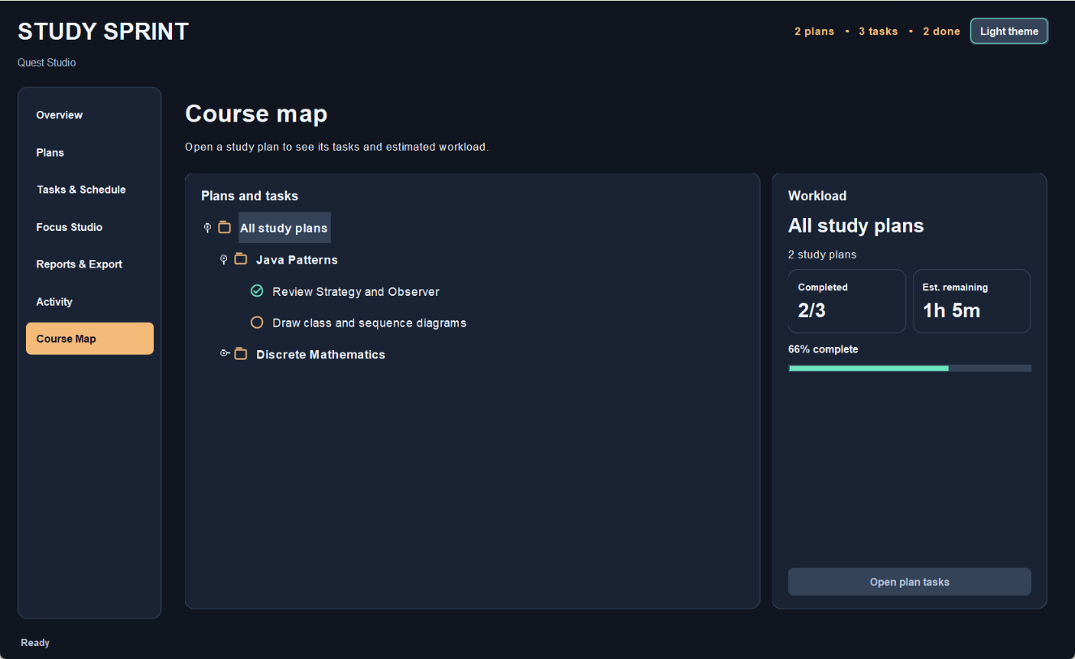
Figure 3. Course Map with the workspace selected. The workload card aggregates two plans and three tasks.
The course map shows the estimated work left for a whole workspace, a plan or a task. Completing a task removes its estimate from the remaining workload. Select a plan or task and choose Open plan tasks to continue working.

UML Class Diagram
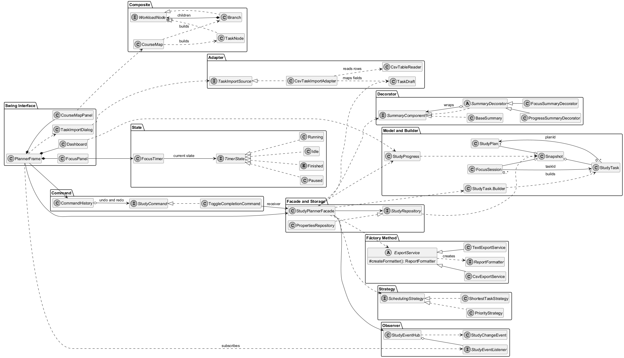
Figure 4. Domain entities, UI, repository and the participants in the ten patterns. Open the separate PNG for full-size labels.

Responsibilities
FocusPanel owns the running countdown. FocusTimer measures active time with a monotonic clock. The facade saves the completed timer and calculates a StudyProgress view of the current snapshot. Dashboard presents this view and does not write persistent data.
PriorityStrategy and ShortestTaskStrategy order the same unfinished tasks. Summary decorators wrap a shared component and can be combined. The export service subclasses supply different formatter implementations.

UML Sequence Diagram
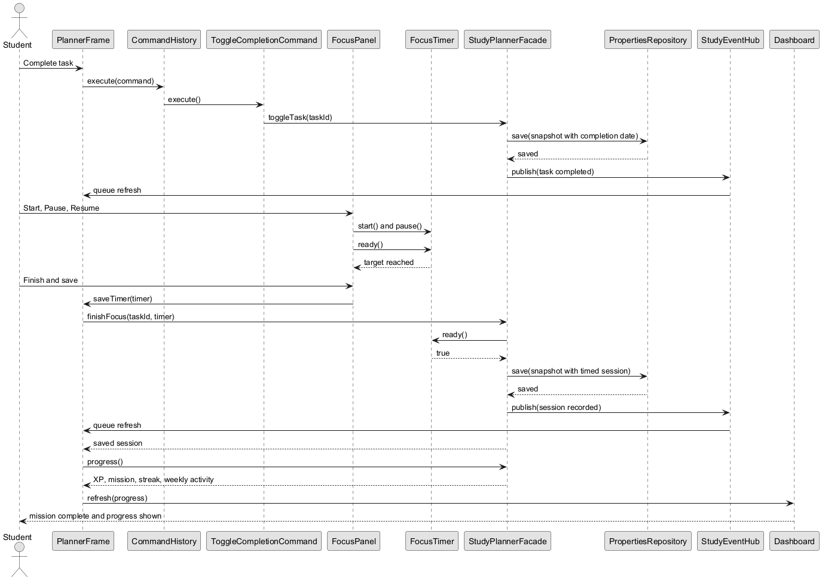
Figure 5. Completing a task and saving a timer satisfy the daily mission.

Progress rules
A currently completed task contributes 20 XP, a saved timer contributes 15 XP, and a qualifying mission adds 10 XP per day. Level 1 begins at zero XP and each additional 100 XP increases the level. Manual logs remain available for reports.
Reopening a task reverses its contribution. Completing it again restores the original completion date. Editing the minutes or date of a timed record converts it to a manual record. An active streak ends today, or yesterday if there is no activity today.

Java Implementation Excerpts

Builder and Facade
The facade constructs validated tasks through the builder and accepts a timer only after its full active interval.
StudyTask task = StudyTask.builder(UUID.randomUUID().toString(), planId).title(title)
.estimateMinutes(minutes).priority(priority).dueDate(due).build();
if (!timer.ready()) throw new IllegalArgumentException("Finish the countdown first");
return saveSession(new FocusSession(timer.id(), taskId,
timer.targetMinutes(), LocalDate.now(clock), true));

Strategy and Decorator
The chosen schedule strategy orders tasks. Each report option wraps the same summary component.
return List.copyOf(Objects.requireNonNull(strategy).order(tasks(planId)));
SummaryComponent summary = new BaseSummary(plan);
if (progress) summary = new ProgressSummaryDecorator(summary, tasks);
if (focus) summary = new FocusSummaryDecorator(summary, sessions);

Factory Method and Observer
The export creator delegates formatter creation to subclasses. The facade publishes the change after the repository saves it.
protected abstract ReportFormatter createFormatter();
repository.save(next);
state = next;
events.publish(message);

Composite and State
for (WorkloadNode child : children) {
total = total.plus(child.progress());
}
public void start() { state = state.start(nanoTime.getAsLong()); }
public void pause() { state = state.pause(nanoTime.getAsLong()); }
Excerpts from StudyPlannerFacade, ExportService, CourseMap and FocusTimer. Some long lines are wrapped for print.

Testing and Individual Defense
Java 17 automated run: 23 passed, 0 failed. Reproduce with .\scripts\test.bat on Windows or bash scripts/test.sh on Linux or macOS. The project contains the full expected and actual results in docs/test-scenarios.csv and the execution log in docs/test-results.txt.
Tests | Coverage | Observed result
T01–T03 | Seed, create, edit, reload | Sample and modified data loaded correctly.
T04–T06 | Strategy, Observer, Decorator | Order, notification and preview changed.
T07–T08 | Session CRUD and exports | Manual journal and both export formats worked.
T09–T13 | Invalid inputs and cascade | Invalid requests rejected and related records removed.
T14–T18 | Timer, quest, XP, dates, migration | Pause excluded, no duplicate XP, old files loaded.
T19–T23 | Command, CSV import, course map, State | Undo restored saved state, failed imports were atomic, totals matched, timer stayed finished.

Individual contributions
Team members and actual code contributions: Salim Zhubaniyaz, Dias Sagyngali, Erdaulet Erboluly, Dauren Alaukhan
GitHub or GitLab repository URL daurenemes/StudySprint-Finaaal
Each student should demonstrate the patterns they implemented, explain their participants and trade-offs, and independently make a small change during the defense.

Conclusion and future work
Quest Studio connects imported tasks, workload, timed study and saved progress in one desktop workflow. Future work could add configurable mission targets and weekly history navigation.
AI disclosure. Codex assisted with the implementation update, report and verification. Record each team member’s actual work and disclose tool use under course policy.

