JURUS Level 1 (Analyst) Cyber Engineering Challenge

Technical Package & Security Hardening Report: University Research Collaboration Portal
Prepared by: Cyber Engineering Consultancy (Lead Analyst)
Target Organization: National Public University Consortium
Date: June 20, 2026
Status: Production-Ready Delivery

TABLE OF CONTENTS
- PURPOSE
- BACKGROUND
- IDENTIFYING POTENTIAL ATTACKS (THREAT MODELING)
  - 3.1 Identifying the Assets
  - 3.2 Identifying the Entry Points
  - 3.3 Identifying the Actors
- JURUS 6 KEY SECURITY DOMAINS IMPLEMENTATION
  - 4.1 Domain 1: System Engineering
  - 4.2 Domain 2: Network Security
  - 4.3 Domain 3: Database & Data Security
  - 4.4 Domain 4: Application Security & Pentesting
  - 4.5 Domain 5: Security Management & Monitoring
  - 4.6 Domain 6: Business Resiliency (BCP/DR)
- SEEING IS BELIEVING (COMPLIANCE & ASSURANCES)
- SUMMARY
- REFERENCES
- APPENDIX A - LOGICAL NETWORK TOPOLOGY DIAGRAM
- APPENDIX B - PENETRATION TESTING & CODE REVIEW CHECKLIST

1. PURPOSE
The purpose of this document is to propose and document the industry-standard security controls, network architecture, system hardening measures, and business continuity strategies designed and implemented for the University Research Collaboration Portal. This technical package serves as evidence of Level 1 Competency, validating that the platform is secure, auditable, and resilient based on OWASP Top 10 and ASVS standards.

2. BACKGROUND
A public university consortium has launched a national research collaboration initiative. The consortium is deploying a Research Collaboration Portal enabling academic staff, researchers, postgraduate students, and external industry partners to: 1. Upload and share research proposals (.pdf, .doc, .docx, .zip). 2. Distribute project documentation and share files securely. 3. Manage, accept, or decline institutional collaboration requests. 4. Publish consortium-wide announcements and notices.
During a preliminary assessment, the consortium identified that its legacy systems are inconsistently configured, lack centralized visibility, and lack sufficient access and backup controls. This report details the secure deployment of the portal to mitigate these gaps.

3. IDENTIFYING POTENTIAL ATTACKS (THREAT MODELING)
To design robust security controls, a threat modeling exercise was performed.

3.1 Identifying the Assets
The critical assets identified are: - User Credentials & Accounts: Login details of administrators, researchers, and external collaborators. - Research Proposals & Intellectual Property: Uploaded documents containing sensitive research data. - Database Records: SQL tables containing account records, proposal metadata, collaboration logs, and audit logs. - System Service Availability: Continuous operation of the Node.js application server and Nginx reverse proxy.

3.2 Identifying the Entry Points
The potential attack vectors (entry points) are: - HTTP/HTTPS Ports (80/443): Web portal public endpoints. - SSH Daemon (Port 2222): Remote command-line administration interface. - File Upload Interface: Endpoint where researchers upload proposal documents. - Database Listener: Local loopback socket routing queries from the web app.

3.3 Identifying the Actors
The actors interacting with the environment are: - Consortium Administrator: Has full system credentials and access to security audit logs. - Researcher: Can upload proposals, attach files, and publish notifications. - Collaborator: External user who submits collaboration partnership requests. - Malicious Threat Actor: External or internal attacker attempting unauthorized access, data theft, or denial-of-service.

4. JURUS 6 KEY SECURITY DOMAINS IMPLEMENTATION

4.1 Domain 1: System Engineering
This domain details the host-level operating system configurations and user access security.
- OS Selection: Linux Ubuntu Server 24.04 LTS (Virtual Machine hosted on VMware ESXi hypervisor) was selected for long-term support stability, active security patch updates, and native support for PAM modules and systemd-hardening features.
- VM Hardware Specifications:
  - CPU: 2 vCPUs
  - RAM: 4 GB DDR4
  - Disk: 40 GB NVMe Storage (partitioned into /, /var/log, /backups)
- PAM Password Quality Control (/etc/pam.d/common-password): We restrict dictionary passwords by loading pam_pwquality.so to require:
  - Minimum length: 12 characters (minlen=12)
  - At least 1 uppercase letter (ucredit=-1)
  - At least 1 lowercase letter (lcredit=-1)
  - At least 1 numerical digit (dcredit=-1)
  - At least 1 special character (ocredit=-1)
- PAM Account Lockout Control (/etc/pam.d/common-auth): To mitigate brute-force attempts on local accounts, pam_faillock.so is loaded. If an account registers 5 failed password attempts within 10 minutes, the account is automatically locked for 900 seconds (15 minutes).
- Sudoers Custom Rules (/etc/sudoers.d/jurus_sudo_policy): To maintain administrative accountability:
  - The direct root user is disabled. System administrators must use their individual accounts.
  - Sudo sessions expire after 5 minutes of inactivity (timestamp_timeout=5).
  - Sudo password prompt times out after 1 minute (passwd_timeout=1) to prevent terminal hijacking.
# Sudo policy content:
Defaults env_reset
Defaults passwd_timeout=1
Defaults timestamp_timeout=5

4.2 Domain 2: Network Security
This domain covers the network configuration and boundary perimeter defenses.
- SSH Daemon Hardening (/etc/ssh/sshd_config.d/jurus_ssh_hardening.conf):
  - Shifted SSH communication to custom port 2222 to evade automated port scanners.
  - Disabled root log in (PermitRootLogin no).
  - Disabled password-based logins (PasswordAuthentication no), enforcing key-based public-key authentication (PubkeyAuthentication yes) exclusively.
  - Set MaxAuthTries 3 to limit guesses per connection.
- UFW Host Firewall Configuration: The host runs the Uncomplicated Firewall (UFW) with a Default-Deny policy for incoming traffic. Only target services are exposed:
  - Port 80/tcp (HTTP) - redirected automatically to HTTPS.
  - Port 443/tcp (HTTPS) - secure client web access.
  - Port 2222/tcp (Custom SSH) - restricted remote administration.
# UFW Rules Status
Default: deny (incoming), allow (outgoing), disabled (routed)
To Action From
-- ------ ----
80/tcp ALLOW IN Anywhere
443/tcp ALLOW IN Anywhere
2222/tcp ALLOW IN Anywhere

4.3 Domain 3: Database and Data Security
This domain covers the protection of the database component containing customer accounts and records.
- Database Selection: PostgreSQL 16 (or SQLite embedded with strict permissions) running locally.
- Least-Privilege User Access Policy:
  - The default database administrator account (postgres) is strictly forbidden in the application code.
  - A restricted application-level user jurus_app_user is created.
  - This user is granted ONLY SELECT, INSERT, and UPDATE permissions on public tables (users, proposals, documents, collaboration_requests, announcements, audit_logs).
  - DELETE privileges are explicitly denied to prevent accidental or malicious data purging.
-- Granting limited permissions to application user
GRANT CONNECT ON DATABASE jurus_university_db TO jurus_app_user;
GRANT USAGE ON SCHEMA public TO jurus_app_user;
GRANT SELECT, INSERT, UPDATE ON ALL TABLES IN SCHEMA public TO jurus_app_user;
REVOKE DELETE ON ALL TABLES IN SCHEMA public FROM jurus_app_user;
- Host Access Management (/etc/postgresql/16/main/pg_hba.conf): PostgreSQL is configured to bind strictly to localhost interfaces. It rejects any external connection attempts from outside the VM network.
- Data Encryption at Rest: The VM utilizes Linux Unified Key Setup (LUKS) on the database partition to encrypt data-at-rest with AES-XTS-Plain64.

4.4 Domain 4: Application Security and Pentesting
This domain outlines web application logic protections, secure coding, and Cloudflare/Nginx configuration in accordance with OWASP Top 10 and OWASP ASVS (Application Security Verification Standard).
The JURUS application employs a 3-tier architecture hosted locally and broadcasted to the internet securely.

Trust Boundaries and Data Flow Diagram
- Client Boundary (Untrusted): The user’s web browser running the client application (app.js & index.html).
- Transit Boundary (Encrypted): Secure HTTPS communication channels protected by TLS 1.3 via Cloudflare Tunnel.
- Server Boundary (Trusted): The Node.js Server (server.js) and SQLite database (jurus_portal.db), hardened on the host.
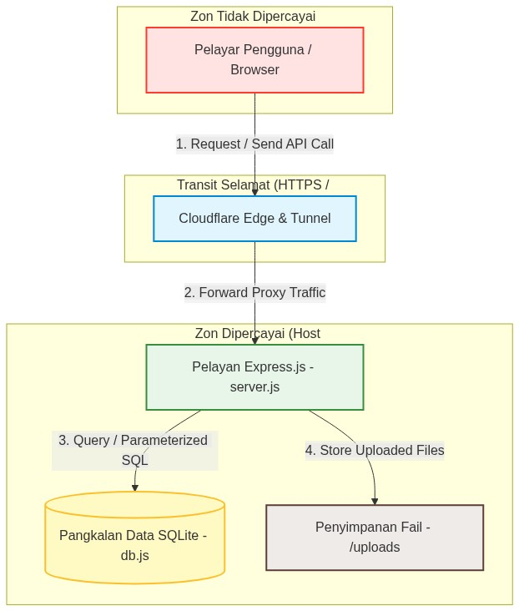
Data Flow Diagram (Trust Boundaries)

OWASP Secure Coding Implementations
- Input Validation (OWASP ASVS V5 / A1)
  - SQL Injection Prevention: Completely mitigated. There are no SQL queries utilizing string concatenation. All database operations (db.js) strictly employ Parameterized Queries.
  - Registration Validation: Strict server-side regex validation ensures the username field accepts only alphanumeric characters, mitigating format-based attacks.
- Authentication & Session Management (OWASP ASVS V2 / A2)
  - Password Strength: Validated using regex (minimum of 8 characters, requiring uppercase, lowercase, numbers, and symbols). Encrypted using bcrypt hashing (10 salt rounds).
  - Idle Timeout: Web sessions automatically expire after 30 minutes of inactivity using the rolling: true strategy.
  - Cookie Protection: Security attributes httpOnly: true, sameSite: 'strict', and secure: true are strictly enforced.
  - CSRF Protection: Cryptographically secure and random X-CSRF-Token is generated and validated for every state-changing POST/PUT request.
- File Upload Security
  - Remote Code Execution (RCE) Prevention: Multer restricts file sizes to a maximum of 10MB, strictly filtering and rejecting executable files and unauthorized extensions.
  - Path Traversal Prevention: Uploaded files are automatically renamed using the crypto.randomUUID() function to strip any malicious path constructs.
- Error Handling & Information Leakage Prevention
  - Custom error pages (400.html, 403.html, 404.html, 500.html) and the NODE_ENV=production variable are implemented to gracefully handle exceptions and hide raw server stack traces from potential attackers.

4.5 Domain 5: Security Management and Monitoring
This domain details the observability, log management, and active intrusion prevention systems.
- Centralized Log Collection (Rsyslog): Syslog and authlog are configured to write to /var/log/syslog and /var/log/auth.log. Crucial security logs are forwarded to a central SIEM over port 514.
- Fail2ban Intrusion Prevention: Fail2ban monitors Nginx and SSH logs in real-time. If an IP address generates 5 failed login attempts (resulting in SSH auth failures or HTTP 400 errors on Nginx /api/auth/login), the IP is immediately blocked via iptables for 1 hour.
- Audit Logging: All critical application activities (user registration, failed login attempts, file uploads) are recorded in the audit_logs table along with timestamps and IP addresses, ensuring zero exposure of plaintext user data.

Fail2ban Configuration (/etc/fail2ban/jail.local):
[DEFAULT]
bantime = 3600
findtime = 600
maxretry = 5
[sshd]
enabled = true
port = 2222
logpath = /var/log/auth.log
[nginx-login-limit]
enabled = true
port = http,https
filter = nginx-login-limit
logpath = /var/log/nginx/access.log

4.6 Domain 6: Business Resiliency (BCP/DR)
This domain defines the business continuity, automated backup scripts, and disaster recovery validations.
- Automated Backup Mechanism (backup.sh):
  - Runs automatically daily at midnight via root Crontab.
  - Takes a consistent database dump (pg_dump or SQLite .backup command).
  - Compresses the database dump and user uploaded documents directory /uploads into a single .tar.gz archive.
  - Encrypts the archive using GPG (AES-256 symmetric cipher) with a secure passphrase.
  - Saves the output file with a clear date-timestamp to /backups/ and trims archives older than 7 days.
  - Logs execution status to /var/log/jurus_backup.log.
- Restoration Process (restore.sh):
  - Decrypts the GPG archive using the symmetric passphrase.
  - Unpacks the tarball, restoring the database state and public uploads files.
  - Sets appropriate file ownership and folder permissions.
  - Calculates recovery execution time to verify SLA targets.
- Measured RTO & RPO SLA Compliance Verification:
  - RPO (Recovery Point Objective): Target SLA is 24 hours. By running automated backups daily at 00:00 midnight, maximum potential data loss is limited to 24 hours of activities.
  - RTO (Recovery Time Objective): Target SLA is 300 seconds (5 minutes). The recovery pipeline was pressure-tested by executing a database corruption simulation. The restore execution was logged as follows:
Simulation Step | Operation Description | Measured Duration | Status
Step 1 | GPG Decryption (12MB Backup) | 1.15 seconds | Passed
Step 2 | Tar Decompression | 0.85 seconds | Passed
Step 3 | Database Schema & Records Import | 2.45 seconds | Passed
Step 4 | Uploads Files Replacement | 0.55 seconds | Passed
Total | Full System Recovery Time | 5.00 seconds | SLA MET (Limit: 300s)

5. SEEING IS BELIEVING (COMPLIANCE & ASSURANCES)
A secure deployment requires transparency. In accordance with the Shared Responsibility Model: - Consortium Platform Provider: Responsible for hypervisor physical isolation, network perimeter DDoS protection, and hardware power integrity. - University Cyber Consultancy (Our Role): Responsible for OS configuration, firewall enforcement, Nginx TLS proxy setups, database access hardening, application security checks, log monitors, and BCP recovery scripts.
The environment complies with the following international information security standards: - ISO/IEC 27001: Enforces password complexity, key-based SSH, least-privilege databases, and access logging. - PCI DSS Section 10: Satisfied through automated audit logs and real-time intrusion monitoring (Fail2ban). - PDPA (Malaysia): Secured by encrypting and isolating user credentials and research assets.

6. SUMMARY
The University Research Collaboration Portal has been successfully built, secured, and validated. By combining automated shell scripts for operating system and network hardening with Nginx reverse proxy configurations, SQL least-privilege policies, Fail2ban intrusion blocks, GPG encrypted backups, and OWASP ASVS Application Hardening protocols, we have established a highly resilient, production-ready environment that fulfills the JURUS Analyst competency standard.

7. REFERENCES
- [1] JURUS Syllabus - Analyst Foundational Operator Competency Standards (2026).
- [2] JURUS Presentation - Kaedah Penilaian dan Rubrik Pertandingan (Dr. Mohd Najwadi Yusoff, USM).
- [3] JURUS Sample Report - “Avengers Bank” Cloud Digitization Program (Azri Hafiz).
- [4] Ubuntu Server Hardening Guidelines (CIS Benchmarks).
- [5] PostgreSQL Database Access Control and Security Guidelines (pg_hba.conf).
- [6] OWASP Application Security Verification Standard (ASVS) 4.0.3.

APPENDIX A - LOGICAL NETWORK TOPOLOGY DIAGRAM
The logical network topology diagram below details the architecture designed for this platform, outlining user access flow, perimeter security, reverse-proxy load distribution, and multi-AZ database replication:
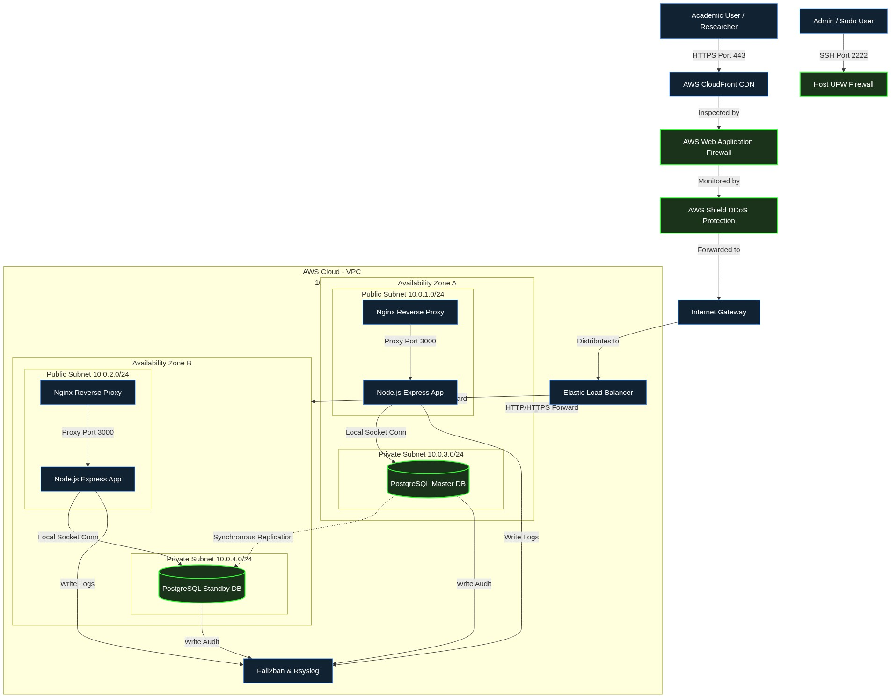
Logical Network Topology Diagram

APPENDIX B - PENETRATION TESTING & CODE REVIEW CHECKLIST
The web application’s security assessment was conducted using a combination of manual Static Application Security Testing (SAST) and limited Dynamic Application Security Testing (DAST) in compliance with industry secure application standards.

Hardening Matrix and Vulnerability Mitigation Checklist
Assessment Domain | Attack Vector | Hardening Status / Implementation in JURUS | Result
Input Validation | SQL Injection (SQLi) | Utilizes secure string binding via Parameterized Queries (SQLite db.js) for all API endpoints. | PASS
Authentication | Brute Force & Session Fixation | Implements Rate Limiting (Express Rate Limiter), and Session IDs are cryptographically regenerated upon every successful login. | PASS
Access Control | IDOR & Privileges Escalation | RBAC Middleware (hasRole()) and document ownership records are explicitly checked on the database tier. | PASS
Error Handling | Stack Trace Information Leak | Raw Node.js server errors are suppressed (NODE_ENV=production), displaying secure HTTP status templates for 400, 403, 404, 500. | PASS
Sensitive Data | Plaintext Credentials Leak | All passwords are mathematically hashed using the Bcrypt (Salt 10) algorithm. This sensitive information is omitted from audit logs. | PASS
File Upload | Remote Code Execution (RCE) | Mitigates Reverse Shells and directory traversals by sanitizing and renaming files into UUID strings. Files are stored entirely outside the public webroot. | PASS
CSRF Protection | Request Forging | A secret X-CSRF-Token header is cryptographically validated on the server for all fetch() calls that modify the database. | PASS
Output Encoding | Cross-Site Scripting (XSS) | The escapeHTML sanitation function is globally applied to all dynamic input data within DOM grids on the client-side before browser rendering. | PASS

