1. **Data Preparation**

Table 1. In this study, 22 patients are enrolled from which no disease, diabetes with complication, and diabetes without complication are 7, 8, and 7, respectively. Each subject has at least three replicates.

|  |  |  |  |
| --- | --- | --- | --- |
|  | No disease  (N=7) | Diabet with complication (N=8) | Diabet without complication (N=7) |
| No treatment | 21 | 26 | 25 |
| Treated (with 30mM insulin) | 21 | 26 | 25 |

Design matrix for differential expression analysis

* DwC: Disease with complication
* DwoC: Disease without complication
* NoD: No disease

--------------------------------------------------------------------------------------------

Case_Number Subject Condition Treatment

--------------------------------------------------------------------------------------------

DwC_1026_30mM.1 1 disease_comp insulin

DwC_1026_30mM.2 1 disease_comp insulin

DwC_1026_30mM.3 1 disease_comp insulin

DwC_1026_30mM.4 1 disease_comp insulin

DwC_1026_30mM.5 1 disease_comp insulin

DwC_1026_norm.1 2 disease_comp control

DwC_1026_norm.2 2 disease_comp control

DwC_1026_norm.3 2 disease_comp control

DwC_1026_norm.4 2 disease_comp control

DwC_1026_norm.5 2 disease_comp control

DwC_6009_30mM.1 3 disease_comp insulin

DwC_6009_30mM.2 3 disease_comp insulin

DwC_6009_30mM.3 3 disease_comp insulin

DwC_6009_norm.1 4 disease_comp control

DwC_6009_norm.2 4 disease_comp control

DwC_6009_norm.3 4 disease_comp control

DwC_11167_30mM.1 5 disease_comp insulin

DwC_11167_30mM.2 5 disease_comp insulin

DwC_11167_30mM.3 5 disease_comp insulin

DwC_11167_norm.1 6 disease_comp control

DwC_11167_norm.2 6 disease_comp control

DwC_11167_norm.3 6 disease_comp control

DwC_13206_30mM.1 7 disease_comp insulin

DwC_13206_30mM.2 7 disease_comp insulin

DwC_13206_30mM.3 7 disease_comp insulin

DwC_13206_norm.1 8 disease_comp control

DwC_13206_norm.2 8 disease_comp control

DwC_13206_norm.3 8 disease_comp control

DwC_17075_30mM.1 9 disease_comp insulin

DwC_17075_30mM.2 9 disease_comp insulin

DwC_17075_30mM.3 9 disease_comp insulin

DwC_17075_norm.1 10 disease_comp control

DwC_17075_norm.2 10 disease_comp control

DwC_17075_norm.3 10 disease_comp control

DwC_21127_30mM.1 11 disease_comp insulin

DwC_21127_30mM.2 11 disease_comp insulin

DwC_21127_30mM.3 11 disease_comp insulin

DwC_21127_norm.1 12 disease_comp control

DwC_21127_norm.2 12 disease_comp control

DwC_21127_norm.3 12 disease_comp control

DwC_26008_30mM.1 13 disease_comp insulin

DwC_26008_30mM.2 13 disease_comp insulin

DwC_26008_30mM.3 13 disease_comp insulin

DwC_26008_norm.1 14 disease_comp control

DwC_26008_norm.2 14 disease_comp control

DwC_26008_norm.3 14 disease_comp control

DwC_27141_30mM.1 15 disease_comp insulin

DwC_27141_30mM.2 15 disease_comp insulin

DwC_27141_30mM.3 15 disease_comp insulin

DwC_27141_norm.1 16 disease_comp control

DwC_27141_norm.2 16 disease_comp control

DwC_27141_norm.3 16 disease_comp control

DwoC_2318_30mM.1 17 disease insulin

DwoC_2318_30mM.2 17 disease insulin

DwoC_2318_30mM.3 17 disease insulin

DwoC_2318_30mM.4 17 disease insulin

DwoC_2318_30mM.5 17 disease insulin

DwoC_2318_norm.1 18 disease control

DwoC_2318_norm.2 18 disease control

DwoC_2318_norm.3 18 disease control

DwoC_2318_norm.4 18 disease control

DwoC_2318_norm.5 18 disease control

DwoC_3395_30mM.1 19 disease insulin

DwoC_3395_30mM.2 19 disease insulin

DwoC_3395_30mM.3 19 disease insulin

DwoC_3395_norm.1 20 disease control

DwoC_3395_norm.2 20 disease control

DwoC_3395_norm.3 20 disease control

DwoC_6154_30mM.1 21 disease insulin

DwoC_6154_30mM.2 21 disease insulin

DwoC_6154_30mM.3 21 disease insulin

DwoC_6154_norm.1 22 disease control

DwoC_6154_norm.2 22 disease control

DwoC_6154_norm.3 22 disease control

DwoC_16362_30mM.1 23 disease insulin

DwoC_16362_30mM.2 23 disease insulin

DwoC_16362_30mM.3 23 disease insulin

DwoC_16362_norm.1 24 disease control

DwoC_16362_norm.2 24 disease control

DwoC_16362_norm.3 24 disease control

DwoC_18296_30mM.1 25 disease insulin

DwoC_18296_30mM.2 25 disease insulin

DwoC_18296_30mM.3 25 disease insulin

DwoC_18296_norm.1 26 disease control

DwoC_18296_norm.2 26 disease control

DwoC_18296_norm.3 26 disease control

DwoC_21183_30mM.1 27 disease insulin

DwoC_21183_30mM.2 27 disease insulin

DwoC_21183_30mM.3 27 disease insulin

DwoC_21183_norm.1 28 disease control

DwoC_21183_norm.2 28 disease control

DwoC_21183_norm.3 28 disease control

DwoC_25224_30mM.1 29 disease insulin

DwoC_25224_30mM.2 29 disease insulin

DwoC_25224_30mM.3 29 disease insulin

DwoC_25224_30mM.4 29 disease insulin

DwoC_25224_30mM.5 29 disease insulin

DwoC_25224_norm.1 30 disease control

DwoC_25224_norm.2 30 disease control

DwoC_25224_norm.3 30 disease control

DwoC_25224_norm.4 30 disease control

DwoC_25224_norm.5 30 disease control

NoD_7012_30mM.1 31 normal insulin

NoD_7012_30mM.2 31 normal insulin

NoD_7012_30mM.3 31 normal insulin

NoD_7012_norm.1 32 normal control

NoD_7012_norm.2 32 normal control

NoD_7012_norm.3 32 normal control

NoD_7344_30mM.1 33 normal insulin

NoD_7344_30mM.2 33 normal insulin

NoD_7344_30mM.3 33 normal insulin

NoD_7344_norm.1 34 normal control

NoD_7344_norm.2 34 normal control

NoD_7344_norm.3 34 normal control

NoD_11985_30mM.1 35 normal insulin

NoD_11985_30mM.2 35 normal insulin

NoD_11985_30mM.3 35 normal insulin

NoD_11985_norm.1 36 normal control

NoD_11985_norm.2 36 normal control

NoD_11985_norm.3 36 normal control

NoD_14381_30mM.1 37 normal insulin

NoD_14381_30mM.2 37 normal insulin

NoD_14381_30mM.3 37 normal insulin

NoD_14381_norm.1 38 normal control

NoD_14381_norm.2 38 normal control

NoD_14381_norm.3 38 normal control

NoD_14520_30mM.1 39 normal insulin

NoD_14520_30mM.2 39 normal insulin

NoD_14520_30mM.3 39 normal insulin

NoD_14520_norm.1 40 normal control

NoD_14520_norm.2 40 normal control

NoD_14520_norm.3 40 normal control

NoD_14569_30mM.1 41 normal insulin

NoD_14569_30mM.2 41 normal insulin

NoD_14569_30mM.3 41 normal insulin

NoD_14569_norm.1 42 normal control

NoD_14569_norm.2 42 normal control

NoD_14569_norm.3 42 normal control

NoD_14581_30mM.1 43 normal insulin

NoD_14581_30mM.2 43 normal insulin

NoD_14581_30mM.3 43 normal insulin

NoD_14581_norm.1 44 normal control

NoD_14581_norm.2 44 normal control

NoD_14581_norm.3 44 normal control

------------------------------------------------------------------------------------------------------

1. **Data Preprocessing**

Data matrix: 47282 (probes) x 144 (samples).

Note that 47282 is the common probes among the four different batches.

1. **Raw data (box plot)**
2. 1-144 samples all together



1. 1-46 samples only



1. 47-92 samples only



1. 93-144 samples only



1. **Normalized data (box plot)**
   1. 1-144 samples all together



* 1. 1-46 samples only



* 1. 47-92 samples only



* 1. 93-144 samples only



**Data clustering (normalized data only: 144 samples all together)**

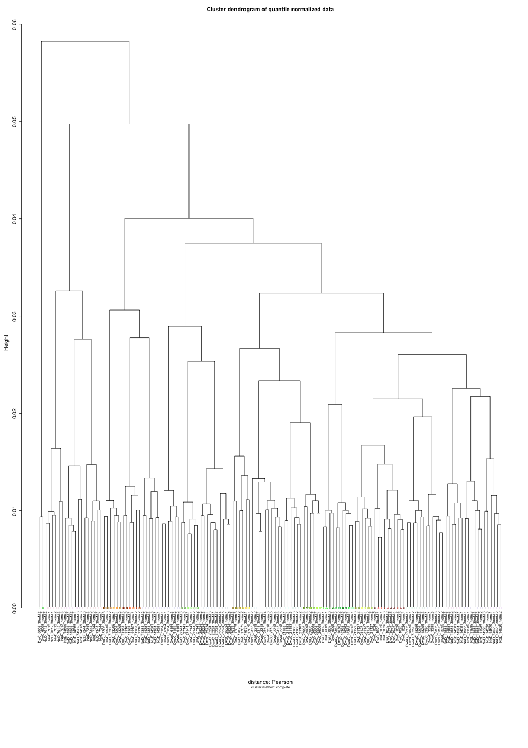

1. 1-46 samples only

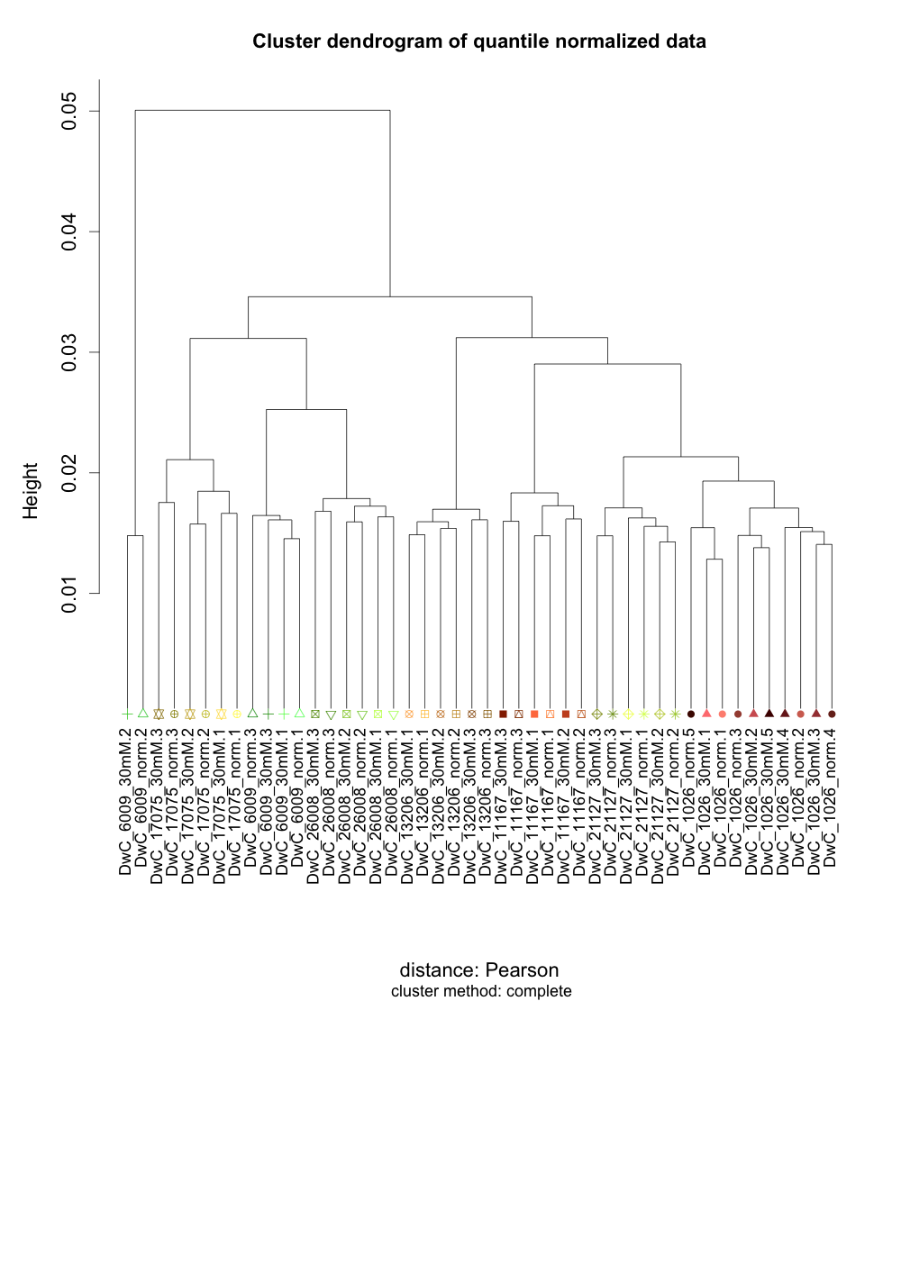

1. 47-92 samples only

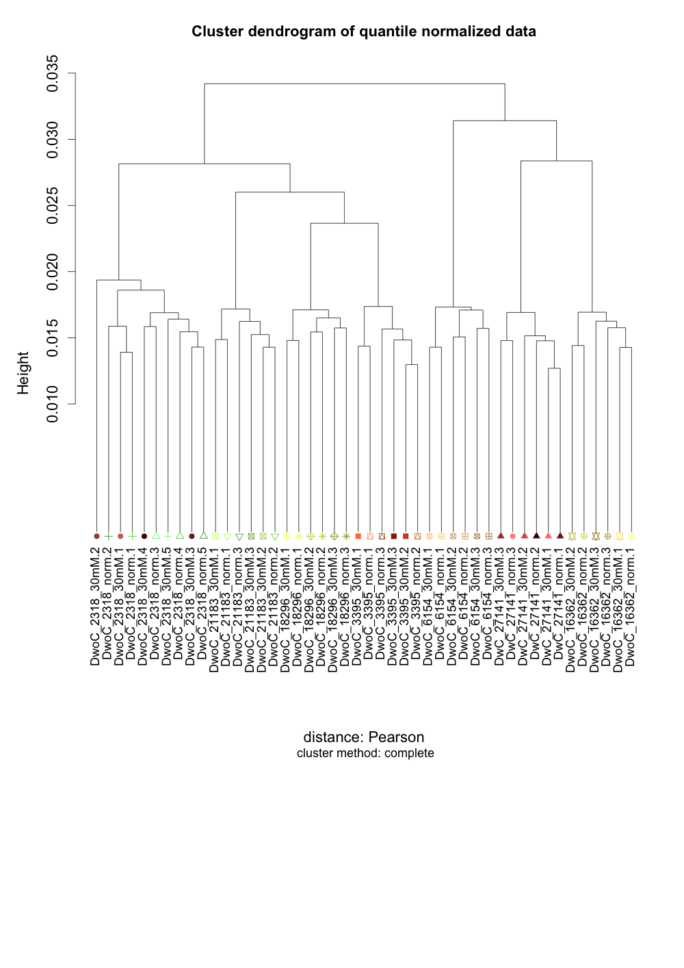

1. 93-144 samples only

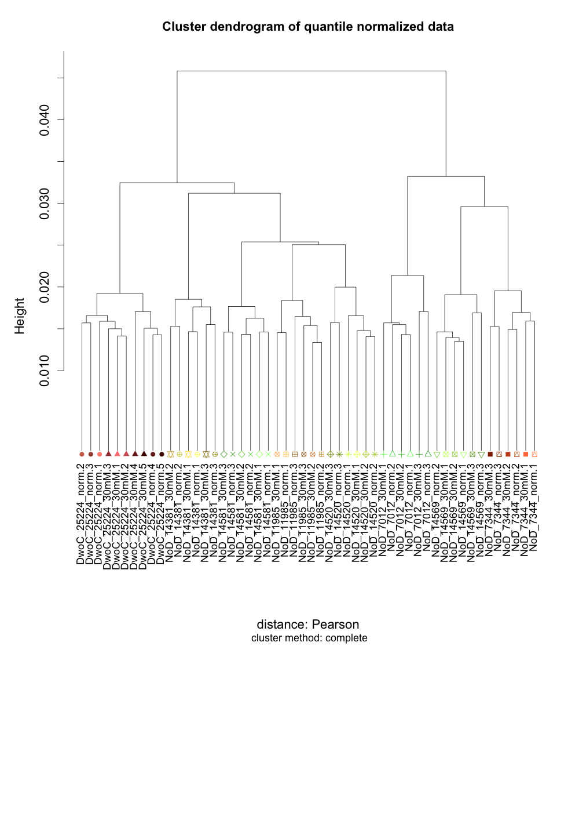

1. **44 samples without replicates**

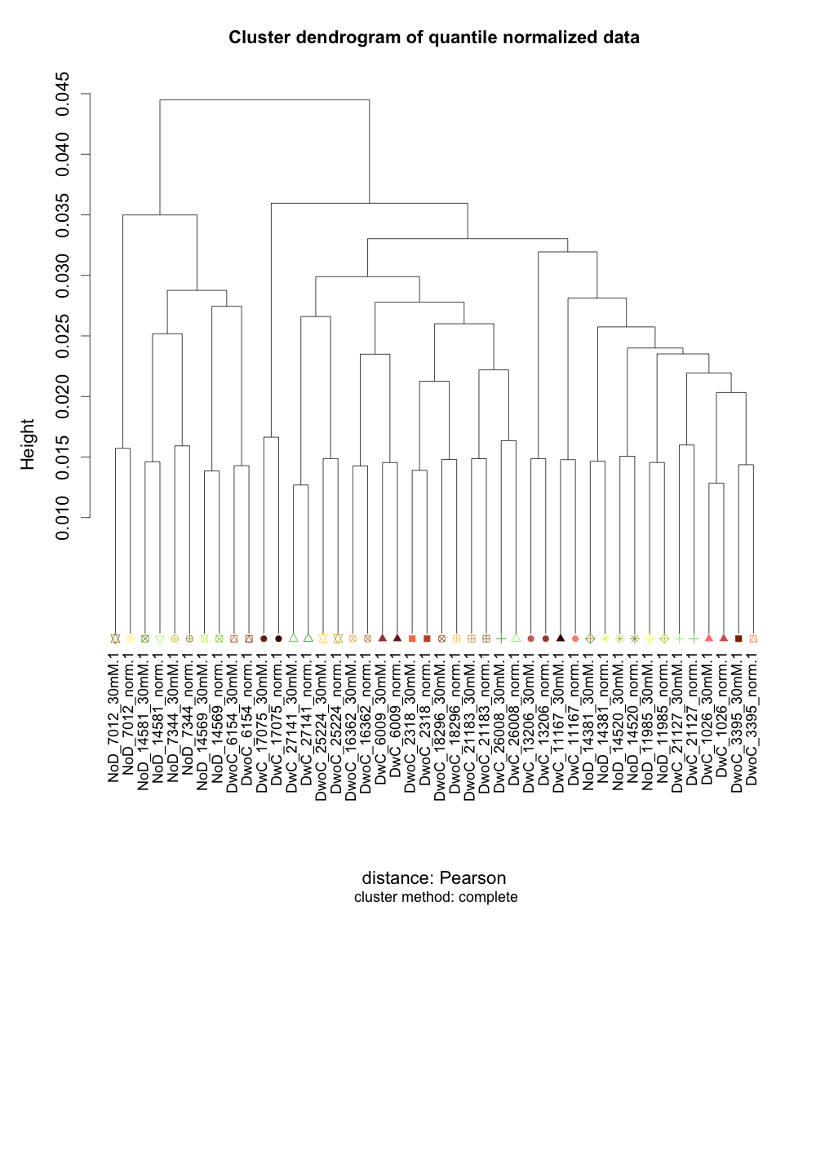

1. **Data filtering**
   1. 16436 unexpressed probes are removed that will reduce false positives (matrix size: 30846 x 144)
   2. 8871 probes that do not have annotated genes are removed (matrix size: 21975 x 144)
2. **Differential expression analysis (using limma)**

Input data matrix: 21975 probes x 144 samples

**Comparison design (cutoff: p.val <0.05) – note that no significant q-value is achieved**

1. disease without complication insulin vs control

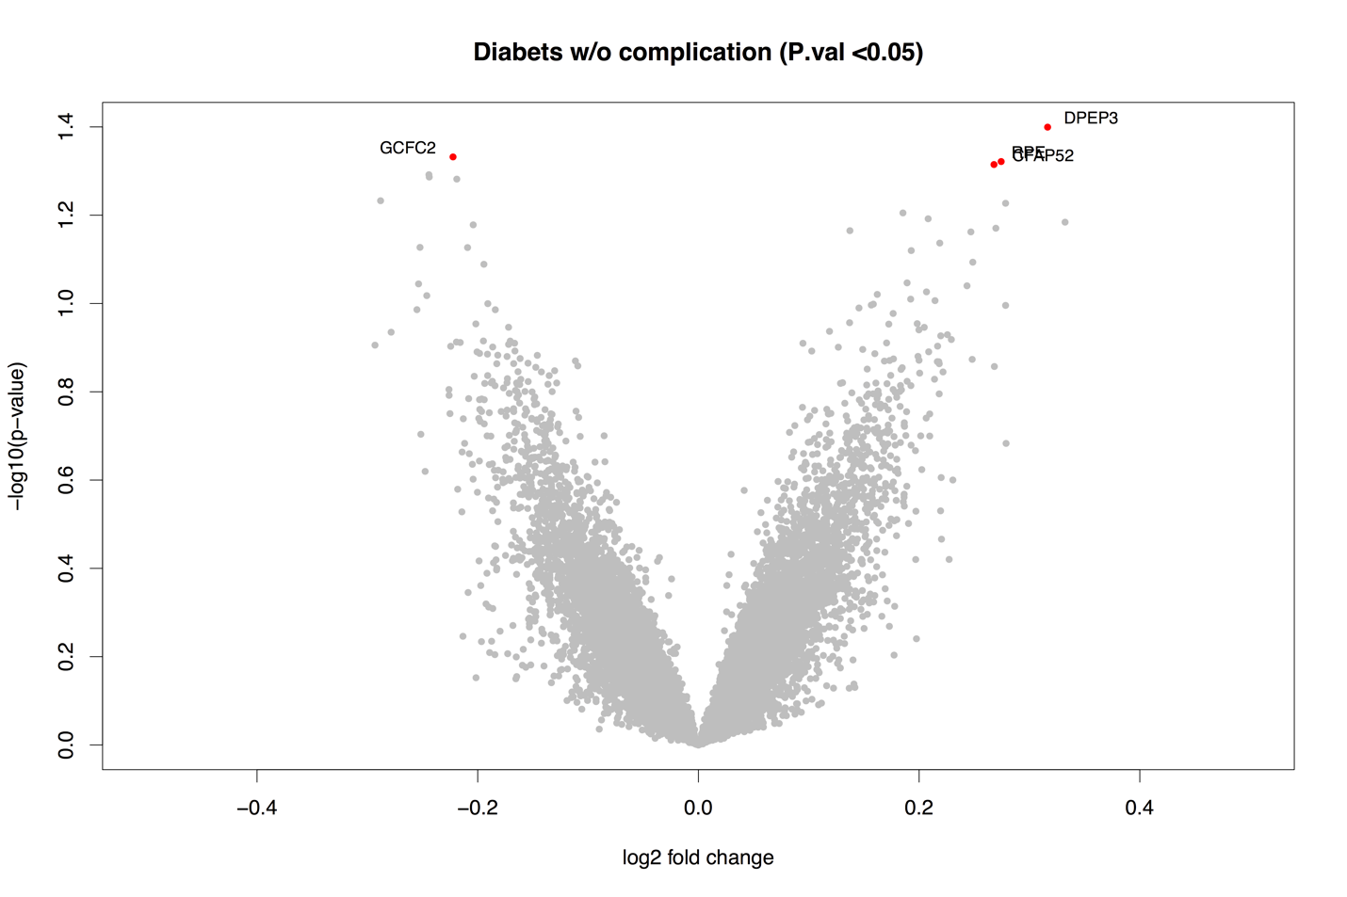

|  |  |  |  |  |
| --- | --- | --- | --- | --- |
| **Gene Symbol** | **Gene Name** | **log2 FC** | **Ave Expr** | **P.Value** |
| **DPEP3** | **dipeptidase 3** | **0.316** | **3.767** | **0.040** |
| **GCFC2** | **GC-rich sequence DNA-binding factor 2** | **-0.222** | **4.325** | **0.047** |
| **RPE** | **ribulose-5-phosphate-3-epimerase** | **0.274** | **3.754** | **0.048** |
| **CFAP52** | **cilia and flagella associated protein 52** | **0.268** | **3.864** | **0.048** |

1. disease with complication insulin vs control

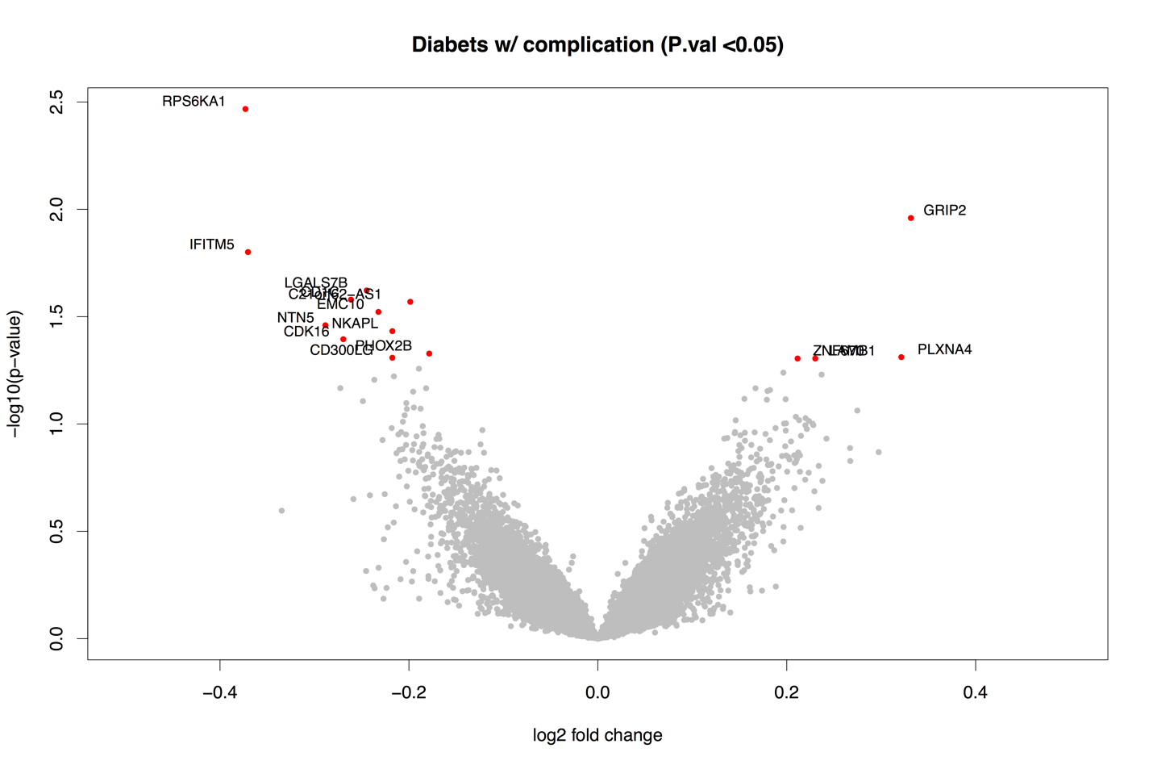

|  |  |  |  |  |
| --- | --- | --- | --- | --- |
| **Gene Symbol** | **geneName** | **Log2 FC** | **Ave Expr** | **P.Value** |
| **RPS6KA1** | **ribosomal protein S6 kinase, 90kDa, polypeptide 1** | **-0.373** | **4.194** | **0.003** |
| **GRIP2** | **glutamate receptor interacting protein 2** | **0.331** | **4.230** | **0.011** |
| **IFITM5** | **interferon induced transmembrane protein 5** | **-0.370** | **3.617** | **0.016** |
| **LGALS7B** | **lectin, galactoside-binding, soluble, 7B** | **-0.245** | **3.897** | **0.024** |
| **CD1C** | **CD1c molecule** | **-0.261** | **3.892** | **0.026** |
| **C21orf62-AS1** | **C21orf62 antisense RNA 1** | **-0.199** | **4.477** | **0.027** |
| **EMC10** | **ER membrane protein complex subunit 10** | **-0.232** | **4.140** | **0.030** |
| **NTN5** | **netrin 5** | **-0.288** | **3.932** | **0.035** |
| **NKAPL** | **NFKB activating protein-like** | **-0.218** | **4.108** | **0.037** |
| **CDK16** | **cyclin-dependent kinase 16** | **-0.269** | **3.937** | **0.040** |
| **PHOX2B** | **paired-like homeobox 2b** | **-0.179** | **4.186** | **0.047** |
| **PLXNA4** | **plexin A4** | **0.321** | **3.747** | **0.049** |
| **CD300LG** | **CD300 molecule-like family member g** | **-0.218** | **4.103** | **0.049** |
| **LAMB1** | **laminin, beta 1** | **0.230** | **4.260** | **0.050** |
| **ZNF670** | **zinc finger protein 670** | **0.211** | **4.453** | **0.050** |

1. no disease insulin vs control

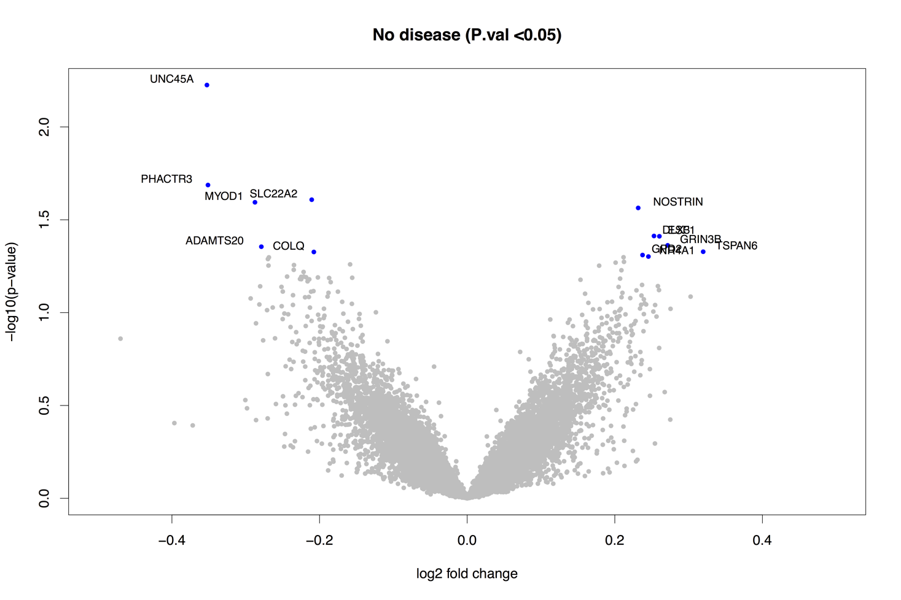

|  |  |  |  |  |
| --- | --- | --- | --- | --- |
| **Gene Symbol** | **Gene Name** | **log2 FC** | **Ave Expr** | **P.Value** |
| **UNC45A** | **unc-45 myosin chaperone A** | **-0.353** | **4.097** | **0.006** |
| **PHACTR3** | **phosphatase and actin regulator 3** | **-0.351** | **3.956** | **0.021** |
| **SLC22A2** | **solute carrier family 22 (organic cation transporter), member 2** | **-0.211** | **4.329** | **0.025** |
| **MYOD1** | **myogenic differentiation 1** | **-0.288** | **4.002** | **0.025** |
| **NOSTRIN** | **nitric oxide synthase trafficking** | **0.232** | **4.121** | **0.027** |
| **DLX3** | **distal-less homeobox 3** | **0.253** | **4.198** | **0.039** |
| **ESF1** | **ESF1 nucleolar pre-rRNA processing protein homolog** | **0.260** | **3.925** | **0.039** |
| **GRIN3B** | **glutamate receptor, ionotropic, N-methyl-D-aspartate 3B** | **0.272** | **3.980** | **0.043** |
| **ADAMTS20** | **ADAM metallopeptidase with thrombospondin type 1 motif, 20** | **-0.279** | **3.858** | **0.044** |
| **TSPAN6** | **tetraspanin 6** | **0.320** | **3.878** | **0.047** |
| **COLQ** | **collagen-like tail subunit (single strand of homotrimer) of asymmetric acetylcholinesterase** | **-0.208** | **4.408** | **0.047** |
| **GPD2** | **glycerol-3-phosphate dehydrogenase 2 (mitochondrial)** | **0.238** | **4.114** | **0.049** |
| **NR4A1** | **nuclear receptor subfamily 4, group A, member 1** | **0.246** | **4.000** | **0.050** |