Software Engineering in Construction Information Systems

Assignment #3
ETL: Extract / Transform / Load
SUPPLIX — Construction Material Supplier Management Platform
Lecturer: Yo-Ming Hsieh
Group 4
Dau Thuy Dung D11505807@mail.ntust.edu.tw
Huang Ching M11505502@mail.ntust.edu.tw

1. Database and Table Creation
We created the SUPPLIX database and all MVP tables based on our normalized ER Diagram (3NF). Each table includes appropriate primary keys, data types, NOT NULL constraints, and foreign key constraints to maintain referential integrity.

1.1 Create Database
Purpose: Create the SUPPLIX database and select it for use
CREATE DATABASE SUPPLIX;
USE SUPPLIX;
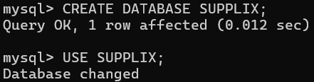

1.2 User Table
Purpose: Stores all user accounts. The role field restricts values to GC, Supplier, or PM.
CREATE TABLE User (
user_id VARCHAR(20) PRIMARY KEY,
name VARCHAR(100) NOT NULL,
email VARCHAR(100) NOT NULL UNIQUE,
password_hash VARCHAR(255) NOT NULL,
role ENUM('GC', 'Supplier', 'PM') NOT NULL,
phone VARCHAR(20),
created_at DATETIME NOT NULL DEFAULT NOW()
);
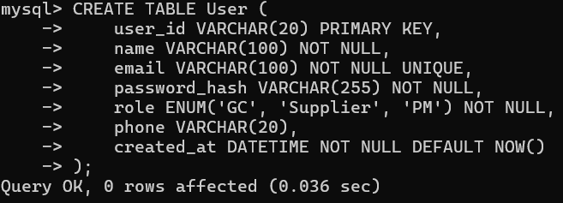

1.3 Project Table
Purpose: Stores project records. FK references User to ensure the project owner exists.
CREATE TABLE Project (
project_id VARCHAR(20) PRIMARY KEY,
user_id VARCHAR(20) NOT NULL,
name VARCHAR(100) NOT NULL,
location VARCHAR(200),
status ENUM('active', 'completed') NOT NULL DEFAULT 'active',
start_date DATE,
end_date DATE,
CONSTRAINT FK_Project_User FOREIGN KEY (user_id) REFERENCES User(user_id)
);
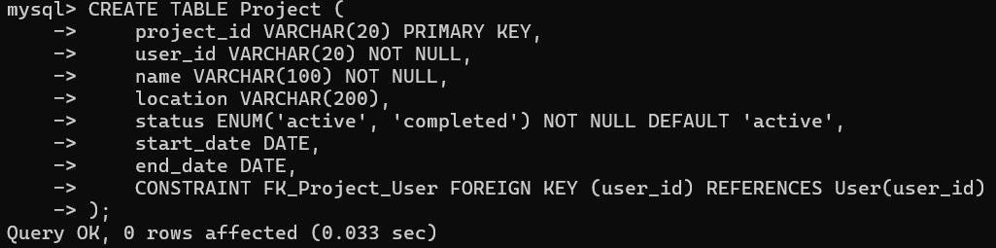

1.4 Supplier Table
Purpose: Stores supplier company profiles. FK references User for the linked account.
CREATE TABLE Supplier (
supplier_id VARCHAR(20) PRIMARY KEY,
user_id VARCHAR(20),
company_name VARCHAR(200) NOT NULL,
description TEXT,
location VARCHAR(200),
phone VARCHAR(100),
email VARCHAR(200),
is_verified BOOLEAN NOT NULL DEFAULT FALSE,
created_at DATETIME NOT NULL DEFAULT NOW(),
CONSTRAINT FK_Supplier_User FOREIGN KEY (user_id) REFERENCES User(user_id)
);
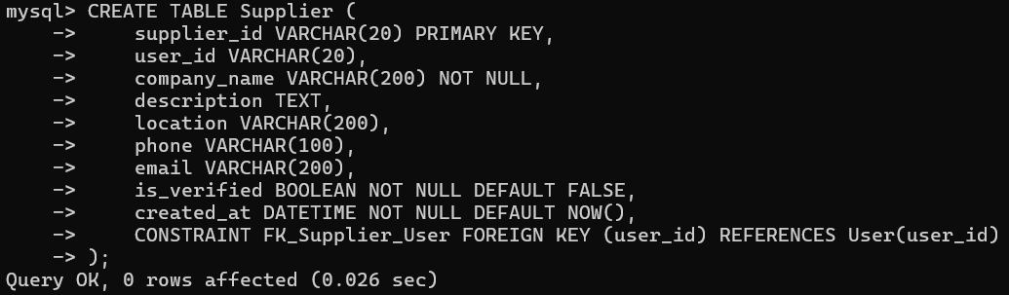

1.5 Material Table
Purpose: Stores construction materials. FK references Supplier to ensure the material provider exists.
CREATE TABLE Material (
material_id VARCHAR(20) PRIMARY KEY,
supplier_id VARCHAR(20),
name TEXT NOT NULL,
unit VARCHAR(50) NOT NULL,
unit_price DECIMAL(10,2) NOT NULL,
price_stdev DECIMAL(10,2),
no_samples INT,
stock_available BOOLEAN NOT NULL DEFAULT TRUE,
CONSTRAINT FK_Material_Supplier FOREIGN KEY (supplier_id) REFERENCES Supplier(supplier_id)
);
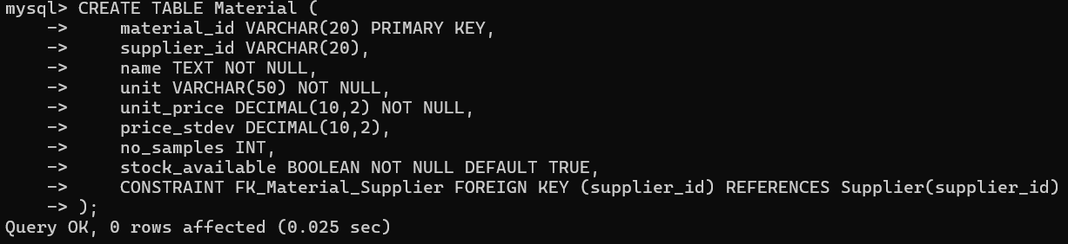

1.6 RFQ and RFQ_Item Tables
Purpose: RFQ stores quotation requests. RFQ_Item stores individual material line items within each RFQ.
CREATE TABLE RFQ (
rfq_id VARCHAR(20) PRIMARY KEY,
project_id VARCHAR(20) NOT NULL,
user_id VARCHAR(20) NOT NULL,
deadline DATE NOT NULL,
status ENUM('open', 'closed') NOT NULL DEFAULT 'open',
created_at DATETIME NOT NULL DEFAULT NOW(),
CONSTRAINT FK_RFQ_Project FOREIGN KEY (project_id) REFERENCES Project(project_id),
CONSTRAINT FK_RFQ_User FOREIGN KEY (user_id) REFERENCES User(user_id)
);
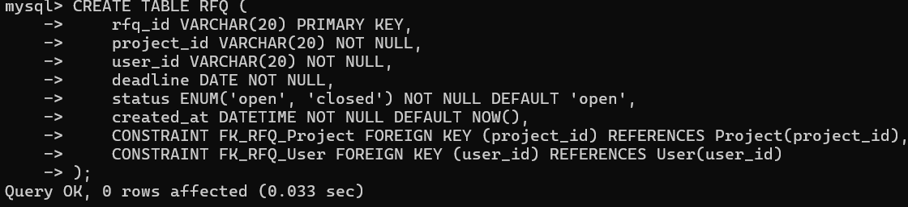

CREATE TABLE RFQ_Item (
rfq_item_id VARCHAR(20) PRIMARY KEY,
rfq_id VARCHAR(20) NOT NULL,
material_id VARCHAR(20) NOT NULL,
quantity DECIMAL(10,2) NOT NULL,
required_date DATE,
CONSTRAINT FK_RFQItem_RFQ FOREIGN KEY (rfq_id) REFERENCES RFQ(rfq_id),
CONSTRAINT FK_RFQItem_Material FOREIGN KEY (material_id) REFERENCES Material(material_id)
);
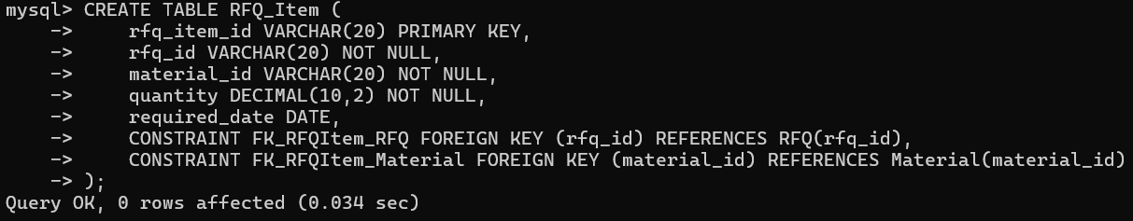

1.7 Quotation Table
Purpose: Stores supplier responses to RFQs. Each supplier can submit one quotation per RFQ.
CREATE TABLE Quotation (
quotation_id VARCHAR(20) PRIMARY KEY,
rfq_id VARCHAR(20) NOT NULL,
supplier_id VARCHAR(20) NOT NULL,
unit_price DECIMAL(10,2) NOT NULL,
quantity DECIMAL(10,2) NOT NULL,
delivery_date DATE NOT NULL,
delivery_terms TEXT,
status ENUM('pending', 'accepted', 'rejected') NOT NULL DEFAULT 'pending',
created_at DATETIME NOT NULL DEFAULT NOW(),
CONSTRAINT FK_Quotation_RFQ FOREIGN KEY (rfq_id) REFERENCES RFQ(rfq_id),
CONSTRAINT FK_Quotation_Supplier FOREIGN KEY (supplier_id) REFERENCES Supplier(supplier_id)
);
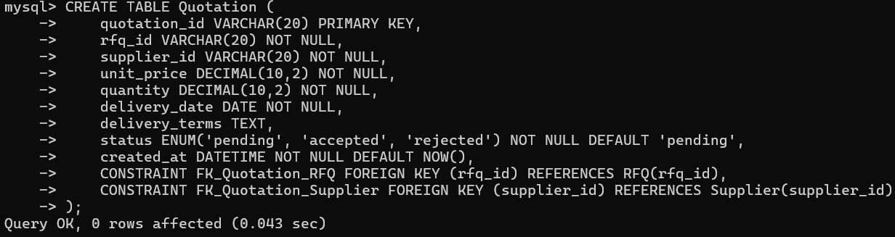

1.8 PurchaseOrder Table
Purpose: Stores purchase orders created from accepted quotations. FKs reference Project, Supplier, and User.
CREATE TABLE PurchaseOrder (
po_id VARCHAR(20) PRIMARY KEY,
project_id VARCHAR(20) NOT NULL,
quotation_id VARCHAR(20),
supplier_id VARCHAR(20) NOT NULL,
user_id VARCHAR(20) NOT NULL,
status ENUM('pending','accepted','in_progress','fulfilled') NOT NULL DEFAULT 'pending',
total_amount DECIMAL(10,2) NOT NULL,
transaction_date DATE,
notes TEXT,
created_at DATETIME NOT NULL DEFAULT NOW(),
CONSTRAINT FK_PO_Project FOREIGN KEY (project_id) REFERENCES Project(project_id),
CONSTRAINT FK_PO_Supplier FOREIGN KEY (supplier_id) REFERENCES Supplier(supplier_id),
CONSTRAINT FK_PO_User FOREIGN KEY (user_id) REFERENCES User(user_id)
);
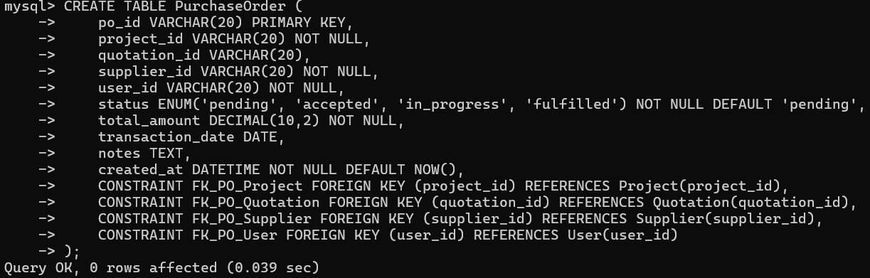

1.9 PO_Item Table
Purpose: Stores individual material line items within each purchase order.
CREATE TABLE PO_Item (
po_item_id VARCHAR(20) PRIMARY KEY,
po_id VARCHAR(20) NOT NULL,
material_id VARCHAR(20) NOT NULL,
quantity DECIMAL(10,2) NOT NULL,
unit_price DECIMAL(10,2) NOT NULL,
discount_rate DECIMAL(5,2) NOT NULL DEFAULT 0,
subtotal DECIMAL(10,2) NOT NULL,
CONSTRAINT FK_POItem_PO FOREIGN KEY (po_id) REFERENCES PurchaseOrder(po_id),
CONSTRAINT FK_POItem_Material FOREIGN KEY (material_id) REFERENCES Material(material_id)
);
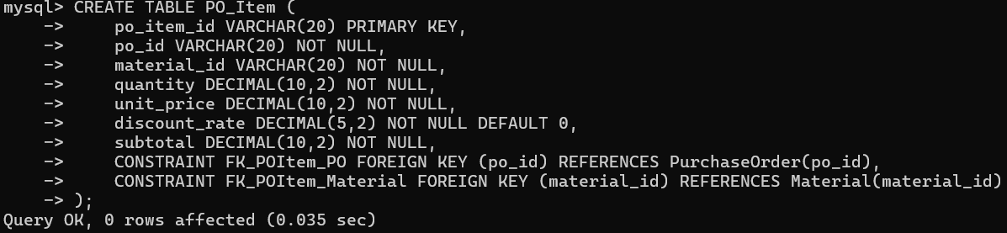

1.10 Delivery Table
Purpose: Tracks delivery status for each purchase order.
CREATE TABLE Delivery (
delivery_id VARCHAR(20) PRIMARY KEY,
po_id VARCHAR(20) NOT NULL,
status ENUM('dispatched','out_for_delivery','delivered','delayed') NOT NULL DEFAULT 'dispatched',
estimated_date DATE NOT NULL,
actual_date DATE,
delay_reason TEXT,
updated_at DATETIME NOT NULL DEFAULT NOW(),
CONSTRAINT FK_Delivery_PO FOREIGN KEY (po_id) REFERENCES PurchaseOrder(po_id)
);
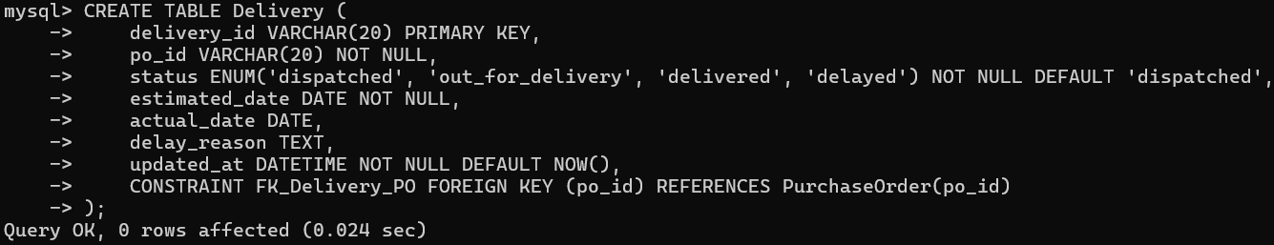

1.11 Document Table
Purpose: Stores procurement documents (certificates, invoices, contracts, etc.) linked to suppliers, projects, or orders.
CREATE TABLE Document (
document_id VARCHAR(20) PRIMARY KEY,
project_id VARCHAR(20),
supplier_id VARCHAR(20),
po_id VARCHAR(20),
uploaded_by VARCHAR(20),
document_type ENUM('certificate','invoice','safety_sheet','contract') NOT NULL,
file_name VARCHAR(200) NOT NULL,
file_url VARCHAR(500) NOT NULL,
expiry_date DATE,
created_at DATETIME NOT NULL DEFAULT NOW(),
CONSTRAINT FK_Document_Project FOREIGN KEY (project_id) REFERENCES Project(project_id),
CONSTRAINT FK_Document_Supplier FOREIGN KEY (supplier_id) REFERENCES Supplier(supplier_id),
CONSTRAINT FK_Document_PO FOREIGN KEY (po_id) REFERENCES PurchaseOrder(po_id),
CONSTRAINT FK_Document_User FOREIGN KEY (uploaded_by) REFERENCES User(user_id)
);
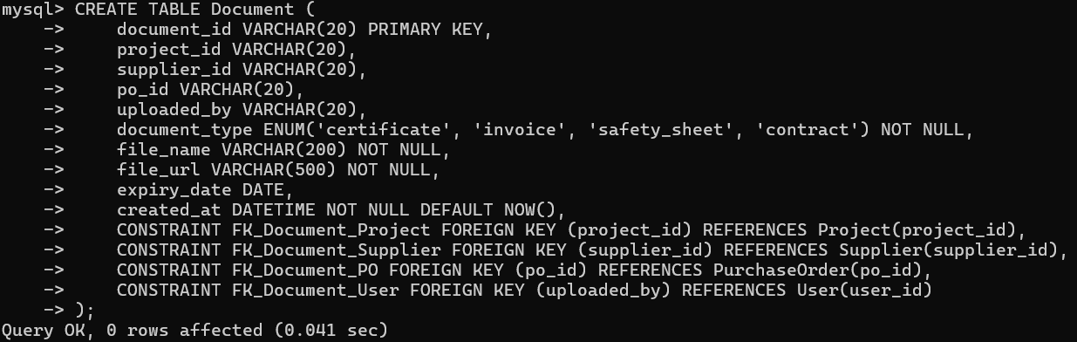

1.12 Verify All Tables Created
Purpose: Confirm all 11 tables were created successfully
SHOW TABLES;
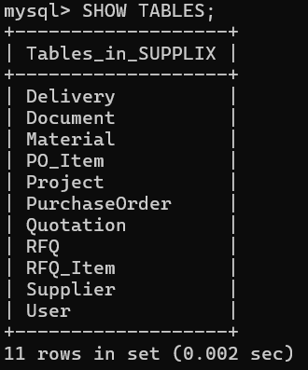

2. Staging Tables
Three staging tables are created to load the raw TSV data provided by the instructor. Staging tables have no foreign key constraints, allowing all raw data to be loaded first before quality checks are performed.

2.1 stg_materials
Purpose: Staging table for materials.tsv — stores raw construction material data
CREATE TABLE stg_materials (
material_id VARCHAR(20),
Item TEXT,
Unit VARCHAR(50),
PriceAvg FLOAT,
PriceStdev FLOAT,
NoSamples INT
);
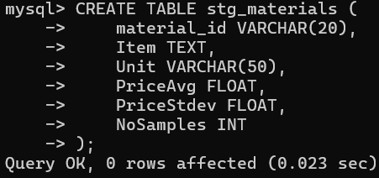

2.2 stg_companies
Purpose: Staging table for companies.tsv — stores raw supplier/company data
CREATE TABLE stg_companies (
company_id VARCHAR(20),
name VARCHAR(200),
description TEXT,
address TEXT,
phone VARCHAR(100),
email VARCHAR(200),
comments TEXT
);
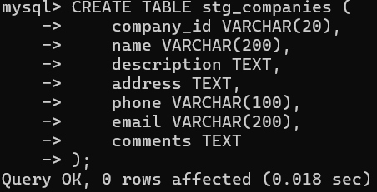

2.3 stg_transactions
Purpose: Staging table for transactions.tsv — stores raw transaction history
CREATE TABLE stg_transactions (
transaction_id VARCHAR(20),
company_id VARCHAR(20),
material_id VARCHAR(20),
quantity FLOAT,
price_per_unit FLOAT,
discount_rate FLOAT,
total_price FLOAT,
transaction_date DATE,
notes TEXT
);
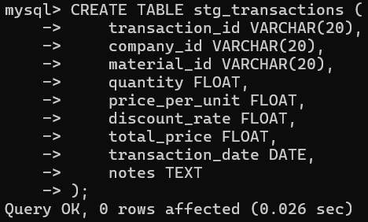

3. Loading Raw Data into Staging Tables
The three TSV files are first copied into the Docker container, then loaded into the staging tables using the LOAD DATA INFILE command.

3.1 Copy TSV Files into Docker Container
Purpose: Run these commands in PowerShell to copy the data files into the MySQL container
docker cp "$env:USERPROFILE\Downloads\materials.tsv" supplix:/var/lib/mysql-files/
docker cp "$env:USERPROFILE\Downloads\companies.tsv" supplix:/var/lib/mysql-files/
docker cp "$env:USERPROFILE\Downloads\transactions.tsv" supplix:/var/lib/mysql-files/
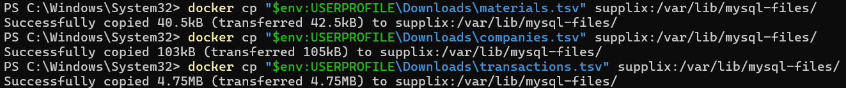

3.2 Load materials.tsv — 458 rows
Purpose: Load construction material data from materials.tsv into stg_materials
LOAD DATA INFILE '/var/lib/mysql-files/materials.tsv'
INTO TABLE stg_materials
FIELDS TERMINATED BY '\t'
LINES TERMINATED BY '\n'
IGNORE 1 ROWS;
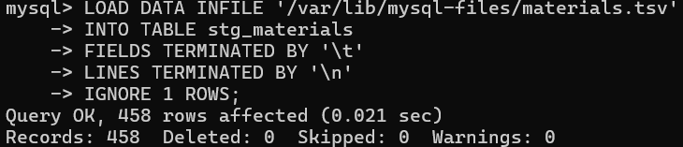

3.3 Load companies.tsv — 500 rows
Purpose: Load supplier/company data from companies.tsv into stg_companies
LOAD DATA INFILE '/var/lib/mysql-files/companies.tsv'
INTO TABLE stg_companies
FIELDS TERMINATED BY '\t'
LINES TERMINATED BY '\n'
IGNORE 1 ROWS;
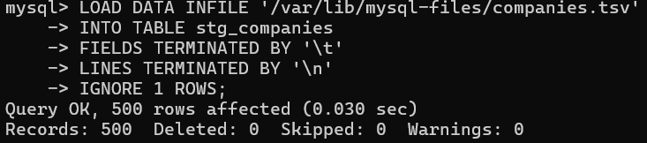

3.4 Load transactions.tsv — 51,947 rows
Purpose: Load transaction history from transactions.tsv into stg_transactions
LOAD DATA INFILE '/var/lib/mysql-files/transactions.tsv'
INTO TABLE stg_transactions
FIELDS TERMINATED BY '\t'
LINES TERMINATED BY '\n'
IGNORE 1 ROWS;
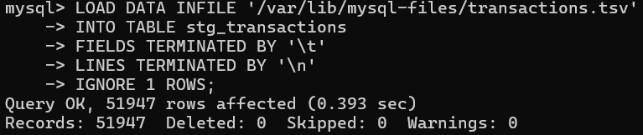

4. Data Quality Checks
We performed systematic data quality checks on all three datasets to identify errors intentionally introduced by the instructor. Four types of errors were found.

Error 1: Orphaned company_id in transactions
Purpose: Use LEFT JOIN + IS NULL to find transactions referencing company_id values that do not exist in stg_companies
SELECT COUNT(*)
FROM stg_transactions t
LEFT JOIN stg_companies c ON t.company_id = c.company_id
WHERE c.company_id IS NULL;
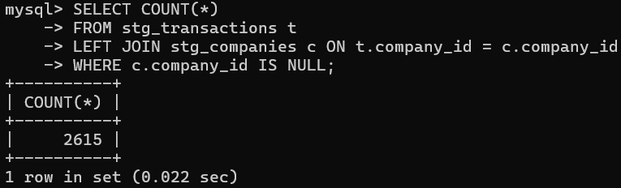
Why this is an error:
These 2,615 transactions reference a company_id that does not exist in the stg_companies table. In a normalized database, every foreign key must point to a valid primary key in the referenced table. If these records were loaded into the production PurchaseOrder table, they would violate the FK_PO_Supplier constraint and cannot be linked to any real supplier. They represent either data entry mistakes or records from companies that were never registered in the system. These rows must be deleted before loading.

Error 2: Orphaned material_id in transactions
Purpose: Use LEFT JOIN + IS NULL to find transactions referencing material_id values that do not exist in stg_materials
SELECT COUNT(*)
FROM stg_transactions t
LEFT JOIN stg_materials m ON t.material_id = m.material_id
WHERE m.material_id IS NULL;
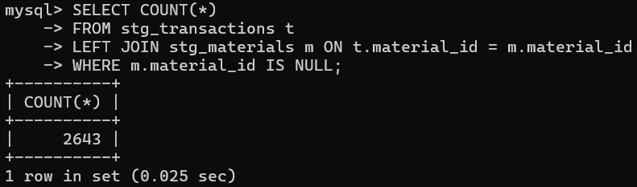

Why this is an error:
These 2,643 transactions reference a material_id that does not exist in the stg_materials table. A transaction must refer to a real material that exists in the system — without a valid material, the order has no meaningful content and cannot be used for procurement analysis. Loading these rows into PO_Item would violate the FK_POItem_Material foreign key constraint. These invalid records were removed to ensure referential integrity.

Error 3: Incorrect total_price calculation
Purpose: The correct formula is: total_price = quantity x price_per_unit x (1 - discount_rate / 100). Rows where total_price deviates by more than 1 are flagged as errors.
SELECT COUNT(*)
FROM stg_transactions
WHERE ABS(total_price - (quantity * price_per_unit * (1 - discount_rate/100))) > 1;
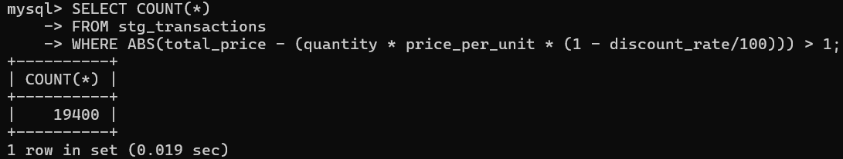

Sample of incorrect records:
SELECT transaction_id, quantity, price_per_unit, discount_rate, total_price,
ROUND(quantity * price_per_unit * (1 - discount_rate/100), 2) AS correct_total
FROM stg_transactions
WHERE ABS(total_price - (quantity * price_per_unit * (1 - discount_rate/100))) > 1
LIMIT 5;
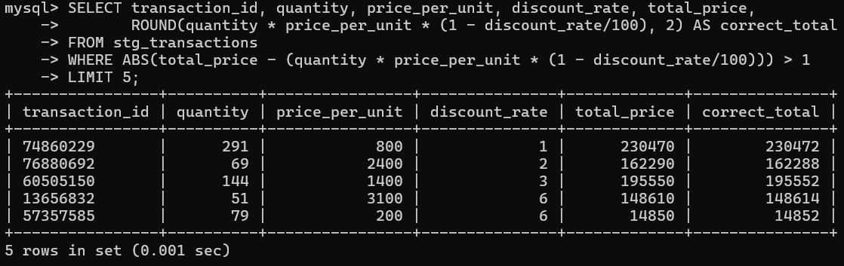
Why this is an error:
The correct formula for total_price is: quantity x price_per_unit x (1 - discount_rate / 100). Any row where the stored total_price deviates from this formula by more than 1 unit is considered erroneous. This discrepancy is likely caused by rounding errors or incorrect calculations at the data source. Storing wrong totals would lead to incorrect financial reporting and unreliable procurement analytics. All 17,545 affected rows were recalculated and corrected using the proper formula before loading.

Error 4: Labor and machine records mixed into materials data
Purpose: The Material table should only contain construction materials. Records with Unit = "Day" or "Hour" are labor or machine operator entries, not materials.
SELECT COUNT(*)
FROM stg_materials
WHERE Unit IN ('Day', 'Hour');
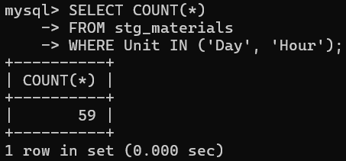
Why this is an error:
The stg_materials table is intended to hold only construction materials (physical goods with units such as kg, bag, piece, etc.). However, 59 records with units of 'Day' or 'Hour' were found — these represent labor costs (workers, technicians) and machine operator fees, which are not materials. Mixing labor records into the Material table would corrupt material-based procurement queries, skew price analytics, and misrepresent what was actually purchased. These records were separated into a dedicated stg_labor table and excluded from the production Material table.

Sample of labor/machine records found:
SELECT material_id, Item, Unit, PriceAvg
FROM stg_materials
WHERE Unit IN ('Day', 'Hour')
LIMIT 10;
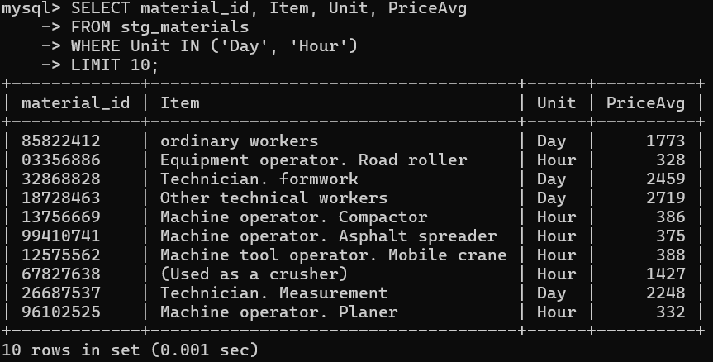

Additional Checks: Duplicate IDs and Invalid Values
Purpose: Check for duplicate primary keys and invalid numeric values across all three datasets. These checks confirm data integrity beyond referential errors.
-- Check for duplicate company_id in stg_companies (result: 0 — no duplicates)
SELECT company_id, COUNT(*) FROM stg_companies
GROUP BY company_id HAVING COUNT(*) > 1;
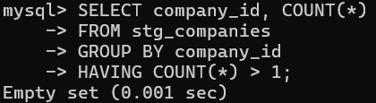
-- Check for duplicate material_id in stg_materials (result: 0 — no duplicates)
SELECT material_id, COUNT(*) FROM stg_materials
GROUP BY material_id HAVING COUNT(*) > 1;
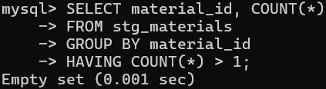
-- Check for duplicate transaction_id in stg_transactions (result: 0 — no duplicates)
SELECT transaction_id, COUNT(*) FROM stg_transactions
GROUP BY transaction_id HAVING COUNT(*) > 1;
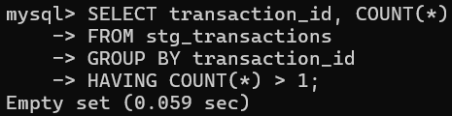
-- Check for zero or negative quantity values (result: 0 — no invalid values)
SELECT COUNT(*) FROM stg_transactions WHERE quantity <= 0;
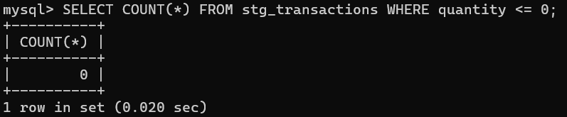
-- Check for zero or negative price values (result: 0 — no invalid values)
SELECT COUNT(*) FROM stg_transactions WHERE price_per_unit <= 0;
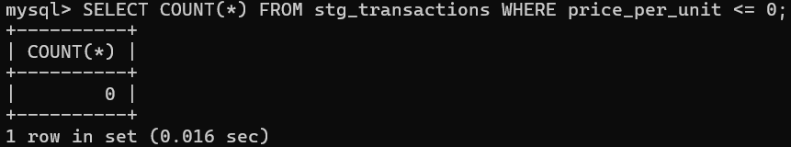
-- Check for zero or negative material prices (result: 0 — no invalid values)
SELECT COUNT(*) FROM stg_materials WHERE PriceAvg <= 0;
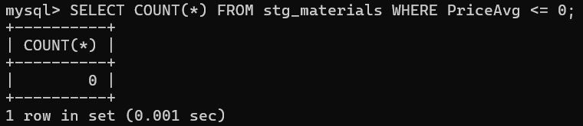
-- Check for invalid email format in stg_companies (result: 0 — all emails valid)
SELECT COUNT(*) FROM stg_companies WHERE email NOT LIKE '%@%';
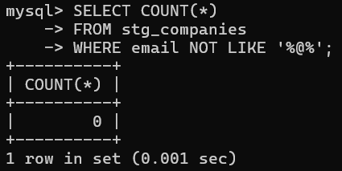
All additional checks returned 0 rows, confirming no duplicate IDs, no invalid numeric values, and no malformed email addresses in the raw data.

5. Data Cleaning
Each of the four errors identified in Section 4 is addressed with the appropriate SQL statement.

5.1 Delete transactions with invalid company_id
Purpose: Remove 2,615 rows where company_id does not exist in stg_companies
DELETE FROM stg_transactions
WHERE company_id NOT IN (
SELECT company_id FROM stg_companies
);
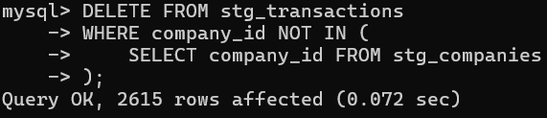

5.2 Delete transactions with invalid material_id
Purpose: Remove 2,497 rows where material_id does not exist in stg_materials
DELETE FROM stg_transactions
WHERE material_id NOT IN (
SELECT material_id FROM stg_materials
);
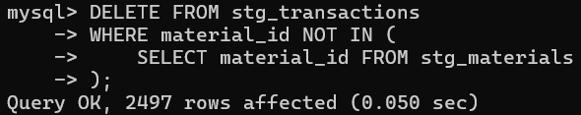

5.3 Correct total_price calculation errors
Purpose: Recalculate total_price using the correct formula for all 17,545 affected rows
UPDATE stg_transactions
SET total_price = ROUND(quantity * price_per_unit * (1 - discount_rate/100), 2)
WHERE ABS(total_price - (quantity * price_per_unit * (1 - discount_rate/100))) > 1;
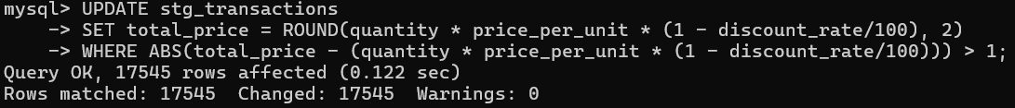
Verify the fix — result should be 0:
SELECT COUNT(*) FROM stg_transactions
WHERE ABS(total_price - (quantity * price_per_unit * (1 - discount_rate/100))) > 1;
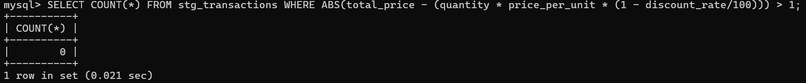

5.4 Separate labor/machine data from materials
Purpose: Move 59 labor/machine records to a separate stg_labor table, then delete them from stg_materials
-- Create a separate table for labor and machine data
CREATE TABLE stg_labor (
material_id VARCHAR(20), Item TEXT, Unit VARCHAR(50),
PriceAvg FLOAT, PriceStdev FLOAT, NoSamples INT
);

-- Move labor/machine records to stg_labor
INSERT INTO stg_labor
SELECT * FROM stg_materials WHERE Unit IN ('Day', 'Hour');

-- Remove labor/machine records from stg_materials
DELETE FROM stg_materials WHERE Unit IN ('Day', 'Hour');
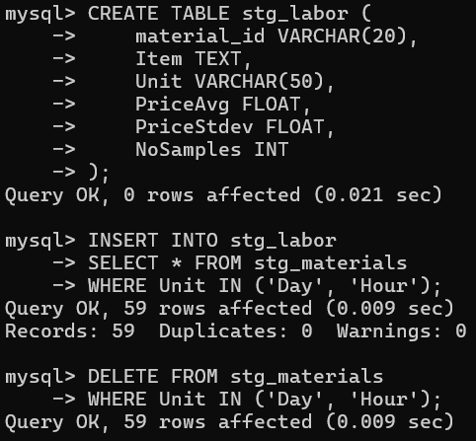

Verify remaining record count in stg_materials:
SELECT COUNT(*) FROM stg_materials;
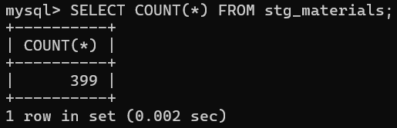

6. ETL: Loading into Production Tables
Clean data from the staging tables is now inserted into the production tables using INSERT INTO ... SELECT statements.

6.1 Insert default User and Project
Purpose: Historical transaction data must reference a User and Project via FK. We insert one default record for each to satisfy the constraints.
INSERT INTO User (user_id, name, email, password_hash, role)
VALUES ('U001', 'Default GC', 'gc@supplix.com', 'hashed_password', 'GC');

INSERT INTO Project (project_id, user_id, name, status)
VALUES ('P001', 'U001', 'Default Project', 'active');
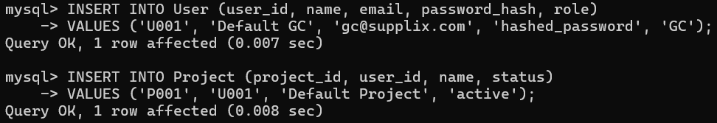

6.2 Load Supplier table — 500 rows
Purpose: Map company data from stg_companies into the Supplier production table
INSERT INTO Supplier (supplier_id, company_name, description, location, phone, email)
SELECT company_id, name, description, address, phone, email
FROM stg_companies;
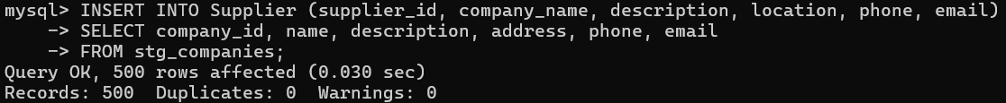

6.3 Load Material table — 458 rows
Purpose: Map material data from stg_materials into the Material production table
INSERT INTO Material (material_id, name, unit, unit_price, price_stdev, no_samples)
SELECT material_id, Item, Unit, PriceAvg, PriceStdev, NoSamples
FROM stg_materials;
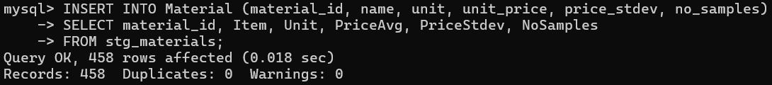

6.4 Load PurchaseOrder table
Purpose: Map transaction records from stg_transactions into the PurchaseOrder production table
INSERT INTO PurchaseOrder (po_id, project_id, supplier_id, user_id, total_amount, transaction_date, notes, status)
SELECT t.transaction_id, 'P001', t.company_id, 'U001',
t.total_price, t.transaction_date, t.notes, 'fulfilled'
FROM stg_transactions t;

6.5 Load PO_Item table
Purpose: Map transaction line items from stg_transactions into the PO_Item production table
INSERT INTO PO_Item (po_item_id, po_id, material_id, quantity, unit_price, discount_rate, subtotal)
SELECT t.transaction_id, t.transaction_id, t.material_id,
t.quantity, t.price_per_unit, t.discount_rate, t.total_price
FROM stg_transactions t;

6.6 Remove labor-related records from production tables
Purpose: Delete PO_Item and PurchaseOrder rows linked to labor/machine materials, then remove those materials from the Material table
-- Remove PO_Item rows linked to labor/machine materials
DELETE FROM PO_Item
WHERE material_id IN (SELECT material_id FROM stg_labor);

-- Remove PurchaseOrder rows that no longer have any PO_Item
DELETE FROM PurchaseOrder
WHERE po_id NOT IN (SELECT po_item_id FROM PO_Item);

-- Remove labor/machine records from Material table
DELETE FROM Material WHERE unit IN ('Day', 'Hour');
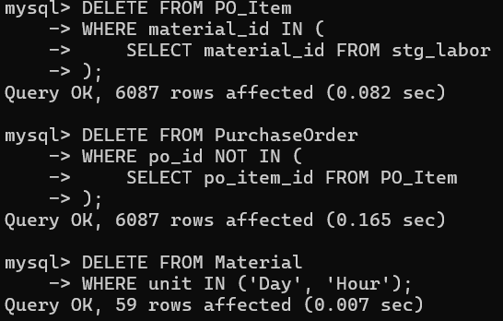

7. Data Verification
Final verification queries confirm that all data was loaded correctly and that the production tables are consistent.

7.1 Final row counts
Purpose: Confirm the final row count for all production tables
SELECT 'Supplier' AS TableName, COUNT(*) AS Count FROM Supplier
UNION ALL SELECT 'Material', COUNT(*) FROM Material
UNION ALL SELECT 'PurchaseOrder', COUNT(*) FROM PurchaseOrder
UNION ALL SELECT 'PO_Item', COUNT(*) FROM PO_Item;
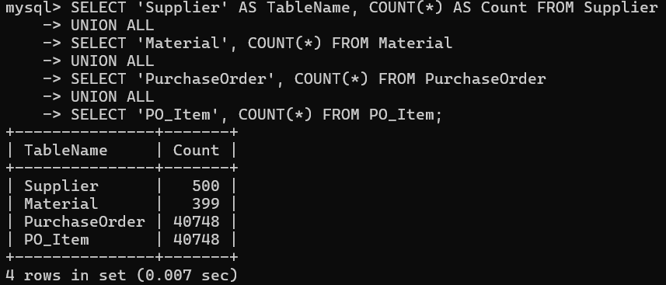
Table | Final Row Count | Notes
Supplier | 500 | All company records loaded
Material | 399 | 458 loaded, 59 labor/machine records removed
PurchaseOrder | 40,748 | 51,947 raw → cleaned → removed labor-related POs
PO_Item | 40,748 | Matches PurchaseOrder count

7.2 Top 5 suppliers by total transaction amount
Purpose: Verify that the JOIN between Supplier and PurchaseOrder works correctly
SELECT s.company_name, COUNT(po.po_id) AS total_orders,
ROUND(SUM(po.total_amount), 2) AS total_amount
FROM PurchaseOrder po
JOIN Supplier s ON po.supplier_id = s.supplier_id
GROUP BY s.company_name
ORDER BY total_amount DESC LIMIT 5;
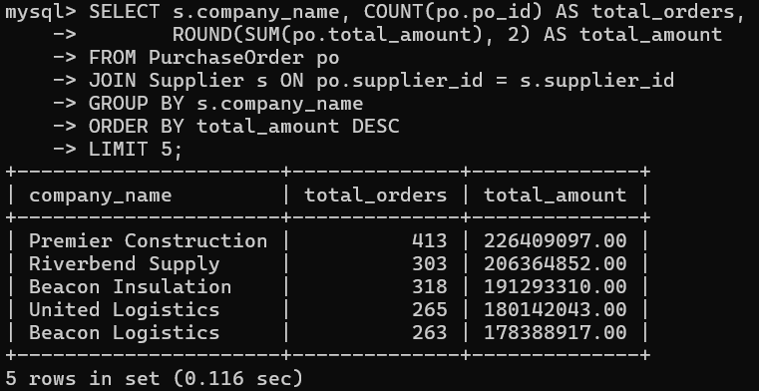

7.3 Top 5 most frequently ordered materials
Purpose: Verify that the JOIN between Material and PO_Item works correctly
SELECT m.name, COUNT(pi.po_item_id) AS times_ordered,
ROUND(SUM(pi.subtotal), 2) AS total_revenue
FROM PO_Item pi
JOIN Material m ON pi.material_id = m.material_id
GROUP BY m.name
ORDER BY times_ordered DESC LIMIT 5;
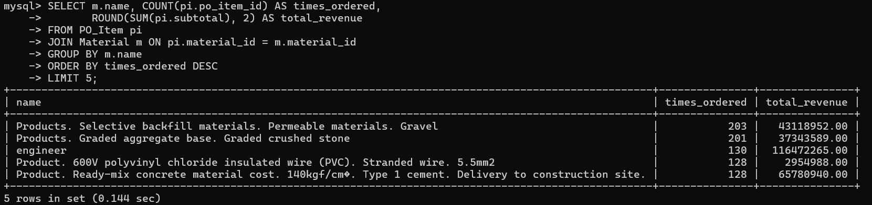

8. Error Summary
The following table summarizes all data errors identified and resolved during the ETL process.

# | Error Type | Count | Action Taken
1 | transactions with company_id not found in companies | 2,615 rows | Deleted
2 | transactions with material_id not found in materials | 2,497 rows | Deleted
3 | total_price calculation errors (rounding discrepancy) | 17,545 rows | Updated with correct formula
4 | Labor/machine records mixed into materials data | 59 rows | Moved to stg_labor and deleted

Raw data volume and cleaning results:
• Raw transactions loaded: 51,947 rows
• Deleted (invalid company_id): -2,615 rows
• Deleted (invalid material_id): -2,497 rows
• Updated (total_price corrected): 17,545 rows
• Valid transactions after cleaning: 46,835 rows
• Final PurchaseOrder (after removing labor-related): 40,748 rows

