Bài phát triển phần mềm hướng đối tượng buổi 8
Họ và tên: Trần Trọng Hiếu
Lớp: 11CNPM2
MSSV: 1150080093

Bài thực hành 1:
Tạo bảng cơ sở dữ liệu bằng code:
Create database QuanLyBanSach
go
use quanlybansach
CREATE TABLE NhaXuatBan (
MaNXB CHAR(10) PRIMARY KEY,
TenNXB NVARCHAR(100) NOT NULL,
DiaChi NVARCHAR(500)
);

CREATE TABLE Sach (
MaSach CHAR(10) PRIMARY KEY,
TenSach NVARCHAR(300) NOT NULL,
MaNXB CHAR(10) NOT NULL,
TenTacGia NVARCHAR(100),
NamXuatBan DATETIME,
GhiChu NVARCHAR(500),
FOREIGN KEY (MaNXB) REFERENCES NhaXuatBan(MaNXB)
);
Thêm dữ liệu bằng code:
insert into NhaXuatBan
values ('001', N'Học viện X-men', N'Quang Trung, Hà Nội')
insert into NhaXuatBan
values ('002', N'Khoa học xã hội', N'Trần Phú, Hà Nội')
insert into NhaXuatBan
values ('003', N'Viện văn hóa thể thao', N'Hai Bà Trưng, Hà Nội')
-- Them du lieu cho bang Sach
insert into Sach
values ('1', N'Học lập trình C ', '001', 'N Nguyễn Lưu', COnVERT(datetime,
'2022'), 'Khg')
insert into Sach
values ('2', N'Lập trình ASfl. ET core', '002', N'Trọng Khải', COnVERT(datetime,
'2019'), 'Khg')
insert into Sach
values ('3', N'Lập trình Scratch', '002', N'Bá Trọng', COnVERT(datetime, '2022'),
'Khg')
Code FormHienThi.cs:
namespace BaiBuoi8
{
partial class Form1
{
private System.ComponentModel.IContainer components = null;
private System.Windows.Forms.ListView lsvNXB;
private System.Windows.Forms.ColumnHeader colMaNXB;
private System.Windows.Forms.ColumnHeader colTenNXB;
private System.Windows.Forms.ColumnHeader colDiaChi;
private System.Windows.Forms.GroupBox groupDanhSach;
private System.Windows.Forms.GroupBox groupNhapLieu;
private System.Windows.Forms.Label lblMaNXB;
private System.Windows.Forms.Label lblTenNXB;
private System.Windows.Forms.Label lblDiaChi;
private System.Windows.Forms.TextBox txtMaNXB;
private System.Windows.Forms.TextBox txtTenNXB;
private System.Windows.Forms.TextBox txtDiaChi;
private System.Windows.Forms.Button btnThem;
private System.Windows.Forms.Label lblTitle;

protected override void Dispose(bool disposing)
{
if (disposing && (components != null))
components.Dispose();
base.Dispose(disposing);
}

private void InitializeComponent()
{
this.lsvNXB = new System.Windows.Forms.ListView();
this.colMaNXB = new System.Windows.Forms.ColumnHeader();
this.colTenNXB = new System.Windows.Forms.ColumnHeader();
this.colDiaChi = new System.Windows.Forms.ColumnHeader();
this.groupDanhSach = new System.Windows.Forms.GroupBox();
this.groupNhapLieu = new System.Windows.Forms.GroupBox();
this.lblMaNXB = new System.Windows.Forms.Label();
this.lblTenNXB = new System.Windows.Forms.Label();
this.lblDiaChi = new System.Windows.Forms.Label();
this.txtMaNXB = new System.Windows.Forms.TextBox();
this.txtTenNXB = new System.Windows.Forms.TextBox();
this.txtDiaChi = new System.Windows.Forms.TextBox();
this.btnThem = new System.Windows.Forms.Button();
this.lblTitle = new System.Windows.Forms.Label();
this.groupDanhSach.SuspendLayout();
this.groupNhapLieu.SuspendLayout();
this.SuspendLayout();
//
// groupDanhSach
//
this.groupDanhSach.Controls.Add(this.lsvNXB);
this.groupDanhSach.Location = new System.Drawing.Point(12, 50);
this.groupDanhSach.Name = "groupDanhSach";
this.groupDanhSach.Size = new System.Drawing.Size(360, 250);
this.groupDanhSach.TabIndex = 0;
this.groupDanhSach.TabStop = false;
this.groupDanhSach.Text = "Danh sách nhà xuất bản";
//
// lsvNXB
//
this.lsvNXB.Columns.AddRange(new System.Windows.Forms.ColumnHeader[] {
this.colMaNXB,
this.colTenNXB,
this.colDiaChi});
this.lsvNXB.FullRowSelect = true;
this.lsvNXB.GridLines = true;
this.lsvNXB.Location = new System.Drawing.Point(10, 25);
this.lsvNXB.Name = "lsvNXB";
this.lsvNXB.Size = new System.Drawing.Size(340, 210);
this.lsvNXB.TabIndex = 0;
this.lsvNXB.UseCompatibleStateImageBehavior = false;
this.lsvNXB.View = System.Windows.Forms.View.Details;
//
// colMaNXB
//
this.colMaNXB.Text = "Mã NXB";
this.colMaNXB.Width = 80;
//
// colTenNXB
//
this.colTenNXB.Text = "Tên NXB";
this.colTenNXB.Width = 120;
//
// colDiaChi
//
this.colDiaChi.Text = "Địa chỉ";
this.colDiaChi.Width = 130;
//
// groupNhapLieu
//
this.groupNhapLieu.Controls.Add(this.lblMaNXB);
this.groupNhapLieu.Controls.Add(this.txtMaNXB);
this.groupNhapLieu.Controls.Add(this.lblTenNXB);
this.groupNhapLieu.Controls.Add(this.txtTenNXB);
this.groupNhapLieu.Controls.Add(this.lblDiaChi);
this.groupNhapLieu.Controls.Add(this.txtDiaChi);
this.groupNhapLieu.Controls.Add(this.btnThem);
this.groupNhapLieu.Location = new System.Drawing.Point(390, 50);
this.groupNhapLieu.Name = "groupNhapLieu";
this.groupNhapLieu.Size = new System.Drawing.Size(240, 250);
this.groupNhapLieu.TabIndex = 1;
this.groupNhapLieu.TabStop = false;
this.groupNhapLieu.Text = "Thông tin nhập liệu";
//
// lblMaNXB
//
this.lblMaNXB.AutoSize = true;
this.lblMaNXB.Location = new System.Drawing.Point(15, 35);
this.lblMaNXB.Name = "lblMaNXB";
this.lblMaNXB.Size = new System.Drawing.Size(52, 15);
this.lblMaNXB.Text = "Mã NXB:";
//
// lblTenNXB
//
this.lblTenNXB.AutoSize = true;
this.lblTenNXB.Location = new System.Drawing.Point(15, 75);
this.lblTenNXB.Name = "lblTenNXB";
this.lblTenNXB.Size = new System.Drawing.Size(57, 15);
this.lblTenNXB.Text = "Tên NXB:";
//
// lblDiaChi
//
this.lblDiaChi.AutoSize = true;
this.lblDiaChi.Location = new System.Drawing.Point(15, 115);
this.lblDiaChi.Name = "lblDiaChi";
this.lblDiaChi.Size = new System.Drawing.Size(49, 15);
this.lblDiaChi.Text = "Địa chỉ:";
//
// txtMaNXB
//
this.txtMaNXB.Location = new System.Drawing.Point(80, 32);
this.txtMaNXB.Size = new System.Drawing.Size(140, 23);
//
// txtTenNXB
//
this.txtTenNXB.Location = new System.Drawing.Point(80, 72);
this.txtTenNXB.Size = new System.Drawing.Size(140, 23);
//
// txtDiaChi
//
this.txtDiaChi.Location = new System.Drawing.Point(80, 112);
this.txtDiaChi.Size = new System.Drawing.Size(140, 23);
//
// btnThem
//
this.btnThem.BackColor = System.Drawing.Color.Honeydew;
this.btnThem.Location = new System.Drawing.Point(40, 170);
this.btnThem.Size = new System.Drawing.Size(160, 40);
this.btnThem.Text = "Thêm nhà xuất bản";
this.btnThem.Click += new System.EventHandler(this.btnThem_Click);
//
// lblTitle
//
this.lblTitle.AutoSize = true;
this.lblTitle.Font = new System.Drawing.Font("Segoe UI", 14F, System.Drawing.FontStyle.Bold);
this.lblTitle.Location = new System.Drawing.Point(230, 10);
this.lblTitle.Text = "Thêm dữ liệu";
//
// Form1
//
this.ClientSize = new System.Drawing.Size(650, 320);
this.Controls.Add(this.groupDanhSach);
this.Controls.Add(this.groupNhapLieu);
this.Controls.Add(this.lblTitle);
this.Text = "Thêm nhà xuất bản: Trần Trọng Hiếu - 1150080093";
this.Load += new System.EventHandler(this.Form1_Load);
this.groupDanhSach.ResumeLayout(false);
this.groupNhapLieu.ResumeLayout(false);
this.groupNhapLieu.PerformLayout();
this.ResumeLayout(false);
this.PerformLayout();
}
}
}

Code FormHienThi.Designer.cs:
using System;
using System.Data;
using System.Data.SqlClient;
using System.Windows.Forms;

namespace BaiBuoi8
{
public partial class Form1 : Form
{
// 🔗 Chuỗi kết nối — chỉnh lại đúng đường dẫn mdf của bạn
//private string strCon = @"Data Source=LAPTOP-5P15D2CV\MSSQLSERVER01;AttachDbFilename=D:\QuanLyBanSach.mdf;Integrated Security=True";
private string strCon = @"Data Source=LAPTOP-5P15D2CV\MSSQLSERVER01;Initial Catalog=QuanLyBanSach;Integrated Security=True;";
private SqlConnection sqlCon = null;

public Form1()
{
InitializeComponent();
}

// Mở kết nối
private void MoKetNoi()
{
if (sqlCon == null)
sqlCon = new SqlConnection(strCon);

if (sqlCon.State == ConnectionState.Closed)
sqlCon.Open();
}

// Đóng kết nối
private void DongKetNoi()
{
if (sqlCon != null && sqlCon.State == ConnectionState.Open)
sqlCon.Close();
}

// Hiển thị danh sách nhà xuất bản bằng sp_HienThiNXB
private void HienThiNXB()
{
try
{
MoKetNoi();

using (SqlCommand cmd = new SqlCommand("HienThiNXB", sqlCon))
{
cmd.CommandType = CommandType.StoredProcedure;

SqlDataReader reader = cmd.ExecuteReader();
lsvNXB.Items.Clear();

while (reader.Read())
{
string ma = reader["MaNXB"].ToString();
string ten = reader["TenNXB"].ToString();
string diaChi = reader["DiaChi"].ToString();

ListViewItem lvi = new ListViewItem(ma);
lvi.SubItems.Add(ten);
lvi.SubItems.Add(diaChi);
lsvNXB.Items.Add(lvi);
}

reader.Close();
}
}
catch (Exception ex)
{
MessageBox.Show("Lỗi khi hiển thị NXB: " + ex.Message);
}
finally
{
DongKetNoi();
}
}

private void Form1_Load(object sender, EventArgs e)
{
HienThiNXB();
}

// Gọi SP sp_ThemDuLieu
private void btnThem_Click(object sender, EventArgs e)
{
if (string.IsNullOrWhiteSpace(txtMaNXB.Text) ||
string.IsNullOrWhiteSpace(txtTenNXB.Text))
{
MessageBox.Show("Vui lòng nhập đủ thông tin Mã và Tên NXB!");
return;
}

try
{
MoKetNoi();

using (SqlCommand cmd = new SqlCommand("ThemDuLieu", sqlCon))
{
cmd.CommandType = CommandType.StoredProcedure;
cmd.Parameters.AddWithValue("@maNXB", txtMaNXB.Text.Trim());
cmd.Parameters.AddWithValue("@tenNXB", txtTenNXB.Text.Trim());
cmd.Parameters.AddWithValue("@diaChi", txtDiaChi.Text.Trim());

int kq = cmd.ExecuteNonQuery();

if (kq > 0)
{
MessageBox.Show("Đã thêm thành công!");
HienThiNXB();
txtMaNXB.Clear();
txtTenNXB.Clear();
txtDiaChi.Clear();
txtMaNXB.Focus();
}
else
{
MessageBox.Show("Không có dữ liệu nào được thêm (SP có thể đã kiểm tra trùng).");
}
}
}
catch (Exception ex)
{
MessageBox.Show("Lỗi khi thêm dữ liệu: " + ex.Message);
}
finally
{
DongKetNoi();
}
}
}
}

Kết quả:
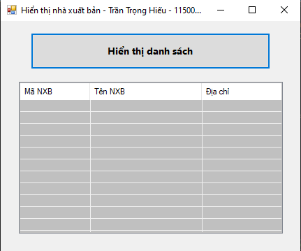
Bài thực hành 2:
Code stored procedure T-sql:
create proc ThemDuLieu
@maNXB char(10),
@tenNXB nvarchar(100),
@diaChi nvarchar(500)
as
begin
insert into NhaXuatBan
values (@maNXB, @tenNXB, @diaChi)
end
Code Form1.cs:
using System;
using System.Data;
using System.Data.SqlClient;
using System.Windows.Forms;

namespace BaiBuoi8
{
public partial class Form1 : Form
{
// 🔗 Chuỗi kết nối — chỉnh lại đúng đường dẫn mdf của bạn
//private string strCon = @"Data Source=LAPTOP-5P15D2CV\MSSQLSERVER01;AttachDbFilename=D:\QuanLyBanSach.mdf;Integrated Security=True";
private string strCon = @"Data Source=LAPTOP-5P15D2CV\MSSQLSERVER01;Initial Catalog=QuanLyBanSach;Integrated Security=True;";
private SqlConnection sqlCon = null;

public Form1()
{
InitializeComponent();
}

// Mở kết nối
private void MoKetNoi()
{
if (sqlCon == null)
sqlCon = new SqlConnection(strCon);

if (sqlCon.State == ConnectionState.Closed)
sqlCon.Open();
}

// Đóng kết nối
private void DongKetNoi()
{
if (sqlCon != null && sqlCon.State == ConnectionState.Open)
sqlCon.Close();
}

// Hiển thị danh sách nhà xuất bản bằng sp_HienThiNXB
private void HienThiNXB()
{
try
{
MoKetNoi();

using (SqlCommand cmd = new SqlCommand("HienThiNXB", sqlCon))
{
cmd.CommandType = CommandType.StoredProcedure;

SqlDataReader reader = cmd.ExecuteReader();
lsvNXB.Items.Clear();

while (reader.Read())
{
string ma = reader["MaNXB"].ToString();
string ten = reader["TenNXB"].ToString();
string diaChi = reader["DiaChi"].ToString();

ListViewItem lvi = new ListViewItem(ma);
lvi.SubItems.Add(ten);
lvi.SubItems.Add(diaChi);
lsvNXB.Items.Add(lvi);
}

reader.Close();
}
}
catch (Exception ex)
{
MessageBox.Show("Lỗi khi hiển thị NXB: " + ex.Message);
}
finally
{
DongKetNoi();
}
}

private void Form1_Load(object sender, EventArgs e)
{
HienThiNXB();
}

// Gọi SP sp_ThemDuLieu
private void btnThem_Click(object sender, EventArgs e)
{
if (string.IsNullOrWhiteSpace(txtMaNXB.Text) ||
string.IsNullOrWhiteSpace(txtTenNXB.Text))
{
MessageBox.Show("Vui lòng nhập đủ thông tin Mã và Tên NXB!");
return;
}

try
{
MoKetNoi();

using (SqlCommand cmd = new SqlCommand("ThemDuLieu", sqlCon))
{
cmd.CommandType = CommandType.StoredProcedure;
cmd.Parameters.AddWithValue("@maNXB", txtMaNXB.Text.Trim());
cmd.Parameters.AddWithValue("@tenNXB", txtTenNXB.Text.Trim());
cmd.Parameters.AddWithValue("@diaChi", txtDiaChi.Text.Trim());

int kq = cmd.ExecuteNonQuery();

if (kq > 0)
{
MessageBox.Show("Đã thêm thành công!");
HienThiNXB();
txtMaNXB.Clear();
txtTenNXB.Clear();
txtDiaChi.Clear();
txtMaNXB.Focus();
}
else
{
MessageBox.Show("Không có dữ liệu nào được thêm (SP có thể đã kiểm tra trùng).");
}
}
}
catch (Exception ex)
{
MessageBox.Show("Lỗi khi thêm dữ liệu: " + ex.Message);
}
finally
{
DongKetNoi();
}
}
}
}

Code Form1.Designer.cs:
namespace BaiBuoi8
{
partial class Form1
{
private System.ComponentModel.IContainer components = null;
private System.Windows.Forms.ListView lsvNXB;
private System.Windows.Forms.ColumnHeader colMaNXB;
private System.Windows.Forms.ColumnHeader colTenNXB;
private System.Windows.Forms.ColumnHeader colDiaChi;
private System.Windows.Forms.GroupBox groupDanhSach;
private System.Windows.Forms.GroupBox groupNhapLieu;
private System.Windows.Forms.Label lblMaNXB;
private System.Windows.Forms.Label lblTenNXB;
private System.Windows.Forms.Label lblDiaChi;
private System.Windows.Forms.TextBox txtMaNXB;
private System.Windows.Forms.TextBox txtTenNXB;
private System.Windows.Forms.TextBox txtDiaChi;
private System.Windows.Forms.Button btnThem;
private System.Windows.Forms.Label lblTitle;

protected override void Dispose(bool disposing)
{
if (disposing && (components != null))
components.Dispose();
base.Dispose(disposing);
}

private void InitializeComponent()
{
this.lsvNXB = new System.Windows.Forms.ListView();
this.colMaNXB = new System.Windows.Forms.ColumnHeader();
this.colTenNXB = new System.Windows.Forms.ColumnHeader();
this.colDiaChi = new System.Windows.Forms.ColumnHeader();
this.groupDanhSach = new System.Windows.Forms.GroupBox();
this.groupNhapLieu = new System.Windows.Forms.GroupBox();
this.lblMaNXB = new System.Windows.Forms.Label();
this.lblTenNXB = new System.Windows.Forms.Label();
this.lblDiaChi = new System.Windows.Forms.Label();
this.txtMaNXB = new System.Windows.Forms.TextBox();
this.txtTenNXB = new System.Windows.Forms.TextBox();
this.txtDiaChi = new System.Windows.Forms.TextBox();
this.btnThem = new System.Windows.Forms.Button();
this.lblTitle = new System.Windows.Forms.Label();
this.groupDanhSach.SuspendLayout();
this.groupNhapLieu.SuspendLayout();
this.SuspendLayout();
//
// groupDanhSach
//
this.groupDanhSach.Controls.Add(this.lsvNXB);
this.groupDanhSach.Location = new System.Drawing.Point(12, 50);
this.groupDanhSach.Name = "groupDanhSach";
this.groupDanhSach.Size = new System.Drawing.Size(360, 250);
this.groupDanhSach.TabIndex = 0;
this.groupDanhSach.TabStop = false;
this.groupDanhSach.Text = "Danh sách nhà xuất bản";
//
// lsvNXB
//
this.lsvNXB.Columns.AddRange(new System.Windows.Forms.ColumnHeader[] {
this.colMaNXB,
this.colTenNXB,
this.colDiaChi});
this.lsvNXB.FullRowSelect = true;
this.lsvNXB.GridLines = true;
this.lsvNXB.Location = new System.Drawing.Point(10, 25);
this.lsvNXB.Name = "lsvNXB";
this.lsvNXB.Size = new System.Drawing.Size(340, 210);
this.lsvNXB.TabIndex = 0;
this.lsvNXB.UseCompatibleStateImageBehavior = false;
this.lsvNXB.View = System.Windows.Forms.View.Details;
//
// colMaNXB
//
this.colMaNXB.Text = "Mã NXB";
this.colMaNXB.Width = 80;
//
// colTenNXB
//
this.colTenNXB.Text = "Tên NXB";
this.colTenNXB.Width = 120;
//
// colDiaChi
//
this.colDiaChi.Text = "Địa chỉ";
this.colDiaChi.Width = 130;
//
// groupNhapLieu
//
this.groupNhapLieu.Controls.Add(this.lblMaNXB);
this.groupNhapLieu.Controls.Add(this.txtMaNXB);
this.groupNhapLieu.Controls.Add(this.lblTenNXB);
this.groupNhapLieu.Controls.Add(this.txtTenNXB);
this.groupNhapLieu.Controls.Add(this.lblDiaChi);
this.groupNhapLieu.Controls.Add(this.txtDiaChi);
this.groupNhapLieu.Controls.Add(this.btnThem);
this.groupNhapLieu.Location = new System.Drawing.Point(390, 50);
this.groupNhapLieu.Name = "groupNhapLieu";
this.groupNhapLieu.Size = new System.Drawing.Size(240, 250);
this.groupNhapLieu.TabIndex = 1;
this.groupNhapLieu.TabStop = false;
this.groupNhapLieu.Text = "Thông tin nhập liệu";
//
// lblMaNXB
//
this.lblMaNXB.AutoSize = true;
this.lblMaNXB.Location = new System.Drawing.Point(15, 35);
this.lblMaNXB.Name = "lblMaNXB";
this.lblMaNXB.Size = new System.Drawing.Size(52, 15);
this.lblMaNXB.Text = "Mã NXB:";
//
// lblTenNXB
//
this.lblTenNXB.AutoSize = true;
this.lblTenNXB.Location = new System.Drawing.Point(15, 75);
this.lblTenNXB.Name = "lblTenNXB";
this.lblTenNXB.Size = new System.Drawing.Size(57, 15);
this.lblTenNXB.Text = "Tên NXB:";
//
// lblDiaChi
//
this.lblDiaChi.AutoSize = true;
this.lblDiaChi.Location = new System.Drawing.Point(15, 115);
this.lblDiaChi.Name = "lblDiaChi";
this.lblDiaChi.Size = new System.Drawing.Size(49, 15);
this.lblDiaChi.Text = "Địa chỉ:";
//
// txtMaNXB
//
this.txtMaNXB.Location = new System.Drawing.Point(80, 32);
this.txtMaNXB.Size = new System.Drawing.Size(140, 23);
//
// txtTenNXB
//
this.txtTenNXB.Location = new System.Drawing.Point(80, 72);
this.txtTenNXB.Size = new System.Drawing.Size(140, 23);
//
// txtDiaChi
//
this.txtDiaChi.Location = new System.Drawing.Point(80, 112);
this.txtDiaChi.Size = new System.Drawing.Size(140, 23);
//
// btnThem
//
this.btnThem.BackColor = System.Drawing.Color.Honeydew;
this.btnThem.Location = new System.Drawing.Point(40, 170);
this.btnThem.Size = new System.Drawing.Size(160, 40);
this.btnThem.Text = "Thêm nhà xuất bản";
this.btnThem.Click += new System.EventHandler(this.btnThem_Click);
//
// lblTitle
//
this.lblTitle.AutoSize = true;
this.lblTitle.Font = new System.Drawing.Font("Segoe UI", 14F, System.Drawing.FontStyle.Bold);
this.lblTitle.Location = new System.Drawing.Point(230, 10);
this.lblTitle.Text = "Thêm dữ liệu";
//
// Form1
//
this.ClientSize = new System.Drawing.Size(650, 320);
this.Controls.Add(this.groupDanhSach);
this.Controls.Add(this.groupNhapLieu);
this.Controls.Add(this.lblTitle);
this.Text = "Thêm nhà xuất bản: Trần Trọng Hiếu - 1150080093";
this.Load += new System.EventHandler(this.Form1_Load);
this.groupDanhSach.ResumeLayout(false);
this.groupNhapLieu.ResumeLayout(false);
this.groupNhapLieu.PerformLayout();
this.ResumeLayout(false);
this.PerformLayout();
}
}
}

Kết quả:
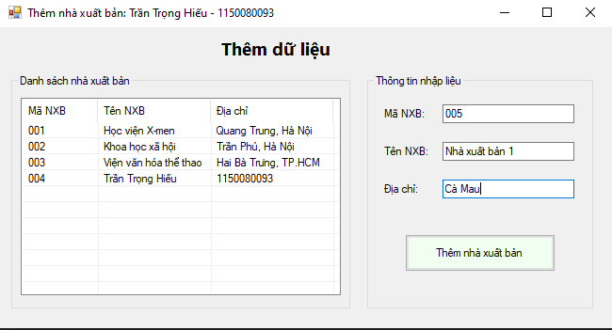
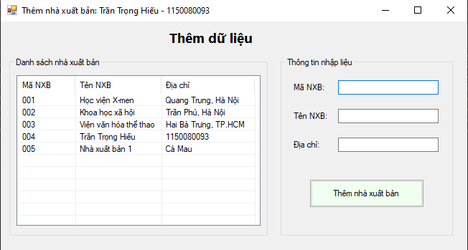
Bài thực hành 3:
Code stored procedure T-sql:
create proc CapNhatThongTin
@maNXB char(10),
@tenNXB nvarchar(100),
@diaChi nvarchar (500)
as
begin update NhaXuatBan
set
MaNXB=@maNXB,
TenNXB = @tenNXB,
DiaChi = @diaChi
where MaNXB = @maNXB
end
Code FormUpdate.cs:
using System;
using System.Data;
using System.Data.SqlClient;
using System.Windows.Forms;

namespace BaiBuoi8
{
public partial class FormUpdate : Form
{
//private string strCon = @"Data Source=(LocalDB)\MSSQLLocalDB;AttachDbFilename=D:\QuanLyBanSach.mdf;Integrated Security=True";
private string strCon = @"Data Source=LAPTOP-5P15D2CV\MSSQLSERVER01;Initial Catalog=QuanLyBanSach;Integrated Security=True;";
private SqlConnection sqlCon = null;

public FormUpdate()
{
InitializeComponent();
}

private void MoKetNoi()
{
if (sqlCon == null)
sqlCon = new SqlConnection(strCon);
if (sqlCon.State == ConnectionState.Closed)
sqlCon.Open();
}

private void DongKetNoi()
{
if (sqlCon != null && sqlCon.State == ConnectionState.Open)
sqlCon.Close();
}

// Hiển thị danh sách NXB bằng stored procedure sp_HienThiNXB
private void HienThiNXB()
{
try
{
MoKetNoi();
using (SqlCommand cmd = new SqlCommand("HienThiNXB", sqlCon))
{
cmd.CommandType = CommandType.StoredProcedure;
SqlDataReader reader = cmd.ExecuteReader();

lsvNXB.Items.Clear();
while (reader.Read())
{
string ma = reader["MaNXB"].ToString();
string ten = reader["TenNXB"].ToString();
string diaChi = reader["DiaChi"].ToString();

ListViewItem lvi = new ListViewItem(ma);
lvi.SubItems.Add(ten);
lvi.SubItems.Add(diaChi);
lsvNXB.Items.Add(lvi);
}
reader.Close();
}
}
catch (Exception ex)
{
MessageBox.Show("Lỗi khi hiển thị NXB: " + ex.Message);
}
finally
{
DongKetNoi();
}
}

// Khi form load, hiển thị danh sách
private void FormUpdate_Load(object sender, EventArgs e)
{
HienThiNXB();
}

// Khi chọn 1 dòng trong ListView, hiển thị thông tin sang textbox
private void lsvNXB_SelectedIndexChanged(object sender, EventArgs e)
{
if (lsvNXB.SelectedItems.Count == 0) return;

ListViewItem lvi = lsvNXB.SelectedItems[0];
txtMaNXB.Text = lvi.SubItems[0].Text;
txtTenNXB.Text = lvi.SubItems[1].Text;
txtDiaChi.Text = lvi.SubItems[2].Text;
}

// Gọi stored procedure sp_SuaDuLieu để cập nhật
private void btnCapNhat_Click(object sender, EventArgs e)
{
if (txtMaNXB.Text.Trim() == "")
{
MessageBox.Show("Vui lòng chọn nhà xuất bản cần cập nhật!");
return;
}

try
{
MoKetNoi();

using (SqlCommand cmd = new SqlCommand("CapNhatThongTin", sqlCon))
{
cmd.CommandType = CommandType.StoredProcedure;
cmd.Parameters.AddWithValue("@maNXB", txtMaNXB.Text.Trim());
cmd.Parameters.AddWithValue("@tenNXB", txtTenNXB.Text.Trim());
cmd.Parameters.AddWithValue("@diaChi", txtDiaChi.Text.Trim());

int kq = cmd.ExecuteNonQuery();

if (kq > 0)
{
MessageBox.Show("Cập nhật thành công!");
HienThiNXB();
}
else
{
MessageBox.Show("Không có bản ghi nào được cập nhật!");
}
}
}
catch (Exception ex)
{
MessageBox.Show("Lỗi khi cập nhật: " + ex.Message);
}
finally
{
DongKetNoi();
}
}
}
}

Code FormUpdate.Designer.cs:
namespace BaiBuoi8
{
partial class FormUpdate
{
private System.ComponentModel.IContainer components = null;
private System.Windows.Forms.ListView lsvNXB;
private System.Windows.Forms.ColumnHeader colMaNXB;
private System.Windows.Forms.ColumnHeader colTenNXB;
private System.Windows.Forms.ColumnHeader colDiaChi;
private System.Windows.Forms.GroupBox groupDanhSach;
private System.Windows.Forms.GroupBox groupNhapLieu;
private System.Windows.Forms.Label lblMaNXB;
private System.Windows.Forms.Label lblTenNXB;
private System.Windows.Forms.Label lblDiaChi;
private System.Windows.Forms.TextBox txtMaNXB;
private System.Windows.Forms.TextBox txtTenNXB;
private System.Windows.Forms.TextBox txtDiaChi;
private System.Windows.Forms.Button btnCapNhat;
private System.Windows.Forms.Label lblTitle;

protected override void Dispose(bool disposing)
{
if (disposing && (components != null))
components.Dispose();
base.Dispose(disposing);
}

private void InitializeComponent()
{
this.lsvNXB = new System.Windows.Forms.ListView();
this.colMaNXB = new System.Windows.Forms.ColumnHeader();
this.colTenNXB = new System.Windows.Forms.ColumnHeader();
this.colDiaChi = new System.Windows.Forms.ColumnHeader();
this.groupDanhSach = new System.Windows.Forms.GroupBox();
this.groupNhapLieu = new System.Windows.Forms.GroupBox();
this.lblMaNXB = new System.Windows.Forms.Label();
this.lblTenNXB = new System.Windows.Forms.Label();
this.lblDiaChi = new System.Windows.Forms.Label();
this.txtMaNXB = new System.Windows.Forms.TextBox();
this.txtTenNXB = new System.Windows.Forms.TextBox();
this.txtDiaChi = new System.Windows.Forms.TextBox();
this.btnCapNhat = new System.Windows.Forms.Button();
this.lblTitle = new System.Windows.Forms.Label();
this.groupDanhSach.SuspendLayout();
this.groupNhapLieu.SuspendLayout();
this.SuspendLayout();
//
// groupDanhSach
//
this.groupDanhSach.Controls.Add(this.lsvNXB);
this.groupDanhSach.Location = new System.Drawing.Point(12, 50);
this.groupDanhSach.Name = "groupDanhSach";
this.groupDanhSach.Size = new System.Drawing.Size(360, 250);
this.groupDanhSach.Text = "Danh sách nhà xuất bản:";
//
// lsvNXB
//
this.lsvNXB.Columns.AddRange(new System.Windows.Forms.ColumnHeader[] {
this.colMaNXB,
this.colTenNXB,
this.colDiaChi});
this.lsvNXB.FullRowSelect = true;
this.lsvNXB.GridLines = true;
this.lsvNXB.Location = new System.Drawing.Point(10, 25);
this.lsvNXB.Name = "lsvNXB";
this.lsvNXB.Size = new System.Drawing.Size(340, 210);
this.lsvNXB.View = System.Windows.Forms.View.Details;
this.lsvNXB.SelectedIndexChanged += new System.EventHandler(this.lsvNXB_SelectedIndexChanged);
//
// colMaNXB
//
this.colMaNXB.Text = "Mã NXB";
this.colMaNXB.Width = 70;
//
// colTenNXB
//
this.colTenNXB.Text = "Tên NXB";
this.colTenNXB.Width = 120;
//
// colDiaChi
//
this.colDiaChi.Text = "Địa chỉ";
this.colDiaChi.Width = 140;
//
// groupNhapLieu
//
this.groupNhapLieu.Controls.Add(this.lblMaNXB);
this.groupNhapLieu.Controls.Add(this.txtMaNXB);
this.groupNhapLieu.Controls.Add(this.lblTenNXB);
this.groupNhapLieu.Controls.Add(this.txtTenNXB);
this.groupNhapLieu.Controls.Add(this.lblDiaChi);
this.groupNhapLieu.Controls.Add(this.txtDiaChi);
this.groupNhapLieu.Controls.Add(this.btnCapNhat);
this.groupNhapLieu.Location = new System.Drawing.Point(390, 50);
this.groupNhapLieu.Size = new System.Drawing.Size(240, 250);
this.groupNhapLieu.Text = "Thông tin nhập liệu:";
//
// lblMaNXB
//
this.lblMaNXB.AutoSize = true;
this.lblMaNXB.Location = new System.Drawing.Point(15, 35);
this.lblMaNXB.Text = "Mã NXB:";
//
// txtMaNXB
//
this.txtMaNXB.Location = new System.Drawing.Point(80, 32);
this.txtMaNXB.Size = new System.Drawing.Size(140, 23);
this.txtMaNXB.ReadOnly = true; // khóa lại vì không sửa mã
//
// lblTenNXB
//
this.lblTenNXB.AutoSize = true;
this.lblTenNXB.Location = new System.Drawing.Point(15, 75);
this.lblTenNXB.Text = "Tên NXB:";
//
// txtTenNXB
//
this.txtTenNXB.Location = new System.Drawing.Point(80, 72);
this.txtTenNXB.Size = new System.Drawing.Size(140, 23);
//
// lblDiaChi
//
this.lblDiaChi.AutoSize = true;
this.lblDiaChi.Location = new System.Drawing.Point(15, 115);
this.lblDiaChi.Text = "Địa chỉ:";
//
// txtDiaChi
//
this.txtDiaChi.Location = new System.Drawing.Point(80, 112);
this.txtDiaChi.Size = new System.Drawing.Size(140, 23);
//
// btnCapNhat
//
this.btnCapNhat.BackColor = System.Drawing.Color.Gainsboro;
this.btnCapNhat.Location = new System.Drawing.Point(40, 170);
this.btnCapNhat.Size = new System.Drawing.Size(160, 40);
this.btnCapNhat.Text = "Cập nhật thông tin";
this.btnCapNhat.Click += new System.EventHandler(this.btnCapNhat_Click);
//
// lblTitle
//
this.lblTitle.AutoSize = true;
this.lblTitle.Font = new System.Drawing.Font("Segoe UI", 14F, System.Drawing.FontStyle.Bold);
this.lblTitle.Location = new System.Drawing.Point(230, 10);
this.lblTitle.Text = "Cập nhật dữ liệu";
//
// FormUpdate
//
this.ClientSize = new System.Drawing.Size(650, 320);
this.Controls.Add(this.groupDanhSach);
this.Controls.Add(this.groupNhapLieu);
this.Controls.Add(this.lblTitle);
this.Text = "Cập nhật dữ liệu: Trần Trọng Hiếu - 1150080093";
this.Load += new System.EventHandler(this.FormUpdate_Load);
this.groupDanhSach.ResumeLayout(false);
this.groupNhapLieu.ResumeLayout(false);
this.groupNhapLieu.PerformLayout();
this.ResumeLayout(false);
this.PerformLayout();
}
}
}

Kết quả:
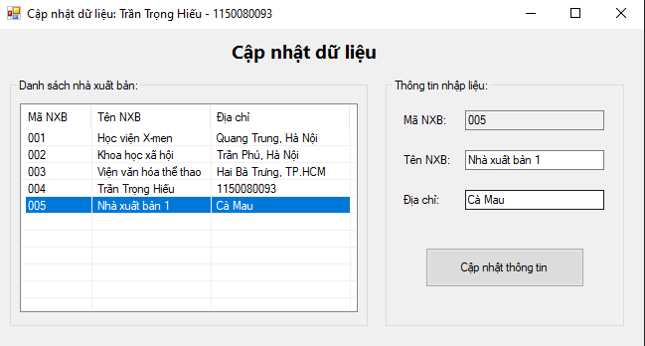
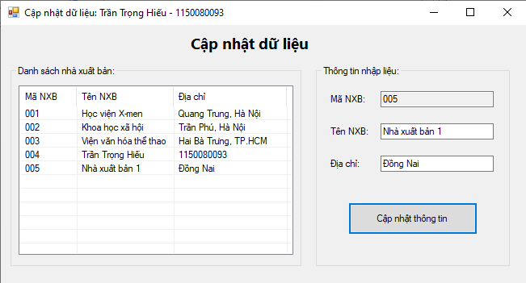
Bài thực hành 4:
Code stored procedure:
create proc XoaNXB
@maNXB char(10)
as
begin
delete from NhaXuatBan where MaNXB = @maNXB
end

Code FormDelete.cs:
using System;
using System.Data;
using System.Data.SqlClient;
using System.Windows.Forms;

namespace BaiBuoi8
{
public partial class FormDelete : Form
{
//private string strCon = @"Data Source=(LocalDB)\MSSQLLocalDB;AttachDbFilename=D:\QuanLyBanSach.mdf;Integrated Security=True";
private string strCon = @"Data Source=LAPTOP-5P15D2CV\MSSQLSERVER01;Initial Catalog=QuanLyBanSach;Integrated Security=True;";
private SqlConnection sqlCon = null;

public FormDelete()
{
InitializeComponent();
}

private void MoKetNoi()
{
if (sqlCon == null)
sqlCon = new SqlConnection(strCon);
if (sqlCon.State == ConnectionState.Closed)
sqlCon.Open();
}

private void DongKetNoi()
{
if (sqlCon != null && sqlCon.State == ConnectionState.Open)
sqlCon.Close();
}

// Hiển thị danh sách NXB từ SP
private void HienThiNXB()
{
try
{
MoKetNoi();

using (SqlCommand cmd = new SqlCommand("HienThiNXB", sqlCon))
{
cmd.CommandType = CommandType.StoredProcedure;
SqlDataReader reader = cmd.ExecuteReader();
lsvNXB.Items.Clear();

while (reader.Read())
{
string ma = reader["MaNXB"].ToString();
string ten = reader["TenNXB"].ToString();
string diaChi = reader["DiaChi"].ToString();

ListViewItem lvi = new ListViewItem(ma);
lvi.SubItems.Add(ten);
lvi.SubItems.Add(diaChi);
lsvNXB.Items.Add(lvi);
}

reader.Close();
}
}
catch (Exception ex)
{
MessageBox.Show("Lỗi khi hiển thị NXB: " + ex.Message);
}
finally
{
DongKetNoi();
}
}

private void FormDelete_Load(object sender, EventArgs e)
{
HienThiNXB();
}

// Khi chọn 1 dòng trong ListView, đánh dấu để xóa
private void lsvNXB_SelectedIndexChanged(object sender, EventArgs e)
{
if (lsvNXB.SelectedItems.Count == 0)
btnXoa.Enabled = false;
else
btnXoa.Enabled = true;
}

// Gọi stored procedure sp_XoaDuLieu
private void btnXoa_Click(object sender, EventArgs e)
{
if (lsvNXB.SelectedItems.Count == 0)
{
MessageBox.Show("Vui lòng chọn một nhà xuất bản để xóa!");
return;
}

string maNXB = lsvNXB.SelectedItems[0].SubItems[0].Text;

DialogResult result = MessageBox.Show(
$"Bạn có chắc chắn muốn xóa NXB '{maNXB}' không?",
"Xác nhận xóa", MessageBoxButtons.YesNo, MessageBoxIcon.Warning);

if (result == DialogResult.No)
return;

try
{
MoKetNoi();
using (SqlCommand cmd = new SqlCommand("XoaNXB", sqlCon))
{
cmd.CommandType = CommandType.StoredProcedure;
cmd.Parameters.AddWithValue("@maNXB", maNXB);

int kq = cmd.ExecuteNonQuery();
if (kq > 0)
{
MessageBox.Show("Xóa dữ liệu thành công!");
HienThiNXB();
}
else
{
MessageBox.Show("Không có bản ghi nào được xóa!");
}
}
}
catch (Exception ex)
{
MessageBox.Show("Lỗi khi xóa dữ liệu: " + ex.Message);
}
finally
{
DongKetNoi();
}
}
}
}

Code FormDelete.Designer.cs:
namespace BaiBuoi8
{
partial class FormDelete
{
private System.ComponentModel.IContainer components = null;
private System.Windows.Forms.ListView lsvNXB;
private System.Windows.Forms.ColumnHeader colMaNXB;
private System.Windows.Forms.ColumnHeader colTenNXB;
private System.Windows.Forms.ColumnHeader colDiaChi;
private System.Windows.Forms.GroupBox groupDanhSach;
private System.Windows.Forms.Button btnXoa;
private System.Windows.Forms.Label lblTitle;

protected override void Dispose(bool disposing)
{
if (disposing && (components != null))
components.Dispose();
base.Dispose(disposing);
}

private void InitializeComponent()
{
this.lsvNXB = new System.Windows.Forms.ListView();
this.colMaNXB = new System.Windows.Forms.ColumnHeader();
this.colTenNXB = new System.Windows.Forms.ColumnHeader();
this.colDiaChi = new System.Windows.Forms.ColumnHeader();
this.groupDanhSach = new System.Windows.Forms.GroupBox();
this.btnXoa = new System.Windows.Forms.Button();
this.lblTitle = new System.Windows.Forms.Label();
this.groupDanhSach.SuspendLayout();
this.SuspendLayout();
//
// groupDanhSach
//
this.groupDanhSach.Controls.Add(this.lsvNXB);
this.groupDanhSach.Location = new System.Drawing.Point(12, 50);
this.groupDanhSach.Name = "groupDanhSach";
this.groupDanhSach.Size = new System.Drawing.Size(610, 220);
this.groupDanhSach.Text = "Danh sách nhà xuất bản:";
//
// lsvNXB
//
this.lsvNXB.Columns.AddRange(new System.Windows.Forms.ColumnHeader[] {
this.colMaNXB,
this.colTenNXB,
this.colDiaChi});
this.lsvNXB.FullRowSelect = true;
this.lsvNXB.GridLines = true;
this.lsvNXB.Location = new System.Drawing.Point(10, 25);
this.lsvNXB.Name = "lsvNXB";
this.lsvNXB.Size = new System.Drawing.Size(590, 180);
this.lsvNXB.View = System.Windows.Forms.View.Details;
this.lsvNXB.SelectedIndexChanged += new System.EventHandler(this.lsvNXB_SelectedIndexChanged);
//
// colMaNXB
//
this.colMaNXB.Text = "Mã NXB";
this.colMaNXB.Width = 100;
//
// colTenNXB
//
this.colTenNXB.Text = "Tên NXB";
this.colTenNXB.Width = 200;
//
// colDiaChi
//
this.colDiaChi.Text = "Địa chỉ";
this.colDiaChi.Width = 250;
//
// btnXoa
//
this.btnXoa.BackColor = System.Drawing.Color.MistyRose;
this.btnXoa.Enabled = false;
this.btnXoa.Location = new System.Drawing.Point(230, 285);
this.btnXoa.Size = new System.Drawing.Size(180, 45);
this.btnXoa.Text = "Xóa dữ liệu";
this.btnXoa.Click += new System.EventHandler(this.btnXoa_Click);
//
// lblTitle
//
this.lblTitle.AutoSize = true;
this.lblTitle.Font = new System.Drawing.Font("Segoe UI", 14F, System.Drawing.FontStyle.Bold);
this.lblTitle.Location = new System.Drawing.Point(250, 10);
this.lblTitle.Text = "Xóa dữ liệu";
//
// FormDelete
//
this.ClientSize = new System.Drawing.Size(640, 350);
this.Controls.Add(this.groupDanhSach);
this.Controls.Add(this.btnXoa);
this.Controls.Add(this.lblTitle);
this.Name = "FormDelete";
this.Text = "Xóa dữ liệu: Trần Trọng Hiếu - 1150080093";
this.Load += new System.EventHandler(this.FormDelete_Load);
this.groupDanhSach.ResumeLayout(false);
this.ResumeLayout(false);
this.PerformLayout();
}
}
}

Kết quả:
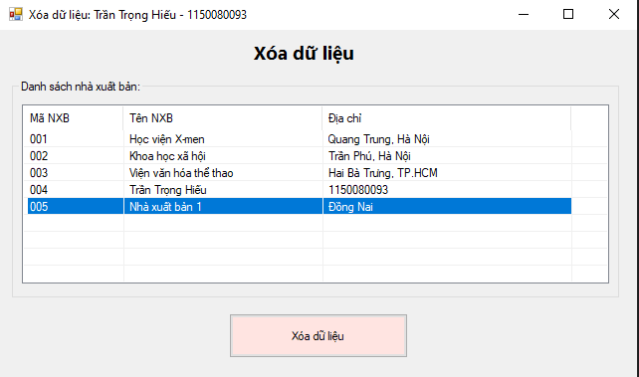
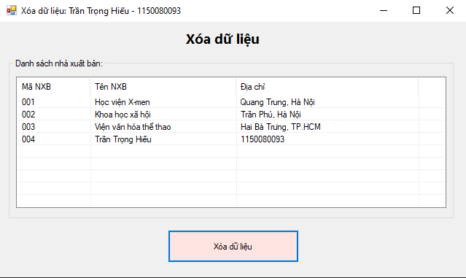

Form báo sinh viên:
