**Q1]**

1.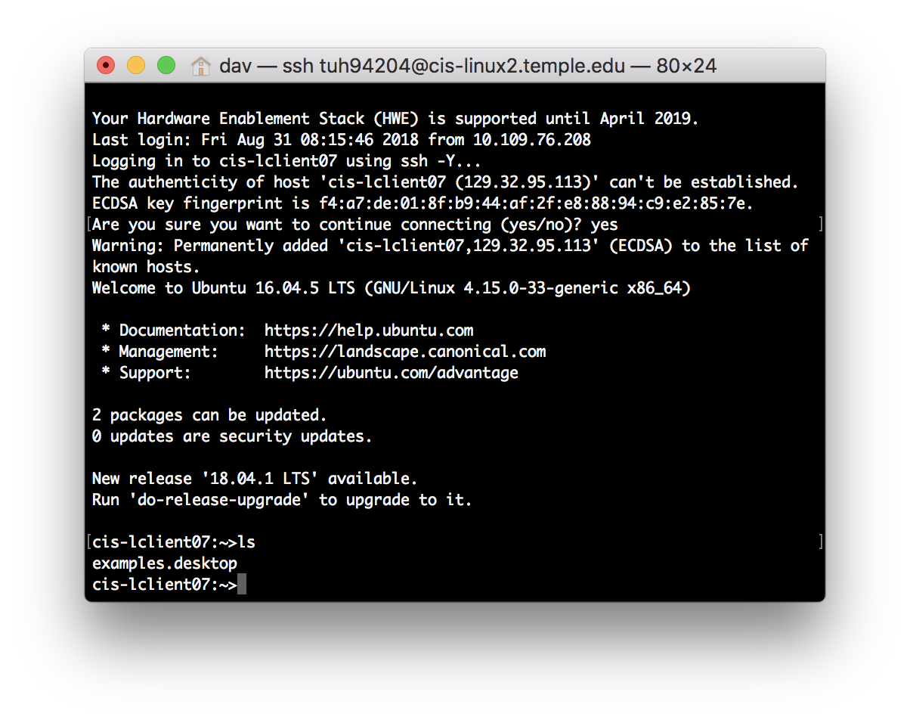

Shows the files in the current directory

2.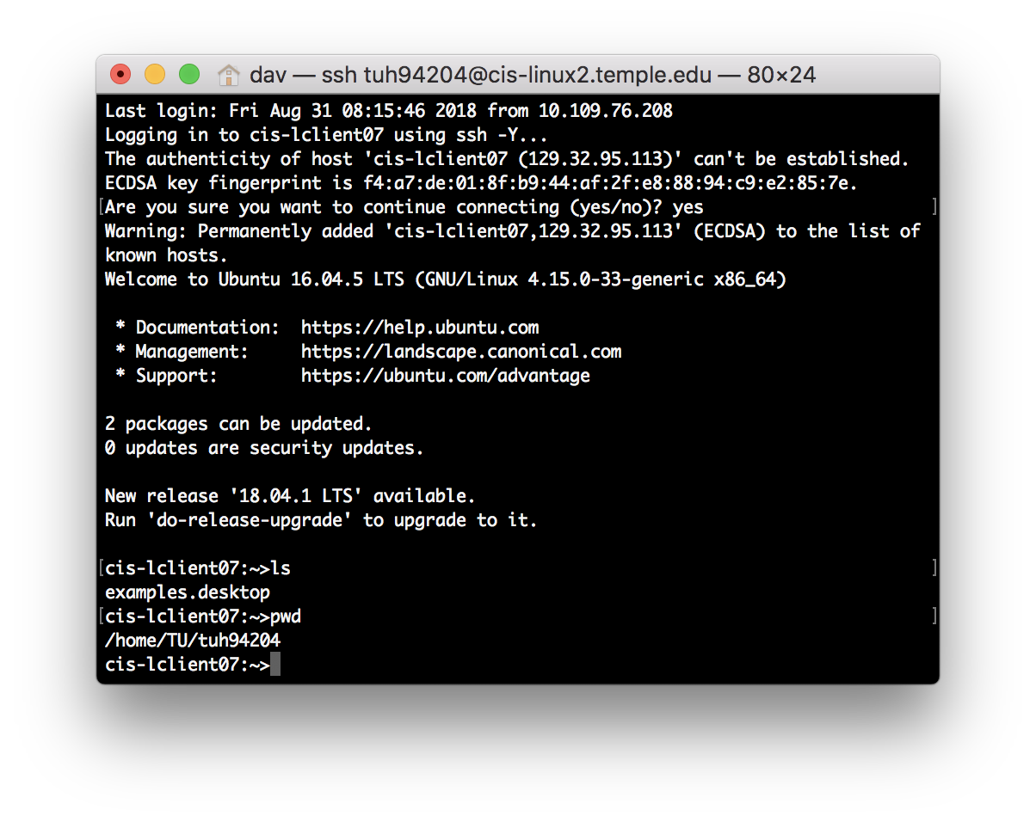

Shows the path of current directory

3.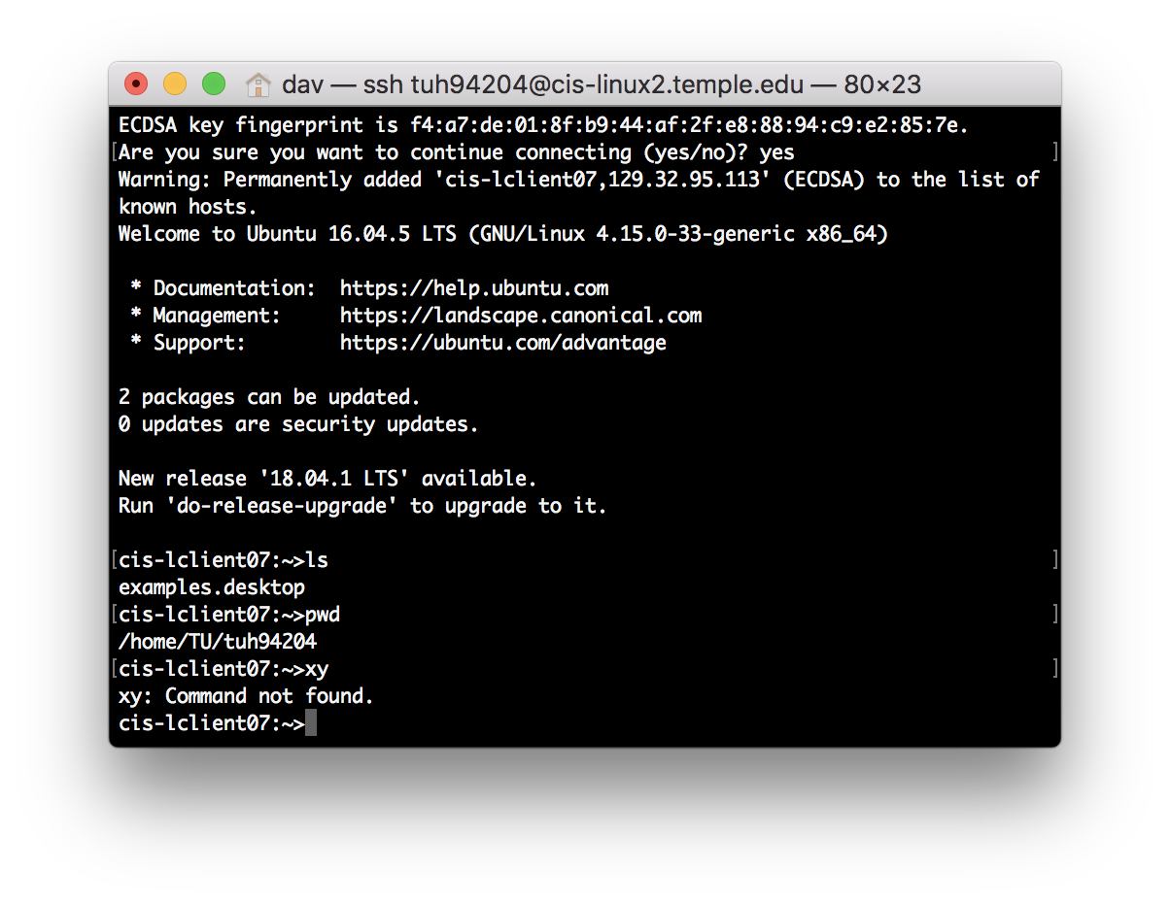

Does not do anything, not a command

4.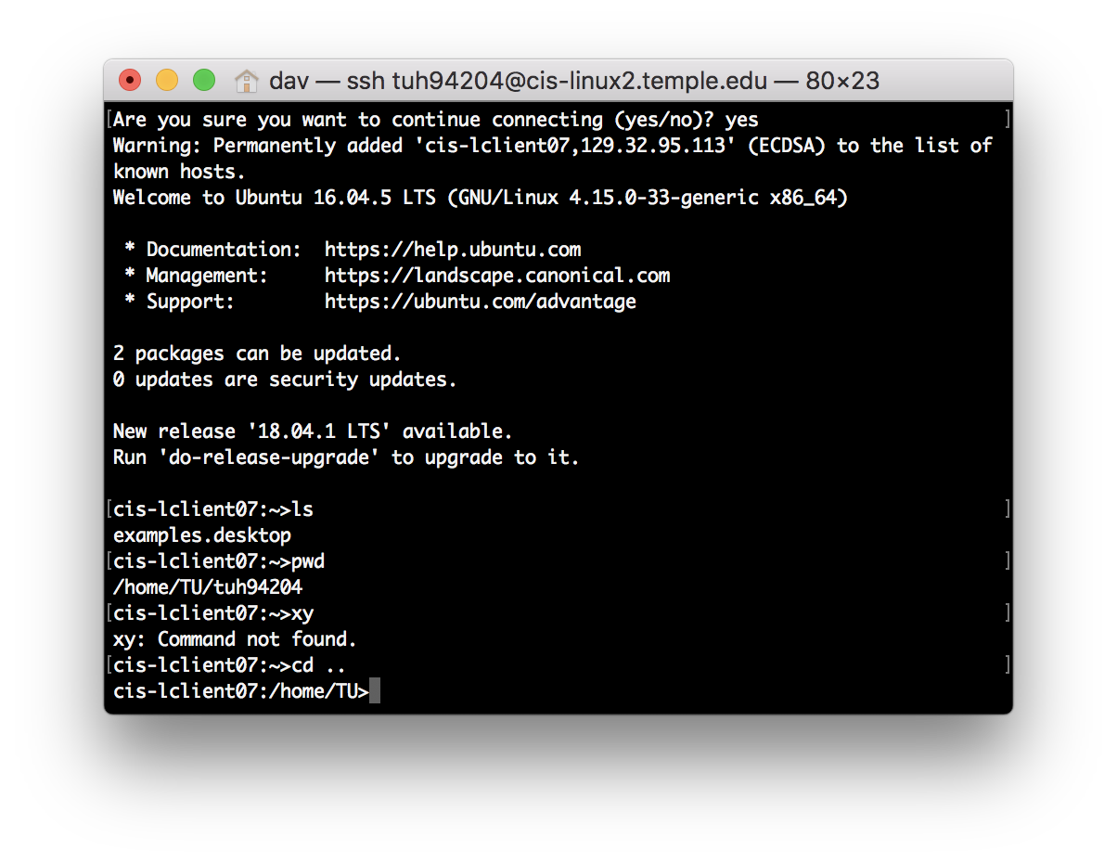

Takes me back to parent directory

5.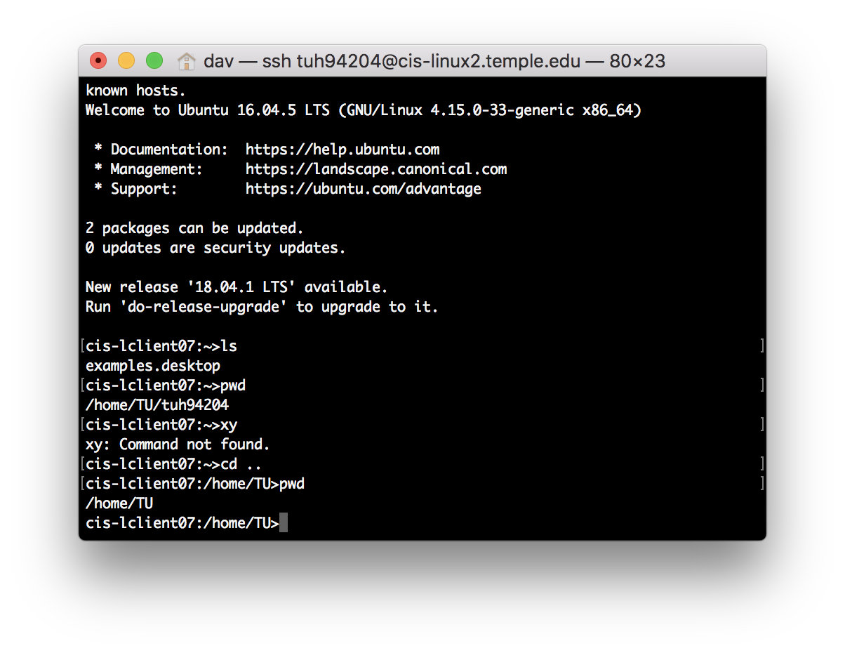

Shows path of current directory, moved back by one

6.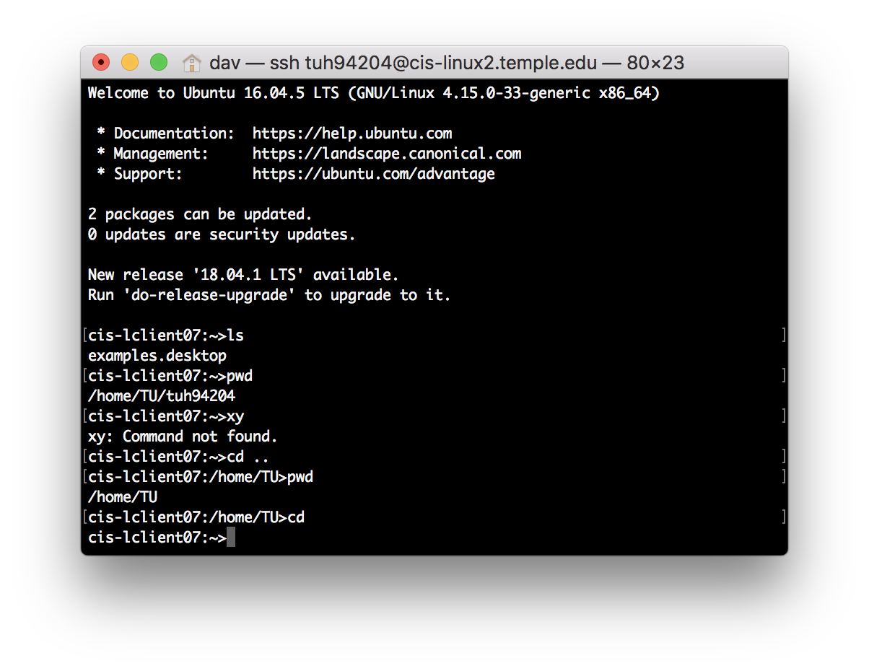

Takes me to home directory

7.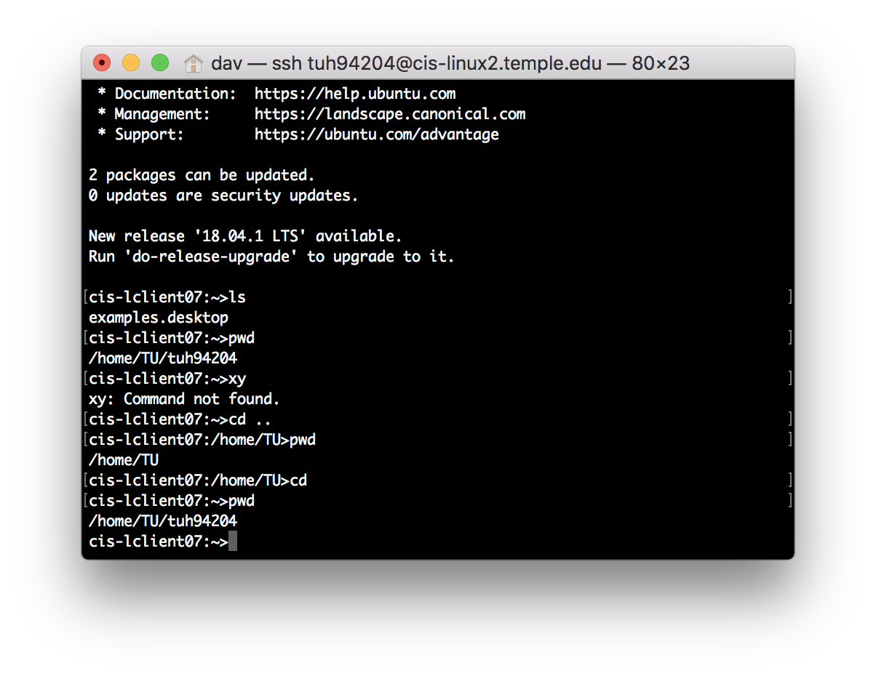

Shows the path of home directory

8.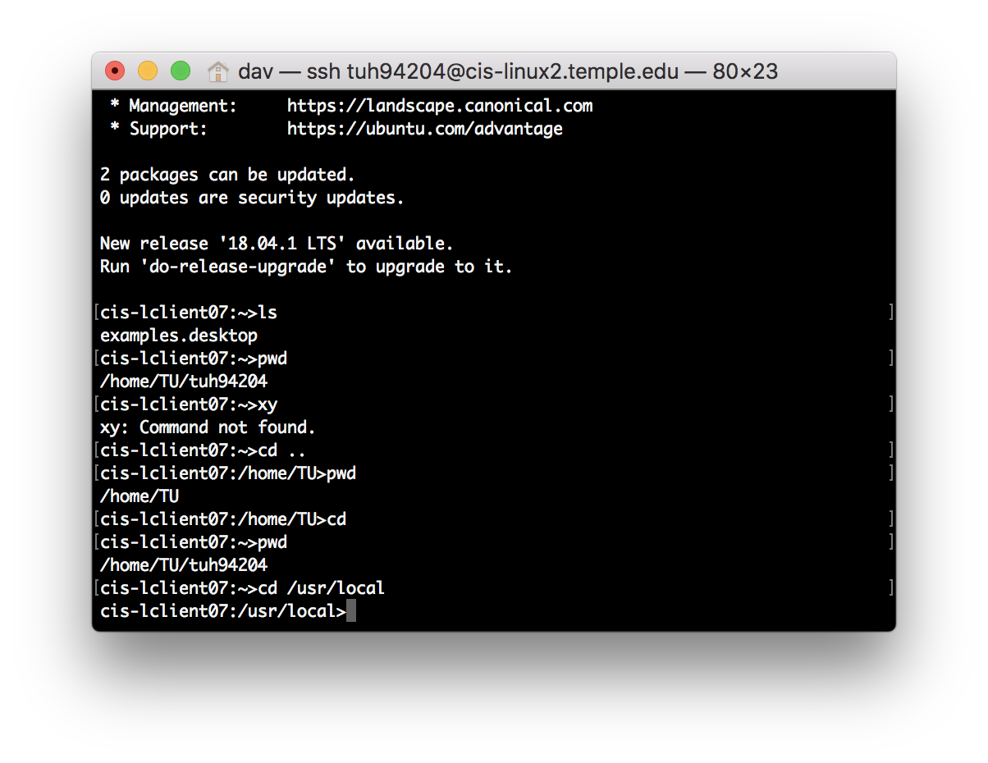

Takes me to the /usr/local directory

9.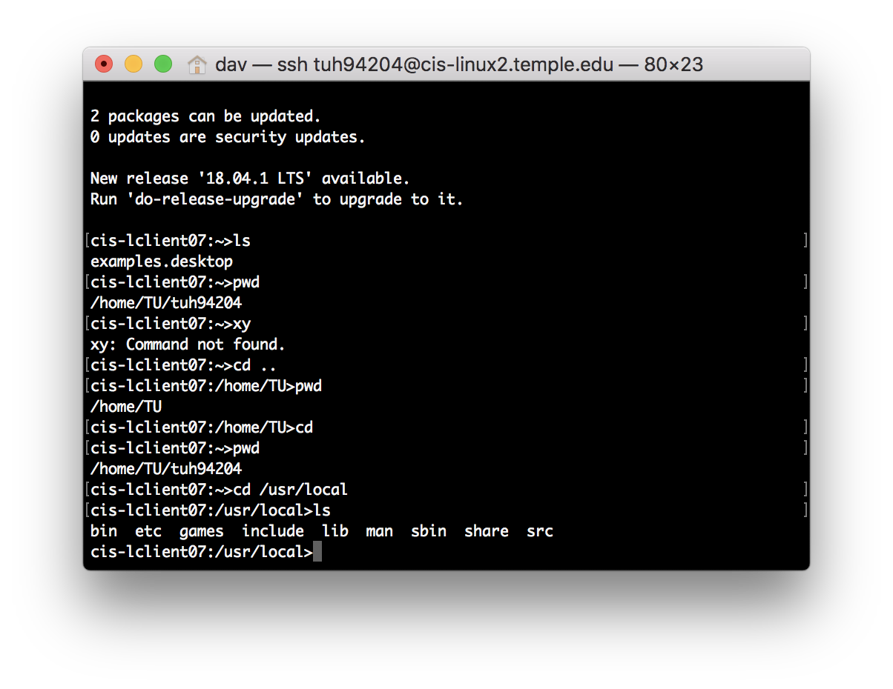

Shows files within the current directory

10.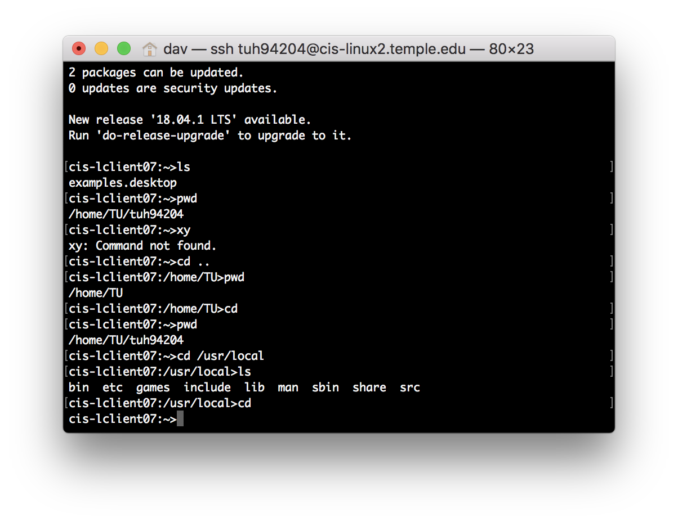

Takes me to the home directory

**Q2]**

|  |  |  |
| --- | --- | --- |
| # | cat |  |
| 1 | more | Allows user to go through texts one screen at a time |
| 2 | cp | You can copy from one or multiple sources to a destination directory |
| 3 | mv | Move or rename files from source to a destination directory |
| 4 | rm | Removes a file |
| 5 | ls | Lists all files within current directory |
| 6 | mkdir | Makes a new directory(ies) in current directory |
| 7 | cd | (no manual) but this will put you in the home directory |
| 8 | pwd | Shows the filepath of current directory |
| 9 | rmdir | Removes directory, deletes the directory if it is empty |
| 10 | whoami | Shows the name of the user |

**Q3]**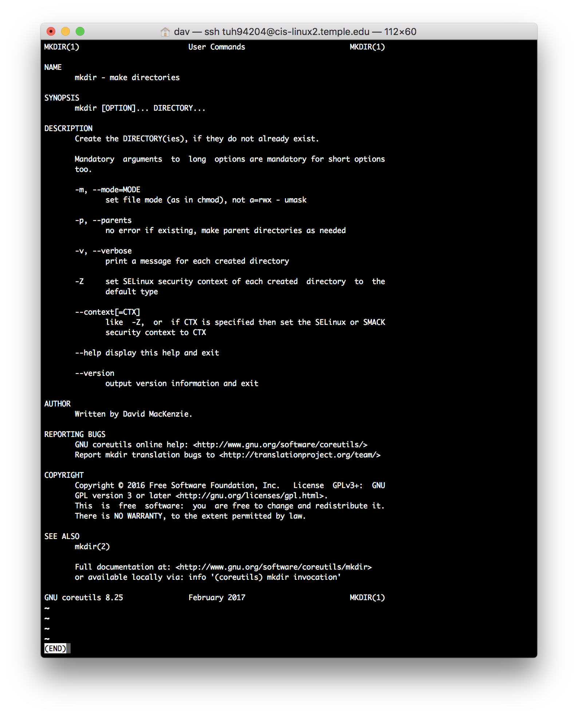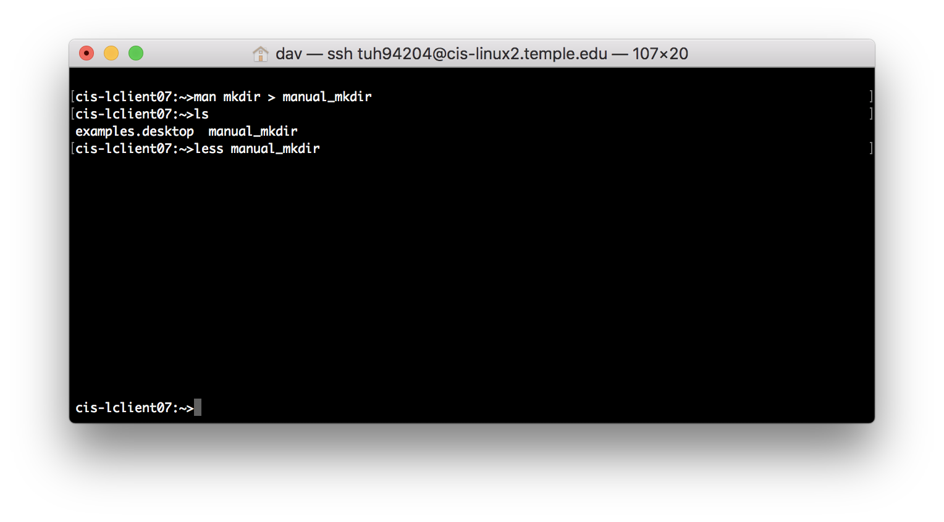

Displayed the contents of file, and it was the same as the manual for mkdir

**Q4]**

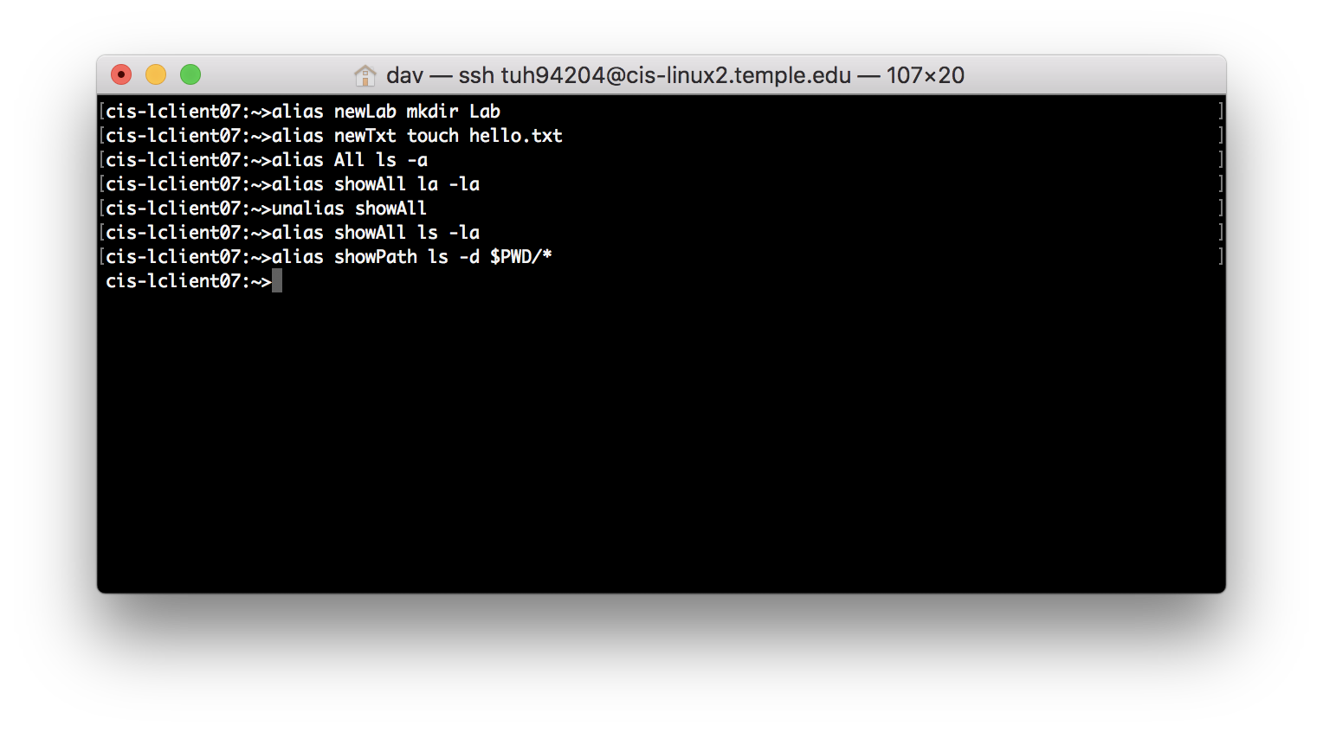

Had to unalias one because of a typo. Tested these, and they worked.

**Q5]**

1. cal 4  
   cal 52  
   cal 1752  
   cal 1952

cal 2004

cal 2005

1. Yes, it works for both leap and non-leap years. I can tell because every year I entered that was a leap year showed 29 days for February while the non-leap year (2005) only showed 28 days.
2. 1752 has 355 days. Google showed 8.7 million results. When the Gregorian Calendar replaced the Julian Calendar, the date September 3 1752 became September 14 1752. The Gregorian calendar is named after Pope Gregory XIII who introduced it in 1582. Source: <http://projectbritain.com/calendar/September/calendar.html>

**Q6]**

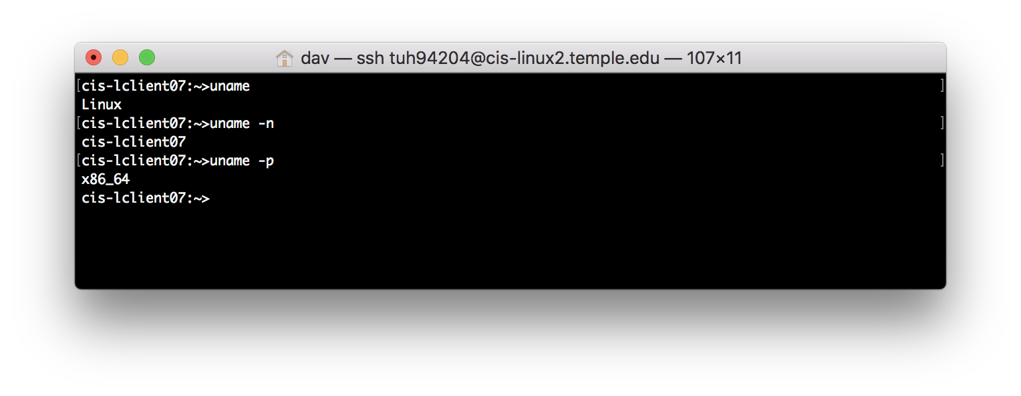

1. Linux
2. cis-lclient07
3. x86_64

**Q7]**

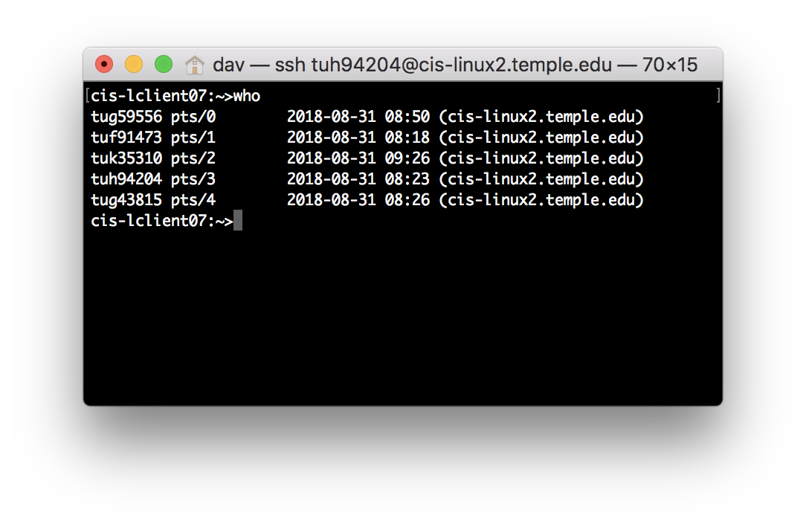

5 people including myself are using the UNIX system.

**Q8]**

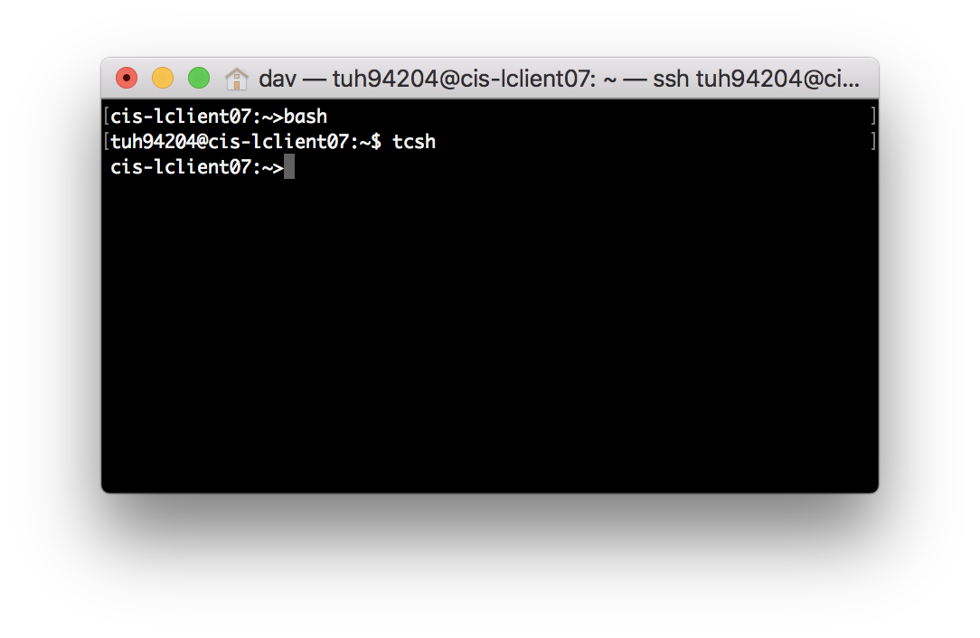

When bash is typed, the username is shown, when tcsh is typed it only shows the system name.