UNIT-II
Relational Model: Introduction to relational model, concepts of domain, attribute, tuple, relation, importance of null values, constraints (Domain, Key constraints, integrity constraints) and their importance, Relational Algebra, Relational Calculus.
BASIC SQL: Simple Database schema, data types, table definitions (create, alter), different DML operations (insert, delete, update)
Introduction
- Relational Model was proposed by E.F Codd to model data in the form of relations or tables.
- After designing the conceptual model of database using ER diagram, we need to convert the conceptual model in the relational model which can be implemented using any RDBMS (Relational Data Base Management System) like SQL, MY SQL etc.
- The relational model is very simple and elegant; a database is a collection of one or more relations, where each relation is a table with rows and columns.
- This simple tabular representation enables even new users to understand the contents of a database, and it permits the use of simple, high-level languages to query the data.
Relational Model
- Relational Model represents how date is stored in relational databases. A Relational database stores data in the form of relations (tables).
- Consider a relation STUDENT with attributes ROLL_NO, NAME, ADDRESS, PHONE and AGE as shown in table.
ROLL_NO | NAME | ADDRESS | PHONE | AGE
1 | A | Hyderabad | 9455123451 | 28
2 | B | Guntur | 9652431843 | 27
3 | C | Nellore | 9156253131 | 26
4 | D | Ongole | 9215635311 | 25

Relation Schema::
A relational schema defines the structure and organization of data in a relational database. It specifies the tables (relations), their attributes (columns), domains (data types), and integrity constraints that ensure data consistency and validity.
A schema is typically represented as: RelationName(Attribute1, Attribute2, ..., AttributeN)
Core Components
- Relation Name – Unique table name (e.g., Student, Department).
- Attributes – Columns in the table, each with a domain specifying allowed values (e.g., INTEGER, VARCHAR).
- Primary Key – Uniquely identifies each tuple (row) and cannot be NULL.
- Foreign Key – Links one table to another by referencing a primary key in another table.
- Constraints – Rules like NOT NULL, UNIQUE, CHECK, and DEFAULT to maintain data integrity.
- Attribute: Attributes are the properties that define a relation. Ex: ROLL_NO, NAME
- Tuple: Each row in a relation is known as tuple.
Ex:
1 | A | Hyderabad | 9455123451 | 28
- Degree: The number of attributes in the relation is known as degree.
Ex: The degree of the given STUDENT table is 5.
- Column: Column represents the set of values for a particular attribute. The column ROLL_NO is extracted from the relation STUDENT
ROLL_NO
1
- Null values: The value which is not known or unavailable is called NULL VALUE. It is represented by blank space.
- Cardinality: The number of tuples is present in the relation is called as its cardinality.
Ex: The Cardinality of the STUDENT table is 4.
Concept of Domain
  - The domain of a database is the set of all allowable values (or) attributes of the database.
Ex: Gender (Male, Female, Others).
Relation
  - A relation is defined as a set of tuples and attributes.
  - A relation consists of Relation schema and relation instance.
  - Relation schema: A relation schema represents the name of the relation with its attributes.
  - Ex: STUDENT (ROLL_NO, NAME, ADDRESS, PHONE and AGE) is Relation schema for STUDENT.
Emp_code | Emp_Name | Dept_Name
01234 | John | HR
12567 | Smith | Sales
21678 | Sai | Production
12456 | Jay | Design

Importance of Null values:
- SQL supports a special value known as NULL which is used to represent the values of attributes that may be unknown or not apply to a tuple.
- For example, the apartment_number attribute of an address applies only to the address that is in apartment buildings and not to other types of residences.
- It is important to understand that a NULL value is different from Zero value.
- A Null value is used to represent a missing value, but that is usually has one of the following interpretations:
  - Value unknown (Value exists but it is unknown)
  - Value not available (exists but it is purposely withheld)
  - Attribute not applicable (undefined for this tuple)
Testing for NULL Values
To test for NULL values in SQL, the IS NULL and IS NOT NULL operators are used instead of comparison operators like = or <>. This is because SQL considers each NULL value as distinct from every other NULL value.
Example: Using IS NULL and IS NOT NULL
Consider the following Employee table:
CREATE TABLE Employee (
Fname VARCHAR(50),
Lname VARCHAR(50),
SSN VARCHAR(11),
Phoneno VARCHAR(15),
Salary FLOAT);
INSERT INTO Employee (Fname, Lname, SSN, Phoneno, Salary)
VALUES
('Shubham', 'Thakur', '123-45-6789', '9876543210', 50000.00),
('Aman', 'Chopra', '234-56-7890', NULL, 45000.00),
('Aditya', 'Arpan', NULL, '8765432109', 55000.00),
('Naveen', 'Patnaik', '345-67-8901', NULL, NULL),
('Nishant', 'Jain', '456-78-9012', '7654321098', 60000.00);
To find employees with no SSN:
SELECT Fname, Lname FROM Employee WHERE SSN IS NULL;
To count employees with SSNs:
SELECT COUNT(*) AS Count FROM Employee WHERE SSN IS NOT NULL;
Updating NULL Values
You can update NULL values in a table using the UPDATE statement. Use the IS NULL operator in the WHERE clause to select rows with NULL values and set the new value using the SET keyword.
Example: Updating NULL Values
To update the SSN for 'Aditya Arpan':
UPDATE Employee
SET SSN = '789-01-2345'
WHERE Fname = 'Aditya' AND Lname = 'Arpan';
Deleting Records with NULL Values
To delete records containing NULL values, use the DELETE FROM statement with the IS NULL operator in the WHERE clause.
Example: Deleting Records with NULL Values
To delete employees with NULL salaries:
DELETE FROM Employee WHERE Salary IS NULL;
Constraints
In DBMS, constraints refer to limitations placed on data or data processes. This indicates that only a particular type of data may be entered into the database or that only a particular sort of operation can be performed on the data inside.
Constraints thereby guarantee data accuracy in a database management system (DBMS).
The following can be guaranteed via constraints
Data Accuracy ? Data accuracy is guaranteed by constraints, which make sure that only true data is entered into a database. For example, a limitation may stop a user from entering a negative value into a field that only accepts positive numbers.
Data Consistency ? The consistency of data in a database can be upheld by using constraints. These constraints are able to ensure that the primary key value in one table is followed by the foreign key value in another table.
Data integrity ? The accuracy and completeness of the data in a database are ensured by constraints. For example, a constraint can stop a user from putting a null value into a field that requires one.
Types of Constraints in DBMS
- Domain Constraints
- Key Constraints
- Entity Integrity Constraints
- Referential Integrity Constraints
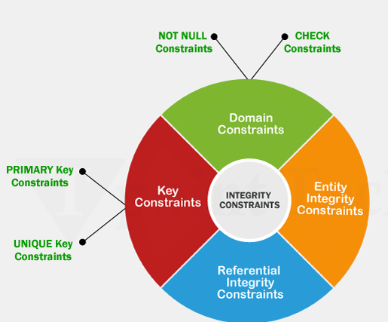

Domain Constraints
In a database table, domain constraints are guidelines that specify the acceptable values for a certain property or field. These restrictions guarantee data consistency and aid in preventing the entry of inaccurate or inconsistent data into the database. The following are some instances of domain restrictions in a DBMS :
- Data type constraints :These limitations define the kinds of data that can be kept in a column. A column created as VARCHAR can take string values, but a column specified as INTEGER can only accept integer values.
- Length Constraints : These limitations define the largest amount of data that may be put in a column. For instance, a column with the definition VARCHAR(10) may only take strings that are up to 10 characters long.
- Range constraints :The allowed range of values for a column is specified by range restrictions. A column designated as DECIMAL(5,2), for example, may only take decimal values up to 5 digits long, including 2 decimal places.
- Nullability constraints : Constraints on a column's capacity to accept NULL values are known as nullability constraints. For instance, a column that has the NOT NULL definition cannot take NULL values.
- Unique constraints : Constraints that require the presence of unique values in a column or group of columns are known as unique constraints. For instance, duplicate values are not allowed in a column with the UNIQUE definition.
- Check constraints :Constraints for checking data: These constraints outline a requirement that must hold for any data placed into the column. For instance, a column with the definition CHECK (age > 0) can only accept ages that are greater than zero.
- Default constraints : Constraints by default: Default constraints automatically assign a value to a column in case no value is provided. For example, a column with a DEFAULT value of 0 will have 0 as its value if no other value is specified.
Key Constraints
Key constraints are regulations that a DBMS uses to ensure data accuracy and consistency in a database. They define how the values in a table's one or more columns are related to the values in other tables, making sure that the data remains correct.
In DBMS, there are several key constraint kinds, including
- Primary Key Constraint : A primary key constraint is an individual identifier for each record in a database. It guarantees that each database entry contains a single, distinct value or a pair of values that cannot be null as its method of identification.
- Foreign Key Constraint : Reference to the primary key in another table is a foreign key constraint. It ensures that the values of a column or set of columns in one table correspond to the primary key column(s) in another table.
- Unique Constraint : In a database, a unique constraint ensures that no two values inside a column or collection of columns are the same.
Entity Integrity Constraints
A database management system uses entity integrity constraints (EICs) to enforce rules that guarantee a table's primary key is unique and not null. The consistency and integrity of the data in a database are maintained by EICs, which are created to stop the formation of duplicate or incomplete entries.
Each item in a table in a relational database is uniquely identified by one or more fields known as the primary key. EICs make a guarantee that every row's primary key value is distinct and not null. Take the "Employees" table, for instance, which has the columns "EmployeeID" and "Name." The table's primary key is the EmployeeID column. An EIC on this table would make sure that each row's unique EmployeeID value is there and that it is not null.
If you try to insert an entry with a duplicate or null EmployeeID, the database management system will reject the insertion and produce an error. This guarantees that the information in the table is correct and consistent.
EICs are a crucial component of database architecture and assist guarantee the accuracy and dependability of the data contained in a database.
Referential Integrity Constraints
A database management system will apply referential integrity constraints (RICs) in order to preserve the consistency and integrity of connections between tables. By preventing links between entries that don't exist from being created or by removing records that have related records in other tables, RICs guarantee that the data in a database is always consistent.
By the use of foreign keys, linkages between tables are created in relational databases. A column or collection of columns in one table that is used as a foreign key to access the primary key of another table. RICs make sure there are no referential errors and that these relationships are legitimate.
Domain Constraints In DBMS
- In DBMS table is viewed as a combination of rows and columns
- For example, if you are having a column called month and you want only (jan, feb, march……) as values allowed to be entered for that particular column which is referred to as domain for that particular column

Definition:
Domain constraint ensures two things it makes sure that the data value entered for that particular column matches with the data type defined by that column. It shows that the constraints (NOT NULL/UNIQUE/PRIMARY KEY/FOREIGNKEY/CHECK/DEFAULT)

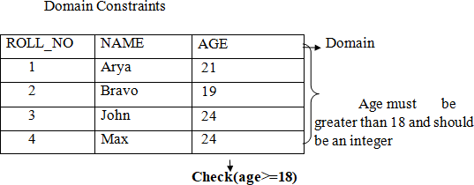

Domain constraint= data type check for the column +constraints.
Example:, we want to create a table “STUDENT” with “stu_id” field having a value greater than 100, can create a domain and table like this.
- Create domain id_value int constraint id_test check (value>=100);
- CREATE table STUDENT (stu_id id value primary key, stu_name varchar (30), stu_age int);

Key constraints in DBMS:
- Constraints are nothing but the rules that are to be followed while entering data into columns of the database table.
- Constraints ensure that the data entered by the user into columns must be within the criteria
specified by the condition.
- We have 6 types of key constraints in DBMS
- Not Null
- Unique
- Default
- Check
- Primary key
- Foreign key
- Not Null:
  - Null represents a record where data may be missing data or data for that record may be optional.
  - Once not null is applied to a particular column, you cannot enter null values to that column.
  - A not null constraint cannot be applied at table level.
  - Example :
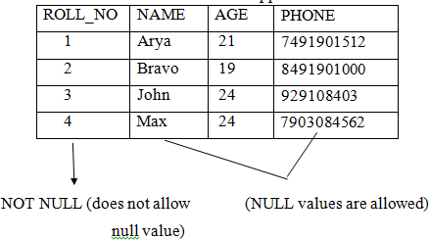
Create table EMPLOYEE (roll_no number(5) Not null, name varchar2(20) Not null, Age number(5) not null, phone number(15));

- Unique:
  - Sometimes we need to maintain only. Unique data in the column of a database table, this is possible by using a Unique constraint.
  - Unique constraint ensures that all values in a column are Unique.
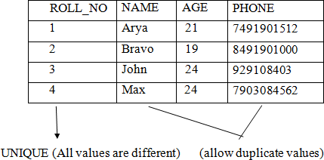
Example:Create table EMPLOYEE (roll_no number(5) UNIQUE, name varchar2(20) Not null, Age number(5) not null, phone number(15));
Default:
    - Default in SQL is used to add default data to the columns.
    - When a column is specified as default with same value then all the rows will use the same value i.e., each and every time while entering the data we need not enter that value.
    - But default column value can be customized i.e., it can be over ridden when inserting a data for that row based on the requirement.
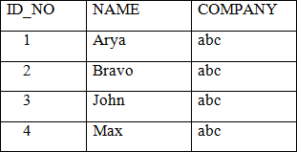
(Row with default values “abc”

Example:
Create table EMP(id_no number(5) primary key, name varchar2(20), company varchar2(20) default abc);
  - As a result, whenever you insert a new row each time you need not enter a value for thisdefault column that is entering a column value for a default column is optional.
- Check:
  - Check constraint ensures that the data entered by the user for that column is within the range of values or possible values specified.
Example:
Create table STUDENT (roll_no number(5) primary key, name varchar2(25), age number(3)
check(age>=18));
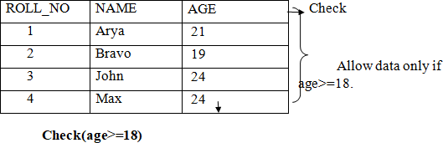
- Primary Key:
  - A primary key is a constraint in a table which uniquely identifies each row record in a database table by enabling one or more column in the table as primary key.
Example:
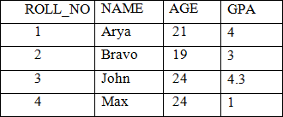
Create table EMP (roll_no number(5) primary key, name varchar(20), age number(5), gpa number(5));

- Foreign Key:
  - The foreign key constraint is a column or list of columns which points to the primary keycolumn of another table.
  - The main purpose of the foreign key is only those values are allowed in the present table thatwill match to the primary key column of another table.
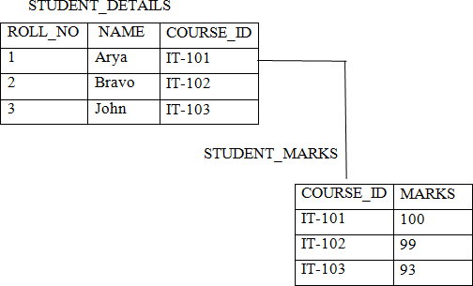
Example:
(Reference Table)
Create table CUSTOMER1 (roll_no number(5) primary key, name varchar2(20), course_id number(5));
(Child table)
Create table CUSTOMER2 (course_id number(5), marks number(5) references customer1(ID));
Integrity Constraints in DBMS:
There are two types of integrity constraints
- Entity Integrity Constraints
- Referential Integrity Constraints
- Entity Integrity constraints:
  - These constraints are used to ensure the uniqueness of each record or row in the data table.
  - Entity Integrity constraints says that no primary key can take NULL VALUE, since using primary key we identify each tuple uniquely in a relation.
Example:
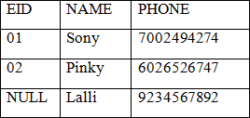

- Referential Integrity constraints:
  - The referential integrity constraint is specified between two relations or tables and usedto maintain the consistency among the tuples in two relations.
  - This constraint is enforced through foreign key, when an attribute in the foreign key of relation R1 have the same domain as primary key of relation R2, then the foreign key ofR1 is said to reference or refer to the primary key of relation R2.
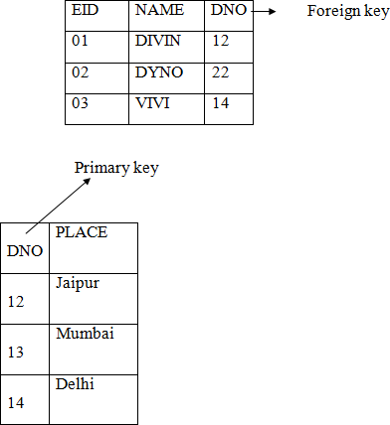
  - The values of the foreign key in a tuple of relation R1 can either take the values of the primary key for some tuple in Relation R2, or can take NULL values, but can‟t be empty.
Explanation:
- In the above, DNO of the first relation is the foreign key and DNO in the second relation is the primary key
- DNO=22 in the foreign key of the first relation is not available in the second relation so, since DNO=22 is not defined in the primary key of the second relation therefore Referential integrity constraints is violated here.

RELATIONAL ALGEBRA
- Relational algebra is one of the two formal query languages associated with the relational model. Queries in algebra are composed using a collection of operators.
- A fundamental property is that every operator in the algebra accepts (one or two) relation instances as arguments and returns a relation instance as the result. This property makes it easy to compose operators to form a complex query.
- Relational Algebra Expression is recursively defined to be a relation, a unary algebra operator applied to a single expression, or a binary algebra operator applied to two expressions.
- The basic operators of the algebra (selection, projection, union, cross- product, and difference.
- Each relational query describes a step-by-step procedure for computing the desired answer, based on the order in which operators are applied in the query. The procedural nature of the algebra allows us to think of an algebra expression as a plan, for evaluating a query, and relational systems in fact use algebra expressions to represent query evaluation plans.
The operators in relational algebra are classified
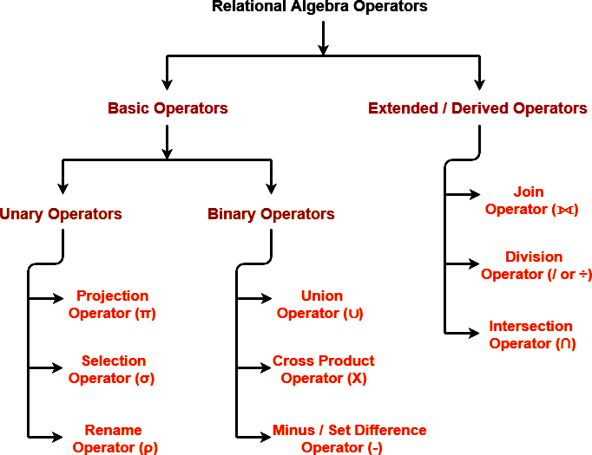

SELECT (σ)
The SELECT operation is used for selecting a subset of the tuples according to a given selection condition. It is denoted by sigma (σ).
Notation: σ p(r)
Where: σ is used for selection prediction
r is used for relation
p is used as a propositional logic formula which may use connectors like: AND OR and NOT. These relational can use as relational operators like =, ≠, ≥, <, >, ≤.

Example 1
σ _{topic = "Database"} (Tutorials)
Output - Selects tuples from Tutorials where topic = 'Database'.
Example 2
σ topic = "Database" and author = "Raghuramakrishna" ( Tutorials)
Output - Selects tuples from Tutorials where the topic is 'Database' and 'author' is Raghuramakrishna
Example 3
σ _{sales > 50000} (Customers)
Output - Selects tuples from Customers where sales is greater than 50000 For example: LOAN Relation
BRANCH_NAME | LOAN_NO | AMOUNT
Downtown | L-17 | 1000
Redwood | L-23 | 2000
Perryride | L-15 | 1500
Downtown | L-14 | 1500
Mianus | L-13 | 500
Roundhill | L-11 | 900
Perryride | L-16 | 1300
Input:
σ _{BRANCH_NAME="perryride"} (LOAN)
Output:
BRANCH_NAME | LOAN_NO | AMOUNT
Perryride | L-15 | 1500
Perryride | L-16 | 1300

Projection(π)
- The projection eliminates all attributes of the input relation but those mentioned in the projection list.
- This helps to extract the values of specified attributes to eliminates duplicate values.
- (pi) The symbol used to choose attributes from a relation. This operation helps you to keep specific columns from a relation and discards the other columns.
Notation: ∏ _{A1, A2, An} (r)
Where A1, A2, A3 is used as an attribute name of relation r.
Example of Projection:
Consider the following table

CustomerID | CustomerName | Status
1 | Google | Active
2 | Amazon | Active
3 | Apple | Inactive
4 | Alibaba | Active

Here, the projection of CustomerName and status will give
Π _{CustomerName, Status} (Customers)
CustomerName | Status
Google | Active
Amazon | Active
Apple | Inactive
Alibaba | Active

Union operation (U)
UNION is symbolized by ∪ symbol. It includes all tuples that are in tables A or in B. It also eliminates duplicate tuples. So, set A UNION set B would be expressed as:
Notation: A ∪ B
R and S must have the attribute of the same number. Duplicate tuples are eliminated automatically.
For a union operation to be valid, the following conditions must hold -
- R and S must be the same number of attributes.
- Attribute domains need to be compatible.
- Duplicate tuples should be automatically removed.
Example
Consider the following tables.

Table A |  |  | Table B
column 1 | column 2 |  | column 1 | column 2
1 | 1 |  | 1 | 1
1 | 2 |  | 1 | 3

A ∪ B gives
Table A ∪ B
column 1 | column 2
1 | 1
1 | 2
1 | 3

Set Difference (-)
- Symbol denotes it. The result of A - B, is a relation which includes all tuples that are in A but not in B.
  - The attribute name of A has to match with the attribute name in B.
  - The two-operand relations A and B should be either compatible or Union compatible.
  - It should be defined relation consisting of the tuples that are in relation A, but not in B.
Example
Consider the following tables.
Table A |  |  | Table B
column 1 | column 2 |  | column 1 | column 2
1 | 1 |  | 1 | 1
1 | 2 |  | 1 | 3

A-B

Table A - B
column 1 | column 2
1 | 2
Intersection Operator (∩)
Intersection operator is denoted by ∩ symbol and it is used to select common rows (tuples) from two tables (relations).
We have two relations R1 and R2 both have same columns and we want to select all those tuples(rows) that are present in both the relations, then in that case we can apply intersection operation on these two relations R1 ∩ R2.
Syntax of Intersection Operator (∩)
table_name1 ∩ table_name2
Example
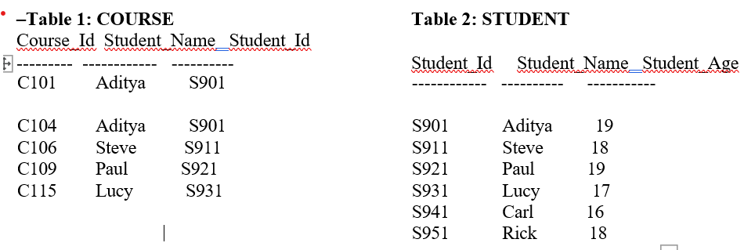
Query:
∏ Student_Name (COURSE) ∩ ∏ Student_Name (STUDENT)
Student_Name
Aditya
Steve
Paul
Lucy

Cartesian product (X)
- Cartesian Product is denoted by X symbol.
- For example we have two relations R1 and R2 then the cartesian product of these two relations (R1 X R2) would combine each tuple of first relation R1 with the each tuple of second relation R2.
Syntax of Cartesian product (X)
R1 X R2
Example
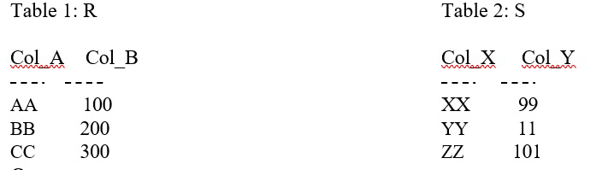
cartesian product of table R and S R X S

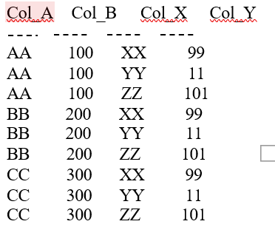
Rename (ρ)
Rename (ρ) operation can be used to rename a relation or an attribute of a relation.

Syntax:
ρ(new_relation_name, old_relation_name)

Example
Lets say we have a table customer, we are fetching customer names and we are renaming the resulted relation to CUST_NAMES.
Table: CUSTOMER

Customer_Id | Customer_Name | Customer_City
C10100 | Steve | Agra
C10111 | Raghu | Agra
C10115 | Chaitanya | Noida
C10117 | Ajeet | Delhi
C10118 | Carl | Delhi
Query:
ρ(CUST_NAMES, ∏(Customer_Name)(CUSTOMER))
Output:
CUST_NAMES

Steve
Raghu
Chaitanya
Ajeet
Carl

Join Operations
- The join operation is one of the most useful operations in relational algebra and is the most commonly used way to combine information from two or more relations.
- Join can be defined as a cross-product followed by selections and projections.
- The result of a cross-product is typically much larger than the result of a join there are several variants of the join operation.
- Inner joins
- Outer joins
Inner Join
- An inner join is the widely used join operation and can be considered as a default join-type.
- The inner JOIN is used to return rows from both tables which satisfy the given condition.
- An Inner join or equijoin which uses equality comparisons in the join- predicate. If we use other comparison operators like ">" can't be called equijoin.
Syntax:
- SELECT table1.column, table2.column FROM table1 INNER JOIN table2 ON table1.common_column = table2.common_column;
Example: Suppose you have employees and departments tables.
SELECT employees.name, departments.department_name FROM employees
INNER JOIN departments ON employees.department_id = departments.department_id;

Employees table
emp_id | name | department_id
1 | Anu | 10
2 | Ravi | 20
3 | Meena | 30

Departments
department_id | department_name
10 | CSE
20 | ECE
OUTPUT:
name | department_name
Anu | CSE
Ravi | ECE
Example-2
STUDENTS
student_id | student_name | course_id
1 | Anu | C1
2 | Ravi | C2
3 | Meena | C3
COURSES
course_id | course_name
C1 | DBMS
C2 | OS
SQL Query
SELECT students.student_name, courses.course_name
FROM students
INNER JOIN courses
ON students.course_id = courses.course_id;
Output
student_name | course_name
Anu | DBMS
Ravi | OS

Another INNER JOIN Example
Tables
ORDERS
order_id | customer_id | order_date
101 | C1 | 01-Jan-25
102 | C2 | 05-Jan-25
103 | C3 | 10-Jan-25
CUSTOMERS
customer_id | customer_name
C1 | Anu
C2 | Ravi
Query
SELECT customers.customer_name, orders.order_date
FROM orders
INNER JOIN customers
ON orders.customer_id = customers.customer_id;
Output
customer_name | order_date
Anu | 01-Jan-25
Ravi | 05-Jan-25

Outer Join
An outer join doesn't require each record in the two join tables to have a matching record. In this type of join, the table retains each record even if no other matching record exists.
Three types of Outer Joins are:
- Left Outer Join
- Right Outer Join
- Full Outer Join
Left Outer Join
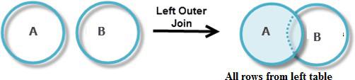
The LEFT JOIN returns all the rows from the table on the left even if no matching rows have been found in the table on the right. Where no matching record found in the table on the right, NULL is returned.

Consider the following 2 Tables
B
Num | Cube
2 | 8
3 | 18
5 | 75

A
Num | Square
2 | 4
3 | 9
4 | 16

A B
A ⋈ B
Num | Square | Cube
2 | 4 | 4
3 | 9 | 9
4 | 16 | NULL

Right Outer Join
RIGHT outer JOIN is the opposite of LEFT JOIN. The RIGHT JOIN returns all the columns from the table on the right even if no matching rows have been found in the table on the left. Where no matches have been found in the table on the left, NULL is returned
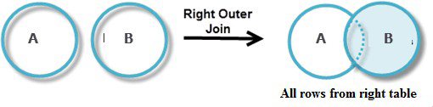

A ⋈ B
Num | Cube | Square
2 | 8 | 4
3 | 18 | 9
5 | 75 | NULL

Full Outer Join
In a full outer join, all tuples from both relations are included in the result, irrespective of the matching condition.
Example:

A ⋈ B
Num | Cube | Square
2 | 4 | 8
3 | 9 | 18
4 | 16 | NULL
5 | NULL | 75

RELATIONAL CALCULUS:
Relational calculus is a non-procedural query language. In the non-procedural query language, the user is concerned with the details of how to obtain the end results. The relational calculus tells what to do but never explains how to do.

Types of Relational calculus:
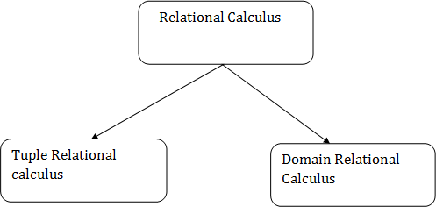
Tuple Relational Calculus (TRC)
The tuple relational calculus is specified to select the tuples in a relation. The result of the relation can have one or more tuples.
Notation: {T | P (T)} or {T | Condition (T)}
Where
T is the resulting tuples
P(T) is the condition used to fetch T.
For example:
{T.name | Author(T) AND T.article = 'database' }
OUTPUT: This query selects the tuples from the AUTHOR relation. It returns a tuple with 'name' from Author who has written an article on 'database'.
{t | TEACHER (t) and t.SALARY>20000}
It implies that it selects the tuples from the TEACHER in such a way that the resulting teacher tuples will have a salary higher than 20000.
Domain Relational Calculus (DRC)
In domain relational calculus, filtering variable uses the domain of attributes. Domain relational calculus uses the same operators as tuple calculus. It uses logical connectives ∧ (and), ∨ (or) and ┓ (not).
It uses Existential (∃) and Universal Quantifiers (∀) to bind the variable.
Notation:
{ a1, a2, a3, ..., an | P (a1, a2, a3, ... ,an)}
Where
a1, a2 are attributes
P stands for formula built by inner attributes
For example:
{< article, page, subject > | ∈ cse ∧ subject = 'database'}
Output: This query will yield the article, page, and subject from the relational cse, where the subject is a database.
Consider the “Students” table:
ID | Name | Age | Grade
1 | Alice | 20 | A
2 | Bob | 19 | B
3 | Charlie | 22 | A
4 | David | 18 | C

Example 1: Find the Names of Students with Grade ‘A’
TRC Query:
{ t | t ∈ Students ∧ t.Grade = ‘A’ }
DRC Query:
{<Name> | ∃ ID, Age, Grade (Students(ID, Name, Age, Grade) ∧ Grade = ‘A’)}
Example 2: Find the Names and Ages of Students Older Than 18
TRC Query:
{ t | t ∈ Students ∧ t.Age > 18 }
DRC Query:
{<Name, Age> | ∃ ID, Grade (Students(ID, Name, Age, Grade) ∧ Age > 18)}
Basic SQL (introduction)
  - SQL stands for Structure Query Language it is used for storing and managing data in relational database management system.
  - It is standard language for relational database system. It enables a user to create, read, update and delete relational databases and tables.
  - All the RDBMS like MYSQL, Oracle, MA access and SQL Server use SQL as their standard database language.
  - SQL allows users to Query the database in a number of ways using statements like common English.
Rules: SQL follows following rules
    - SQL is not a case sensitive. Generally, keywords are represented in UPPERCASE.
    - Using the SQL statements, you can perform most of the actions in a database.
    - Statements of SQL are dependent on text lines. We can use a single SQL statement on one or multiple text line.
SQL Process:
  - When an SQL command is executing for any RDBMS, then the system figure out the best way to carry out the request and the sql engine determines that how to interrupt the task.
  - In the process, various components are included. These components can be optimization engine, query engine, query dispatcher etc.,
  - All the non-sql queries are handled by the classic query engine, but sql query engine
handle logical files.
Characteristics of SQL:
  - SQL is easy to learn.
  - SQL is used to access data from relational database management system.
  - SQL is used to describe the data.
  - SQL is used to create and drop the database and table.
  - SQL allows users to set permissions on tables, procedures and views.

SQL Commands:
- SQL commands are instructions. It is used to communicate with the database. It is also used to perform specific tasks, functions, and queries of data.
- SQL can perform various tasks like create a table, add data to tables, drop the table, modify the table, set permission for users.
- SQL Commands are five types: DDL, DML, DCL, TCL, and DQL.
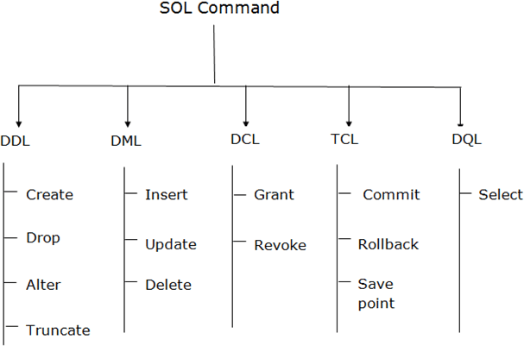
- Data Definition Language (DDL)
- DDL changes the structure of the table like creating a table, deleting a table, altering a table, etc.
- All the command of DDL are auto-committed that means it permanently save all the changes in the database.
- Here are some commands that come under DDL:
  - CREATE
  - ALTER
  - DROP
  - TRUNCATE
- CREATE: It is used to create a new table in the database.
Syntax:
CREATE TABLE TABLE_NAME (COLUMN_NAME DATATYPES[,... ]);
Example:
CREATE TABLE EMP
(Name VARCHAR2(20), Class VARCHAR2(100), DOB VARCHAR2(20));
- DROP: It is used to delete both the structure and record stored in the table.
Syntax
DROP TABLE ;
Example
DROP TABLE EMPLOYEE;
- ALTER: It is used to alter the structure of the database. This change could be either to modify the characteristics of an existing attribute or probably to add a new attribute.
Syntax:
To add a new column in the table
ALTER TABLE table_name ADD column_name COLUMN-definition; To modify existing column in the table:
ALTER TABLE MODIFY(COLUMN DEFINITION... );
EXAMPLE

ALTER | TABLE | STU_DETAILS | ADD(ADDRESS VARCHAR2(20));
ALTER | TABLE | STU_DETAILS | MODIFY (NAME VARCHAR2(20));
- TRUNCATE: It is used to delete all the rows from the table and free the space containing the table.
Syntax:
TRUNCATE TABLE table_name;
Example:
TRUNCATE TABLE EMPLOYEE;
- Data Manipulation Language
- DML commands are used to modify the database. It is responsible for all form of changes in the database.
- The command of DML is not auto-committed that means it can't permanently save all the changes in the database. They can be rollback.
- Here are some commands that come under DML:
  - INSERT
  - UPDATE
  - DELETE
- INSERT: The INSERT statement is a SQL query. It is used to insert data into the row of a table.
Syntax:
INSERT INTO TABLE_NAME
(col1, col2, col3, col N)
VALUES (value1, value2, value3, valueN);
Or
INSERT INTO TABLE_NAME
VALUES (&col1, &col2, &col3, &colN);
For example:
INSERT INTO emp (name, job) VALUES ("Rams", "Manager"); Or
INSERT INTO EMP VALUES(&EMPNO, ‘&ENAME’ , ‘&JOB’);
Enter value for empno : 001 Enter value for ename : Rams Enter value for job: Manager
- UPDATE: This command is used to update or modify the value of a column in the table.
Syntax:
UPDATE table_name
SET [column_name1= value1, column_nameN = valueN]
[WHERE CONDITION]
For example:
UPDATE students
SET User_Name = 'Sonu' WHERE Student_Id = '3' ;
- DELETE: It is used to remove one or more row from a table.
Syntax:
DELETE FROM table_name [WHERE condition];
For example:
DELETE FROM student WHERE sname="Sonu";
- Data Control Language
- DCL commands are used to grant and take back authority from any database user.
- Here are some commands that come under DCL:
  - Grant
  - Revoke
- Grant: It is used to give user access privileges to a database.
Example
GRANT SELECT, UPDATE ON MY_TABLE TO SOME_USER, ANOTHER_USER;
- Revoke: It is used to take back permissions from the user.
Example
REVOKE SELECT, UPDATE ON MY_TABLE FROM USER1, USER2;
- Transaction Control Language
- TCL commands can only use with DML commands like INSERT, DELETE and UPDATE only.
- These operations are automatically committed in the database that's why they cannot be used while creating tables or dropping them.
- Here are some commands that come under TCL:
  - COMMIT
  - ROLLBACK
  - SAVEPOINT
- Commit: Commit command is used to save all the transactions to the database.
Syntax:
COMMIT;
Example:
DELETE FROM CUSTOMERS WHERE AGE = 25;
COMMIT;
- Rollback: Rollback command is used to undo transactions that have not already been saved to the database.
Syntax:
ROLLBACK;
Example:
DELETE FROM CUSTOMERS WHERE AGE = 25; ROLLBACK;
- SAVEPOINT: It is used to roll the transaction back to a certain point without rolling back the entire transaction.
Syntax:SAVEPOINT SAVEPOINT_NAME;
- Data Query Language
  - DQL is used to fetch the data from the database.
  - It uses only one command:
SELECT
SELECT: This is the same as the projection operation of relational algebra. It is used to select the attribute based on the condition described by WHERE clause.
Syntax:
SELECT expressions FROM TABLES
WHERE conditions; For example: SELECT emp_name FROM employee WHERE age > 20;
SQL Data Types:
- SQL Datatype is used to define the values that a column can contain.
- Every column is required to have a name and data type in the database table.
SQL data types specify the type of data that a column or variable can hold in a SQL database. These data types include numeric, character and string, date and time, binary, boolean, enumerated, array, and JSON types. Each data type has a specific range of values and uses. Choosing the appropriate data type for a column or variable is essential for accurate and efficient data storage and retrieval.
Data type of SQL:
SQL data types can be broadly categorized into several categories:
- Numeric data types: It stores numeric values, such as integers and floating-point numbers. Examples include INT, BIGINT, FLOAT, NUMERIC, and DECIMAL.
- Character and string data types: It stores character strings, such as names and addresses. Examples include CHAR, VARCHAR, and TEXT.
- Date and time data types: It stores date and time values. Examples include DATE, TIME, DATETIME, and TIMESTAMP.
- Binary data types: It stores binary data, such as images and files. Examples include BLOB, BINARY, and VARBINARY.
- Boolean data types: It stores true/false values. Examples include BOOL and BOOLEAN.
Here are some examples of common SQL data types and their uses:

Data Type | Description
INT | The INT data type stores integer values. It can hold whole numbers, such as items in stock or orders placed. INT values can range from -2147483648 to 2147483647.
NUMERIC | The NUMERIC data type stores exact numeric values with a fixed precision and scale. The precision is the total number of digits in a number, and the scale is the number of digits to the right of the decimal point. For example, 124.56 has a precision of 5 and a scale of 2.
DECIMAL | The DECIMAL data type is similar to the NUMERIC data type that stores exact numeric values with a fixed precision and scale. It's important to note that NUMERIC and DECIMAL are synonyms in SQL, and it's up to the developer to choose which one to use.
CHAR | The CHAR data type stores fixed-length character strings. It can hold a fixed number of characters, specified by the field's length. For example, a CHAR(10) field can store a string of up to 10 characters. If the inserted string is shorter than the specified length, the remaining characters will be filled with spaces.
VARCHAR | The VARCHAR data type stores variable-length character strings. It can hold a variable number of characters, specified by the field's length. For example, a VARCHAR(10) field can store a string of up to 10 characters. If the string inserted is shorter than the specified length, it will only use the necessary amount of storage.
TEXT | The TEXT data type stores variable-length character strings, similar to the VARCHAR data type. It can store a large amount of character data, and the maximum length of a TEXT field is typically much larger than that of a VARCHAR field. The exact maximum length of a TEXT field can vary depending on the specific SQL implementation being used.
DATE | The DATE data type stores date values. It can be used to hold a date, which includes the day, month, and year. It's defined as DATE and used to store date information such as birthdate, hiring date, order date, etc. The format of a DATE value can vary depending on the specific SQL implementation being used, but it typically follows the format of "YYYY-MM-DD" where YYYY represents the year, MM represents the month, and DD represents the day.
TIME | The TIME data type stores time values. It can keep time, which includes hours, minutes, and seconds. It can store information such as opening, closing, arrival, departure, etc. The format of a TIME value can vary depending on the specific SQL implementation being used, but it typically follows the format of "HH:MM:SS" where HH represents the hour, MM represents the minutes, and SS represents the seconds.
DATETIME | The DATETIME data type stores both date and time values. It can be used to hold a date and time, which includes the day, month, year, and time, which consists of the hours, minutes, and seconds. It's defined as DATETIME, and it's used to store date and time information such as start time, end time, and timestamp. The format of a DATETIME value can vary depending on the specific SQL implementation, but it typically follows the format of "YYYY-MM-DD HH:MM:SS".
TIMESTAMP | In SQL, the TIMESTAMP data type stores both date and time values, similar to the DATETIME data type. It can be used to store a date, which includes the day, month, year, and time, which consists of the hours, minutes, and seconds. It's defined as TIMESTAMP, which stores date and time information such as start time, end time, and timestamp. The format of a TIMESTAMP value can vary depending on the specific SQL implementation being used. Some implementations provide automatic initialization and updating for TIMESTAMP columns.
YEAR | The YEAR data type stores year values. It can be used to hold a year, which includes four digits representing the year. It's defined as YEAR and used to store year information such as birth year, hire year, etc.
BINARY | The BINARY data type stores fixed-length binary data. It is comparable to the CHAR data type but holds binary values instead of character strings. The BINARY data type requires a fixed length to be specified and can be used to store any binary data, such as images, audio, or other binary files.
BLOB | The BLOB (Binary Large OBject) data type stores extensive binary data such as images, audio, or other binary files. It can hold a large amount of binary data, and the maximum size of a BLOB field can vary depending on the specific SQL implementation being used. BLOB is typically used to store data that is not character or string data.
BOOLEAN | The BOOLEAN data type stores true/false or yes/no values. It can hold only two possible values: TRUE, FALSE, YES, or NO. It's defined as BOOLEAN and used to store logical values. The exact representation of a BOOLEAN value can vary depending on the specific SQL implementation being used, but it typically follows the format of "TRUE" or "FALSE" or "1" or "0" or "YES" or "NO".
SQL Data Types with Examples
When creating a table, the data types for each column must be specified. For example, the following SQL statement creates a table called "customers" with several columns, each with a specific data type:
CREATE TABLE customers (
customer_id INT PRIMARY KEY,
first_name VARCHAR(50) NOT NULL,
last_name VARCHAR(50) NOT NULL,
email VARCHAR(255) UNIQUE,
date_of_birth DATE,
is_active BOOLEAN NOT NULL DEFAULT TRUE,
last_login TIMESTAMP);
- In the example above, the "customer_id" column has an INT data type and is set as the primary key, meaning it must contain a unique value for each row in the table.
- The "first_name" and "last_name" columns have VARCHAR data types with a maximum length of 50 characters and are both set as "NOT NULL", meaning they must contain a value.
- The "email" column has a VARCHAR data type with a maximum length of 255 characters and is set as "UNIQUE", meaning it must contain a unique value across the entire table.
- The "date_of_birth" column has a DATE data type.
- The "is_active" column has a BOOLEAN data type and is set as "NOT NULL" and "DEFAULT TRUE".
- The "last_login" column has a TIMESTAMP data type.
Database Schema
A database schema is a blueprint that defines the logical structure, organization, and relationships of data within a database, serving as a foundation for data storage and management.
(OR)
A database schema is a formal description of the structure of a database. It outlines how data is organized, including the tables, fields, data types, and the relationships between different data elements. Essentially, it acts as a blueprint for how data is stored, accessed, and manipulated within a database management system (DBMS).
Key Components of a Database Schema
- Tables: The primary structure for storing data, organized in rows and columns. Each table represents a specific entity (e.g., customers, orders) and contains related data.
- Fields: Columns within a table that hold specific types of data (e.g., name, date, price). Each field has a defined data type (e.g., integer, varchar) that specifies the kind of data it can contain.
- Relationships: Defines how tables are related to one another, often through primary and foreign keys. This ensures data integrity and allows for complex queries across multiple tables.
Types of Database Schemas
- Conceptual Schema: Provides a high-level view of the database structure without going into detail about how data is stored. It focuses on the overall organization and relationships between entities.
- Logical Schema: Offers a more detailed outline of the database, including specific tables, fields, and relationships, but does not include technical details about storage.
- Physical Schema: Describes how data is physically stored in the database, including file locations, indexing strategies, and storage formats. This schema is crucial for optimizing performance and ensuring efficient data retrieval.
Importance of a Database Schema
- Data Integrity: A well-defined schema helps maintain data accuracy and consistency by enforcing rules and constraints on data entry
- Scalability: By organizing data clearly, schemas facilitate easier scaling of database systems as business needs grow.
- Accessibility: Schemas provide a logical framework that makes it easier for users and applications to access and manipulate data effectively.

