Lab 3: Age-structured populations

NRES 470/670

Feb 9, 2017

In this lab we will have an opportunity to build more complex population models in InsightMaker. Among the concepts we will play around with are *age structure*, *life tables*, and *age/stage matrices*.

First let's do some math!

## Mathematics of Age-structured populations

### Life tables

Let's start with some notation- population ecology, and life tables in particular, are full of notation. We should at least be aware of the major terms used in population ecology!

**Survivorship: $l(x)=\frac{S_{x}}{S_{0}} (Eq. 1)$** , where $S_{x}$ is the number of survivors from the original cohort at year $x$

**Survival rate: $g(x)=\frac{S_{x+1}}{S_{x}} (Eq. 2)$** , where $S_{x}$ is the number of survivors from the original cohort at year $x$

**Birth rate: $b(x)$** is simply the per-capita number of offspring produced by a given age class.

**Lifetime reproductive potential: $R_{0}=\sum_{x=0}^{k}{l}(x)⋅b(x) (Eq. 3)$** , where $k$ is the maximum age.

**Average lifespan** is defined as: $L=\frac{\sum_{x=0}^{k}{l}(x)⋅x}{\sum_{x=0}^{k}{l}(x)} (Eq. 4)$

**Generation time** is defined as the *Average age of the parents of all the offspring produced by a single cohort*. This can be computed as: $G=\frac{\sum_{x=0}^{k}{l}(x)⋅b(x)⋅x}{\sum_{x=0}^{k}{l}(x)⋅b(x)} (Eq. 5)$

**Intrinsic rate of growth, $r$** is defined (to a first-order approximation) as: $r=\frac{ln(R_{0})}{G} (Eq. 6)$

One more concept I want to introduce here is **reproductive value**, or V(x). This represents the expected present and future reproductive output of an individual of age x: $V(x)=b(x)+\sum_{t=x+1}^{k}{\frac{l(t+1)}{l(t)}}⋅b(t) (Eq. 7)$. This could also be expressed as: $V(x)=b(x)+\sum_{t=x+1}^{k}{g}(t)⋅b(t)$.

## Exercise 1: basic life table analysis

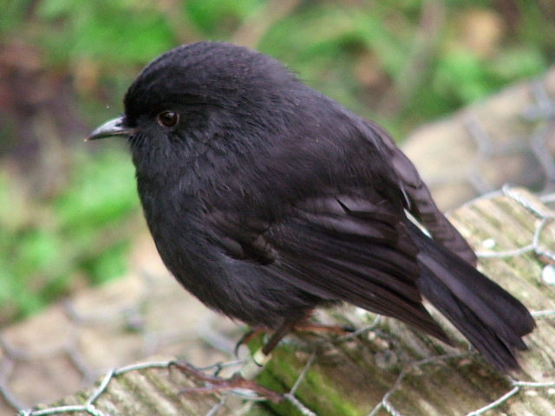

Let's imagine that we are following a *cohort* of reintroduced Chatham Island robins on a small island through time.

* First, we establish fake nests and place 350 captive-laid eggs in them.
* All individuals are given a unique marking as soon as they hatch. These markings are permanent and not affected by tag loss!
* We visit the island once per year, and we count all the individuals with tags who still exist in the population. We can assume that if the individual is alive then we will observe it. If we do not see the individual we know with certainty that it is dead!
* We record the following numbers of robins over 5 years revisiting the island (starting with 350 at year 0): 50, 25, 10, 2, and 0.
* We record the following reproductive rates for each age: 0, 5.2, 5.5, 4.7, 3.3, and 0

You can load these data in [this handy CSV file](life_table2.csv). It should look something like this:

|  |  |  |
| --- | --- | --- |
| x | S(x) | b(x) |
| 0 | 350 | 0.0 |
| 1 | 50 | 5.2 |
| 2 | 25 | 5.5 |
| 3 | 10 | 4.7 |
| 4 | 2 | 3.3 |
| 5 | 0 | 0.0 |

### QUESTIONS, Exercise 1 (basic life tables):

1a. Plot the survivorship curve (survivorship over age) in two ways: (1) raw survivorship vs. age, and (2) log (base 10) transformed survivorship vs. age (this is the "correct" way!). Does this population most closely resemble type I, II, or III survivorship? Explain your reasoning. Does the log-transformation change your answer?

1b. Describe *Equation 3* above in plain English in a way that makes sense to you. What is the net reproductive output, $R_{0}$ for this population? Is this population growing, declining or stable?

1c. What is the mean lifespan, $L$, and generation time, $G$ for this population? What happens to your generation time estimate if "age 1" individuals do not reproduce -- that is, if b(1) is set to zero?

1d. What is the reproductive value($V$) for each age (x) in this population? Which age has the highest reproductive value? If you were to remove some of this population to translocate to another island (to start a new population), why might you select individuals at this age (that is, the age with highest reproductive value)?

1e. Are the vital rates in this population **Density-dependent**? If so, explain your reasoning. If not, explain what additional information you would need to evaluate this question.

## Exercise 2: more complex life table analysis

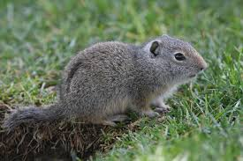

Let's take the Uinta ground squirrel example from the Gotelli book. Take a minute to read the description in Gotelli (end of Ch. 3)...

This is *real data* from a long-term experimental study.

The first life table (on the left) represents a cohort of ground squirrels in a population at typical densities.

The second life table (right) represents a cohort of ground squirrels in a population at lower-than-average densities (many conspecifics removed prior to the start of the experiment).

Load up the [Uinta ground squirrel life table data](life_table3.csv) given to us by Gotelli (reproduced from Slade and Balph 1974).

### QUESTIONS, Exercise 2 (more advanced life table analysis):

2a. Compare the two life tables using the following major life-table metrics: $R0$, $G$, $r$, and $V$. What changes do you notice between these two life tables?

2b. Is generation time ($G$) an intrinsic trait of a species, or can it vary as a function of factors like forage quality? How could you test this in Excel? What l(x) or b(x) entries might change in the Excel spreadsheet if the population experienced a substantial improvement in forage quality? Try it- describe what you changed, and how it affected generation time.

2c. [return to the black robin example] Imagine you have the following initial population of black robins: 10 individuals of age 2, 10 individuals of age 3 and 10 individuals of age 4. How would you **simulate** the abundance of robins in each of the 6 age classes next year? Try it, and explain how you got your answer!

## Exercise 3: age-structured models in InsightMaker

Let's build an age-structured model from scratch. To do this, you can follow these steps:

1. Open a blank workspace and save it.
2. Make three new stocks: *Age 1*, *Age 2* and *Age 3*.
3. Make a new flow called *Recruitment*. This should represent new *Age 1* individuals. We will ignore immigration for now, so new recruiment into the "Age 1" stock represents the only way new individuals can be added to the population. We will assume that *Age 2* and *Age 3* are the only reproductive ages. Therefore, draw links from *Age 2* and *Age 3* to *Recruitment*.
4. Make new flows from *Age 1 to Age 2* and from *Age 2 to Age 3*, called *Transition to Age 2* and *Transition to Age 3*, respectively. These flows represent **growth**, or advancement from *Age 1* to *Age 2* is dependent on the number of individuals in *Age 1*. Therefore, draw a link from *Age 1* to *Transition to Age 2*. Do the same for *Transition to Age 3*.
5. Make three new flows representing, emerging respectively from each stock and called *Age 1 mortality*, *Age 2 mortality*, and *Age 3 mortality*. The total number of deaths is dependent on the numbers in each stock, so draw links from each stock to the respective *mortality* outflow.

Your new insight should look something like this:

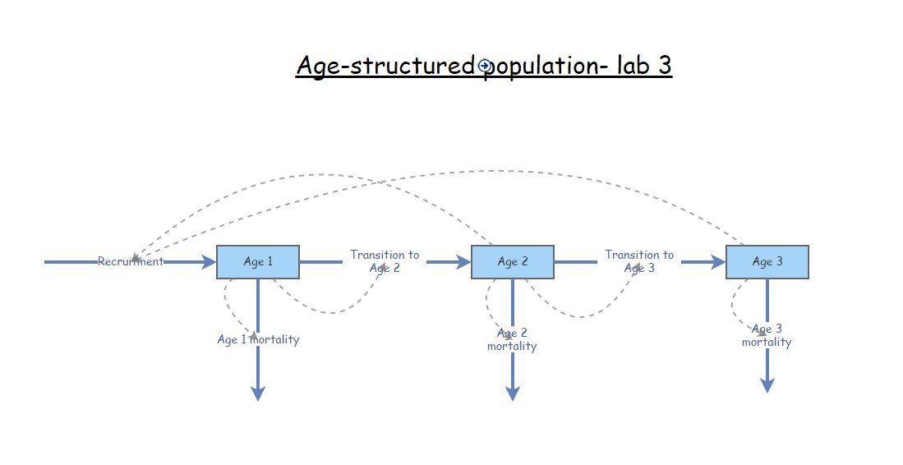

1. Parameterize your new age-structured population! 6a. For recruitment, make new variables called *Recruitment rate, age 2* and *Recruitment rate, age 3*, representing the per-capita recruitment rate for age 2 and age 3, respectively. Draw links from these variables to *Recruitment*, and set these variables at 1.1 and 1.8, respectively. Click on the equation editor for *Recruitment* and set the equation appropriately (see questions below) 6b. For the transitions, make new variables representing the per-capita transition rates, called *Transition rate, Age 1 to 2* and *Transition rate, Age 2 to 3*. Set these rates at 0.4 and 0.3, respectively. Now click on the equation editors for the transition rates, and specify the transition rates appropriately.  
   6c. For the mortality rates, note that all individual in the *Age 1* stock must either transition to *Age 2* or die. In addition, all individuals in the *Age 3* stock must die- there is no *Age 4* class! Now click on the equation editors for the mortality rates, and specify the mortality rates appropriately.
2. Explore the model- make sure you understand how it works!

### QUESTIONS, Exercise 3 (age-structured model in InsightMaker):

3a. What is the equation for *Recruitment* in the above model? Copy and paste your equation from InsightMaker. Now explain this equation in plain english!

3b. What is the equation for *Age 1 Mortality* in the above model? Copy and paste the equation from InsightMaker. Now explain this equation in plain english! What about *Age 3 mortality*?

3c. Initialize the population like the spadefoot toad example from lecture- so that the population consists of only individuals in the first (*Age 1*) age class. What population dynamics occur at the beginning of the simulation? What about the end of the simulation? How do the dynamics change if you change the simulation time step to 0.1?

3d. Can you tweak the initial abundances so that the population exhibits smooth exponential growth/decline for all three age classes? What is the **Stable Age Distribution** for this population? Would the stable age distribution change if you changed the vital rates (recruitment rates, transition rates etc.)?

3e. Is this a growing or declining population? Imagine you could enact a predator-control program and reduce the mortality of *Age 1* individuals. How much would you have to reduce mortality of this age class to make a growing population? What if you could only reduce *Age 2* mortality?

## Exercise 4: more complex age-structured models in InsightMaker!

Try to implement the following model (adding onto the previous age-structured model in InsightMaker). *If the total population (all three age classes combined!) exceeds 75 individuals, then recruitment rates drop to 25% of normal rates.*

4a. Please provide your full InsightMaker model (share with instructors and send as a link).

4b. Change the Age 1 mortality rate to 0.3. Run the simulation starting with 75 individuals, all in Age class 1. What happens? Is this a **stochastic** model? If not, why does it look like it has a random component?

## Checklist for Lab 3 completion

* Please bundle the materials into one Word document and submit to Professor Shoemaker and Margarete Walden *using WebCampus*!

The InsightMaker model (Q 4a) should be shared directly in InsightMaker (share with the instructors and send the URLs).

***Due Feb. 17 at 11 am.***

* Word document with short answers
  + **Exercise 1**
    - *Short answer (1a.)*
    - *Short answer (1b.)*
    - *Short answer (1c.)*
    - *Short answer (1d.)*
    - *Short answer (1e.)*
  + **Exercise 2**
    - *Short answer (2a.)*
    - *Short answer (2b.)*
    - *Short answer (2c.)*
  + **Exercise 3**
    - *Short answer (3a.)*
    - *Short answer (3b.)*
    - *Short answer (3c.)*
    - *Short answer (3d.)*
    - *Short answer (3e.)*
  + **Exercise 4**
    - *InsightMaker model (4a.)*
    - *Short answer (4b.)*