Lab 8: Population Viability Analysis: Vortex

Adult Survival: MARK known-fate Analysis

NRES 470/670

April 28, 2017

**Exercise 1- Population Viability Analysis**

Open VORTEX 10. Select “New Project.” This will bring you to the Project Settings screen. In the Project name box, name your project.

Now select the *Simulation Input* tab at top of the window. You’ll notice on the left side of the screen, there is a list of 14 blue links corresponding to a specific category of parameters. Each of these directs you to a window to input specific parameters and setting for your model. We will work through each of these windows as we progress through the setup. Below you will find a list of values separated by category for the parameters of your **base model**. The specified category will be listed in **Bold Blue** with a number in parentheses. The number in the parentheses indicates the number of parameters that will be changed or modified on each page. Listed after each category, you will find the name of the parameter or setting that will be changed and the value it will be changed to. Unless specified, please leave unlisted parameters set at the default setting.

Later on, we will be testing additional scenarios that deviate from the base scenario. Please note that you can add a scenario by selecting “Add” just below the *Simulation Input* tab in the top left corner.

**Step 1: Build the Base Mode**

First, we will parameterize our **base model**. Start with the Scenario Settings category and proceed through this list until the model is completely parameterized.

**Scenario Settings (5)**

Scenario Name: Base Scenario

Number of Iterations: 100

Number of years (timesteps): 100

Duration of each year in days: 365

Number of Populations: 1

**Species Description (1)**

Inbreeding depression: Uncheck this box

**State Variables (0)**

No changes on this page.

**Dispersal (0)**

No changes on this page and the tab should be greyed out because there is only one population.

**Reproductive System (7)**

Type of breeding system: Polygynous

Females breed from age 2 to age 10

Males breed from age 2 to age 10

Maximum age of survival: 12

Sex ratio (percent males) at birth: 50

**Reproductive Rates (4)**

Percent of adult females breeding each year: 98

SD in % breeding due to EV(SD): 0.05

Percent of adult males in the pool of breeders: 100

Normal distribution of brood size with mean: 1.7 with SD: 1

**Reproductive Rates (12)**

Female annual mortality rates (as percents):

Age 0 to 1: 64 with EV(SD): 13

Age 1 to 2: 29 with EV(SD): 3

After age 2: 29 with EV(SD): 3

Male annual mortality rates (as percents):

Age 0 to 1: 64 with EV(SD): 13

Age 1 to 2: 29 with EV(SD): 3

After age 2: 29 with EV(SD): 3

**Catastrophes (1)**

Number of Catastrophes: 0

This will grey out other options on this page because we are not including catastrophes in this model.

**Mate Monopolization (1)**

Percent of adult males in breeding pool: 100

**Initial Population Size (2)**

Initial Population Size: 2600

Ensure that you select “Use stable age distribution”

Your age distribution by sex should look something like this:

Age 0 1 2 3 4 5 6 7 8 9 10 11 12 Total

Females 0 307 238 184 143 111 85 67 51 40 31 24 19 1300

Males 0 307 238 184 143 111 85 67 51 40 31 24 19 1300

**Carrying Capacity (2)**

Carrying capacity: 4616 with EV(SD): 0

**Harvest (8)**

Population harvested?: Check the box

First year of harvest: 1

Last year of harvest: 100

Interval between harvests: 1

Number of females of each age to be harvested:

Harvest from age 1 to 2: 0

Harvest from after age 2: 0

Number of males of each age to be harvested:

Harvest from age 1 to 2: 229

Harvest from after age 2: 261

Your harvest parameter should look something like this:

Age 0 1 2

Females 0 0 7

Males 0 229 261

**Supplementation (0)**

We will not be including supplementation in our model. Ensure that this category is not populated**.**

**Genetics (0)**

We will not be including genetics in our model. Ensure that this category is not populated.

**Step 2: Run the Base Model**

Now that our model is parameterized, let’s see how our population performs. To run the model, click on the *Green Arrow* on the toolbar or press F5 on the keyboard. A window will pop up asking which scenarios you would like to include in the simulation. Ensure that the box next to base scenario is checked and click RUN. (Note: later on we will be testing different scenarios and you can check multiple scenarios to run simultaneously).

1a. Describe the overall population trend? Is this population at risk of going extinct? Provide your plot to back up your answer.

1b. Name one parameter that may be driving this trend? Justify your answer.

**Step 3: Demographics**

Now we will add a scenario by selecting “Add” just below the *Simulation Input* tab in the top left corner. A window will pop up. Select your Base Scenario as a base and select OK. Now, let’s take harvest out of the mix. Go to the **Harvest** category and deselect the “Population harvested” box.

We will now focus on adult female mortality. Leaving all else constant, test different values for adult female mortality (age 1 to 2 AND after age 2). Be sure that you use the same value for each when you make the modification. For each test, create a new scenario so you can refer back to them. Also, be sure to name this scenario appropriately so that you can identify the female survival specified for each scenario you created.

1c. What is the minimum decrease in adult female mortality required to ensure the population persists for the duration of the model? Please provide a plot to support your answer. (Note: you can run and plot multiple scenarios simultaneously).

1d. Why might female mortality have such a strong influence on population persistence? Justify your answer.

**Step 4: Harvest**

Now, we will test the effect of harvest on our population. Begin by adding a new scenario with the **Base Model** as the base. This time we will set adult female (age 1 to 2 AND after age 2) mortality to 15%. Now, let’s test different harvest scenarios. For simplicity, we will focus on male harvest and we will reduce harvest by a percentage evenly for both yearlings and adults. For example: Harvest is currently set at 229 and 261 for yearling males and adult males, respectively. A 10 percent reduction would result in the harvest of 206 yearling males and 235 adult males each year. Remember to create a new scenario for each test so you can refer back to them. Also, be sure to name this scenario appropriately so that you can identify the harvest reduction for each scenario you created.

1e. What is the maximum level of harvest that can be sustained long term for this population (population does not have a decreasing trend)? In other words, we want the population to persist, but minimize the amount we reduce harvest. Please provide a plot to support your answer. (Note: you can run and plot multiple scenarios simultaneously).

1f. Suppose adult female mortality is 15% and harvest is currently at the initial level specified in the base scenario. As a wildlife manager, what management recommendation would you make in regard to harvest for this population based on the scenarios tested in question 1e?

**Exercise 2- Known-Fate models in Program MARK**

Program MARK: Known-Fate Model

When we know the fate of each individual with certainty we can use the known-fate model. In these models encounter probability is 1.0. Studies utilizing radio-marked individuals are good candidates for known-fate. Collar data can be imported in an input file and then be used to estimate survival probability (S) based on a variety of factors (covariates). Known-fate models estimate survival probability between sampling occasions. We know the status of the individual (alive or dead) and therefore precision is usually quite high.

Below is a portion of the capture history used in the input file for this lab. The columns represent monthly occasion intervals. Each row is a capture history for an individual.



An abbreviated version might look something like:

|  |  |  |  |  |  |  |
| --- | --- | --- | --- | --- | --- | --- |
| **Occasion 1** | **Occasion 2** | **Occasion 3** | **Occasion 4** | **Occasion 5** | **Occasion 6** | **Occasion 7** |
| **00** | **10** | **10** | **10** | **11** | **0** | **0** |

“00” indicates that individual is absent in that study at that occasion

“10” indicates the individual being present and alive for that occasion

“11” indicates the individual is dead at that occasion

So the above example would read: Individual absent from the study for the first occasion. Present and alive for the next three occasions. Dead at the fourth occasion and absent for the remaining two occasions.

Question 2a:

Write out a known-fate history for an animal that was tagged and present in the first occasion of a 5 year study and then died in the third year.

Open Program Mark and load the provided know-fate model titled: PDH_KnownFate.

Three different models should already be loaded. These models allow time to vary differently.

The display should look like:

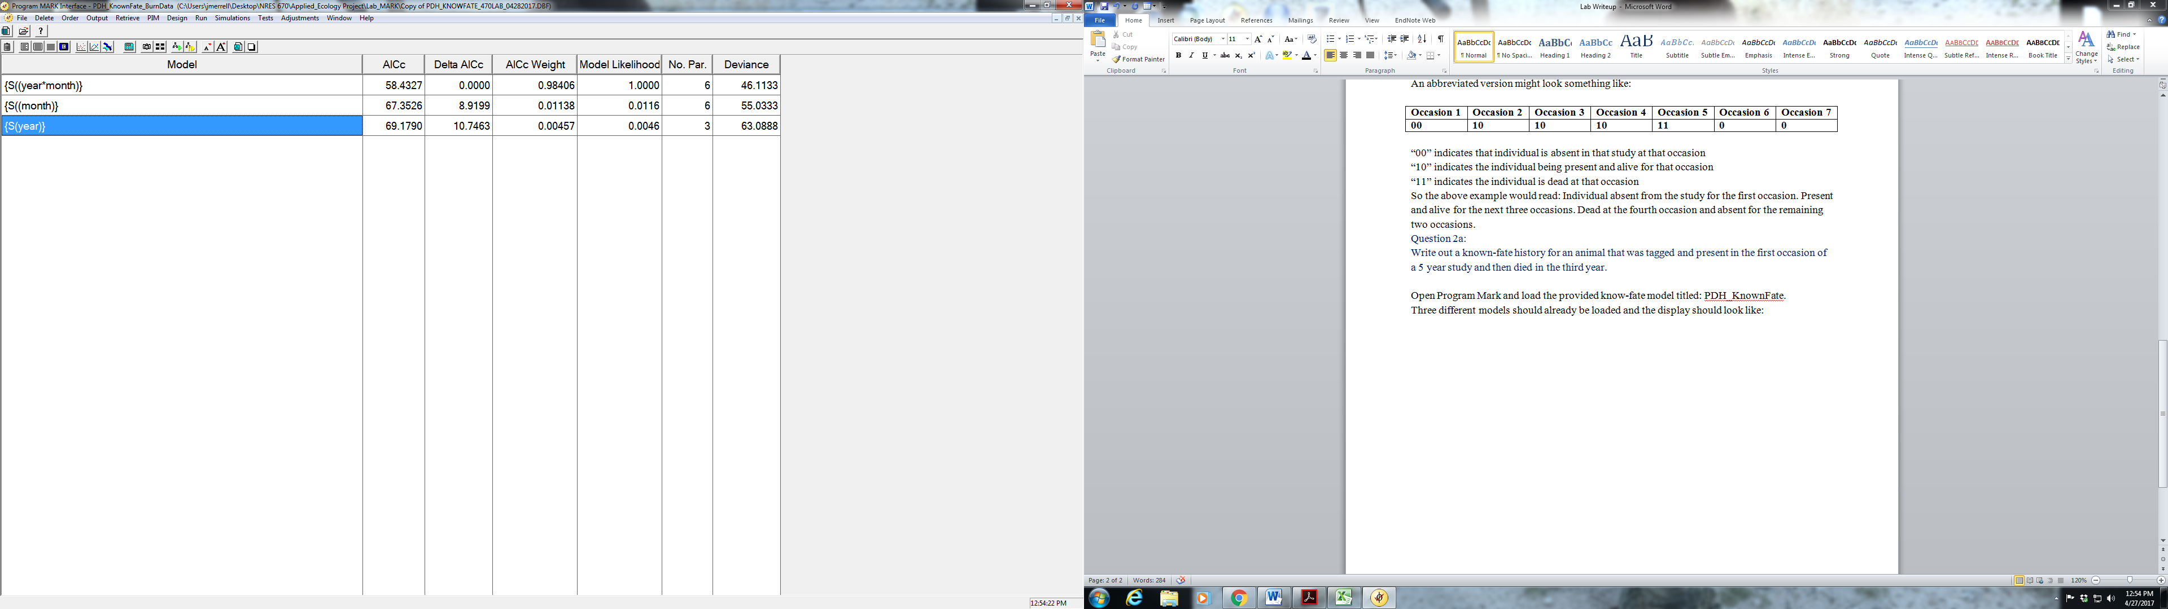

Model 1: S(year) is allowing time to vary by year.

Right click on this model. Select “Retrieve”. This will bring up the design matrix for this model.

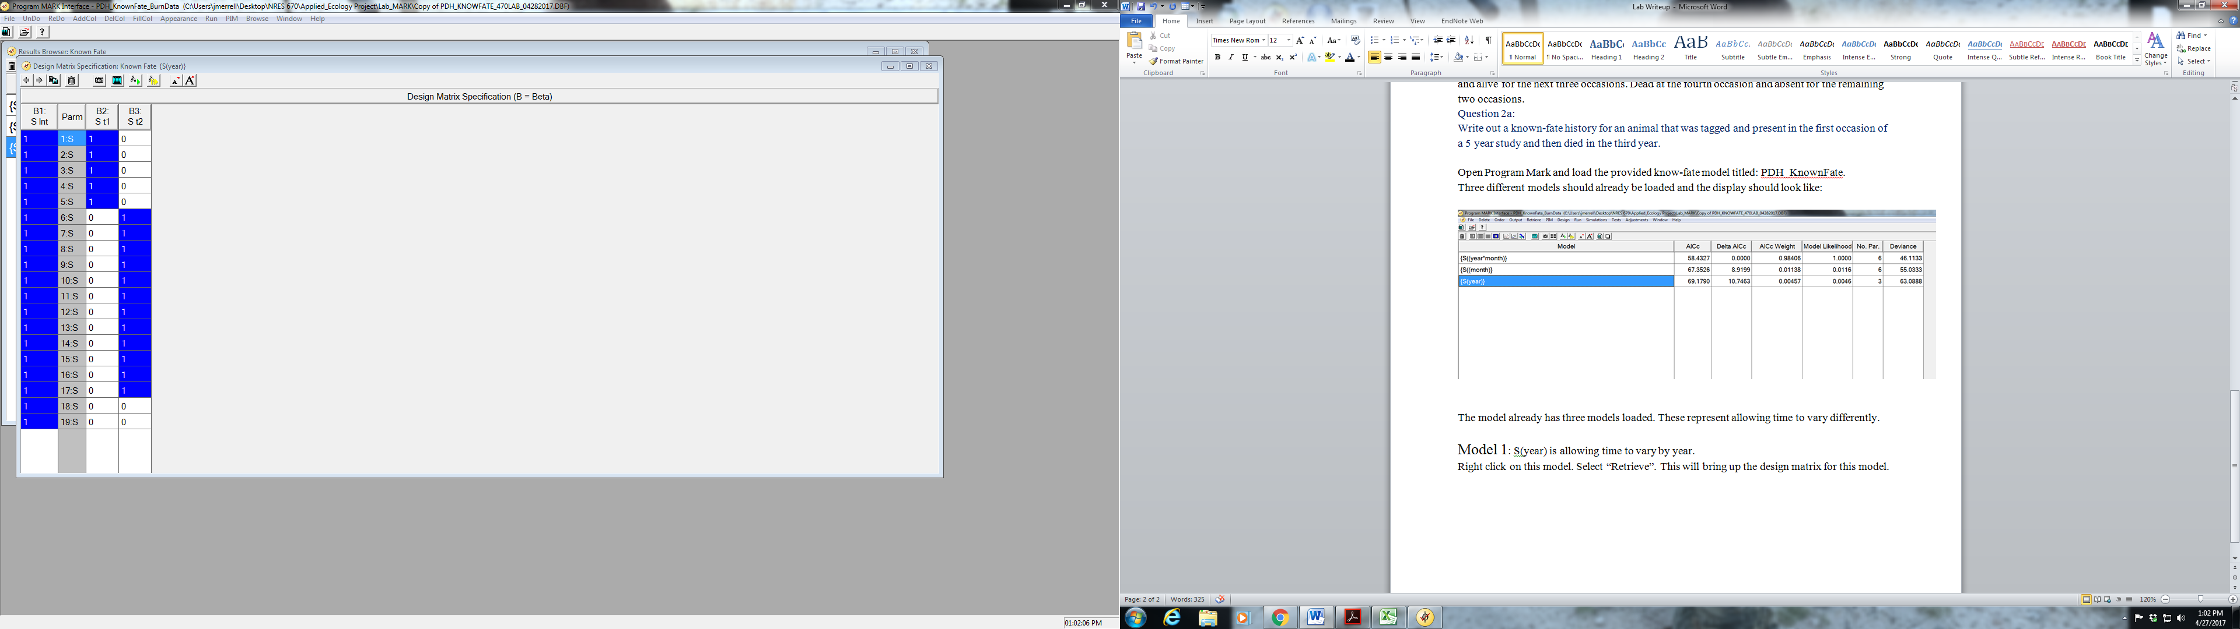

Model 2: S(month) is comparing months against each other. (i.e., all Mays together, all June’s together…) Right click and retrieve this model.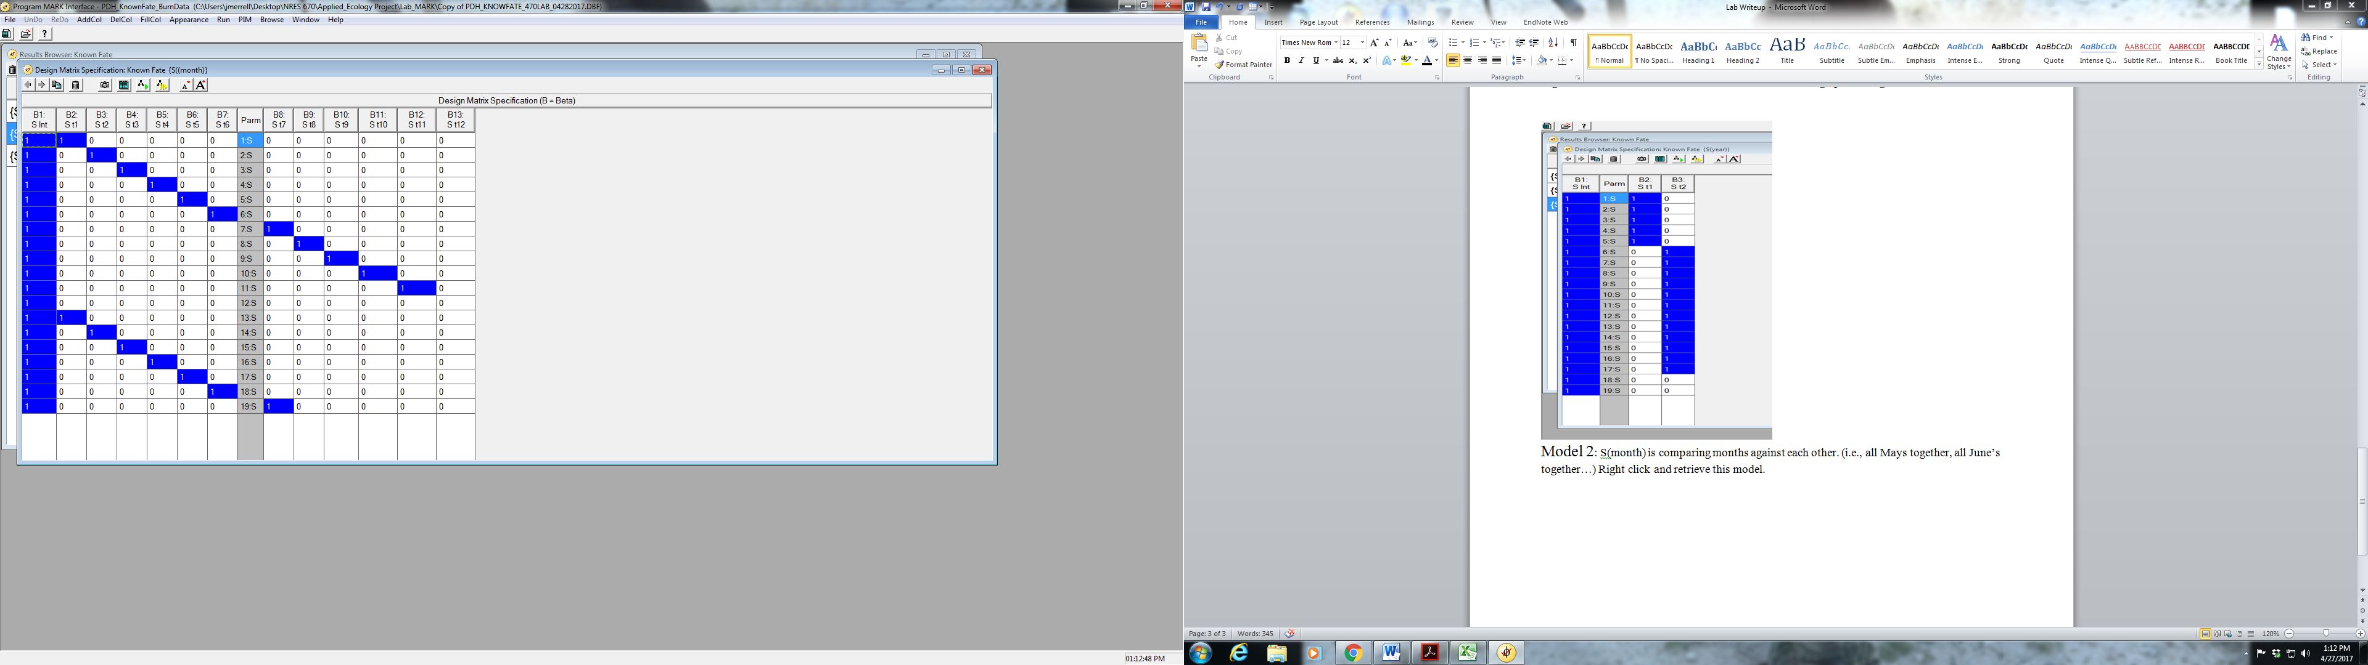

Model 3: S(year*month) is allowing each month to vary independently and is the top model for time. Right click and retrieve.

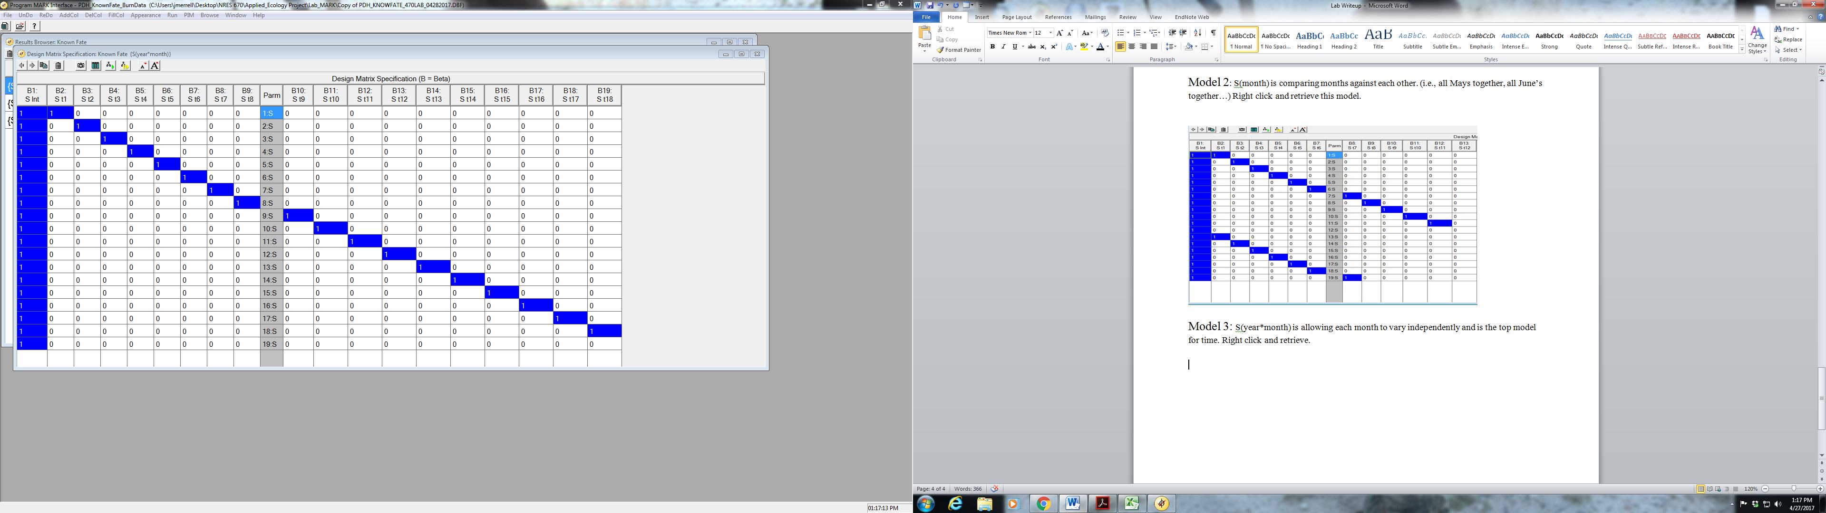

**Adding Covariates!!**

Covariate table

|  |  |
| --- | --- |
| **Body Condition Scores** |  |
| Body Length | Overall Body Length |
| Weight | Visually estimated body weight |
| Ribs | Body Condition Score-Ribs |
| Pelvis | Body Condition Score-Pelvis |
| Total | Total of all Body Condition Scores |
| **Migration** |  |
| 15_AM_STRT | 2015 Autumn Migration -Start Day |
| 15_AM_DAYS | 2015 Autumn Migration-Total Days Spent Migrating |
| 15_AM_DIST | 2015 Autumn Migration-Total Distance Migrated |
| 15_AM_SO_D | 2015 Autumn Migration-Number of Days Spent at Stop Over Sites |
| 16_SM_STRT | 2015 Spring Migration -Start Day |
| 16_SM_DAYS | 2015 Spring Migration-Total Days Spent Migrating |
| 16_SM_DIST | 2015 Spring Migration-Total Distance Migrated |
| 16_SM_SO_D | 2016 Spring Migration-Number of Days Spent at Stop Over Sites |
| 16_AM_STRT | 2016 Autumn Migration -Start Day |
| 16_AM_DAYS | 2016 Autumn Migration-Total Days Spent Migrating |
| 16_AM_DIST | 2016 Autumn Migration-Total Distance Migrated |
| 16_AM_SO_D | 2016 Autumn Migration-Number of Days Spent at Stop Over Sites |
| **King Fire Burn Usage** |  |
| 15_AM_MDIB | 2015 Autumn Migration Days Spent in Burn |
| 15_Total_D | Total Days Spent in Burn Area for 2015 |
| 16_SM_MDIB | 2016 Spring Migration Days Spent in Burn |
| 16_AM_MDIB | Total Days Spent in Burn Area for 2016 |
| 16­_Total_D | Total Days Spent in Burn Area for 2016 |

Now that we have our top model for time we can start adding covariates to see if we can strengthen the model. Select the S(year*month) model and retrieve the design matrix. Right click and a list will appear. Select “Add One Column”. Right click over the new Column and select “Individual Covariates” and a list of all the covariates will appear. Select the “Species” covariate (the Pacific Deer Herd has both mule and black tail deer) and add to the model. Run the model with the name {S(year*month+species)}(leave all other settings the same).

2b. Did adding species to this model improve it?

2c. Take your current top model and separately add “GIRTH”, “WEIGHT” and “PELVIS”. Which of the body condition covariates was best at predicting survival?

2d. Now we will add environmental factors to our model to see what effects they might have. Determining if days spent in the King Fire burn are influencing survival. Construct a model (using your current top model as a starting point) that incorporates days spent in the burn area throughout the year. Keep in mind that the occurrences are not all happening in the same year and that there are covariates vary by year. There is a table below that will help match up occurrences to months.

Did spending time within the burn area have an effect on survival? What would be the biological reasoning driving this?

|  |  |  |  |
| --- | --- | --- | --- |
| 1:S | August-15 | 11:S | June-16 |
| 2:S | September-15 | 12:S | July-16 |
| 3:S | October-15 | 13:S | August-16 |
| 4:S | November-15 | 14:S | September-16 |
| 5:S | December-15 | 15:S | October-16 |
| 6:S | January-16 | 16:S | November-16 |
| 7:S | February-16 | 17:S | December-16 |
| 8:S | March-16 | 18:S | January-17 |
| 9:S | April-16 | 19:S | February-17 |
| 10:S | May-16 |  |  |

Checklist for Lab 8 completion

* Please bundle all your responses into a single Word document and submit *using WebCampus*!

***Due***

* Word document with short answers, model URLs, and figures (where appropriate)
  + **Exercise 1**
    - *Short answer (1a.)*
    - *Short answer (1b.)*
    - *Short answer (1c.)*
    - *Short answer (1d.)*
    - *Short answer (1e.)*
    - *Short answer (1f.)*
  + **Exercise 2**
    - *Short answer (2a.)*
    - *Short answer (2b.)*
    - *Short answer (2c.)*
    - *Short answer (2d.)*