Data contains two types of data points

1. Fish locations and associated habitat variables at these locations
2. Other locations, or ‘available’ locations where habitat variables were collected

|  |  |
| --- | --- |
| Date | Date of observation |
| Pass | Generally, 2 passes were done for each date |
| Tag | Tag ID number or fish ID number |
| Lon | Longitudinal position within study reach  Ranges from roughly -30 → ~250  Indicates metres upstream from a designated starting point  This is the position of the fish at the time of the observation |
| Lat | Latitudinal position within the stream  Centimetres from the left bank (while looking upstream)  Not generally recorded for times when tag is recorded  Points collected at 20cm spacings from the left hand bank, so min(lat) = 20 and max(lat) I think goes up to about 200 or more, not above (I don’t think) |
| Depth | Water depth (cm) |
| Flow | Water velocity (m/s) |
| BR  B  C  P  G  S  Silt | Substrate proportions – how much of each substrate was present within a 10cm radius around each point.  Sum(BR:Silt) should equal 100 (100%)  Substrate particle sizes refelective of the “Wentworth Scale” (see geology textbooks) Boulder is the largest, Silt is the smallest, bedrock is just bedrock  Bedrock  Boulder  Cobble  Pebble  Gravel  Sand  Silt |
| Rip  Aqu  Und  leaf | Other habitat features present or absent at each point (1 = present, 0 = absent)  Overhanging ‘riparian’ vegetation  Aquatic veg / in-stream macrophytes  Undercut banks  Leaf litter/debris in-stream |
| Comment | Random comments – was the fish found dead, other stuff |

The first few rows are where fish were released (batch-released at a few locations)

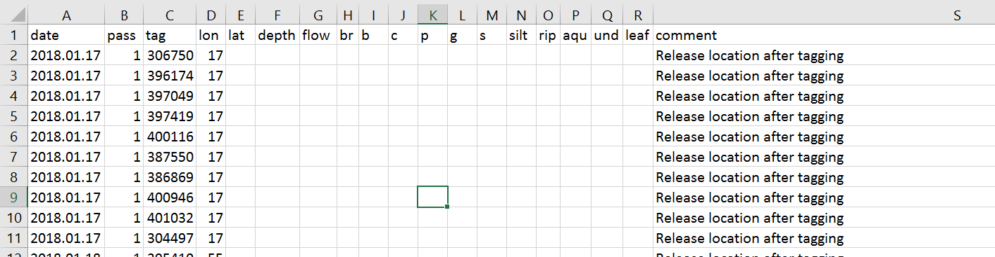

Then, when fish are located habitat variables are recorded (initially only for pass 1, but later for both passes 1 and 2)

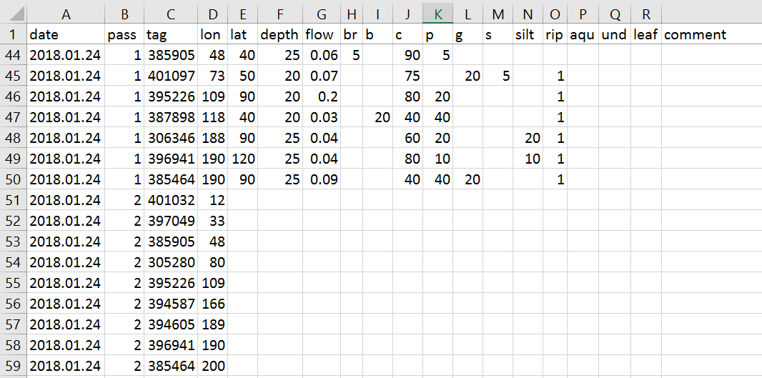

Or, habitat variables are recorded in the ‘available’ locations

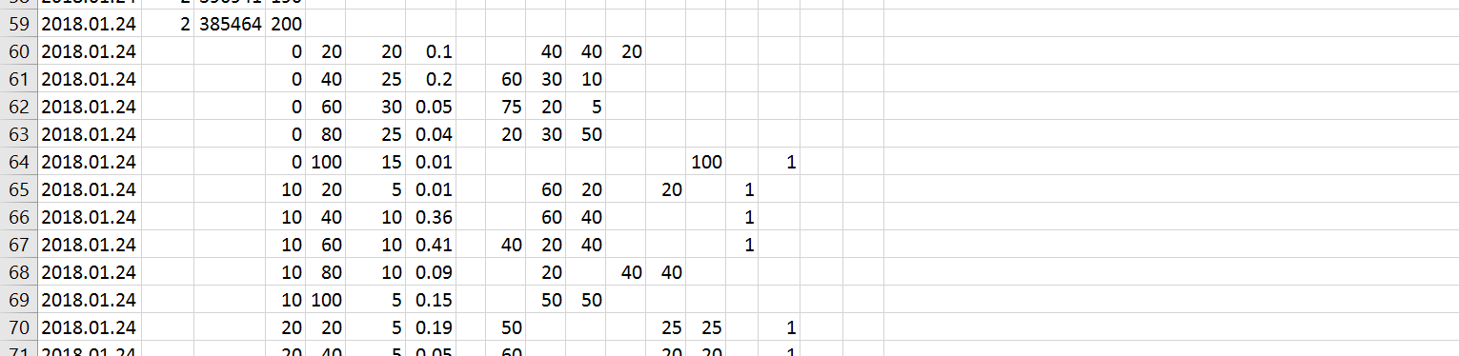

Questions:

Do fish prefer to use areas with high proportions of certain substrates?

* We may expect fish prefer areas of larger substrates (boulder, cobble), and less of small substrates (silt, sand)?

Do fish prefer some of the other habitat variables (rip, aqu, und, leaf)?

* We may expect fish like these habitat features as they provide cover from predators etc

Do fish prefer areas of fast/slow water, and likewise deep/shallow water?

* Also, depth may be related to velocity, which may be related to dominant substrate type (higher velocity = larger substrate particles)

Or, do fish just use the available habitat in the proportions that it is available?