Stoat control does not lead to larger mouse eruptions in New Zealand beech forest

The draft introduction for an article manuscript prepared for the Wildlife Research journal

Table of Contents

Summary 2

Introduction 2

Methods 6

Data collection 6

Analysis of the capture-mark-recapture data 7

Seedfall 9

Treatments 10

Stoat treatment 10

Rat treatment 10

Statistical tests 11

Prediction A 11

Prediction B 11

Prediction C and D 12

Prediction E 13

Overall priors 13

Software 13

Results 14

Seedfall 14

Mice 15

Rats 15

Prediction A 16

Prediction B 17

Prediction C 18

Prediction D 19

Prediction E 20

Discussion 21

Stoat control 22

Rat presence 23

Seed avalabibility 24

Management implications 24

Predator-free NZ 25

Editor?? 26

# Summary

A computationally reproducible manuscript for *Draft* manucript [Davidson *et al.* 2020].

*Mouse populations* ***were not*** *affected by stoat control during any of the four seasonal seasons of New Zealand beech forests.*

*Outcomes from predictions A-D did* ***not change*** *when rat populations were manually reduced to lower densities.*

[*contents page coming*]

# Introduction

Worldwide, but particularly on islands, introduced predators have had significant impacts on native populations (Gurevitch and Padilla 2004), and in the worst cases global extinctions (Doherty and Ritchie 2017; Towns 2011). On the Island of Guam, the invasion of the Brown Tree Snake (*Boiga irregularis*) was identified as the primary driver of multiple local extinction events (Fritts and Rodda 1998) and foxes predate heavily on native marsupials throughout Australia, impacting the geo-spatial range of many native species (Kinnear et al. 2016). In New Zealand, mammalian predators contribute to a disprorpoitatly large group of invaders that impact native populations nationally (Saunders and Norton 2001). Introduced species have destructive impacts on native birds in New Zealand’s (NZ) remaining/remnant native forests. In these systems direct predation is commonly proposed as the reason for native species decline (Fritts and Rodda 1998; Kinnear et al. 2016). These contemporary ecological communities usually contain at least one of the following four mammalian predators (King 2005); Stoats (*Mustela erminea*); Brushtail possums (*Trichosurus vulpecula*);Ship rats (*Rattus rattus* referred to as rats); House mice (*Mus musculus*; referred to as mice).

Stoats are regarded as the top predator when they are present in these ecosystems (King 1983), following their deliberate introduction in the late nineteenth century (King 2017). Stoat control is commonly undertaken in these systems to protect native species that are vulnerable to mammalian predation (White and King 2006), in particular, hole-nesting species like mohua (*Mohoua ochrocephala;* O’Donnell, Weston, and Monks (2017)). However, the primary food source for stoats in NZ forests are rodents (Jones et al. 2011), and consequently there is a concern that reducing stoat populations to protect native species may allow rodent populations to increase (e.g Rayner et al. (2007)). An increase in the number of rats and mice would offset the benefits of stoat control because rodents are known to consume the eggs, chicks and even adult birds (Russell et al. 2015; Towns, Atkinson, and Daugherty 2006; Latham et al. 2017), directly compete with native species for food resources such as flowers and seeds (McQueen and Lawrence 2008) and predate on invertebrates (Ruscoe et al. 2012). In this paper we address the question: does stoat control lead to increased abundance of rodents, particularly the most common rodent, mice, in NZ beech forests?

Studies elsewhere in the world have shown that removing or reducing the abundance of a top predator often leads to an increase in the numbers of predators at lower trophic levels (termed mesopredator release; for a review see Prugh et al. (2009)), which in turn, can lead to suprising outcomes(Caut, Angulo, and Courchamp 2009) and often negative outcomes for native species (for examples see Rayner et al. (2007); Robles and Desharnais (2002)). While mesopredator release has been widely documented elsewhere, it is unclear if stoat control in NZ forests will cause rodent populations to increase in the wild. Rodent populations in NZ forests are predicted to respond strongly to variation in food supply (Choquenot and Ruscoe 2000; Ruscoe, Goldsmith, and Choquenot 2001; Blackwell, Potter, and Minot 2001; Blackwell et al. 2003; Ruscoe et al. 2005; Tompkins and Veltman 2006; Tompkins, Byrom, and Pech 2013; Holland et al. 2015; Latham et al. 2017), primarily seed availability (Figure 1).

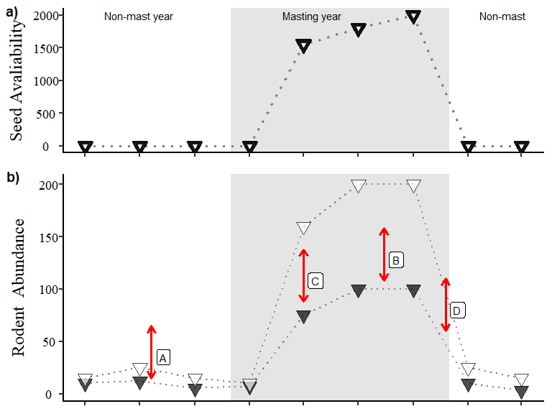

Figure 1: Expected changes in rodent populations in New Zealand beech forests (bottom panel) in response to changes in seed availability (top panel) during non-mast and mast years (grey blocks). In the bottom panel, differences between the hollow and filled symbols represent the proposed differences between areas with and without stoat control respectively. The arrows labelled A-D represent four of the five proposed outcomes of stoat removal that we tested; A) during non-mast years when little seed is available we expect that mice populations will be similar, B) at the peak of mouse abundance (during winter and spring in mast years) when we would expect larger mouse populations in areas where stoats are absent (hollow symbols), C) during increased seed availability (generally between Summer and Autumn), we expected areas with stoat control to also have larger mouse populations; D) when mouse populations are declining from peak abundance, stoats would additionally reduce mouse abundance through predation in addition to other density dependent processes.

This is particularly pronounced in beech forests (spp. *nothofagus*) throughout New Zealand, where, between years beech seed production is highly variable. Little seed is produced in most years (Figure 1a: non-mast years) with occasional years of high seed production (Figure 1a: mast years; grey boxes). Mouse populations are low in the non-mast years, due to low food availability (Choquenot and Ruscoe 2000; King 1983). In mast years, when seed becomes abundant, mouse populations can increase quickly following a predictable seasonal cycle. Seed begins to fall and accumulate on the forest floor in late summer (February) allowing mouse populations to increase, with mouse populations typically remaining high through winter (August) and into the following spring (November). Beech seed that is not consumed by mice and other seed predators germinates in spring to early summer, meaning this food resource disappears and mouse populations begin to decline in the subsequent seasons. If the following year is a non-mast year with little seed available, mouse populations fall to low levels.

Previous studies have investigated the likely response of mouse populations to stoat control by modelling the outcome of interactions between stoats, mice and seed availability. Blackwell, Potter, and Minot (2001) made four predictions regarding the likely effects of stoat predation on mouse dynamics (see Figure 1 arrows) with a subsequent field study (Blackwell et al. 2003) concluding that stoat predation should have minimal effects on the population dynamics of mice. The authors identified three different phases in the eruption cycle where stoats could have an effect (Figure 1) and indicated that stoat control had little detectable effect on mouse populations during the peak, decline and low phases of the beech eruption cycle. Subsequent modelling work reached similar conclusions (Tompkins and Veltman 2006; Tompkins, Byrom, and Pech 2013) but identified that the response of mice to stoat control should depend on interactions with rats. Specifically, (Tompkins, Byrom, and Pech 2013) concluded that, where rats were present, stoat control alone should allow rats to increase, which would have a suppressive effect on mouse populations through either predation or competition. In contrast, when both stoats and rats were controlled, mouse populations could increase to higher levels than in the absence of control (see Figure 1).

Our aim was to test the predictions outlined above and in both Blackwell et al. (2003) and Tompkins and Veltman (2006) using data from our independent, large-scale field study. Specifically, during our study we measured the abundance of rodents on trapping grids over six years in beech forest in two adjacent valleys, one with intensive stoat trapping and one without. In each valley we also manipulated rat densities by including trapping grids where rats were removed and compared these to grids without rat removal. This allowed us to examine if predicted responses of mouse populations to stoat control (see Prediction A-D) was influenced by interactions with rats (Prediction E).

# Methods

We carried out our study in beech forests in the South Island of New Zealand, in two adjacent valleys: the Eglinton Valley (GPS *co-ord*, S ${44}^{∘}$ $45'$ S ${168}^{∘}$ $10'$ E $m.a.s.l$) and the Hollyford Valley (GPS *co-ord*, S ${44}^{∘}$ $2'$ S ${168}^{∘}$ $5'$ E $m.a.s.l$). Stoats were the main predator and mice were the most abundant rodent species (King 1983). Ship rats (*Rattus rattus*; Innes (2005)) and kiore (*Rattus exulans*; Roberts (1991)) were also present but at much lower numbers (King (1983); Ruscoe, Goldsmith, and Choquenot (2001)). Intensive stoat control has been under taken in the Eglinton Valley since 1983 and no stoat control had been conducted prior our study in the Hollyford Valley (*pers comms*).

We tested whether reducing predator populations by stoat control influenced mouse population dynamics as shown in Figure 1, and whether the outcomes were affected by interactions between mice and rats. Specifically, we tested the following five predictions (Blackwell, Potter, and Minot (2001); Blackwell et al. (2003); Tompkins and Veltman (2006); and Tompkins, Byrom, and Pech (2013); Figure 1: Prediction A to D). If stoat control affects mouse population dynamics then, relative to sites with stoat control (Figure 1; hollow symbols), mouse populations at sites without stoat control should exhibit changes in abundance in the direction of red arrow in Figure 1:

1. Higher mouse abundance in non-mast years;
2. Higher peak mouse abundance in mast years;
3. A faster rate of mouse population increase in response to high seed availability in late summer/winter;
4. A slower rate of mouse population decline from peak abundance;
5. Predictions A-D should hold only when both stoats and rats are controlled.

## Data collection

To test Predictions A-E, we use data from four trapping grids, in each valley, with each grid located at least **xx** kms apart. On each grid, we monitored the abundance of rodent species (mice, rats and kiore) using live capture Elliot traps (**Landcare Research Animal Ethics Approval number 02/99**). Each grid comprised of $81$ traps, each $20$ metres apart in a $9×9$ grid covering a total area of $2.56$*ha* ( $25600$ $m^{2}$).

We estimated the abundance of rodents on each grid using capture-mark-recapture techniques (CMR), assuming a closed population during each trip, which typically lasted five nights. Traps were set each night and all rodents captured were marked with ear tags so that individuals could be uniquely identified. Mice had a single unique ear-tag, and each individual was ear notched with a notch position that identified the season of first capture so we could identify animals that had been captured but had lost ear tags. Rats were double ear tagged. We sexed and weighed each captured animal. We aimed to trap for five nights during each trapping session (trip) but due to unfavourable weather, some trips were shorter.

To measure food availability, we recorded the amount of seed reaching the forest floor (seedfall) by placing four standard circular seed-traps on each grid. Each seed trap had a radius of $0.125$ metres ($m$)equating to an area of $0.0491m^{2}$ metres and a overall sampled area on each grid of $0.1964m^{2}$. These seed traps were in place for the duration of the study, with each trap elevated $1.2$ metres above the ground and covered by wire netting to exclude seed predators. The contents of each seed-trap were collected once during each trip and the contents were sorted to remove unwanted plant matter (e.g. leaf litter). We counted beech seeds, recording only those with a kernel because rodents are known to only consume the kernel of beech seeds (Ruscoe et al. 2005).

Rats could influence the population dynamics of mice through overlapping diets (King 2005; McQueen and Lawrence 2008), or direct predation (Bridgman et al. 2013). During our study we captured rats (ship rats and Kiore combined) less often than mice. Due to the low recaptures in this dataset we regarded it as not complete enough to fit a full capture-recapture analysis. As a less precise approximation we used the number of unique rats captured on each grid during each trip (the minimum number alive) as an index of rat abundance ($R_{j,t}$).

## Analysis of the capture-mark-recapture data

We used a capture-mark-recapture model (CMR) to estimate the number of mice $(N_{j,t})$ on each grid ($j$) during each trip ($t$), assuming the numbers of mice on each grid were independent of each other and that the populations on each grid were closed for the duration of each trip. We had data on the number of times each mouse, $i$, was captured on each grid, during each trip ($y_{i,j,t}$). We used the method described in Royle, Dorazio, and Link (2007) to estimate the true abundance of mice from the CMR data using data augumentation (Royle 2009; Royle and Dorazio 2012). The benifit of this approach allowed us to combinedatasets from different sites and to build study specific predictions/tests. To do this we augmented our data for each individual mice captured on each grid during each trip with pseudo-individuals. Each psuedo-individual represents a mouse that were potentially present on the grid but were not captured during our study. For these pseudo-individuals, the number of captures $y_{i,j,t}$ was set to zero. Each individual mouse, including the pseudo-individuals, was assigned an indicator variable $z_{i,j,t}$ taking the value 1 if the individual was present on the grid and 0 otherwise. For mice that were captured, $z_{i,j,t}$ was known and takes the value 1. For the pseudo-individuals, the value of $z_{i,j,t}$ is unknown and was estimated by the model as being drawn from a Bernoulli distribution with overall probability of an individual mouse being present on a grid during a trip as $psi_{j,t}$:

$$z_{i,j,t}∼Bernoulli(psi_{j,t})$$

The probability that an individual mouse (including pseudo-individuals) was captured $y_{i,j,t}$ times was drawn from a binomial distribution with probability, $μ_{i,j,t}$, conditional on the number of nights trapping on each grid during each trip $J_{j,t}$.

$$y_{i,j,t}∼Binomial\left(μ_{i,j,t},J_{j,t}\right)$$

$μ_{i,j,t}$ is the probability an individual was captured during one night of trapping on a grid. This probability depends on whether the individual was present on the grid or not ($z_{i,j,t}$) and the probability of capture conditional on presence ($p_{i,j,t}$).

$$μ_{i,j,t}=z_{i,j,t}×p_{i,j,t}$$

We specified the number of pseudo-individuals ($m_{j,t}$) to be $4×$ the total number of mice captured on each grid during each trip ($N_{j,t}$), which should be sufficient to ensure a non-informative prior for the number of mice on each grid during each trip (Royle, Converse, and Link 2012; Ruscoe et al. 2011). We anticipated that the capture probabilities could vary between grids and trips, and there is often heterogeneity among individuals in capture probability for small mammals (Krebs et al. 2011). We therefore modelled variation in individual capture probability on the logit scale, allowing for heterogeneity by assuming values were drawn from a normal distribution with a different mean for each trip and grid ($μ.ind_{i,j,t}$). and a variance estimated from the data, which reflected unobserved among-individual heterogeneity. The mean capture probabilities for each trip and grid ($μ.ind_{j,t}$) were modelled hierarchically, treating them as draws from a normal distribution with overall mean and variance estimated from the data.

$$logit(p_{i,j,t})=lp_{i,j,t}$$

$$lp_{i,j,t}∼Normal(μ.ind_{j,t},τ.ind)$$

$$μ.ind_{j,t}∼Normal(μ_{p},τ_{p})$$

We estimated the number of mice on each grid during each trip $N_{j,t}$ by summing the values of $z_{i,j,k}$.

$$N_{j,t}=∑z_{i,j,t}$$

## Seedfall

Our study aimed to determine the relationship between stoat control and mice populations. Differences in food avalaibility between populations (grids) was collected using a standard seedtrap methodology for beech forests [cite??]. Within each population, an individual mouse can only consume a maximum amount of seed in any given time period between t and t+1. To incorporate this individual “intake rate”($S_{j,t}$) we fitted three relationships previously proposed in the literature to our observed field data (seedfall);

1. a linear relationship between seed availability and $r_{j,t}=β_{0}+β_{1}(Seed_{j,t})$;
2. a decelerating relationship similar to a Type II response $r_{j,t}=β_{0}+β_{1}(log(Seed_{j,t}))$;
3. a relationship based on a Type II functional response $r_{j,t}=1042.1\left(1-e^{-(Seed_{j,t}×0.00139)}\right)$.

The data used to fit our models were collected in the same valley (Eglinton Valley) as Ruscoe et al. (2005). Ruscoe et al. (2005) fitted a wide range of functional responses to laboratory data harvested from the same valley as rates of increase in mice populations ($r_{j,t}$). They concluded that the IR (type II functional response) proposed by Choquenot and Ruscoe (2000) and extended in Ruscoe et al. (2005) was the best fitting functional response from experimental data. We used the transformed variable from the best fitting model above to incorporate individual “intake rate” $S_{j,t}$. After fitting the curve between seedfall and mouse abundance in our data we selected the best fitting model using AIC (**???**). The *intake rate* we used was $S_{j,t}=log(Seed_{j,t})$.

Other demographic and environmental processes are also known to regulated mouse populations in New Zealand beech forests (Ruscoe et al. 2005). Population density has been identified as a key driver of mouse abundance in multiple studies in similar forest systems to this research (Choquenot and Ruscoe (2000); Holland et al. (2015); Ruscoe et al. (2005)). In previous research it was still not clear what exact density dependent processes were acting on mouse populations, however, it is still regarded that they are an important component of mice dynamics (Holland et al. 2015). In our model we included the estimate of mouse abundance ($N_{j,t}$) at the beginning of each time step as a crude measure of density dependence.

## Treatments

We aimed to test our predictions about the effects of stoat control by comparing mouse population dynamics in the two valleys. However, because we lacked replication at the valley-level, we could not be certain that differences in mouse population dynamics between valleys was due only to the presence or absence of stoat control. To overcome this, we undertook stoat control in the Hollyford Valley commencing in May 2002, allowing us to examine mouse dynamics in the presence or absence of stoat control in the same valley in addition to the between-valley comparison.

### Stoat treatment

Stoats were removed in the Hollyford Valley using 13 Fenn Traps (are they following the road wendy? On map?). The original treatments applied to the eight grids (two valleys; one with stoat control, one without, and; four grids in each valley, two with rat control and two without) were maintained from May 1999 to May 2002. From November 2002 until the end of the study (August 2004), we reduced the number of trapping grids to three in each valley.

### Rat treatment

We experimentally reduced rat (kiore and ship rats collectively) densities on two randomly selected grids in each valley by removing and humanely killing all captured rats on those grids. On the remaining two grids in each valley, we marked and released rats, as we did for mice on all grids. We undertook a total of $20$ trips to the two valleys, with each trip spaced three months apart from May 1999 to February 2004. The timing of trips during the year corresponded to each of the four seasons (February = Summer, May = Autumn, August = Winter, and November = Spring).

## Statistical tests

Prediction A and B were tested using a mixed-model structure (GLM) to account for heterogeneity in estimates. We accounted for the spatial heterogeneity between valleys (Eglinton and Hollyford Valleys) and our rat removal conditions where, on some grids, rat numbers were artificially reduced).

Mice are known to be under different processes during each of the four seasons of the year. We added season as a random co-variate to test prediction A to allow for the effect of varying seed by taking the relative “intake rate”. We assessed model fit using AIC and assessed model fit using visual assessment of residual diagnostics to check the model assumptions were meet.

### Prediction A

We tested if stoat control would resulted in more mice during non-mast years when mouse abundance was low (Prediction A) using equation below:

$$N_{t}∼β_{0}+β_{1}(Valley_{t})+β_{2}(Control_{t})+β_{3}(Rat_{t})+β_{4}(Rat_{t}:Control_{t})$$

We compared the average mouse abundance from our CMR model in each grid, grouped by our three treatments ($Valley_{j},Control_{j},Rat_{j}$. We only selected grids and trips in low seedfall years (Figure @ref(fig:figure-one-plot1; label A) for this test. We used the replicates in these non-mast years (n = 42) to compare the mean differences in areas with and without stoat control using a two-way analysis of variance (ANOVA). We log transformed mouse abundance for the general parametric assumption of normality of this simple test and to bound the results to above one (count data).

### Prediction B

$$log(\frac{N_{t}}{S_{t}})∼β_{0}+β_{1}(Valley_{t})+β_{2}(Control_{t})+β_{3}(Rat_{t})+β_{4}(Rat_{t}:Control_{t})$$

We tested if stoat control resulted in *higher peak mouse abundance* (Prediction B) after accounting for the fact that peak abundance on grids would be partly driven by seedfall (King 1983). We therefore compared the number of mice per seed ($\frac{N_{j}}{S_{j}}$) among grids with and without stoat control using the same ANOVA test as Prediction A.

### Prediction C and D

To test prediction C and D (increasing and decreasing phases of mouse dynamics) we needed to incorperate the other factors known to affect mouse populations. We estimated ($r_{j,t}$) by grouping replicates by Stoat Control(S), Valley(V) and Rat removal conditions(C). we used the complete data likelihood approach described by Schofield and Barker (2014) (for details see supplementary material) to propagate the uncertainty in our abundance estimates. We then tested predictions C and D we compared rates of increase with and without stoat control using the associated model co-effiecents.

To test Prediction C and D we modelled the rate of increase of mice ($r_{j,t}$) between successive seasons (Figure 1) with rate of increase calculated as:

$$r_{j,t}=log\left(\frac{N_{j,t+1}}{N_{j,t}}\right)$$

We identified the most appropriate numerical response to test with our predicitons and model system.

$$r_{j,t}=β_{0,S,V,C}+β_{1,S,V,C}(S_{j,t})+β_{2,S,V,C}(N_{j,t})+β_{3,S,V,C}(R_{j,t})$$

To test Prediction C and D respectively (*does stoat control increase the rate at which mouse populations initially increasing/decreasing in response to beech seed intake*) we compared the population model intercept ($β_{i}$) between grids, with and without stoat control. Where $β_{0,S,V,C}$ (model intercept) is equivalent to $r_{j,t}$ when all other parameters are set to mean for each group (treatment); $β_{1,S,V,C}$ is the adjusted[1] effect of a intake rate ($S_{j,t}$) on $r_{j,t}$; $β_{2,S,V,C}$ is the adjusted effect of a single unit change in mouse density at the beginning of the previous season $N_{j,t-1}$ and $β_{3,S,V,C}$ is the adjusted effect of a single unit change of the minimum number of rats alive ($R_{j,t}$) at the beginning of the previous season $R_{j,t}$. If mesopredator release occurs in the increasing seasons; the intercept ($β_{0}$) for the areas with stoat control will be greater than the uncontrolled areas.

### Prediction E

We tested if $r_{j,t}$ (mesopredator release) only occurs when *rat populations are reduced to low densities.* (Prediction E) by comparing differences between population model coefficient for rats ($β_{3}$) grouped into the grids where we reduced rat densities and the others that where not. If rat interactions are sufficiently high to impact mice populations but only when stoats are at low levels would result in differences between these parameter estimates with replicates (trips and grids) showing differing population dynamics.

### Overall priors

Non-informative prior distributions were selected to allow the data to drive parameter estimation (Gelman and Pardoe 2006). The prior distributions of capture histories were assigned binomial distributions and variance terms were assigned broad uniform prior (0-100) as suggested by Gelman and Pardoe (2006). The remaining parameters were assigned normally distributed prior with mean 0 and variance 0.00001. Each model was run for 100 000 iterations with a burn-in of 50 000 iterations, which was sufficient to achieve convergence as judged by visual inspection of the chain histories (Bronder, n.d.). For a full model description see Appendix.

## Software

Models were fitted in a Bayesian framework using Markov Chain Monte Carlo (MCMC) methods and implemented in JAGS (Plummer 2011), called from R v.4.3.4 using the jagsUI package (Kellner 2018). Software pipeline used to reproduce this manuscript was generated using workflowr, rmarkdown using a tidyverse approach and the following additional packages (*cite all other packges?*)

# Results

We captured at total of 2370 individual mice, 219 ship rats, and Kiore during a total of 94 trips. The stoat control operation in the Eglinton Valley removed a total of 792 individual stoats between January 1999 and June 2001 (Choquenot and Ruscoe 2003). During this operation, low numbers of rats were also removed as by-catch in stoat traps but no other independent predator control was conducted in either study Valley during our data collection. Incidental stoat captures during our routine rodent trapping sessions were uncommon (proportion of total captures that were stoats < *0.01*). Lower numbers of stoats were captured in the Eglinton Valley ($N_{stoats}=8$) where the long-term predator control program was undertaken than the Hollyford Valley ($N_{stoats}=20$).

## Seedfall

Our study captured two years (2000 and 2003) of generically high seedfall (seedfall > $2000m^{2}$). During 2001, 2002 and 2004 we observed low seedfall on all grids (Figure ??). We observed high spatial variability both between and within each trip. For example, in 2000, the observed difference in seedfall between grids varied from the highest largest estimate of available seed ( $Seed_{7,2}$ = 3387 $m^{2}$); Eglinton Valley) and two grids in the Hollyford Valley recorded zero seedfall on the same trip ( $Seed_{4,2}$ and $Seed_{4,5}=0$ $m^{2}$).

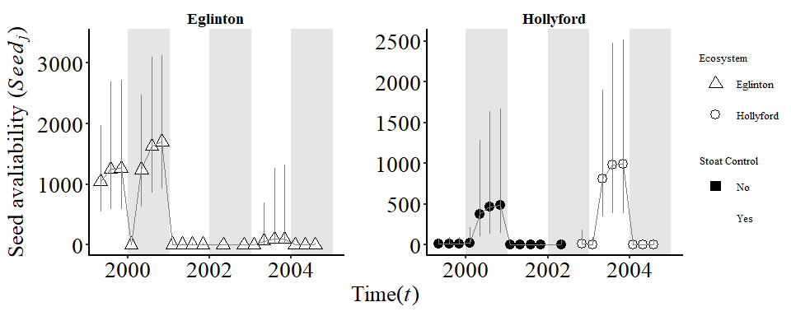

Figure 2: The average beech seedfall collected each season during the study period (Autumn 1999 to Winter 2004; n = 20). The shape distinguishes the two valleys apart (triangles = Eglinton Valley, circles = Hollyford Valley). Hollow symbols represent cases where stoats are controlled and solid fill in valleys with stoat were uncontrolled.

## Mice

We estimated mouse abundance ($N_{j,t}$), where $j$ represents each unique grid and $t$ for each trip from the overall community dynamics model. We found that mouse abundance was greatest in the Eglinton Valley in grids and trips where seed availability was also high. In any given year mouse abundance was on average greater in the Eglinton Valley (Figure 3; triangles) than the Hollyford Valley (Figure 3; circles).

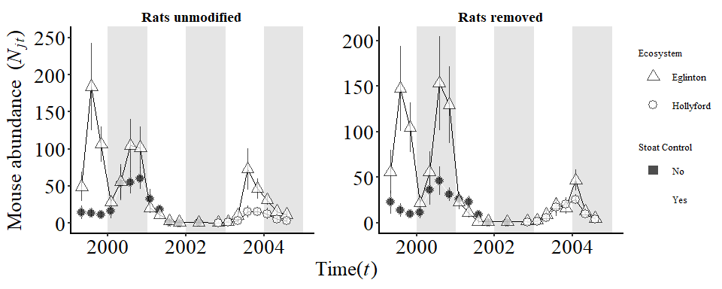

Figure 3: The abundance of mice ($N_{j,t}$; point estimates) collected each trip during the study period (Autumn 1999 to Winter 2004). The shape distinguishes the two valleys apart (triangles = Eglinton Valley, circles = Hollyford Valley) and solid symbols represent cases where stoats are uncontrolled and hollow in valleys where stoat control was undertaken. Rats were removed in the right hand figure.

## Rats

Rats and mice displayed a similar response to beech seed (Figure ?? and 3 respectively). However, the overall number of rats captured ($R_{j,t}$) remained relatively low in both valleys throughout our six-year study, except for a single trip in Spring 2004 (*n = 25*). The highest rat abundances were recorded in the Hollyford Valley.

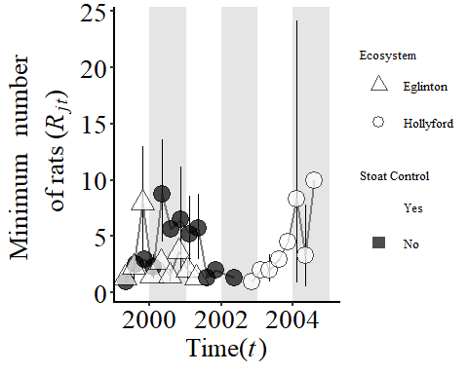

Figure 4: The avarage number of rat captures ($R_{j,t}$; point estimates) collected each trip during the study period (Autumn 1999 to Winter 2004). The shape of each point distinguishes the two valleys (triangle = Eglinton Valley, circle = Hollyford Valley) and solid symbols represent cases where stoats are uncontrolled and hollow in valleys with stoat removal.

All other trips with high rat records were in areas with stoat control. In the Hollyford Valley during both mast-years (2000, 2003), rats increased both before and after stoat control being implemented in May 2002. No rats were captured after May 2002 in the Eglinton Valley but there was also much more food avaliable in the Hollyford valley during the same time (trips).

## Prediction A

*Stoat control does not increase mouse populations at times of low abundance.*

Wrong numbers…

We compared the abundance of mice during trips when both mouse abundance and seedfall were low (2002 and 2003 using the model. We found no visually observable or statistically significant differences in the estimates between areas with and without stoat control (0.2989793 SE = 0.1289556, p-value = 0.6662361) during any of the trips during our study.

SORT CAPTION….

CI legend (grey boxes…)

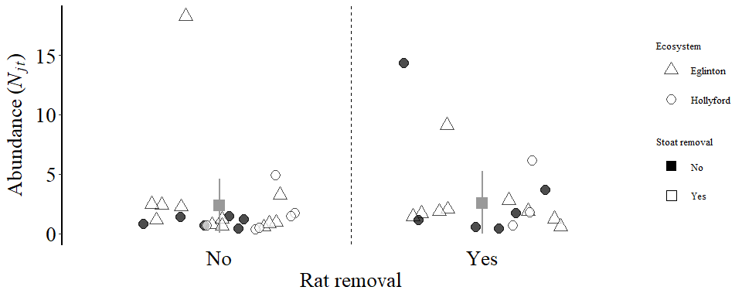

Figure 5: The unmodified abundance of mice in non-mast years (2001, 2003). The point represents a replicated sample. The shape distinguishes the two valleys (triangles = Eglinton Valley, circles = Hollyford Valley). The grids are divided into hollow symbols where stoat control was undertaken and solid symbols represent areas where stoats where not controlled. Replicates where rats were manually removed and points on the right had un-modified rat populations.

For Prediction A we did not need to account for varying seed input because seed fall was biological equivalent to zero for all grids and trips during low abundance seasons (Choquenot and Ruscoe 2000).

## Prediction B

*Stoat control does not result in higher peak abundance of mice*

We found no significant difference between the stoat controlled and uncontrolled areas. We found that the *intake rate $(S_{j,t})$* we transformed from the seedfall data $(Seed_{j,t})$ always had the greatest impact on the rate of increase of mice $(r_{j,k})$. Greater than both mouse density ($N_{j,t}$) and rat presence ($R_{j,t}$; Appendix).

Overall we did observe lower peak mouse abundance in the Hollyford Valley compared to the Eglinton Valley ($-0.17$, SE = $0.09$, $'p-value'=0.06$). Although this is not below the *0.05* threshold. It should be noted that when the rat removal treatment was removed the p-value did drop to *0.05*.

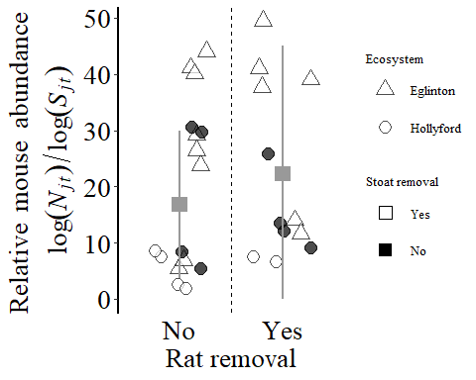

Figure 6: Difference between areas with and without stoat control at peak mouse abundance. The shape difference distinguishes the two valleys (triangle = Eglinton Valley, circle = Hollyford Valley). The grids are divided into the two groups on the x-axis (areas with and without stoat control). Solid symbols represent cases where rats are present and removed at points with hollow symbols.

Our model accounted for the confounding effects of numerical processes such as density ($N_{j,t}$) and intake rate ($S_{j,t}$) using our Bayesian hierarchical model and then tested for evidence of mesopredator release of mice during our study. We used the fitted model parameters to estimate the differences between the key predictions proposed for areas with and without stoat control after accounting for both the observation error (data collection and population estimates) and process error (population dynamics; Ahrestani, Hebblewhite, and Post (2013)).

## Prediction C

*Stoat control did not increase mouse populations as food becomes available.*

We tested the differences in the rate of increase of mouse populations between the four seasons, two valleys and stoat control areas (excluding the rat treatment) during seasons when mouse population were increasing (August; Autumn - Winter). We found was no significant differences between mice populations ($r_{j,t}$) during the increasing seasons of mouse dynamics. All 95% credible intervals for the differences between these trips included zero.

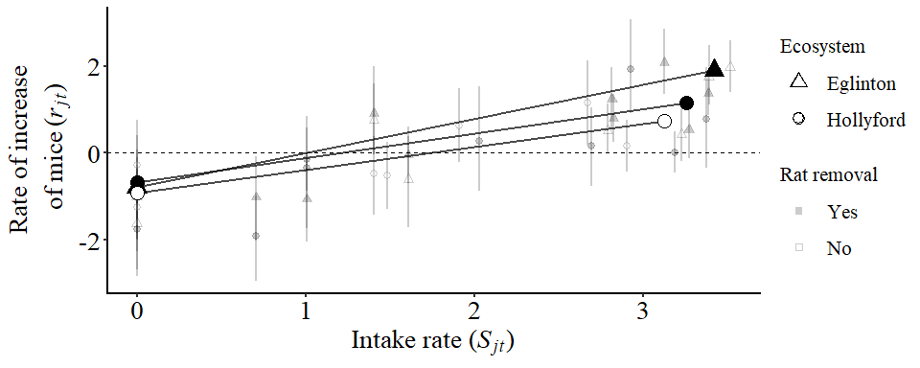

Figure 7: Visual representation of prediction C. Large points and lines are estimated from the mean effect of stoat control from the full Bayesian model. Prediction C was interested in the increasing seedfall phase (Autumn to Winter). The different shapes distinguish the two valley systems (triangles = Eglinton Valley; circles = Hollyford Valley) and all solid symbols represent cases where stoats are present and removed at points with hollow symbols. Each smaller transperent point is a data point used for the analysis (n = 144)

## Prediction D

*Stoat control did not hasten the decline from peak abundance.*

This prediction specifically focused on the Spring and Summer seasons, when rodent populations are crashing (Figure 3 vs. Figure 4). Overall density had a weak negative effect on mice dynamics under all conditions (Figure 3) but was greatest during the declining seasons of mice dynamics. After accounting for seed and density in the population model there was a faster rate of decline in the Hollyford Valley (large solid circles) compared to the Eglinton Valley (large hollow circles) but this was not statistically significant.

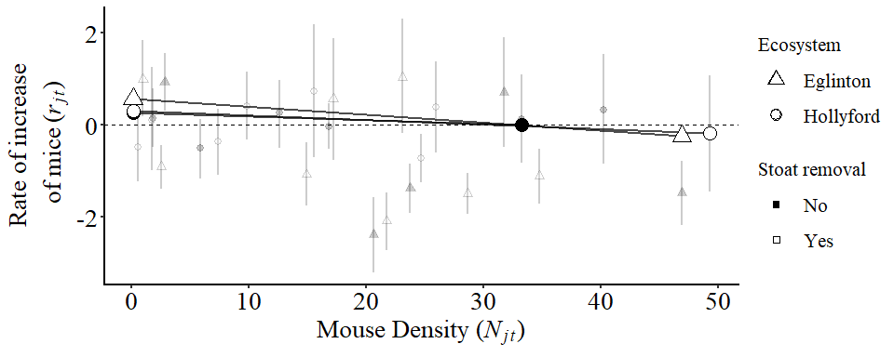

Figure 8: Visual representation of the effect of stoat control during decreasing mouse abundance (Spring to Summer; Prediction D). The different shapes distinguish the two valley systems (triangles = Eglinton Valley; circles = Hollyford Valley) and all solid symbols represent cases where stoats are present and removed at points with hollow symbols.

## Prediction E

*Does the presence of rats impact the population dynamics of mice at each of the seasons tested in Predictions A-D.*

We found that rat numbers $R_{j,t}$ had the smallest overall effect on mice dynamics ( $μ(β_{3}$ $|AllSeasons)=$ $0.007$) and was the most variable parameter in our community model ($CV_{rats}=5.74$). We recorded the highest number of rats in February and May, at the same times of high mouse abundance (Figure 3). The relationship between rats and mice was examined by comparing the estimated differences between treatments (Figure 8; lines represent mean relationships in the three treatment groups). We also statistically testing the difference between each different treatment and found no differences across all parameters (Figure 9).

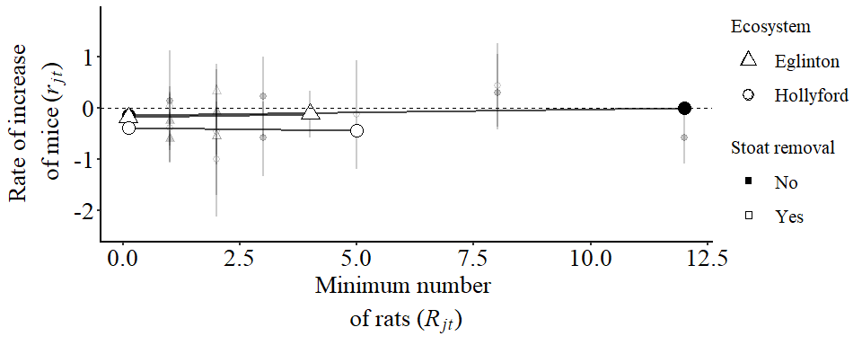

Figure 9: Differences in estimates between rats during each season of mice dynamics.

We did not have enough data to estimate a statistical interaction between rats and mice (non-linear relationship) or other more complex non-linear models for rat dynamics.

# Discussion

Our study focused on understanding the effects of stoat control on wild mouse populations in New Zealand beech forests. Specifically, we were interested in whether mesopredator release of mouse populations occured in areas where stoat control was undertaken compared to areas without stoat control. Similar to previous research, we found that populations with higher “intake rates” also had higher mouse abundance in the subseeding months until natural germation of the seeds in mid/late summer. The *intake rate* had the greatest impact on mice populations in all seasons. These phemonona are commonly observed in NZ beech forests (Figure 1; Choquenot and Ruscoe (2000); Ruscoe et al. (2005)) and other NZ mixed-forest types (Innes et al., n.d.; Sweetapple, n.d.; Ruscoe et al. 2011, 2012). We found that the effect of mouse density ($N_{j,t}$) and rats ($R_{j,t}$) abundance was lower than the “*intake rate*” ($S_{j,t}$). We observed density dependance was greatest during population declines. The effect of mouse density and rats on the rate of increase of mouse populations was much lower but similar to other published results (Choquenot and Ruscoe 2000). These processes are commonly observed in NZ beech forests (Figure 1; Choquenot and Ruscoe (2000); Ruscoe et al. (2005)), and to a lesser extent, other NZ mixed-forest types (Innes et al., n.d.; Sweetapple, n.d.; Ruscoe et al. 2011, 2012).

A naïve investigation of the summarised data we collected (Figure 1, 1, and 1 compared to the predictions in Figure 1 might have falsely lead to the conclusion that rats negitively effect mice dynamics in NZ Beech forests.

It was unclear whether stoat populations can increase at a great enough rate to exert sufficiently strong predation pressure to alter these food-driven population eruptions. As with other studies we observed high heterogeneity in observations. Count data in biological systems like this can be difficult to model correctly in many frequentist frameworks. Our study design and bayesian methodology allows to observe signals of heterogeneity in different groups without over parameterising the model.

To encorperate the underlying processes we build a Bayesian Hierarichal Model. By taking the proposed processes that effect mice dynamics and applying a hierarchical model framework allows us to test and estimate effect sizes that further reduce uncertainty in the outcomes of predator control in NZ beech forests. Importantly, our model incorperates both the observational and process variability within NZ beech forests and therefore should be more realistic when describing the system. We also conclude that the underlying heterogeneity in small mammal populations was sufficiently large to make estimating true response of mice to rats difficult in biological experiments (Figures ??-4). We used this BHM after encorperating the confounding effects of food availability, mouse density, and the presence of rats to simultaneously assess the overall differences in the mice dynamics between our different treatment groups (stoat control and rat removal).

## Stoat control

During our study we found stoat control had minimal impact on mice populations relative to seedfall.

**<MORE PRECISE??>**

High individual heterogeneity in the capture rates of stoats at both high and low mouse densities makes reductions to zero individuals virtually impossible targets. This was the case in our study where by-catch of stoats in controlled areas was observed. As an indication of removal, $4.75$ times more stoats were removed from the stoat control program (Hollyford Valley 2001-2004) than caught in by-catch in areas already being controlled prior to the experiment. Our before/after treatment tested this and verified that we did not find differences within the grid when experimental treatments were changed. We may also be missing the impact of by-catch of other pests in stoat traps. We believe that any effect this may have on mice dynamics would be limited due to the limited impacts of rat removal in our data. Biologically, the differences in home range size of rodent species (10’s ha; (Bramley 2014; Innes and Skipworth 1983; Pryde, Dilks, and Fraser 2005)) relative to the home range of stoats and the scale of trap line (100’s ha; (Miller, Elliot, and Alterio 2001; Murphy and Dowding 1995)) which suggests that population level impacts from these removals is unlikely due to the limited number of animals removed and the re-invasion biology of rodents (Bramley 2014).

1. The lack of any observed effects of stoat control on mouse abundance was that the removal of animals was potentially limited by the effectiveness of a particular stoat control program, management or experimental design. If trapping did not remove a sufficient number of individual stoats to reduce predation pressure we will not observe the theoretical responses proposed by Tompkins, Byrom, and Pech (2013) and others.
2. One explaination for this is that Beech forests exhibit the processes defined by *resource pulse systems* (**???**). Strong resource pulses cause strong effects throughout an entire ecosystem (Yang et al. 2008). A proposed result of resource-pulse phenomenon are that even in the absence of regulation, predators can not attain high enough densities to limit mouse populations when food availability is high (King 1983).
3. Furthermore, the intrinsic differences in the reproductive and growth rates (life history traits) of each species reduces the ability for species like stoats to regulate mouse populations. King (2011) modelling the reproductive processes of stoats at the beginning of a masting event (King and Powell 2011).

## Rat presence

Our results suggested that it is unlikely that rats have strong impacts on the rate of increase of mice in NZ beech forests. In part, this could be due to the high variability in the number of rats and kiore between grids and sampling trips in our study (**??**), which is often the case in non-laboratory studies.

Instead of rats/kiore being present but at low numbers in all grids (low effect size and low uncertainty), there were only a few grids that had comparability high numbers. This result suggests that refugee areas may exist and can support larger rodents in beech forests that current averages suggest. Overall, it is likely that beech forests do not have enough resources to support larger spatially uniform populations of rats.

Somewhat contrary to our field results, previous laboratory experiments suggested that interactions between mice and rats were related to predation or competition effects and limited evidence of competition release has been observed in mixed podocarp-tawa forests in NZ. We found that rats had the smallest impact on mice dynamics (Figure 4).

**<<<<<seed/rat rato???>>>>**

### Seed avalabibility

1. could be different for mice and rats

After comparing a selection of functional responses to our data (Appendix) we found the best fitting model was a type II response and converted our estimated $Seed_{j,k}$ per $m^{2}$ to the “*intake rate*” $S_{j,t}$.

## Management implications

Our model has subtle but important differences compared previous research when in comes to management application.

1. The Bayesian model be have build can be fitted to future datasets
2. simulation to show this???

We have incorporated a reproducible workflow (British Ecological Society 2018) for the future development of model testing for different and new datasets (Wickham 2014).

In doing this we have incorporated leading reproducible science techniques to help address any aspects of our study may need for further support. Often studies of such large scale can address key population-level questions however these studies struggle to find replication because of the scale at which they are conducted (Oksanen 2001). Many issues that many confront a PFNZ2050 will be reduced by using simple but well fitted BHMs for predicting and allocation management resources.

### Predator-free NZ

Our integrated population modelling approach and the large, high-quality CR data used to parametrise the model allowed us to predict and report the biologically relevant effect sizes. We used this to address the direct question of stoat control in NZ Beech Forests. Future studies can now test and assess the beech forest ecosystem compared to the data they collect. By using the unified modelling framework presented in this paper (Appendix; [Davidson (2019)), reproducible research practises and “tidy-data” (Wickham 2014). Many of the processes we have verified were previously hypothesized using indices of mice abundance (Blackwell, Potter, and Minot 2001; Blackwell et al. 2003), laboratory experiments (Bridgman et al. 2013), novel systems such as remote islands (Mulder et al. 2009) and small patches of mainland forest (Blackwell, Potter, and Minot 2001; Blackwell et al. 2003). We have integrated these results into a framework that can now test these results in other systems that are hypothesized to be different. It will be important for future work to continue monitoring this system for anomalies and unexpected patterns such as increases in other invasive predators, particularly rats.

Sorting references has been much hard than I expected when there are multiple types of software to use and different ways to link them.

The core problems I have needed to solve are:

* Storing pdfs locally and working on them.

1. Mendeley works well for looking and searching through pdfs and was the reason I switched from EndNote (that my supervisors were using at the time) to Mendeley.
2. Convert references attached to pdfs in reference manager into a bibtex file so that citr and refmanageR can read these.
3. Zotero because it has good extentions that can turn bib references into bibtex structure for R packages that use a variation on the .bib structure in R.
4. Convert stable referencing in .Rmd to other document types and structures.
5. This has now become hard to understand how this is all working so I have had to layout a software path (and maybe future Docker image) to ensure that the refences converge and the errors are solvable (or at least I can work out where they come from)

## Editor??

To work with .bib files (to find errors to begin with) it is much nice to have some code snippit support (highlighting syntax). These are the options for .bib file editors:

1. [ ]

Ahrestani, Farshid S., Mark Hebblewhite, and Eric Post. 2013. “The Importance of Observation Versus Process Error in Analyses of Global Ungulate Populations.” *Scientific Reports* 3 (1). <https://doi.org/10.1038/srep03125>.

Blackwell, G L, M A Potter, J A McLennan, and E O Minot. 2003. “The Role of Predators in Ship Rat and House Mouse Population Eruptions: Drivers or Passangers?” *Oikos* 100 (3): 601–13.

Blackwell, G. L., M. A. Potter, and E. O. Minot. 2001. “Rodent and Predator Population Dynamics in an Eruptive System.” *Ecological Modelling* 142 (3): 227–45. <https://doi.org/10.1016/S0304-3800(01)00327-1>.

Bramley, Gary N. 2014. “Home Ranges and Interactions of Kiore (Rattus Exulans) and Norway Rats (R. Norvegicus) on Kapiti Island, New Zealand.” *New Zealand Journal of Ecology* 38 (2): 7.

Bridgman, L. J., J. Innes, C. Gillies, N. B. Fitzgerald, S. Miller, and C. M. King. 2013. “Do Ship Rats Display Predatory Behaviour Towards House Mice?” *Animal Behaviour* 86 (2): 257–68. <https://doi.org/10.1016/j.anbehav.2013.05.013>.

British Ecological Society. 2018. “The British Ecological Society’s Guide to Reproducible Science.” <https://blog.revolutionanalytics.com/2017/12/bes-reproducible-science.html>.

Bronder, Steve. n.d. “Bayesian Hierarchical Models,” 19.

Caut, Stéphane, Elena Angulo, and Franck Courchamp. 2009. “Avoiding surprise effects on Surprise Island: Alien species control in a multitrophic level perspective.” *Biological Invasions* 11 (7): 1689–1703. <https://doi.org/10.1007/s10530-008-9397-9>.

Choquenot, David, and Wendy A Ruscoe. 2000. “Mouse Population Eruptions in New Zealand Forests: The Role of Population Density and Seedfall.” *Journal of Animal Ecology* 69: 1058–70.

Choquenot, D, and W a Ruscoe. 2003. “Landscape complementation and food limitation of large herbivores: habitat related constraints on the foraging effiency of wild pigs.” *Jounral of Animal Ecology* 72: 14–26.

Davidson, Anthony R. 2019. *Anthony Davidson - Overview*. <https://github.com/davan690>.

Doherty, Tim S., and Euan G. Ritchie. 2017. “Stop Jumping the Gun: A Call for Evidence-Based Invasive Predator Management” 10 (1): 15–22. <https://doi.org/10.1111/conl.12251>.

Fritts, Thomas H., and Gordon H. Rodda. 1998. “The role of introduced species in the degradation of island ecosystems: a case history of Guam.” *Annual Review of Ecology and Systematics* 29 (1): 113–40. <https://doi.org/10.1146/annurev.ecolsys.29.1.113>.

Gelman, Andrew, and Iain Pardoe. 2006. “Bayesian Measures of Explained Variance and Pooling in Multilevel (Hierarchical) Models.” *Technometrics* 48 (2): 241–51. <https://doi.org/10.1198/004017005000000517>.

Gurevitch, Jessica, and Dianna K. Padilla. 2004. “Are Invasive Species a Major Cause of Extinctions?” *Trends in Ecology and Evolution* 19 (9): 470–74. <https://doi.org/10.1016/j.tree.2004.07.005>.

Holland, E Penelope, Alex James, Wendy A Ruscoe, Roger P Pech, Andrea E Byrom, and E Byrom. 2015. “Climate-Based Models for Pulsed Resources Improve Predictability of Consumer Population Dynamics: Outbreaks of House Mice in Forest Ecosystems.” *PloS One*, 1–16. <https://doi.org/10.1371/journal.pone.0119139>.

Innes, J. G., and J. P. Skipworth. 1983. “Home Ranges of Ship Rats in a Small New Zealand Forest as Revealed by Trapping and Tracking.” *New Zealand Journal of Zoology* 10 (1): 99–110. <https://doi.org/10.1080/03014223.1983.10423895>.

Innes, John G. 2005. “Ship Rat.” In *The Handbook of New Zealand Mammals*, edited by Carolyn M King, 2nd ed., 187–203. Melbourne: Oxford University Press.

Innes, John, Dave Kelly, Jacob McC Overton, and Craig Gillies. n.d. “Predation and Other Factors Currently Limiting New Zealand Forest Birds,” 1.

Jones, Christopher, Roger Pech, Guy Forrester, Carolyn M. King, and Elaine C. Murphy. 2011. “Functional Responses of an Invasive Top Predator Mustela Erminea to Invasive Meso-Predators Rattus Rattus and Mus Musculus, in New Zealand Forests.” *Wildlife Research* 38 (2): 131–40. <https://doi.org/10.1071/WR10137>.

Kellner, Ken. 2018. *jagsUI: A Wrapper Around ’Rjags’ to Streamline ’JAGS’ Analyses*. <https://CRAN.R-project.org/package=jagsUI>.

King, Carolyn M. 1983. “The Relationships Between Beech (Nothofagus Sp.) Seedfall and Populations of Mice (Mus Musculus), and the Demographic and Dietary Responses of Stoats (Mustela Erminea), in Three New Zealand Forests.” *Journal of Animal Ecology* 52 (1): 141–66.

King, Carolyn M. 2017. “Pandora’s Box down-Under: Origins and Numbers of Mustelids Transported to New Zealand for Biological Control of Rabbits.” *Biological Invasions* 19 (6): 1811–23. <https://doi.org/10.1007/s10530-017-1392-6>.

King, Carolyn M., and Roger A. Powell. 2011. “Managing an Invasive Predator Pre-Adapted to a Pulsed Resource: A Model of Stoat (Mustela Erminea) Irruptions in New Zealand Beech Forests.” *Biological Invasions* 13 (12): 3039–55. <https://doi.org/10.1007/s10530-011-9993-y>.

King, C M. 2005. *The Handbook of New Zealand Mammals*. Oxford University Press.

Kinnear, J E, C Pentland B, N Moore, and C J Krebs. 2016. “Fox control and 1080 baiting conundrums: time to prepare for a CRISPR solution” 39. <https://doi.org/10.1071/AM16020>.

Krebs, Charles J., Rudy Boonstra, Scott Gilbert, Donald Reid, Alice J. Kenney, and Elizabeth J. Hofer. 2011. “Density Estimation for Small Mammals from Livetrapping Grids: Rodents in Northern Canada.” *Journal of Mammalogy* 92 (5): 974–81. <https://doi.org/10.1644/10-MAMM-A-313.1>.

Latham, A. David M., Bruce Warburton, Andrea E. Byrom, and Roger P. Pech. 2017. “The Ecology and Management of Mammal Invasions in Forests.” *Biological Invasions* 19 (11): 3121–39. <https://doi.org/10.1007/s10530-017-1421-5>.

McQueen, Shirley, and Barry Lawrence. 2008. “Diet of Ship Rats Following a Mast Event in Beech Nothofagus Spp Forest.” *New Zealand Journal of Ecology* 32 (8): 214–18.

Miller, Craig, Mike Elliot, and Nic Alterio. 2001. “Home Range of Stoats (Mustela Erminea) in Podocarp Forest, South Westland, New Zealand: Implications for a Control Strategy.” *Wildlife Research* 28 (2): 165. <https://doi.org/10.1071/WR00001>.

Mulder, Christa P. H., M. Nicole Grant-Hoffman, David R. Towns, Peter J. Bellingham, David A. Wardle, Melody S. Durrett, Tadashi Fukami, and Karen I. Bonner. 2009. “Direct and Indirect Effects of Rats: Does Rat Eradication Restore Ecosystem Functioning of New Zealand Seabird Islands?” *Biological Invasions* 11 (7): 1671–88. <https://doi.org/10.1007/s10530-008-9396-x>.

Murphy, Elaine C, and John E Dowding. 1995. “Ecology of the Stoat in Nothofagus Forest: Home Range, Habitat Use and Diet at Different Stages of the Beech Mast Cycle.” *New Zealand Journal of Ecology* 19 (2): 13.

O’Donnell, Colin F. J., Kerry A. Weston, and Joanne M. Monks. 2017. “Impacts of Introduced Mammalian Predators on New Zealand’s Alpine Fauna.” *New Zealand Journal of Ecology* 41 (1): 1–22.

Oksanen, Lauri. 2001. “Logic of Experiments in Ecology: Is Pseudoreplication a Pseudoissue?” *Oikos* 94 (1): 27–38.

Plummer, Martyn. 2011. “JAGS Developers Manual.” <https://sourceforge.net/projects/mcmc-jags/files/Manuals/3.x/jags_user_manual.pdf/download>.

Prugh, Laura R., Chantal J. Stoner, Clinton W. Epps, William T. Bean, William J. Ripple, Andrea S. Laliberte, and Justin S. Brashares. 2009. “The Rise of the Mesopredator.” *BioScience* 59 (9): 779–91. <https://doi.org/10.1525/bio.2009.59.9.9>.

Pryde, Moira, Peter Dilks, and Ian Fraser. 2005. “The Home Range of Ship Rats (Rattus Rattus) in Beech Forest in the Eglinton Valley, Fiordland, New Zealand: A Pilot Study.” *New Zealand Journal of Zoology* 32 (3): 139–42.

Rayner, Matt J, Mark E Hauber, Michael J Imber, Rosalie K Stamp, and Mick N Clout. 2007. “Spatial Heterogeneity of Mesopredator Release Within an Oceanic Island System.” *Proceedings of the National Academy of Sciences of the United States of America* 104 (52): 20862–5. <https://doi.org/10.1073/pnas.0707414105>.

Roberts, Mere. 1991. “Origin, Dispersal Routes, and Geographic Distribution of Rattus Exulans, with Special Reference to New Zealand!” *PACIFIC SCIENCE* 45: 8.

Robles, Carlos D, and Robert Desharnais. 2002. “History and Current Development of a Paradigm of Predation in Rocky Intertidal Communities.” *Ecology* 83 (6): 1521–36. [https://doi.org/10.1890/0012-9658(2002)083[1521:HACDOA]2.0.CO;2](https://doi.org/10.1890/0012-9658(2002)083%5B1521:HACDOA%5D2.0.CO;2).

Royle, J. Andrew. 2009. “Analysis of Capture-Recapture Models with Individual Covariates Using Data Augmentation.” *Biometrics* 65 (1): 267–74. <https://doi.org/10.1111/j.1541-0420.2008.01038.x>.

Royle, J. Andrew, Sarah J. Converse, and William A. Link. 2012. “Data Augmentation for Hierarchical Capture-Recapture Models,” November. <http://arxiv.org/abs/1211.5706>.

Royle, J. Andrew, and Robert M. Dorazio. 2012. “Parameter-Expanded Data Augmentation for Bayesian Analysis of Capture–Recapture Models.” *Journal of Ornithology* 152 (S2): 521–37. <https://doi.org/10.1007/s10336-010-0619-4>.

Royle, J. Andrew, Robert M Dorazio, and William A Link. 2007. “Analysis of Multinomial Models with Unknown Index Using Data Augmentation.” *Journal of Computational and Graphical Statistics* 16 (1): 67–85. <https://doi.org/10.1198/106186007X181425>.

Ruscoe, Wendy A, Joseph S Elkinton, David Choquenot, and Robert B Allen. 2005. “Predation of beech seed by mice: effects of numerical and functional responses.” *Journal of Animal Ecology* 74: 1005–19. <https://doi.org/10.1111/j.1365-2656.2005.00998.x>.

Ruscoe, Wendy A, Ruth Goldsmith, and David Choquenot. 2001. “A Comparison of Population Estimates and Abundance Indices for House Mice Inhabiting Beech Forests in New Zealand.” *Wildlife Research* 28: 173–78.

Ruscoe, Wendy A, David S. L. Ramsey, Roger P. Pech, Peter J. Sweetapple, Ivor Yockney, Mandy C. Barron, Mike Perry, et al. 2011. “Unexpected Consequences of Control: Competitive Vs. Predator Release in a Four-Species Assemblage of Invasive Mammals.” *Ecological Letters* 14: 1035–42. <https://doi.org/10.1111/j.1461-0248.2011.01673.x>.

Ruscoe, Wendy A., Peter J. Sweetapple, Mike Perry, and Richard P. Duncan. 2012. “Effects of Spatially Extensive Control of Invasive Rats on Abundance of Native Invertebrates in Mainland New Zealand Forests: Effects of Invasive Rat Control.” *Conservation Biology* 27 (1): 74–82. <https://doi.org/10.1111/j.1523-1739.2012.01932.x>.

Russell, James C., John G. Innes, Philip H. Brown, and Andrea E. Byrom. 2015. “Predator-Free New Zealand: Conservation Country.” *BioScience* 65 (5): 1–6. <https://doi.org/10.1093/biosci/biv012>.

Saunders, A., and D. A. Norton. 2001. “Ecological Restoration at Mainland Islands in New Zealand.” *Biological Conservation* 99 (1): 109–19. <https://doi.org/10.1016/S0006-3207(00)00192-0>.

Schofield, Matthew R., and Richard J. Barker. 2014. “Hierarchical Modeling of Abundance in Closed Population Capture–Recapture Models Under Heterogeneity.” *Environmental and Ecological Statistics* 21 (3): 435–51. <https://doi.org/10.1007/s10651-013-0262-3>.

Sweetapple, P J. n.d. “Effect of Reduced Possum Density on Rodent and Stoat Abundance in Podocarp-Hardwood Forests,” 25.

Tompkins, Daniel M., Andrea E. Byrom, and Roger P. Pech. 2013. “Predicted Responses of Invasive Mammal Communities to Climate-Related Changes in Mast Frequency in Forest Ecosystems.” *Ecological Applications* 23 (5): 1075–85. <https://doi.org/10.1890/12-0915.1>.

Tompkins, Daniel M, and Clare J Veltman. 2006. “Unexpected Consequences of Vertebrate Pest Control. Predictions from a Four-Species Community Model.” *Ecological Applications* 16 (3): 1050–61.

Towns, David R. 2011. “Eradications of Vertebrate Pests from Islands Around New Zealand: What Have We Delivered and What Have We Learned?” *Island Invasives: Eradication and Management*, 364–71.

Towns, David R., Ian A. E. Atkinson, and Charles H. Daugherty. 2006. “Have the Harmful Effects of Introduced Rats on Islands Been Exaggerated?” *Biological Invasions* 8 (4): 863–91. <https://doi.org/10.1007/s10530-005-0421-z>.

White, Piran C L, and Carolyn M. King. 2006. “Predation on Native Birds in New Zealand Beech Forests: The Role of Functional Relationships Between Stoats Mustela Erminea and Rodents.” *Ibis* 148 (4): 765–71. <https://doi.org/10.1111/j.1474-919X.2006.00579.x>.

Wickham, Hadley. 2014. “Tidy Data.” *Journal of Statistical Software* 59 (1): 1–23. <https://doi.org/10.18637/jss.v059.i10>.

Yang, Louie H., Justin L. Bastow, Kenneth O. Spence, and Amber N. Wright. 2008. “WHAT CAN WE LEARN FROM RESOURCE PULSES.” *Ecology* 89 (3): 621–34. <https://doi.org/10.1890/07-0175.1>.

1. 1