**WORKING Title of Research Project:**

Population dynamics of interacting invasive species in New Zealand forests



Institute for Applied Ecology,

University of Canberra,

Canberra, ACT,

Australia

**Student Name:**

Anthony Raphael Davidson (u3164284)

**Degree:**

Doctor of Philosophy

**Supervisor/s Name:**

Professor Richard Duncan1, Associate Professor Bernd Gruber1, Dr Roger Pech2, Dr Wendy Ruscoe3

1. Institute for Applied Ecology, University of Canberra (Supervisor),
2. Landcare Research, Christchurch, New Zealand (Advisor),
3. Institute for Applied Ecology, University of Canberra (Advisor)

**Date:**

26th November 2018

***Abstract***

One of the main causes of decline in native biota on islands is predation by invasive mammals. In New Zealand, conservation actions are frequently aimed at reducing and eradicating invasive mammal species from offshore islands, mainland islands and conservation land. While eradications have been successfully carried out on islands, a bold new focus for conservation management in New Zealand is aimed at eradicating widespread invasive mammals on the mainland.

An important lesson from island eradications, however, is that removal of single species can produce unexpected outcomes for other species. Such unexpected outcomes are also likely to occur when attempting to remove widespread and well established pest mammal populations on mainland New Zealand. Management to reverse the decline of native species through removal of invasive mammals needs to consider multiple threats, including possible additive, and synergistic effects of species interactions.

This thesis aims to build models of invasive mammal species interactions in New Zealand forests to understand how populations of interacting species will react under different conditions. These models will be parameterized using Bayesian hierarchical methods and capture-recapture data from studies in pure beech forest and mixed (podocarp/hardwood) forests in New Zealand. A third dataset will be used to link native species responses to changes in invasive mammal populations.

Outputs from these models will provide information to understand trends in community structure before, during and after different control measures for managing invasive species. An additional advantage of this framework allows for the continued use and development of the proposed models for future management.

***Introduction***

Invasive species often invade native ecosystems and cause negative effects. Research suggests that they are the second most important driver of global biodiversity loss (Vitousek et al. 1997). Mammalian invasions alone have caused numerous extinctions and therefore it is common practice for organisations to control these populations (Gurevitch & Padilla 2004; Clavero & Garcia-Berthou 2005). Even under a range of different social, economic and political constraints (DIISE 2015; Innes et al. 2010) eradication programs are still very successful at removing the target species (e.g. Keitt et al. 2011).

Nevertheless, successful reductions and eradications of invasive species can lead to indirect ecological responses from other species, most often when top predators are removed (Rayner et al. 2007; Courchamp et al. 1999; Courchamp et al. 2011; Ruscoe et al. 2011). The removal of wolves (top predator) in Yellowstone National park lead to trophic cascades, and the subsequent re-introduction has restored interactions between key species within the park (Smith et al. 2003; Fortin et al. 2005; Barber-Meyer 2015). In the reverse application of this issue, the deliberate removal of top predators through pest control of cats on Macquarie Island highlighted negative issues with the increase of a mesopredator (rats; Bergstrom et al. 2009). And the removal of dingoes (the top predator in many Australian ecosystems) appears to allow fox and cat populations (mesopredators) to increase in abundance (Glen & Dickman 2005).

Islands ecosystems have been the focus of both observational and experimental manipulation to observe the outcomes of ecosystem modification. For example, the increase in mesopredators after the removal of invasive cats on Little Barrier Island (New Zealand; (Rayner et al. 2007), the effect of the brown treesnake (*Boiga irregularis*) on frugivorous bird species and the forest structure on Gaum (Rogers et al. 2017) and, the role of ship rats (*Rattus rattus*) and mice (*Mus musculus*) on Surprise Island, New Caledonia (Courchamp et al. 2011; Caut et al. 2009). Theoretical scenarios provide the framework for such unanticipated and complex outcomes to be simulated under a range of simple interactions which have produced sometimes complex and unexpected outcomes between predators, prey and competing species (e.g. Caut et al. 2009; Courchamp et al. 2003; Courchamp et al. 2000; Caut et al. 2007). Theoretical models provide insight into the range of possible effects we might observe, but these models need to be tested using data from real ecosystems to evaluate their validity. Additionally, larger inhabited islands and continental systems may consist of more interacting species, that in turn may increase the likelihood of observing these sorts of unexpected outcomes following invasive species removal (e.g. Ruscoe et al. 2011).

One approach to ensure conservation goals are met is to conduct comprehensive, pre, during and post eradication studies that allow the effects of management actions on interacting species to be evaluated throughout the control program. For example, the role of ship rats (*Rattus rattus*) on an invaded tropical Pacific atoll, Surprise Island, New Caledonia (Courchamp et al. 2011; Caut et al. 2009). “Surprise” effects were avoided by conducting a pre-eradication study of several years (annual surveys) from which the control strategy was developed accordingly. A small mouse population was identified in the pre-eradication phase, and therefore simultaneous removal of both mice and rats occurred. During the eradication phase several additional poison sessions were conducted because mice numbers were still unknown. The post-eradication survey’s confirmed the successful removal of rats and mice. Comprehensive research like this is often not possible due to logistical and economic issues. Another more economically viable way is to construct a range of process models using the available data (models describing species interactions) and test these theoretical models against high quality data.

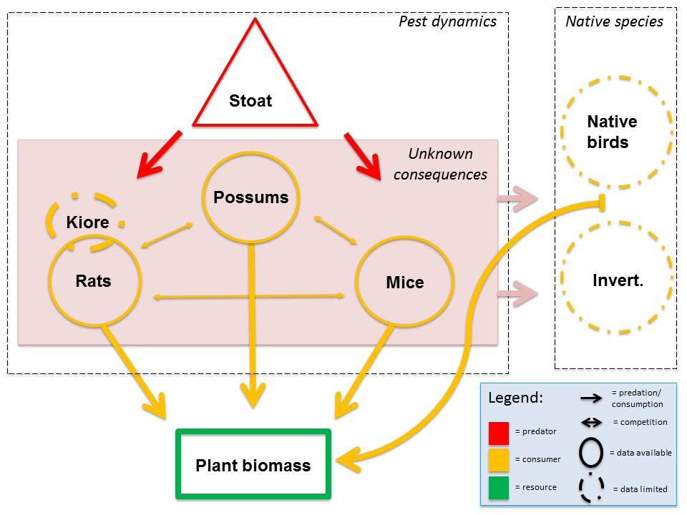

**Figure 1:** Key trophic relationships between introduced invasive species and native species in relation to predation (stoats) and resource availability (Plant biomass).

The relatively recent history of species introductions means New Zealand has a record of ecosystem changes that provide an array of natural addition and removal experiments (Oksanen 2001). These relationships can be used to test the relative strength of bottom-up and top-down processes in ecosystems. However, different environments and species compositions create challenges due to the high potential for unexpected outcomes (Glen & Dickman 2005). Figure one is a diagrammatical representation of the key invasive species in New Zealand forest systems and the identified interactions. Mice *(Mus musculus)*, stoats *(Mustela erminea)*, rats (*Rattus rattus*), and possums *(Trichosurus vulpecula)* are widespread in New Zealand forest systems (Duffey 2001)*.* Less is known about the Pacific rat or Kiore *(Rattus exulans).* Other invasive species are known to affect a wide range of ecosystems throughout New Zealand (e.g. cats (Rayner et al. 2007), including a range of large herbivores (Parkes et al. 2003)). If they are thought to be ecologically important then analysis should account for these species when they are present.

To reduce the risk of unexpected outcomes, a combined modelling and experimental approach can clarify the outcomes of invasive species control (Ogle 2009). Previous research has attempted to characterize the interactions between species and resources (Choquenot & Ruscoe 2000). Both numerical and functional responses for species have been shown to explain some of the population dynamics observed in New Zealand temperate forests (e.g. Holland et al. 2015; Ruscoe et al. 2005; Choquenot & Ruscoe 2000; Ruscoe et al. 2004; King et al. 2003). To test theoretical relationships with the observed data I will build ecosystem models that allow me to directly quantify the interactions among invasive species (Peng 2015). Advances in ecological modelling tools have opened up opportunities to assess and parameterize theoretical models from observational data (King 2012). Statistical software such as JAGS (Plummer 2010), WinBUGS (Suess & Trumbo 2010) and STAN (STAN development Team 2015) in combination with increasing computational power has allowed these advance (Ogle 2009).

This project will advance our ecological understanding by:

1. Using data where invasive species populations have been experimentally manipulated to more accurately quantify the strength of interactions among species, and to quantify their impact on native biodiversity;
2. Make maximum use of the available data by using advanced modelling tools and a Bayesian approach to combine prior information, observational data and underlying process models to understand and quantify these interactions;
3. The results will be used to forecast the likely outcomes of different management options to maximise biodiversity gains from invasive species control. These advances will be especially valuable as New Zealand attempt to be predator-free by 2050.

***Research Aims***

The overarching aim of this PhD is to examine the role of predation, competition and resource flow in regulating invasive mammal populations in NZ forests, and to use this understanding to forecast the likely effects of species removals. To do this I will construct ecological models that describe the population dynamics of interacting invasive species in New Zealand forests. I will use the understanding derived from these models to predict the effects of management manipulations and reduce the likelihood of unanticipated outcomes. Aligning this ecological research with good research practise that insures the results are reproducible and replicable by allowing open access to statistical code and analysis.

This will be done by using invasive species control as removal experiments. The main objectives are:

1. To collect literature on New Zealand invasive species dynamics and use the hypotheses proposed in the literature to develop a Bayesian modelling framework that incorporates both the proposed ecological processes (e.g. predation) and observation error (e.g. estimating population size) into models of New Zealand invasive species dynamics (Chapter One).
2. Assess the importance of bottom-up and top-down processes in regulating invasive species in New Zealand forests. I have a case study in a pure beech forest system to model these relationships with data. This will focus on how mouse populations respond to changes in resources, predator abundance and interspecific competition (Chapter Two).
3. Mixed forests (beech/podocarp-hardwood) are more complex with higher abundances of possums, meaning processes like competition between rodents and possums may influence how populations respond to species removal. I will examine the role of top-down (predator removal) and bottom-up (food availability and competition for food resources) processes in regulating species abundances using a larger, more extensive dataset from podocarp/hardwood forests in the North Island, New Zealand (Chapter Three).
4. Once the key drivers are identified for different forest types, a third, mixed forest dataset from the Tararua Ranges will be used to examine the effects of removing different invasive species on the responses of native species over time (Chapter Four).
5. Overall, this research aims to inform managers of the potential for complex interactions between invasive species to result in unanticipated management outcomes, and to design management approaches to minimise this (Chapter Five).

The next section of this research proposal describes the overall methods that will be applied using the first case study (Chapter Two) in New Zealand beech forests as an example. This chapter will develop the study design and methods that will be used in the following two, more complex case studies.

***Chapter Two***

-----------------------------------------------------------------------------------------------------------------

**Case study one (Beech forest dynamics)**

**See draft Manuscript attached**

***Chapter Three***

-----------------------------------------------------------------------------------------------------------------

**Case study two (Multiple invasive species dynamics database):**

**Key question**:

Quantifying the interactions among invasive species to better inform control options.

***Background***

This chapter will extend on the modelling explored for the beech forest system (Chapter Two). Previous research has shown that complex interactions between native and exotic species exist in NZ mixed forest systems (Ruscoe et al. 2011; Ruscoe et al. 2012). This chapter parameterizes a model to account for these different interactions in an extension of the beech forest model in the previous chapter to account for different food resources and other invasive species dynamics.

***Objectives***

This chapter has the overall objective to model additional interactions and species in a New Zealand forest system. Beech forests have a limited number of species producing food for invasive mammals. When the ecosystem has more resources with different availability to the mesopredators the system is expected to have different outcomes (Choquenot & Ruscoe 2000). For example, mice populations are thought to persist in podocarp/hardwood forests at higher densities than adjoining beech forest (Choquenot & Ruscoe 2000).

To meet the objective for this chapter, the model will extend on the proposed forest model in the previous chapter to account for different food resources and other invasive species dynamics. The multi-species dataset (MPD) will allow for the modelling of native bird species and investigate more complex interactions in a different forest type.

The aims of this chapter are:

1. Estimate observation models for rodents, possums, seed production and invertebrates.
2. Link these using a process model of links between species. In this process we will test multiple possible processes driving these dynamics including predator and competition release between native and invasive species.
3. Simulation studies will investigate possible errors associated with different data collection methods.

***Study Design***

This dataset has been generated from a large scale ecological experiment. Four areas of mixed podocarp/broadleaf forest were picked to compare different treatment effects. The dataset has abundance data on invasive species (possums, rats, mice) as well as invertebrates, and a larger range of resources (e.g. beech seed, podocarp seed, flowers and others).

Research on the same dataset has investigated differences in the abundance indices for invasive species (Ruscoe et al. 2011). The response of invertebrates to different invasive species control was also investigated (Ruscoe et al. 2012). I will extend on these analyses to build an overall model incorporating the additional invasive species dynamics.

***Chapter Four***

-------------------------------------------------------------------------------------------------------

**Case study three (DOC Tararua ranges dataset):**

**Key question**:

Do different native New Zealand species respond differently to invasive control applied at different time scales?

***Background***

This work will extend on the skills and some of the observed model relationships from the beech forest analysis and chapter three. This chapter uses data collected as part of Project Kaka. Project Kaka is a ambitious 10 year ecological restoration project starting in 2009. The study is in the Tararua Forest Park, lower North Island, New Zealand. This forest type is the same as chapter four.

***Objectives***

This final data chapter will add both the beech dynamics and the mixed forest model. To test the relationships observed with the high quality data from the previous chapters with a dataset of different abundance indices. In addition to the model parameterization, this analysis will compare the effects of different invasive species control treatments in a mixed forest block over 1yr, 3yr, and 5yr control regimes.

These analyses will have more complex links between the process and observation models, as some of the data are collected have much more uncertainty associated with it. Such as chew track cards ~ presence/absence/relative abundance, Kill trap data ~ abundance, Tracking data ~predation rates.

The aims of this chapter are:

1. Develop the observational models further to incorporate 5 minute bird counts, kill trapping and chew track cards.
2. Incorporate these observation models into the process model developed on the MPD dataset (chapter three) and test these outcomes against the new data with additional observer error.
3. Analyse and compare the effects of different treatments in a mixed forest block.

***Methods***

The methods will follow the same structure as Chapter Two. The process model will extend the beech dynamics model in the two levels of hierarchal structure (process and observation models). This will need to incorporate the additional invasive species that occur in mixed forest systems. To account for the additional observer error, I will parameterise detection models for bird species. These models will have more observer error associated with the estimates than previous models. Sensitivity analysis will test the effect of observer error in these models using simulation.

An interactive pest management tool is an additional outcome that is possible to develop with the same framework. I could incorporate data collection from conservation groups and use an interactive web tool such as Shiny in R Studio (RStudio Team 2015). Shiny links the r-console (interface for statistical analysis with an interactive webpage from the underlying statistical model. By keeping all posterior estimates from similar systems the user (conservation group or like) will be able to see what theory suggests should happen in their ecosystem. When they do add their data into the model, the output will help quantify deviations from the expected theory. This is a great advance that will allow the quick response needed for a predator free New Zealand.

***Budget ***

***Timetable***

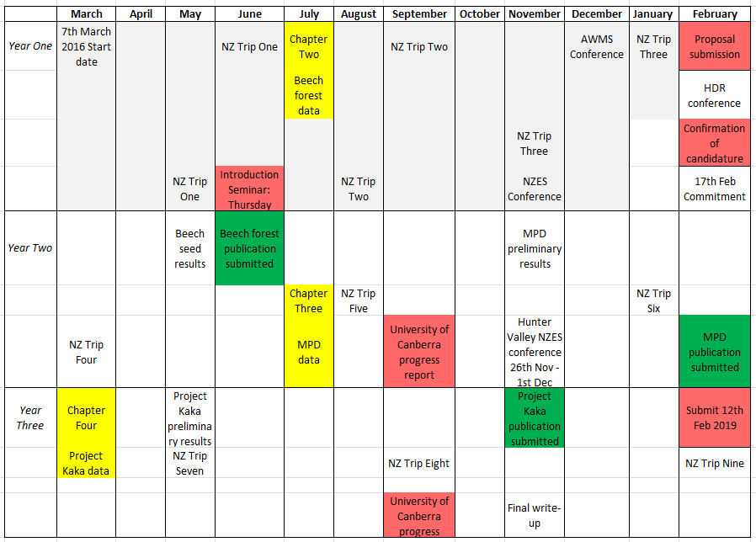

***References***

Barber-Meyer, S.M., 2015. Trophic cascades from wolves to grizzly bears or changing abundance of bears and alternate foods? *Journal of Animal Ecology*, (Fryer 1997), p.n/a-n/a. Available at: http://doi.wiley.com/10.1111/1365-2656.12338.

Bergstrom, D.M. et al., 2009. Indirect effects of invasive species removal devastate World Heritage Island. *Journal of Applied Ecology*, 46(1), pp.73–81.

Blackwell, G.L., Potter, M.A. & Minot, E.O., 2001. Rodent and predator population dynamics in an eruptive system. *Ecological Modelling*, 142(3), pp.227–245.

Caut, S. et al., 2007. Rats dying for mice: Modeling the competitor release effect. *Austral Ecology*, 32, pp.858–868.

Caut, S., Angulo, E. & Courchamp, F., 2009. Avoiding surprise effects on Surprise Island: Alien species control in a multitrophic level perspective. *Biological Invasions*, 11(7), pp.1689–1703.

Choquenot, D. & Ruscoe, W.A., 2000. Mouse population eruptions in New Zealand forests: the role of population density and seedfall. *Journal of Animal Ecology*, 69, pp.1058–1070.

Clavero, M. & Garcia-Berthou, E., 2005. Invasive species are a leading cause of animal extinctions. *Trends in Ecology and Evolution*, 20(3), p.110.

Courchamp, F. et al., 2011. Eradication of alien invasive species: surprise effects and conservation successes. *Island invasives: eradication and management*, (March 2016), pp.285–289.

Courchamp, F., Chapuis, J.-L. & Pascal, M., 2003. Mammal invaders on islands: impact, control and control impact. *Biological Reviews*, 78(3), pp.347–383. Available at: http://www.ncbi.nlm.nih.gov/pubmed/14558589%5Cnhttp://apps.isiknowledge.com/full_record.do?product=UA&colname=WOS&search_mode=CitingArticles&qid=3&SID=N2cfE3Dn1oF18GG75fn&page=4&doc=31.

Courchamp, F., Langlais, M. & Sugihara, G., 1999. Cats protecting birds: Modelling the mesopredator release effect. *Journal of Animal Ecology*, 68(2), pp.282–292.

Courchamp, F., Langlais, M. & Sugihara, G., 2000. Rabbits killing birds: Modelling the hyperpredation process. *Journal of Animal Ecology*, 69(1), pp.154–164.

DIISE, 2015. The Database of Island Invasive Species Eradications, developed by Island Conservation, Coastal Conservation Action Laboratory UCSC, IUCN SSC Invasive Species Specialist Group, University of Auckland and Landcare Research New Zealand. Available at: http://diise.islandconservation.org.ion.org. [Accessed September 23, 2016].

Duffey, E., 2001. Introduced pest species and biodiversity conservation in New Zealand. *Biological Conservation*, 99(1), p.1. Available at: http://linkinghub.elsevier.com/retrieve/pii/S000632070000183X.

Fortin, D. et al., 2005. Wolves influence elk movements: behavior shapes a trophic cascade in Yellowstone national park. *Ecology*, 86(5), pp.1320–1330.

Glen, A.S. & Dickman, C.R., 2005. Complex interactions among mammalian carnivores in Australia , and their implications for wildlife management. *Biological Reviews*, 80(2005), pp.387–401.

Gurevitch, J. & Padilla, D.K., 2004. Are invasive species a major cause of extinctions? *Trends in Ecology and Evolution*, 19(9), pp.470–474.

Holland, E.P. et al., 2015. Climate-based models for pulsed resources improve predictability of consumer population dynamics: outbreaks of house mice in forest ecosystems. *PloS one*, pp.1–16.

Innes, J. et al., 2010. Predation and other factors currently limiting New Zealand forest birds. *New Zealand Journal of Ecology*, 34(1), pp.86–114.

Kay, C.E., 1998. Are ecosystems structured from the top-down or bottom-up: A new look at an old debate. *Wildlife Society Bulletin*, 26(3), pp.484–498.

Keitt, B. et al., 2011. The Global Islands Invasive Vertebrate Eradication Database: A tool to improve and facilitate restoration of island ecosystems. *Island invasives eradication and management*, (July 2015), p.74–77.

King, C.M. et al., 2003. Matching productivity to resource availability in a small predator, the stoat (Mustela erminea). *Canadian Journal of Zoology*, 81, pp.662–669.

King, R., 2012. A review of Bayesian state-space modelling of capture-recapture-recovery data. *Interface focus*, 2, pp.190–204. Available at: http://www.scopus.com/inward/record.url?eid=2-s2.0-84860903772&partnerID=tZOtx3y1 [Accessed January 7, 2015].

Krebs, C.J. et al., 2004. Can outbreaks of house mice in south-eastern Australia be predicted by weather models? *Wildlife Research*, 31, pp.465–474.

Krebs, C.J., 2009. Population dynamics of large and small mammals: Graeme Caughley’s grand vision. *Wildlife Research*, 36(1), pp.1–7.

O’Donnell, C.F.J., Dilks, P.J. & Elliott, G.P., 1996. Control of a stoat (Mustela erminea) population irruption to enhance mohua (yellowhead) (Mohoua ochrocephala) breeding success in New Zealand. *New Zealand Journal of Zoology*, 23(April), pp.279–286.

Ogle, K., 2009. Hierarchical Bayesian statistics: merging experimental and modeling approaches in ecology. *Ecological Applications*, 19(3), pp.577–781.

Oksanen, L., 2001. Logic of Experiments in Ecology: Is Pseudoreplication a Pseudoissue? *Oikos*, 94(1), pp.27–38.

Parkes, J., Murphy, E. & Parkes, J., 2003. Management of introduced mammals in New Zealand. *New Zealand Journal of Zoology*, 30(4), pp.335–359.

Peng, R., 2015. The reproducibility crisis in science. , pp.30–32.

Plummer, M., 2010. JAGS Version 2.2.0 user manual. , pp.0–39.

Rayner, M.J. et al., 2007. Spatial heterogeneity of mesopredator release within an oceanic island system. *Proceedings of the National Academy of Sciences of the United States of America*, 104(52), pp.20862–20865.

Rogers, H.S. et al., 2017. Effects of an invasive predator cascade to plants via mutualism disruption. *Nature Communications*, 8, p.14557. Available at: http://www.nature.com/doifinder/10.1038/ncomms14557.

RStudio Team, 2015. RStudio: Integrated Development for R. , p.Version. Available at: http://www.rstudio.com/.

Ruscoe, W.A. et al., 2004. A house mouse (*Mus musculus*) population eruption in response to rimu (*Dacrydium cupressinum*) seedfall in southern New Zealand. *New Zealand Journal of Ecology*, 28(2), pp.259–265.

Ruscoe, W.A. et al., 2012. Effects of Spatially Extensive Control of Invasive Rats on Abundance of Native Invertebrates in Mainland New Zealand Forests. *Conservation Biology*, 27(1), pp.74–82.

Ruscoe, W.A. et al., 2005. Predation of beech seed by mice: effects of numerical and functional responses. *Journal of Animal Ecology*, 74, pp.1005–1019.

Ruscoe, W.A. et al., 2011. Unexpected consequences of control: competitive vs . predator release in a four-species assemblage of invasive mammals. *Ecological Letters*, 14, pp.1035–1042.

Smith, D.W., Peterson, R.O. & Houston, D.B., 2003. Yellowstone after Wolves. , 53(4).

Suess, E.A. & Trumbo, B.E., 2010. Using WinBUGS for Bayesian Estimation.

Team, S.D., 2015. Stan modeling language users guide and reference manual [Computer software manual]. Available at: http://mc-stan.org/.

Tompkins, D.M., Byrom, A.E. & Pech, R.P., 2013. Predicted responses of invasive mammal communities to climate-related changes in mast frequency in forest ecosystems. *Ecological Applications*, 23(5), pp.1075–1085.

Vitousek, P.M. et al., 1997. Human Domination of Earth’ s Ecosystems. *Science*, 277(5325), pp.494–499.

Wilson, P.R. et al., 1998. The role of introduced predators and competitors in the decline of kaka (Nestor meridionalis) populations in New Zealand. *Biological Conservation*, 83(2), pp.175–185.