## Next steps

I have found it hard to understand the correct paperwork and documentation that needs to be submitted. This has occurred throughout my PhD as the documentation, financial support and location of my studies has been changed because of the university restructuring and rearrangement.

### Reproducible reporting

Generally, as a graduate student there are a complex array of tasks that develop as each project takes shape. I have created a database of tasks and other information associated with administration.

### Concept of Reproducibility

I think this may be highlighted during my PhD candidature, as I have read heavily in both the ecological literature and reproducibility literature for over 2 years now.

Without the reproducible workflow I have developed (tidypipes - chapter 2 not included anymore) I acknowledge that this is not timeline would not be possible. I believe that all the background models and the underlying framework I have modified means that fitting and publishing Bayesian Hierarchical Models is much less time consuming now. This would have been possible without the adoption of the State-Space framework that Richard and I have been developing. Simulatiously, the research community are beginning to focus on reproducible research through open science platforms such as the OSF and more universal platforms such as Github and the statistical programming language implemented throughout my PhD (R).

## Resources

Due to the code behind this document it is possible to make some of the APR process much easier by combining templates such as I have done for this document with respect to the information avaliable online (and copied below).

### Required Milestones

Indicate when you plan to complete the following mandatory milestones as part of your academic progress where the status of the milestone is PLANNED. For more information on academic milestones, please refer to the HDR Milestones Policy found [here.](https://www.canberra.edu.au/Policies/policyprocedure/Index/376).

#### Issues and concerns

Please comment on any issues or concerns that have hampered your progress, or may affect completion of your research (3000 characters max).

#### Timetable of plan

Please provide a timetable for the remaining work in your program, giving a brief description of each stage (3000 characters max).

**Please indicate your study pattern for 2021**

### Software

*[…coming…]*: one of the advantages of working in open-source software involves the development of packages and other tools to undertake the same tasks in the future under the same conditions. This project has generated several reproducible and open-source science tools. I have developed the documentation through GitHub and development packages are accessible on the web under my education profile.

#### PhDtimeline2020

A repository of functions, packages and vignettes explaining in detail the underlying computation code for each function used here.

ABSTRACT:

tidyPipes - An approach I have developed to capture the scientific flow of proposing, addressing and communicating research using open source packages in R; namely: dataspice, tidyverse and bookdown.

ABSTRACT:

## APR info

Extended from UC documentation

The Annual Progress Report 2020 (APR) is a mandatory milestone for all HDR candidates with these key aspects.

*HDR candidates do not have to complete APR if they:* - are in their first semester of candidature; - are on leave and will be on leave, until Semester 2, 2021; - are have submitted their thesis and are waiting for reports.

*After seven days,* if you have still not reviewed and resubmitted your APR, you will receive an email letting you know that your APR has been forwarded automatically to your ADR. You will not be able to review the APR until the ADR has completed their assessment.

### Overview

The annual progress report (APR) is a formal process that provides an opportunity for HDR candidates to express their views on their candidature during the past year, and the progress of their research to date. This reproducible document extends this to decrease the administrative load on graduates as well as develop and create code for future replication or reproduction. The APR is an important mechanism for the University to monitor and evaluate the progress of our candidates, and identify any areas where additional support may be required.

Your continuing enrolment in the research degree is contingent on a complete and satisfactory APR. If the APR process is not completed, you will not be re-enrolled for the next year, and may face discontinuation from your degree.

The 2020 Research Annual Progress Reports (APR) were submitted on … and are now live, and must be fully completed by you, your supervisor and ADR.

The APR is a four-stage process:

### One: Initial comments

the candidate enters their initial comments;

### Two: Supervisor comments

the supervisor provides their feedback;

### Three: Candidate review

the candidates reviews that feedback and acknowledges comments; and

### Four: ADR final comments

the ADR review and provides their final recommendation.

It starts, therefore, with you, and we ask that you aim to have completed the initial stage by: *Monday 7 September. then 30 September but now?* [completed]

## APR FAQs

Overall the UC administration can be difficult to understand or follow. There are the collection of inimentinent email information I have recieved about issues using, accessing and submitting graduate assessments.

### Online RGrad issues

Overall, throughout my candidature the paperwork and documentation at UC has often been corrected and re-corrected. Much of this confusion is communicated in different emails and to different email addressses. The notes below are a combination of my personal challenges with the APR process and the collection of email advice and resources sent to HDRs.

If a completed Seminar is appearing as PLANNED in this report, this indicates HDR Support has not received the relevant paperwork from your Faculty to process.

Follow-up with your supervisor and/or Faculty administrator to ensure all required paperwork is submitted to [hdrsupport@canberra.edu.au](mailto:hdrsupport@canberra.edu.au)

### How to Access and Complete your 2020 APR

You can access your APR through MyUC, under the Research tab or directly by clicking [here.](https://www.canberra.edu.au/OnlineForms/AnnualProgressReport/CandidateDashboard). You must login using your Student ID number and password.

If you do not know your password, please contact the IT Service Desk on $(02) \space 6201 \space 5500$ or at servicedesk@canberra.edu.au to obtain your password.

### Submission structure

The APR must be submitted online under the follow structure. [child structure]

1. [Dashboard](https://www.canberra.edu.au/OnlineForms/AnnualProgressReport/CandidateDashboard)

This will include information such as:

* Your Information
* Your Details
* Research Milestones
* Progress Summary
* Candidate Enrolment
* Confirm Submission

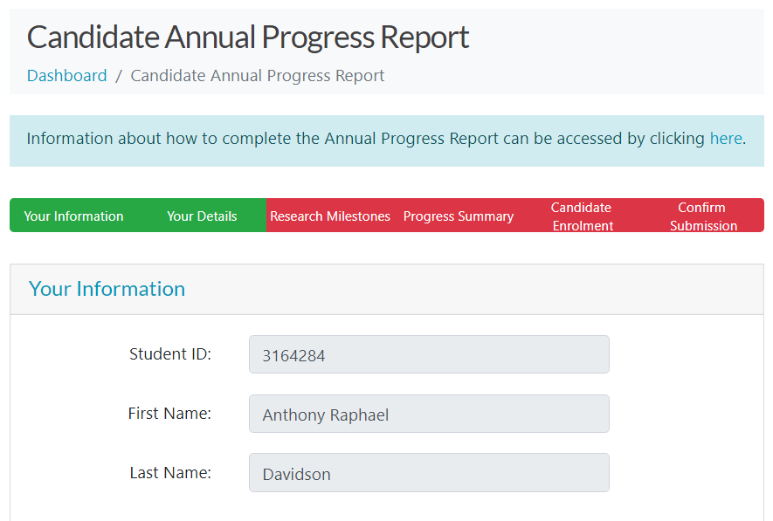

Screen shot of the APR submission dashboard 2020

1. Candidate Annual Progress Report

Information about how to complete the Annual Progress Report can be accessed by clicking on the following link when you are already logged on: https://www.canberra.edu.au/OnlineForms/AnnualProgressReport/FAQ). *[The links here are incorrect, please update when online and logged into* [*MyUC*](https://www.canberra.edu.au/myuc-u/)*.]*

The APR is a mandatory and formal process that provides an opportunity for HDR candidates to express their views on their candidature during the past year, and the progress of their research to date. It is also an important mechanism for the University to monitor and evaluate the progress of our candidates, and identify any areas where additional support may be required.

Your continuing enrolment in the research degree is contingent on a complete and satisfactory APR. If the APR process is not completed, you will not be re-enrolled for the next year, and may face discontinuation from your degree.

**NOTE:** This has not been to my supervisors yet.

The 2020 Research Annual Progress Reports (APR) were submitted on … and are now live, and must be fully completed by you, your supervisor and ADR.

The APR is a four-stage process:

1. the candidate enters their initial comments;
2. the supervisor provides their feedback;
3. the candidates reviews that feedback and acknowledges comments; and
4. the ADR review and provides their final recommendation.

It starts, therefore, with you, and we ask that you aim to have completed the initial stage by: Monday 7 September. then 30 September but now?

##### How to Access and Complete your 2020 APR

You can access your APR through MyUC, under the Research tab or directly by clicking here.You must login using your Student ID number and password.

If you do not know your password, please contact the IT Service Desk on (02) 6201 5500 or at [servicedesk@canberra.edu.au](mailto:servicedesk@canberra.edu.au) to obtain your password.

##### Submission structure

The APR must be submitted online under the follow structure.

[child structure]

1. [Dashboard](https://www.canberra.edu.au/OnlineForms/AnnualProgressReport/CandidateDashboard)
2. Candidate Annual Progress Report

Information about how to complete the Annual Progress Report can be accessed by clicking [here](https://www.canberra.edu.au/OnlineForms/AnnualProgressReport/FAQ).

* Your Information
* Your Details
* Research Milestones
* Progress Summary
* Candidate Enrolment
* Confirm Submission

If the below address details are incorrect, please update instantly in [MyUC](https://www.canberra.edu.au/myuc-u/my-details/addresses).

#### Change of enrolment

International Students must be enrolled full-time. If you are considering a change to part-time or withdrawal from units, consult the international students advisors before completing a [Unit Registration form](https//www.canberra.edu.au/current-students/canberra-students/current-research-students/manage-your-candidature/degree-milestones-and-generic-skills/annual-progress-report) in order to ensure visa requirements are met.

Please note if submission is planned for Semester 1, 2021, enrolment information is required for both semesters in case of a change in circumstances. You must be enrolled in the semester that you submit.

##### Accessing the APR

You must be log into MyUC using your **student** details (the id number beginning with **u**: e.g. *u123456*).

Once you have logged into MyUC, navigate to the Research tab and there will be a link to the APR under the Research Portals section.

1. [Go to the UC website](https://www.canberra.edu.au/)



image-20201011130016802

1. Then Current students [in the top menu bar](https://www.canberra.edu.au/)

* 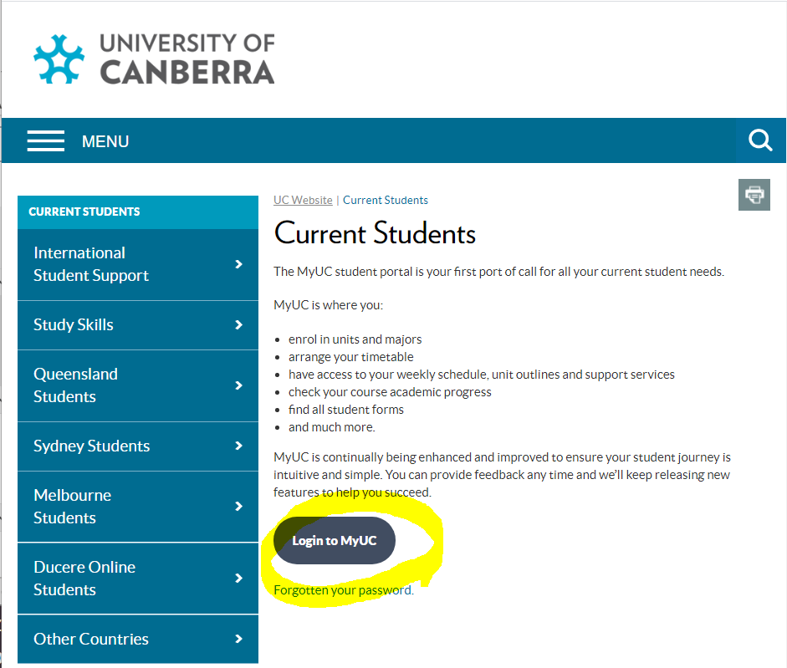
* image-20201011130227834

1. LogIN (maker sure this is student email)
2. Follow links to graduate research page.. 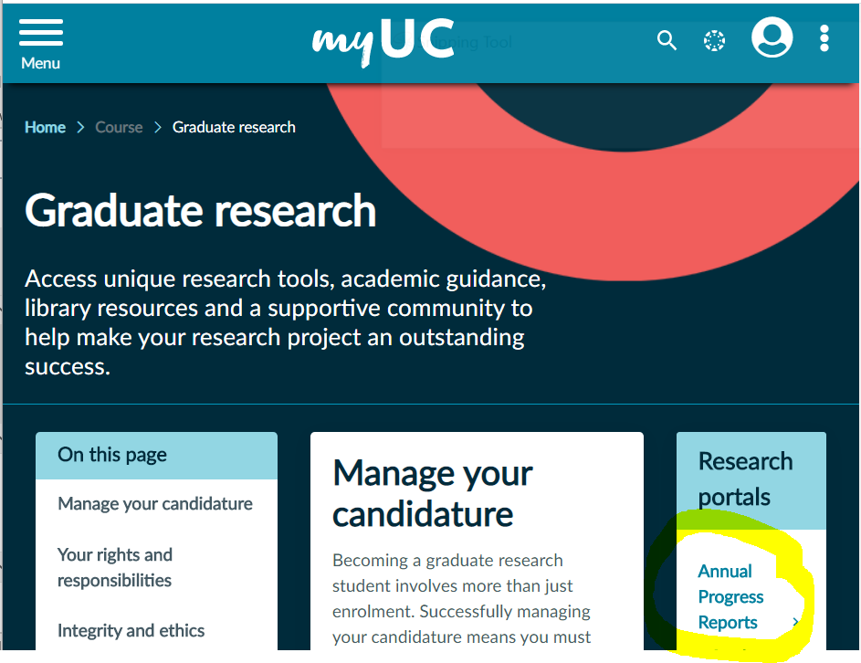
   1. And finally to the Annual Progress reports…
   2. 
   * image-20201011131510659

#### Known page and report errors

##### Comments field

The comments fields all seem to be mandatory this year (2020) but are not identified as being mandatory.

##### Search fail

It is not possible to simply find the APR using the main search bar. Can this be fixed?

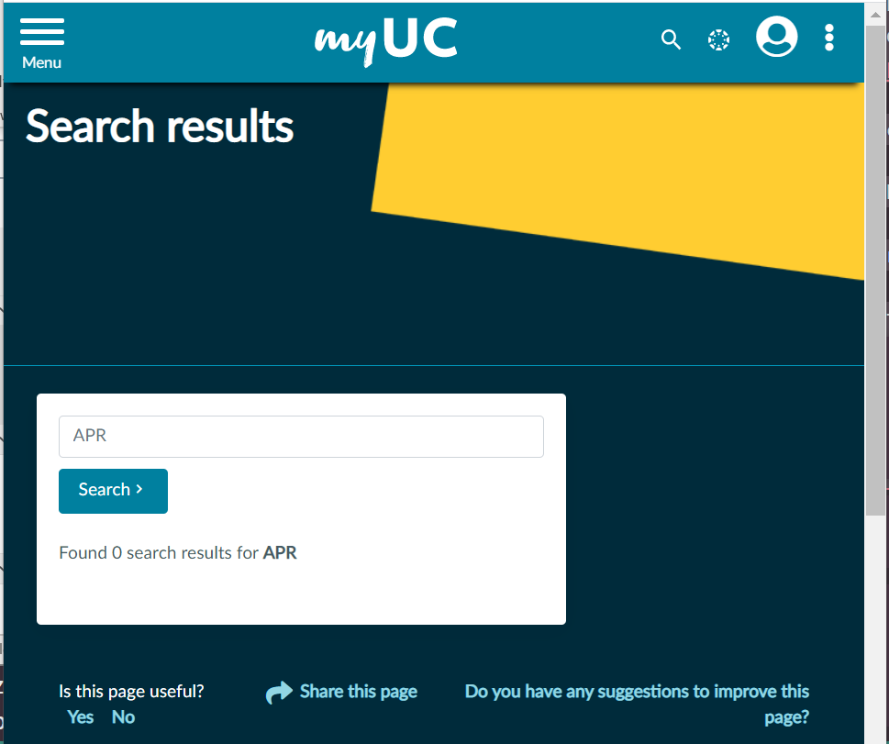

image-20201011125916214

##### Milestones page missing

The comments fields all seem to be mandatory this year but are not identified as being mandatory.

A number of students have reported that they are unable to submit their APR as the milestones page is showing as incomplete. Please try entering comments against all of the milestones, even if the text is ‘no comment’

##### Saving error

A number of staff and students have reported that the APR will not save after they have entered all of their comments. We understand that this is incredibly frustrating and Service Desk are working to resolve the problem. To avoid this from happening please save the APR after completing each comment box.

##### Additional unit appearing in Enrolments section

Some students have reported that there is a unit listed in the Candidate Enrolment section of the APR that they have not been enrolled in. So far this always seems to be the unit 10454 – Health Program Planning and Evaluation. If this happens please check RGrad that the unit is not listed there, if its not then its just an error in the APR. In order to progress the APR please enter a comment stating that this unit is incorrectly listed and proceed with submitting your APR.

We are not sure why any of these errors are occurring and understand that they make completing the online APR more frustrating however we are working with ITM to have these resolved and we hope to have a smooth system back in place soon.

If the suggest work arounds do not work, or you encounter any other problems please let our office know.

APRs must be completed through the online system in order to progress the workflow to ensure all stakeholders submit their comments and a proper review is completed.

NOTE: *Please complete your APR as soon as possible.*

### Quick UC Links

* [Find a Course](https://www.canberra.edu.au/future-students/courses/find-a-course)
* [Find a Unit](https://www.canberra.edu.au/future-students/courses/find-a-unit)
* [Reconciliation](https://www.canberra.edu.au/about-uc/reconciliation)
* [Donate](https://www.canberra.edu.au/about-uc/uc-foundation)
* [Information for Journalists](https://www.canberra.edu.au/about-uc/media/monitor)
* [Find a Staff Member](https://www.canberra.edu.au/directory/)
* [Learning at UC](https://www.canberra.edu.au/about-uc/learning-at-uc)
* [Jobs at UC](https://www.canberra.edu.au/about-uc/work-at-uc/vacancies)

### UC Contacts

* [Domestic Future Students](https://www.canberra.edu.au/future-students/domestic-students)  
  1800 864 226  
  [Email](mailto:study@canberra.edu.au?subject=Enquiry)  
  [Enquire Online](https://www.canberra.edu.au/askuc/domesticenquiry)
* [International Future Students](https://www.canberra.edu.au/future-students/international-students)  
  +61 2 6201 5342  
  [Email](mailto:international@canberra.edu.au?subject=Enquiry)  
  [Enquire Online](https://www.canberra.edu.au/askuc/InternationalEnquiry)
* [Current Students](https://www.canberra.edu.au/current-students)  
  1300 301 727  
  [Email](mailto:student.centre@canberra.edu.au?subject=Enquiry)

#### The UC Group

* [About the University of Canberra](https://www.canberra.edu.au/about-uc)
* [UC Schools](https://www.canberra.edu.au/about-uc/uc-group/uc-schools)
* [UC College (UCC)](https://www.canberra.edu.au/uc-college)
* [UCC English Language Centre](https://www.canberra.edu.au/uc-college/uccelc)
* [UC Union](https://www.canberra.edu.au/about-uc/uc-group/uc-union)

#### Our Faculties

* [Arts and Design](https://www.canberra.edu.au/about-uc/faculties/arts-design)
* [Business, Government and Law](https://www.canberra.edu.au/about-uc/faculties/busgovlaw)
* [Education, Science, Technology and Mathematics](https://www.canberra.edu.au/about-uc/faculties/estem)
* [Health](https://www.canberra.edu.au/about-uc/faculties/health)

#### Our Research Institutes

* [Institute for Applied Ecology](https://appliedecology.edu.au)
* [Institute for Governance and Policy Analysis](https://www.governanceinstitute.edu.au/)
* [Research Institute for Sport and Exercise](https://www.canberra.edu.au/research/institutes/ucrise)
* [More About Our Research](https://www.canberra.edu.au/research)

[Facebook](https://www.facebook.com/UniversityOfCanberra) [Twitter](https://twitter.com/UniCanberra) [Instagram](https://instagram.com/unicanberra) [YouTube](https://www.youtube.com/user/uniofcanberra)

### Previous APR submissions

In the previous APR (2019) I did not get time to submit the comments and response to Richards comments as stated in Stage 3: *the candidates reviews that feedback and acknowledges comments*; and the ADR review (I also contacted the ADR regarding this and had no reply but this is understandable as there has been a range of different people in this role). Previous submissions can be found in the ./old_reports/ folder of this project.

[1] "APR2020_reportV1.Rmd" "APR2020_reportV1_cache"   
 [3] "APR2020v2.docx" "APR2020v3.docx"   
 [5] "APR2RGRAD.docx" "APRcomments2020.Rmd"   
 [7] "APRindex.Rmd" "basicDEMOnov.docx"   
 [9] "basicDEMOnov2.docx" "codebook.Rmd"   
[11] "CovidAPPLICATIONbursary.Rmd" "covidUCimpact.Rmd"   
[13] "data2021" "dogs_I_am_close_tooo.zip"   
[15] "drafts" "FortnightlyTimetable.Rmd"   
[17] "IssuesConcerns.docx" "IssuesConcerns.Rmd"   
[19] "Previous submission.nb.html" "Previous_submission.Rmd"   
[21] "ProgressReport.Rmd" "ResearchPlanReview.html"   
[23] "ResearchPlanReview.Rmd" "SCHOLARSHIP PAYMENT SCHEDULE.xlsx"  
[25] "SciTechApplication2020.Rmd" "SciTechCoiv19Application.Rmd"   
[27] "SciTechCoiv19Application2021.Rmd" "SciTEchDECsubmission"   
[29] "Shinydemo.Rmd" "shonyIDEAS.Rmd"   
[31] "Stafffiles.win.canberra.edu.au" "submitted"   
[33] "UC_annual_reporting_PhD.Rmd" "Untitled.md"

##### September 2020

The tasks needed to finish my PhD thesis are now achievable and have been working on each aspect of the thesis chapters to insure I can finish them within a final 6 months of funding.

The key steps that have made this possible are:

1. Finallising first manuscript (Beech forests)
2. Methods and simulation draft for the second chapter (MPD data)
3. Third chapter content discussed and have begun developing publication structure (ShinyDynamics)

*NOTE:* At this point I have also personally proposed a publication/chapter on my reproducible workflow (tidyPipes) but I have decided not to keep working on this but instead focus on three more incrimental chapters using the bayesian SSM approach for all chapters.

##### June 2020

I have been waiting to have a final paper for this, but this is the working draft as I have now changed the modelling approach to this paper to align with the modelling approach in the other two datasets.

##### March 2020

Over the past year I have continued to work on the publications for my PhD with the focus on the first chapter and publication. This has continued to be a long process but I am happy with the progress and feel it is going in the right direction. I am confident I have all the work needed for a “distinctive by design” thesis. I am just not sure how long it will take to finish.

After drafting the first paper several times as a Bayesian GLM (pre-2020) I have now needed to write up all the papers using the newer Bayesian State Space approach that I had been working on for the second chapter orginally.

##### November 2019

1. I have developed a reproducible framework for PhD publications and thesis construction using my PhD research: ./tidyPipes/
2. I had a finalised draft manuscript for the submission of the Bayesian model for beech forests(changed to SSM as of August 2020): Old Draft ./content/beech-manuscript-wr.docx
3. Drafted a simple interactive “science communication” website
4. Simple mixed models fitted in the first chapter are explained here <https://www.davan690.github.io/beech-anova-simple/>
5. Complex Bayesian outputs overlaid on the raw data are here (both in colour and b&w as journal for publication requires b&w only): <https://www.davan690.github.io/beech-complex-outputs/>
6. State space modelling and simulation of both the beech and MPD datasets: <https://www.davan690.github.io/SSMmodels/>
7. Nature submission on the impacts of graduate stress and mental health challenges in relation to computational reproducibility.

##### March 2019

Since 2019 my workflow (tidyPipes) gives my work a unique twist by combining aspects of the computer science literature (computational reproducibility), programming (R and RStudio) and IT development tools (GIT and GitHub version control) to produce reproducible [and in the future interactive] online resources and evidence for each chapter/publication and done here. I have created a tidyPipes manual ([draft communication template and manual](%22https://www.davan690.github.io/tidyPipes/)) to help support the application of the resources within each chapter of my thesis.