Mpd reproducible start

Anthony Davidson

13/10/2019

Just the start. Here is the basic start and then I will contunie to move files into independent .rmd files and vignettes folder.

Data

## Joining, by = c("grid", "month")

Rats

## Warning: Removed 6 rows containing missing values (geom_point).

## Warning: Removed 6 rows containing missing values (geom_errorbar).

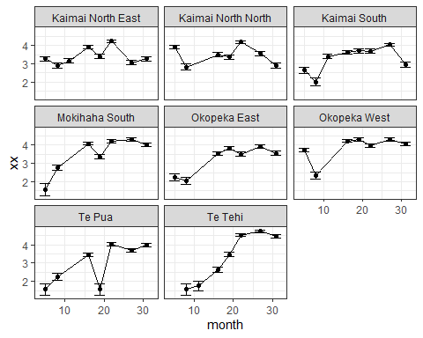

Seed

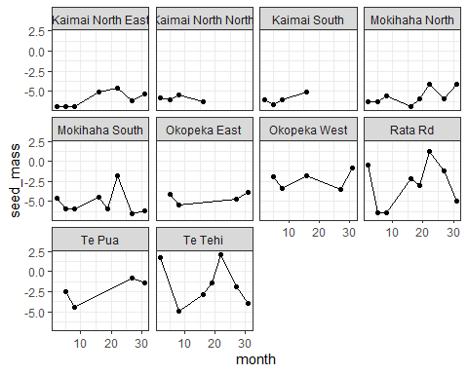

Analysis

Current model

Gompertz model with same parameters for each grid here:

$$K=exp(\frac{b}{d})$$

Gompertz model

If the resource changes over time (e.g. seed availability, rainfall….) then both the rate of increase and the carrying capacity will change over time.

$$N_{t+1}=N_{t}×e^{(r+β_{resource}-d×log(N_{t}))}$$

An example with $β=0.2$ and starting value $N=1$, with a fluctuating resource.

If we set $X_{t}=log(N_{t})$ and log-transform equation 2 we get:

$$X_{t+1}=X_{t}+r+β_{resource}-d×X_{t}$$

This is the process model we can now fit from our discrete time-series data (e.g CR data or indices)

Model fit

This model assumes the same underlying population model at each site - observation error is associated with differences between grids at the same site

* missing values for seed are modelled at the site level
* specify the rainfall lag for the process model in the data statement

mod <- "model {  
  
 # Observation model  
 for(i in 1:nYears) {  
 for(j in 1:nGrids) {  
 Ytau[i, j] ~ dnorm(mu.Ytau, tau[5])  
 Y[i, j] ~ dnorm(X[i, j], Ytau[i, j])  
 # model seed as an overall mean (alpha1), an offset for each year (alpha2) and an offset for each grid (alpha3)  
 seed[i, j] ~ dnorm(mu.r[i, j], tau[1])  
 mu.r[i, j] <- alpha1 + alpha2[i] + alpha3[j]  
 }  
 }  
   
 # priors for the observation and seed models  
 for(i in 1:nYears) {  
 alpha2[i] ~ dnorm(0, tau[2])  
 }  
  
 for(j in 1:nGrids) {  
 alpha3[j] ~ dnorm(0, tau[3])  
 X[1, j] ~ dnorm(0, 0.1)   
 simX[1, j] <- X[1, j]   
 }  
   
 # Process model  
 for(j in 1:nGrids) {  
 for(i in 2:nYears) {  
  
 X[i, j] ~ dnorm(predX[i, j], tau[4])  
 # include rainfall on the raw scale (e.g. exp(log(rain)) - this fits much better  
 predX[i, j] <- X[i-1, j] + (r + beta.seed * (seed[i-lag, j]) - d * X[i-1, j]) * td[i]  
  
 # get independent estimates for the fitted process model  
 simX[i, j] ~ dnorm(predsimX[i, j], tau[4])  
 predsimX[i, j] <- simX[i-1, j] + (r + beta.seed * (seed[i-lag, j]) - d * simX[i-1, j]) * td[i]  
 }  
 }  
  
 # priors  
 mu.Ytau ~ dnorm(0, 0.001)T(0, )  
 r ~ dnorm(0, 0.001)T(0, )  
 beta.seed ~ dnorm(0, 0.01)  
   
 d ~ dnorm(0, 0.01)T(0, )  
 alpha1 ~ dnorm(0, 0.001)  
  
 for(i in 1:5) {  
 tau[i] <- 1 / (sigma[i] * sigma[i])  
 sigma[i] ~ dunif(0, 100)  
 }  
  
 }"  
  
# write model  
write(mod, "model.txt")

##   
## Processing function input.......   
##   
## Done.   
##   
## Beginning parallel processing using 3 cores. Console output will be suppressed.  
##   
## Parallel processing completed.  
##   
## Calculating statistics.......

## Warning in doTryCatch(return(expr), name, parentenv, handler): At least one  
## Rhat value could not be calculated.

##   
## Done.

## mean 2.5% 97.5% Rhat n.eff  
## r 6.4042161 4.08661403 8.7846278 1.0032577 852  
## d 1.7464941 1.09469572 2.4183466 1.0032521 836  
## beta.seed 0.2726964 0.02675609 0.5213452 1.0000811 17646  
## sigma[1] 1.1078321 0.82724527 1.5140057 1.0019767 1066  
## sigma[2] 1.6255883 0.66724891 3.4928227 1.0008618 8271  
## sigma[3] 2.0729890 1.07572666 4.0880917 1.0009368 17646  
## sigma[4] 0.5692032 0.44587322 0.7266135 1.0000804 20501  
## sigma[5] 42.1684821 35.07943985 51.1404531 1.0000033 45000  
## X[1,1] 3.2577292 3.01980198 3.4948289 0.9999974 45000  
## X[2,1] 2.9426020 2.66634086 3.2230433 1.0000283 45000  
## X[3,1] 3.1724671 2.92418151 3.4168273 0.9999871 45000  
## X[4,1] 3.9140946 3.72900454 4.1014057 0.9999965 45000  
## X[5,1] 3.4236818 3.19245668 3.6532609 1.0000117 45000  
## X[6,1] 4.2191391 4.05609875 4.3812474 0.9999779 45000  
## X[7,1] 3.0873774 2.84496935 3.3316960 1.0000302 45000  
## X[8,1] 3.2728487 3.02760724 3.5159001 1.0000340 45000  
## X[1,2] 3.8952160 3.70393851 4.0875083 1.0000743 45000  
## X[2,2] 2.8930947 2.60264230 3.1852648 0.9999944 45000  
## X[3,2] 3.2348602 2.10454148 4.3613036 1.0000295 44543  
## X[4,2] 3.4847469 3.26542299 3.7048342 1.0001244 13893  
## X[5,2] 3.3902134 3.15608622 3.6223739 1.0000635 26089  
## X[6,2] 4.1688333 3.99546000 4.3435892 1.0000347 45000  
## X[7,2] 3.5508640 3.34384532 3.7609966 1.0000229 45000  
## X[8,2] 2.9529241 2.67716833 3.2293994 1.0000054 45000  
## X[1,3] 2.6033994 2.29475982 2.9111601 1.0001289 18887  
## X[2,3] 2.1763404 1.76583391 2.5806818 1.0000589 40513  
## X[3,3] 3.3793656 3.14850371 3.6122228 1.0000203 45000  
## X[4,3] 3.6253916 3.42123029 3.8306264 1.0000744 19764  
## X[5,3] 3.7013023 3.49500060 3.9075270 0.9999770 45000  
## X[6,3] 3.7054651 3.50005084 3.9107739 1.0000206 37178

Results

What is this for??

Wrangling results

Extract model fit

## Joining, by = c("grid", "month")

## Warning: Column `grid` joining factor and character vector, coercing into  
## character vector

## Joining, by = c("grid", "month")

Figures

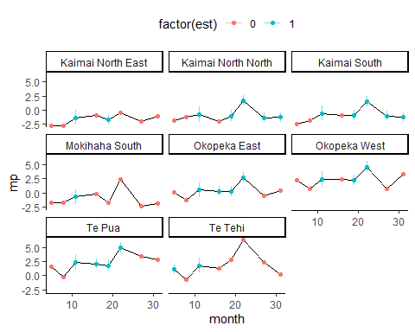

Overall fit

Notes

* fitted process model is the red line circles are the grid data
* black line is the estimate of the true population having accounted for observation error (e.g. variation between grids at the same site)

## Warning: Removed 6 rows containing missing values (geom_point).

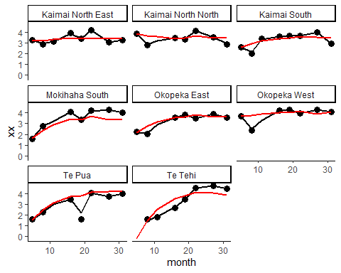

My notes

Other models

# run the model in JAGS with three chains  
mod1.jags <- jags(model = "model1.txt",  
 data = list(Y = Y, Ytau = Ytau, seed = nseed, nGrids = nGrids, nYears = nYears, lag = lag.sp, td = td),  
 param = c("r", "d", "beta.seed", "sigma", "X", "simX", "seed"),  
 n.chains = 3,  
 n.iter = 200000,  
 n.burnin = 5000,  
 parallel = TRUE)

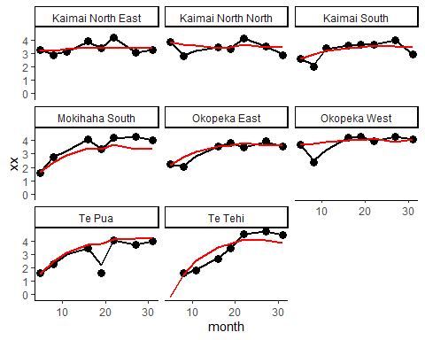

# run the model in JAGS with three chains  
mod2.jags <- jags(model = "model1.txt",  
 data = list(Y = Y, Ytau = Ytau, seed = nseed, nGrids = nGrids, nYears = nYears, lag = lag.sp, td = td),  
 param = c("r", "d", "beta.seed", "sigma", "X", "simX", "seed"),  
 n.chains = 3,  
 n.iter = 100000,  
 n.burnin = 50000,  
 parallel = TRUE)

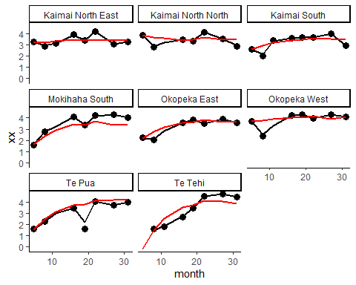

v3

# run the model in JAGS with three chains  
mod3.jags <- jags(model = "model1.txt",  
 data = list(Y = Y, Ytau = Ytau, seed = nseed, nGrids = nGrids, nYears = nYears, lag = lag.sp, td = td),  
 param = c("r", "d", "beta.seed", "sigma", "X", "simX", "seed"),  
 n.chains = 3,  
 n.iter = 2000,  
 n.burnin = 500,  
 parallel = TRUE)

