Taking advantage of all the symbols in ggplot2

There are a few things in R that are particularly annoying and I have left them all to the last steps. This is the case for any package or set of tools we choice to use as researchers. The issues below are a random collection of issues do with the tidyverse approach and the other packages I use to do analysis. Here are my learning steps for the annoying R issues.

# ggplot2 symbols

I have been writing my first paper for my PhD for a ridiculously long time and as I am finally finishing figures for the manuscript I have had huge issues trying to sort these symbols.

## aes(shape = Valley; colour = Control, fill = Rats)

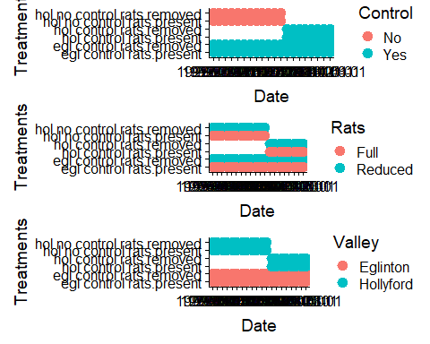

[Figure 1: Plot of the three different factors, each with two levels that I want to each have the following representative symbols](./figs/plot3-symbols.jpeg)

# My solution for this script

For the example above there are three factors (valley, control, rats) each has 2 levels. However, because we are missing some combinations we have a total of 6 treatments.

## aes(shape = Valley; colour = Control)

To plot this I need to split the symbols. I have decided to do this as follows: shape = Valley; colour = Control; fill = Rats. And in ggplot2 this is wrapped with the aes() function.

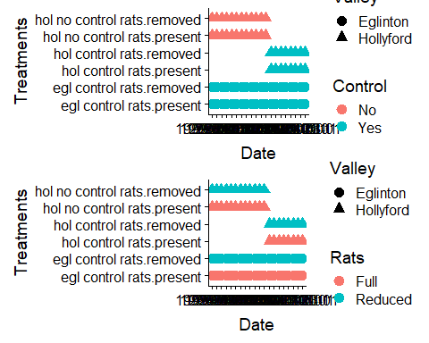

[Figure 2](./figs/plot2-symbols.jpeg)

## aes(shape = Valley; colour = Control, fill = Rats)

And in ggplot2 this is wrapped with the aes(shape = Valley; colour = Control, fill = Rats) function. And then it looks like this:

## aes(shape = Valley; colour = Control, fill = Rats)

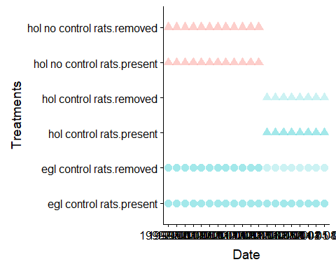

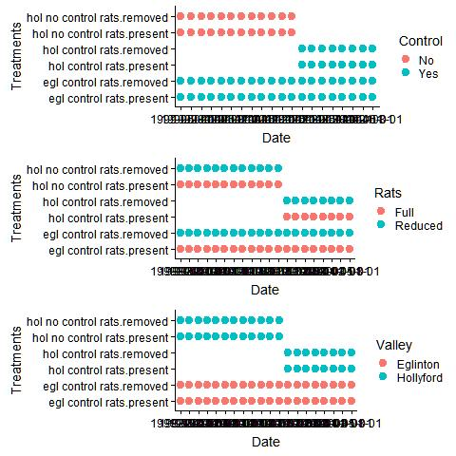

Figure 3

**WHAT makes this such a hard question??**

But for some reason fill doesn’t work the way I want with rings for rats!

This is why??

## Resources

Dealing with factors can be hard in R and here are some resources for FACTORS in R:

* [A collection of scripts I use](https://github.com/davan690/usefulr/)
* [An .Rmd file for factoring](https://github.com/davan690/usefulr/tree/gh-pages/RMarkdown-vigettes)
* []

# The dreaded legend

## Resources