.model small

Name: Tet Davann

Group:C

.data

var1 db "Please input your numbers:$"

var2 db 13,10,"The next integer is:$"

.code

main proc

mov ax,@data

mov ds,ax

mov dl,offset var1

mov ah,9h

int 21h

mov ah,1h

int 21h

cmp al,13

jz result1

mov ah,0

push ax

mov ah,1h

int 21h

cmp al,13

jz result2

mov ah,0

push ax

mov ah,1h

int 21h

mov ah,0

push ax

mov dl,offset var2

mov ah,9h

int 21h

pop ax

pop bx

pop cx

push ax

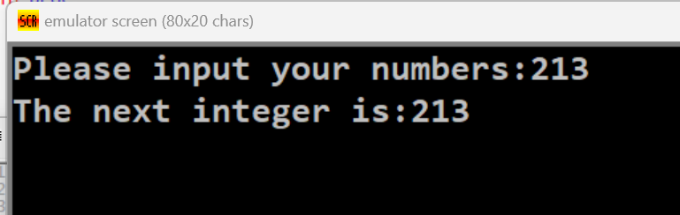 push bx

push cx

pop ax

pop bx

pop cx

mov ah,2h

mov dx,ax

int 21h

mov ah,2h

mov dx,bx

int 21h

mov ah,2h

mov dx,cx

int 21h

jmp stop

result1:

mov dl,offset var2

mov ah,9h

int 21h

jmp stop

result2:

mov dl,offset var2

mov ah,9h

int 21h

pop ax

mov ah,2h

mov dx,ax

int 21h

stop:

main endp

end main