  - laporan Proyek mata kuliah PEMROGRAMAN DASAR
  - Semester gASAL 2025/2026

Online Shopping



Anggota Tim
- 25/565780/TK/63818 | Muhammad Daffa Wirawan

Departemen Teknik Elektro dan Teknologi Informasi
Fakultas Teknik
Universitas Gadjah Mada
2025
Github Repository: https://github.com/davausername/Project-Online-Shop-Muhammad-Daffa-Wirawan-565780

DESKRIPSI APLIKASI
Aplikasi ini (Online Shop) merupakan simulasi aplikasi online shopping dimana users bisa berinterasi dengan fitur-fitur yang ada di dalam aplikasi tersebut seperti register, pemilihan category, pembelian barang dan simulasi proses delivery yang sangat simple.

Aplikasi ini dirancang untuk kemudahan user dalam berinteraksi dengan interface yang simple dan mudah digunakkan. Dalam awal pembuatannya, aplikasi ini dirancang dengan UML yang dibuat di Enterprise Architect. Selain itu, online shop dibuat dengan C++ yang berbasis console sehingga seluruh interaksi dilakukan melalui terminal.
Pada projek ini dikembangkan aplikasi online shop mencakup analisis dan desain:
- Analisis dan pemodelan menggunakan UML
- Pengembangan menggunakan konsep OOP
- Bahasa pemograman C++
- Interaksi user dengan terminal / console

ANALISIS KEBUTUHAN
Aplikasi Online Shop berbasis C++ ini memiliki feature user interactive yang dapat mempermudah user dalam melakukan process pembelian suatu barang dengan menampilkan menu, product description, user expenses, dan melakukan proses simulasi delivery yang sangat simple.

Kebutuhan Fungsional
Kebutuhan fungsional yang ada di dalam aplikasi ini mencangkup berbagai functions untuk melakukan tugas tertentu dalam melakukan particular process dalam aplikasi. Beberapa kebutuhan fungsional tersebut terletak dalam table di bawah ini.
Table 1 Kebutuhan Fungsional
Req-ID | Kebutuhan Fungsional | Deskripsi
F-01 | Sign Up | Feature to add user to database
F-02 | Sign In | Feature remember user and access all functionality
F-03 | View User Details | Feature to view user details (full name, password, etc.
F-04 | Remove Account | Feature to remove user from database
F-05 | Save Product to Cart | Feature to save product to cart
F-06 | Checkout | Feature to checkout all products in user cart
F-07 | Buy | Feature to buy product
F-08 | Simple Delivery Process | Simple feature to view delivery process
F-09 | Track User Expenses | Feature to see how much user has spent in the shop

Kebutuhan Non Fungsional
Deskripsikan kebutuhan non fungsional. Dapat mencakup hal-hal sbb:
- UML Enterprise Architect
- Quick performance and easy usability
- C++ Compiler (MSYS2)
- VS CODE & Terminal
- Information sources from internet
- Keterbatasan knowledge and potential bugs
- Flexible Working Schedule

PEMODELAN DAN PERANCANGAN SISTEM

Use Case Diagram
Our application was involved by use case diagram to visually mapping, structuring, and defining system. so it acts a bridge to help defining what system does, make program structure easily understood, and help what developer need to do.
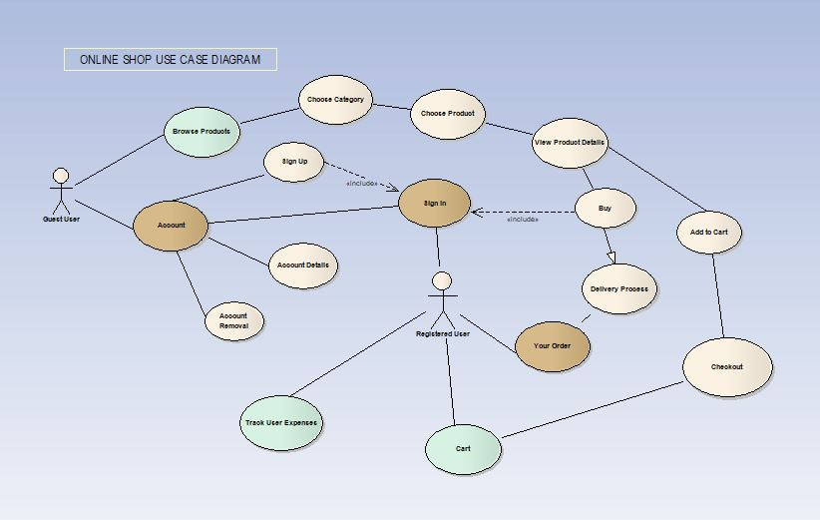
Tambahkan Use Case Skenario
Req-ID | Kebutuhan Fungsional | Skenario use case
F-01 | Sign Up | - User choose Account (if from menu/home)  - Click Sign Up  - Insert User Informations.  - Enter and it saves the data to database
F-02 | Sign In | - User choose Account  - Click Sign In  - Enter username and password  - Check and successful then sends user to menu
F-03 | View User Details | - User choose Account  - Click Account Details  - Enter username and password  - Fetch the data and shows the user Information and buying record
F-04 | Remove User | - User choose Account  - Click Remove Account  - Enter username and password  - Remove User Account
F-05 | Save Product to Cart  (Registered Feature) | - Browse product you want by choose the category.  - Then, choose stuff you want to see  - After that, click “1” to save to cart
F-06 | Buy & Checkout  (Registered Feature) | - Firstly, you need to save products to cart or buy directly.  - If you save products to cart, you visit the cart section and checkout all the stuff
F-07 | Simple Delivery Process  (Registered Feature) | - Buy stuff you want or checkout products in your cart.  - Then it shows simple delivery processing.  - Done.
F-08 | Track User Expenses  (Registered Feature) | - In the homepage, enter “P”  - Then it shows your total expenses in the store

Class Diagram
Pada bagian ini dapat digunakan beberapa jenis UML diagram untuk menggambarkan aspek perilaku (behavioral) dari system atau aplikasi.
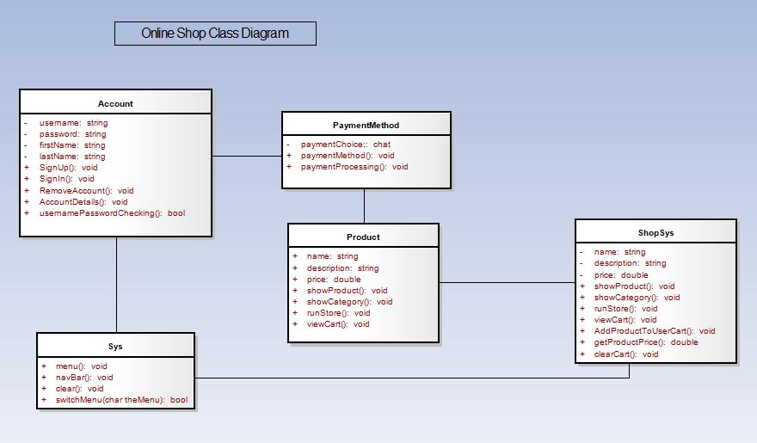

Perancangan User Interface
User Interface digunakkan pada aplikasi ini yaitu console dengan pilihan menu dengan simple and interactive design yang dapat diakses dengan memasukkan char yang terdapat pada menu dan click enter to continue the process.
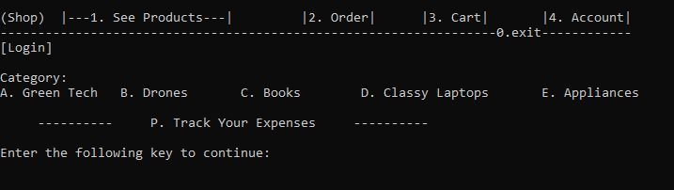

Transformasi Class Diagram Menjadi Kode Program
Jelaskan proses transformasi class diagram menjadi source code.
ProductDatabase class;
class ProductDatabase {
private:
std::map<std::string, std::vector<Product>> categories;

public:
ProductDatabase() {
categories["Green Tech"] = {
{"Solar Panels", "High-efficiency solar panels for home energy.", 1200.0},
{"Home Wind Turbine", "Small wind turbine for household use.", 800.0},
{"Smart Thermostat", "AI thermostat saving up to 40% electricity.", 250.0},
{"Green AC", "Eco-friendly AC system.", 1500.0},
{"Smart Sprinklers", "Smart sprinklers that save up to 60% water.", 300.0}
};

categories["Drones"] = {
{"Camera Drone", "4K drone with stabilizer.", 600.0},
{"Military Drone", "Heavy-duty surveillance drone.", 2500.0},
{"Adventure Drone", "Durable drone for extreme travel.", 1200.0},
{"Winter Drone", "Cold-resistant drone.", 900.0},
{"Delivery Drone", "Autonomous delivery drone.", 2000.0}
};

categories["Books"] = {
{"Atomic Habits", "A book about building better habits.", 15.0},
{"Surrounded By Idiots", "Understanding personality types.", 20.0},
{"Think and Grow Rich", "Classic self-development book.", 18.0},
{"The Psychology of Money", "Money behavior explained.", 22.0},
{"The Intelligent Investor", "Investment principles.", 25.0}
};

categories["Classy Laptops"] = {
{"Apple MacBook Pro", "High-performance laptop with M1 chip.", 2000.0},
{"HP Spectre x360", "Convertible laptop with touch screen.", 1500.0},
{"Dell XPS 13", "Compact and powerful laptop.", 1300.0},
{"Microsoft Surface Laptop", "Lightweight laptop with touch screen.", 1400.0},
{"Nokia Laptop", "High-efficiency laptop.", 700.0}
};

categories["Appliances"] = {
{"LED Light", "Energy-efficient LED light bulb.", 15.0},
{"Smart Refrigerator", "Energy-saving smart fridge.", 1200.0},
{"Microwave Oven", "Compact microwave oven.", 150.0},
{"Air Conditioner", "Energy-efficient air conditioner.", 500.0},
{"Washing Machine", "High-efficiency washing machine.", 700.0}
};

categories["German Cars"] = {
{"BMW 3 Series", "Luxury sedan with sporty performance.", 41000.0},
{"Audi A4", "Premium sedan with advanced technology.", 39000.0},
{"Mercedes-Benz C-Class", "Elegant sedan with luxurious features.", 42000.0},
{"Volkswagen Golf", "Compact car with efficient performance.", 25000.0},
{"Porsche 911", "High-performance sports car.", 99000.0}
};

categories["German Tech"] = {
{"Siemens Home Appliance", "Energy-efficient home appliance.", 800.0},
{"Bosch Power Tool", "Durable and powerful tool.", 300.0},
{"SAP Software Suite", "Enterprise software solutions.", 5000.0},
{"Adidas Smartwatch", "Fitness smartwatch with advanced features.", 200.0},
{"Bayer Health Device", "Health monitoring device.", 150.0}
};

categories["German Books"] = {
{"Panzer Commander", "A classic account from a German tank commander.", 15.0},
{"Mein Kampf", "Infamous as Hitler's autobiographical manifesto.", 20.0},
{"Berlin Alexanderplatz by Döblin", "Modernist novel set in Berlin.", 14.0},
{"All Quiet on the Western Front by Remarque", "World War I novel.", 10.0},
{"The Magic Mountain by Mann", "Philosophical novel.", 18.0}
};

categories["German Appliances"] = {
{"Miele Washing Machine", "High-efficiency German washing machine.", 900.0},
{"Bosch Dishwasher", "Quiet and efficient dishwasher.", 700.0},
{"Siemens Refrigerator", "Energy-saving German refrigerator.", 1200.0},
{"AEG Oven", "Advanced cooking oven.", 800.0},
{"Liebherr Freezer", "High-capacity German freezer.", 1000.0}
};
}

// Safe access
const std::vector<Product>& getCategory(const std::string& name) const {
return categories.at(name);
}

bool hasCategory(const std::string& name) const {
return categories.find(name) != categories.end();
}

std::vector<std::string> getCategoryNames() const {
std::vector<std::string> names;
for (const auto& c : categories)
names.push_back(c.first);
return names;
}
};

Account.h
class UserInfo {
private:
string FirstName, LastName, Username, Password;

public:
// functions
void SignUp();
void LogIn();
void RemoveAccount();
void AccountDetails();

bool usernamePasswordChecking(const string& inputUser, const string& inputPass);
};

IMPLEMENTASI APLIKASI
Pada bab ini silahkan dilaporkan luaran atau hasil dari pengembangan aplikasi yang telah dirancang pada tahap sebelumnya. Hal-hal yang dapat dijelaskan di sini:
- Perubahan apa saja yang dilakukan dari source code hasil code generation dari UML Tool.
- Komponen (modul) apa yang telah diimplementasikan dari perancangan awal. Misalnya berapa fitur yang telah dibuat dari total kebutuhan fungsional.
- Tangkapan layar dari sistem informasi dan penjelasannya. Bisa dijelaskan berdasarkan kebutuhan fungsional

Fitur F-01 Register New Person / Sign Up
Sign up feature, serve as bridge to connect user to database (.txt in our case). Once user has registered they have full functionality of this app, they can buy product and track their record.
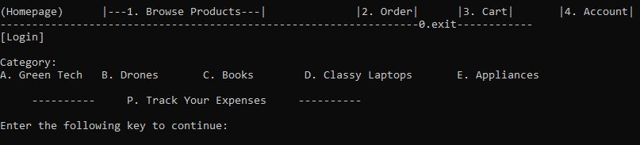
Dari menu user enter ‘4’ untuk pergi ke account section
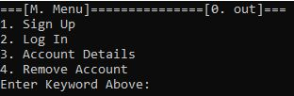
Penguna memilih ‘2’ untuk sign up dan enter. Setelah itu memasukkan detail info.
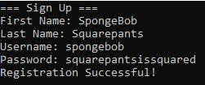

Fitur F-02 Sign In
Our app also has feature to remember user and its data. To do it you need to the account section and click Sign in like above and then enter your username and password.
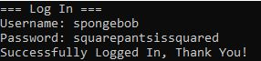
After that, it automatically redirect you to homepage!

Fitur F-03 View User Details
If you want to see your details, you can do it with this feature. What you need to do is go to the account section and choose User Details. Then insert your username and password. Here’s an example below!
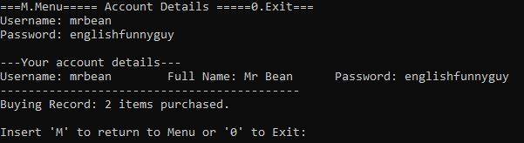

Fitur F-04 Remove User Account
If you want to remove your user account, you do like so go the account section, then choose remove account. Enter your username and password. And yeah, your username has been removed.
Ex.
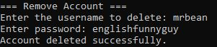

Fitur F-06 Save Product to Cart
Lorem ipsum dolor sit amet, consectetur adipiscing elit. Aenean at laoreet nunc. Praesent convallis, urna quis tempor semper, arcu nisi porttitor quam, eget tincidunt tellus odio nec nulla.
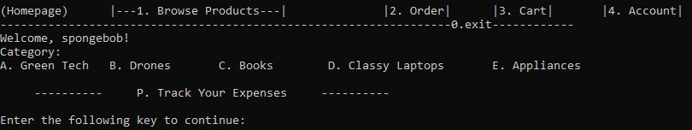
In the home page you can browse more categories by vising “Browse Products” or choose any category in the menu.
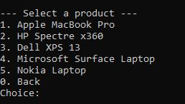
Then choose any desired product.

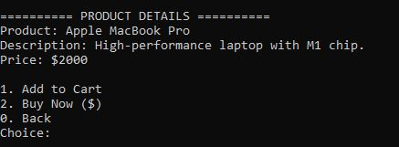
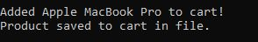

After you choose a stuff you wanna but, you see brief description. To add to your cart just enter ‘1’ (as simple as it is).
If you want to check your cart, you may go back to the menu and enter ‘3’ for cart. Once you’ve got into the cart page you’ll such below!
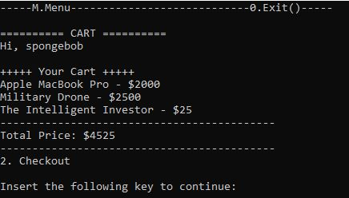

Fitur F-07 Buy & Checkout
Fitur buy & checkout dapat dilihat dengan mengakses product yang dinginkan dan click buy, pilih payment method dan akan dialihkan
Untuk mencoba fitur tersebut pilih product yang ingin dibeli dan enter “2” untuk Buy now atau Checkout.
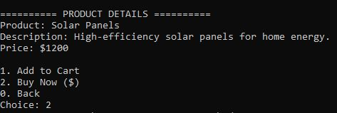

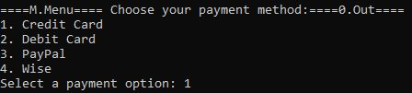
Pilih metode pembayaran yang diinginkan dan enter. Setelah itu pembayaran diprocess dan successful.
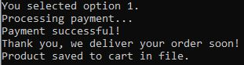

Fitur F-09 Simple Delivery Process
Feature simple delivery process merupakan fitur untuk track process pengiriman barang yang sedang bekerja. Proses delivery dalam aplikasi ini sangat simple dengan waktu pengiriman yang fix dan tidak random.

Fitur F-10 Track User Expenses
Fitur track user expenses merupakan feature untuk mengetahui berapa banyak uang yang telah dihabiskan di aplikasi online store ini.
Dibawah ini merukan contoh berapa total uang yang telah dihabiskan oleh user bernama Spongebob dengan total expenses mencapai $51625.
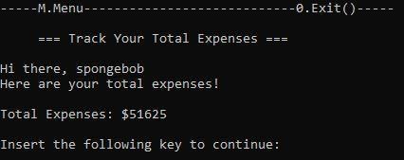

LAMPIRAN
- Full source code and beyond can be accessed through:
https://github.com/davausername/Project-Online-Shop-Muhammad-Daffa-Wirawan-565780

- Brief Source code:

Main.cpp
#include <iostream>
#include "Header/System.h"
using namespace std;

int main() {

menu();

return 0;

}

Interface.cpp
#include <iostream>
#include "Header/System.h"
#include "BuyingSystem/ProductDataBase.h"
#include "BuyingSystem/Products.h"
#include "Header/Account.h"

bool isLoggedIn = false; // actual storage
std::string currentUser = "";

using namespace std;

void navBar(){
cout << endl << "(Homepage)\t" << "|---1. Browse Products---|\t\t" << "|2. Order|\t" << "|3. Cart|\t" << "|4. Account|" << endl;
cout << "------------------------------------------------------------------0.exit------------" << endl;
}

bool menuM (char menuM) {
ProductDatabase db;
switch (menuM) {
case 'A': {
clear();
cout << "Green Tech" << endl;
Product().showCategory(db.getCategory("Green Tech"));
return true;
}
case 'B': {
clear();
cout << "Drones" << endl;
Product().showCategory(db.getCategory("Drones"));
return true;
}
case 'C': {
clear();
cout << "Books" << endl;
Product().showCategory(db.getCategory("Books"));
return true;
}
case 'D': {
clear();
cout << "Classy Laptops" << endl;
Product().showCategory(db.getCategory("Classy Laptops"));
return true;
}
case 'E': {
clear();
cout << "Appliances" << endl;
Product().showCategory(db.getCategory("Appliances"));
return true;
}
case 'P': {
cout << "Track Your Expenses" << endl;
clear();
UserExpenses();
return true;
}
}
return false;
}

void menu() {

navBar();

// loggedin
if (isLoggedIn)
cout << "Welcome, " << currentUser << "!\n";
else
cout << "[Login]\n" << endl;

cout << "Category:\n" << "A. Green Tech\t" << "B. Drones\t" << "C. Books\t" << "D. Classy Laptops\t" << "E. Appliances\t" << endl << endl;

cout << " ---------- P. Track Your Expenses ---------- " << endl << endl;

while (true)
{
char menu;
cout << "Enter the following key to continue: ";
cin >> menu;
menu = toupper(menu);

bool handled = false;

handled |= switchMenu(menu);
handled |= menuM(menu);

if(!handled)
cout << "Please Choose the given keys!";
}
}

System.cpp
#include <iostream>
#include <cstdlib>
#include "Header/System.h"
#include "BuyingSystem/Products.h"
#include "Header/Account.h"
using namespace std;

void clear(){
#ifdef _WIN32
system("cls");
#else
system("clear");
#endif
}

bool switchMenu(char theMenu){
switch (theMenu)
{
case '0':
clear();
cout << "\nSee Ya, Danke" << endl;
exit(0);
return true;
case '1':
clear();
Product().runStore();
return true;
case '2':
clear();
deliveryProcess();
return true;
case '3':
clear();
cout << "Cart" << endl;
Product().viewCart();
return true;
case '4':
clear();
UserInterraction();
return true;
}
return false;
}

Payment.cpp
#include <iostream>
#include "payment.h"
#include "../Header/System.h"
using std::cout;
using std::cin;
using std::endl;

void PaymentMethod::paymentMethod() {
cout << "====M.Menu==== Choose your payment method:====0.Out====" << endl;
cout << "1. Credit Card\n2. Debit Card\n3. PayPal\n4. Wise" << endl;

while (true) {
char choice;
cout << "Select a payment option: ";
cin >> choice;

PaymentMethod pm;
pm.setPaymentChoice(choice);
if (choice == '0') {
cout << "See you, Danke." << endl;
exit(0);
return;
} else if (choice == '1' || choice == '2' || choice == '3' || choice == '4') {
cout << "You selected option " << choice << "." << endl;
paymentProcessing();
return;
} else if (choice == 'M' || choice == 'm') {
menu();
return;
} else {
cout << "Invalid choice. Please try again." << endl;
}
}

}

void PaymentMethod::paymentProcessing() {
cout << "Processing payment..." << endl;
cout << "Payment successful!" << endl;
}

Total terdapat 13 c++ files dengan 7 .cpp files dan 5 header files
Semua files c++ project ini terdapat di link Github:
https://github.com/davausername/Project-Online-Shop-Muhammad-Daffa-Wirawan-565780

