Quantum Information and Computing - Assignment 8
In this assignment we were required to calculate the effective Hamiltonian and ground state for the Ising model with many sites, using the real space renormalization group; in this algorithm we iteratively double the system size by assuming that the new ground state is given by the first m eigenstates of each half-system.
To achieve this, the new Hamiltonian will be given by ; this means we’ll have the “old” Hamiltonian acting on the first half of the system plus the same Hamiltonian acting on the second half of the system plus an interaction term; I_{m} is the identity of the appropriate size, which means m*m since at the end of each step we change basis by projecting onto its first m eigenvectors, finding a diagonal matrix with m entries.
The interaction term for the Ising model would be in the computational basis when going from a size N to a size 2N system; however, we have to account for the projection that we do at each iteration. In the initial step we’ll have an expression that is exactly the one given above; in the second step we’ll have , and so forth; Π₁ denotes the projector found at the first iteration, with the first m eigenvectors of the previous Hamiltonian as columns.
If we write the interaction term as , we can iteratively find the two halves of the expression using at each step and , starting from and , with Π_{n} denoting the projector found at iteration n.
To simplify the algorithm, I used m=2^{n0}, where n₀ is the initial number of sites.
The function takes as arguments the initial size, the number of iterations and the value of lambda to use in the Ising model, and returns the Hamiltonian found at the last iteration, a list of the projectors for each step and the value of the ground level at each iteration.
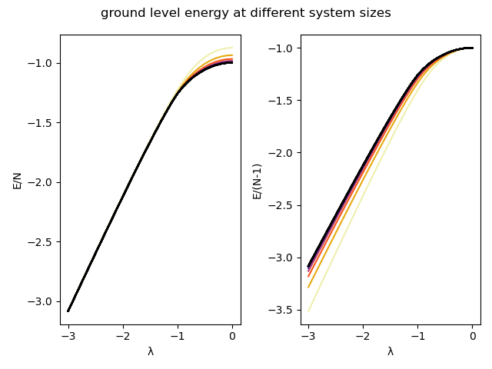
Here are the results of the ground level energy at different system sizes for varying lambda; they have been plotted both as energy over number of sites, to show the e~lambda behavior at large lambda (prevalence of σ_{z} term), and as energy over number of sites minus one, to show e~1 at small lambda (prevalence of σ_{x} term).
The colors get darker as the number of sites gets bigger; after the first 5-6 iterations the algorithm converges, finding the black curve. The algorithm was run with 40 iterations, starting with 4 sites; the separation in energy for the last iterations is of the order of ~10⁻¹².

