🌊 What is a Normalizing Flow (intuitively)?
A normalizing flow is a way to turn simple randomness into complex data by applying a sequence of smooth transformations.
Think of it like this:
Start with something simple (like Gaussian noise)
→ gradually “shape” it
→ until it looks like real data (images, sounds, etc.)

🧠 Core Idea in One Sentence
A normalizing flow is:
A chain of reversible transformations that converts a simple distribution into a complicated one.

🎨 Visual Intuition
1. Start simple
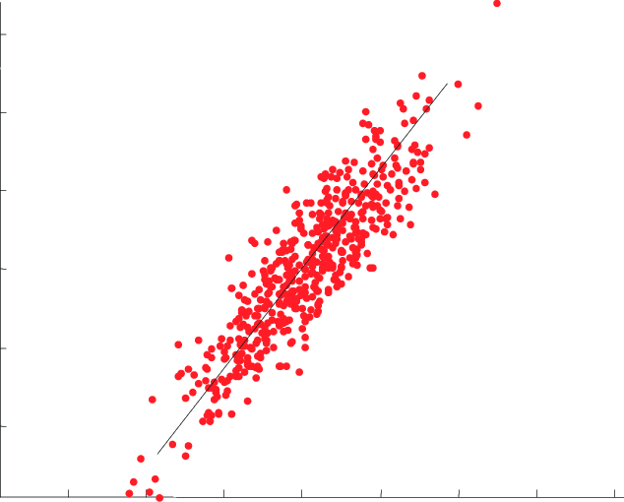
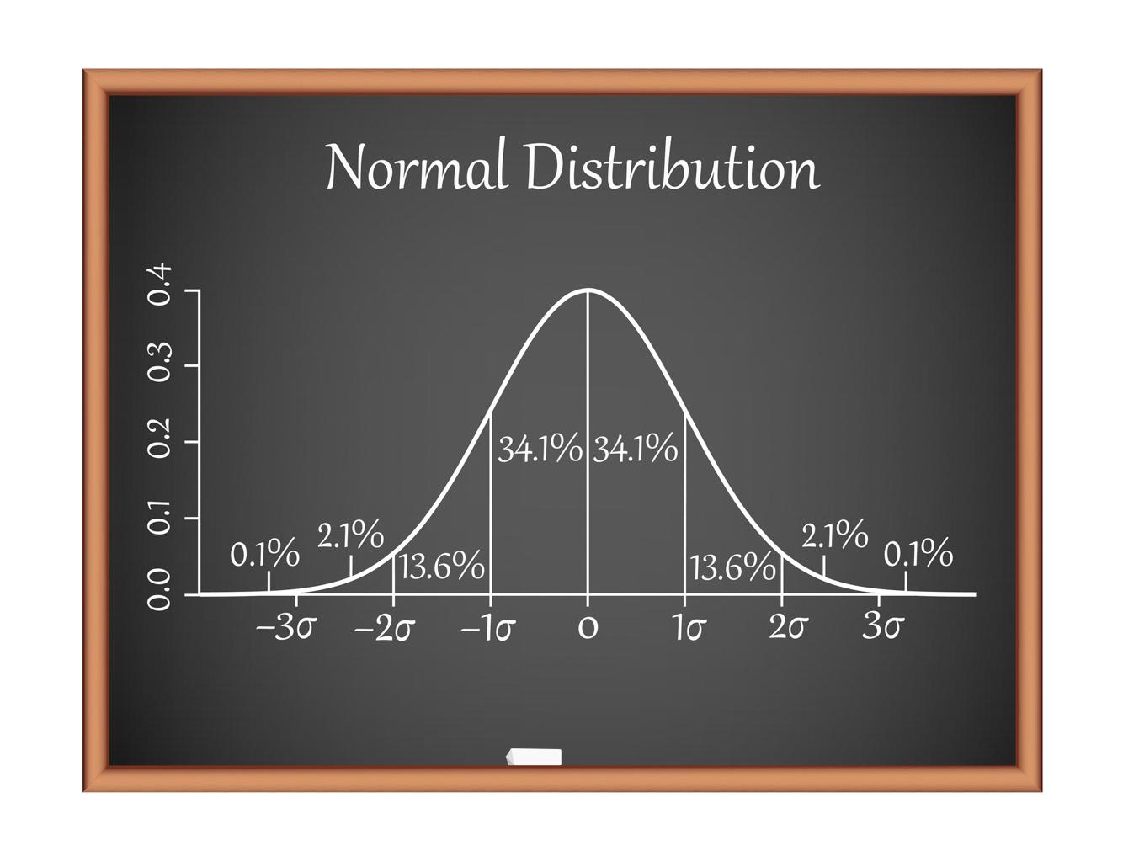
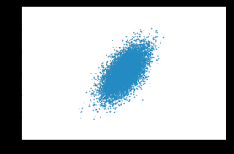
Imagine points sampled from a simple Gaussian:
- round
- smooth
- boring

2. Apply transformations
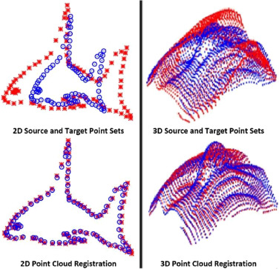
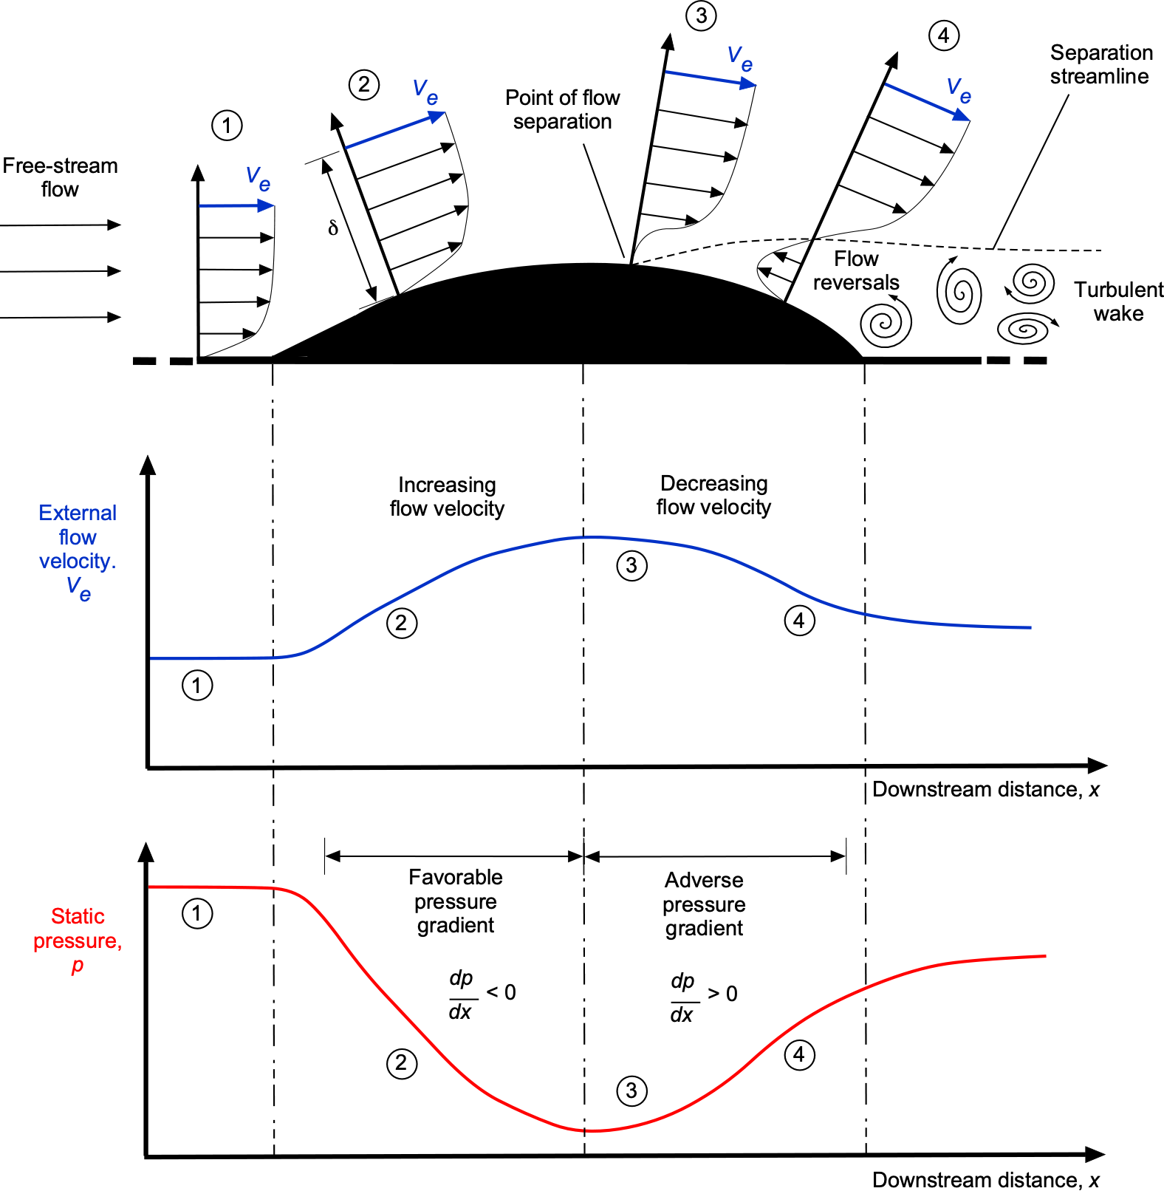
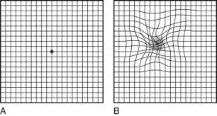
Now we warp the space:
- stretch
- bend
- twist
After several steps, the points become:
- curved
- clustered
- structured

3. End with complex data
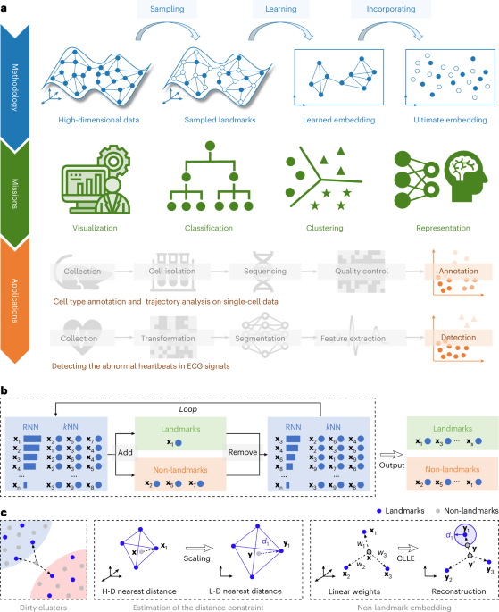
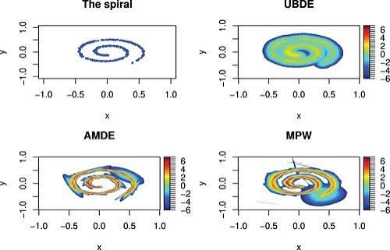
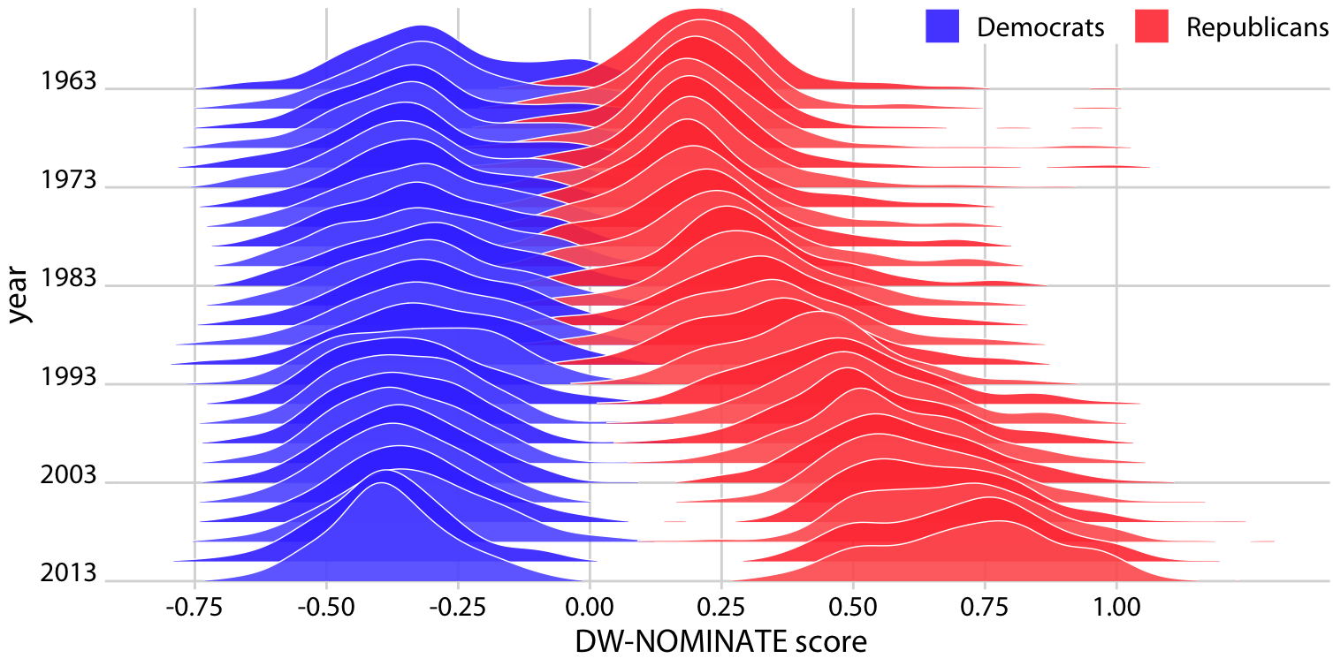
Now the distribution looks like:
- real-world data
- complex patterns
- nontrivial structure

🔁 Why “Flow”?
Because you can imagine:
probability mass flowing through transformations
Like water:
- starts smooth
- gets shaped by pipes and obstacles
- ends up in complex patterns

⚙️ What makes it special?
1. Reversible (invertible)
Every step can be undone:
- data → noise
- noise → data
This is crucial.

2. Exact probability (this is the big deal)
Unlike GANs:
Normalizing flows can compute exact likelihood
Meaning:
- you can say how likely a data point is
- very useful for theory and density estimation

🧩 Key Mechanism (intuitive)
Suppose:
- you start with simple variable: z∼Gaussianz \sim \text{Gaussian}z∼Gaussian
- apply transformation: x=f(z)x = f(z)x=f(z)
Then:
The density of xxx depends on how fff stretches space

Important intuition:
- If a region is stretched, density decreases
- If a region is compressed, density increases
So:
density = original density × “volume change”

🧮 The One Key Formula (intuition only)
The probability changes like:
density after transform=density before×how volume changes\text{density after transform} = \text{density before} \times \text{how volume changes}density after transform=density before×how volume changes
The “volume change” is measured by something called the Jacobian determinant.
Don’t worry about details—just remember:
It tracks how space expands or shrinks.

🔗 Why multiple steps?
One transformation is not enough.
So we stack many:
z→f1→f2→⋯→fk→xz \rightarrow f_1 \rightarrow f_2 \rightarrow \cdots \rightarrow f_k \rightarrow xz→f1​→f2​→⋯→fk​→x
Each step:
- slightly reshapes the distribution
- together they build complex structure

🧠 Intuition via Analogy
Clay shaping analogy 🧱
- Start with a ball of clay (Gaussian)
- Apply:
  - stretch
  - twist
  - squeeze
- Eventually:
  - sculpt a statue (data distribution)
Each move is:
- smooth
- reversible
- controlled

🤖 Where are Normalizing Flows used?
1. Density estimation
- model probability of data
2. Generative modeling
- generate new samples
3. Variational inference
- better approximations than simple Gaussians
4. Scientific modeling
- physics, chemistry, simulations

⚖️ Compared to Other Generative Models
Model | Key idea
VAE | approximate distribution
GAN | adversarial game
Diffusion | iterative denoising
Flow | exact transformation of probability

⚠️ Limitations (important)
Flows must be:
- invertible
- tractable (easy Jacobian)
So:
they trade flexibility for mathematical control

💡 Final Intuition
If you remember only one thing:
A normalizing flow reshapes a simple distribution into a complex one using reversible transformations, while keeping track of how probability changes.

