|  |  |
| --- | --- |
|  | Guaranteed shoe company leveraging it |
|  | http://tischlerei-markboege.de/wp-content/uploads/2015/01/tischlerei_boege_Planet-Sports_ladenausbau-00.jpg  Figure 1 http://tischlerei-markboege.de/wp-content/uploads/2015/01/tischlerei_boege_Planet-Sports_ladenausbau-00.jpg |
| 5/30/2018 | CS782 Assignment No. 3 David L Capps |
|  | How can Guaranteed Shoe Company leverage IT utilizing new technologies, such as, ERP, data mining, SCM and CRM? |

Table of Contents

CS782 Assignment No. 3 David L Capps i

*introduction* 1

*Section 1: ERP* 2

Eliminating data duplication and inconsistency 3

Replacing paper-based processes with e-based processes 3

Tracking, management and planning based on historic and real-time data 4

*section 2: Data mining* 4

Dealing with size 5

Causal 5

Section 3: SCM 6

Demand planning 6

production planning 7

Supply planning 7

*section 4: CRM* 8

Operation CRM 9

Analytic Crm 9

Collaborative CRM 10

Portal Based CRM 10

Conclusion 10

Bibliography 1

# *TAble of figures*

Figure 1 http://tischlerei-markboege.de/wp-content/uploads/2015/01/tischlerei_boege_Planet-Sports_ladenausbau-00.jpg i

Figure 2 https://image.slidesharecdn.com 1

Figure 3 https://wolfstreet.com 2

Figure 4 https://thumbs.dreamstime.com/z/erp-characteristics-28111754.jpg 3

Figure 5 http://www.invegix.com/starcode/blog/pos-for-shoe-store/shoe-store-pos-product-management.jpg 4

Figure 6 http://statconsulting.nazwa.pl/instalator/wordpress/wp-content/uploads/2015/07/data_mining_process.png 5

Figure 7 https://images2015.cnblogs.com/news/66372/201702/66372-20170203131734683-86714811.png 5

Figure 8 https://help.sap.com/saphelp_ewm70/helpdata/en/3e/99ad39e4692453e10000000a114084/Image94.gif 6

Figure 9 http://unarstech.com/img/blog/PP.jpg 7

Figure 10 https://www.salesforce.com/content/dam/blogs/legacy/2014/12/6a00e54ee3905b883301b7c722f89b970.jpg 8

Figure 11 http://qwtjlive.com/wp-content/uploads/2017/03/CRM-Analytics-Market.jpg 9

Figure 12 https://www.crmswitch.com/wp-content/uploads/2012/05/CRM-Partner-Portal-Salesforce.png 10

T

# *introduction*

Guaranteed Shoe is a brick and mortar mall shoe store with global reach. Recently, they started an E-commerce site and developed M-business applications for their customers. They offer free shipping on any shoes they do not have in stock.

Assumptions:

1) Guaranteed Shoe main focus is athletic shoes for men and women.

2) Guaranteed Shoe maintains 1000 stores globally.

3) Guaranteed Shoe is number 11 globally with 1.7% of global athletic shoe sales.

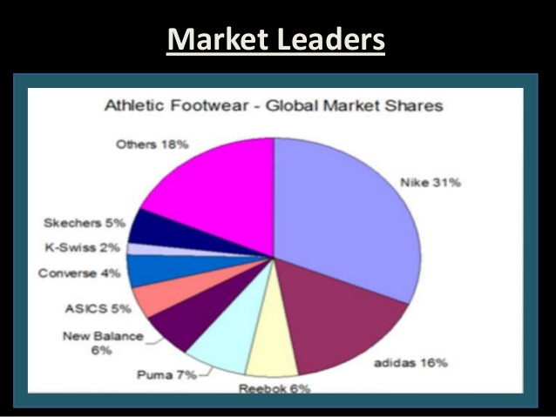

Figure 2 https://image.slidesharecdn.com

Can Guaranteed Shoe leverage IT to gain market share and enter the top 10 global leaders in athletic shoe sales? Over the past 10 years brick and mortar sales have been stagnant, so Guaranteed Shoe launched an E-Commerce site to help spur growth.

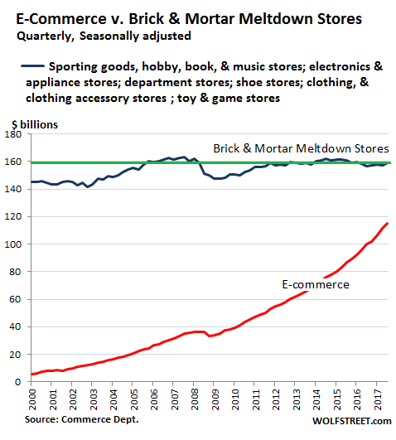

Figure 3 https://wolfstreet.com

Let’s look at how they can gain competitive and operational advantage by implementing ERP, Data Mining, SCM, and CRM.

# *Section 1: ERP*

Guaranteed Shoe can implement an enterprise resource planning system to connect all core business systems, like finance, logistics and HR. This will integrate all enterprise data, replace paper based processes with E-processes and business decisions and operations based on real time data (Arakelian). ERP implementations have an estimated fail rate of 29% (BISTA). Most of the problems arise with customizing the ERP applications provided by the system provider, such as SAP, or having an inexperienced program manager over the implementation. Guaranteed Shoe’s implementation will contain minimal customization and a strong program manager to mitigate the risk in implementation.

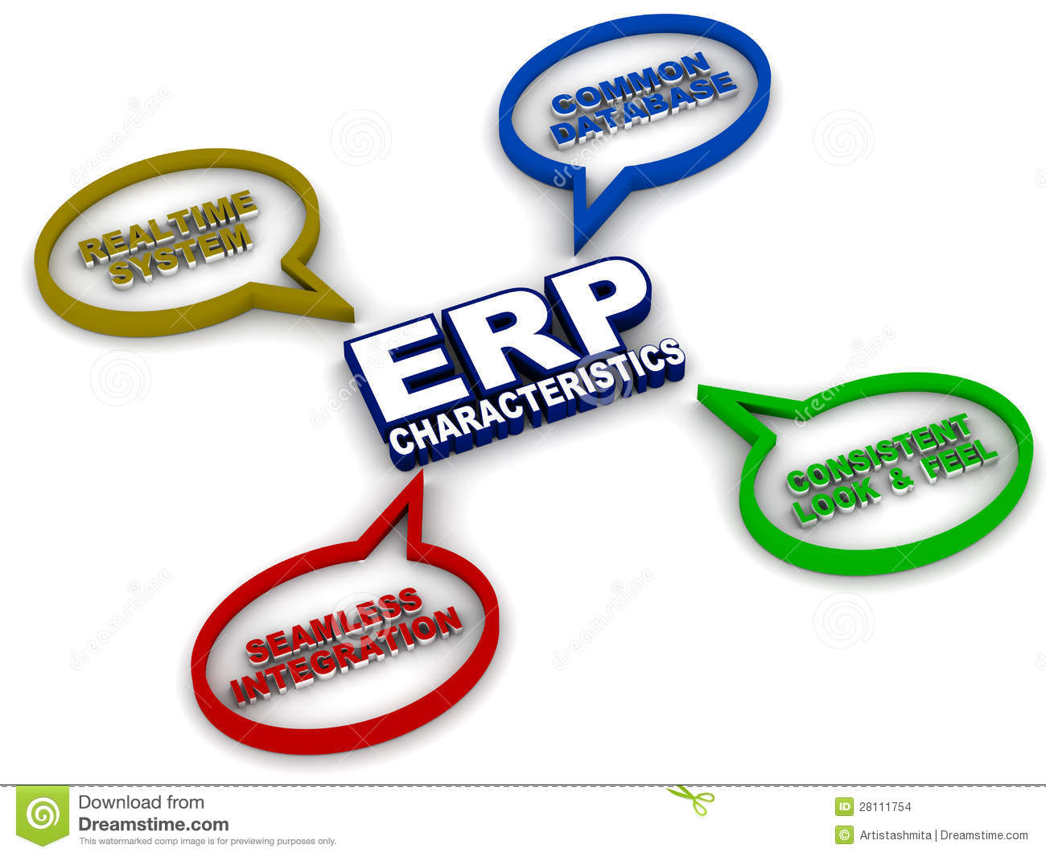

Figure 4 https://thumbs.dreamstime.com/z/erp-characteristics-28111754.jpg

## Eliminating data duplication and inconsistency

With 1,000 stores globally and over 20 branch offices in different countries, Guaranteed Shoe must take legacy systems from all 20 branches and create an enterprise system which eliminates duplicated customer, employee and supplier data. "On average, we have found that in the best countries about 10% of the data is duplicated. In the worst countries it is about 30%," says Andy Bloomfield, SAP deployment manager at Xerox Europe (Twentyman). Working on a global scale and eliminating data duplication is easier than ever. With an ERP system Guarantee shoe will gain operational agility and a competitive edge over shoe stores without enterprise resource planning systems.

## Replacing paper-based processes with e-based processes

Branch managers will need to conference with their shoe store managers and set a date to stop using paper based products for inventory, logistics and all other enterprise business transactions. This is needed to achieve real time data access on a global scale. This leads to tighter inventory control, less warehouse storage use and better customer service due to inventory levels seen in real time.

## Tracking, management and planning based on historic and real-time data

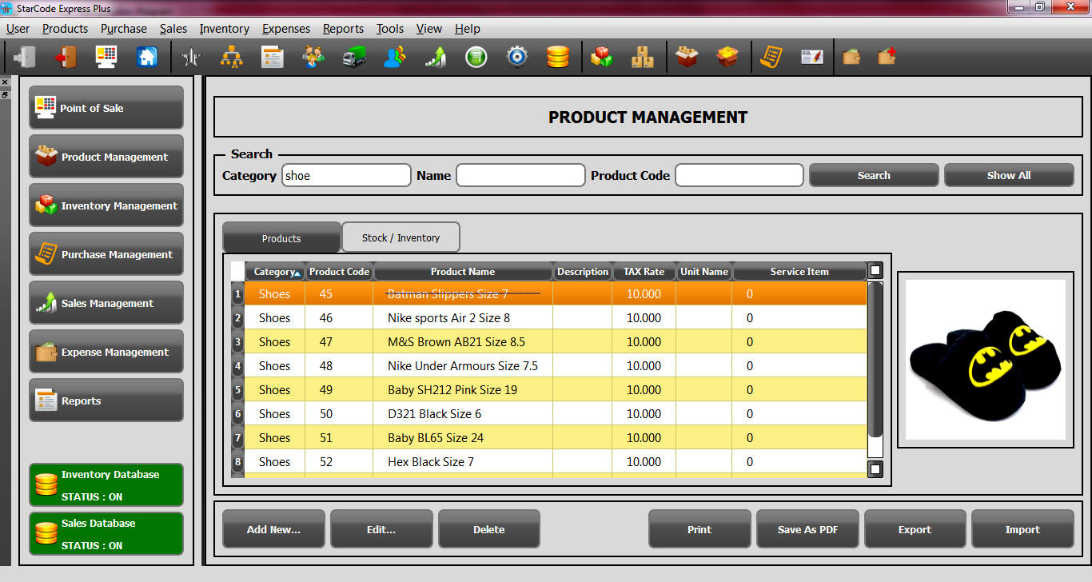

Figure 5 <http://www.invegix.com/starcode/blog/pos-for-shoe-store/shoe-store-pos-product-management.jpg>

With historic and current data loaded into the ERP system, Guaranteed Shoe can plan work schedules, product deliveries and inventories based on historical lulls and surges in sales plus predicted growth in sales.

# *section 2: Data mining*

Data mining is employed to make discoveries that are beneficial to the business. By examining the past and the present they can predict future trends (Arakelian, Module 2 Big Data). Guaranteed Shoe can gain competitive advantage, but the price is steep. First they must hire a data scientist at about 100K probably cheaper in some global locations. Second they need the infrastructure for big data. Cost can be mitigated by using existing servers and implementing ROLAP which is OLAP using relational databases such as Oracle. Data mining leads to operational advantage when the discovered knowledge is implemented correctly.

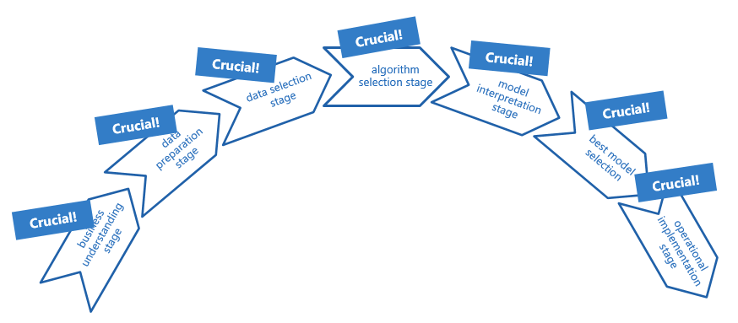

Figure 6 http://statconsulting.nazwa.pl/instalator/wordpress/wp-content/uploads/2015/07/data_mining_process.png

## Dealing with size

The data collected from 1,000 shoe stores is enormous. The volume of data per day is probably in the terabyte range. The chance that an employee can pick out relevant patterns in the data to help the company is worse than finding a needle in a hay stack. A good data scientist can forensically look at the data and figure out why sales plummeted instead of increased during a failed advertising campaign. Guaranteed Shoe Company will be able to learn from their mistakes and predict future growth trends with implementation of data mining.

Causal 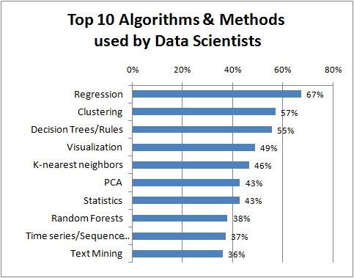

Figure 7 <https://images2015.cnblogs.com/news/66372/201702/66372-20170203131734683-86714811.png>

Data mining can produce random variations that mimic useful patterns. The data scientist uses sound algorithms and approaches to mitigate these problems.

# Section 3: SCM

Many great implementation success stories of supply chain management systems are out there. Some good examples of SCM implementation are Amazon, McDonalds, and Home Depot. These companies all have competitive advantage over their competitors. Unfortunately, some implementations go bad. Adidas in 1996 implemented a new warehouse system and they under shipped products by 80% in January, costing then millions and they lost market share to Nike for multiple years (Supply Chain Digest). Nike also had a bad implementation of a planning system that cost them 100 million dollars and a 20% stock drop (Supply Chain Digest). Fortunately, SCM software has progressed in the last 20 years and now the risks of implementations and the causes of failures have been addressed. Another option for Guaranteed Shoe would be to partner with Amazon send their shoes to the Amazon Warehouse where Amazon customers have free two day shipping. Amazon packages the shoes and sends them out at an industry best time to customer around. There are three main types of planning in SCM, demand planning, production planning and Supply planning.

## Demand planning

Guaranteed shoes will predict how many of each shoe is needed by customers based on historic input from all partners and past sales data. This will include seasonal fluctuations and predicted weather conditions when needed.

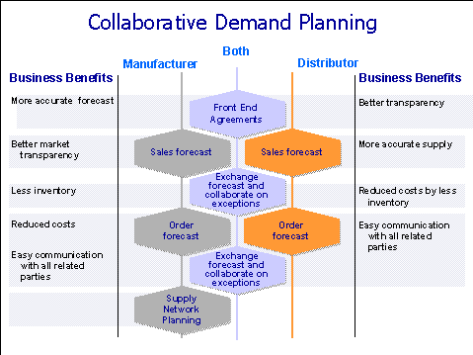

Figure 8 https://help.sap.com/saphelp_ewm70/helpdata/en/3e/99ad39e4692453e10000000a114084/Image94.gif

Operational advantage of getting just what you need to run the stores without excess stock to warehouse is huge in cost savings alone. Plus, keeping customers satisfied by having a continuous supply of stock prevents a disaster like Adidas had in 1996.

## production planning

When hundreds of different shoe types need producing at any given time it is important to forecast production runs to efficiently produce shoes to meet the upcoming demand planning forecast. Planning with the forecasted and real data is an operational advantage which involves staffing increases or decreases, estimate of needed supplies, and capacity to produce shoes . 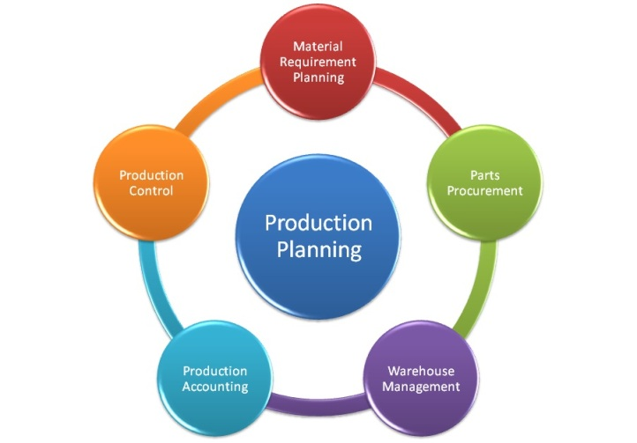

Figure 9 http://unarstech.com/img/blog/PP.jpg

## Supply planning

Once the demand planning forecasts future needs of the customers, then supply planning must ensure all materials needed to produce the shoes are ordered and arriving in time for their production runs (Demand Caster). This is where Guaranteed shoes needs to pick reliability over cost to ensure their suppliers consistently come through. Fire those suppliers that are consistently behind schedule on deliveries.

# *section 4: CRM*

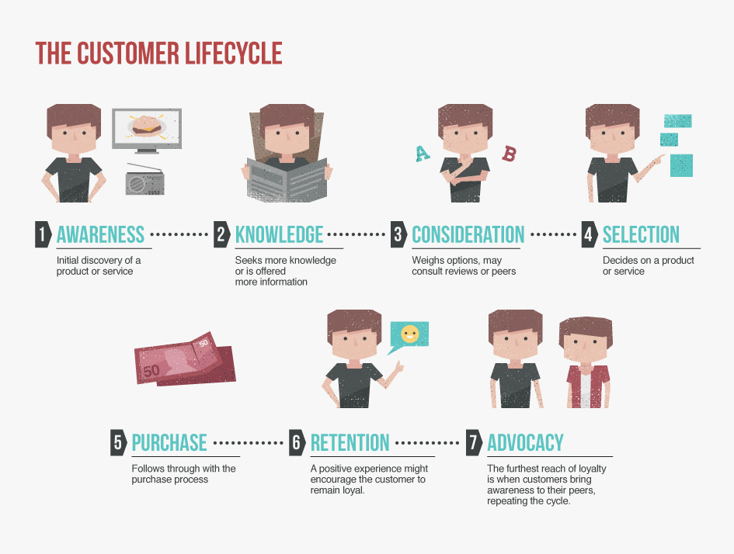

Figure 10 https://www.salesforce.com/content/dam/blogs/legacy/2014/12/6a00e54ee3905b883301b7c722f89b970.jpg

Guaranteed Shoe Company excels at some aspects of CRM. Their policy on no shipping on shoes wanted that are out of stock is commendable. Customers are fickle and a continuous evaluation of customer satisfaction is a must. If there are multiple stores in the area, can they use the automotive parts store solution to out of stock parts, have a floater go to the store that has the shoes in stock and fetch them for the customer? It’s all about customer retention and loyalty that grows your existing customer base. The CRM system is usually a 4 part system, operation, analytic, collaborative and Portal based. Customer support, employees, managers and marketing all have access to the same customer information to help mitigate any potential conflicts involving customers (Arakelian, Module 3 CRM).

## Operation CRM

Guaranteed Shoe operational level CRM involves direct customer interaction at mall stores or indirect via e-commerce. Very important to be courteous to customers and this is where marketing and special sales help with customer satisfaction.

## Analytic Crm

Using the customer data from all stores allows Guaranteed Shoe to predict future trends and sales. Customer surveys can be leveraged into new shoe design ideas. Even new product lines can be created if customer support is strong enough customers support is strong enough. CRM analytics allows you to target the right customer at the right time, understand their needs and target them on mobile devices, tablets or phones.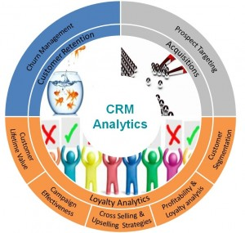

Figure 11 <http://qwtjlive.com/wp-content/uploads/2017/03/CRM-Analytics-Market.jpg>

## Collaborative CRM

Collaborative systems link customers to employees capable of answering questions via chat in real time, or email monitoring so responses to customers are timely. Phone lines where customers can talk to customer support to resolve issues in real time. Guaranteed Shoe can enhance customer loyalty with 24/7 chat lines available through e-commerce and mobile business applications. Customer retention is worth the extra cost associated with customer service and is a competitive advantage.

## Portal Based CRM

The use of a portal will make setting roles for different types of employees, customers, customer support representatives easier. You can have customers see information relevant to them, Managers see more, employees less. Guaranteed Shoe’s CRM portal will contain every component of the CRM implementation. One place to access all components makes it easier to administer (TMC.net). CRM implementation may fail if adequate training time is not giving to employees to learn the portal functions.

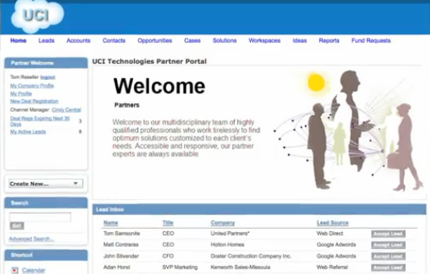

Figure 12 https://www.crmswitch.com/wp-content/uploads/2012/05/CRM-Partner-Portal-Salesforce.png

# Conclusion

Guaranteed Shoe Company has much to gain by leveraging new IT technologies. Using ERP to eliminate inconsistencies and duplication in data gives them operational advantages. Data mining gives competitive advantages with forecasting future demands and growth strategies. SCM is heavy on operational advantages; competitive advantage is received from efficiencies of production and meeting future demands of the customer. Lastly, CRM focuses on the customer and how to retain them and instill brand loyalty for years to come.

# Bibliography

Arakelian, Adam. CS 782 Module 3 ERP section. 30 May 2018. May 2018 <https://onlinecampus.bu.edu/webapps/blackboard/execute/displayLearningUnit?course_id=_48064_1&content_id=_5928116_1&framesetWrapped=true>.

—. Module 2 Big Data. 30 May 2018. May 2018 <https://onlinecampus.bu.edu/webapps/blackboard/execute/displayLearningUnit?course_id=_48064_1&content_id=_5928183_1&framesetWrapped=true>.

—. Module 3 CRM. 30 May 2018. may 2018 <https://onlinecampus.bu.edu/webapps/blackboard/execute/displayLearningUnit?course_id=_48064_1&content_id=_5928217_1&framesetWrapped=true>.

BISTA. 10 reasons for ERP Implementation failures. 24 April 2013. May 2018 <https://www.bistasolutions.com/resources/blogs/erp-implementation-failures/>.

Demand Caster. Supply Planning: Processes, Options & Analytics, Oh My. 19 April 2007. May 2018 <https://www.demandcaster.com/blog-news/supply-planning-processes-options-analytics-oh-my/>.

EVRY. White Paper Analytics in CRM Insights to Action. Unknown. May 2018 <https://www.evry.com/globalassets/insight/bank2020/analytics-in-crm---labs-whitepaper.pdf>.

Supply Chain Digest. The 11 Greatist Supply Chain Disasters. January 2006. May 2018 <http://www.scdigest.com/assets/reps/SCDigest_Top-11-SupplyChainDisasters.pdf>.

TMC.net. CRM Portals: Open your doors to your Customers, Partners and Employees. 22 May 2006. May 2018 <http://www.tmcnet.com/channels/crm-solutions/articles/1272-crm-portals-open-doors-your-customers-partners-employees.htm>.

Twentyman, Jessica. For many companies, having inconsistent data is not just inconvenient, it is a major impediment to business agility and competitiveness. 13 Sep 2007. May 2018 <https://www.computerweekly.com/news/2240082958/How-to-eliminate-duplicated-data>.