Term Project

MET CS 669

Instructor Pamela Farr

Facilitator Warren Mansur

By

David L Capps

24 APR 2018

Business Rules Section

Aspect 1 New Products

1) Each product category contains zero to many Products; Each Product belongs to only one category.

2) One seller has 0 to many products; Products lists many products for each seller. (re-thinking this rule Seller more linked to inventory which is linked to products more involved in Aspect 2).

Aspect 2 Product Delivery

3) Each Seller ships o to many items to products; zero to many products received from each seller.

4) Each Seller inventory is updated by products; Products updates 0 to many seller inventories.

5) 1 condition for 0 to many products on the seller inventory; o to many products in seller inventory have 1 condition code

Aspect 3 New Customer Accounts

6) Each customer account has 1 customer address record; each customer address record is for 1 customer account.

Aspect 4 Purchased Products

7) A customers account orders o to many items on 1 customer order; 1 customer order has 1 customer account.

8) 1 shipping speed is on every customer order; customer orders contain 1 shipping speed per order.

Conceptual ERD

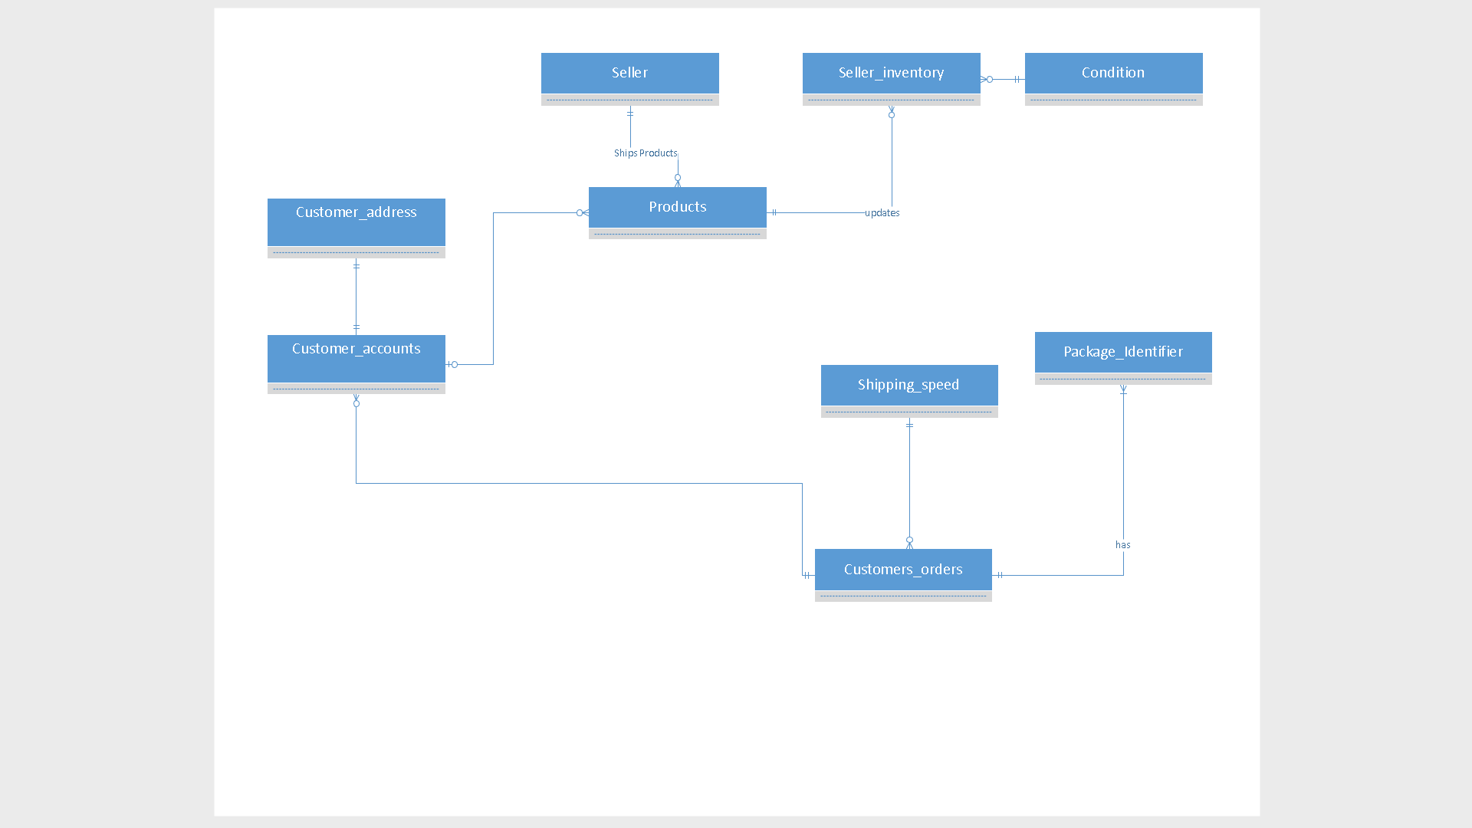

Logical ERD

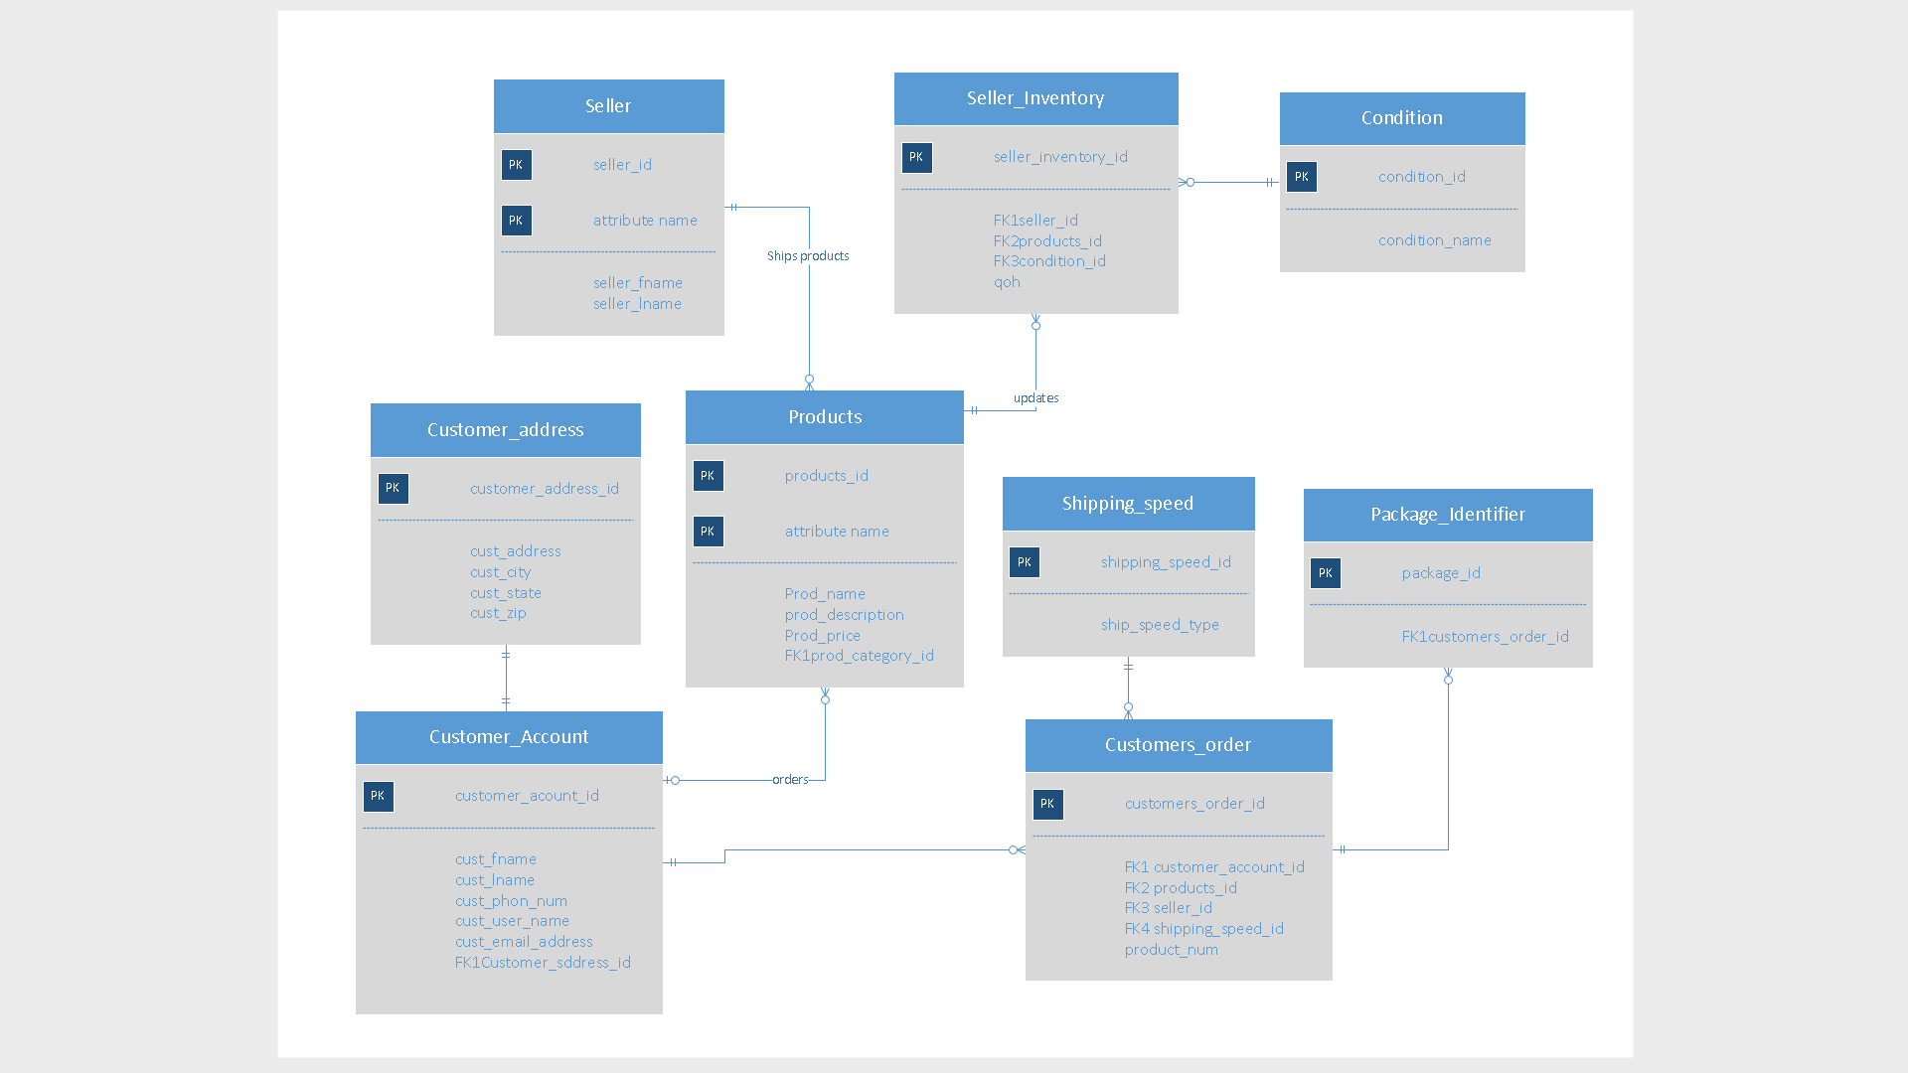

Aspect1

Reusable stored Procedure.

Created stored procedure ADD_NEW_PRODUCT.

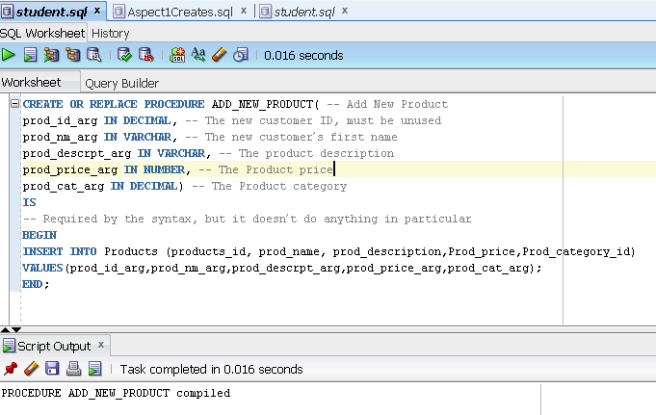

Using stored procedure first time.

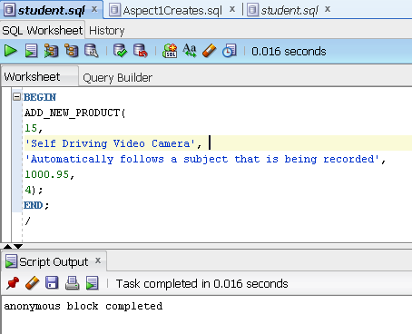

Using stored procedure second time.

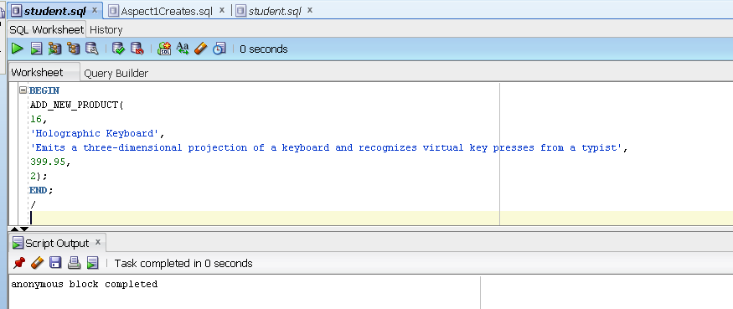

New products have been added

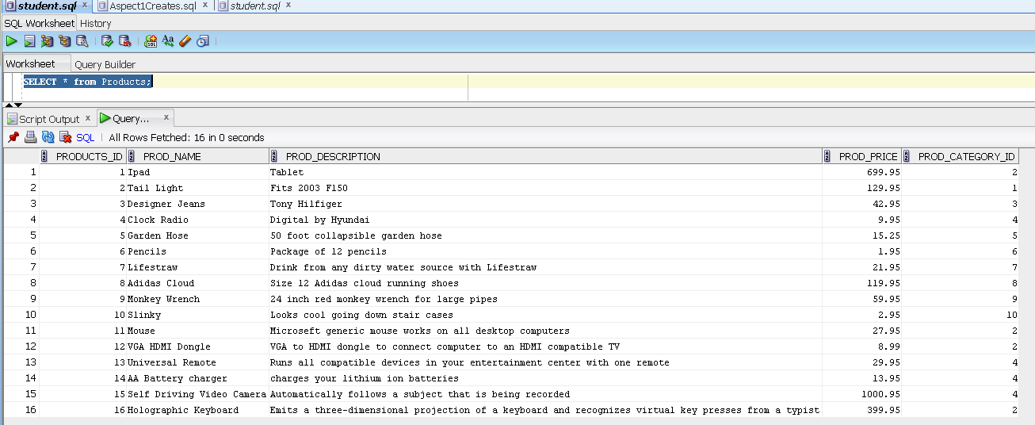

Aspect1 SQL query

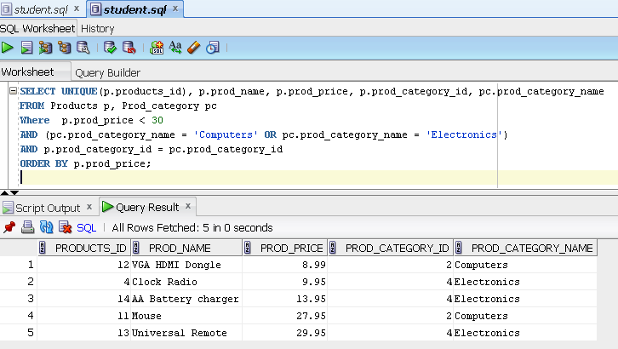

I would choose Products.prod_name to add an index to because many amazon searches are by name of product which would speed up searches of their millions if not billions of products.

Index Created on Products.prod_name

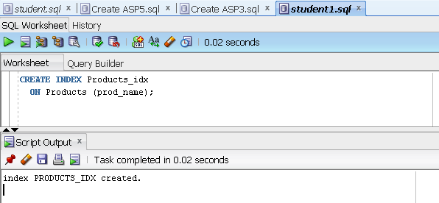

Aspect 2

1. Reusable stored procedure.

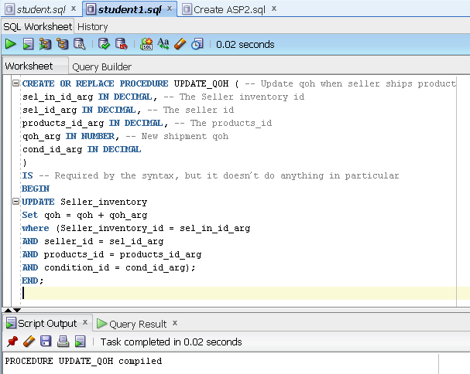

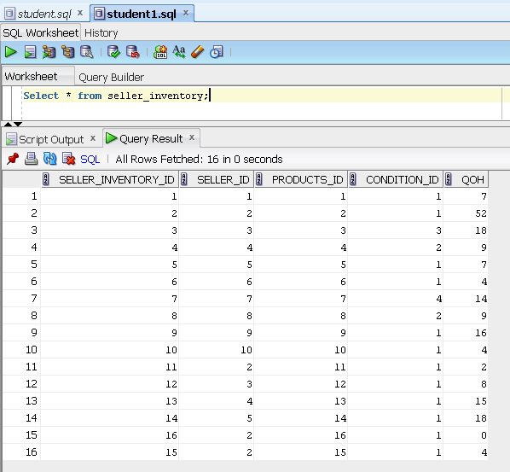

USE of Stored Procedure

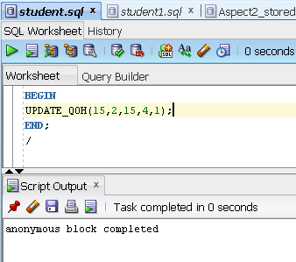

Used stored Procedure second time

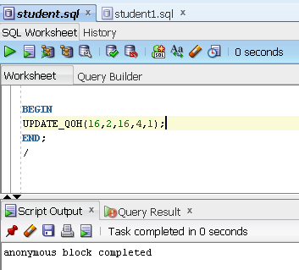

Qoh now 4 for both product_id 15 and 16 with seller number 2

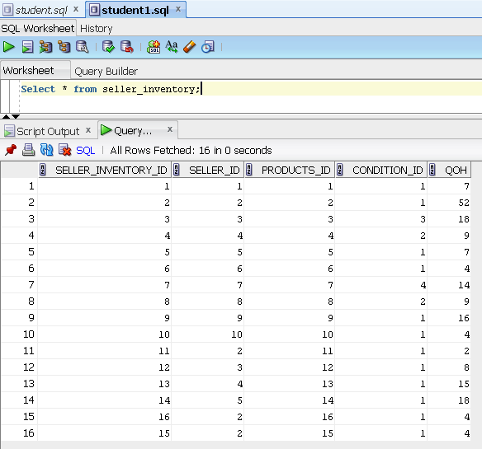

SQL Query Aspect 2

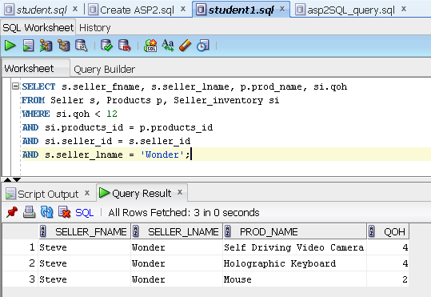

Aspect 3 Reusable stored procedure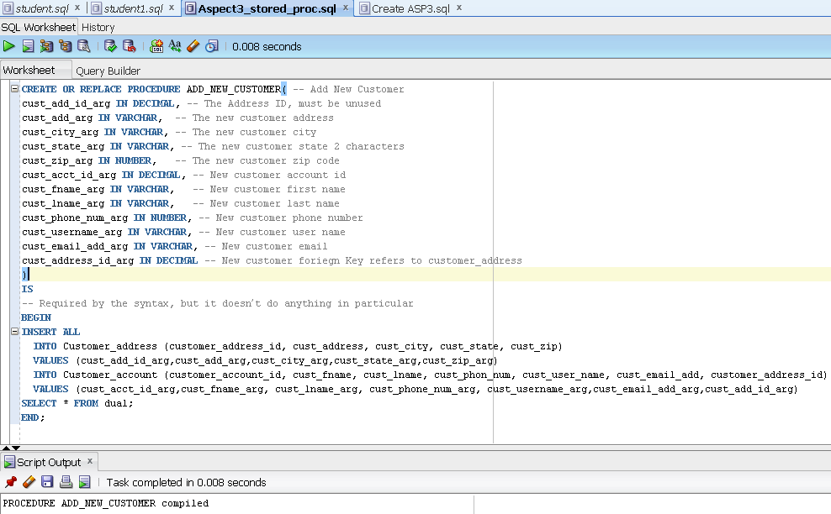

Use of the stored procedure

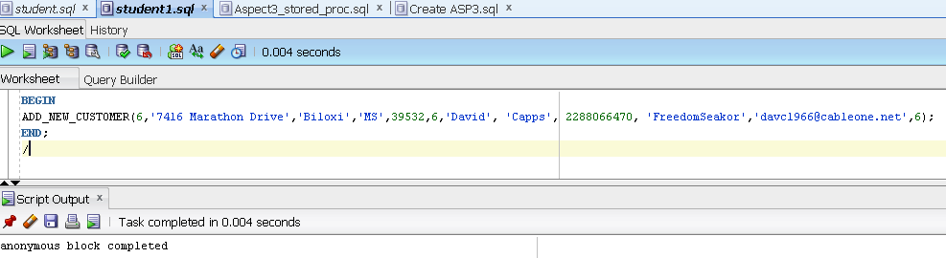

Use of stored procedure 2

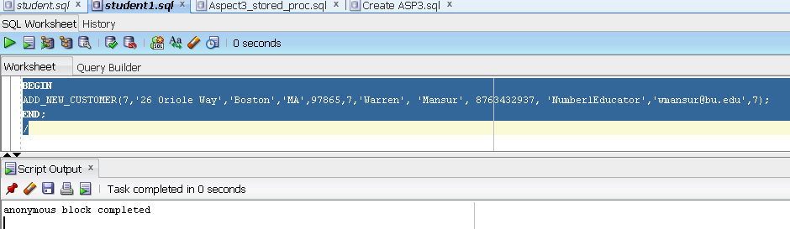

Me and Facilitator added to customer account and address Tables

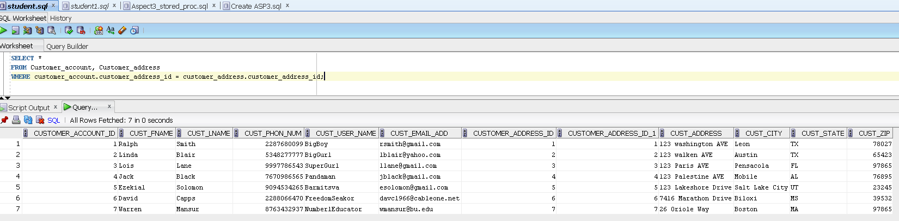

Aspect 3 SQL Query

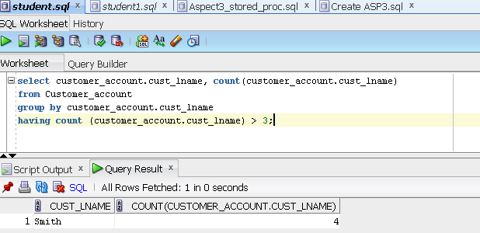

Aspect 4

Reusable stored procedure.

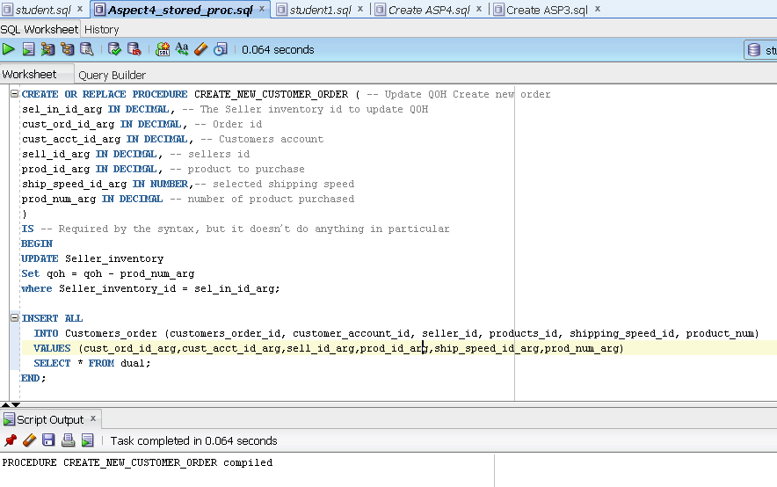

1. Use of the stored procedure.

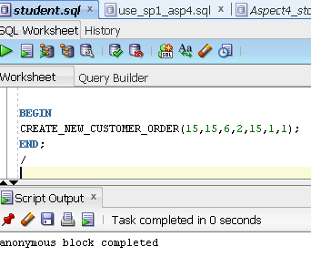

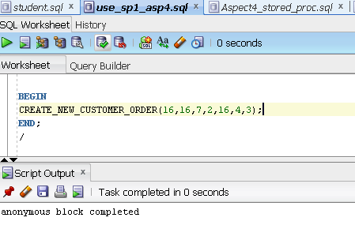

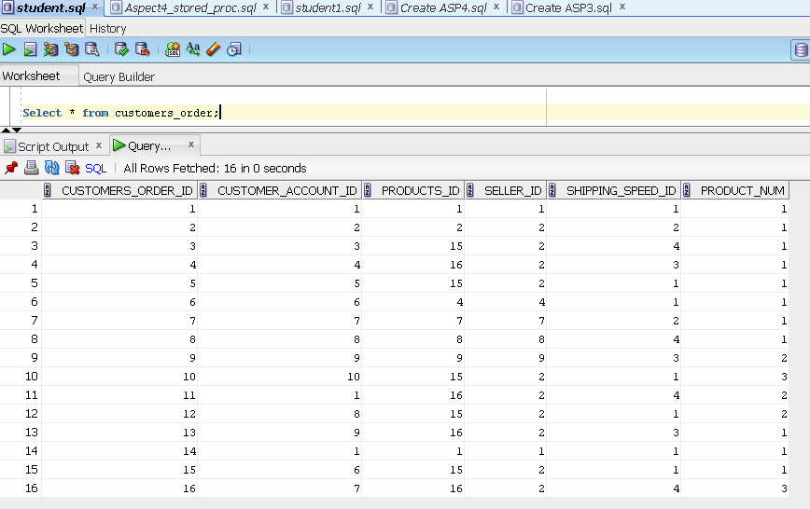

I updated the qoh to 20 for product 15 Video cam and 16 the Keyboard qoh updated correctly

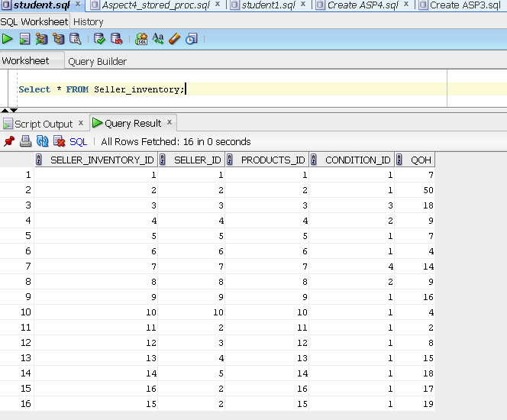

1. SQL query.

