Research Strategy

Significance
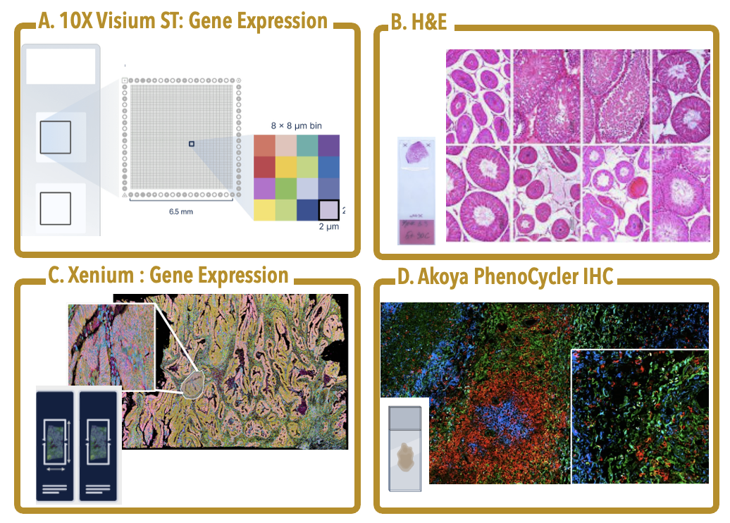
Figure 1. Within this proposal, we develop these deep learning tools, integrating A. 10X Genomics Visium and B. H&E staining, to identify novel features and impute them onto additional H&E slides. We will validate these by expert pathology curation, C. Xenium targeted in situ sequencing, and D. Akoya PhenoCycler IHC targeting 48-plex proteins. Not shown, we will utilize custom standard IHC for protein validation and RNAscope for validating expression.
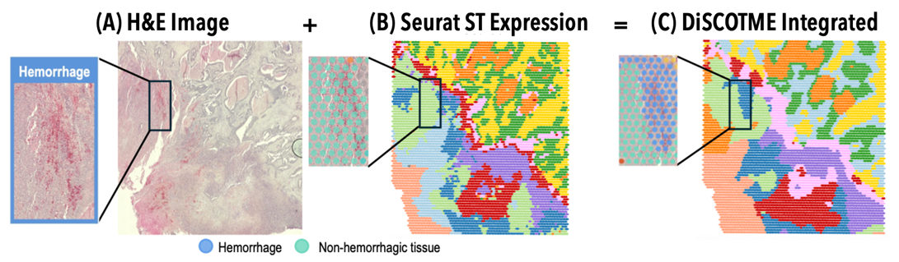
Figure 2. Preliminary Data showing integrated analysis with DiSCo-TME (in review) identifies pathological features missed by standard ST analysis. A. H&E staining reveals a region of hemorrhage that B. standard gene expression clustering does not clearly detect. Although two erythrocyte-specific genes, HBA and HBB, show strong expression, their signals alone did not drive accurate clustering. DiSCo-TME integrates contrastive learning and dilated multiscale attention to combine histological and gene expression into a unified analysis. This approach clearly distinguishes key pathological events.

Current computational tools for spatial multi-omics remain fundamentally descriptive, unable to distinguish drivers from passengers or predict tissue responses to intervention. Spatial transcriptomics and multiplex imaging technologies have revolutionized tissue characterization, yet computational analysis remains confined to pattern identification: clustering, trajectory inference, and correlation-based biomarker discovery (Figure 1. These approaches identify what features co-occur but cannot determine whether a molecular change is a cause, consequence, or coincidental byproduct of local tissue context ⁵. This limitation is not merely academic. Without causal identification, spatial data cannot answer the questions most relevant for translational science: which molecular events drive tissue states, how these states evolve, and how tissues would respond to targeted interventions ^{6,7}. This proposal develops computational infrastructure to transform spatial multi-omics from a descriptive measurement technology into a platform for mechanistic inference. ⁸⁻¹⁰

Three recent developments converge to make causal inference from spatial data both urgent and achievable. First, spatial profiling platforms have matured: Visium provides whole-transcriptome spatial profiles¹¹, Xenium enables subcellular resolution¹², and multiplex protein imaging anchors molecular data to phenotypes¹³). These technologies now generate quantitative, high-quality data across large cohorts. Second, foundation models for digital pathology (i.e. UNI¹⁴, GigaPath¹⁵, and Virchow¹⁶) now extract rich morphological representations from routine histology, enabling alignment between expensive spatial assays and the millions of H&E slides in clinical archives(Figure 2, showing our own preliminary data). Third, recent studies of somatic variation in tissues, including our own work in Figure 5, show that independently segregating extrachromosomal DNA creates spatially resolvable phenotypic compartments. These stochastic events act as natural, quasi random perturbations that are detectable with current spatial technologies. Together, high cost spatial assays provide ground truth, low cost histology provides scale, and somatic variation provides causal leverage. What remains missing is computational infrastructure that can formalize causal inference from these observations. ¹⁷ Our proposal addresses this gap directly

The "neighborhood effect" confounds existing approaches to identifying molecular drivers from spatial data. Current multimodal approaches excel at identifying patterns and correlations but cannot reliably distinguish causes from consequences due to strong influences from the local tissue environment. For example, consider two cells with identical genetic profiles. One cell located near a blood vessel in an oxygen-rich environment may show rapid growth, distinct cell shape, and sensitivity to therapy, while an identical cell in a low-oxygen region may behave quite differently¹⁸. These differences arise from local environmental factors rather than intrinsic genetic differences. Similar situations occur throughout spatial biology, where immune cell interactions, extracellular matrix density, stromal cell composition, and local signaling pathways create relationships that obscure the true molecular causes of observed behaviors¹⁹. Current computational methods, including our own, further complicate this by blending histological and molecular data into single combined representations optimized for visualization rather than causal interpretation^{20,21}. While helpful for recognizing important motifs, these combined representations are only a start and do not determine whether changing a specific gene’s expression would directly alter cellular morphology. Being able to separate intrinsic genetic effects from those imposed by the environment is critical for accurate therapeutic targeting and biomarker development, yet existing tools do not provide this capability.

Somatic variability can enable mechanistic interpretation in observational tissue data through causal inference. Somatic variations are post-mitotic changes in DNA sequence that propagate through cell division, generating clonal populations with distinct genetic states. ²²⁻²⁴ The standard approach for establishing causation relies on controlled intervention, where a variable is perturbed and the resulting effect is measured.²⁵ In intact tissues, this strategy fails because the required perturbations disrupt the spatial structure under study. Genome editing, drug treatment, and genetic knockouts alter tissue organization, while dissociation removes spatial context entirely. Organoid systems lack key features of native microenvironments, and xenograft models introduce confounding from species differences.²⁶ Alternative causal approaches face similar limitations: Mendelian randomization depends on germline variants shared by all cells in a tissue, providing no leverage for distinguishing causal relationships among neighboring cells.²⁷ Consequently, spatial biology lacks causal inference methods that operate on intact tissue from single, static observations. Our central observation is that tissues themselves contain a solution. Somatic processes generate heritable variation among nearby cells through stochastic events that occur independently of local context. X-chromosome inactivation patterns, mitochondrial DNA mutations, and somatic mosaicism all introduce variation in gene dosage or allelic state among neighboring cells (Figure 3). This variation propagates across cellular descendants, creating clones with distinct molecular states sharing identical microenvironmental contexts. ²⁸ This variation acts as a natural source of quasi-random perturbation, enabling instrumental variable analysis while preserving native tissue architecture.
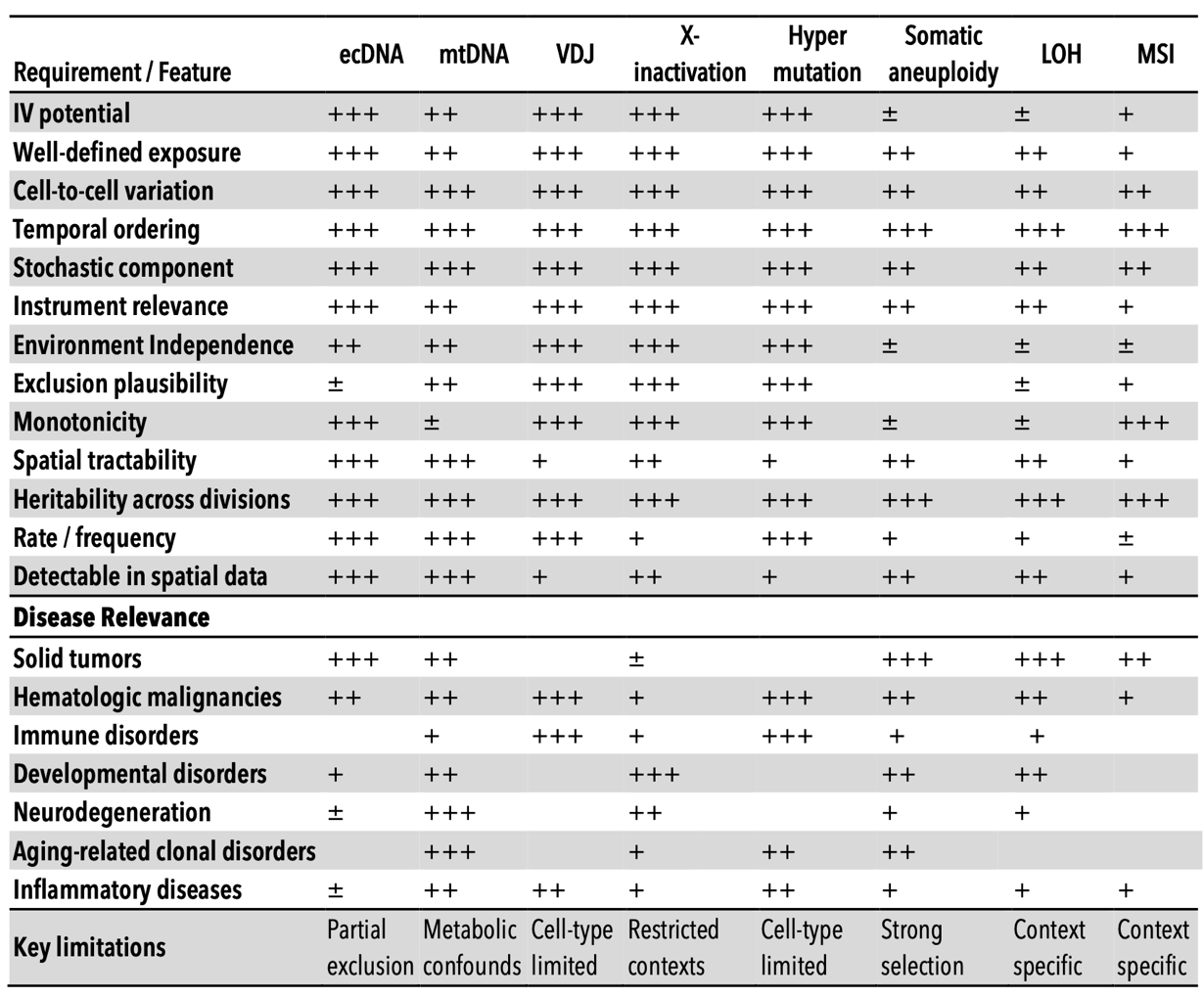
Figure 3. Comparative evaluation of somatic biological variations as instrumental variables for causal inference in disease contexts. This framework qualitatively summarizes various somatic features according to criteria central to instrumental variable analyses, including definability of exposure, stochasticity of cell-to-cell variation, temporal ordering, heritability, spatial detectability, and adherence to core instrumental variable assumptions (relevance, independence from confounding, and exclusion) ¹⁻³. Practical considerations such as event frequency, known limitations, instrumental variable utility, and disease specificity are also indicated. Qualitative ratings reflect relative suitability: (+++) strong, (++) moderate, (+) limited, (±) context-dependent, and (–) generally unsuitable.

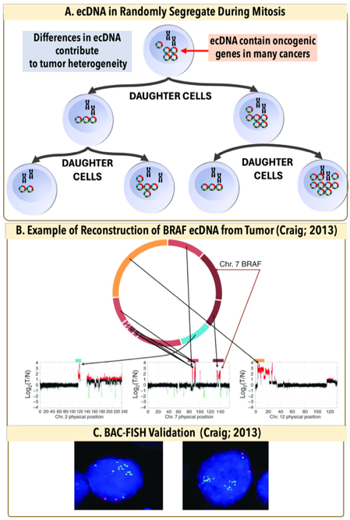
Causal reasoning asks: “Which features are upstream drivers, which are downstream responses, and what would change under a specific perturbation?" In this framing, AI provides the measurement and representation layer, while causal reasoning provides the interpretation layer that converts embeddings into mechanistic hypotheses and counterfactual predictions. Causal inference provides the formal framework needed to interpret learned patterns mechanistically by explicitly modeling directionality, separating drivers from passengers, and enabling predictions about how biological systems would respond to perturbation rather than simply describing observed states. Somatic variation propagates across cellular descendants, creating clones with distinct molecular states sharing identical microenvironmental contexts, and can be considered a somatic Instrumental Variable (IV) as part of a Structural Causal Models (SCM).¹⁷ The logic is if a somatic event ‘Z’ (the instrument) affects phenotype ‘Y’ only through its effect on gene expression ‘X’, and if Z arose independently of current microenvironmental confounders, then the Z→X→Y pathway isolates causal effects. This approach for causal reasoning, foundational in econometrics and epidemiology, has been underutilized in spatial biology because appropriate biological instruments were not recognized ²⁹. We identify somatic stochasticity as precisely such an instrument. The framework is broadly applicable wherever heritable somatic variation exists: cancer, developmental biology, aging, and neurological disease³⁰.
Figure 4. Extrachromosomal DNA as an instrumental variable for causal inference in cancer.
(A) ecDNAs are circular DNA elements located outside chromosomes in tumor nuclei that frequently carry oncogenes and regulatory sequences. Their random segregation during mitosis generates stochastic copy number variation that is independent of local microenvironmental states, while increased copy number drives elevated transcription, satisfying key requirements for an instrumental variable. (B) Example reconstruction of ecDNA architecture published by Craig et al., 2013 using long-insert mate-pair sequencing, showing CN at breakpoints linking segments from chromosomes 1, 7, and 12. Arrows indicate amplified junctions. (C) BAC-FISH validation of BRAF-containing ecDNA, with locus-specific BAC probes labeled in green and chromosome 7 centromeric probes labeled in red.

Extrachromosomal DNA (ecDNA) provides an ideal benchmark system because its random segregation is experimentally verified and its downstream effects are well characterized. ecDNA elements are circular DNA fragments carrying oncogenes that lack centromeres and therefore cannot engage the mitotic spindle (Figure 4) ³¹⁻³⁴. This absence has a critical consequence: ecDNA elements partition randomly to daughter cells during division. Single-cell sequencing, FISH tracking, and live-cell imaging have independently confirmed this stochastic inheritance. The tissue-level result is that neighboring cells in identical microenvironments can carry dramatically different oncogene dosages, not because of local signaling differences but because of how elements happened to segregate at the last division. This creates precisely the natural experiment our framework requires: genetically variable cells sharing environmental context, enabling separation of intrinsic molecular effects from neighborhood confounding (Figure 4). First observed as "double minutes" in the 1960s, ecDNA has since been shown to occur in nearly half of human cancers, drive elevated oncogene transcription through accessible chromatin architecture, and enable rapid tumor adaptation to therapy.^{33,35,36} Our group contributed the first long-insert whole-genome reconstruction of an ecDNA element in 2013³⁷ and recently published spatial analysis of co-occurring EGFR and MDM2 ecDNAs creating distinct tumor compartments (Figure 5, Nature Communications, 2025)³⁸. This well-characterized biology provides ground truth against which we validate our computational causal inference framework before generalizing to other somatic variation types.
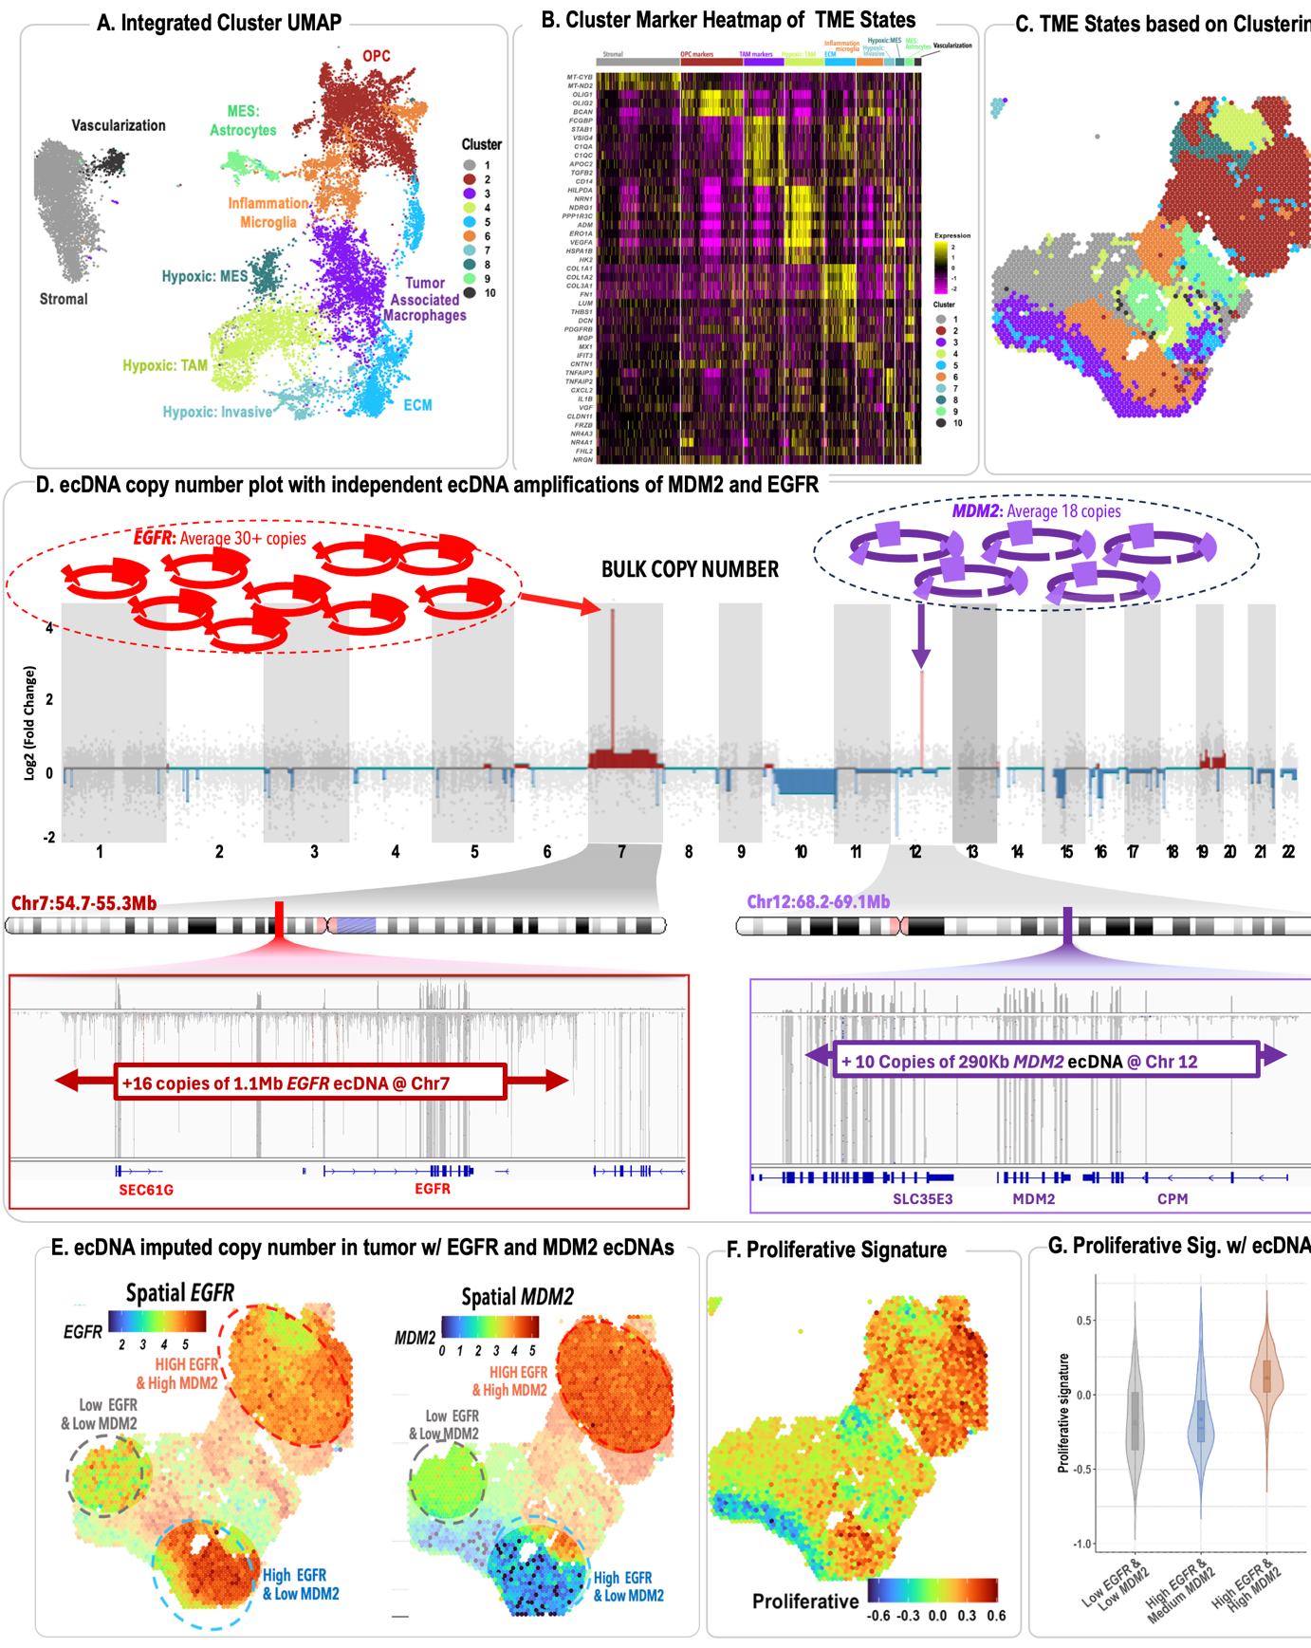
Figure 5. Preliminary data showing spatial genomic heterogeneity driven by co-occurring EGFR and MDM2 ecDNA in glioblastoma in Visium data correlated to proliferative signatures. Our recent work demonstrates how independent somatic events can be used to resolve causal relationships in the tumor microenvironment. By leveraging the stochastic emergence of EGFR and MDM2 ecDNAs, we identify spatially segregated tumor compartments that exist within the same native tissue context. (A–C) Computational mapping of single-cell clusters onto Visium data defines distinct cellular neighborhoods and their corresponding hypoxic or proliferative programs. (D–E) Whole-exome sequencing identifies focal amplifications of EGFR and MDM2 as distinct ecDNA species, creating independent genomic territories within the tissue. (F–G) Strong genotype-phenotype coupling is observed, where regions dominated by EGFR ecDNA exhibit significantly higher proliferative signatures compared to MDM2-amplified regions. These data illustrate how somatic variability functions as a natural source of quasi-random perturbation, enabling us to distinguish upstream genomic drivers from downstream transcriptional responses in intact clinical samples. (Webb et al 2025)

Translating this framework into practice requires explicit validation of instrumental variable assumptions. The ecDNA system provides ground truth for testing whether somatic variation meets the formal requirements for causal identification. Valid inference requires more than statistical association; it demands that instruments satisfy three core assumptions:¹⁷ (i) Relevance: The instrument must strongly shift the exposure. ecDNA segregation generates large. Over two decades of ecDNA research (and most recently by Mischel et al) showing a dependence of copy number with pathogenicity in cancer ^{31,36}; (ii) Independence: The instrument must arise independently of unmeasured confounders. Mitotic segregation is a probabilistic physical process decoupled from transcriptional or signaling states at the time it occurs, a characteristic most recently established by many groups, most recently by Hung et al ³⁹; (iii) Exclusion: The instrument should affect outcomes primarily through the defined exposure. While absolute exclusion is rare in biology, our framework incorporates sensitivity analyses to assess robustness to violations and uses negative control exposures to bound alternative pathways.

The proposed work will transform spatial biology from descriptive mapping into rigorous causal analysis, directly addressing fundamental questions about therapeutic targets. For instance, in glioblastomas co-amplified for EGFR and MDM2, proliferative signatures cluster with EGFR-rich regions and hypoxic signatures with MDM2-rich regions³⁸. Current methods cannot determine whether EGFR amplification directly triggers proliferation or is simply retained preferentially by proliferating cells. Likewise, it remains unclear if MDM2 amplification drives hypoxia adaptation or merely arises within hypoxic microenvironments. Answering these causal questions is critical: therapies targeting EGFR would only be effective if EGFR amplification causally drives proliferation rather than coincidentally tracking it.

The proposed work has broad relevance across disease and biology. While benchmarked initially with ecDNA, our tools have broad relevance where heritable somatic variation includes lineage tracing through X-chromosome inactivation, mitochondrial heteroplasmy in aging, and somatic mosaicism in neurological disorders. Crucially, this causal infrastructure aligns closely with NIH and FDA goals for non-animal testing (NATs), enabling mechanistic insights from existing spatial datasets and clinical tissue archives, thereby reducing dependence on animal models and costly perturbation experiments.

Innovation

Core conceptual innovation: Somatic mosaicism as within-tissue randomization for causal identification. The fundamental innovation is conceptual rather than algorithmic. We repurpose somatic variation, typically studied as a biological phenomenon, as a statistical resource for causal inference. ecDNA's lack of centromeres causes stochastic segregation during mitosis, creating heritable cell-to-cell variation in oncogene copy number among nearby cells sharing identical microenvironments. We model this stochastic segregation as a somatic instrumental variable within a Structural Causal Model, enabling separation of copy-number-driven effects from microenvironmental confounding. This reframing treats somatic mosaicism as biological randomization rather than noise, enabling causal effect estimation from static tissue sections without disruptive physical perturbations.

Architectural innovation: Preserving causal identifiability within multimodal integration. Existing multimodal frameworks merge histology and gene expression into unified embeddings optimized for clustering and visualization. This design choice destroys information needed for causal analysis: once molecular signal and microenvironmental context are entangled in a shared latent space, their independent contributions cannot be recovered. Our architecture maintains explicit separation between three components: the instrumental variable (ecDNA dosage), the outcome of interest (transcriptional state), and potential confounders (neighborhood context and morphology). Each component occupies a distinct representational subspace, linked by learned alignment functions rather than merged into a single embedding. This structure directly mirrors the conditional independence assumptions required for valid instrumental variable estimation. The practical consequence is that we can ask causal questions, such as the effect of copy number on expression holding neighborhood fixed, that unified embeddings cannot answer regardless of downstream analysis.

C. Methodological innovation: Phylodynamics, reconstructing temporal dynamics from static spatial data. Spatial omics provides detailed snapshots but limited leverage on event order and clonal dynamics. DiSCo-VERSE infers temporal ordering from static sections using irreversible genomic events (ecDNA boundary changes and loss of heterozygosity) as molecular anchors. Inferred lineages are embedded into the physical tissue plane using spatially constrained Steiner tree formulations that respect both evolutionary continuity and spatial geometry, yielding quantitative expansion vector fields that estimate direction and rate of clonal growth. The innovation is extracting dynamic information (when and how fast) from static measurements (where and what).

Translational innovation: From descriptive maps to counterfactual simulation. Most spatial analysis pipelines terminate at segmentation, clustering, and association, describing what is present but not what would change under intervention. We extend this paradigm by coupling the causal framework from Aims 2 and 3 with a conditional generative model that produces predicted tissue states under alternative genomic scenarios. Because the latent space preserves causal structure, we can formally specify interventions (for example, reducing ecDNA copy number in a defined region) and propagate their effects through the model to generate synthetic but biologically grounded predictions of altered transcriptional programs and stromal reorganization. This capability transforms spatial omics from a descriptive tool into a platform for in silico hypothesis testing, allowing researchers to explore therapeutic scenarios before committing to experimental validation. Crucially, this causal infrastructure aligns closely with NIH and FDA goals for non-animal testing (NATs).

Approach
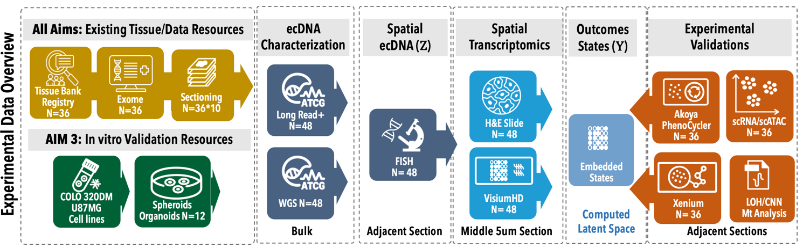

Overview of Experimental Design and Data Generation. The computational methods developed in this proposal require multimodal spatial datasets with defined genomic ground truth for training, calibration, and validation. We generate these datasets through two complementary systems: patient-derived tumor tissue provides the biological complexity and clinical relevance necessary for robust method development, while established cell line models offer controlled environments with known ecDNA status for perturbation experiments. To ensure cross-tissue generalizability, we examine multiple tumor types harboring ecDNA. All experimental data generation will be directed by Dr. Craig, who brings over 25 years of experience leading genomics and spatial omics cores at TGen, USC, and City of Hope. Assays will be conducted within NCI-designated shared resources or Dr. Craig's laboratory, following validated SOPs with centralized quality control and harmonized metadata standards.

Tissue Cohort Selection. We will leverage City of Hope's precision medicine cohort of over 40,000 consented individuals, including approximately 8,000 tumors with matched germline exome sequencing (400×) and bulk RNA-seq generated under standardized clinical protocols. Candidate tumors will be prioritized based on copy-number profiles showing focal, high-amplitude amplifications characteristic of ecDNA at recurrent oncogenic loci including EGFR, MYC, MDM2, and MDM4. From this screen, we will advance 36 deeply characterized specimens for spatial profiling, method training, and validation to support representation learning in Aim 1, causal inference in Aim 2, and phylodynamic and counterfactual modeling in Aim 3.

Serial Sectioning and Assay Allocation. Incompatible fixation and detection chemistries necessitate processing each tumor as a series of consecutive 5 μm FFPE sections; fresh frozen samples will be used when available. The standard sequence allocates the initial section to ecDNA FISH quantification with DAPI nuclear counterstain, followed by adjacent sections for Visium HD spatial transcriptomics with paired 40× H&E imaging, Xenium high-plex in situ transcriptomics, and multiplexed immunohistochemistry (PhenoCycler). Whole-slide H&E images serve as the anatomical reference for computational alignment, enabling fine-scale registration across modalities. Copy number and loss of heterozygosity will be inferred from spatially resolved expressed SNPs or established CNA inference tools, as demonstrated in Figure 5, earlier.

ecDNA Characterization. Definitive identification of ecDNA requires distinguishing circular extrachromosomal elements from chromosomally integrated homogeneously staining regions. We employ a tiered strategy. Screening. Existing high-depth exome sequencing (400×) will identify candidate ecDNA events through copy-number analysis and, where coverage permits, breakpoint detection (as in Figure 5D). Samples without adequate breakpoint resolution will undergo Illumina whole-genome sequencing at sufficient depth to detect high-amplitude amplifications and reconstruct candidate ecDNA structures. Structural resolution. High-confidence candidates will undergo Oxford Nanopore long-read sequencing with preservation of high-molecular-weight DNA to resolve ecDNA topology and junctions at base-pair resolution. Targeted qPCR will validate key breakpoints. ⁴⁰⁻⁴³

Spatially Co-registered Multimodal Profiling

ecDNA FISH quantification of somatic Instrumental Variable (Z). ecDNA copy number will be quantified in FFPE tissue using DNA FISH combined with DAPI nuclear staining on sections immediately adjacent to those used for Visium HD spatial transcriptomics. When ecDNA breakpoint junctions are resolved by genomic reconstruction, custom oligonucleotide FISH probes spanning circular junctions will be used; otherwise, dual-color BAC FISH targeting amplified loci and corresponding centromeres will serve as validated surrogates. Nuclei will be segmented from DAPI images using established nuclear segmentation tools (e.g., Cellpose ⁴⁴ or StarDist ⁴⁵), independent of FISH signal, and ecDNA puncta will be quantified per nucleus using standard image analysis workflows in FIJI/ImageJ or QuPath.⁴⁶ FISH images will be registered to Visium histology using affine and non-linear transformations (e.g., ANTs or SimpleITK) ⁴⁷, leveraging nuclear density and tissue morphology as alignment landmarks. Segmented nuclei will then be projected into Visium coordinate space, and cell-level ecDNA measurements will be assigned to Visium HD spots using centroid-based. Secondary quantification of ecDNA by median expression of amplicon genes. Because ecDNA amplicons contain multiple genes, expression of ecDNA-resident genes can serve as a secondary, semi-quantitative proxy for ecDNA copy number. The median expression across regions scales with ecDNA dosage. While influenced by transcriptional regulation, this orthogonal measure correlates with junction-based FISH (Figure 5D) and provides an independent consistency check on ecDNA burden.
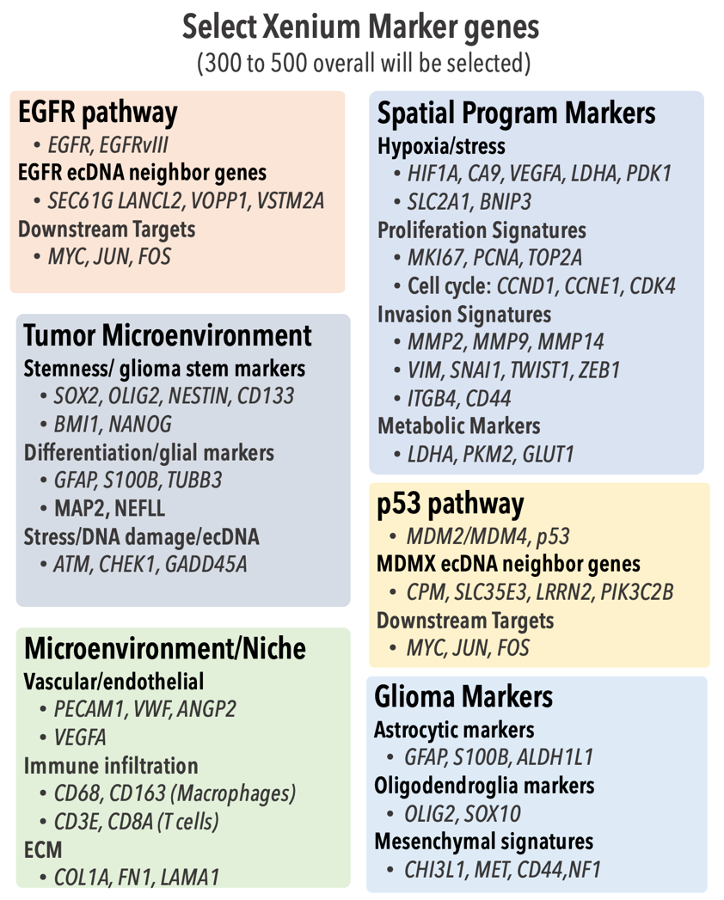
Figure 6. Example Xenium RNA markers. Xenium provides a direct validation of cell-level prediction of states/embeddings.

Visium HD transcriptome spatial profiling. We will use 10x Genomics Visium HD to generate unbiased, whole-transcriptome spatial expression profiles from FFPE tissue sections co-registered with matched H&E histology. Visium HD provides near-single-cell-scale resolution while preserving transcriptome-wide coverage, enabling quantification of expression programs that may not be captured by the targeted Xenium panel. These data serve as the primary training modality for Aim 1’s contrastive learning framework, which must learn spatially informed molecular representations bridging histology and gene expression. Visium HD profiles also anchor multimodal integration by providing dense spatial transcriptional measurements that can be aligned with targeted Xenium, proteomic PhenoCycler, and cytogenetic ecDNA measurements across aims.

Xenium in situ transcriptomics: The Xenium platform occupies a unique role in our experimental design because it simultaneously quantifies ecDNA and its transcriptional output within the same assay at subcellular resolution. Our custom gene panel (300 to 500 genes) is specifically designed to serve the causal framework central to Aim 2. The panel includes three probe classes: (1) high-density probes targeting amplified oncogenes (e.g., EGFR, MDM2 as in Figure 6) that directly measure ecDNA copy number through transcript abundance, providing the instrumental variable; (2) probes for specific structural variants such as EGFRvIII, enabling allele-resolved dosage estimation. This design enables direct estimation of causal effects of ecDNA dosage on spatial transcriptional programs and neighborhood composition within a single analytical framework at core of Aim 2.
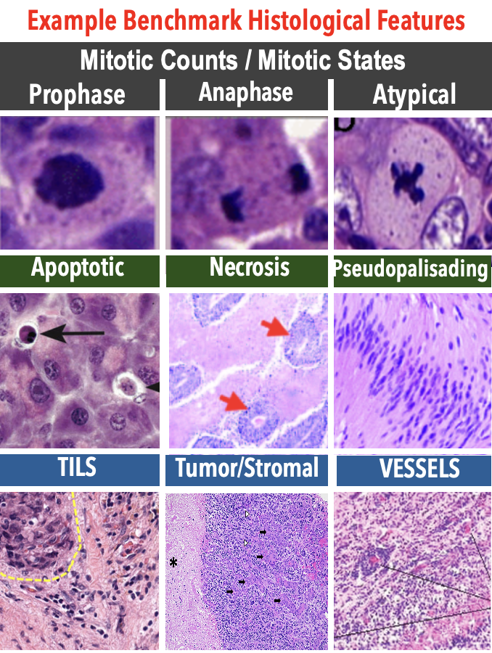
Figure 7. Morphological validation of outcome states from H&E. Standard histological hallmarks abstracted from shared embeddings will serve as gold-standard benchmark validations, obtained from pathologist review, orthogonal IHC, and external analysis.

Histopathological Annotation. To validate that Aim 1 computationally inferred spatial states correspond to interpretable and biologically meaningful tissue features, we will generate histopathological annotations through three complementary approaches: standardized manual review by the NCI designated Cancer Center Research Pathology Core, automated analysis using PATH-AI services, and feature extraction from digitized whole slide H&E images. Annotations will capture structural and morphological features including nuclear morphology, mitotic activity, necrosis, fibrosis, and tissue architectures. These annotations will serve two roles: as training labels for the histology encoder in the Aim 1 contrastive framework. Additionally, validation will focus on interpretable features, such as blood vessels, necrosis, dense immune infiltrates, and stromal fibrosis as baseline ground truth (examples in Figure 7). Beyond these landmarks, we will assess whether inferred spatial states recover morphologically distinct cell populations, capture spatially organized proliferative or stress associated regions, and preserve contextual relationships such as inflammation gradients.

Multiplexed immunohistochemistry (PhenoCycler). To validate aim 1, multiplexed immunofluorescence will be performed using Akoya PhenoCycler on adjacent tissue sections to visualize the spatial distribution of approximately 40 key proteins. The panel includes amplified oncogenes, p53 pathway components, proliferation markers, hypoxia markers, DNA damage response proteins, immune cell identity markers, and stemness associated factors. These protein level measurements provide orthogonal validation of transcriptional programs and spatial states inferred from RNA based assays. They also enable independent confirmation that causal relationships estimated from spatial transcriptomic data manifest at the protein level.

Single-nucleus/Cell multimodal sequencing. To provide cell intrinsic molecular profiles independent of spatial context, we will perform single nucleus RNA sequencing and single nucleus ATAC sequencing from matched specimens, as well as single cell RNA and ATAC sequencing from fresh or cultured samples when available. These data define reference transcriptional and chromatin state atlases used to annotate Xenium cells and deconvolve Visium HD spots. Single cell and single nucleus data also support Aim 3 by enabling limited temporal validation through expressed SNP based inference of irreversible events such as LOH and chromatin state changes associated with ecDNA amplification. These non-spatial references provide an independent benchmark for validating spatially inferred causal and evolutionary relationships.

In Vitro Controlled Benchmarking Models

Rationale. Patient-derived tissue provides the biological complexity needed for robust method development, but it lacks the experimental control necessary for rigorous benchmarking: ecDNA status varies across cells in ways that cannot be independently manipulated, and perturbation experiments on primary tissue are not feasible. Cell-line models with known ecDNA profiles address this gap by providing controlled systems where ground truth is defined a priori and perturbation responses can be directly measured, enabling the validation experiments required for Aim 3’s counterfactual framework.

Cell-line selection and 3D culture. To establish a robust benchmarking framework for Aim 3 and temporal events, we will utilize established GBM (U87, U251) and CRC (HCT116, COLO-320DM) cell lines with characterized ecDNA amplifications (EGFRvIII, MYC) to generate 3D organoids and spheroids through the City of Hope Stem Cell and Organoid Core. These architectures, optimized to 200–300 micron to simulate in vivo-like nutrient gradients and spatial heterogeneity, will be harvested using an agarose encapsulation protocol and processed into FFPE blocks to maintain structural integrity. This standardized approach enables consecutive serial sectioning for Xenium, Visium HD, and PhenoCycler profiling, with DNA FISH validation. Scaffold-free methods using ultra-low attachment plates will be prioritized for high-throughput spheroid formation, while matrix-based systems (Matrigel, synthetic PEG-hydrogels) will be employed for lines requiring biochemical cues to achieve in vivo-like polarity. These cultures will provide reproducible lineages to assess temporal series of events as organoids/systems form tertiary structures, allowing validation of phylodynamic analysis via analysis of inherited SNPs for loss of heterozygosity and mitochondrial flux via shifting heteroplasmy.

Alternative strategies. If specific cell lines prove refractory to 3D assembly, we will implement assembloid strategies, co-culturing tumor cells with supportive stroma (fibroblasts or astrocytes) to provide necessary assembly cues. If static cultures fail to capture sufficient spatial dynamics for Aim 3 validation, we will utilize microfluidic organ-on-a-chip systems to introduce perfusion and better simulate vascular influence on ecDNA-bearing subclone behavior. For high-resolution subcellular mapping of ecDNA-carried oncogenes beyond the resolution of Visium HD, we will use Xenium as the primary spatial platform for cell-line experiments.

Aim 1: Optimize and Scale DiSCo-TME: A Contrastive Multimodal Latent Space for Spatial Biology.

Rationale: Spatial transcriptomics and proteomics offer unprecedented maps of tissue architecture, yet most computational methods remain descriptive, relying on predefined spatial neighborhoods and fixed-resolution inputs that cannot capture multi-scale tissue organization. Our preliminary work with stHistoCLIP addresses these constraints through contrastive alignment of histology and gene expression, revealing latent biological states not visible in either modality alone. DiSCo-TME extends this foundation by structuring latent space around somatic Instrumental Variables (SIVs), formalizing heritable stochastic events such as ecDNA segregation within a Structural Causal Model to enable causal inference from static sections.

Architectural Approach: As shown in Figure 8, DiSCo TME introduces a spatially aware causal framework that structures latent space around somatic Instrumental Variables (SIVs), incorporating dilated attention to model multi-scale tissue context. A new component, built on heritable stochastic events, such as the random segregation of ecDNA, are formalized as SIVs within a Structural Causal Model. These complement a dual-encoder framework for histology and gene expression, that incorporates multiscale modelling and contrastive learning.

Histology Encoder: We employ a Vision Transformer (ViT) ⁴⁸ backbone initialized with weights from histopathology foundation models (GigaPath ¹⁵ or CONCH⁴⁹), which have been pre-trained on millions of slides to recognize features such as nuclear atypia, mitotic figures, and desmoplastic stroma. Unlike CNNs with local receptive fields, ViTs use self-attention to capture global morphological dependencies. H&E slides are tessellated into patches corresponding to spatial transcriptomics resolution.

Gene Expression Encoder: Spatial transcriptomics data are sparse and high-dimensional. We use a hybrid architecture in which an MLP projects normalized, log-transformed count vectors into dense embeddings, followed by a transformer encoder where genes function as tokens. Self-attention explicitly learns gene-gene co-expression relationships, and a CLS token aggregates context. This design is permutation-invariant and robust to dropout noise. We will benchmark against foundation models (scGPT⁵⁰, SCimilarity⁵¹, and CellFM⁵²) to assess the value of prior single-cell knowledge. Validation milestone: reconstruction error below 15% relative to original PCA space.
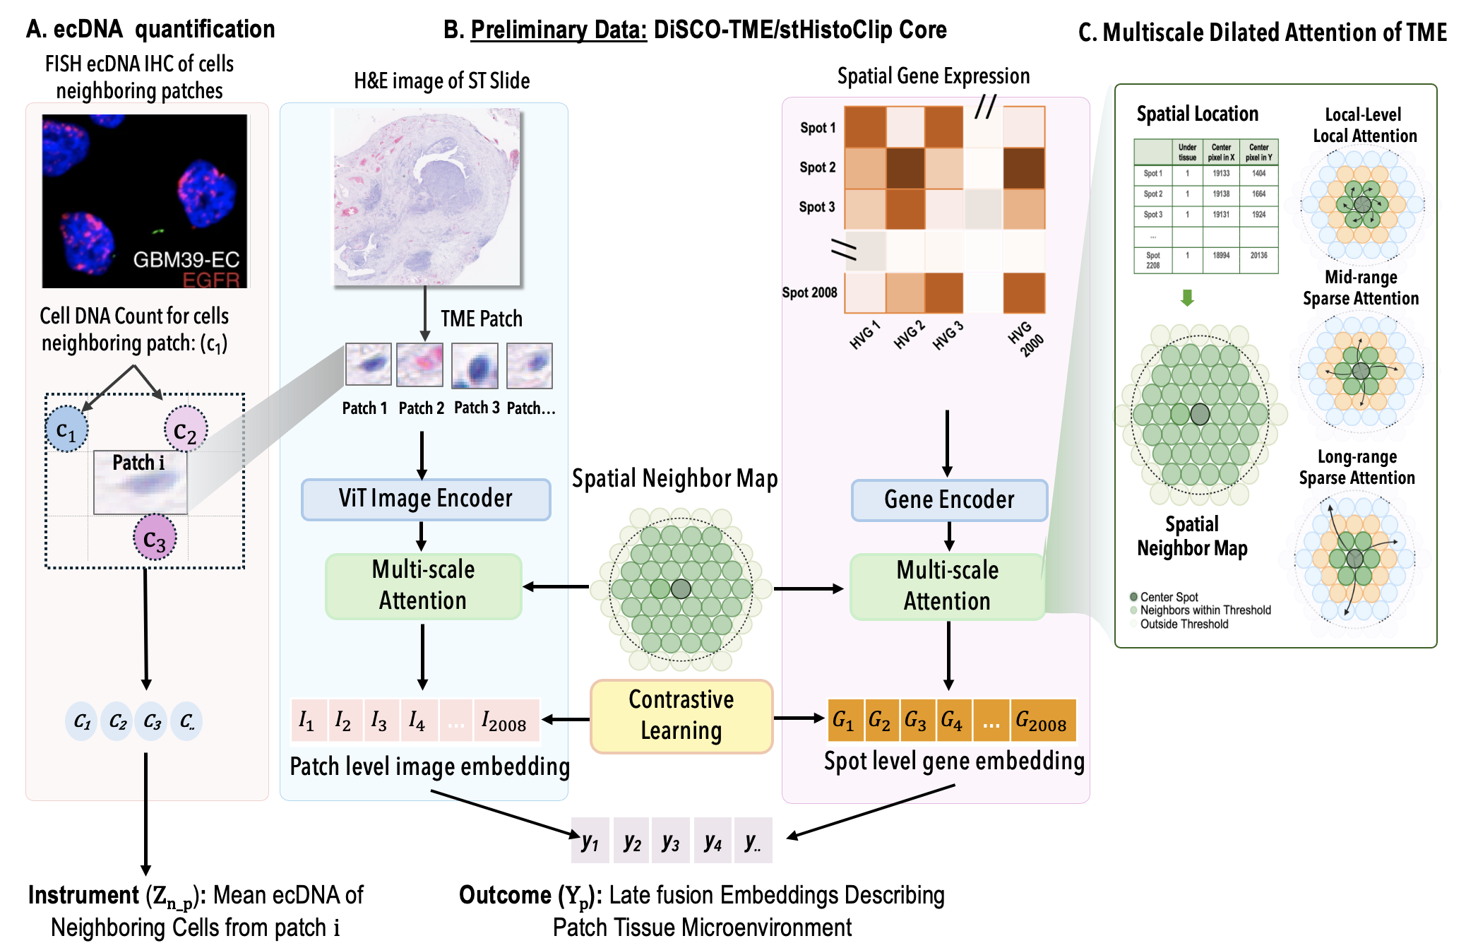
Figure 8. DiSCO-TME architecture integrating multimodal data with somatic instrumental variables. Core components of the multimodal architecture constitute preliminary data developed under the stHistoCLIP codebase and previously presented as a platform talk at AACR. (A) ecDNA is quantified at the single-cell level by DNA FISH and aggregated across spatially neighboring cells to define a patch-level somatic instrument, representing the mean ecDNA burden surrounding patch H&E patches and gene expression spots correspond to identical spatial locations on the Visium platform. (B) H&E patches are encoded using a Vision Transformer, while matched gene expression profiles are encoded using a residual MLP applied to variable genes, producing a shared latent embedding space by contrastive learning. These embeddings form basis for abstraction of tissue features such as pleiotropy and necrosis that are independently validated using Xenium spatial transcriptomics or IHC. (C) DiSCO-TME provides multiscale dilated spatial attention, integrating local, mid-range, and long-range neighborhood context to model tissue microenvironment structure.

Spatial Context Integration: The LongNet Layer. Observational confounding in tissue is primarily spatial: a cell's state is influenced by its neighbors. To capture this, both histology and expression embeddings pass through a LongNet layer using dilated attention to aggregate information at exponentially increasing radii: local context (<20 µm; direct cell-cell contact and juxtacrine signaling), mid-range context (20–100 µm; paracrine domains and immune clusters), and long-range context (>100 µm; tissue-wide gradients such as oxygenation). By explicitly encoding these environmental factors into a "context embedding" w_{i}, the model can condition on the microenvironment during the causal inference stage. These multiscale efforts leverage collaborations by the Craig group with Dr. Hoifung Poon of Microsoft Research, who separately published Gigapath. Assessment: Morphology-specific gain versus ImageNet ViT and untrained DINO; Spatial autocorrelation (Moran’s I).

Contrastive Alignment. The two encoder branches are unified using a symmetric contrastive loss. For a batch of N spatial locations, the model maximizes cosine similarity between matched image-gene embedding pairs while minimizing similarity for unmatched pairs. Tjos alignment forces the latent space to capture biologically meaningful variation consistent across modalities, filtering out assay-specific noise. We will validate integrative performance by median correlation of imputed values against held-out Xenium RNA and PhenoCycler protein measurements, similar to Fig. 9.
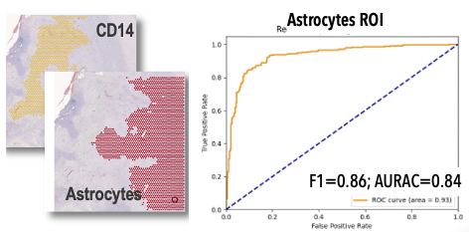
Figure 9. Example assessment of feature imputation of morphology from expression. Preliminary analysis of initial cell-type / gene prediction in glioblastoma tumor as identified from ST. Previously, stHistClip was used to predict astrocytes showing an overall AURAC of 0.84. Similar assessments will be conducted to Xenium/IHC

Alternative Approaches. If the gene encoder fails to capture broad biological signals with individual gene tokens, we will evaluate grouping genes into pathway-level tokens informed by curated gene sets. If contrastive alignment converges poorly, we will incorporate pre-trained weights from single-cell foundation models (scGPT, SCimilarity) to provide stronger initialization for the expression encoder.

Aim 2: Create DiSCo-CAUS: A framework for causal inference in spatial biology from somatic stochasticity

Rationale: From Spatial Correlation to Causal Mechanism. Emerging spatial technologies map tissue architecture at high resolution, but current analytical approaches remain descriptive. Standard methods identify associations, such as colocalizing molecular features with morphological phenotypes, yet they cannot distinguish true biological drivers from environmental confounders. An observed correlation between oncogene expression and immune exclusion might represent a genuine driver effect, or it might be a spurious artifact of unmeasured regional factors like hypoxia or necrosis. Aim 2 addresses this inference gap by developing DiSCo-CAUS (Discovery of Causal Structure), a framework that repurposes chaotic tumor evolution as an analytical asset. The core premise: somatic stochasticity, specifically the random segregation of heritable elements like ecDNA, creates natural experiments within the tissue that enable causal inference. When neighboring cells in the same microenvironment inherit different oncogene copy numbers by chance, we can isolate the effect of gene dosage from spatial confounding. By formalizing these evolutionary events within Structural Causal Models and applying Instrumental Variable estimators, DiSCo-CAUS mathematically decouples genetic effects from environmental ones. This transforms static spatial data from map-making into mechanistic interrogation, quantifying how specific molecular alterations remodel the local microenvironment.

. Turning Random Segregation into a Natural Experiment & Causal Mathematical Framework using ecDNA as a Benchmark A central challenge in cancer biology is distinguishing correlation from causation. For example: Are cells with high EGFR expression aggressive because EGFR causes aggressive behavior, or do other factors make cells both aggressive and high in EGFR? Answering this requires an experiment, but we cannot manually change gene dosage in individual cells within a patient's tumor. Shown in Fig. 10, our approach solves this by leveraging a natural experiment that occurs during every cell division. Because ecDNA lacks a centromere, it is randomly and unevenly passed to daughter cells during mitosis. This is like nature randomly "dealing" different numbers of ecDNA copies to each new cell, creating natural variation that is independent of the cell's environment or pre-existing state.

Applying Causal Inference to Test Directionality. This random segregation provides the perfect setup for a powerful statistical framework known as Instrumental Variable analysis. The logic is if the randomly inherited ecDNA copy number (the instrument) consistently predicts which cells develop aggressive features, we can causally link the ecDNA's gene products to that behavior. Using this approach, implemented with structural equation models, we can statistically prove whether a random increase in EGFR ecDNA causes a subsequent increase in EGFR protein, which in turn causes a proliferative phenotype. This transforms the tumor's own heterogeneity into a living experimental system, allowing us to definitively separate molecular drivers from correlative markers, quantify their specific effects, and parse the distinct contributions of the EGFR and p53 pathways to malignancy.
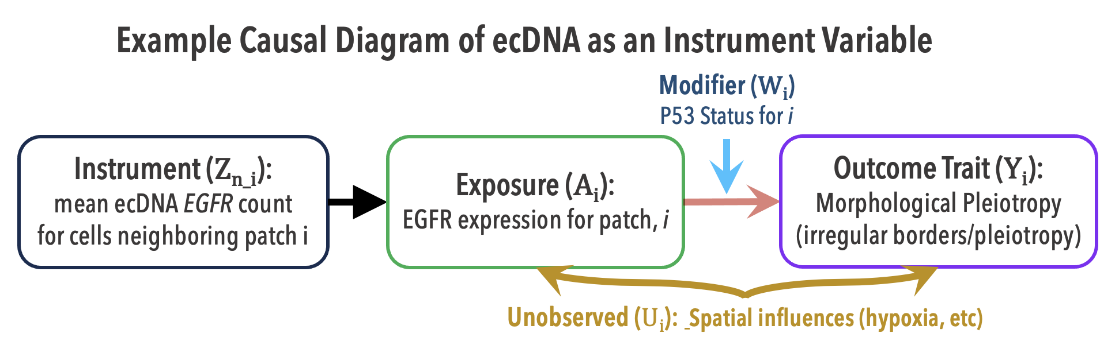
Figure 10. Illustrative Application: Dissecting Context-Dependent Drivers via Causal Inference. The Challenge: Standard spatial correlations between oncogene expression (A_{i}) and phenotype (Y_{i}) are confounded by unobserved environmental factors (U), such as hypoxia, which independently drive both signaling and morphological changes. The Methodology: We overcome this by utilizing the spatial consistency of clonal growth to create a genetic instrument (Z_{n_i}): the neighbor’s DNA dosage predicts the patch’s expression potential, effectively anchoring the analysis in lineage rather than the variable local environment. The Meaningful Insight: By modeling co-occurring mutations (e.g., p53 status, Wi)) as effect modifiers on the causal path (blue arrow), this framework mathematically distinguishes opposing biological states, such as Oncogene-Induced Senescence versus Malignant Transformation. This provides a generalizable example of how the tools developed in this proposal determine not just if a gene drives a trait, but under what permissive conditions it drives it, recognizing that these tools can have impacts outside of oncology (see Figure 3).

Biological Basis of the Instrument. ecDNA elements lack centromeres and segregate randomly during mitosis. This biological mechanism satisfies the three core assumptions required for a valid IV::

Relevance (Z_{i_n}→A_{i}): By defining the instrument Z_{i_n} as the mean ecDNA count of the spatially adjacent neighbors, you solve the confounding problem through the principle of Clonal Heredity. This randomness creates a "natural experiment" analogous to randomization in a clinical trial. Because tumors grow clonally, a patch is highly likely to share the same genetic lineage as its immediate neighbors. The Logic: "My neighbor has high ecDNA. Therefore, I probably inherited high ecDNA too (Relevance). However, the fact that my neighbor has ecDNA is not caused by the fact that I am currently suffocating from lack of oxygen (Exogeneity)."

Independence (Z_{i_n}⟂U_{i}): The segregation of ecDNA is stochastic. While the survival of a clone is subject to selection (and thus confounding), the allocation of copy numbers to daughter cells at the moment of division is a random process, independent of the local microenvironment.

Exclusion Restriction (Z_{i_n}→A_{i}→Y_{i}): The assumption that ecDNA copy number influences the phenotype only through the expression of the oncogene (and linked cargo). While potential violations exist (discussed below), this assumption allows us to attribute phenotypic changes to the dosage of the driver gene.

Causal Modeling of ecDNA Dynamics via Structural Causal Models (SCM). A central challenge in pathogenesis is distinguishing whether ecDNA amplifications directly drive malignant programs or whether they simply co-occur with microenvironmental changes. We take advantage of the fact that ecDNA segregates randomly during mitosis, creating natural variation in oncogene copy number across otherwise similar cells. This stochastic inheritance provides a biologically grounded “instrument” to test causality, as shown in Figure 8. We formalize the relationship in two stages:

Stage 1: ecDNA copy → oncogene activity: $A_{i}=α_{0}+α_{1}Z_{i}+u(s_{i})+ε_{A,i}$
Here, the mean ecDNA copy number of the spatial neighbor (Z_{n_i}) serves as a genetic anchor, predicting the patch's expression potential based on lineage while remaining independent of the patch's immediate microenvironmental stressors. The term A_{i} represents the portion of gene expression variance driven by genetics, independent of environmental confounders.

Stage 2: oncogene activity → malignant program: $Y_{i}=β_{0}+β_{1}{\hat{A}}_{i}+u(s_{i})+ε_{Y,i}$
In Stage 2, Y_{i} is a downstream program (such as proliferation, invasion, or hypoxia adaptation). By using the predicted oncogene activity ${\hat{A}}_{i}$ from Stage 1, we test whether ecDNA-driven variation in activity causally alters tumor programs, while still accounting for the spatial context. While this description is meant to provide a conceptual view, we will practically leverage more robust packages such as the package SIGNET ⁵³ (Statistical Inference on Gene Regulatory Networks), a flexible software package that reveals networks of causal regulation between genes built upon large-scale transcriptomic and genotypic data at the population level⁵³.

Interpretation. Stage 1 quantifies how random changes in ecDNA copy alter oncogene activity. Stage 2 then asks whether those changes propagate into malignant cell states. The spatial term $u(s_{i})$ensures we can separate causal effects of ecDNA from the background influence of tumor niches. By embedding spatial information directly into the equations, this framework allows us to test hypotheses such as whether EGFR ecDNA drives proliferative programs in the tumor core, or whether p53-deficient, ecDNA-positive clones are disproportionately enriched at invasive edges. Linking these spatially resolved causal effects to patient outcomes will enable us to move beyond descriptive association and identify ecDNA-driven programs that truly determine prognosis.

Potential Challenges in Causal Inference. ecDNA provides a powerful instrument for causal inference in spatial oncology, but realizing this potential requires methods designed for how ecDNA actually behaves in tumors. Acentric segregation during mitosis generates stochastic cell-to-cell dosage variation; subsequent clonal selection then reshapes this distribution based on metabolic and therapeutic pressures. Rather than treating selection as a threat to validity, our framework leverages it: the observed spatial distribution of ecDNA copy number encodes both the initial randomization and the fitness landscape that shaped it. We preserve instrument validity by conditioning on spatial context and cell-cycle state while excluding variants associated with clinicopathological confounders, ensuring that residual dosage variation reflects genetic perturbation rather than survival bias.

The regulatory architecture of ecDNA requires equally deliberate handling. ecDNA circles cluster into nuclear hubs and engage in trans-activation across chromosomal and extrachromosomal loci, creating coordinated effects that extend beyond single cargo genes. We decompose these effects rather than correcting them away. Network-regularized estimators prioritize instruments with high functional proximity to target pathways, separating direct dosage effects from distal trans-regulatory programs. MR-Egger-style regression quantifies systematic pleiotropy as an estimable parameter rather than an untestable assumption. Matched ecDNA-negative controls with equivalent expression levels isolate dosage-driven phenotypes from the globally accessible chromatin state of circular DNA. Together, these approaches yield causal estimates with explicit uncertainty bounds under biologically plausible violations.

Specific Aim 3: Implement DiSCo-SIM: A framework for Phylodynamic reconstruction and virtual perturbation
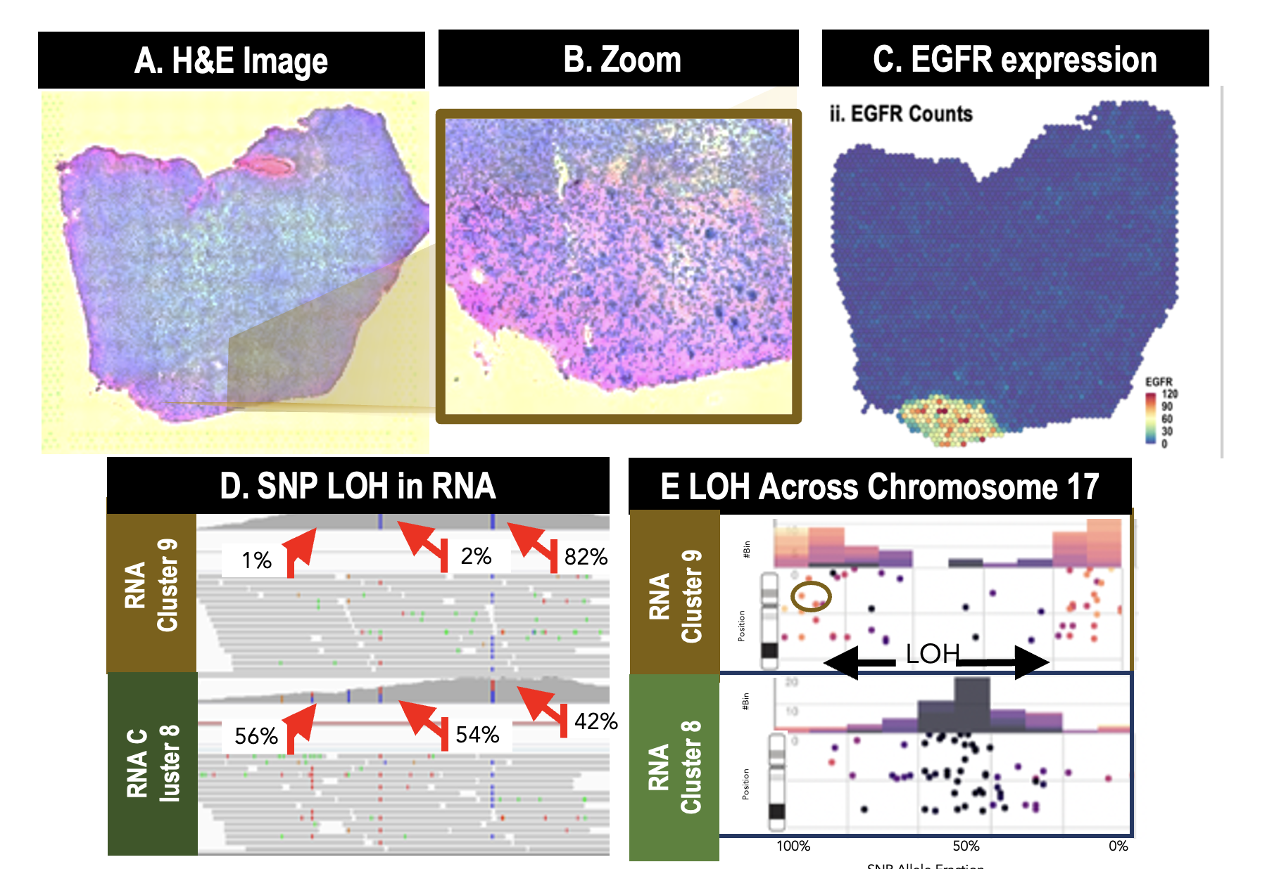
Figure 11. Preliminary Data Showing Spatial phylodynamic inference using expressed SNPs.(A-B) Region exhibiting ecDNA-driven (C) EGFR amplification with concurrent chromosome 17 LOH at the TP53 locus. (D-E)Allele-specific expression analysis reveals only mutant TP53 transcripts, establishing that LOH occurred after the initial point mutation, demonstrating temporal ordering of somatic events from static spatial data. Data et al., 2025. Spatial phylodynamic reconstruction using co-occurring EGFR amplification and chr 17 LOH.

Rationale: Tissues evolve, but spatial omics captures only single moments. This temporal blindness obscures whether a cell population is expanding or contracting, newly emerged or long-established, functionally stable or transitioning. Answering these questions requires recovering developmental or pathological history from static sections. Aim 3 exploits a key biological principle: certain somatic events accumulate irreversibly. Loss of heterozygosity, mitochondrial heteroplasmy shifts, and structural rearrangements such as ecDNA boundaries cannot reverse, embedding a molecular record of lineage relationships within tissue architecture. By mapping these genomic anchors onto spatial coordinates, we reconstruct cellular phylogenies that reveal not just what is present but how it got there. Reconstructing the past then enables predicting the future. Because Aims 1 and 2 isolate heritable variation from microenvironmental confounding, we can specify interventions and propagate their consequences through a generative model: if we altered dosage of an amplified gene, how would surrounding cellular organization respond? Which populations would expand into the vacated niche? We benchmark this framework using ecDNA in tumors, where genomic architecture is well-characterized and clinical relevance is immediate, but the approach generalizes to any system with heritable somatic variation.

Aim 3A: Spatial Phylodynamics.
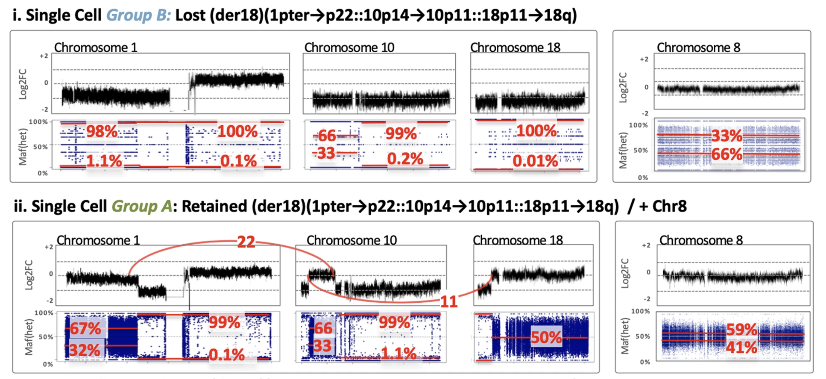
Figure 12. Preliminary Data Allele-specific signals constrain evolutionary ordering in COLO829 through LOH. Shallow single-cell DNA sequencing resolves subclones using heterozygous SNP allele fractions, copy number segments, and breakpoint-supporting reads to place chromosomal events into a parsimonious evolutionary sequence. The key principle for Aim 3A/B: once a region undergoes LOH or allele-specific copy transition, the resulting SNP imbalance makes some histories plausible (single ancestral event followed by divergence) and others unlikely (independent recurrence). We will apply this logic to spatial data by extracting allele-specific imbalance from expressed heterozygous SNPs to call LOH and copy-state transitions, then use these as temporal constraints to order events and align inferred genomic trajectories to molecular and spatial states. Cell lines provide the reproducibility and ground truth needed for training and validation. (Published by Craig group in 2020 ⁴

Reconstructing time from space: the fourth dimension problem. Spatial multi-omics captures tissue architecture at a single moment, but the questions that matter most are temporal: what caused this state, what comes next, and how would intervention alter the trajectory. Current methods infer progression from transcriptomic similarity, yet this assumption fails in solid tissues for two reasons. Transcriptomic similarity can reflect convergent evolution rather than shared ancestry; hypoxic cells in distant tumor regions cluster together despite arising independently. And standard pseudotime ignores physical reality. A cell cannot seed descendants across the tissue without a contiguous migration path. We anchor trajectory inference to irreversible genomic events that impose ground-truth temporal constraints. Loss of heterozygosity, allele-specific copy transitions, and ecDNA boundary rearrangements are one-way gates: once a region loses an allele, descendants cannot regain it. Figure 11 illustrates this in spatial data, where expressed SNP imbalance marks a tumor sector defined by chromosome 17 loss; Figure 12 shows the same logic in COLO829 single-cell DNA sequencing, resolving subclonal structure invisible to expression-based methods. DiSCo-SIM combines discrete phylogenetic reconstruction with continuous spatial transport modeling, producing clonal expansion vector fields constrained by both evolutionary logic and tissue geometry.

Primary Approach: Spatially Constrained Steiner Trees (SCST). To reconstruct the lineage of discrete subclones, we frame the problem as finding a Steiner Tree within the high-dimensional latent space, subject to physical constraints on the tissue slide ⁵⁴. Theoretical Formulation. A Steiner Tree connects a set of "terminal nodes" (observed cell states) via the minimum total edge weight, potentially introducing unobserved "Steiner nodes" (ancestral states). This formulation is superior to Minimum Spanning Trees (MST) because it acknowledges that the true ancestor of two observed clones may no longer exist (or wasn't sampled), requiring the inference of a hidden common ancestor. Terminals: The terminal nodes are the distinct subclones identified by clustering causal latent vectors from Aim 1.

Cost Function: The edge weight W between two nodes is a composite metric, where D_{latent} is the distance in the causal expression space (transcriptomic similarity); D_{spatial} is the geodesic distance on the physical tissue slide. This constraint enforces the "Isolation by Distance" principle, that is that clones are more likely to spawn neighbors than distant cells. We incorporate "resistance masks" (e.g., necrosis, bone) where migration is impossible. P_{genomic} is a penalty for impossible transitions (e.g., regaining a lost allele).
(eq 2)

Temporal Anchors. To orient the Steiner Tree (converting it into a directed graph), we use Temporal Anchors, that is irreversible genomic events that serve as clocks.
- ecDNA Boundaries: While copy number is volatile, the specific structural breakpoints (junctions) of an ecDNA species are unique clonal fingerprints.
- Loss of Heterozygosity (LOH): LOH is an irreversible event. If Clone A is heterozygous and Clone B is homozygous null, and they are related, the direction is A→B.
- Mitochondrial Drift: We will also utilize mitochondrial SNVs (mtSNVs) detectable in the spatial sequencing data. mtSNVs accumulate rapidly and provide a high-resolution molecular clock for recent lineage divergence.

Secondary Approach: Spatiotemporal Optimal Transport (SOCS). While Steiner Trees excel at reconstructing the discrete branching of clones, they do not model the continuous flow of cellular masses. To address this, and to provide a robust alternative strategy, we will implement Spatiotemporal Optimal Transport with Contiguous Structures (SOCS) ⁵⁵. Optimal Transport (OT) computes the most efficient plan to move a probability distribution (source) to another (target). In our context, we map the distribution of an ancestral clone (identified by the SCST) to its descendants.
- Contiguity Constraint: Standard OT (e.g., Waddington-OT) allows mass to teleport. SOCS imposes a regularization term that penalizes transport plans where neighboring cells in the source distribution become separated in the target distribution. This effectively models the cohesive expansion of a tumor mass.
- Unbalanced Transport: We utilize Unbalanced Gromov-Wasserstein OT to account for proliferation (mass creation) and apoptosis (mass destruction).
- Expansion Vector Fields. The output of the SOCS model is a transport matrix γ. We project this matrix onto the 2D spatial coordinates to generate Expansion Vector Fields. Shown in equation 3, This vector field provides a quantitative visualization of tumor growth: arrows at each spot indicate the direction and velocity of clonal spread. Unlike "RNA Velocity," which infers direction from splicing ratios (often noisy in ST), this velocity is derived from the rigorous integration of genomic lineage and spatial transport physics.
(eq 3)
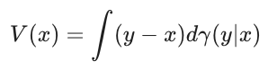

Validation. Validation will utilize multi-regional sequencing datasets. We will select cases where phylogenetic trees have already been established via deep whole-genome sequencing of multiple distinct tumor sectors. We will apply to a single slide from these tumors and quantify the Robinson-Foulds metric (tree distance) between our spatially inferred tree and the ground-truth genomic tree. Additionally, we will use synthetic data generated by Agent-Based Models (ABMs) where the full evolutionary history is known.

Aim 3B: Synthetic Perturbations.

Rationale. The ultimate goal of analyzing tumor maps is to learn how to alter them. Aim 1 identifies causal drivers, and Aim 2 establishes the temporal context. Aim 3 closes the loop by building a simulator capable of answering counterfactual questions: "What would the morphology of this specific tissue region look like if we knocked down EGFR?" Standard predictive models can estimate a scalar outcome (Y) from an input (A), but they cannot generate a high-fidelity spatial representation of the counterfactual state. We need a generative model that can hallucinate the tissue's response to therapy while preserving its fundamental architecture (vasculature, stroma).

Architecture. Variational Autoencoder (VAE): We first train a VAE to compress H&E patches into a low-dimensional latent space z. This reduces the computational dimensionality and focuses the model on semantic features. Denoising U-Net: The core component is a U-Net trained to reverse a diffusion process (removing noise from z_{t} to recover z_{t-1}. Causal Conditioning: The U-Net is conditioned via Cross-Attention layers. The "keys" and "values" for attention are derived from the causal embedding E_{causal}= MLP( Z, A, W), where Z is the instrument, A is the oncogene expression, and and W is the spatial context.

Counterfactual Inference Procedure. To generate a "treated" version of a patient's tumor patch:
- Inversion: We take the spot expression and use DDIM Inversion to map it to its specific noise representation zt. This step is critical; it "locks in" the patient-specific details (e.g., the exact location of blood vessels) that should not change during the perturbation.
- Intervention (The "Do" Operator): We mathematically intervene on the condition vector. We replace the observed high oncogene state (A_{high}) with a target low state A_{low}), creating a counterfactual condition C_{cf}.
- Generation: We run the reverse diffusion process starting from the patient's specific z_{T}, but guided by the counterfactual condition C_{cf}.
- Result: The model generates a synthetic image that retains the patient's stromal architecture but hallucinates the morphological changes associated with the therapeutic reduction of the oncogene (e.g., reduced nuclear density, apoptosis).

Alternative Approaches. If assumptions for causal inference are not fully met, we will pursue complementary strategies. Perturbation data from CRISPR knockdowns, pharmacologic inhibition, and published functional screens will serve as external benchmarks for causal directionality. Sensitivity analyses, such as negative control instruments and leave-one-out models, will test robustness. Directed acyclic graphs will help visualize dependencies and identify hidden confounders. We will also compare causal inference predictions with results from organoid and xenograft perturbation experiments to determine whether statistical inferences align with experimental evidence. These alternatives provide support for causal conclusions even if instrumental variable assumptions are partly violated.

Aim 3 Rigor and Feasibility. This aim integrates single-cell and spatial multi-omics across outcome-linked GBM cohorts, using established pipelines for Xenium and PhenoCycler data with validated probe and antibody panels and defined QC standards. Causal inference models do more than identify associations; they can formally test causal relationships by using instrumental variables and mediation frameworks, treating ecDNA copy number as the instrument. Analyses are pre-specified, with covariate adjustment and sensitivity tests to control confounding. Adequate sample sizes provide power for spatial program discovery, and validation in independent cohorts will confirm robustness. Potential pitfalls, such as low ecDNA prevalence in subsets or model instability, are addressed by pathway-level aggregation, bootstrapped confidence intervals, and hierarchical modeling. Together, these safeguards make Aim 2 feasible and likely to yield reproducible mechanistic insight into the spatial dynamics of EGFR/p53 ecDNA interactions in GBM.

Project Timeline and Software Milestones

Year 1 (Alpha): Foundational data and early causal prototypes. In Year 1, we will generate initial multimodal spatial datasets with validated ecDNA ground truth and use these data to develop alpha versions of the core computational components. For Aim 1, we will implement an alpha multimodal embedding framework that aligns histology and spatial transcriptomics while modeling spatial context. In parallel, Aim 2 alpha prototypes will formalize preliminary structural causal models and instrumental variable estimators using ecDNA as a somatic source of variation. These alpha releases will support early testing of identifiability, spatial confounding, and integration between representation learning and causal inference. Experimental data generation will be in all years.

Year 2 (Beta for Aim 1, Alpha to Beta for Aim 2): Scaled data and stabilized representations. In Year 2, we will scale multimodal spatial profiling across the patient cohort and use these expanded datasets to finalize a beta release of Aim 1. This version will deliver stable, interpretable embeddings validated across tissues and platforms, constituting the production-ready representation layer. Concurrently, Aim 2 will transition from alpha to beta, incorporating hierarchical spatial models, refined instrumental variable estimators, and initial robustness analyses. Causal estimates will be benchmarked against protein expression and histopathological annotations to guide final refinement.

Year 3 (Production for Aim 2, Production for Aim 3A): Causal inference and spatial phylodynamics. In Year 3, we will complete production release of Aim 2, delivering a fully validated spatial causal inference framework with comprehensive sensitivity analyses addressing pleiotropy and spatial confounding. Strong validation will be emphasized using orthogonal molecular and pathological benchmarks. In parallel, we will complete Aim 3A, producing a production-ready spatial phylodynamics module that reconstructs temporal ordering and evolutionary trajectories from static tissue sections, validated using irreversible genomic events such as loss of heterozygosity and ecDNA inheritance.

Year 4 (Production for Aim 3B): Counterfactual simulation and end-to-end validation. In Year 4, we will complete production release of Aim 3B, implementing counterfactual simulation and virtual perturbation models. This release will enable rigorous benchmarking in controlled three-dimensional cell line systems and time course experiments, comparing predicted tissue responses with observed outcomes. The final phase will emphasize end-to-end validation across aims, generalization across tumor types, and preparation of software, documentation, and datasets for dissemination.

