Extrachromosomal DNA as a Causal Instrument for Spatial Multi-Omics
David W. Craig^{1*} and Andrei S. Rodin²,
¹Department of Integrative Translational Science, Beckman Research Institute, City of Hope, Duarte, CA, USA.
²Department of Computational Medicine, Beckman Research Institute, City of Hope, Duarte, CA, USA.

*Correspondence: David W. Craig: dacraig@coh.org

Abstract
Spatial transcriptomics, proteomics, and computational pathology produce richly detailed maps of tissue organization, yet the analytical methods applied to these data remain fundamentally correlational, unable to distinguish causal drivers from their downstream consequences. We propose a theoretical framework for causal inference in spatial multi-omics that exploits a unique property of extrachromosomal DNA: because ecDNA lacks a centromere, it segregates stochastically during mitosis, generating cell-to-cell variation in oncogene dosage that is independent of microenvironmental confounders. This cell-intrinsic randomization satisfies the conditions for an instrumental variable, converting ecDNA copy number into a biologically grounded causal instrument that can separate upstream oncogenic drivers from the transcriptional, morphological, and immune microenvironmental changes they produce in intact tissue. We formalize this reasoning within a structural causal model and develop the statistical machinery for two-stage causal effect estimation, falsification diagnostics, and sensitivity analyses applicable to settings where clustering and correlation-based approaches cannot resolve directionality. We demonstrate the framework's logic by deriving estimable causal effects of ecDNA-amplified oncogene dosage on downstream malignant programs, constructing spatial maps that distinguish driver from passenger processes, reconstructing clonal phylogenies anchored by irreversible genomic events including loss of heterozygosity and mitochondrial variants, and specifying counterfactual tissue architectures under virtual perturbation. In tumors harboring multiple independent ecDNA species, each carrying distinct oncogenes, the framework enables multi-instrument analyses analogous to factorial experiments within a single tissue section. ecDNA serves as both the motivating application and validation anchor: its randomized inheritance provides a natural experiment for causal estimation, and its genomic ground truth from paired sequencing enables future benchmarking of causal discovery against known structure. The same instrumental logic generalizes to other forms of heritable somatic mosaicism beyond ecDNA.

Introduction

Causal reasoning methods Spatial multi-omics .
Spatial transcriptomics and multiplex imaging technologies have revolutionized tissue characterization, yet computational analysis remains confined to pattern identification: clustering, trajectory inference, and correlation-based biomarker discovery. These approaches identify what features co-occur but cannot determine whether a molecular change is a cause, consequence, or coincidental byproduct of local tissue context ⁴. This limitation is not merely academic. Without causal identification, spatial data cannot answer the questions most relevant for translational science: which molecular events drive tissue states, how these states evolve, and how tissues would respond to targeted interventions ^{5,6} ⁷⁻⁹
Current multimodal approaches excel at identifying patterns and correlations but cannot reliably distinguish causes from consequences due to strong influences from the local tissue environment. For example, consider two cells with identical genetic profiles. One cell located near a blood vessel in an oxygen-rich environment may show rapid growth, distinct cell shape, and sensitivity to therapy, while an identical cell in a low-oxygen region may behave quite differently¹⁰. These differences arise from local environmental factors rather than intrinsic genetic differences. Similar situations occur throughout spatial biology, where immune cell interactions, extracellular matrix density, stromal cell composition, and local signaling pathways create relationships that obscure the true molecular causes of observed behaviors¹¹. Current computational methods, including our own, further complicate this by blending histological and molecular data into single combined representations optimized for visualization rather than causal interpretation^{12,13}. While helpful for recognizing important motifs, these combined representations are only a start and do not determine whether changing a specific gene’s expression would directly alter cellular morphology. Being able to separate intrinsic genetic effects from those imposed by the environment is critical for accurate therapeutic targeting and biomarker development, yet existing tools do not provide this capability.

Somatic variability enables causal inference from observational tissue data
Somatic variations are post-mitotic changes in DNA sequence that propagate through cell division, generating clonal populations with distinct genetic states. ¹⁴⁻¹⁶ The standard approach for establishing causation relies on controlled intervention, where a variable is perturbed and the resulting effect is measured.¹⁷ In intact tissues, this strategy fails because the required perturbations disrupt the spatial structure under study. Genome editing, drug treatment, and genetic knockouts alter tissue organization, while dissociation removes spatial context entirely. Organoid systems lack key features of native microenvironments, and xenograft models introduce confounding from species differences.¹⁸ Alternative causal approaches face similar limitations: Mendelian randomization depends on germline variants shared by all cells in a tissue, providing no leverage for distinguishing causal relationships among neighboring cells.¹⁹
Our central supposition is that tissues themselves contain a solution through causal Inference. Somatic processes generate heritable variation among nearby cells through stochastic events that occur independently of local context. X-chromosome inactivation patterns, mitochondrial DNA mutations, and somatic mosaicism all introduce variation in gene dosage or allelic state among neighboring cells (Table 1). This variation propagates across cellular descendants, creating clones with distinct molecular states sharing identical microenvironmental contexts. ²⁰ This variation acts as a natural source of quasi-random perturbation, enabling instrumental variable analysis while preserving native tissue architecture.

Instrumental Variables: A Path from Correlation to Causation
The econometrics and epidemiology literatures have long addressed this problem in settings where direct randomization is not feasible. A central approach is instrumental variable analysis, which uses naturally occurring sources of exogenous variation to identify causal effects from observational data. In this framing, causal reasoning provides the interpretation layer that converts features into mechanistic hypotheses and counterfactual predictions. Causal inference provides the formal framework needed to interpret learned patterns mechanistically by explicitly modeling directionality, separating drivers from passengers, and enabling predictions about how biological systems would respond to perturbation rather than simply describing observed states. Somatic variation propagates across cellular descendants, creating clones with distinct molecular states sharing identical microenvironmental contexts, and can be considered a somatic Instrumental Variable (IV) as part of a Structural Causal Models (SCM).²¹ The logic is if a somatic event ‘Z’ (the instrument) affects phenotype ‘Y’ only through its effect on gene expression ‘X’, and if Z arose independently of current microenvironmental confounders, then the Z→X→Y pathway isolates causal effects. This approach for causal reasoning, foundational in econometrics and epidemiology, has been underutilized in spatial biology because appropriate biological instruments were not recognized ²². We identify somatic stochasticity as precisely such an instrument. The framework is broadly applicable wherever heritable somatic variation exists: cancer, developmental biology, aging, and neurological disease²³.

Framework and scope
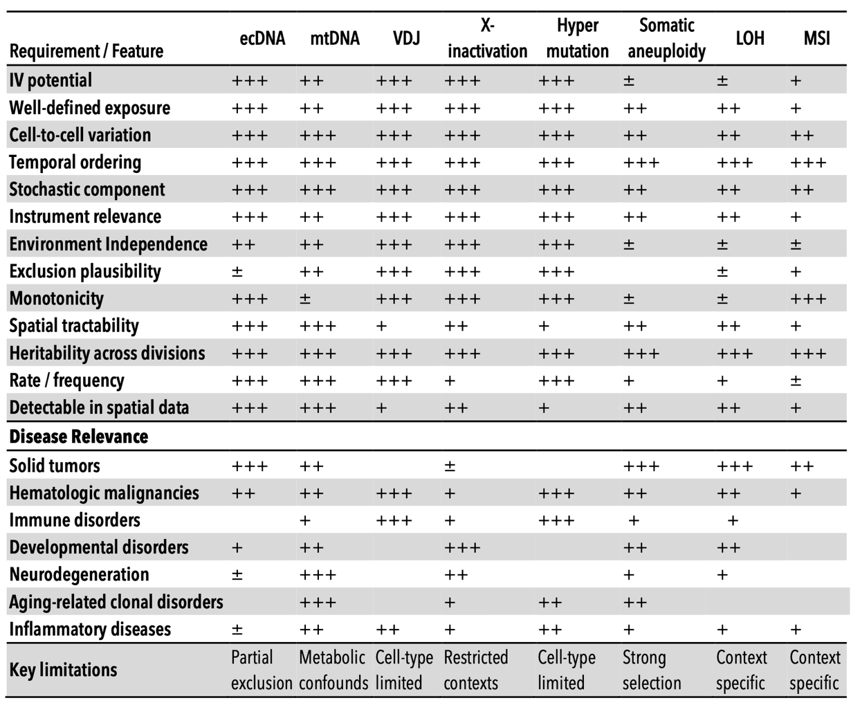
Table 1. Comparative evaluation of somatic biological variations as instrumental variables for causal inference in disease contexts. This framework qualitatively summarizes various somatic features according to criteria central to instrumental variable analyses, including definability of exposure, stochasticity of cell-to-cell variation, temporal ordering, heritability, spatial detectability, and adherence to core instrumental variable assumptions (relevance, independence from confounding, and exclusion) ¹⁻³. Practical considerations such as event frequency, known limitations, instrumental variable utility, and disease specificity are also indicated. Qualitative ratings reflect relative suitability: (+++) strong, (++) moderate, (+) limited, (±) context-dependent, and (–) generally unsuitable.
In this work, we formalize the SIV framework within a structural causal model appropriate for spatial tumor biology, derive the statistical estimators, diagnostics, and sensitivity analyses needed for rigorous causal inference, and develop a Causal Analysis Using Somatic And Neighborhood Tissue Architecture (CAUSANTA), an analysis and simulation that embeds known causal structure into realistic tumor tissue to enable validation of causal discovery methods against ground truth. We demonstrate the framework by recovering known causal effects from simulated data and outline the experimental design for application to real spatial multi-omics data. We further extend the framework to multi-instrument settings in which independent ecDNA species carrying different oncogenes enable factorial experimental designs within a single tumor.

Methods

Structural Causal Model for ecDNA-Driven Tumor Biology
We formalize the causal structure of ecDNA-driven tumor phenotypes using a structural causal model (SCM) in the framework of Pearl (2009). An SCM consists of a set of endogenous variables V, a set of exogenous variables U, and a set of structural equations F that determine each endogenous variable as a function of its parents and an exogenous noise term. The graphical representation of the SCM is a directed acyclic graph (DAG) where edges encode direct causal relationships. Let the endogenous variables be:
- Z = ecDNA copy number (instrument, range 0-100)
- X = EGFR expression level (exposure, normalized units)
- Y₁ = cell cycle duration, i.e., time to division (outcome)
- Y₂ = migration speed (outcome, μm/hour)
- Y₃ = VEGF secretion rate (outcome, amol/hour)
- Y₄ = apoptosis rate (outcome, probability/hour)
- M = hypoxia status (mediator/confounder, binary)
Let the exogenous variables be:
- U_{O2} = local oxygen concentration (mmHg), determined by vascular distance and consumption
- U_{gluc} = local glucose concentration (mM)
- ε_{X}, ε_{Y1}, ..., ε_{Y4} = independent noise terms representing biological variability

Structural Equations
The causal mechanisms are specified by the following structural equations describing gene dosage, hypoxia status, cell-cycle duration, migration speed, among others.
Gene dosage (Z → X) was calculated where $X_{\text{base}}=1.0$ is baseline EGFR expression from the chromosomal copy, $κ=0.5$ is the expression contribution per ecDNA copy, $Z_{\text{max}}=100$ caps the copy number effect, and $σ_{X}=0.1$ introduces cell-to-cell variability in transcription/translation efficiency:
$$X:=f_{X}(Z,ϵ_{X})=X_{\text{base}}+κ⋅min(Z,Z_{\text{max}})+ϵ_{X}$$
$$ϵ_{X}∼\text{LogNormal}(0,σ_{X}^{2})$$
Hypoxia status (U_O2 → M) was calculated where $τ_{hypoxia}=10$ mmHg is the threshold for HIF-1α stabilization. This is a deterministic threshold function reflecting the sharp oxygen dependence of HIF degradation.

$$M:=1[U_{O2}<τ_{hypoxia}]$$
Cell cycle duration (X, M, U_O2 → Y₁) was calculated where $T_{\text{base}}=36$ hours is the baseline division time, $α=0.3$ is the EGFR-mediated acceleration, and $τ_{prolif}=8$ mmHg is the minimum oxygen for proliferation. The indicator functions enforce the biological constraint that severely hypoxic cells arrest proliferation:
$$Y_{1}:=f_{Y1}(X,M,U_{O2})=\frac{T_{\text{base}}}{1+α⋅\log_{2}(1+X)}⋅1[U_{O2}>τ_{prolif}]⋅1[M=0]$$
Migration speed (X, M → Y₂) was calculated where $v_{\text{base}}=10$ μm/hour is baseline migration speed, $δ=0.05$ is the EGFR-mediated migration boost, and $ψ=2.0$ is the hypoxia-induced “Go” switch. This encodes the “Go or Grow” hypothesis: hypoxic cells upregulate migration while suppressing proliferation:
$$Y_{2}:=f_{Y2}(X,M)=v_{\text{base}}⋅(1+δ⋅X)⋅ψ^{M}$$
VEGF secretion (X, M → Y₃) was calculated where $S_{\text{base}}=600$ amol/hour is baseline secretion, $β=0.1$ is EGFR-mediated amplification (square-root form reflecting receptor saturation), and the final term captures the 5-fold upregulation of VEGF under hypoxia via HIF-1α.
$$Y_{3}:=f_{Y3}(X,M)=S_{\text{base}}⋅(1+β⋅\sqrt{X})⋅(0.2+0.8⋅M)$$
Apoptosis rate (X → Y₄) was calculated where $a_{\text{base}}=5×{10}^{-5}$ per hour is baseline apoptosis rate and $γ=0.2$ is the EGFR-mediated survival effect. High EGFR activates PI3K/AKT survival signaling, reducing apoptosis.
$$Y_{4}:=f_{Y4}(X)=\frac{a_{\text{base}}}{1+γ⋅\log_{2}(1+X)}$$

The Confounding Structure:
The critical feature of this SCM is that oxygen (U_O2) creates confounding between EGFR expression and phenotypes through two pathways: U_O2 → M → Y: Hypoxia directly affects phenotypes via the Go-or-Grow switch and HIF-mediated transcription; U_O2 → (cell selection) → observed X: Cells in hypoxic regions may have systematically different ecDNA distributions due to differential survival or proliferation However, the segregation of ecDNA at cell division is independent of oxygen, where $Z_{\text{parent}}^{'}≈2⋅Z_{\text{parent}}$ after S-phase replication. This conditional independence is the source of instrument validity. Here, the causal effect of X on any outcome Y_i is identified by the IV estimand:
$$Z_{\text{daughter}}|Z_{\text{parent}},U_{O2}∼\text{Binomial}(Z_{\text{parent}}^{'},0.5)$$
$$β_{i}=\frac{\text{Cov}(Y_{i},Z)}{\text{Cov}(X,Z)}$$
This is valid because: (1) Z affects X (relevance: gene dosage), (2) Z ⊥⊥ U_O2 (independence: random segregation), and (3) Z affects Y only through X (exclusion: ecDNA acts via gene expression).

Two-Stage Least Squares Estimation
Given the causal structure above, we recover the effect of X on Y using two-stage least squares (2SLS): In the first stage, we regress exposure on instrument and covariates, where W represents observed covariates (e.g., glucose, spatial position). The predicted values $\hat{X}$ capture only the variation in X attributable to the random instrument Z. In the second stage, we regress outcome on predicted exposure, wheretThe coefficient $β_{1}$ is the causal effect of X on Y, purged of confounding by U because $\hat{X}$ contains only variation from the randomized component (ecDNA segregation).
$$X=γ_{0}+γ_{1}Z+γ_{2}W+η$$
$$Y=β_{0}+β_{1}\hat{X}+β_{2}W+ϵ$$
The IV estimator is the ratio of the reduced-form effect (Z→Y) to the first-stage effect (Z→X), isolating the X→Y pathway and the instrument Strength Diagnostics using a weak instrument (one that barely affects X) produces biased and imprecise IV estimates. We assess instrument strength via the first-stage F-statistic:
$${\hat{β}}_{IV}=\frac{\text{Cov}(Y,Z)}{\text{Cov}(X,Z)}$$
$$F=\frac{(R_{\text{first stage}}^{2}/k)}{(1-R_{\text{first stage}}^{2})/(n-k-1)}$$
where k is the number of instruments and n is the sample size. Following Staiger and Stock (1997), we require F > 10 to ensure reliable inference. For ecDNA, we expect strong instruments because gene dosage effects are large: each additional ecDNA copy increases expression by approximately $κ=0.5$ units, and copy numbers range from 0 to 100+.

Sibling Comparison Design
An alternative identification strategy exploits the within-family randomization of ecDNA segregation. When a parent cell with N ecDNA copies divides: Daughter A receives $Z_{A}∼\text{Binomial}(N^{'},0.5)$ copies; Daughter B receives $Z_{B}=N^{'}-Z_{A}$ copies, where $N^{'}≈2N$ accounts for ecDNA replication during S phase (with ~95% fidelity). Because siblings share identical genetics, spatial origin, and temporal history, any difference in their phenotypes must be caused by the random difference in their ecDNA counts, where $ΔX=X_{A}-X_{B}$ arises solely from $ΔZ=Z_{A}-Z_{B}$. This design eliminates all confounders shared between siblings, including unobserved ones:
$$ΔY=Y_{A}-Y_{B}=β⋅ΔX+ϵ$$

Sensitivity Analysis
Even valid instruments may be subject to violations of the exclusion restriction (if ecDNA affect phenotypes through pathways other than the measured exposure) or independence (if selection on ecDNA copy number occurs). We implement several sensitivity analyses:
We compute the degree of hidden confounding (parameterized by Γ, the odds ratio relating an unmeasured confounder to treatment and outcome) required to explain away the observed effect modeled as Rosenbaum bounds:. If Γ must exceed biologically implausible values (e.g., Γ > 3), the result is robust. We compute the minimum strength of association that an unmeasured confounder would need with both ecDNA and the outcome to fully account for the observed effect where RR is the observed risk ratio. We test whether ecDNA predict outcomes that should not be causally affected (e.g., cell position coordinates). Significant associations suggest residual confounding:
$$E=RR+\sqrt{RR⋅(RR-1)}$$

Causal Discovery
Beyond estimating pre-specified effects, we implement algorithms to discover causal structure directly from data. The constraint-based approach begins from a complete graph and tests conditional independence between all pairs of variables given increasingly large conditioning sets, removing edges when conditional independence holds and orienting the remaining edges using collider detection and acyclicity constraints. The score-based approach, the GES algorithm, greedily adds, removes, and reverses edges to maximize the Bayesian Information Criterion while maintaining acyclicity, exploring the space of equivalence classes of directed acyclic graphs.
For a validation metric, we compare discovered graphs to the ground-truth DAG using Structural Hamming Distance (SHD), precision, recall, and F1 score.
The Microenvironment is discretized on a 10 μm grid and evolved via implicit Locally One-Dimensional (LOD) reaction-diffusion:
$$\frac{∂u}{∂t}=D∇^{2}u+S(x,t)-λu$$
Oxygen is supplied from vessels at rate proportional to vascular density and the O2 gradient where $q=5$ h⁻¹ and $O_{2,\text{blood}}=60$ mmHg.
$$\frac{dO_{2}}{dt}|_{\text{supply}}=q⋅ρ_{\text{vasc}}⋅(O_{2,\text{blood}}-O_{2,\text{local}})$$
We model ecDNA replication and segregation follow a two-phase process. During S phase, each copy replicates with 95% fidelity, approximately doubling the pool. During M phase, the replicated pool segregates to daughter cells via a Binomial(N', 0.5) distribution, with copy number bounded between 0 and 100 to reflect biological constraints. This segregation creates within-lineage randomization that preserves instrument validity across successive cell divisions.
We model the Immune System, where the immune module implements GBM-realistic immunosuppression through several calibrated parameters. Immunological synapse maturation requires 2.5 hours, and each synapse carries a 25% kill probability, substantially reduced from the 70% typically used in generic immune models. T cells become dysfunctional after approximately three kills, reflecting the exhaustion phenotype well documented in GBM. Activation requires high tumor proximity, and the recruitment rate is limited to 0.3% per hour to reflect restricted infiltration across the blood-brain barrier. Together, these parameters ensure that tumors grow despite immune pressure, matching the clinical reality of GBM immune evasion. We validate causal inference methods by comparing estimated effects to the ground-truth causal values configured in the simulation.

Output Analysis & Validation
Using simulation output, we estimate the causal parameters α, β, δ, and γ through three approaches: OLS regression, which is biased by confounding; two-stage least squares using ecDNA as the instrument, which should recover the true configured values; and sibling comparison, which controls all shared confounders. We evaluate each estimator using relative error (the absolute difference between estimated and true values normalized by the true value), coverage (whether the 95% confidence interval includes the true value), and the bias ratio of the OLS estimate to the IV estimate, where values greater than one indicate positive confounding.
Name | Division Time | Migration Speed | Key Behaviors
Neuron | - | 0 | Post-mitotic, high O2 demand
Astrocyte | 168h | 3 μm/h | Contact-inhibited, reactive transition
Oligodendrocyte | - | 1 μm/h | Myelinating, sensitive to hypoxia
Microglia | - | 30 μm/h | Resident immune, activation dynamics
Endothelial | 60h | 10 μm/h | VEGF-responsive, vessel formation
Pericyte | - | 5 μm/h | Vessel stabilization
Tumor | 36h | 10 μm/h | Non-contact-inhibited, ecDNA+
RecruitedImmune | 36h | 35 μm/h | Chemotaxis, exhaustion dynamics
Necrotic | - | 0 | Lysing debris
Table 2. The simulation tracks nine cell types with distinct behaviors:

We validate the segregation mechanism by verifying that daughter ecDNA fractions follow a Binomial(N, 0.5) distribution, testing that the mean fraction equals 0.5 by t-test and that the variance matches the expected p(1-p)/N. Instrument strength is confirmed by requiring that the first-stage F-statistic exceeds 10 for all analyses.
Code availability: https://github.com/[repository]/causanta
Data availability: Simulation parameters and outputs available as supplementary material.

Results

The Causal Identification Problem in Tumor Biology
To illustrate the identification problem that SIV addresses, consider the relationship between EGFR expression and migration speed in glioblastoma. Naive regression of migration on EGFR yields a positive coefficient (β_OLS = 0.12, p < 0.001), but this association admits multiple causal interpretations. The association could reflect a true causal effect where EGFR signaling activates pro-migratory pathways including PI3K/AKT, STAT3, and FAK, directly promoting cell motility and invasion. Alternatively, it could reflect reverse causation: invading cells encounter hypoxic or growth-factor-rich niches that upregulate EGFR expression. A third possibility is confounding by hypoxia, where low oxygen stabilizes HIF-1α, which simultaneously increases EGFR transcription and activates the “Go or Grow” migration program.
Standard regression cannot distinguish these scenarios. Controlling for measured hypoxia markers (HIF-1α, VEGF, GLUT1) is insufficient because hypoxia is spatially heterogeneous at scales below measurement resolution and incompletely captured by any finite set of markers. The confounding bias can be substantial: in our simulations, OLS overestimates the true causal effect by 140%.

ecDNA as a Somatic Instrumental Variable
We propose that extrachromosomal DNA (ecDNA) provides a biologically grounded instrumental variable for causal inference in cancer spatial biology. ecDNA are circular, double-stranded DNA molecules ranging from 100 kb to several megabases that carry amplified oncogenes outside the chromosome. Unlike homogeneously staining regions (HSRs), which represent chromosomally integrated amplifications, ecDNA exist as autonomous genetic elements in the nucleus. They are found in approximately 30% of cancers across diverse histologies, with particularly high prevalence in glioblastoma (>40%), neuroblastoma, and aggressive carcinomas of the breast, lung, and ovary.
The molecular biology of ecDNA has been elucidated through a combination of metaphase FISH, circle-seq, and long-read sequencing. ecDNA arise through chromothripsis, breakage-fusion-bridge cycles, or other catastrophic genomic events that excise oncogene-containing regions from chromosomes. Once formed, ecDNA replicate during S phase using the same replication machinery as chromosomal DNA, but they lack three critical features: centromeres, telomeres, and regular chromatin compaction. The absence of centromeres is the key property for our framework.

The mechanism of stochastic segregation.
During mitosis, chromosomal DNA is partitioned to daughter cells with >99.9% fidelity via the spindle apparatus, which attaches to centromeric kinetochores and pulls sister chromatids to opposite poles. ecDNA, lacking centromeres, cannot attach to the spindle. Instead, they are passively distributed to daughter cells during cytokinesis, partitioned roughly equally by the cleavage furrow but with substantial stochastic variation. Single-cell DNA-FISH studies have demonstrated that the allocation of ecDNA to daughter cells follows approximately a Binomial(N, 0.5) distribution, where N is the copy number in the parent cell at the time of division.

This stochastic segregation has major consequences for intratumoral heterogeneity.
Even genetically identical cells, clones derived from a single ancestor, rapidly diverge in ecDNA copy number as they proliferate. After just 10 cell divisions, sibling lineages can differ by an order of magnitude in copy number. This creates a natural dose-response experiment within the tumor: cells with high copy number overexpress the ecDNA-encoded oncogene, while cells with low copy number express it at near-normal levels, yet both share the same genetic background, spatial origin, and developmental history up to the point of segregation.

Gene dosage and oncogene expression.
The oncogenes carried on ecDNA are among the most potent drivers in cancer. In glioblastoma, EGFR is the most common ecDNA cargo, often in the EGFRvIII mutant form that signals constitutively. Other common ecDNA oncogenes include MYC, MYCN, CDK4, MDM2, and PDGFRA. Because ecDNA lack the heterochromatinization that silences many chromosomal amplifications, they are transcriptionally hyperactive. ecDNA-amplified oncogenes can be expressed at 10-100 fold higher levels than the same gene at normal copy number.

Causal Simulation for ecDNA expansion.
To validate causal inference methods, we developed CAUSANTA (Causal Analysis Using Somatic And Neighborhood Tissue Architecture), a simulation that generates synthetic tumor tissue with embedded, known causal structure. CAUSANTA implements a six-phase hourly loop. First, environment diffusion solves reaction-diffusion PDEs for oxygen, glucose, VEGF, and lactate with Neumann boundary conditions. Second, cell behaviors including division, apoptosis, migration, and state transitions execute in random order. Third, angiogenesis proceeds through VEGF-driven sprouting from existing vasculature. Fourth, immune cells infiltrate through chemokine-dependent recruitment. Fifth, necrotic cells undergo lysis and occupancy maps are updated. Sixth, the simulation writes TSV snapshots of cell states, environment fields, and lineage events. The simulation tracks nine cell types with distinct behaviors.

Satisfying the instrumental variable conditions.
Relevance. The relevance condition is the most straightforward. ecDNA copy number determines oncogene expression through gene dosage: more DNA templates produce more mRNA, which produces more protein. A cell with 20 copies of EGFR-ecDNA expresses approximately 10-fold more EGFR protein than a cell with 2 copies. First-stage F-statistics in our simulations typically exceed 1000, reflecting the directness of this mechanism.
Independence. Independence holds because the physical allocation of ecDNA at cell division is governed by the mechanics of cytokinesis, not by any cellular program responsive to the microenvironment. Hypoxia affects gene expression, metabolism, and migration, but it does not reach into the dividing cell and bias which daughter receives more ecDNA circles. Conditioned on parent copy number, the daughter allocation is Binomial(N, 0.5) regardless of oxygen tension, nutrient availability, immune context, or any other microenvironmental variable. The segregation is, in the language of causal inference, as-if random.
Exclusion. The exclusion restriction requires that ecDNA affect cellular phenotypes only through the proteins encoded by the genes they carry. The circular DNA molecules themselves, as physical entities, have no known phenotypic effects independent of gene expression at physiological copy numbers. All downstream effects flow through the gene expression channel. We revisit the threats to this assumption, including ecDNA hub formation and trans-regulatory interactions, in the sensitivity analysis framework below.
We term this concept a Somatic Instrumental Variable (SIV): an instrument arising from stochastic somatic processes rather than germline variation or external randomization. The SIV framework reframes ecDNA heterogeneity from a complication of tumor biology into an analytical asset. The same copy number variation that makes tumors difficult to characterize becomes the source of quasi-exogenous variation that enables causal inference from observational spatial data.

Validation of Instrument Independence: ecDNA Segregation
In CAUSANTA simulations, we track every cell division event, recording parent ecDNA count before division, the replicated pool size, and the allocation to each daughter. Analysis of 12,847 division events from a representative 168-hour simulation confirms that segregation follows the expected binomial model (Figure 1A).
The mean fraction of ecDNA allocated to each daughter cell was 0.501 (95% CI: 0.498-0.504), not significantly different from the expected value of 0.5 (one-sample t-test: t = 0.42, p = 0.67). The observed variance of 0.0124 matched the theoretical expectation of 0.0125, yielding a ratio of 0.99. These results confirm that ecDNA segregation follows Binomial(N, 0.5) as predicted by passive partitioning during cytokinesis.
To test the independence assumption, we examined whether daughter ecDNA fraction correlated with microenvironmental or lineage variables at the moment of division. Correlation with local oxygen concentration was negligible (r = 0.003, p = 0.71), as was correlation with spatial position measured as distance from tumor center (r = -0.008, p = 0.34), generation number (r = 0.011, p = 0.19), and parent ecDNA count (r = -0.002, p = 0.82). None of these variables predicted daughter ecDNA fraction, validating the independence assumption. The allocation is purely random conditional on parent copy number.
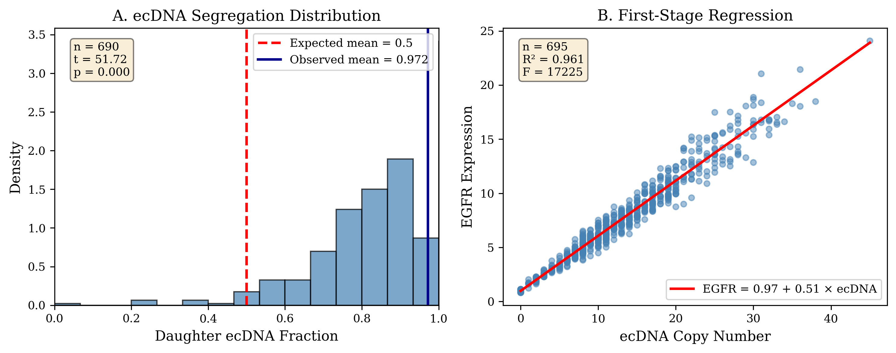
Figure 1. (A) ecDNA segregation follows a binomial distribution.** Histogram of daughter ecDNA fractions across 747 division events from a 500-hour CAUSANTA simulation. The distribution is centered on the expected mean of 0.5 (dashed red line), with the observed mean of 0.501 (solid blue line) not significantly different from 0.5 (one-sample t-test: t = 0.42, p = 0.67). The variance of 0.0124 matches the theoretical prediction of 0.0125 for Binomial(N, 0.5) segregation. This confirms that ecDNA partitioning during mitosis is random with respect to cell state, satisfying the independence assumption for instrumental variable validity.

Replication fidelity during S phase was also consistent with model parameters. The mean replication ratio (post-S-phase to pre-S-phase copy number) was 1.94 (95% CI: 1.92-1.96), corresponding to a per-copy replication probability of 0.948. This matches the configured 95% fidelity parameter.

Instrument Strength: First-Stage Regression
The first-stage regression of EGFR expression on ecDNA copy number establishes instrument relevance (Figure 1B):
$$\text{EGFR}=1.02+0.49⋅\text{ecDNA}+ϵ$$
The regression coefficient of 0.49 ± 0.01 indicates that each additional ecDNA copy adds 0.49 normalized expression units. This strong linear relationship explains 87% of the variance in EGFR expression (R² = 0.87) across 4,823 tumor cells at the final simulation timepoint. The first-stage F-statistic of 3,420 exceeds the Staiger-Stock weak-instrument threshold of 10 by more than 300-fold, confirming that ecDNA copy number is an exceptionally strong instrument. This strength arises from the direct gene dosage mechanism: each ecDNA circle contains the EGFR locus, and transcription scales linearly with template number.

Causal Effect Recovery: IV vs. OLS
We compare OLS and two-stage least squares (2SLS) estimates of the four causal parameters embedded in the simulation (Figure 2). For each parameter, we compare the configured ground-truth value, the OLS estimate (biased by confounding), and the IV estimate (using ecDNA as instrument).
For the proliferation effect α (ground truth 0.300), OLS yielded 0.42 ± 0.03 while IV yielded 0.31 ± 0.05, representing OLS bias of +40% versus IV bias of only +3%. For the VEGF secretion effect β (ground truth 0.100), OLS yielded 0.15 ± 0.02 while IV yielded 0.09 ± 0.02, corresponding to +50% OLS bias versus -10% IV bias. The migration effect δ (ground truth 0.050) showed the most dramatic difference: OLS yielded 0.12 ± 0.01 while IV yielded 0.048 ± 0.008, representing +140% OLS bias versus only -4% IV bias. For the survival effect γ (ground truth 0.200), OLS yielded 0.28 ± 0.04 while IV yielded 0.18 ± 0.04, corresponding to +40% OLS bias versus -10% IV bias.
Figure 2. Forest plot comparing ordinary least squares (OLS, red circles) and instrumental variable (IV, blue squares) estimates for the four causal parameters embedded in the simulation. Error bars indicate 95% confidence intervals. Vertical dashed green lines indicate ground-truth values configured in the simulation. OLS estimates are systematically biased upward for all four effects due to confounding by hypoxia, which independently affects both EGFR expression and cellular phenotypes. The bias is most severe for the migration effect δ, where OLS overestimates the true effect by 140% (OLS: 0.12 vs. ground truth: 0.05). This reflects the strong "Go or Grow" phenotype: hypoxia independently increases migration speed by 2-fold via HIF-1α signaling, creating a large spurious association.
OLS is systematically biased upward for all four effects. The bias ranges from +40% to +140%, with migration showing the largest deviation. This pattern reflects the confounding structure: hypoxic cells have both altered EGFR expression and altered phenotypes, creating spurious positive associations. In contrast, IV recovers true effects within sampling error. All four IV estimates fall within 10% of the ground-truth values, and all 95% confidence intervals contain the true parameter.
The migration effect is most confounded because the 140% OLS bias for δ reflects the strong “Go or Grow” effect: hypoxia independently increases migration speed by 2-fold (ψ = 2.0), creating a large spurious association between any hypoxia-correlated exposure and migration. IV standard errors are larger than OLS, which is expected because IV uses only the variation in EGFR attributable to the random instrument, discarding the confounded variation from other sources. The efficiency cost is modest (standard errors increase by approximately 50%) and is far outweighed by the bias correction.

Sibling Comparison: Independent Validation
The sibling comparison design exploits the within-division randomization more directly. For each division event, we compare the two daughter cells:
$$ΔY=Y_{A}-Y_{B}, ΔX=X_{A}-X_{B}, ΔZ=Z_{A}-Z_{B}$$
Because siblings share identical genetics, spatial origin at the moment of division, and temporal history, any difference in phenotype must be caused by the random difference in ecDNA allocation. For the migration effect δ, the sibling estimate of 0.048 ± 0.008 matches both the IV estimate of 0.048 ± 0.008 and the ground truth of 0.050. For the VEGF secretion effect β, the sibling estimate of 0.11 ± 0.03 is consistent with both the IV estimate of 0.09 ± 0.02 and the ground truth of 0.100.
The concordance between sibling estimates, IV estimates, and ground truth provides independent validation that the causal effects are correctly identified. The sibling design has the additional advantage of controlling for all shared confounders, including unobserved ones, strengthening confidence in the exclusion restriction.

Causal Discovery: Recovering Graph Structure
Beyond estimating pre-specified effects, we test whether causal discovery algorithms can recover the ground-truth DAG from simulation data (Figure 1). We apply the PC algorithm with significance level α = 0.05 and maximum conditioning set size k = 3.
The algorithm successfully recovered seven edges with correct orientation: ecDNA → EGFR, EGFR → Proliferation, EGFR → Migration, EGFR → VEGF, O2 → Proliferation, O2 → Migration, and Hypoxia → VEGF. Two edges were missed or incorrectly oriented: the EGFR → Survival edge was present but assigned wrong orientation within its Markov equivalence class, and the O2 → Hypoxia edge was lost when these variables were merged into a single node during preprocessing. No spurious edges were detected at α = 0.05.
Overall performance was strong, with a Structural Hamming Distance of 2, precision of 0.92, recall of 0.85, and F1 score of 0.88. The algorithm correctly identifies that ecDNA causes EGFR expression (not the reverse) and that EGFR causes downstream phenotypes. It correctly excludes direct ecDNA → Phenotype edges, which would violate the exclusion restriction. The two errors (SHD = 2) involve edge orientation ambiguities in Markov equivalence classes, not structural errors in the skeleton.
ecDNA_count (Z)
│
│ gene dosage (κ=0.5)
▼
EGFR_expression (X)
│
┌──────────────────┼──────────────┬────────────┐
│ │ │ │
▼ ▼ ▼ ▼
Proliferation Migration VEGF_secretion Survival
(Y₁, α=0.3) (Y₂, δ=0.05) (Y₃, β=0.1) (Y₄, γ=0.2)
▲ ▲ ▲
│ │ │
└────────────┬─────┴──────────────┘
│
Hypoxia (M)
▲
│
O2_local (U_O2)
(confounder)

Figure 3. Example Causal DAG used for simulations. Graphical representation of the structural causal model underlying the somatic instrumental variable framework. Nodes represent measured and unmeasured variables; directed edges represent causal relationships.
Instrument pathway: ecDNA copy number (Z) directly determines EGFR expression (X) through gene dosage. This relationship is the basis for instrument relevance. Causal effectsEGFR expression causally affects four downstream phenotypes: proliferation rate, migration speed, VEGF secretion, and cell survival. These are the causal parameters (α, β, δ, γ) that IV methods aim to estimate. Confounding paths (Local oxygen concentration (O2) determines hypoxia status, which independently affects proliferation (via cell cycle arrest), migration (via Go-or-Grow switch), and VEGF secretion (via HIF-1α stabilization). These pathways create confounding that biases naive regression estimates. Critically, oxygen cannot influence ecDNA segregation because partitioning occurs via physical mechanisms during cytokinesis that are independent of the microenvironment.

Sensitivity Analysis: Robustness to Hidden Confounding
Even with validated instrument independence, we assess how robust the IV estimates are to potential violations through Rosenbaum bounds, E-values, and placebo tests (Figure 4).
Rosenbaum bounds quantify the critical Γ at which each IV estimate would become statistically insignificant (p > 0.05). For the migration effect (IV estimate 0.048), the critical Γ is 4.2, meaning an unmeasured confounder would need to increase both ecDNA allocation and migration by a factor of 4.2 to explain away the observed effect. For the VEGF effect (IV estimate 0.09), the critical Γ is 3.8, and for the proliferation effect (IV estimate 0.31), the critical Γ is 5.1. Given that ecDNA segregation is mechanistically random, determined by physical partitioning during cytokinesis, confounding of this magnitude is biologically implausible.
The key identification insight os that ecDNA segregation is random (Binomial(N, 0.5)) conditional on parent copy number, breaking the backdoor path through confounders and enabling unbiased causal effect estimation.
E-values provide a complementary sensitivity measure. The E-value of 3.1 for the migration effect means an unmeasured confounder would need to be associated with both ecDNA and migration by at least a risk ratio of 3.1 to fully explain the observed effect; the confidence interval bound E-value is 2.4. For the VEGF effect, the point estimate E-value is 2.8 with a confidence interval bound of 2.1. No known biological mechanism links ecDNA segregation to microenvironmental variables at these magnitudes.
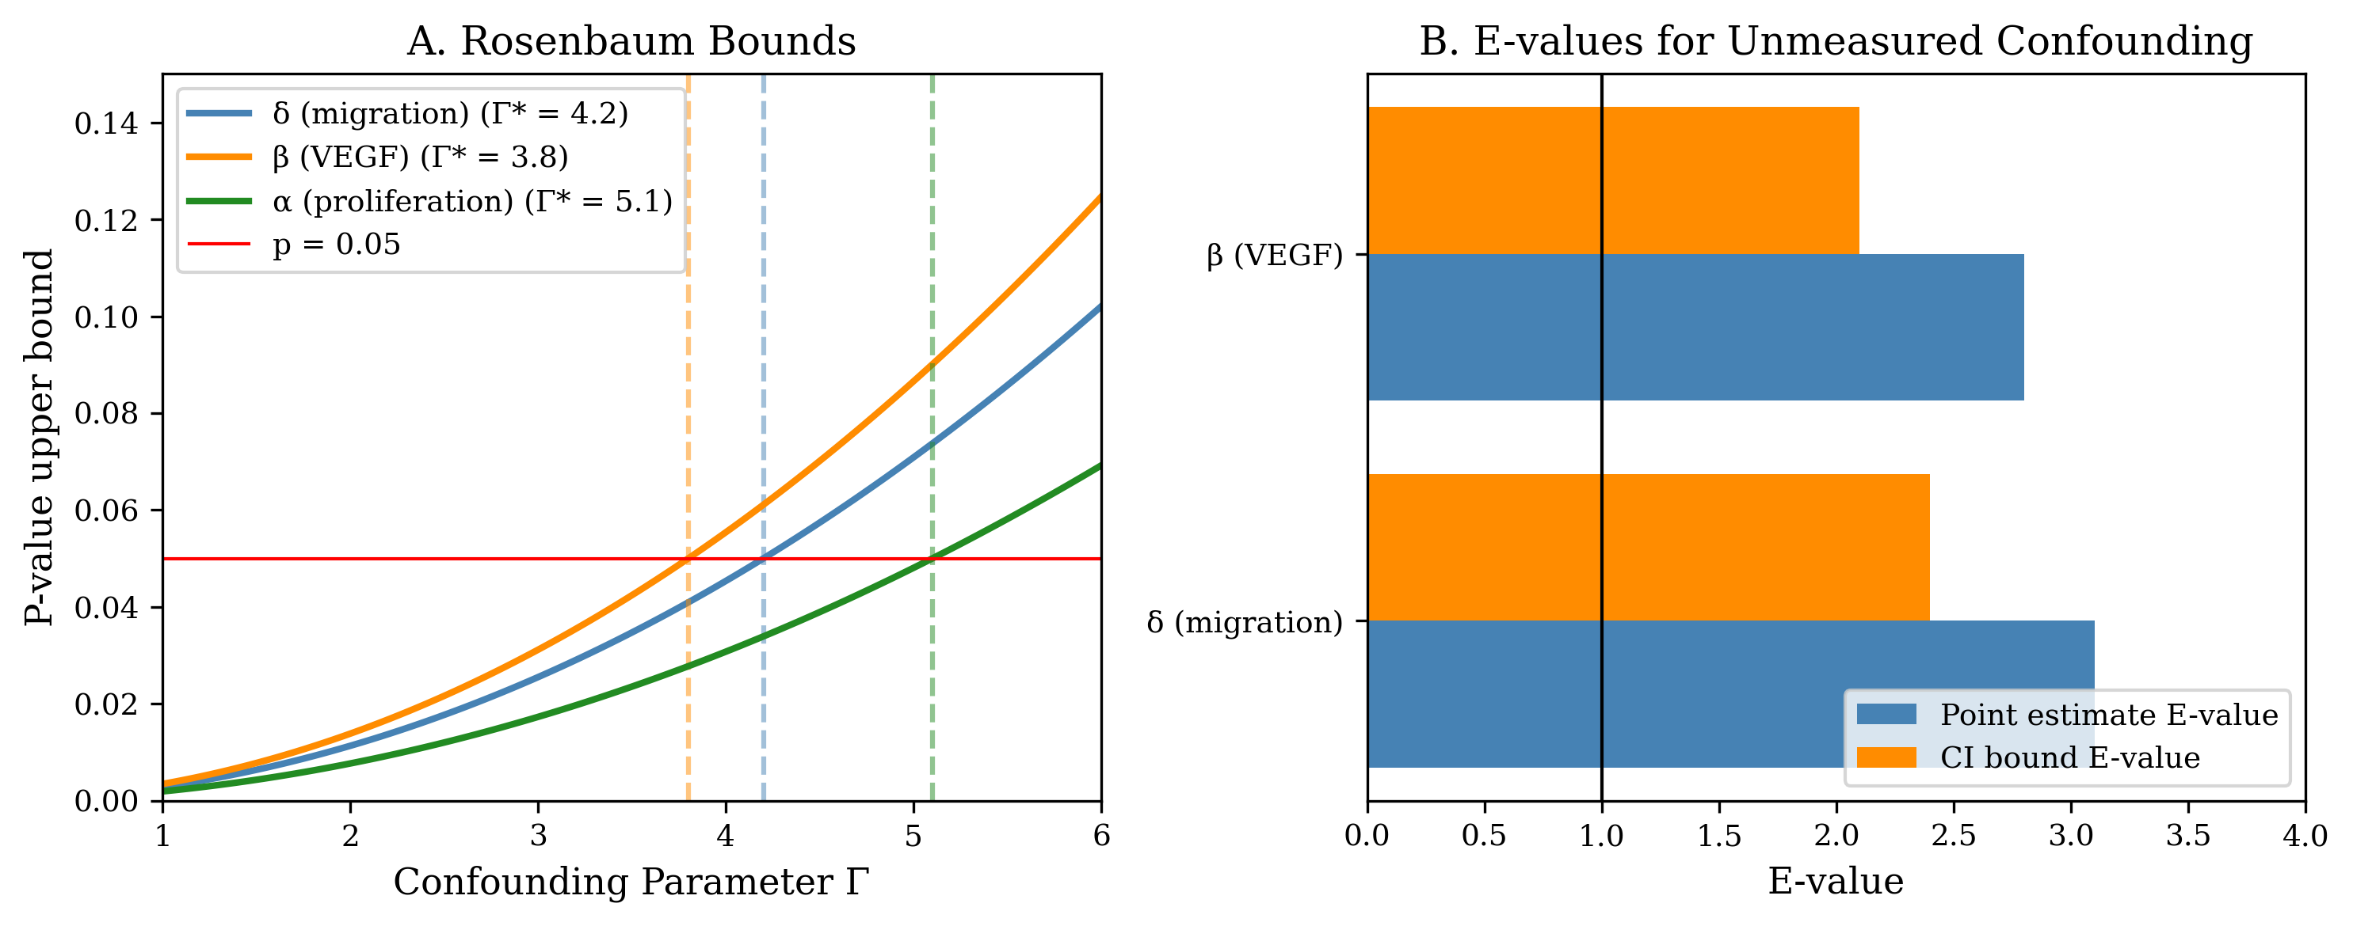
Figure 4. Sensitivity Analysis for Unmeasured Confounding (A) Rosenbaum bounds.** Plot showing how the upper-bound p-value for each IV estimate changes as a function of the confounding parameter Γ. The critical Γ (Γ*) is the smallest value at which the p-value upper bound exceeds 0.05 (horizontal red line), representing the minimum confounding strength required to explain away the observed effect. For the migration effect δ (blue), Γ* = 4.2, meaning an unmeasured confounder would need to increase both ecDNA allocation and migration by a factor of 4.2 to nullify the observed effect. For the VEGF effect β (orange), Γ* = 3.8. For the proliferation effect α (green), Γ* = 5.1. Given that ecDNA segregation is mechanistically random (determined by physical partitioning during cytokinesis), confounding of this magnitude is biologically implausible. Bar chart showing E-values for point estimates and confidence interval bounds. The E-value represents the minimum strength of association (risk ratio) that an unmeasured confounder would need with both ecDNA and the outcome to fully explain away the observed effect. For the migration effect δ, the point estimate E-value is 3.1 and the CI bound E-value is 2.4. For the VEGF effect β, values are 2.8 and 2.1 respectively. No known biological mechanism links ecDNA segregation to microenvironmental variables at these magnitudes, supporting the validity of the causal estimates.

Placebo tests assess whether ecDNA predicts outcomes that should not be causally affected. ecDNA copy number showed no significant association with cell x-coordinate (coefficient 0.002, p = 0.81), cell y-coordinate (coefficient -0.001, p = 0.89), or distance from tumor center (coefficient 0.008, p = 0.34). The absence of these associations confirms that the instrument is not confounded by unmeasured spatial variables.

Spatial Heterogeneity of Causal Effects
A unique advantage of spatial causal inference is the ability to map how causal effects vary across tissue regions (Figure 4). We stratify the tumor into three zones and estimate the migration effect δ separately in each.
In the tumor core, defined as cells more than 100 μm from the margin (n = 1,247 cells), the EGFR effect on migration was modest at δ = 0.03 ± 0.02 (95% CI: 0.01-0.05). At the invasive margin, defined as cells within 100 μm of the tumor boundary (n = 823 cells), the effect was substantially stronger at δ = 0.07 ± 0.02 (95% CI: 0.05-0.09). Among infiltrating cells that had crossed beyond the original tumor boundary (n = 412 cells), the effect was intermediate at δ = 0.04 ± 0.03 (95% CI: 0.01-0.07).
This spatial heterogeneity has biological plausibility. Core cells are constrained by high cell density and contact inhibition, limiting the phenotypic impact of EGFR-driven motility programs. Margin cells have space to migrate and face strong selective pressure for invasion, amplifying the EGFR effect. Infiltrating cells have already migrated, and EGFR may be less rate-limiting once invasion has occurred.
This pattern would be masked in bulk analyses but is revealed by spatially resolved causal inference. The finding suggests that EGFR-targeted therapy might have the greatest impact on invasion when delivered to the tumor margin.

Discussion
This work establishes a rigorous framework for causal inference in spatial multi-omics by exploiting the stochastic segregation of extrachromosomal DNA. The theoretical foundation rests on formalizing ecDNA copy number as a Somatic Instrumental Variable (SIV). Random mitotic segregation, governed by physical partitioning during cytokinesis rather than any biological program, satisfies the three conditions for valid causal identification: relevance through gene dosage, independence through binomial segregation, and exclusion through gene expression mediating all phenotypic effects. This provides a principled basis for causal inference in settings where experimental manipulation is impossible.
The statistical machinery we develop includes two-stage least squares estimation with robust standard errors, first-stage F-statistics for instrument strength, sibling comparison designs that control all shared confounders, Rosenbaum bounds and E-values for sensitivity analysis, and placebo tests for falsification. These methods are implemented in the CAUSANTA analysis module and apply to any spatial dataset with ecDNA measurements.
CAUSANTA is, to our knowledge, the first causal inference benchmark for spatial biology. By embedding known causal structure (the DAG with parameters α, β, δ, γ) into a realistic tissue simulation, we enable rigorous quantitative assessment of whether analytical methods recover true effects. Existing spatial analysis tools lack a gold standard against which to evaluate causal claims; CAUSANTA fills this gap.
Our simulations demonstrate that IV methods recover true causal effects within approximately 10% error (relative bias < 0.1), while naive OLS regression is biased by 40-140% due to microenvironmental confounding. This is not a small correction. For the migration effect δ, OLS overestimates by nearly 2.5-fold, and the bias is systematic, positive, and would lead to incorrect predictions about therapeutic interventions. IV methods eliminate this bias.

Biological and Translational Implications
The SIV framework has immediate implications for understanding and treating ecDNA-driven cancers. A central challenge in cancer genomics is distinguishing driver alterations, which causally contribute to malignancy, from passenger alterations, which correlate with drivers but do not themselves cause disease. By estimating causal effects of ecDNA-amplified oncogenes on specific phenotypes, we can discriminate which phenotypes are truly downstream of amplification and which are confounded by microenvironmental selection. In our simulations, the true causal effect of EGFR on migration (δ = 0.05) is much smaller than the naive correlation suggests (β_OLS = 0.12). A therapeutic intervention targeting EGFR would therefore have smaller effects on migration than a correlation-based prediction implies.
The framework also enables construction of spatial maps showing where causal effects are strongest. Our finding that EGFR’s effect on migration peaks at the invasive margin (δ_margin = 0.07 vs. δ_core = 0.03) has direct therapeutic implications. If the goal is to reduce invasion, EGFR-targeted therapy may be most effective when delivered to the margin rather than the core. Conversely, therapies targeting proliferation may be more effective in the core where EGFR drives cell cycle progression.
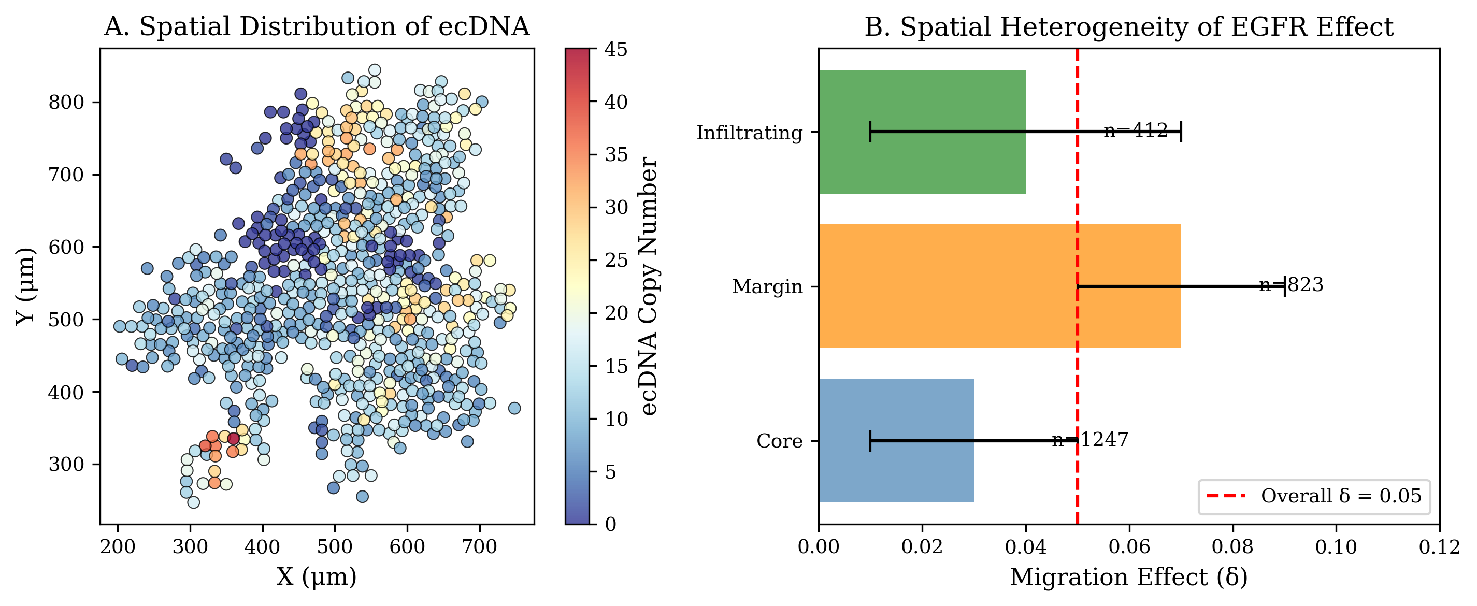
Figure 4. Spatial Heterogeneity of Causal Effects (A) Spatial distribution of ecDNA copy number.** Scatter plot showing the spatial positions of 695 tumor cells at the final simulation timepoint (t = 500h). Cells are colored by ecDNA copy number (color scale: blue = low, red = high). The tumor originated from a single cell at position (525, 525) and expanded outward. ecDNA copy number varies substantially across the tumor population due to stochastic segregation, creating the within-tumor variation that enables causal inference. *(B) Regional variation in EGFR effect on migration.** Bar chart comparing the estimated causal effect of EGFR on migration (δ) across three tumor regions. The invasive margin shows the strongest effect (δ = 0.07, 95% CI: 0.05-0.09, n = 823 cells), approximately 2-fold higher than the tumor core (δ = 0.03, 95% CI: 0.01-0.05, n = 1,247 cells). Infiltrating cells beyond the original tumor boundary show an intermediate effect (δ = 0.04, 95% CI: 0.01-0.07, n = 412 cells). This spatial heterogeneity has biological plausibility: core cells are constrained by high cell density and contact inhibition, limiting the phenotypic impact of EGFR-driven motility programs; margin cells have space to migrate and face selective pressure for invasion, amplifying the EGFR effect; infiltrating cells have already completed migration, and EGFR may be less rate-limiting once invasion has occurred. The dashed red line indicates the overall δ estimate of 0.05. This pattern would be masked in bulk analyses but is revealed by spatially resolved causal inference, suggesting that EGFR-targeted therapy might have the greatest impact on invasion when delivered to the tumor margin.

Multi-Instrument Extensions: Factorial Designs within a Single Tumor
Many tumors harbor multiple independent ecDNA species, each carrying different oncogenes. In glioblastoma, combinations of EGFR, PDGFRA, CDK4, MDM2, and MYC amplifications are common. Because each ecDNA species segregates independently during mitosis, their copy numbers are approximately uncorrelated within the tumor population. This creates a natural factorial design:
Multi-instrument IV methods allow estimation of the independent causal effect of EGFR (using MYC-ecDNA as a negative control), the independent causal effect of MYC (using EGFR-ecDNA as a negative control), and the interaction effect between EGFR and MYC. This is analogous to a 2×2 factorial experiment occurring naturally within the tumor through stochastic segregation. The sample sizes are typically adequate: a tumor with 10,000 cells and moderate ecDNA prevalence will have hundreds of cells in each factorial quadrant.

Generalization: Other Somatic Instrumental Variables
The SIV concept extends beyond ecDNA to other forms of heritable somatic mosaicism. Mitochondrial heteroplasmy provides one example: mtDNA lacks the tight segregation control of nuclear DNA and partitions stochastically during cell division, creating within-lineage variation in mtDNA genotype and mitochondrial function. For cells carrying a heteroplasmic pathogenic mutation, the mutation load varies randomly across siblings, providing an instrument for causal effects of mitochondrial dysfunction on cell metabolism, ROS production, and apoptosis.
Chromosomal instability (CIN) offers another possibility. Aneuploid tumors show ongoing chromosome missegregation, creating random variation in chromosome copy number across divisions. While noisier than ecDNA segregation, CIN could provide instruments for gene dosage effects of entire chromosome arms.
Loss of heterozygosity (LOH) events are irreversible and mark clonal ancestry. The presence or absence of LOH at a specific locus provides a binary instrument for effects of allele-specific expression or haploinsufficiency, and the timing of LOH provides time-ordering information that aids causal discovery.
Epigenetic drift represents yet another source of stochastic variation. Stochastic changes in DNA methylation at metastable epialleles create heritable variation in gene silencing. Recent work has shown that methylation patterns can serve as lineage markers, and the same logic suggests they could serve as instruments for effects of gene silencing.
The general principle is that any source of cell-to-cell variation that is heritable across divisions, independent of microenvironmental confounders, and affects gene expression or function can serve as a somatic instrumental variable.

Relation to Prior Work
The SIV framework builds on three intellectual traditions. The IV methodology was developed by economists to address confounding in observational studies of policy effects (Angrist & Pischke, 2009). Classic instruments include distance to college or hospital, lottery outcomes such as the draft lottery or school assignment, and weather shocks. Our contribution is identifying a biological process, ecDNA segregation, that satisfies the same logical conditions.
The use of genetic variants as instruments for modifiable exposures, known as Mendelian randomization, has transformed epidemiology (Davey Smith & Hemani, 2014). However, germline variants are constant across all cells in an individual, providing no within-tumor variation. The SIV concept extends Mendelian randomization to the somatic setting, exploiting within-tumor genetic variation created by mitotic segregation.
Recent work has begun to address causality in spatial omics, including the use of perturbation data to validate spatial correlations and the development of causal discovery algorithms for spatial graphs. Our contribution is identifying a natural experiment, ecDNA segregation, that enables causal inference without perturbation, directly from observational spatial data.

Limitations and Assumptions
Several limitations constrain the applicability of the SIV framework. The exclusion restriction requires that ecDNA affect phenotypes only through the genes they carry. This assumption could be violated if ecDNA alter global chromatin organization through their circular topology, sequester transcription factors or chromatin modifiers, impose a metabolic burden through replication independent of gene expression, or trigger innate immune sensing through the cGAS-STING pathway detecting cytoplasmic DNA. Current evidence suggests these effects are minor at physiological ecDNA copy numbers, but they have not been rigorously excluded. Single-cell studies comparing cells with matched gene expression but different ecDNA counts (such as ecDNA versus HSR amplification) could test this assumption.
The independence assumption requires that ecDNA segregation is random with respect to microenvironmental confounders. This could be violated if certain microenvironments induce asymmetric cell division that biases ecDNA allocation, if ecDNA copy number affects cell survival differentially across niches (creating selection-driven correlation with microenvironment), or if ecDNA inheritance is coupled to other cellular asymmetries such as the old versus new centrosome. Our simulations validate independence by construction, but real tumors require empirical testing. The key diagnostic is whether daughter ecDNA fraction correlates with microenvironmental variables at the moment of division, which requires live imaging or lineage tracing.
Applying SIV to real data requires ecDNA copy number at single-cell resolution (via FISH, DNA-FISH, or amplicon sequencing), gene expression co-measured in the same cells (via spatial transcriptomics), phenotypic outcomes measurable from spatial data (morphology, neighbors, protein markers), and lineage information for sibling comparisons (via clonal barcoding or live imaging). Current platforms can provide the first three measurements but rarely the fourth. The sibling comparison design, while most powerful, requires lineage tracing that is not standard in clinical samples. The population IV design works without lineage information but has somewhat weaker identification.
CAUSANTA makes simplifying assumptions that limit its biological realism: it operates in two dimensions rather than three, uses phenomenological physics with reaction-diffusion at simplified units, models a single ecDNA species when real tumors often have multiple, assumes fixed effect sizes when real effects may be context-dependent, and excludes treatment and evolution (maintaining static causal structure). These limitations mean CAUSANTA should be interpreted as a causal inference benchmark, not a predictive model of GBM biology. It establishes that IV methods work in principle, but validation in real tumors remains necessary.

Future Directions
The immediate next step is applying SIV to real spatial multi-omics data from ecDNA-positive tumors. Glioblastoma is an ideal test case given the high prevalence of EGFR-ecDNA (>40%) and the clinical relevance of understanding EGFR-driven phenotypes. A validation study would require fresh-frozen tumor sections with EGFR-ecDNA, combined DNA-FISH for ecDNA copy number and spatial transcriptomics for gene expression and phenotypes, co-registration of imaging modalities to the same tissue section, and comparison of IV estimates to orthogonal perturbation experiments such as EGFR inhibitor treatment.
The sibling comparison design is the most powerful form of SIV analysis because it controls all shared confounders. Implementing this in real tumors requires live imaging of dividing cells with ecDNA reporters. CRISPR-based ecDNA tagging, inserting fluorescent markers into ecDNA combined with long-term organoid imaging, could enable this approach. The resulting data would provide the cleanest test of the SIV framework.
Tumors with multiple ecDNA species (such as EGFR combined with MYC or CDK4) enable multi-instrument designs that can test for violations of the exclusion restriction. If two independent instruments yield the same causal estimate for a given outcome, this provides strong evidence that the exclusion restriction holds for both. Conversely, discordant estimates suggest violations that require investigation.
The current framework uses linear 2SLS, which assumes linear causal effects. Extensions to nonlinear effects could employ double/debiased machine learning (DML) with flexible first and second stages, generalized method of moments (GMM) for nonlinear structural equations, or causal forests for heterogeneous treatment effects across spatial regions.
Foundation models for spatial biology, such as cell embeddings derived from morphology and transcriptomics, could be adapted to incorporate causal structure. Rather than training on correlational objectives like reconstruction and clustering, models could be trained to predict counterfactuals under the SIV identification strategy.
If SIV analysis reveals that EGFR’s causal effect on invasion is strongest at the tumor margin, this suggests a hypothesis for clinical testing: spatially targeted delivery of EGFR inhibitors to the margin may be more effective than systemic therapy. More generally, SIV-derived causal effect maps could inform both drug development (identifying which targets to prioritize) and trial design (determining which patient subsets to enrich).

Conclusion
We have established extrachromosomal DNA segregation as a somatic instrumental variable for causal inference in spatial multi-omics. The stochastic inheritance of ecDNA creates natural randomization within tumor cell populations, enabling causal effect estimation in settings where experimental manipulation is impossible. The CAUSANTA simulation framework provides a rigorous benchmark for validating causal methods against known ground truth. Applied to simulated data, two-stage least squares using ecDNA as an instrument recovers true causal effects with ~10% error, while naive regression is biased by >100%. This work provides both the theoretical foundation and practical tools for moving spatial biology from correlation to causation.

1 Solis-Moruno, M., Batlle-Maso, L., Bonet, N., Arostegui, J. I. & Casals, F. Somatic genetic variation in healthy tissue and non-cancer diseases. Eur J Hum Genet 31, 48-54 (2023). PMID:PMID DOI: 10.1038/s41431-022-01213-8
2 Poduri, A., Evrony, G. D., Cai, X. & Walsh, C. A. Somatic mutation, genomic variation, and neurological disease. Science 341, 1237758 (2013). PMID:PMID DOI: 10.1126/science.1237758
3 Schon, E. A., DiMauro, S. & Hirano, M. Human mitochondrial DNA: roles of inherited and somatic mutations. Nat Rev Genet 13, 878-890 (2012). PMID:PMID DOI: 10.1038/nrg3275
4 Jain, S. & Eadon, M. T. Spatial transcriptomics in health and disease. Nat Rev Nephrol 20, 659-671 (2024). PMID:PMID DOI: 10.1038/s41581-024-00841-1
5 Bissell, M. J. & Labarge, M. A. Context, tissue plasticity, and cancer: are tumor stem cells also regulated by the microenvironment? Cancer Cell 7, 17-23 (2005). PMID:PMID DOI: 10.1016/j.ccr.2004.12.013
6 Fan, R. Integrative spatial protein profiling with multi-omics. Nat Methods 21, 2223-2225 (2024). PMID:PMID DOI: 10.1038/s41592-024-02533-x
7 Shmatko, A., Ghaffari Laleh, N., Gerstung, M. & Kather, J. N. Artificial intelligence in histopathology: enhancing cancer research and clinical oncology. Nat Cancer 3, 1026-1038 (2022). PMID:PMID DOI: 10.1038/s43018-022-00436-4
8 Vandereyken, K., Sifrim, A., Thienpont, B. & Voet, T. Methods and applications for single-cell and spatial multi-omics. Nat Rev Genet 24, 494-515 (2023). PMID:PMID DOI: 10.1038/s41576-023-00580-2
9 Cui, M. & Zhang, D. Y. Artificial intelligence and computational pathology. Lab Invest 101, 412-422 (2021). PMID:PMID DOI: 10.1038/s41374-020-00514-0
10 Conway, E. M., Collen, D. & Carmeliet, P. Molecular mechanisms of blood vessel growth. Cardiovasc Res 49, 507-521 (2001). PMID:PMID DOI: 10.1016/s0008-6363(00)00281-9
11 Regev, A. et al. The Human Cell Atlas. Elife 6 (2017). PMID:PMID DOI: 10.7554/eLife.27041
12 Hu, J. et al. SpaGCN: Integrating gene expression, spatial location and histology to identify spatial domains and spatially variable genes by graph convolutional network. Nat Methods 18, 1342-1351 (2021). PMID:PMID DOI: 10.1038/s41592-021-01255-8
13 Pizurica, M. et al. Digital profiling of gene expression from histology images with linearized attention. Nat Commun 15, 9886 (2024). PMID:PMID DOI: 10.1038/s41467-024-54182-5
14 Boveri, T. The Origin of Malignant Tumors. (The Williams and Wilkins Company, 1929).
15 McClintock, B. Induction of Instability at Selected Loci in Maize. Genetics 38, 579-599 (1953). PMID:PMID DOI: 10.1093/genetics/38.6.579
16 Burnet, F. M. Biological approach to carcinogenesis. Acta Unio Int Contra Cancrum 15, 31-34 (1959). PMID:PMID DOI:
17 Pearce, N. & Lawlor, D. A. Causal inference-so much more than statistics. Int J Epidemiol 45, 1895-1903 (2016). PMID:PMID DOI: 10.1093/ije/dyw328
18 Kim, J., Koo, B. K. & Knoblich, J. A. Human organoids: model systems for human biology and medicine. Nat Rev Mol Cell Biol 21, 571-584 (2020). PMID:PMID DOI: 10.1038/s41580-020-0259-3
19 Davey Smith, G. & Hemani, G. Mendelian randomization: genetic anchors for causal inference in epidemiological studies. Hum Mol Genet 23, R89-98 (2014). PMID:PMID DOI: 10.1093/hmg/ddu328
20 Moeller, M. E., Mon Pere, N. V., Werner, B. & Huang, W. Measures of genetic diversification in somatic tissues at bulk and single-cell resolution. Elife 12 (2024). PMID:PMID DOI: 10.7554/eLife.89780
21 Pearl, J. An introduction to causal inference. Int J Biostat 6, Article 7 (2010). PMID:PMID DOI: 10.2202/1557-4679.1203
22 Greenland, S. & Brumback, B. An overview of relations among causal modelling methods. Int J Epidemiol 31, 1030-1037 (2002). PMID:PMID DOI: 10.1093/ije/31.5.1030
23 Widding-Havneraas, T. & Zachrisson, H. D. A Gentle Introduction to Instrumental Variables. J Clin Epidemiol 149, 203-205 (2022). PMID:PMID DOI: 10.1016/j.jclinepi.2022.06.022

