CHANGING HOME LOCATION
Log into Verso with your UN & PW
- Open the Circulation menu>Patron status & Checkout

lpron COL..J(lty .Public library , Dye--sburg State
Community College
V •


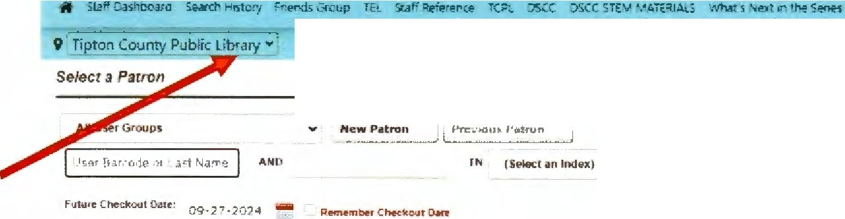
% CJ;culabof\ ,. P.11tlon St tu:i & Checkout
18
0
Submit

0
- Click the dropdown menu where it says DSCC Library

,I ...

Stau Dashboa c Searer 1-:istory nerds Group •

9i Tipton County Public Library..,; % Circulat1
S,Not Assigned
_ DSCC Jimmy Na feh Center. Covington_
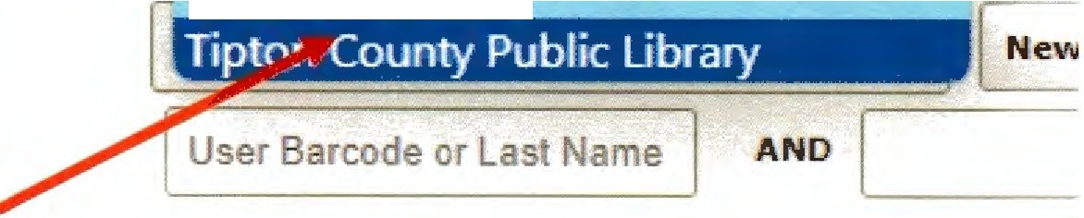
OSCC. Dyers urg

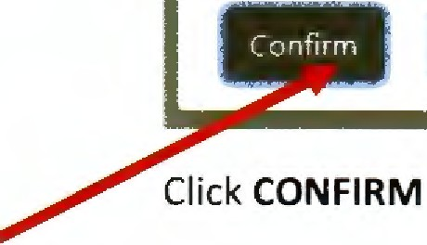
Click Tipton County Public Library
Confirmation

You are changing your home location from Tipton County
P blic Library to DSC Jimmy Naifeh Center Covington
-

