Downtown Roles Guide

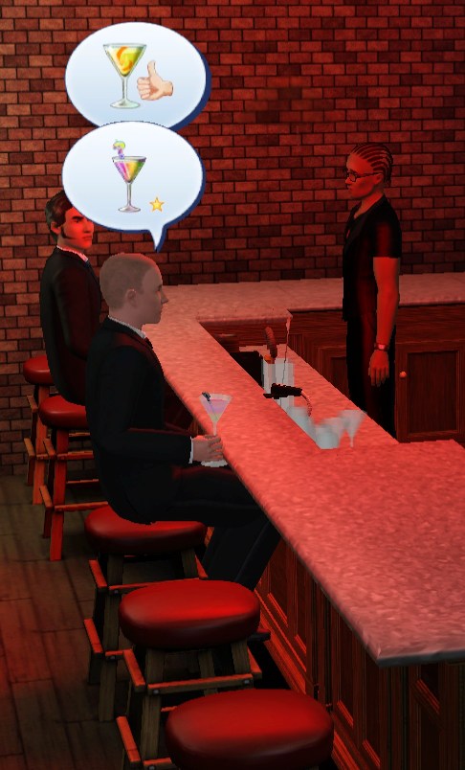A Tippler in a bar
This guide helps you get most out of the Downtown Roles and teaches you how to customize them.

Contents

Installation 1
Recommended Mods 1
The Roles 2
Tippler's Bottle - Tippler/Hang Around 2
Dancer's Stage - Dancer/Exotic Dancer 2
Courtesan's Perfume - Courtesan/Mistress 2
Activating The Role 3
Assigning a Sim to a Role (NRaas Register) 4
Customizing the Sim in Role (NRaas Master Controller) 6
Tips 8
Troubleshooting 8
Uninstallation 8

Installation

Put the .package file(s) to "My Documents\Electronic Arts\The Sims 3\Mods\Packages\" folder.
I also recommend CC Magic (http://www.modthesims.info/d/461888) as it merges .package files similarly than game manages them and your game does not slow down if you have a lot of custom content.

Recommended Mods

While you can play with just Downtown Roles, it is much more fun if you can select which sim will be assigned to which role and change their looks to match the roles. To do that you need following mods:

- NRaas MasterController (http://nraas.wikispaces.com/MasterController) for changing the clothes
- NRaas Register (http://nraas.wikispaces.com/Register) for assigning the roles to sims

The Roles

Tippler's Bottle - Tippler/Hang Around
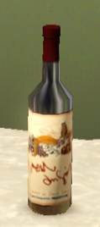Tippler's Bottle

Tippler's Bottle will give you two roles in one. Use the tuning dialog to select whether you want a tippler who will spend most of the night drinking or just a bar regular who likes to be there and socializes more than drinks. Default role is the tippler.

Tippler orders his drinks from the professional bar just like other people in the bar, so make sure there is a bar in the lot. As ordering the drinks from bar takes quite a long time, you don't want many Tipplers in one bar - if you want any drinks yourself, that is!

Tippler's Bottle will also work in other community lots too.

Dancer's Stage - Dancer/Exotic Dancer

(This role will be available later)
Dancer's Stage will give you two roles too, a regular dancer and an exotic dancer. Default role is a regular dancer. Use the tuning dialogs to select clothing and showtimes for the dancer. You can also set showtimes and show duration.

If you want a realistic Exotic Dancer, you'll also want to download some
NoMosaic mod like NRaas Decensor (http://nraas.wikispaces.com/Decensor) and
skintones that do not look funny when the sim is naked. Try for example these skintones in Club Crimsyn (http://club-crimsyn.dreamwidth.org/tag/skintone). Another option is to use LiliSims Nude Top (http://www.lilisims.com/sims3_html/sims3_female_html/sims3_female_adult_html/sims3_female_adult_page_5.html) as sims' sleepwear.

Courtesan's Perfume - Courtesan/Mistress
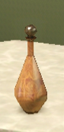
Courtesan's Perfume will give you the world's oldest role. Use the tuning dialog to select working times for the courtesan. If you want a mistress to come to your home lot, you'll have to first activate the role and then take your sim to the lot where the courtesan works. There you can click the role giving object and take the courtesan home as your mistress.

Courtesan's Perfume must be placed in a community lot that has a bed, or the sims have no place to woohoo in

These similar mods should be compatible with this one:
Ani's Working Sims Bed from MTS (http://www.modthesims.info/d/395024) and
NRaas Woohooer (http://nraas.wikispaces.com/Woohooer)

Activating The Role

To activate a Downtown Role, you must place a role giving object to a community lot.

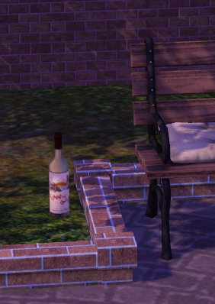Tippler's Bottle in the Central Park
While you are still in Build/Buy mode CTRL+SHIFT-click the object and you can access tuning dialogs. In tuning dialogs you can define the role sim behaviour.

Assigning a Sim to a Role (NRaas Register)

Go to the play mode and take your sim to the lot where the role giving object is. Click it to open NRaas menu and select "Register..."

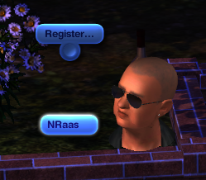Click -> NRaas -> Register...

Now you can see two menus. If a role sim is already assigned, you'll have an option to remove him from the role. And you have an option to "Select" new sim for the role. Click "Select".

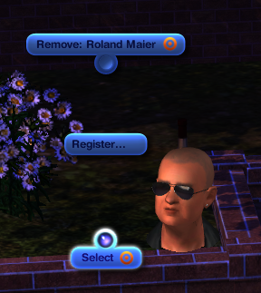Register... -> Select

A new dialog opens, and this time you can choose which group of sims you want to pick the role sim from. In the first version it is safest to pick from residents, but other should be ok too. Select the group that you think the sim you want to assign for the role will be.

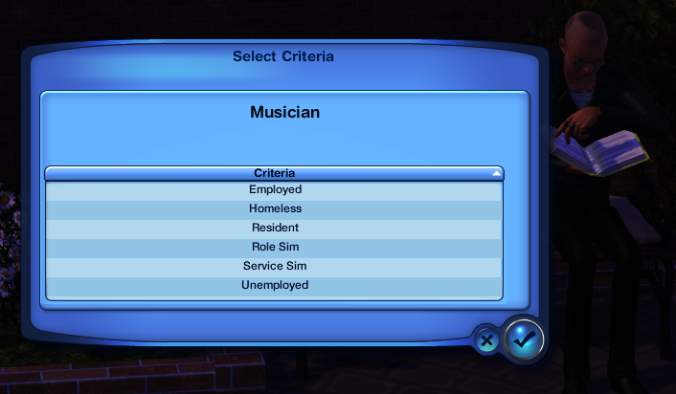Select -> Residents

Yet another dialog opens, and now you finally can see the sims to select from. Pick the sim that you want in this role.

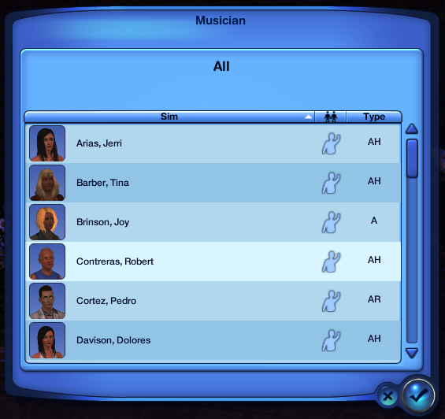Pick a "Musician"

If everything went ok, you'll soon see a message on the upper right corner telling that a "Musician" was selected for the role.

Customizing the Sim in Role (NRaas Master Controller)

Your role sim arrives, but s/he does not look like you wished for:
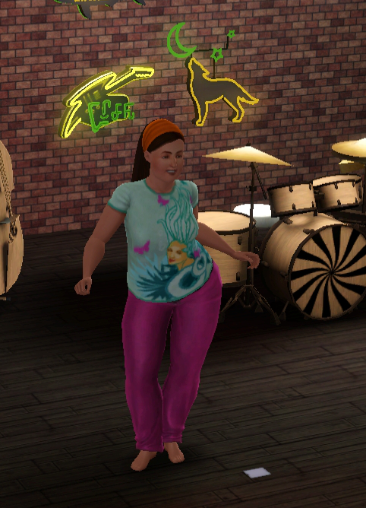Well, this is not exactly the "sleepwear"I thought you would dance in!
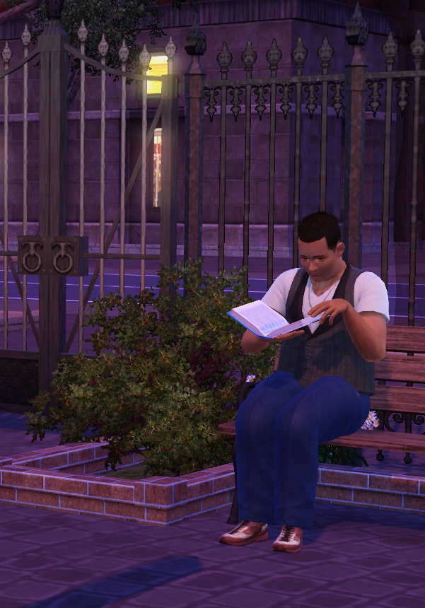If I would live in the park,would my clothes be this neat?
Let's give the man in the park a good makeover. Go to the play mode and take your sim to the lot where the role giving object is. Click it to open NRaas menu and select "Master Controller". The Master Controller dialog opens, select "Advanced".

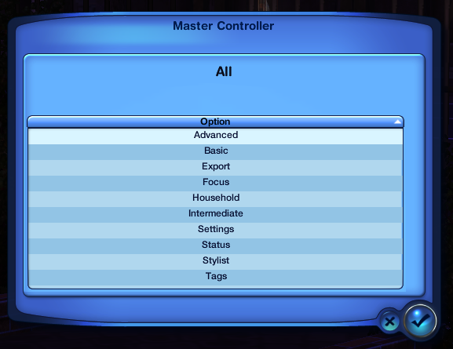Master Controller -> Advanced

Advanced dialog opens. Select "Edit in CAS".

Now Create A Sim view opens and you can change your role sim as you wish. Here is our man after the makeover.
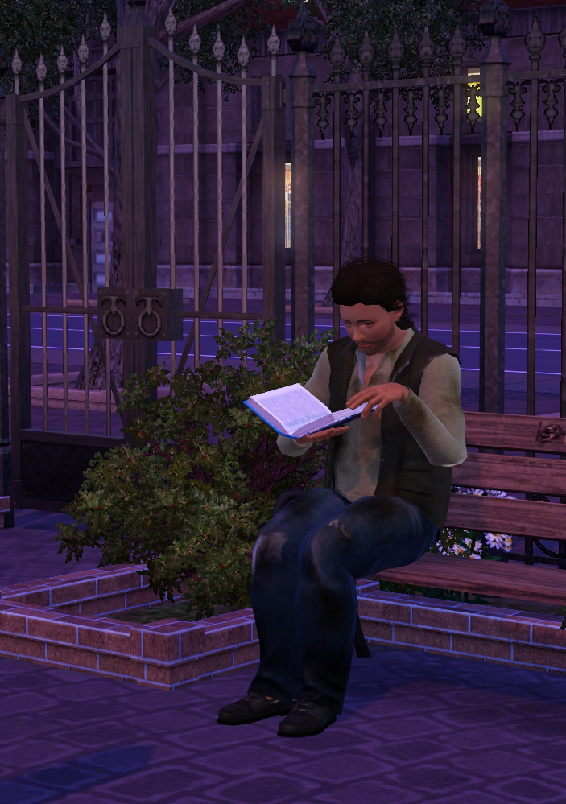Well that's more like it! I like the new hair too.

Tips

- If you are trying to change the clothes of the dancer and s/he is wearing an uniform as part of her show, you'll need to go into Create A Sim view while she is dancing in the uniform
- Give meaningful working times for your role sims - they cannot go home even if they would be tired or hungry
- Don't try putting the role giving object into sim's home lot, it will not work there
- You can access role tuning dialogs also in play mode, but the role will reset when you do that. The role sim will not change, but the sim role behaviour may be strange until the next day
- The role times are not exact, they are just the times when sim starts to *think* about doing the role tasks
- If you don't have NRaas Register, a new role sim will be selected each time you enter Build&Buy mode in that community lot. This is how EA has implemented the roles.

Troubleshooting

PROBLEM: The sim in role never appears

Place a piano to one of your bars and play enought to see if the pianist appears.

If the pianist appears, then there is some problem in Downtown Roles -> Report to the MTS testing thread

If the pianist does not appear, the problem is more generic, check the following:
- There is a maximum number for sims in certain role. If that is up, game will not create new role sims. Use NRaas Register to view/change that number (game thinks these role sims are Pianists, so that is the number to check)
- Are there empty houses for the new townie to move in?

Uninstallation

I did not find any harm happening to my test games even when I just removed the mod without any precautions. However, to be sure, it is better to follow the instructions below.

Remove the role giving object from your community lots and play 1-2 simdays. After that all role data should be cleaned up and you can remove the mod.

If you have NRaas Register you can uninstall faster. Just remove the sim from its role and immediately remove the role giving object.

