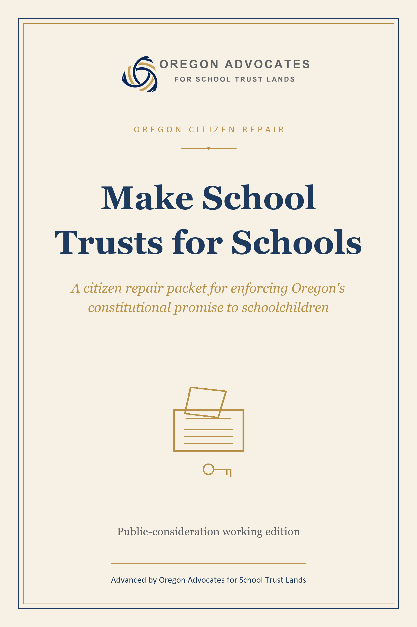

PUBLIC CONSIDERATION DRAFT
Make School Trusts for Schools
A citizen repair packet for enforcing Oregon's constitutional promise to schoolchildren
Advanced by Oregon Advocates for School Trust Lands

Working edition
For public consideration and discussion. Not legal advice. Not filing-ready initiative text. No signature collection is authorized by this booklet.

June 8, 2026
America's School Trust Library supplies the broader research family; Oregon Advocates for School Trust Lands advances this Oregon repair proposal.

The public question
If ordinary institutions will not repair the school-trust enforcement gap, citizens should be ready to say it themselves: make school trusts for schools.

This booklet is not a campaign launch. It is the public working draft of a restrained democratic repair: the trust must be visible, beneficiaries must be able to enforce it, diversions must stop, and courts must have remedies that can restore value to the trust.

Related working documents
These links are for reviewers moving through the packet. The local document links open companion files in this folder; the website link points to the OASTL public home when that domain is active.
- Oregon Advocates for School Trust Lands
- Model Statutory Initiative
- Model Constitutional Amendment
- Section-by-Section Explainer
- Counsel Review Issues
- Coalition One-Pagers
- Source Map
- A Law That Says Nothing New / UPTEA public guide
- America's School Trust Library

Where this booklet fits
This booklet is advanced by Oregon Advocates for School Trust Lands (OASTL). It belongs to the same family as A Law That Says Nothing New, the public guide to the Uniform Public Trust Enforcement Act, but the institutional lead here is OASTL: the Oregon organization asking an Oregon citizen question.
America's School Trust Library supplies the broader record and research family. This booklet translates the national repair idea into a local democratic question:
A school trust is land, money, or another public asset that a state holds for the benefit of public schools and students. Oregon's version of that promise is local enough for citizens to understand and important enough for them to defend.
If courts and legislatures do not repair the school-trust enforcement gap, should Oregon citizens be ready to do it themselves?
The answer offered here is yes, with restraint. Do not ballot the whole national model law. Do not turn trust repair into private damages claims. Do not ask voters to manage forests from the ballot box. Ask for the democratic minimum: the trust must be visible, beneficiaries must be able to enforce it, diversions must stop, and courts must have tools that can restore value to the trust.

The promise
When Oregon became a state in 1859, Congress granted lands for the use of schools. Oregon accepted that bargain. Oregon's Constitution then built the Common School Fund and the State Land Board around the promise.
In plain language, Oregon does not hold those lands and funds as ordinary property. It holds them for schools and schoolchildren, which means officials who manage the property are not simply program managers. They are trusted to manage a public promise for the people it is supposed to benefit.
Most Oregonians were never taught this. They know school budgets rise and fall. They know classrooms need teachers, librarians, buildings, and books. They do not usually know that Oregon also carries a statehood trust for public schools, or that the trust is supposed to last across generations.
The first repair is visibility.

The enforcement gap
A promise can be real on paper and still fail in practice if the machinery around it is weak.
The school-trust enforcement gap has several parts:
- citizens and school beneficiaries may not receive a complete account of the trust;
- beneficiaries may have to fight just to prove they can get into court;
- the State's ordinary lawyers may defend the trustee while no independent lawyer speaks for the trust;
- trust assets may be sold, exchanged, leased, or transferred without enough market discipline;
- trust income may be treated as a substitute for other school obligations;
- courts may lack clear authority to order useful trust-law fixes: complete accounts, restoration of lost value, tools to follow diverted money, and orders that return value to the trust.
No one of these defects has to destroy a trust. Together, they make drift normal. A trust fails quietly when no one can see the books, no one can enforce the duty, and no court order can put value back where it belongs.

Why democratic repair is legitimate
Oregon has an initiative and referendum tradition for a reason. The Oregon System was built so that citizens could propose laws, change the Constitution, or reject laws passed by the Legislature when ordinary institutions failed to act.
As of June 8, 2026, Oregon's official statewide initiative process begins with chief petitioners filing the required state form with the Elections Division. For an initiative, after 1,000 sponsorship signatures are gathered and submitted, the text goes to the Attorney General for a ballot title. Current statewide thresholds for the 2024 and 2026 cycles are 117,173 valid signatures for a statutory initiative and 156,231 for a constitutional initiative, based on the 2022 governor vote. Initiative signatures must be submitted no later than four months before the next regular general election. Those process details must be rechecked before any filing.
This booklet does not start signature collection. It asks Oregon citizens to consider the repair before crisis timing forces a rushed draft.

The citizen minimum
The repair should be narrow enough to explain on a doorstep and strong enough to matter in court.
It should do six things.
- Name the trust. Oregon's school lands, Common School Fund, proceeds, income, records, and claims are school trust property.
- Name the duties. Officials who control school trust property owe duties of loyalty, care, fairness between present and future beneficiaries, accounting, fair-value disposition, and faithful administration.
- Open the books. The State must publish a complete annual public accounting that shows lands, money, revenues, expenses, transfers, distributions, dispositions, debts, claims, and unresolved disputes in a form citizens can read and researchers can analyze.
- Open the courthouse. School districts, beneficiary institutions, students through parents or guardians, appropriate member organizations, and future-beneficiary representatives must be able to enforce the trust for the trust's benefit.
- Stop quiet diversion. School trust property must not be treated as unrestricted state revenue, moved to non-school purposes, or used to substitute for another school-funding duty without clear authority consistent with the trust.
- Give courts usable fixes. Courts must be able to order complete accounts, stop unlawful conduct, declare rights, restore lost value, follow diverted money, appoint special help, and condition or undo improper transactions when existing law allows it. Recoveries belong to the trust, not private plaintiffs.
That is the democratic minimum.

What the proposal does not do
It does not award private damages to parents or students. It does not put judges in charge of day-to-day land management. It does not forbid conservation, restoration, public access, or long-term stewardship when the trust is fairly compensated and duties of loyalty and care are honored. It does not decide any live lawsuit. It does not accuse a named person of wrongdoing in ballot text. It does not commit any lawyer, scholar, board member, organization, or reviewer.
It asks for something simpler and harder to oppose:
Make school trusts for schools.

Statutory repair or constitutional repair?
There are two possible routes.
The statutory route is narrower and easier to amend. It can define trust property, require public accounting, give school beneficiaries a right to get into court, create transaction safeguards, address conflicts, and authorize trust-law fixes. A statutory initiative should be the first model if Oregon lawyers think it can survive ordinary legal attack.
The constitutional route is stronger if statutory repair is too vulnerable. It should stay short. It should name the trust, name the duties of loyalty and care, forbid diversion and substitution, require the Legislature to implement public accounting and a right to sue, and confirm that courts can give trust-law fixes. The detailed machinery should remain in implementing statutes.
The public does not need to choose the final route today. The public does need to see the repair clearly enough to know what is at stake.

Why this belongs in public now
Waiting for perfect legal text before the public sees the idea reverses the civic order. Lawyers can refine language. Courts can test clauses. Ballot-title lawyers can tighten captions. But the public first has to understand that there is a school-trust promise and that an enforcement gap can be repaired.
The question for Oregon is not whether one draft is final. No draft in this packet is final. The question is whether citizens are willing to say that school trusts should be visible, enforceable, and used for schools.
Public consideration can begin now. Signature collection can wait.

What reviewers should ask
- Does the repair stay narrow enough for ordinary voters to understand?
- Does it avoid trying to enact the full national model law by ballot?
- Does it preserve the no-new-duty point: the duties already exist; the measure supplies machinery?
- Does it protect the trust without creating private damages?
- Does it give school districts and students a real enforcement path?
- Does it prevent budget substitution and quiet diversion without freezing legitimate management?
- Does the statutory route look strong enough, or should the constitutional fallback lead?
- What must Oregon lawyers revise before filing?

The first public sentence
Oregon accepted land and money for its schoolchildren. If the promise is real, the public should be able to see the accounts, beneficiaries should be able to enforce the duty, trust assets should not be quietly diverted or substituted, and courts should be able to restore value to the trust. If ordinary institutions will not repair that enforcement gap, citizens should be ready to say it themselves: make school trusts for schools.

Source note
This booklet relies on official Oregon initiative-process sources, the Oregon Admission Act, Oregon Constitution Article VIII, Oregon school-trust statutes and public agency sources, and internal drafting materials from the school-trust reform project. Process statements are dated June 8, 2026 and must be rechecked before any filing. Project work product is a drafting source, not legal authority; external legal claims should cite the underlying official or primary source.

