THE REBIRTH OF AMERICA'S SCHOOL TRUSTS
A roles-and-roadmap brief for making school trusts visible, enforceable, and worth fighting for
Prepared for: Friends, close reviewers, OASTL colleagues, lawsuit partners, lawyers, and future national partners
Prepared by: Dave Sullivan, with AI-agent drafting and source support
Date: June 9, 2026
Status: Public working draft. Not legal advice. Not approved by any organization. No person or institution is committed by this draft.
Objective: Make school trusts visible, enforceable, and worth fighting for. This brief explains the institutional roles, Oregon-first path, publication family, proposed public websites, stable book links, and decisions needed before the work is carried outward.

The Objective
The objective is to change how America understands and enforces school trusts.
A school trust is land, money, or another public asset a state holds for the benefit of public schools and students. Today, those trusts are too often treated as obscure land-office assets, old constitutional leftovers, or school-funding footnotes. They should instead be understood as legal promises requiring public officials to manage school assets for schools and students, not for unrelated public purposes. Those promises should be visible enough for citizens to see, concrete enough for lawyers to enforce, disciplined enough for public officials to administer, and public enough for parents, students, librarians, PTAs, journalists, legislators, and school boards to defend.
That is the rebirth this proposal is about. It is not merely a publication program, a litigation support project, or a website. It is an effort to make school trusts visible, enforceable, and worth fighting for.

Why A Neutral Record Institution Is Essential
A rebirth cannot be built on enthusiasm alone. People will not join a legal, civic, and political effort if every claim sounds like advocacy or every number must be taken on faith. They need a place where the record can be checked.
That is why the rebirth needs a neutral national record institution: a place that gathers primary sources, verifies claims, keeps figures and citations straight, publishes corrections, preserves open drafts with visible status, and gives contributors durable public credit for careful work.
That institution is what America's School Trust Library should become. In ordinary language, the Library is the public record desk for this school-trust repair effort. It is where a lawyer can find authorities, a parent can find the promise, a librarian can find linked source materials, a legislator can find the model-law materials, a trustee can find practice standards, and a witness in another state can bring a documented account that someone else can check.
Once the objective is clear, the institutional roles become easier to sort: the Library keeps the neutral record; Oregon Advocates for School Trust Lands (OASTL) proves the enforcement path in Oregon; Advocates for School Trust Lands (ASTL), the national advocacy organization, helps the proof travel nationally when the time is right.

The Model Enforcement Act
The legal repair instrument in this proposal is a proposed model state law for making existing school-trust fiduciary duties enforceable. Its working title is the Uniform Public Trust Enforcement Act. After the idea and title are clear, the shorthand is UPTEA.
It does not ask Oregon, or any other state, to invent new trust duties. It asks the state to supply the missing machinery for duties that already exist: who is allowed to go to court, what financial records the state must show, how conflicts of interest are handled, what fixes a judge can order, and how public officials learn and review the duties they hold.
A 'uniform act' is a model law written so states can adopt similar rules while still making state-specific choices. A uniform act does not become law by itself. A legislature has to enact it, or citizens may need to propose a state-law version through the tools their state constitution provides.
That is why the declaratory-judgment comparison needs a bridge. Oregon Revised Statutes Chapter 28 is a state law about court process. It lets a judge say what legal rights and duties exist, even when no one is asking for money damages. That chapter may be cited as the Uniform Declaratory Judgments Act. The analogy is not that school trusts and declaratory judgments are the same field. The analogy is procedural: a state can adopt a uniform procedural act that gives courts a practical way to enforce legal rights that already exist.
UPTEA is the proposed school-trust version of that kind of repair. It would make fiduciary duties visible in court and in public records instead of leaving everyone to agree in principle while assuming enforcement is too difficult to attempt.

How This Work Reached The Table
For about six weeks I worked largely in solitary, with important feedback from Margaret, Tonia Day, Bob, Laura, and others. That was not because the work belongs to one person. It was because daily breathless updates would have asked people to react before the pattern was visible.
The work was not merely drafting. It was an editing-and-building process: gather sources, test claims, send AI agents into specific research and writing tasks, compare what came back, correct it, build the next prototype, and repeat. Last year that process would mostly have produced mock-ups. This year, because the agents could return strong source-aware work, the prototypes began to look like real products: book drafts, covers, websites, a legal reference manual for school-trust law, a model-law packet, a citizen-repair booklet, a verification method, an open-draft Writing Room where unfinished work can be checked, and contributor roles.
That makes the next step more delicate, not less. Finished-looking objects can accidentally imply that institutional decisions have already been made. They have not. The build phase has reached the point where it is now useful to ask how OASTL, ASTL, and the Library should relate to one another, what each should publish, and how this work should be governed before it is carried outward.

The Relationship Map
The cleanest operating map has three institutional lanes.
In shorthand: the Library keeps the record. OASTL tests the Oregon path. ASTL helps the proof travel.
The Library should be a separate national record institution, likely its own charitable nonprofit after lawyers and a board decide the right structure. It should not be folded into OASTL or ASTL because its credibility depends on neutral sourcekeeping, verification, corrections, research, and durable public credit.
OASTL should be the Oregon public-demonstration partner: the organization helping Oregon become the first state where the repair is tested in public. It carries Oregon lawsuits, public accountability work, the Oregon model-enforcement-act path, voter-facing repair materials, coordination among the board and lawsuit participants, and the Oregon story. OASTL is the Library's first partner, not the Library's owner.
ASTL should be the national advocates and coalition lane. It can convene state allies, partner organizations, and later replication efforts after Oregon demonstrates that enforceability can be made real. ASTL should not have to absorb the Library to use the Library's record.
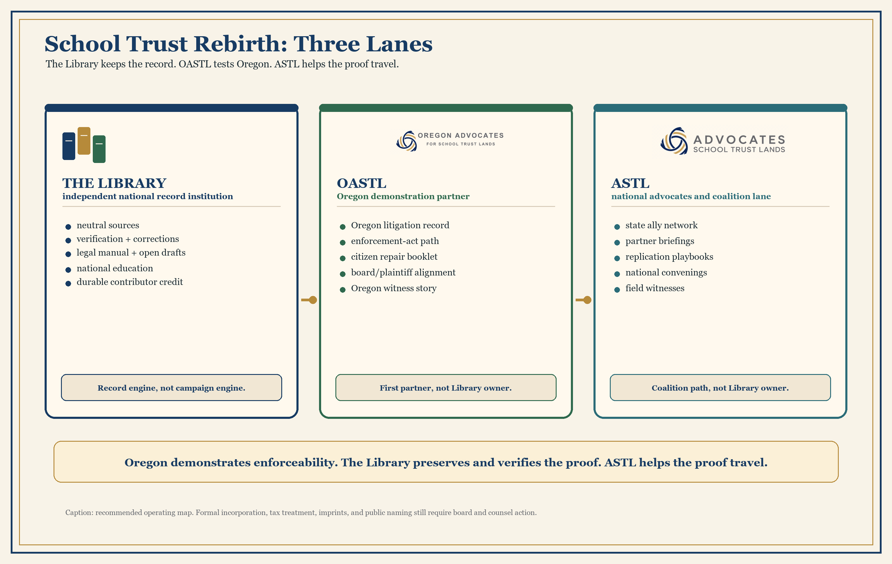
School Trust Rebirth roles map

What Each Institution Carries
The Library keeps the record and publishes neutral research, educational materials, the school-trust legal reference manual, state appendices, the open-draft Writing Room, the Dispatches witness series, corrections, and contributor credit. Its sentence is: the record can be checked here.
OASTL carries the Oregon public-demonstration campaign. Its sentence is: Oregon will be the first state to prove that school-trust enforcement can be made visible, lawful, public, and practical.
ASTL carries the national coalition path. Its sentence is: once the Oregon demonstration exists, other states and partners should have a way to adopt, adapt, sponsor, and replicate it.
Those lanes let each institution keep its own credibility. The Library remains neutral enough to be trusted by researchers, lawyers, librarians, and future partners. OASTL remains focused enough to move in Oregon. ASTL remains spacious enough to become the national coalition home rather than being forced to bless every experimental draft.

The Website Replacement Question
There are two different website questions here: where the public already goes today, and where the improved material currently lives. For ASTL, the familiar public address is schooltrustlands.org. The rebuilt working successor now lives at schooltrustlands.net. For OASTL, the familiar public address is oastl.org. The rebuilt Oregon working site now lives at oastl-oregon.drdavesullivan.workers.dev. The Library remains separate from both advocacy sites, at schooltrusts.org, because its job is to keep the public record rather than advocate for one organization.
The intended ASTL move should be stated plainly: after Tonia and the responsible ASTL decision-makers review and approve the new material, schooltrustlands.org should receive the improved ASTL site material that is now visible at schooltrustlands.net. That could happen by pointing the familiar .org address to the new build, by migrating the material, or by another technical route. The reader does not need the mechanics yet. The reader does need to understand the goal: the address people already know, schooltrustlands.org, should eventually carry the stronger public-facing ASTL material.
The .net site should not vanish in that move. It can remain live as the working build, continuity address, preview site, or technical backup while ASTL decides exactly how it wants to manage domains, redirects, edits, archives, and future improvements. In other words, the choice is not 'old .org or new .net.' The likely path is: keep the new .net work alive, put its approved material where ASTL's public audience already looks, and maintain a clear correction-and-update process going forward.
The parallel OASTL question is similar but Oregon-specific. If OASTL approves the new Oregon site, the material now at oastl-oregon.drdavesullivan.workers.dev should eventually be carried through oastl.org or whatever address OASTL chooses as its public home. Until that decision is made, the Oregon site is a working replacement candidate, not a claim that the board has already adopted it.
The new sites are not decorations for the books and packets. They are proposed public front doors for different jobs. The OASTL site would be the Oregon action site: litigation context, Oregon citizen repair, board-facing materials, Oregon story, and ways for Oregon parents, students, lawyers, librarians, school districts, and supporters to enter the work. The ASTL site would be the national advocacy site: state allies, national coalition materials, replication tools, partner briefings, and a way for the Oregon demonstration to travel without making every national reader start in Oregon.
The reason to replace rather than merely patch the existing sites is that the work has outgrown announcement pages. A school-trust rebirth needs public sites that teach the promise, route different constituencies to their own next step, link claims back to source materials, show what is ready and what is still under review, and make the organizations look capable of carrying the work they are asking others to join.
The new method has already shown why this matters. A page-by-page review of the existing ASTL site, checked against the source-backed record assembled for the Library and OASTL, found ordinary drift: stale dates, a changed Texas management structure, a number that appeared to have lost zeros, a pasted North Dakota passage on a Nebraska page, and smaller consistency issues. The point is not to embarrass anyone. The point is that even careful public sites drift unless they are tied to a living source record, a correction practice, and a named maintenance responsibility.
That is also why the sites should be adopted deliberately. Until OASTL and ASTL review and approve them, the new sites should be treated as working replacement candidates, not as official organizational acts. The question for each board or responsible leader is not, 'Do we like that a site was built?' The question is, 'Does this site now serve our public mission better than the site we have, and are we ready to maintain it as our public front door?'
That does not mean the weaker site should stay in public use for months while everyone studies the question. The transition should be short and disciplined. Review the new site beside the current site; identify only the changes that truly must be made before launch; decide who owns content, corrections, contact routes, and updates; then move the familiar public address to the approved material. After that, maintain one public ASTL site, not two. The old site should be archived or redirected, and the .net site should remain useful as a working build, preview address, or backup, not as a second public front door competing for attention.

Why Oregon Still Goes First
Separating the Library from OASTL does not weaken the Oregon-first strategy. It makes it cleaner.
Oregon is still the right first demonstration state, meaning the first state used to show that the repair can work in public, because the necessary pieces meet here: live school-trust litigation, a public-record history, a citizen initiative tradition, OASTL's new public identity, a public-consideration citizen-repair booklet, and source-linked legal and civic tools that can be inspected before anyone is asked to endorse them.
Oregon is the right first state for two reasons. First, Oregon's failure is genuinely stark. For more than a decade, Oregon's school-trust forest lands have not merely underperformed; they have been managed in a way that loses money or leaves schools carrying costs instead of receiving benefits. Students have become payors rather than beneficiaries. That reversal is a truly distinctive failure of the school-trust promise. Second, Oregon is unusually ready to test repair in public: ordinary people, lawyers, legislators, librarians, public officials responsible for school assets, and school constituencies can see the trust, understand the duty, and use a practical enforcement path.

The Model Enforcement Act And Citizen Repair Path
There are two Oregon routes, and both should stay alive.
The legislative route is the preferred first path if a sponsor and counsel can carry it. The earlier declaratory-judgment example is the reason this can be explained without mystique: Oregon already has a state law, adopted from a uniform-law model, that lets courts say what legal rights and duties exist. UPTEA should be framed in that lineage: it creates no new moral theory; it supplies usable procedure for fiduciary duties that already exist.
The initiative route is the democratic fallback and public pressure instrument. Make School Trusts for Schools is the booklet and packet that ordinary voters can read before anyone decides whether to pursue a ballot-measure or legislative campaign for that route. It should not be treated as signature-gathering authorization. It should be treated as public-consideration infrastructure: a restrained booklet, model statutory language, constitutional fallback, coalition one-pagers, and counsel questions that make the public path credible before crisis timing forces a rushed measure.
The message is the same either way: public assets held for schools should be used for schools.

Why There Is A Book Family
This proposal includes a family of books, booklets, packets, and web sections because the rebirth cannot be explained through one doorway. A lawyer needs authorities and assignments. A parent needs the promise in ordinary language. A librarian needs linked sources and correction practices. A legislator needs model-law choices. A trustee needs practice standards. A witness needs a credible way to bring facts from one state into a record others can check.
The point of the book family is not volume for its own sake. The point is translation with a common backbone: different readers, different doors, one verified record, and one repair program.
That is why the family has several kinds of objects: flagship books for history and future trust design, public booklets for citizens, legal manuals for lawyers and courts, model-law packets for legislatures and counsel, recruitment guides for librarians and lawyers, witness stories, and open-draft web areas where unfinished work can be checked before it is final.

Where The Publications Belong
Once the family is understood that way, the books, booklets, packets, and web sections should not all be forced onto one institutional home. Their homes should follow their function.
The Library home holds neutral record, national education, verification, and durable credit: the history flagship, the forward-looking trust-design book, the school-trust legal reference manual, the lawyer and librarian recruitment books, the legislative guide, the national survey, and the open-draft Writing Room and the Dispatches witness-series surfaces.
The OASTL/Oregon home holds Oregon public demonstration and public action: this alignment brief, the Make School Trusts for Schools citizen-repair booklet and packet, the Oregon model-law campaign packet, the Oregon-origin booklet The Accidental Plaintiff, board and plaintiff packets, and the filed-case record.
The shared repair home holds tools that begin in one place and travel: the plain-language model-act guide A Law That Says Nothing New, the Trustee's Handbook, Uniform Public Trust Enforcement Act / Renewal text and commentary, state and audience editions, and citizen repair packets that begin in Oregon but can be reused nationally.
The ASTL national home should hold coalition infrastructure: state chapter kits, convening decks, partner briefings, replication playbooks, and a witness network whose factual footing is checked by the Library.
The author/witness home holds the formation-story booklet A Useful Life. It can explain Dave's formation and analogies without being owned by OASTL, ASTL, or the Library.
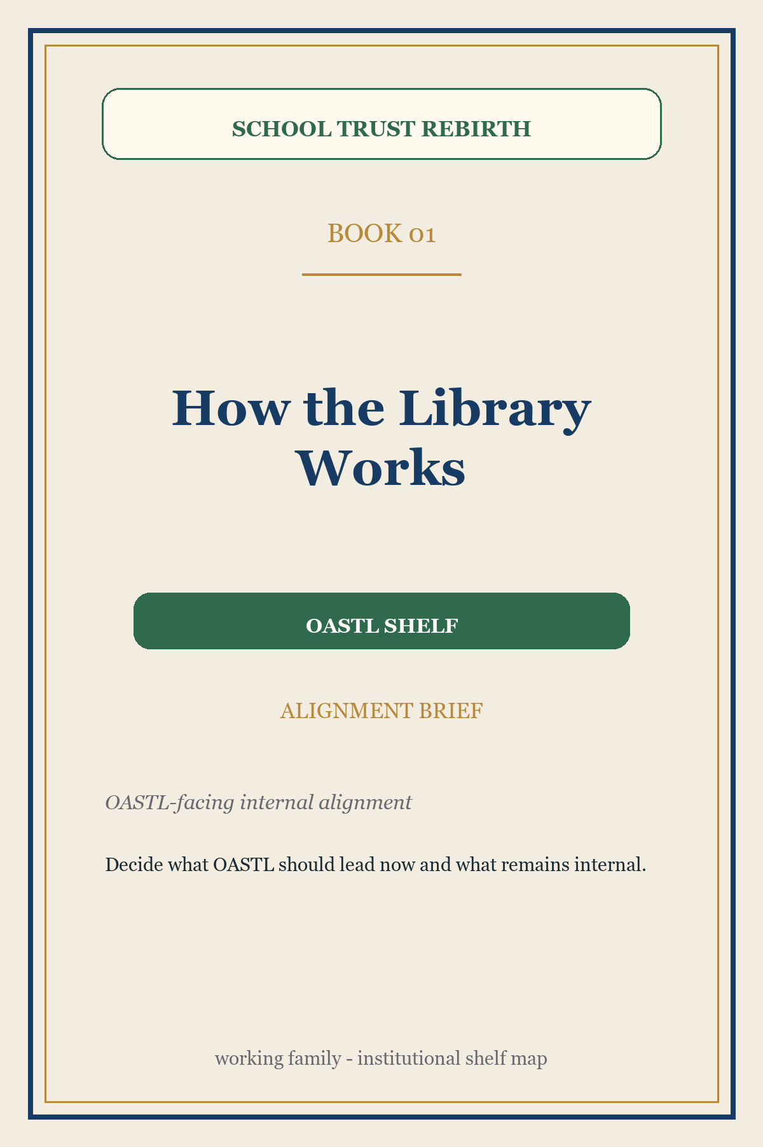 | How the Library Works | OASTL shelf  Publisher/use: OASTL-facing internal alignment  TL;DR: The orientation brief for deciding how the rebirth convoy is governed, sequenced, and explained.  Family fit: The internal alignment brief. It does not sell the Library as the whole project; it explains the convoy and the institutional lanes.  Reader: OASTL board, plaintiffs, counsel, and close colleagues  Next action: Decide what OASTL should lead now and what remains internal.

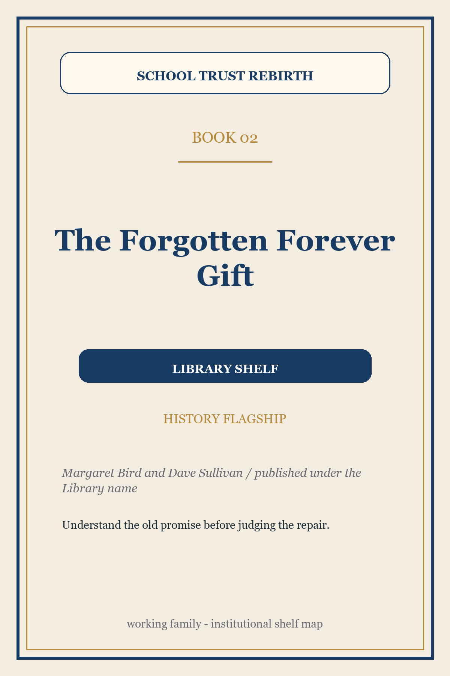 | The Forgotten Forever Gift | Library shelf  Publisher/use: Margaret Bird and Dave Sullivan / published under the Library name  TL;DR: The history of the school-trust promise: what was given, how states honored or lost it, and why the gift still matters.  Family fit: The historical anchor. It gives the movement memory before asking anyone to repair law or practice.  Reader: General readers, board members, and field allies  Next action: Understand the old promise before judging the repair.

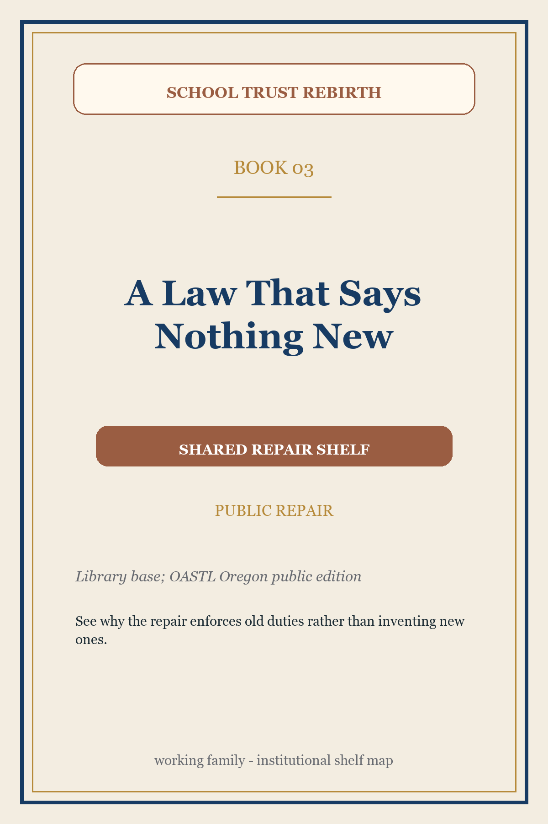 | A Law That Says Nothing New | Shared repair shelf  Publisher/use: Library base; OASTL Oregon public edition  TL;DR: A plain-language explanation of the Uniform Public Trust Enforcement Act (UPTEA): a model law that would make old fiduciary duties visible, enforceable, and usable.  Family fit: The public bridge from agreement to remedy.  Reader: Parents, school boards, legislators, and citizens  Next action: See why the repair enforces old duties rather than inventing new ones.

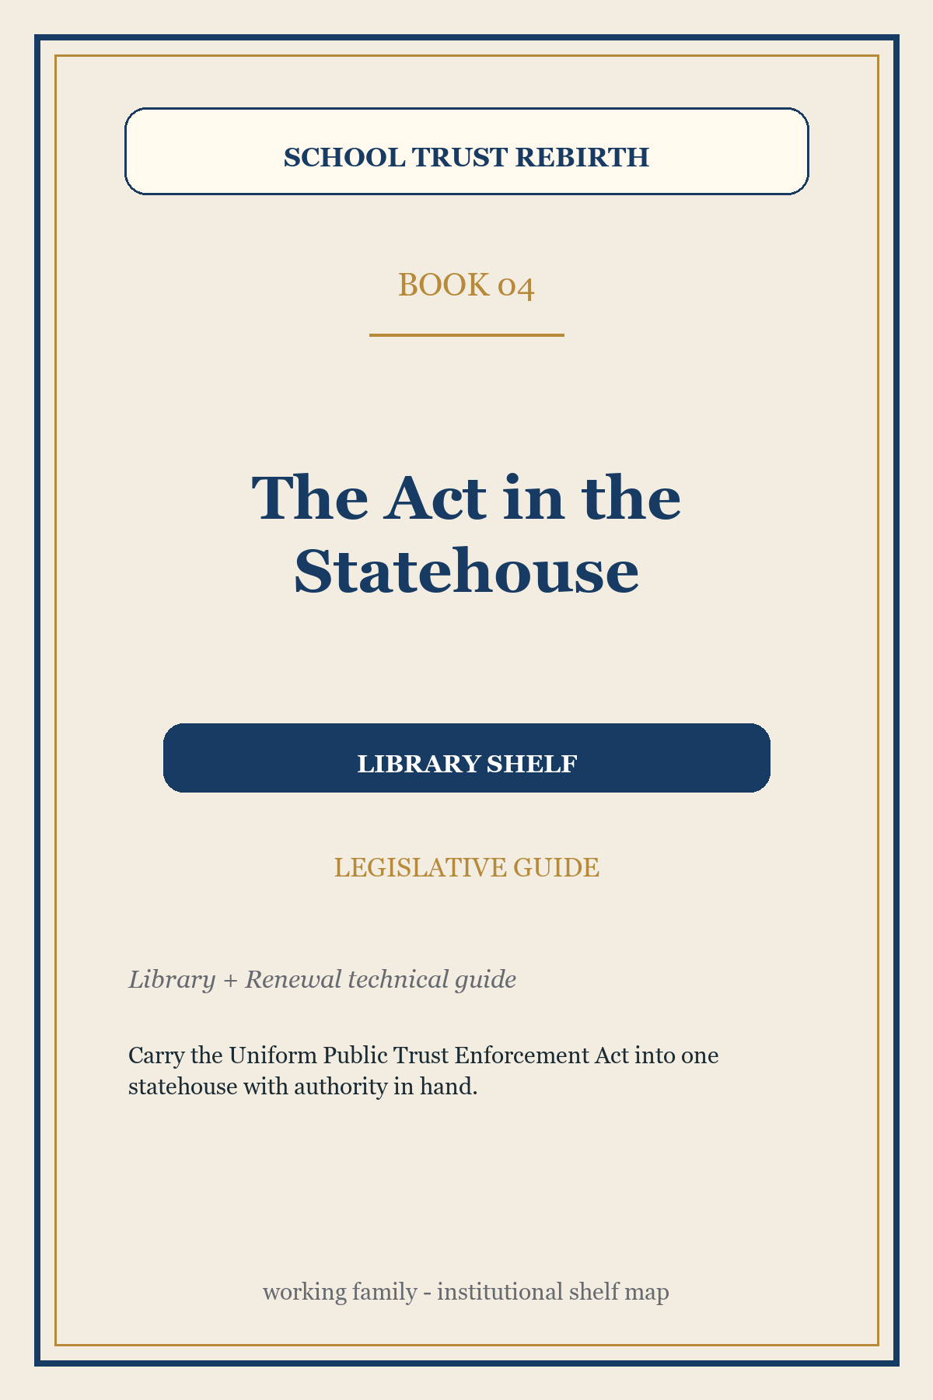 | The Act in the Statehouse | Library shelf  Publisher/use: Library + Renewal technical guide  TL;DR: A technical guide for findings, authorities, drafting choices, state variables, and counsel questions.  Family fit: The enactment workbench for the first serious legislative introduction.  Reader: Legislative counsel, sponsor staff, attorney general reviewers, and experts  Next action: Carry the Uniform Public Trust Enforcement Act into one statehouse with authority in hand.

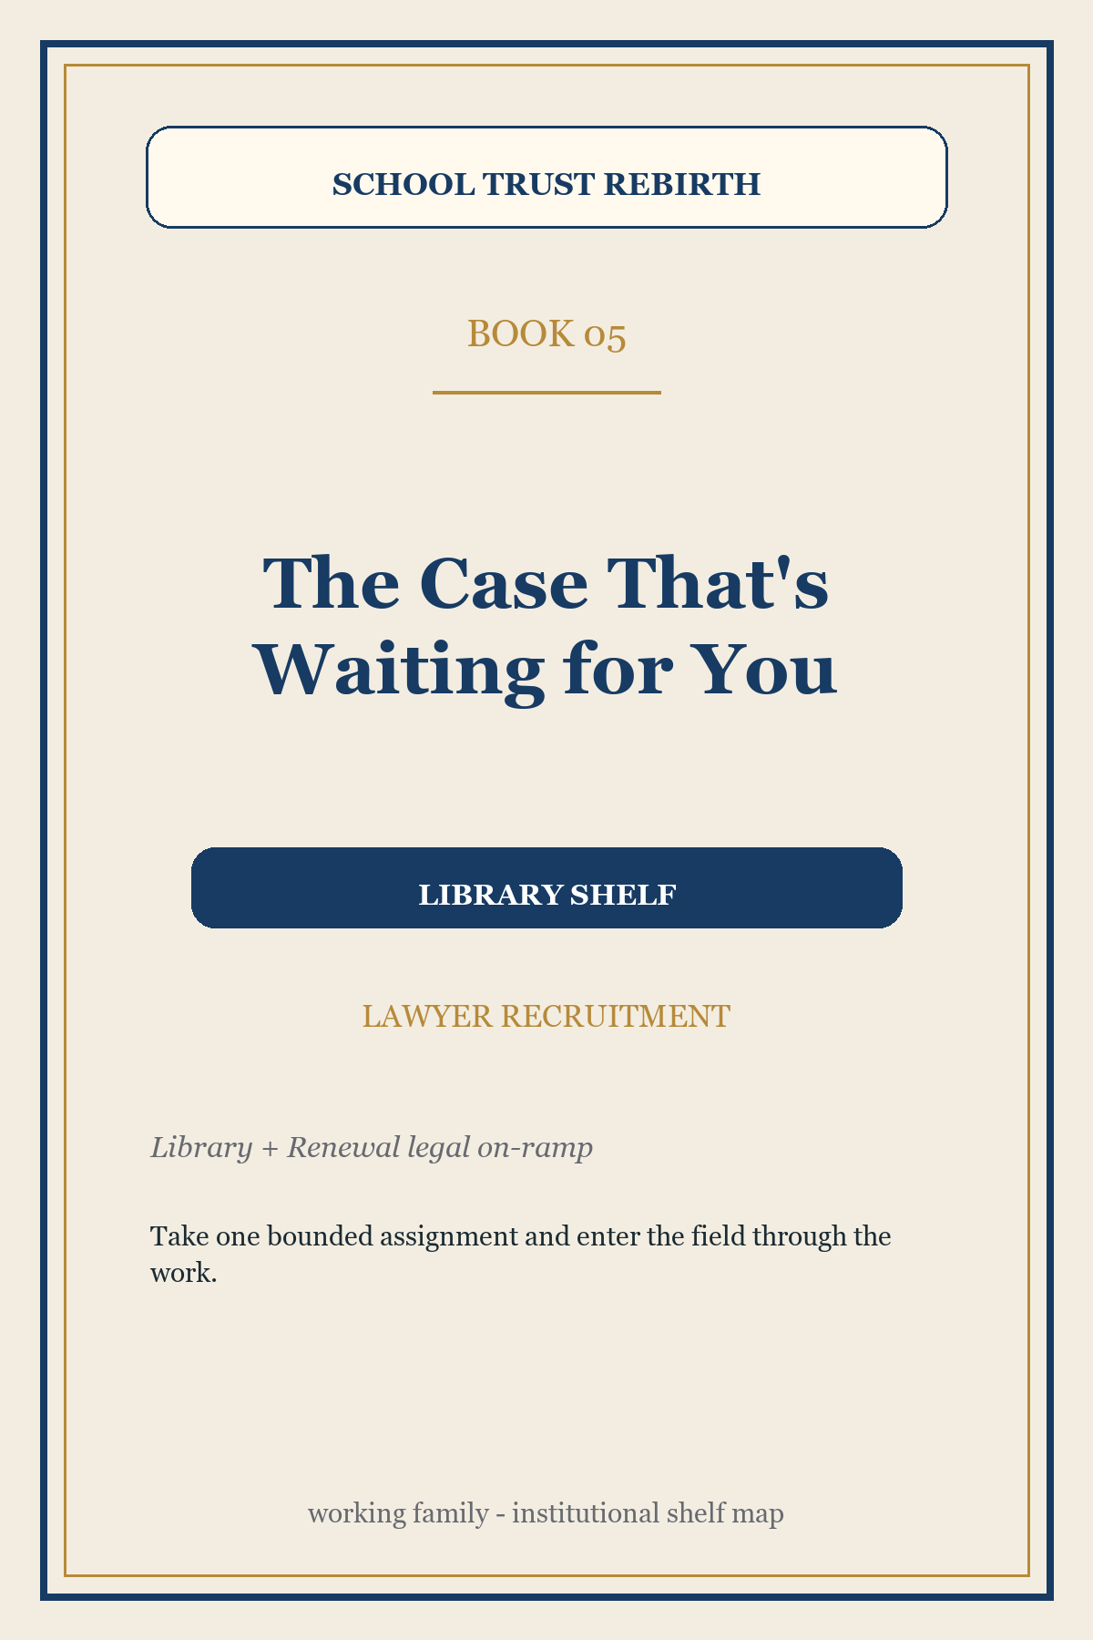 | The Case That's Waiting for You | Library shelf  Publisher/use: Library + Renewal legal on-ramp  TL;DR: A recruitment booklet for lawyers who can take one bounded school-trust assignment.  Family fit: The legal-capacity door. It converts sympathy into professional work.  Reader: Public-interest lawyers, clinics, and retired judges  Next action: Take one bounded assignment and enter the field through the work.

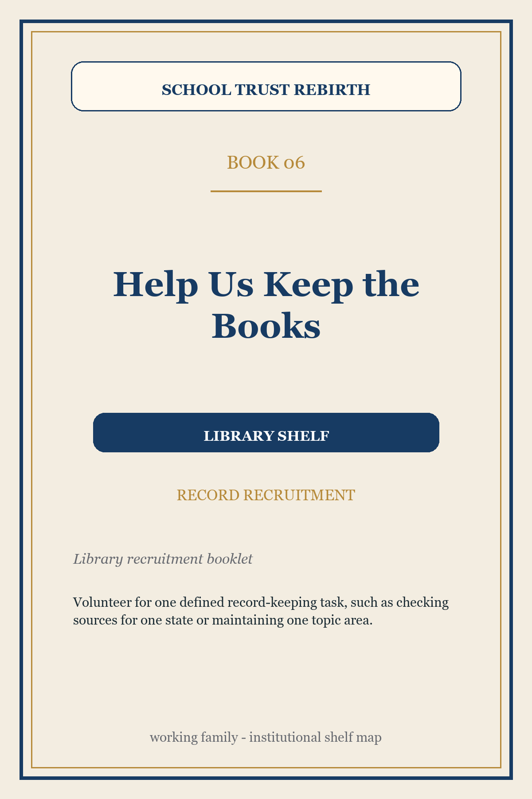 | Help Us Keep the Books | Library shelf  Publisher/use: Library recruitment booklet  TL;DR: An invitation to help keep the record findable, checkable, corrected, and credited.  Family fit: The credibility engine. Without record stewards, the legal and public work cannot stay trustworthy.  Reader: Librarians, archivists, researchers, and careful record-keepers  Next action: Volunteer for one defined record-keeping task, such as checking sources for one state or maintaining one topic area.

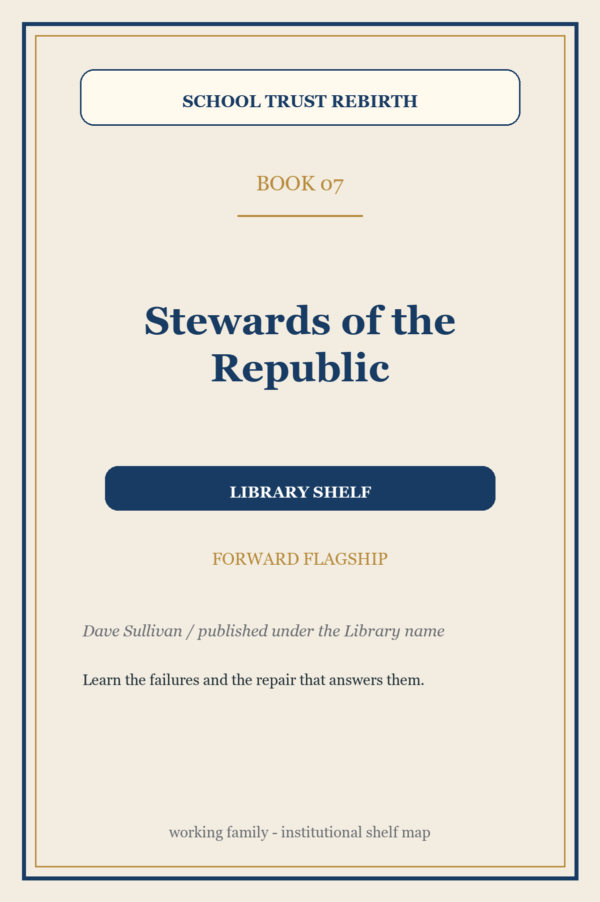 | Stewards of the Republic | Library shelf  Publisher/use: Dave Sullivan / published under the Library name  TL;DR: A forward-looking book about what school-trust failures teach people responsible for long-term public assets and people designing future long-term institutions, including institutions shaped by artificial intelligence.  Family fit: The bridge from school trusts to the design of future forever institutions.  Reader: Trust designers and long-horizon institution builders  Next action: Learn the failures and the repair that answers them.

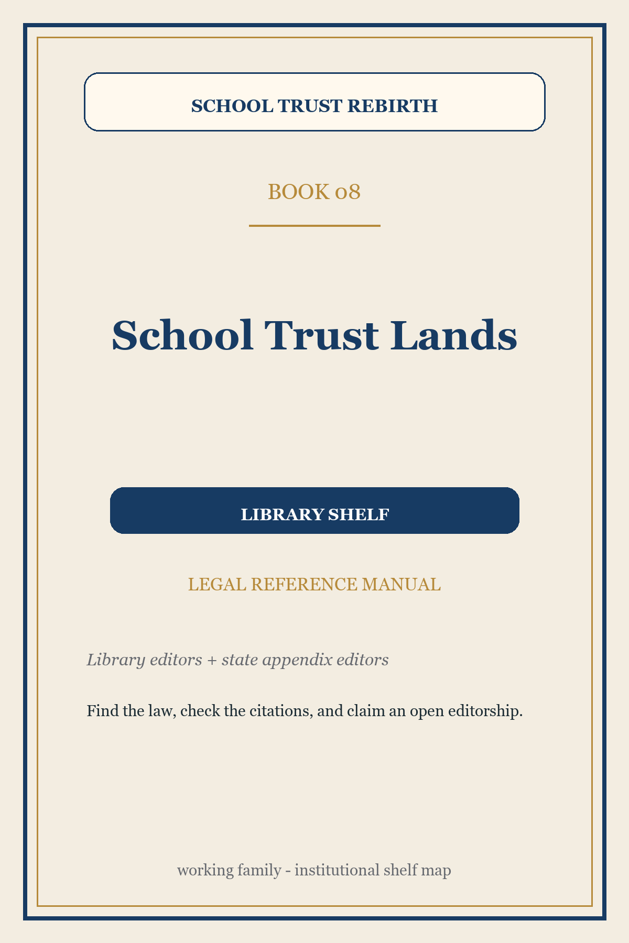 | School Trust Lands | Library shelf  Publisher/use: Library editors + state appendix editors  TL;DR: The legal reference manual: doctrines, cases, statutes, state appendices, citations, and open editorial vacancies.  Family fit: The common legal reference that lets lawyers and courts check the field.  Reader: Practitioners, judges, staff, scholars, and serious students  Next action: Find the law, check the citations, and claim an open editorship.

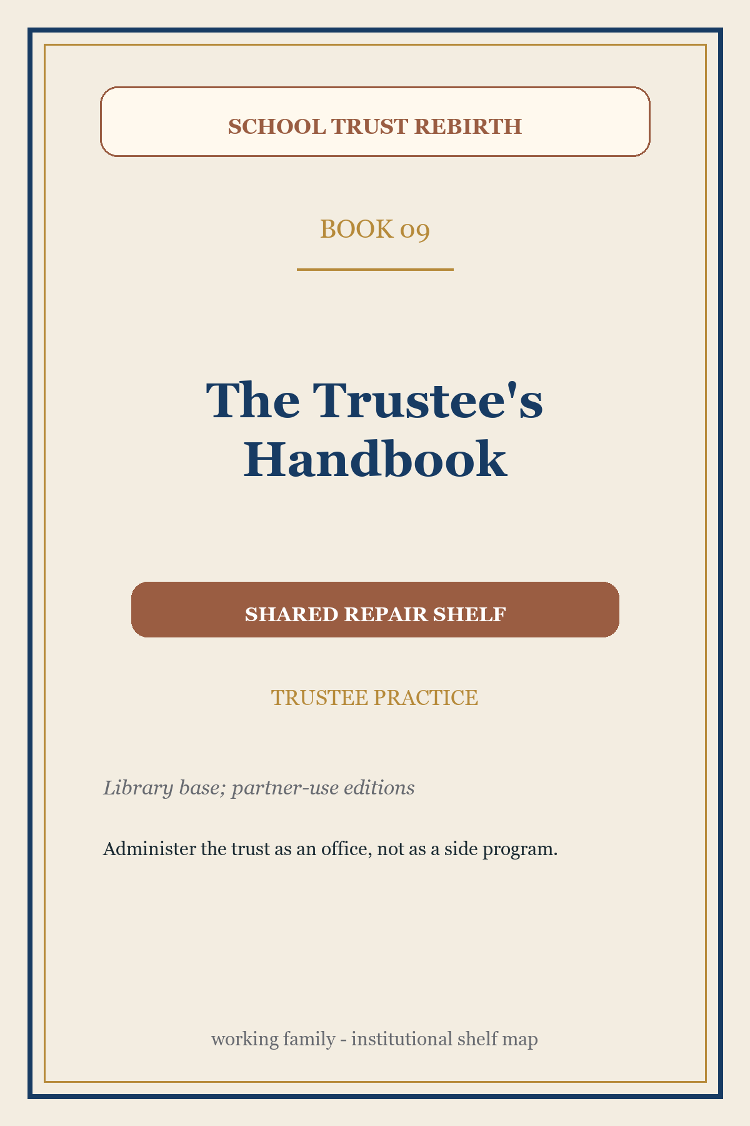 | The Trustee's Handbook | Shared repair shelf  Publisher/use: Library base; partner-use editions  TL;DR: A practical handbook for loyalty, prudence, accounting, disclosure, conflicts, and public explanation.  Family fit: The constructive book. It shows what good trusteeship looks like, not only what failure looks like.  Reader: Trustees, treasurers, agency heads, land-board staff, and counsel  Next action: Administer the trust as an office, not as a side program.

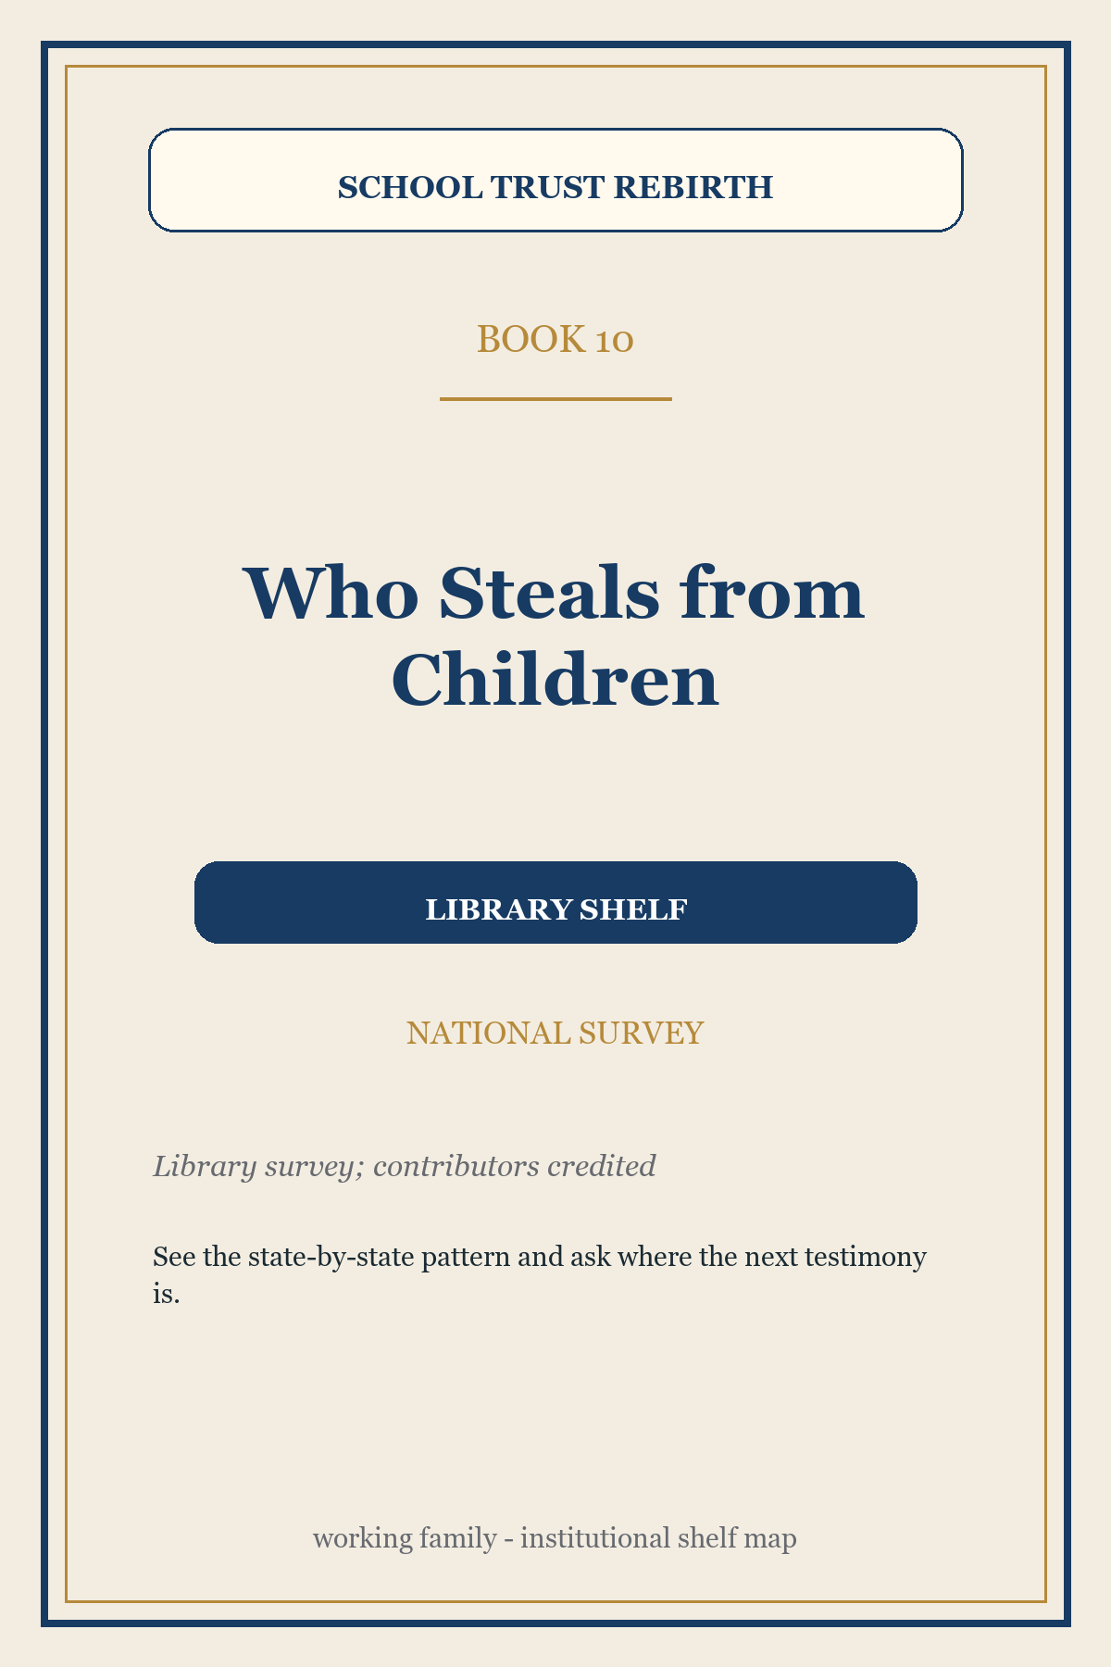 | Who Steals from Children | Library shelf  Publisher/use: Library survey; contributors credited  TL;DR: A national survey of how school trusts have been diverted, neglected, defended, or repaired.  Family fit: The accountability atlas. The Oregon origin story now moves elsewhere so this can stay national.  Reader: Citizens, journalists, donors, and state witnesses  Next action: See the state-by-state pattern and ask where the next testimony is.

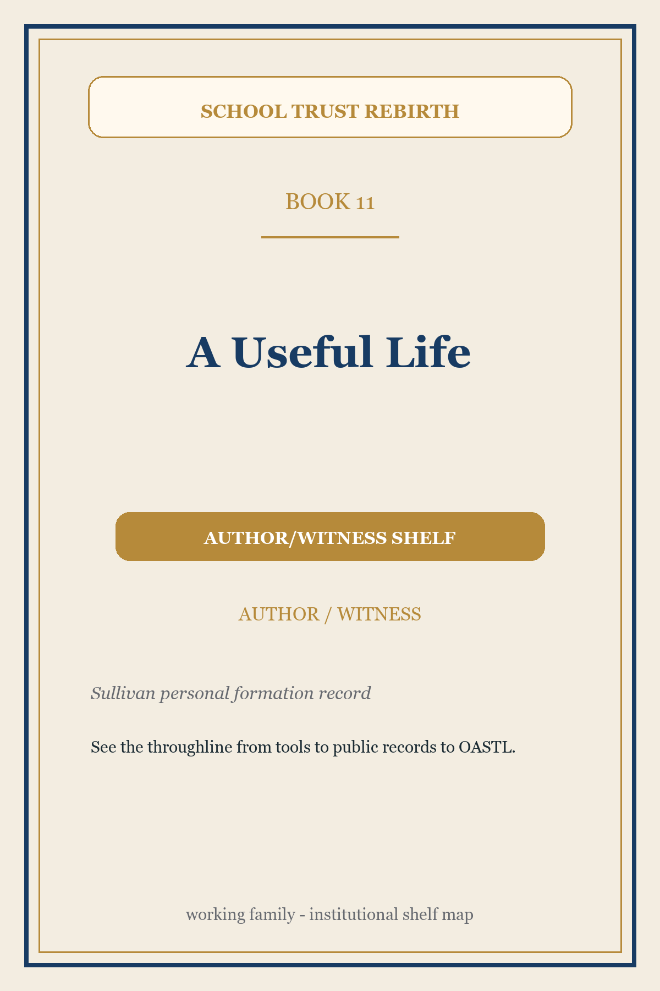 | A Useful Life | Author/witness shelf  Publisher/use: Sullivan personal formation record  TL;DR: Dave's formation story: tools, computers, books, forestry, public records, and the path to OASTL's Oregon school-trust work.  Family fit: A credibility and analogy book. It illuminates the movement without being owned by an institution.  Reader: Readers who need to know who is asking them to inspect the work  Next action: See the throughline from tools to public records to OASTL.

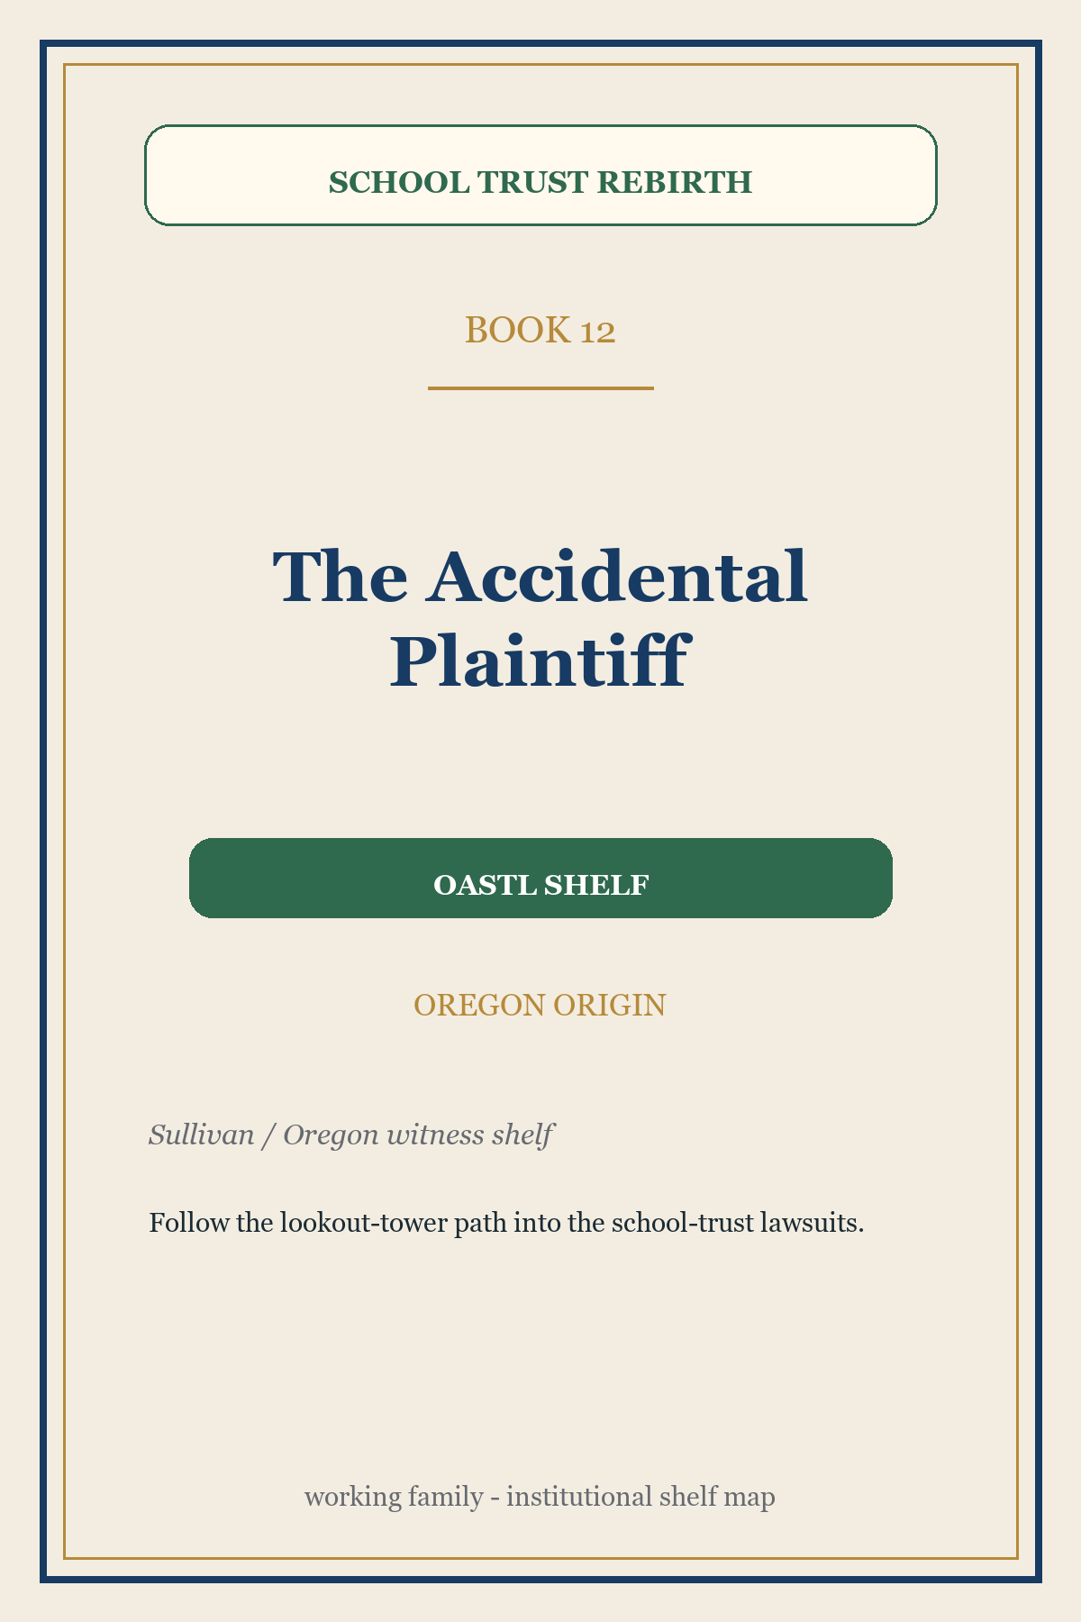 | The Accidental Plaintiff | OASTL shelf  Publisher/use: Sullivan / Oregon witness shelf  TL;DR: The Oregon origin story: a lookout tower, closed meetings, records requests, a drained school fund, and lawsuits brought for grandchildren.  Family fit: The Oregon story door. It gives the Oregon public-demonstration campaign its human entrance.  Reader: Oregonians who need the human story before the law  Next action: Follow the lookout-tower path into the school-trust lawsuits.

The Public System Behind The Proposal
The book family, meaning the related set of books and packets that give different readers an entry point, is not the strategy by itself. It is the public interface for the strategy. Each book or packet gives a different constituency a way into the same verified record and repair program.
The public-link rule should be simple: cite the stable Writing Room book page, not the temporary file behind it. A Word draft, web version, PDF, or later partner edition can move; the Writing Room book page should remain the durable public address.
That rule matters for Make School Trusts for Schools and the other booklets because readers should be able to jump from this roadmap into the working draft without needing to know where the file happens to live today. The stable page can tell them what the document is, what stage it is in, who it is for, and where the current draft or long-term home now sits.
The Writing Room, the Library's open-draft area for work that is visible before it is final, adds a crucial discipline: the shelf can be open without pretending to be finished. Drafts can recruit while showing verification flags, known issues, correction paths, and source standards. That posture matters because school-trust advocacy should model the trusteeship it demands: keep the books visible, publish corrections, credit contributors, and let readers test the record.
Dispatches, the Library's witness-and-contributor series, adds the witness system. A rebirth needs more than experts; it needs documented accounts from states, districts, parents, students, librarians, journalists, and careful citizens. The bargain should be simple: your byline, Library verification. Contributors bring the witnessed facts; the Library checks the footing; recurring contributors can become state correspondents or named record stewards.

The Window That Has To Move
The public belief that has to change is practical as much as moral. Many people already agree that public officials holding school-trust assets should act like fiduciaries. The harder belief is that school-trust duties can actually be enforced at a cost, pace, and risk level that makes the work worth doing.
Lawyers need to see bounded assignments, authorities, who is allowed to sue, what financial records must be shown, what a court can officially declare, what fixes a court can order, and source-backed duties. Legislators need to see a uniform-act path. Citizens need to see an initiative path. Parents and students need to see that the promise belongs to them. Librarians need to see that the record is a public asset. Public officials responsible for school assets need to see that good trusteeship can be named and credited.
The national window moves after one credible state proves the method. Oregon is where that proof can begin.

Different Doors, Real Credit
- OASTL: Lead Oregon first. Carry the Oregon public-demonstration campaign, citizen repair booklet, and legislative/initiative readiness path.
- The Library: Keep the record neutral. Verify sources, publish corrections, maintain the legal reference manual and open-draft Writing Room, and give contributors durable credit.
- ASTL national: Carry replication when ready. Convene state allies, sponsor coalition tools, and help the Oregon proof travel.
- Parents and PTAs: Make the trust a child-and-school issue. Turn an obscure trust question into a public-accountability question families can carry.
- Students and school districts: Make students' and schools' stake visible. Give the promise a human face and a school-level reason to matter.
- Librarians and archivists: Keep the record findable. Make sources checkable, durable, and available to the next person who needs them.
- Lawyers and clinics: Make enforcement bounded. Convert the record into assignments, authority packets, and counsel-reviewed model language.
- Dispatch writers and state correspondents: Bring the witnessed facts. Contribute documented accounts under the bargain: your byline, Library verification.
- Legislators and sponsor staff: Carry the Oregon legislative route. Test whether Oregon can adopt a model enforcement act while preserving an initiative fallback.
- Trustees and agency staff: Restore fiduciary practice. Show what accountable administration looks like and where current structures need repair.

Decisions Before This Brief Is Shared Outside The Planning Circle
- Library formation: Should the Library be treated as a separate national record institution, likely its own charitable nonprofit? Guardrail: Do not fold it into OASTL or ASTL merely because OASTL is the first partner.
- OASTL role: Should OASTL explicitly become the Oregon public-demonstration partner? Guardrail: Do not make OASTL the owner of the national Library.
- ASTL role: What should ASTL be asked to review, adopt, or sponsor later? Guardrail: Do not imply ASTL has already endorsed the full convoy.
- Publishing shelves: Which books are published under the Library name, OASTL/Oregon public demonstration, shared repair, ASTL coalition, or author/witness? Guardrail: Do not force every book into the same institutional identity.
- Model enforcement act path: Does OASTL want the Uniform Public Trust Enforcement Act pursued first through legislation, an initiative fallback, or both paths actively prepared? Guardrail: Public consideration is not signature collection.
- Open-draft posture: How open should the book family be while citations and claims are still being checked? Guardrail: Show verification flags and correction paths honestly; do not let polished covers imply final approval.
- Partner sequence: Which partner category should be approached first: ASTL, PTAs, librarians, lawyers, public officials responsible for school assets, or education-governance groups? Guardrail: Ask for bounded review or participation, not broad endorsement.
- Website adoption: Should ASTL move the approved material now at schooltrustlands.net onto the familiar schooltrustlands.org public address, keep .net alive as a working or continuity site, and then stop maintaining two competing public ASTL sites? Guardrail: No organization should be asked to use a new site merely because it exists, but once the new site is materially better and approved, the transition should be prompt: one public home, one correction path, one maintenance responsibility.
- Public-link rule: Should every public-facing book, booklet, packet, and brief have a stable Writing Room book page before it is referenced from another document? Guardrail: Link to the durable book page. Replace the draft file behind that page as needed.

Inspection Route
- Start with the role map and ask whether the three lanes feel right: Library as record, OASTL as Oregon public demonstration, ASTL as national coalition.
- Read the Oregon-first sections and ask whether they still work once the Library is independent rather than OASTL-owned.
- Inspect the shelves and ask whether each book now has the right institutional home and authorship posture.
- Review the website replacement section and ask whether each proposed site should be revised, adopted as the public front door, or held until board and partner approval.
- Open the Make School Trusts for Schools citizen-repair booklet and ask whether it belongs on the OASTL/Oregon shelf as the citizen repair companion.
- Use the stable Writing Room book links, not temporary draft-file locations, when sending this brief or asking someone to inspect a related booklet.
- Use the links below to follow one model-law claim from the plain-language explanation to the legal reference manual and linked source materials that support it. If a link is internal or unavailable, mark it as a staff-only check.
- Check the open-draft Writing Room and Dispatches witness-series principles: open drafts, visible verification flags, public corrections, byline plus verification.
- Name what OASTL can lead now, what the Library should own as neutral record, what ASTL can later adopt, and what must wait for counsel.

Public And Candidate-Partner Links
- Oregon Revised Statutes Chapter 28 - Oregon's declaratory-judgment chapter, cited as the Uniform Declaratory Judgments Act.
- National Association of State Trust Lands - Potential technical/practice forum for trust-land administrators.
- National PTA mission - Potential family/child advocacy constituency.
- American Association of School Librarians - Potential school-library professional audience.
- American Library Association mission - Potential national library-field audience.
- National School Boards Association - Potential school-board governance audience.
- National Association of State Boards of Education - Potential state education-governance audience.
- Council of Chief State School Officers - Potential state education-leadership audience.
- Education Law Center - Potential public-education legal-policy audience.
- Uniform Law Commission: What is a Uniform Act? - Plain-language source for the model-law adoption concept used in the enforcement-act analogy.
- Uniform Law Commission: Declaratory Judgments Act - Uniform-law source for the declaratory-judgment model that Oregon's ORS Chapter 28 reflects.
- Writing Room - Public working shelf for books, booklets, dispatches, and source-checking methods.
- The Rebirth of America's School Trusts - Durable book page for this roadmap brief, even if the draft file moves.
- How the Library Works - Durable book page for the Library orientation booklet.
- The Forgotten Forever Gift to Public Schools - Durable book page for the historical anchor of the school-trust promise.
- A Law That Says Nothing New - Durable book page for the plain-language model-enforcement-act guide.
- UPTEA for Lawyers and Legislative Counsel - Durable book page for the lawyer-facing model-law packet.
- The Case That's Waiting for You - Durable book page for the lawyer-recruitment booklet as it is assembled.
- Help Us Keep the Books - Durable book page for the librarian, archivist, and record-steward recruitment booklet.
- Stewards of the Republic - Durable book page for the forward-looking trust-design book.
- School Trust Lands: The Law of America's Educational Land Trusts - Durable book page for the school-trust legal reference manual.
- The Trustee's Handbook - Durable book page for the constructive practice handbook.
- Who Steals from Children - Durable book page for the present-tense state record.
- A Useful Life - Durable book page for the author/witness formation story.
- The Accidental Plaintiff - Durable book page for the Oregon origin story.
- Make School Trusts for Schools - Durable book page for the citizen-repair booklet and public-consideration packet.

Linked Source Shelf
- Rebirth Roles Map poster - Full-size roles poster that drove this V4 rewrite.
- Roles map assumptions note - Institutional-lane and publishing-shelf assumptions.
- School Trust Rebirth Brief v3.2 - Immediate predecessor with the now-superseded ownership frame.
- Publishing Doctrine - Ranked dozen and publication-sequencing doctrine.
- OASTL brand assets - Canonical OASTL logo and use rule.
- Make School Trusts README - Oregon citizen repair packet orientation.
- Make School Trusts public booklet source - Public-consideration booklet text.
- Model statutory initiative - Statutory citizen-repair model.
- Uniform Public Trust Enforcement Act v2 packet - Model-law packet for the repair instrument.
- Uniform Public Trust Enforcement Act authority crosswalk - Authorities behind model-law findings.
- Legal reference manual working master - Working legal reference spine.
- Legal reference manual editorships - Credit and recruitment architecture.
- Verified figures register - Reusable figures and as-of dates.
- Writing Room staging page - Open-draft shelf grammar.
- How We Check Our Footnotes - Verification and correction method.
- Dispatches - Contributor model: byline plus verification.
- Autobiography booklet - New #11 draft if present.
- Oregon origin booklet - New #12 draft if present.
- Two-stage website replacement plan - Earlier strategy memo explaining why ASTL and OASTL should stand as separate improved advocacy sites before deeper Library features migrate into them.
- Existing ASTL site fact-check memo - Page-by-page review sent to Margaret Bird and Tonia Day showing the kinds of factual drift that source-linked public sites are meant to catch and repair.
- Writing Room book registry - Single registry that defines each book's stable slug, status, draft link, and eventual current home.
- Writing Room stable book gateway - Template for durable /writing/books/... pages so outside links survive draft-file moves.

Suggested Opening Sentence
I think Oregon Advocates for School Trust Lands should become the first partner in a national school-trust rebirth: a separate neutral Library to keep the record, an Oregon public-demonstration campaign to make enforcement real, a model enforcement act, citizen repair tools, and a national coalition path that ASTL and others can adopt as the Oregon public demonstration matures.

