**MIS 6330: Cybersecurity Fundamentals**

**Individual Homework 8**

1. Consider the VPN configuration described in the class, in particular the *encapsulated* IP packet (the “inner” packet) and the “outer” packet that carries it across the internet.
   1. What is the destination IP address on the outer packet (not the encapsulated packet): (a) that of the destination computer (web server in the picture) OR (b) that of the VPN gateway at the office?
   2. What is the source address on the outer packet: (a) the ISP assigned address or (b) the VPN gateway assigned address?

Briefly explain your answer.

1. I have been browsing an online store, when I was suddenly redirected to the webpage shown in the screenshot below.

* Which of the following threats—*code injection*, *cross-site scripting, buffer overflow*, and *drive-by download*—are potentially involved? Explain your answer.

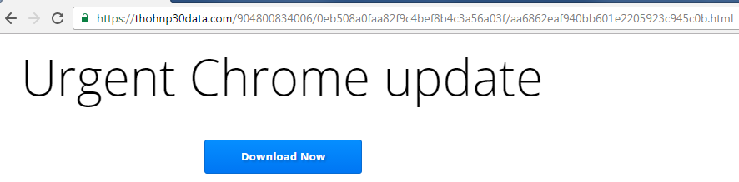

1. Consider the following terms: *compression virus* and *encrypted virus*.
   1. Can you catch these viruses by employing *integrity checks*? Answer YES or NO, and then explain your answer.
   2. If your answer is NO, what techniques do you recommend and why? If your answer is YES, would you still consider alternative techniques such as *generic decryption* and/or *signature scans*?