Lab Exercise 7.2 Calculate Spectral Indices

2024-07-30

# Required time: 30 minutes

# Data required:

R-script: <https://github.com/dave-white2/remote-sensing-soil-survey-applications/blob/main/7.2.calculate-spectral-indices-script.R>

The cloud optimized geotiff (COG) used in this exercise is a median composite of Harmonized Sentinel 2 MSI surface reflectance data for the San Rafael Swell Area of Utah. It was compiled using the code editor in Google Earth Engine.

COG URL: <https://storage.googleapis.com/rsssa-bucket/sen2_srSwell_2015-2020.tif>

Code for San Rafael Swell data set : <https://code.earthengine.google.com/e940db34370875829c85b59ce72c1932?noload=1>

The composite stack includes the following Sentinel2  
bands: [‘B2’,‘B3’,‘B4’,‘B5’,‘B6’,‘B7’,‘B8’,‘B8A’, ‘B11’,‘B12’]  
renamed to: [‘blue’, ‘green’, ‘red’, ‘re1’,‘re2’,‘re3’,‘nir’, ‘nir2’, ‘swir1’, ‘swir2’].

For more information on the Harmonized Sentinel 2 data set: <https://developers.google.com/earth-engine/datasets/catalog/COPERNICUS_S2_SR_HARMONIZED>

# Objectives:

1. Display RGB composite image from cloud optimized geotiffs
2. Define normalized difference function, calculate indices and plot
3. Calculate other well known spectral indices and plot

# Calculate spectral indices overview

In this exercise you will work with a cloud optimized geotiff or COG. This COG contains a composite image of Sentinel2 data. You will visualize this data assigning different bands to each of the different color channel R,G,B. The data will then be used to calculate various spectral indices.

## Load important libraries

library(terra)

## terra 1.7.78

## Load raster data

# The raster data for this example is a cloud optimized geotiff  
s2 <- rast('https://storage.googleapis.com/rsssa-bucket/sen2_srSwell_2015-2020.tif')  
  
# inspect raster names in the s2 stack  
names(s2)

## [1] "blue" "green" "red" "re1" "re2" "re3" "nir" "nir2" "swir1"  
## [10] "swir2"

Get the min/max values from the raster stack. This is needed to display the RGB composite image

setMinMax(s2)

## class : SpatRaster   
## dimensions : 703, 753, 10 (nrow, ncol, nlyr)  
## resolution : 10, 10 (x, y)  
## extent : 1025730, 1033260, 4340580, 4347610 (xmin, xmax, ymin, ymax)  
## coord. ref. : WGS 84 / UTM zone 11N (EPSG:32611)   
## source : sen2_srSwell_2015-2020.tif   
## names : blue, green, red, re1, re2, re3, ...   
## min values : 293, 379, 395, 836, 1045, 1107, ...   
## max values : 3855, 4426, 4932, 5066, 5129, 5266, ...

## Plot Spectral Composite

We can use the plotRGB function of the terra package to view the composite image.

To do this, call the SpatRaster object, s2, and assign a band to each color channel; r,g,b. It is important to remember the band names. To review the band names use: names(s2)

# plot a R,G,B view of the composite image  
plotRGB(s2,  
 r = 'red',  
 g = 'green',  
 b = 'blue')

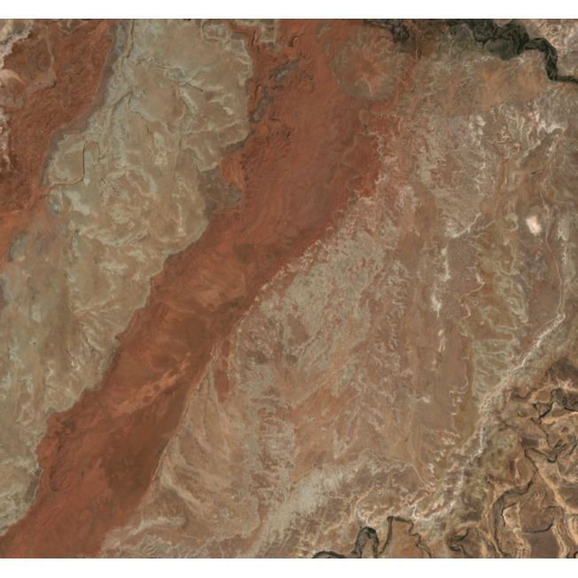

It can be helpful to apply a linear or histogram equalization stretch of the SpatRaster to aid in visualization.

# apply a linear stretch  
plotRGB(s2,  
 r = 'red',  
 g = 'green',  
 b = 'blue',  
 stretch = 'lin') # 'hist'

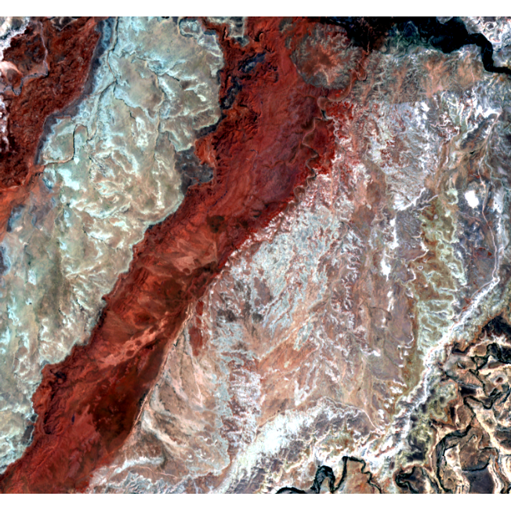

We can also change which bands are shown in the plot. Set the red color channel to swir2, the green color channel to nir, and the blue channel to green. This combination has many useful applications, from mineralogical differences in arid landscapes to differentiating between land cover classes.

For a smoother visual output, set smooth option = TRUE.

plotRGB(s2,  
 r = 'swir2',  
 g = 'nir',  
 b = 'green',  
 stretch = "lin",  
 smooth = T)

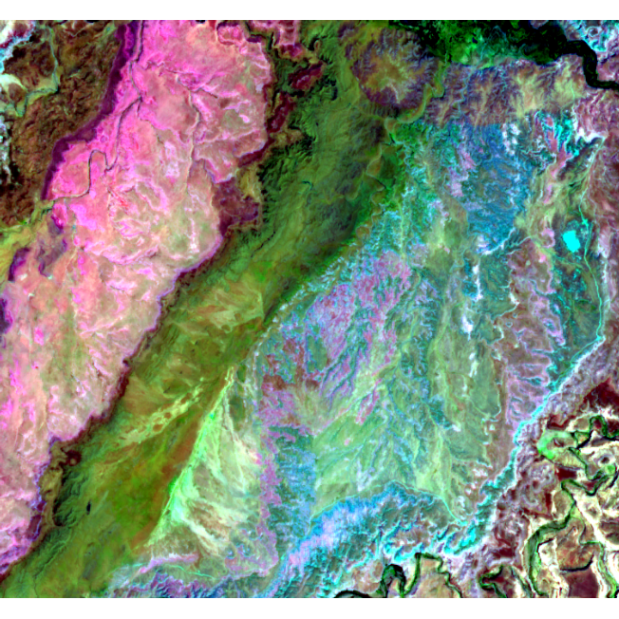

The various spectral indices involve raster math. To simplify these equations, we have opted to store each band as its own object with the name of the band as the object name.

# get individual bands for calculations  
blue <- s2$blue  
green <- s2$green  
red <- s2$red  
nir <- s2$nir  
swir1 <- s2$swir1  
swir2 <- s2$swir2

### Normalized Difference Indices

To calculate normalized difference indices we first need to define the normalized function.

# Normalized Difference index function  
nd_fn <- function(bd1,bd2) {ind <- (bd1 - bd2)/(bd1 + bd2)  
return(ind)  
}

We can then apply this function utilizing bands of interest.

# Normalized difference vegetation index  
NDVI <- nd_fn(nir, red)  
  
# Carbonate index  
CarbIdx <- nd_fn(red, green)   
  
# Rock Outcrop Index  
RockIdx <- nd_fn(swir1, green)  
  
# Gypsum Index  
GypIdx <- nd_fn(swir1, swir2)

Generate a plot of the calculated normalized difference indices.

# plot to check  
plot(c(NDVI, CarbIdx, RockIdx, GypIdx), main = c("NDVI", "Carbonate Index", "RockOutcrop", "Gypsum Index"))

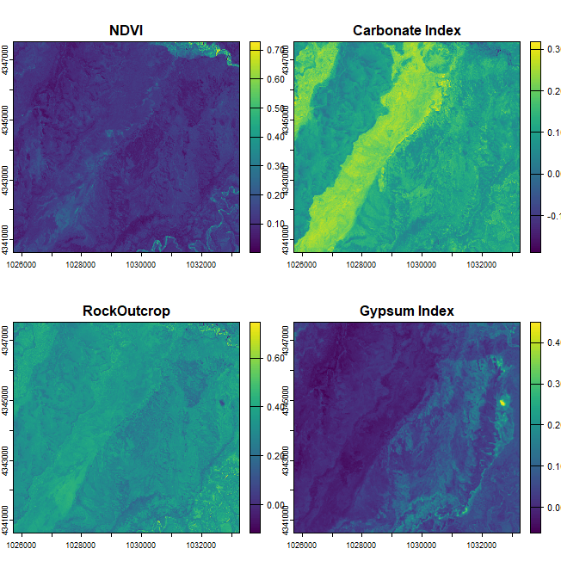

### Other Spectral Calculations

# modified soil adjusted vegetation index  
msavi <-(2*nir+1-sqrt((2*nir+1)**2-8*(nir-red)))/(2)  
   
# simple ratio -- difference vegetation index  
dvi <- (nir)/(red)  
  
# simple ratio -- red blue Iron Oxide  
feox <- (red)/(blue)  
  
# simple ratio -- swir1 nir - ferrous minerals  
ferrous <- (swir1)/(nir)  
  
# clay minerals swir1/swir2  
# simple ratio -- swir1 swir2 ratio  
clayMin <- (swir1)/(swir2)  
   
# soil adjusted vegetation index  
L =0.5  
savi <- ((1+L)*((nir-red)/(nir+red+L)))

Generate a plot of the other calculated spectral indices.

# plot to check  
plot(c(msavi, dvi, feox, ferrous, clayMin, savi), main = c("MSAVI", "DVI", "FeOx", "FerMin", "clayMin", "SAVI"))

