**A REPORT ON SUSTAINABALE DEVELOPMENT 2022**

**BY GROUP 2**

**SUSTAINABLE DEVELOPMENT**

**TEAM MEMBERS**

|  |  |  |
| --- | --- | --- |
| **S.NO** | **NAME** | **ROLL NUMBER** |
| **1** | **DAVE MESHAK J** | **AP22110010486** |
| **2** | **AAKARSH LOHANI** | **AP2211001523** |
| **3** | **PRIYAM** | **AP22110010495** |
| **4** | **TEJA BALARAM** | **AP22110010511** |

**ABSTRACT**

Sustainable development is a crucial topic given the significance of social equality, economic prosperity, and environmental protection in today's society. Humans must take into account the needs of future generations. The regulation of sustainable development is aided by legislation.

Things have gotten worse with the ongoing COVID-19 pandemic and the conflict in Ukraine. Thus, achieving all of the sustainable development goals by 2030 as promised is not nearly impossible. Despite this, the UN is making every effort to bring everyone together to make the world a better place to live.

Sustainable development aims to preserve life as well as to promote it. In this report, we'll look closely at how various nations are tackling these issues.

**TABLE OF CONTENTS**

Foreword 4

1. Thinking beyond the crisis 5

1.1. The statistical data and its entail 5

1.2. The crisis- a helping hand of innovation 6

1.3. Pandemic alarm - a reminder to leave no one behind 7

2. Approaches to Sustainable Development Goals 8

2.1. Derailling progress on ending extreme poverty 8

2.2. Disaster related deaths rose sixfold in 2020 9

2.3. The low labor productivity of small-scale food producers 10

2.4. Deaths of 15 million people due to COVID-19 10

2.5. Awareness of violence against older women and limited data 11

2.6. Rise of child marriage and female genital …. 12

2.7.Loss of wetlands at an alarming rate 12

2.8.The dream of affordable and clean energy. 13

2.9.Increased realative poverty in many countries..........................................................13

2.10.Too much food is being lost or wasted - in every country ever day.........................14

2.11.Alarmingly high subsidies for fossil fuels..................................................................15

2.12.Fossil fuel emissions rebounded to a record high in 2021.......................................16

2.13.Increasing acidification and the ocean's capacity to moderate climate change......16

2.14.Destruction of marine life due to the proliferation of plastic..................................17

2.15.Peace,justice, and strong institutions - the three pillars..........................................18

2.15.1.Homicide rates continue to decline......................................................................18

3.Conclusion.....................................................................................................................19

4.Photo credits.................................................................................................................19

5.References.....................................................................................................................19

**FOREWORD**

The goals outlined in the 2030 Agenda for sustainable development are beginning to seem Utopian as the world deals with more and more interconnected and serious global crises and conflicts. The war in Ukraine is making the COVID-19 pandemic and ensuing endemic, as well as the food, energy, humanitarian, and refugee crises, worse. And this is happening in the midst of a true climate emergency.

The report shows how these crises have a negative impact on achieving the Sustainable Development Goals using data from the previous year. At least 15 million people have already died as a result of the COVID-19 pandemic, either directly or indirectly. Whether we view it as a blessing or a lesson, its effects have put at least 500 million people's lives in danger.

With ongoing worries about new COVID-19 variants, rising inflation, significant supply-chain disruptions, escalating labor market pressures, and unmanageable debt in developing nations, the current global economic recovery is shaky and patchy. The situation continued to deteriorate. Since World War II, there have never been as many conflicts in the world as there are right now. Around 2 billion people reside in nations that are at war.

Prices for food, fuel, and fertilizer have also skyrocketed as a result of the conflict in Ukraine. Supply chains and international trade have been further disrupted, and the financial markets have been distressed. In other words, the COVID-19 pandemic and the conflict have further slowed down the crucial shift to greener economies.

We require a quick response to save the SDG’s from the COVID-19 pandemic and deliver global sustainability. We must fulfill our promises to assist the most defenseless individuals, groups, and countries in the world.

**1.Thinking beyond the crisis:**

The COVID-19 pandemic has altered the way we perceive the world. It has also compelled new ways of thinking and created new opportunities. The statistical community is looking into ways to take advantage of these chances and learn from the pandemic. COVID-19 had a significant impact on national statistics offices (NSOs) all over the world. In-person data collection was abruptly stopped at the beginning of the pandemic in almost every nation.

Many NSOs managed to find new solutions despite the obstacles. One of them involved the use of novel methods for data collection as well as non-conventional data sources like data from mobile phones, satellite imagery, and user-generated data. Additionally, success did not always come easily. Without careful consideration for design and assessment, innovations and new approaches run the risk of unintentionally fostering inequality and exclusion.

The need for timely, DE-aggregated, and high-quality data is greater than ever as the world slowly recovers from the crisis. With the knowledge gained from the pandemic, additional investments in data and information infrastructure are now required.

The analysis that follows is based on four rounds of global surveys that the World Bank and the United Nations Statistics Division jointly conducted between May 2020 and May 2021 to track the impact of the pandemic on national statistical operations.

**1.1.The statistical data and its entail**

Stronger statistical and ICT foundations are required, and COVID-19 was a wake-up call for national statistical systems that were already in trouble. Face-to-face data collection was still taking place in 57% of countries in May 2020, even though 96% of countries had stopped it completely or in part. Prior to the pandemic, nations that only relied on on-site data collection were severely hampered, whereas nations with remote data collection experience or who had tried it out had a significant advantage.

For example, the United Kingdom, the immediate roll-out of a time-use survey during the pandemic benefited from earlier experimentation with remote data collection. The survey, carried out trough the Internet, enabled policymakers to understand how the pandemic changed the way people spent their time.One crack in the statistical foundation exposed during the pandemic was a local of national morality data for adults, which is needed to understand the true death toll of COVID-19. When a United Nations Technical Advisory Group was tasked with estimating national and global COVID-19

related excess mortality, they found that only 38 per cent of countries had the required monthly mortality data from January 2020 to December 2021. This lack of underlying data reflects a serious flaw in national vital statistics systems, which encompass death registration, household surveys and population censuses.

During the pandemic, ICT infrastructure has been essential for enabling countries to conduct remote data collection and training, as well as for storing data and promoting collaboration. Only 62% of all responding nations claimed to have adequate ICT capabilities for remote training in July 2020, and only 55% claimed to have adequate cloud computing services for remote data storage and data exchange. At various income levels, there is a gap between the nations. In terms of ICT, high-income countries were better prepared than low- and lower-middle-income nations.

**1.2.The crisis - as helping hand of innovation:**

National statistical systems have faced an extraordinary challenge as a result of the COVID-19 crisis. In order to meet the demand for data needed for policy making, it has also provided an opportunity to experiment with novel data collection techniques, investigate fresh data sources, and update ICT infrastructures. The significance of completely inclusive data was made clear throughout that process. Future developments in official statistics can be informed by lessons learned from the pandemic.

At the beginning of the crisis, more than 80 per cent of countries indicated they would be using phone surveys to collect data to measure the impact of COVID-19, and 37 per cent said they would be using web surveys - a significant increase from the per-pandemic level. Administrative data, model-based estimates and non-traditional data sources - including phone call detail records, scanner data, social media, remote sensing and citizen-generated data - were all considered by countries.

Many NSOs also accelerated the modernization of their ICT infrastructure. 58% of NSOs reported increases in their overall ICT readiness over the previous six months in May 2021. The two main initiatives were the roll out of new collaboration software (85%) and the provision of staff with new tools (73%). Deploying new remote access tools like Virtual Private Networks (VPN), Virtual Desktops, and Mobile Office (61%) was another important action for enhancing ICT readiness that NSOs highlighted.

**1.3.Pandemic alarm - a reminder to leave no on behind**

Data collection on vulnerable population groups, including immigrants and people with disabilities, is essential for figuring out the problems they face and who is being left behind. Artificial intelligence and mobile phone surveys are two examples of innovative approaches that should be used in conjunction with assessments to make sure they aren't unintentionally harming or excluding the most vulnerable groups.

For instance, the inability to reach specific population groups during the pandemic was attributed primarily to differences in mobile phone ownership and Internet access. 39 percent of the countries surveyed had trouble collecting data on migrants, 27 percent had trouble gathering information on the elderly, and 27 percent had trouble gathering information on people with disabilities. Traditional surveys that only look at households neglect to include people who reside in institutions that have been impacted by the pandemic, including nursing homes and other residential care facilities, homeless shelters, and prisons.

**2.Approaches to Sustainable Development Goals:**

In the following sections, we will take look into how the countries have made approaches to attain the Sustainable Development Goals despite of the challenges posed by the COVID-19 pandemic and the Ukraine conflict.

**2.1.Derailing progress on ending extreme poverty:**

Between 2015 and 2018, global poverty continued its historical decline, with the

extreme poverty rate falling from 10.1 per cent to 8.6 per cent. This means that the

number of people living on less $1.90 a day dropped from 740 million to 656 million over

this period. COVID-19 has made a severe dent in that progress. Now casts suggest that the global poverty rate increased sharply from 2019 to 2020, from 8.3 per cent to 9.2 per cent, the first rise in extreme poverty since 1998 and the largest since 1990. This erased

more than four years of steady gains. It also means that an additional 93 million people worldwide were pushed into extreme because of the pandemic.

Little progress has been made since then in catching up to the pre-COVID trend.Forecasts for 2022 estimate that 75 million more people than expected prior to the pandemic will be living in extreme poverty.Rising food prices and the broader impacts of the war in Ukraine could push that number even higher, to 95 million, leaving the world even further from meeting the target of ending extreme poverty by 2030.

**2.2.Disaster-related deaths rose sixfold in 2020**

Biological hazards such as COVID-19, along with other disasters such as tropical cyclones and floods, can worsen poverty and slow hunger alleviation. In 2020, based on reporting from 80 countries under the Sendai Framework, the disaster-related mortality rate was 5.74 persons per 100,000 population. This estimates takes into account deaths resulting from disasters of all origins, including COVID-19. At least 80 per cent of disaster-related mortality that year was estimated to be due to the corona virus. Even without considering significant under reporting. The WHO estimates global excess deaths of 4.5 million in 2020. This figure is already in stark contrast to to the 2015-2019 period, when the disaster-related mortality rate averaged 0.93 persons per 100,000 population.

**2.3.The low labor productivity of small-scale food producers**

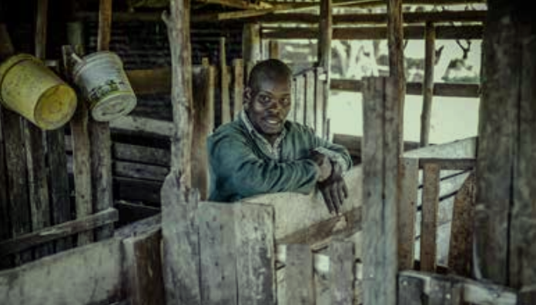

With an increasing number of people experiencing hunger and food insecurity even before the COVID-19 pandemic, the world is on the verge of a global food crisis. A cascading combination of escalating conflicts, climate-related shocks, and growing inequalities has partially undermined the world's food supply systems.

*Alex returned to his rural roots or took over a farm after leaving a job in information technology in Nairobi.He now imparts sound agricultural techniques to other young people.*

Small-scale farmers are backbone of agriculture. Yet despite their importance in combating hunger, small-scale good producers are often among the most vulnerable groups in rural areas and within the agro-food system.

Small farmers' labor productivity in low- and middle-income countries is less than $15 per day. These small-scale producers' earnings continue to be lower than those of their larger-scale competitors, with the disparities being more pronounced in nations with higher incomes. Small-scale farmers earn less than $2,000 on average annually in the majority of the nations where data is available. Women who operate small farms suffer additional disadvantages. Despite having similar productivity, female-led food production units typically earn between 50 and 70 percent less per year on average than male-led ones.

**2.4.Deaths of 15 million people due to COVID-19**

COVID-19 is now a leading cause of death. The latest estimates suggest that 15 million

people have died as a direct result of COVID-19 or from the pandemic’s impact on

health systems and society in 2020 and 2021. This estimate is nearly triple the 5.4

million officially reported COVID-19 deaths in the same period. About 84 per cent of

these “excess deaths” are concentrated in South-East Asia, Europe and the Americas,

and 68 per cent are in just 10 countries.

To effectively curb the spread of COVID-19 and prevent tens of thousands of additional

deaths, it is critical to ensure equitable access to safe and effective vaccines. WHO as

called for 70 per-cent of people in all countries to receive vaccinations by mid-2022.

That said, global vaccine distribution is far more equitable. As of May 2022, only around

17 per cent of people in low-income countries had received at least one does of a

vaccine, compared with more than 80 percent of all countries.

**2.5.Awareness of violence against older women and limited data**

Violence against women and girls is found in all countries and affects women of all ages. Globally, 26 per cent of ever-partnered women aged 15 and older(641 million) have been subjected to physical and/or sexual violence by a husband or intimate partner at least once in their lifetime. Limited evidence points to an intensification of violence against women during the pandemic. A 2021 rapid gender assessment survey in 13 countries, undertaken by the United Nations Entity for Gender Equality and the Empowerment of Women (UN Women), found that 45 per cent of women reported that they or a woman they know has experienced some form of violence since COVID-19.

Global awareness of violence against older women specifically is growing, but data on the subject are limited, and the nature, scale, severity and complexity of such violence may be underestimated. Less than 10 per cent of eligible data on intimate partner violence capture the prevalence of such violence among women aged 50 and older. Limited evidence from 2000-2018 found that between 4 per cent and 7 per cent of women in this age group experienced physical and/or sexual violence by an intimate partner in the last 12 months.

**2.6.Rise of child marriage and female genital mutilation in the light of gender equality**

In 2021, nearly one in five young women were married before the age of 18. The highest rates of child marriage are found in sub-Saharan Africa and Southern Asia, where 35 per cent and 28 per cent of young women, respectively, were married in childhood. Globally, the prevalence of child marriage has declined by about 10 per cent in the past five years. However, the effects of the COVID-19 pandemic have put more girls at risk, owing to economic shocks, school closures and interruptions in social services. By 2030, up to 10 million more girls are likely to become child brides, in addition to the 100 million girls who were projected to be at risk before the pandemic.

Another persistent harmful practise and human rights violation is female genital mutilation (FGM). At least 200 million girls are women alive today have been subjected to FGM, mainly in the 31 countries where the practise is concentrated. In many countries, it remains as common today as it was three decades ago. Even in countries where the practice has become less prevalent, progress would need to be at least 10 times fast to meet the global target of eliminating FGM by 2030. Education is one key to its elimination. Opposition to FGM is highest among girls and women who are educated. Girls whose mothers have primary education are 40 per cent less likely to be cut than those whose mothers have no education.

**2.7.Loss of wetlands at an alarming rate**

Wetlands are home to 40% of all plant and animal species in the world, making them the ecosystems with the greatest biological diversity. Inappropriate use and management of wetlands can result in direct risks, such as disease, in addition to the loss of ecosystem services. A further factor contributing to climate change is the release of carbon from degraded wetlands. Over 85% of the world's wetlands were lost over the past 300 years, primarily due to drainage and land conversion, and many of the remaining wetland areas have been degraded. 81 percent of species that depend on inland wetlands have declined more quickly since 1970 than those that depend on other biomes, and an increasing number of these species are in danger of going extinct.

Other water-related ecosystems across the planet – such as lakes, rivers and reservoirs – are also changing rapidly. One in five river basins have experienced high (i.e., above natural) fluctuations in surface water over the past five years. Population growth, changes to land cover and land use, and climate change are key drivers of these changes.

Urgent efforts are needed to protect them and to prevent further degradation of these precious biological habitats.

**2.8.The dream of affordable and clean energy**

The world continues to advance towards sustainable energy targets. Nevertheless, the current pace of progress is insufficient to achieve the goal of clean and affordable energy by 2030 as promised. Improvements in energy efficiency, for example, will need to accelerate to reach the climate goal of reducing greenhouse gas emission. Hundreds of millions of people still lack access to electricity, and slow progress towards clean cooking solutions means that the health of 2.4 billion people is at risk.

*Martha Alicia Benavente, from from Tucuru, Guatemala, trained for six months to become solar engineer, a traditionally male-dominated field. She can’t wait to start building solar lamps for her community.*

The global electricity access rate increased from 83 percent in 2010 to 91 per cent in 2020. Over this period, those without electricity shrank from 1.2 billion to 733 million. But the pace of progress has slowed in recent years, due to COVID-19 and the increasing complexity of reaching those hardest to reach. In 2018-2020, the electricity access rate rose by an average of 0.5 percentage points annually compared to 0.8 percentage points in 2010-2018.

In 2020, over three quarters (77 per cent) of the global population without electricity lived in sub-Saharan Africa, mainly in rural areas. Due to economic pressures imposed by the pandemic up to 90 million people connected to electricity in Africa and developing countries in Asia could not afford to have an extended bundle of services that year. If current trends continue, only 92 per cent of the world’s population will have access to electricity in 2030, leaving 670 million people unserved. A major push is needed to reach those living in least developed and in fragile and conflict-affected countries.

**2.9.Increased relative poverty in many countries**

The proportion of the population living on less than half the national media income is an important measure of social exclusion, relative poverty and inequality of income distribution within a country, If this proportion grow, it indicates the poorest are falling behind in relative less than half the national media income. However, this average share marks wide variations, from less than 5 per cent in Kazakhstan and Kyrgyzstan to around 25 per cent in Brazil and South Africa.

Currently,only 18 countries have data for 2020,most of which are in Latin America and the Caribbean. Among those, two thirds saw rates of relative low income increase in 2020, suggesting that the effects of the pandemic have intensified social exclusion. However, other countries experienced large declines. Brazil, for example, lowered the share of people living on less than half the median income from 24.1 to 18.3 per cent, thank to large social transfers targeted to the poorest people in that society.

**2.10.Too much food is being lost or wasted - in every country every day**

As the world faces rising food insecurity, too much food continues to be lost of wasted. In 2020, an estimated 13.3 per cent of the world’s food was lost after harvesting and before reaching retail markets. These losses occur during on-farm activities, transport, storage, processing and wholesaling. This share has remained relatively constant since 2016, suggesting no changes in structural patterns of food loss. In addition, an estimated 17 per cent of total food available to consumers(931 million metric tons) is wasted at household, food service and retail levels, translating to 121 kilograms per person each Food loss and

waste are global problems; they happen in all countries, though food losses occur chiefly in developing countries while good waste occurs mostly in developed countries. Sub-

Saharan Africa has the highest level of food insecurity, but also the highest rate of food loss.

Both food loss and food waste have substantial environmental, social and economic consequences. For example, food that ends up in landfill generates consequences. For example, food that ends up in landfills generates 8 to 10 per cent of global greenhouse gas emissions.

**2.11.Alarmingly high subsidies for fossil fuels**

Air and water pollution, as well as climate change, are all adverse effects of subsidies that encourage the production and use of coal, oil, gas, and other fossil fuels. These financial obstacles are among the biggest impeding the global switch to renewable energy sources. Governments spent $375 billion in 2020, down from $526 billion in 2019, on fossil fuel subsidies and other forms of support. However, rather than structural reforms, this decline was primarily caused by low oil prices and decreased demand during the pandemic. The price of commodities and energy sharply recovered in 2021, and it is likely that we will observe an increase in the consumption and production subsidies for fossil fuels.

Today, countries that were hesitant to seize the opportunity presented by low international fuel prices to reform subsidy schemes might be forced to maintain or

increase subsidies to offset the increasing fuel prices faced by consumers across the world. Such shortages will have fiscal consequences, however. They will also reduce the

resources needed to invest in greener recoveries and sustainable growth. The answer to high fossil fuels prices is quicker scaled-up transition to renewable energy sources.

**2.12.Fossil fuel emissions rebounded to a record high in 2021**

In 2020, social and economic disruptions caused by COVID-19 lowered energy around the world. As a result, global carbon dioxide(CO2) emissions declined by 5.2 per cent in 2020 - the equivalent of almost 2 billion metric tons, the largest decline ever and almost five times greater than the 2009 drop following the global financial crisis. But it was only a temporary reprieve. With the phasing out of COVID -related restrictions, demand for coal,oil and gas increased. Consequently, energy -related CO2 emissions for 2021 rose by 6 per cent, reaching their highest level ever and completely wiping out the pandemic -related reduction seen in 2020.

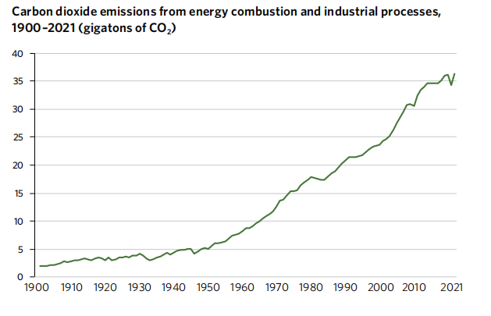

**2.13.Increasing acidification and the ocean’s capacity to moderate climate change**

The ocean absorbs around one quarter of the world’s annual carbon dioxide(CO2) emission, thereby mitigating climate change and alleviating its impacts. This critical service,however, comes at a price: it is altering the carbonate system and increasing the acidity of the ocean. Ocean acidification threatens organisms and ecosystem services,

endangers fisheries and aquaculture, and affects coastal protection by weakening coral reefs. Further increases in acidification are expected to accelerate over the coming decades. As acidification worsens, the ocean’s capacity to absorb CO2 from the atmosphere will diminish, limiting its role in moderating climate change.

The number of observation stations reporting on ocean acidification has nearly doubled over the past two years, going from 178 in 2021 to 308 in 2022. Data and reporting still have gaps. Over the past 20 to 30 years, observation sites in the open ocean have shown a consistent pH decline. Contrarily, coastal observations show a more complex picture because of various stressors.

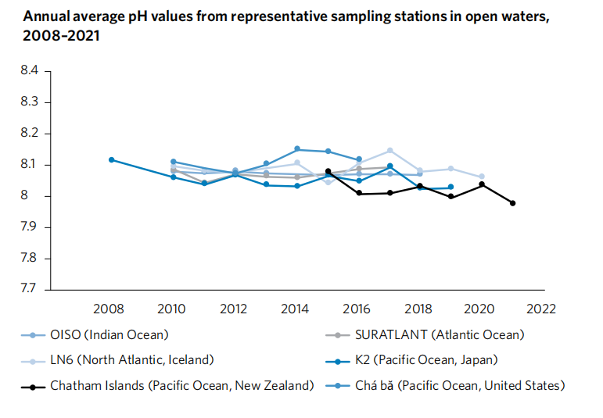

**2.14.Destruction of marine life due to the proliferation of plastic, nutrient run-off and other forms of waste**

The main sources of marine pollution are land-based,leading to a seemingly unstoppable flow of litter, waste and run-off into the ocean. In 2021, a study estimated that more than 17 million metric tons of plastic entered the world’s ocean, making up the bulk (85

per cent) of marine litter. By 2040, it is anticipated that the amount of plastic waste entering the ocean each year will have doubled or tripled, endangering all marine life.

From 2016 to the present, eutrophication brought on by nutrient pollution has increased in coastal areas. As a result, there are now more "dead zones" than ever before, with 400 in 2008 and about 700 in 2019. Due to decreased tourism and other activity, COVID-19 may have decreased coastal pollution in some areas, but the pandemic does not seem to have completely eliminated coastal eutrophication worldwide.

**2.15.Peace,justice and strong institutions - the three pillars**

Please for global peace are growing louder as the world witness the largest number of violent conflicts since 1946, with one quarter of the global population living in conflict-affected countries at the end of 2020. Amid these crises, and despite movement restrictions prompted by COVID-19, forced displacement has continued and even grown. As of May 2022, a record 100 million people had been forcibly displaced worldwide.

*Nicolai bids farewell to his wife Lolita and 4-year-old daughter Elina in Lviv, Ukraine, as they board a train headed for Poland to flee the war.*

**2.15.1.Homicide rates continue to decline**

The global homicide rate decreased from 5.9 to 5.6 homicides per 100,000 people between 2015 and 2020, a decrease of 5.2 percent. Despite the fact that women and girls make up about 60% of all homicide victims killed by intimate partners or family members, 8 out of 10 people who are recorded homicide victims worldwide are men. Regional differences in gender are also present. Between 2015 and 2020, the homicide rate in Latin America and the Caribbean decreased by 6.9 percent for men but increased by 2.7 percent for women. Homicide rates decreased by 35% for men in Eastern and South-Eastern Asia, but only by 20% for women.

The global homicide rate is anticipated to drop from its 2015 level to roughly 4.8 per 100,000 people by 2030, a 19% decrease. This does not achieve the "significant

reduction" by 2030 that the SDG’s call for. In order to make more rapid progress, additional policy interventions to reduce deadly violence in public spaces will be needed, as well as targeted legislation to stop gender-based violence within those spaces.

1. **Conclusion**

As least expected, things really didn’t go the way we wanted it to be. Starting from COVID-19 to the Ukraine conflict. We are facing an unprecedented number of challenged one after the other constantly. And, these are severely affecting our achievement of sustainable development goals by 2030. It would not be an over-exaggeration statement if I say our dreams are in jeopardy now. Nevertheless, as humans we must thrive to sustain and survive with everything we have.

*We must rise higher to rescue the Sustainable Development Goals - and stay true to our promise of a world of peace, dignity and prosperity on a healthy planet*

- Antonio Guterres

Secretary-General of the United Nations

1. **Photo credits**

Page 11 © FAO/Luis Tato

Page 14 © UN Women/Ryan Brown

Page 19 © AP Photo/Emilio Morenatti

1. **References**
2. <https://education.nationalgeographic.org/resource/sustainable-development-goals/>
3. <https://sdgs.un.org/>
4. <https://www.sciencedirect.com/topics/engineering/sustainable-development>
5. <https://www.who.int/health-topics/sustainable-development>
6. <https://unstats.un.org/sdgs/report/2022/>
7. <https://www.oecd.org/greengrowth/sustainabledevelopmentcriticalissues-freeoverviewofthereport.htm>
8. <https://leverageedu.com/blog/concept-of-sustainable-development/>
9. <https://www.wto.org/english/tratop_e/envir_e/sust_dev_e.htm>
10. <https://en.unesco.org/education2030-sdg4/targets>
11. <https://www.britannica.com/topic/sustainable-development>