Rick and Issue Management Procedure

myCash

Version: 0.1
Doc Security: Public
Author: Alonso Cerpa
Date: 10/05/2018


Contents
Purpose 3
Risk and Issue Management Strategy 3
Approach 3
Risk and Issue Management Process 4
Process Flow 5
Process Description 9
Categorization and Evaluation Tables 13
Risk and Issue Impact Evaluation Criteria 13
Risk Severity 14
Approval Cycle 15
Change History 15

Purpose
The purpose of this management plan is to:
- To identify who will be responsible for managing the project's risks and issues;
- To specify the project's risk and issue management process; and
- To determine the parameters to be used when evaluating and classifying the project's risks and issues.
This document is a Project Management deliverable to be applied to all projects run within Flinders University Information Technology Services.

Risk and Issue Management Strategy

Approach
Risks and Issues associated with the projects will be managed by the following responsible project resources:
- Project Manager
- Project Team
Any team member can identify risks or issues associated with a project and they have the responsibility to report and document, the risk or issue to one or more of the roles listed above.
A Risk is defined as:
An event or condition that may impact one or more of a project’s objectives from being met.
A risk requires a mitigation plan to prevent it being realised in the future
A risk is resolved/closed if:
- It has been realised and has become an issue; or
- It has been successfully mitigated and is no longer is a risk to the project at a point in time.
An Issue is defined as:
An actual event or condition that has occurred and is impacting a project to an extent that one or more of the project’s objectives will not be met.
An issue requires an action plan.
An issue is resolved/closed when:
- the action plan is successfully executed; or
- It no longer is an issue for the project at a point in time.

Risk and Issue Management Process

Process Flow
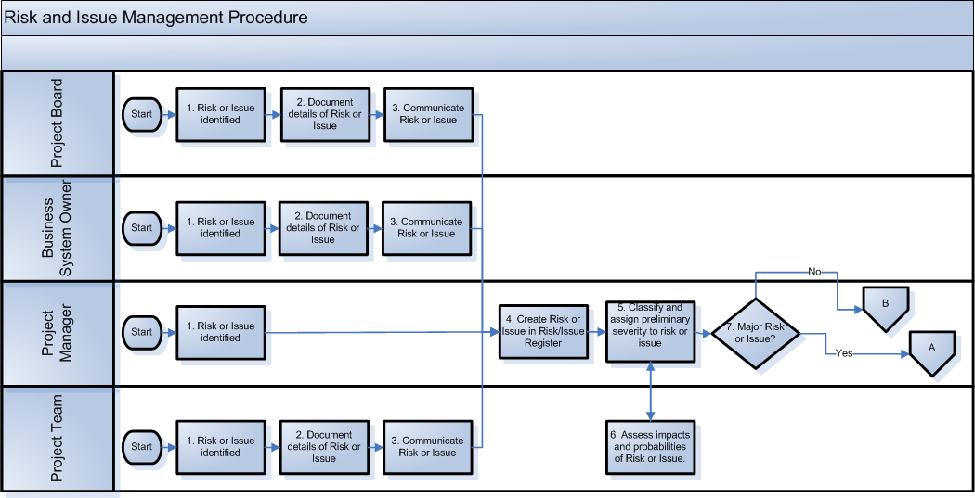

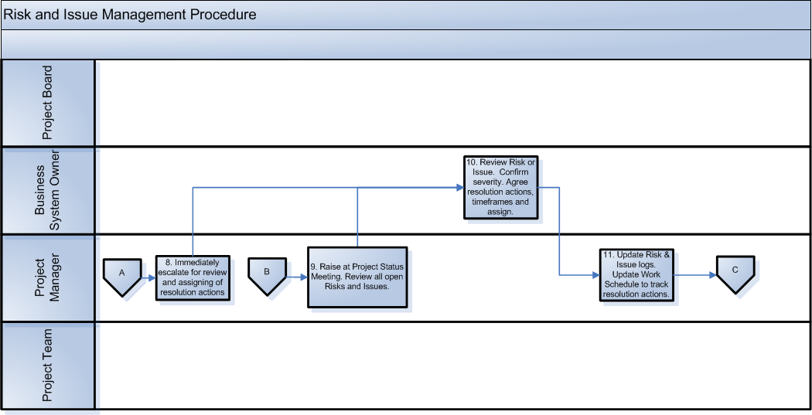

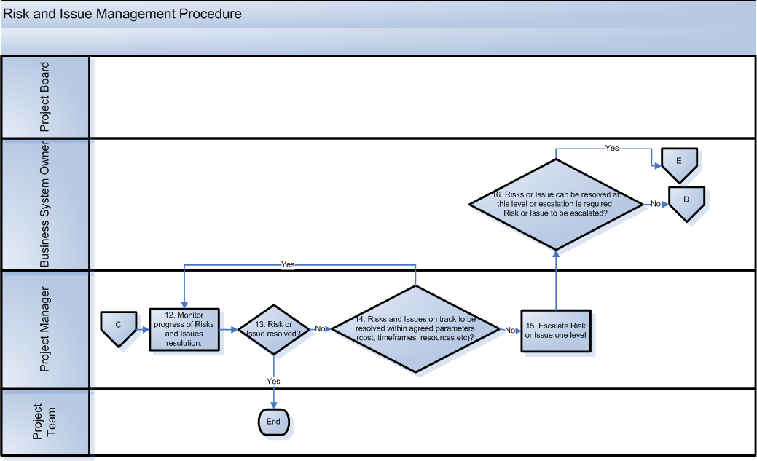
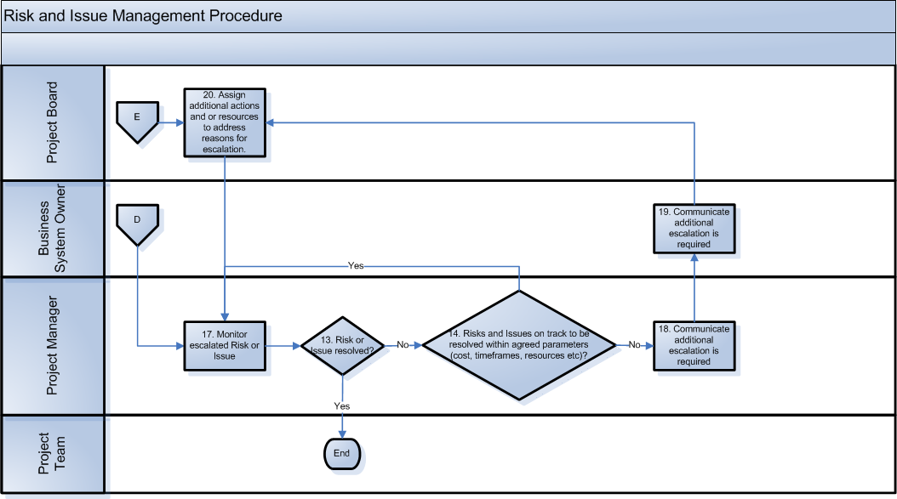

Process Description
Process ID | 1 | Process Name | Risk or Issue identified
Responsible | Frequency | Description
- Project Board  - Business System Owner  - Project Manager  - Project Team | As required | Each project role is responsible for identifying risks and issues. Risks and Issues can be identified at any time throughout the project.

Process ID | 2 | Process Name | Risk or Issue identified
Responsible | Frequency | Description
- Project Board  - Business System Owner  - Project Team | As required | Once identified each Risk and Issue must be documented with sufficient detail to enable investigation and a resolution or action plan to be defined.

Process ID | 3 | Process Name | Risk or Issue identified
Responsible | Frequency | Description
- Project Board  - Business System Owner  - Project Team | As required | Once a Risk or Issue has been identified and documented the identifier communicates the Risk or Issue to the Project Manager.  The communication can be via email, document or meeting minutes.

Process ID | 4 | Process Name | Risk or Issue identified
Responsible | Frequency | Description
- Project Manager | As required | Once the Risk or Issue is received by the Project Manager he/she raises the Risk or Issue in the respective register.

Process ID | 5 | Process Name | Classify and assign preliminary severity to risk or issue
Responsible | Frequency | Description
- Project Manager | As required | The Project Manager examines the detail of the Risk or Issue to determine:  - That the Risk or Issue is in fact a Risk or Issue. Modifications made to the Risk or Issue as required.  - Assigns a preliminary impact and likelihood rating to the Risk or Issue.  The preliminary rating is based on the Project Manager’s knowledge of the project and through discussions with the Project Team.

Process ID | 6 | Process Name | Assess impacts and probabilities of Risk or Issue
Responsible | Frequency | Description
- Project Team | As required | The Project Team participates in the assessment of Risks and Issues.

Process ID | 7 | Process Name | Major Risk or Issue?
Responsible | Frequency | Description
- Project Manager | As required | Based on the preliminary assessment of the Risk or Issue different actions will be taken. A Major severity Risk or Issue will be escalated immediately whereas a Medium or Minor severity Risk or Issues will be escalated through the normal project review cycle.

Process ID | 8 | Process Name | Immediately escalate for review and assigning of resolution actions
Responsible | Frequency | Description
- Project Manager | As required | If the preliminary assessment determines that the Risk or Issue is of major severity the Project Manager immediately escalates the Risk or Issue to the Business System Owner for action.

Process ID | 9 | Process Name | Raise at Project Status Meeting. Review all open Risks and Issues. Determine resolution actions and assign to resources
Responsible | Frequency | Description
- Project Manager | As required | The Project Manager raises medium and minor Risk and Issues at the weekly project status meeting.  All open Risks and Issues are reviewed at this meeting.

Process ID | 10 | Process Name | Review Risk or Issue. Confirm severity. Agree resolution actions, timeframes and assign
Responsible | Frequency | Description
- Business System Owner | As required | All open Risks and Issues are reviewed at the weekly project status meeting to confirm that  - severity rating is appropriate  - the resolution action plan is appropriate  - resources are assigned to the various resolution actions  - timeframes are appropriate and achievable  - an owner is assigned to the Risk or Issue – ie the person responsible for resolving the Risk or Issue  For Major severity Risks and Issues the above items are reviewed as the Risk or Issue is raised, ie the review does not wait for the weekly project status meeting.

Process ID | 11 | Process Name | Update Risk & Issue logs. Update Work Schedule to track resolution actions
Responsible | Frequency | Description
- Project Manager | As required | The outcomes from the Risk and Issue reviews are updated in the Risk and Issue registers.

Process ID | 12 | Process Name | Monitor progress of Risks and Issues resolution
Responsible | Frequency | Description
- Project Manager | As required | The various resolution actions associated with each Risk and Issue are monitored by the Project Manager. Usually the actions are incorporated into the delivery work schedule so they can be tracked as part of the delivery of the project.  Timeframes, cost, dependencies and resourcing are monitored.

Process ID | 13 | Process Name | Risk or Issue resolved?
Responsible | Frequency | Description
- Project Manager | As required | The Project Manager determines if the Risk or Issue has been resolved, ie the circumstances that caused the Risk or Issue to be raised no longer exist or the severity is so low that there will be negligible impact on the project.

Process ID | 14 | Process Name | Risks and Issues on track to be resolved within agreed parameters (cost, timeframes, resources etc)?
Responsible | Frequency | Description
- Project Manager | As required | The Project Manager determines if the Risk or Issue is currently on track to be resolved within the agreed plan and other project constraints, eg cost, resource allocation and overall schedule.

Process ID | 15 | Process Name | Escalate Risk or Issue one level
Responsible | Frequency | Description
- Project Manager | As required | If the Risk or Issue is not forecast to be resolved within the agreed parameters (cost, schedule and resource allocation) the Risk or Issue is escalated by the Project Manager to the next level, i.e. the Business System Owner.

Process ID | 16 | Process Name | Risk or Issue to be escalated?
Responsible | Frequency | Description
- Business System Owner | As required | The escalation point resource examines the Risk or Issue and will either;  - assign additional resources to resolve the risk or issue  - escalate to the Project Board for resolution

Process ID | 17 | Process Name | Monitor escalated Risk or Issue
Responsible | Frequency | Description
- Project Manager | As required | The various resolution actions associated with the escalated Risk and Issue are monitored by the Project Manager. The frequency of monitoring will depend on the Risk or Issue severity.

Process ID | 18 | Process Name | Communicate additional escalation is required
Responsible | Frequency | Description
- Project Manager | As required | If the escalated Risk or Issue is not forecast to be resolved within the agreed parameters (cost, schedule, resource allocation) the Project Manager requests that the Risk or Issue be escalated another level. The request is made to escalation level one, ie to the Business System Owner.

Process ID | 19 | Process Name | Communicate additional escalation is required
Responsible | Frequency | Description
- Business System Owner | As required | If the escalated Risk or Issue is not forecast to be resolved within the agreed parameters (cost, schedule, resource allocation) the Business System Owner requests that the Risk or Issue be escalated another level. The request is made to escalation level one, i.e. to the Project Board.

Process ID | 20 | Process Name | Assign additional actions and or resources to address reasons for escalation.
Responsible | Frequency | Description
- Project Board | As required | The Project Board meets to determine next steps and allocate any required resources to resolve the Risk or Issue.

Categorization and Evaluation Tables

Risk and Issue Impact Evaluation Criteria
This section establishes the criteria used to evaluate the impact of issues and the potential impact of risks for ITS related projects.

 | Impact
Affected Project Areas | 1  Very Low | 2  Low | 3  Moderate | 4  High | 5  Very High
Solution Scope | <1% decrease in business benefits | 1-2% decrease in business benefits | 2-5% decrease in business benefits | 5-10% decrease in business benefits | >10% decrease in business benefits
Solution Quality | <20% increase in response time | 20-40% increase in response time | 40-60% increase in response time | 60-100% increase in response time | >100% increase in response time
Project Cost | <2% increase in project cost | 2-4% increase in project cost | 5-10% increase in project cost | 10-20% increase in project cost | >20% increase in project cost
Project Schedule | Any slippage can be accommodated within the current schedule | Additional activities required to meet key milestones | Key milestones will slip, but the project can be implemented on time | The system will be implemented less than one month late | The system will be implemented more than one month late

Risk Severity
The following matrix is used to determine risk severity:

Likelihood
Very High | 100% | 1 | 2 | 3 | 4 | 5 |  | 2.01 to 5 | Major Risk
 | 75% | 0.75 | 1.5 | 2.25 | 3 | 3.75 |  | 0.5 to 2 | Medium Risk
 | 50% | 0.5 | 1 | 1.5 | 2 | 2.5 |  | 0 to 0.49 | Minor Risk
 | 25% | 0.25 | 0.5 | 0.75 | 1 | 1.25
Very Low | 10% | 0.1 | 0.2 | 0.3 | 0.4 | 0.5
 | 0% | 0 | 0 | 0 | 0 | 0
 |  | 1 | 2 | 3 | 4 | 5
 |  | Very Low |  |  |  | Very High
 |  |  | Impact

When documenting a risk the risk priority is calculated by multiplying the ‘Likelihood value’ with the ‘impact value’ evaluated (0.1 = very low, …, 5 = very high). The risk severity corresponds to the colour of the cell at the intersection of its impact value and ‘Likelihood value’ ratings.

Approval Cycle
Role | Name | Signature | Date
Reviewer(s): | Alonso Cerpa |  | 10/05/18
Approver(s): | Alonso Cerpa |  | 10/05/18

Change History
Version (State) | Author | Change Description | Date
0.1 | Alonso Cerpa | Original draft | 10/05/18

