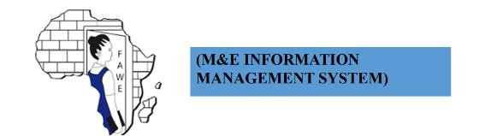

**FAWE M&E INFORMATION MANAGEMENT SYSTEM**

ADMIN MANUAL

Table of Contents

Accessing the System 2

Login Screen 2

Modules and Sub Modules 3

Home & Main Menu 5

# Accessing the System

The **M&E INFORMATION MANAGEMENT SYSTEM** can be accessed with any device (PC/laptop/tablet/mobile) with an internet connection through all major browsers (IE/Chrome/Firefox/Safari).

Type the following URL in the address bar of the browser to access the system.

[**http://102.37.249.108:8080/fawedemo/home**](http://102.37.249.108:8080/fawedemo/home)

# Login Screen

Upon visiting the URL, you will be directed to the login screen of the Forum for African Women Educationalists (FAWE) M&E Information Management System. Below is an example of the login screen:

1. Enter your Username/Email Address: Input your registered username or email address.
2. Enter your Password: Type your password associated with your account.
3. Click on Login: Once both fields are filled, click the Login button to proceed.

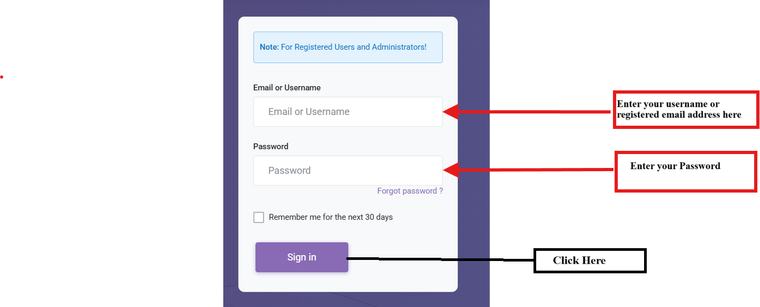

***Image 1***

# Modules and Sub Modules

The main modules and the sub modules in the system are as below (These can be directly accessed from the Main Menu). You can access the modules and sub modules for which you have been granted access rights. In case you do not see the link for a module or sub module you wish to access in the Main Menu, kindly contact your system administrator to request access rights.

Home: Clicking on home in the Main Menu brings you to the home page.

Dashboard: Clicking on dashboard in the Main Menu brings you to the dashboard ((M&E INFORMATION MANAGEMENT SYSTEM).

System Configuration: Clicking on Configuration in the Main Menu brings you to the System Configuration (the System Configuration) of the system.

* Chapters: This Module should be used to enter County data in the system to set up the system for use by other Modules of the system.
* Units: This Module should be used to enter Unit data in the system to set up the system for use by other Modules of the system.
* Dimensions: This Module should be used to enter Dimensions data in the system to set up the system for use by other Modules of the system.
* Implementing Partner: This Module should be used to enter Implementing Partner data in the system to set up the system for use by other Modules of the system.
* Funding Partner: This Module should be used to enter Funding Partner data in the system to set up the system for use by other Modules of the system.
* Field Office: This Module should be used to enter Field Office data in the system to set up the system for use by other Modules of the system.
* Currency: This Module should be used to enter Currency data in the system to set up the system for use by other Modules of the system.

User Management: This module should be used by the system administration to perform user management tasks. User Management has following sub modules.

* + Change Password: This sub module should be used by all users to change their password. It is recommended that the password should be changed at least once every 45 days to minimize the risk of account being hacked.
  + Manage User Roles: This sub module should be used by the system administrator to add, modify or delete user profiles.
  + Manage User Rights: Manage User Rights are categories of users with similar access rights, i.e. users assigned to Manage User Rights would have similar access rights to data and functionality.
  + Manage Users: This sub module should be used by the system administrator to add users, modify user details or remove users.
  + View System Audit Trail: This sub module should be used by the system administrator to view user activities. ... Audit trails improve the audit ability of the system.
  + Access User Manual: This sub module should be used by the system administrator to access the latest copy of manual to get help in regular operation of system.

**Logout:** This option should be used to log out of the system. It is recommended to always log out of the system before closing the browser to minimize the risk of your account being hacked.

All the modules mentioned in the list above are explained in detail further in this document.

# Home & Main Menu

Upon successful login, you would be displayed the home page of the (M&E INFORMATION MANAGEMENT SYSTEM). On the right hand side of the Home Screen you would see the Main Menu of the system which you shall use to navigate the system and access different functionality.



 