CuraLive
Multi-Region Mirroring & Infrastructure Brief
Response to Steve’s Comments

This document preserves the original brief with Steve’s comments (yellow boxes) and David’s responses (blue boxes) inline. Each of Steve’s four highlighted points is addressed directly.

1. Why Multi-Region Mirroring Matters

CuraLive is a real-time investor events platform. When an earnings call or investor presentation is live, any interruption — even 30 seconds of downtime — can damage credibility and lose critical intelligence data.

Mirroring the platform in a second region means:
• If the primary server goes down, a backup takes over automatically
• No data is lost — the database is replicated in real time
• Telephony (phone calls) continues uninterrupted — Twilio already operates globally

STEVE’S COMMENT:
This is really good and Customers will love it, esp big banks.

DAVID’S RESPONSE:
Agreed — this is one of CuraLive’s strongest selling points for enterprise. The key message for sales conversations: active phone calls are managed entirely by Twilio’s global infrastructure and are completely independent of CuraLive’s application servers. A CuraLive server failover does not interrupt any call in progress.

Bank IT teams will specifically ask about this during vendor assessment. I’d recommend making this even more prominent in client-facing materials — perhaps a dedicated callout box rather than a bullet point. This is the sentence their procurement team will want to read.

• Clients in different geographies get faster, lower-latency connections
• Regulatory compliance — some jurisdictions require data to stay within their borders

2. What CuraLive Runs On

CuraLive is a lightweight, modern web application. It does not need heavy infrastructure:

Application Server  Node.js + Express + React  Runs on any cloud VM or container  Small footprint — 1–2 CPU cores, 2–4 GB RAM |  | Database  PostgreSQL  Managed by cloud provider (RDS, Cloud SQL, etc.)  Full replication support built in

Telephony  Twilio (global by default)  No extra setup for multi-region  Calls route through Twilio’s global network |  | AI & Intelligence  OpenAI API (cloud-based)  No infrastructure needed  Works identically from any region

This architecture is cloud-agnostic. CuraLive can run on AWS, Azure, GCP, or any VPS provider. Nothing is locked to a single vendor.

3. How Multi-Region Mirroring Works

🇱🇦 PRIMARY REGION  e.g. South Africa or EU (London)  Main application server  Primary database  Handles all live traffic  This is where operators and clients connect |  | 🇺🇸 SECONDARY REGION  e.g. US East or UK  Standby application server  Replica database (real-time sync)  Ready to take over within 60 seconds  Takes no traffic until failover
↔️ Continuous sync between regions
What happens during a failover:
1. Primary region goes down (server crash, network outage, data centre issue)
2. Health check detects the failure within 30–60 seconds

STEVE’S COMMENT:
Is this done via a polling app/function? If so, can it be configured to carry out the check at shorter intervals? We could build our own AI agent to perform the task?

DAVID’S RESPONSE:
Yes — health checks are performed by the cloud provider’s DNS failover service (e.g. AWS Route 53, Cloudflare). These are polling-based checks that send a request to the application server at configurable intervals.

Default interval: every 10–30 seconds. This can be reduced to as low as every 5 seconds for faster detection. Checks run from multiple geographic locations simultaneously — failure is only confirmed when multiple locations agree, which prevents false positives.

Steve’s idea about building an AI agent for this is creative. Standard cloud health checks are reliable for basic “is the server up” monitoring, but where an AI agent would add real value is at the application level — checking not just server availability but:

• Is the database connected and responsive?
• Is the Twilio API reachable and authenticated?
• Is the OpenAI API responding?
• Are active events still streaming correctly?

This kind of intelligent health monitoring goes beyond a simple HTTP ping. It’s the level of monitoring that enterprise IT and audit teams expect to see. Worth building as a future feature.

3. DNS automatically routes all traffic to the secondary region
4. Database replica is promoted to primary — all data is intact, no loss
5. Telephony continues uninterrupted — Twilio is completely independent of our servers
6. Users reconnect within 1–2 minutes without any manual intervention

Important: phone calls already in progress will not drop.
Twilio manages call audio independently. Only the OCC dashboard reconnects.

Can it be mirrored across countries?
Yes. The two regions can be in different countries entirely. Common setups:
• Primary in South Africa (AWS Cape Town) + Secondary in the UK (AWS London)
• Primary in the EU (London or Frankfurt) + Secondary in the US (Virginia)
• Primary in the US + Secondary in Asia-Pacific (Singapore or Sydney)

The choice depends on where your clients and operators are located, and what data residency rules apply to your industry.

4. Cost Breakdown

These are cloud infrastructure costs only. CuraLive itself has no per-region licensing fee — you are paying for the servers and phone lines, not the software.

THREE TIERS

🟢 STARTER  $200 – $500 / month  1 small cloud server  Managed database replica  Basic health checks  Manual failover |  | 🟠 PRODUCTION  $500 – $1,500 / month  Auto-scaling servers  Real-time DB sync  Automatic DNS failover  Monitoring & alerts  Daily backups |  | 🟣 ENTERPRISE  $1,500 – $5,000 / month  Multi-region active-active  Zero-downtime failover  Dedicated DB clusters  24/7 monitoring  SLA guarantees

EXAMPLE: SA PRIMARY + UK SECONDARY + 3 COUNTRIES

Primary region (AWS Cape Town — application + database) | $200 – $400/mo
Secondary region (AWS London — standby + replica DB) | $150 – $300/mo
Database replication (continuous sync between regions) | $50 – $150/mo
DNS failover service (Route 53 health checks) | $50/mo
SSL certificates (Let’s Encrypt) | Free
Monitoring & alerting (CloudWatch / Datadog basic) | $0 – $50/mo
Local phone numbers — SA, UK, US (3 numbers) | $10/mo
Twilio call minutes (~2,000 minutes/month) | $40 – $80/mo

ESTIMATED MONTHLY TOTAL | $500 – $1,000

At enterprise tier with SLA guarantees and active-active: $2,000 – $5,000/month. This is still very competitive compared to legacy conferencing platforms which charge $10,000–$50,000/month for equivalent setups.

STEVE’S COMMENT:
I agree — actually it’s remarkably low and IMO will ultimately be needed when we get contracts and come under scrutiny from Customer’ internal IT/audit teams.

DAVID’S RESPONSE:
Exactly right. Multi-region mirroring is not a future nice-to-have — it is a requirement for enterprise client acquisition. Financial institutions will require documented disaster recovery and business continuity capabilities during their vendor due diligence process.

The fact that CuraLive can deliver global resilience for $500–$1,000/month versus $10,000–$50,000 for legacy platforms is a major competitive advantage. This cost comparison should be front and centre in sales presentations.

When enterprise clients’ internal IT and audit teams scrutinise the platform, they will specifically ask for:

• Documented disaster recovery procedures
• Business continuity plan with defined RTO/RPO targets
• Evidence of failover testing
• Data residency and jurisdiction documentation

Having these ready before the first enterprise pitch will accelerate the sales cycle significantly.

To build on this……….I’ve copied a section from the Manus Trust Centre - Trust Center - manus.ai
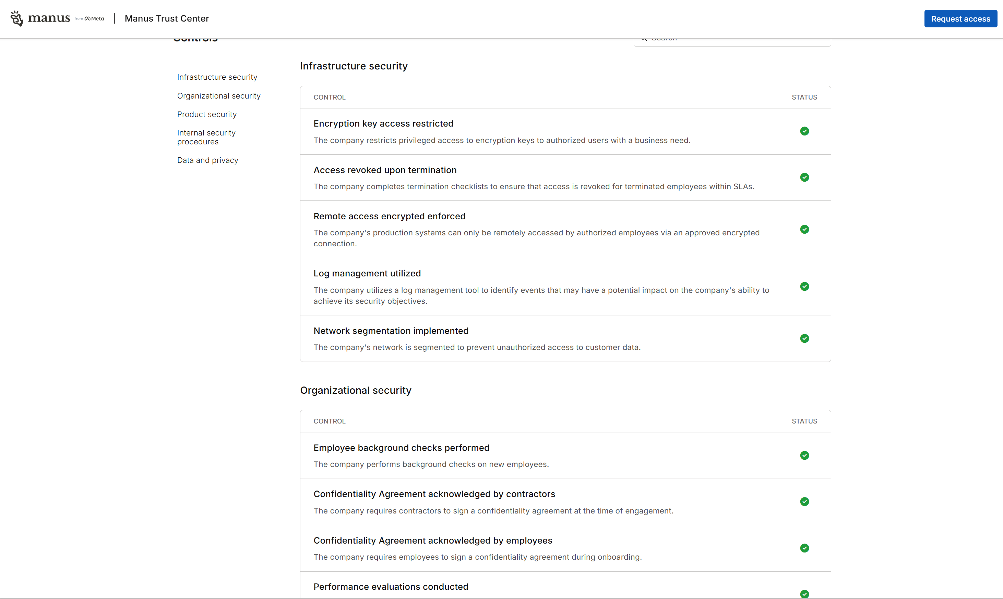
There’s more information in there. We will need to replicate these things in the CuraLive organisation. In that way we are SOC2 compliant as is the tech we build our services on – InfoSec teams will expect this.

5. Telephony & Bring Your Own Carrier

CuraLive currently uses Twilio for all telephony — dial-in, dial-out, bridge connections, and call recording. Twilio is a global carrier that operates in 180+ countries.

However, you are not locked in. CuraLive’s telephony layer supports:

💰 Lower Costs  Bring your own SIP trunks  from a local carrier  Typically 30–70% cheaper  at volume |  | 🇱🇦 Local Numbers  Get local numbers in SA,  UK, US, EU, Asia  Attendees dial local,  not international |  | 🛡️ Redundancy  Run multiple carriers  If one goes down, calls  route through the other  automatically

How BYOC works:
1. You contract with a local carrier (e.g. Vodacom, BT, AT&T, or any SIP provider)
2. They provide SIP trunk credentials and local phone numbers
3. These are configured in CuraLive’s telephony settings
4. All calls now route through your carrier instead of (or alongside) Twilio
5. Twilio can remain as a backup for automatic failover between carriers

Twilio also supports BYOC natively — you can connect your own SIP trunks through Twilio’s platform and keep all existing integrations while benefiting from your own carrier’s rates.

STEVE’S COMMENT:
I think this would be worth investigating when the time’s right. It’s probably a feature of most carriers now, but when we used Bandwidth they had a real-time call performance dashboard that we always had up on a large screen. It showed all kinds of quality metrics at the network level but also allowed us to drill down to the routing that an individual participant used. It showed latency rates, buffering, packet loss etc and was very useful when investigating complaints about call quality.

DAVID’S RESPONSE:
This is excellent operational insight. Steve is right — when running events for banks and financial institutions, having visibility into call quality at the network level is essential for investigating complaints and maintaining SLA compliance.

Good news: Twilio already offers something equivalent. Twilio Insights provides per-call quality metrics including:

• MOS scores (Mean Opinion Score) — the industry standard for call quality
• Jitter — variation in packet arrival time
• Packet loss — percentage of audio packets lost in transit
• Latency — round-trip delay per participant
• Per-participant breakdown — drill down to individual caller quality

This data can be surfaced directly inside the CuraLive OCC, giving operators real-time visibility into call quality alongside the live transcript, sentiment scores, and compliance flags. Operators could identify and respond to quality issues during the event, not after.

When BYOC is implemented, equivalent dashboards from the carrier (like the Bandwidth real-time performance dashboard Steve describes) can be integrated alongside Twilio’s metrics. This gives comprehensive quality monitoring across all telephony paths.

Recommendation: Building call quality monitoring into the OCC should be prioritised alongside the BYOC investigation. Enterprise clients will expect it.

6. What’s Already in Place

• Cloud-agnostic architecture — Node.js + PostgreSQL, runs anywhere
• Twilio telephony with global reach — already multi-region by default
• Stateless application design — any server instance can handle any request
• Database schema supports replication — PostgreSQL streaming replication ready
• AI/Intelligence via cloud APIs (OpenAI) — no region-specific infrastructure needed
• Telnyx already referenced as alternative carrier in the codebase

What needs to be done to go live with mirroring:
1. Choose a cloud provider and two regions (e.g. AWS Cape Town + London)
2. Deploy the application to both regions using containers or VMs
3. Set up managed PostgreSQL with cross-region read replicas
4. Configure DNS failover (Route 53 or Cloudflare)
5. Set up monitoring and health check alerts
6. Test failover with a simulated outage

Timeline: 2–4 weeks for a production-grade deployment with testing. No code changes required — this is purely infrastructure configuration.

7. Why This Matters for Enterprise Sales

• Enterprise readiness — multi-region shows the platform is production-grade, not a prototype
• Global scalability — can serve clients in any geography without rebuilding
• Regulatory flexibility — data can stay within required jurisdictions
• Cost efficiency — $500–$1,000/month for global resilience vs $10,000–$50,000 for legacy platforms
• Carrier independence — not locked to any single vendor, can negotiate rates at scale
• Zero-code migration — no application changes needed to move between clouds

CuraLive is designed to be acquired.
The infrastructure story is as strong as the product story.

Summary — Steve’s Comments & Agreed Actions

Comment 1: Telephony Independence (Section 1)
Steve’s point: Customers — especially big banks — will love the fact that phone calls don’t drop during a failover.
Action: Make call independence the lead selling point in client presentations. Add a dedicated callout in all enterprise materials: “Active calls are managed by Twilio’s global infrastructure, completely independent of CuraLive servers. Server failover does not interrupt calls in progress.”

Comment 2: Health Check Intervals (Section 3)
Steve’s point: Can health checks run at shorter intervals? Could we build an AI agent for monitoring?
Action: Health checks are configurable down to 5-second intervals via the cloud provider. For application-level monitoring (DB, Twilio, AI API, active events), an intelligent health agent is worth building

Comment 3: Cost Positioning (Section 4)
Steve’s point: The cost is remarkably low and will be needed when under IT/audit scrutiny from enterprise clients.
Action: Position the $500–$1,000/month cost comparison against legacy platforms ($10,000–$50,000) as a headline in all sales materials. Prepare disaster recovery documentation, business continuity plan, and RTO/RPO targets before the first enterprise pitch.

Comment 4: Call Quality Monitoring (Section 5)
Steve’s point: Bandwidth had a real-time call performance dashboard showing per-participant quality metrics. This was invaluable for investigating complaints.
Action: Twilio Insights already provides equivalent metrics (MOS, jitter, packet loss, latency per participant). Surface this data inside the CuraLive OCC. When BYOC is implemented, integrate carrier-level quality dashboards alongside Twilio’s. Prioritise this as an enterprise readiness feature.

Overall Assessment

Steve is thinking like an enterprise buyer — exactly the right lens.
Every comment aligns with what bank IT teams and procurement
departments will ask during vendor assessment.

His operational experience (the Bandwidth dashboard reference)
is particularly valuable and should inform how the OCC evolves.

CuraLive — Confidential | Response to Partner Comments | 2026/03/13

