Title of the Invention
System and Method for Artificial Intelligence-Based Anti-Hijack Detection, Journey Integrity Monitoring, Secure Vehicle Authorization, Protected Immobilization, Authenticated Reactivation, Multi-Device Correlation, and Adaptive Emergency Communication
Applicant
[INSERT APPLICANT NAME]
[INSERT PHYSICAL ADDRESS]
Republic of South Africa
Abstract
A system and method for protecting a vehicle and its occupant by learning driver-specific behaviour, monitoring planned, shared, selected, or inferred journeys, correlating signals from an in-vehicle device, a handset, and optionally a wearable device, and detecting anomalous conditions indicative of hijacking, coercion, theft, tampering, or unauthorized startup. The system may determine an authorization state based on one or more trusted credentials and tamper-related signals, place the vehicle in a protected immobilized state when authorization is absent or invalid, and permit authenticated reactivation only after verified authentication. The system may further select among multiple communication pathways, including cellular, Bluetooth relay, wireless, or mesh pathways, to transmit alerts or location data under normal or degraded communication conditions. The invention further provides staged response policies, covert emergency activation, trusted-contact monitoring, and OEM-integrated or secondary-module embodiments.

Field of the Invention
The present invention relates to vehicle security systems, journey monitoring systems, intelligent authorization systems, and emergency communication platforms.
More specifically, the invention relates to artificial intelligence systems capable of learning driver behaviour, monitoring journey integrity, correlating signals from a vehicle, a mobile handset, and optionally a wearable device, detecting unauthorized startup or tampering conditions, and initiating adaptive anti-hijack and emergency response actions.
The invention further relates to secure authorization and immobilization methods in which valid operation of a vehicle is conditioned upon the existence of a verified authorization state and the absence of tamper-related anomalies.

Definitions
Vehicle Device
an in-vehicle electronic device installed in or associated with a vehicle and configured to collect, process, transmit, or store vehicle-related data.
Driver Behaviour Profile
a data-driven representation of normal or expected behaviour of a specific driver, including route choices, timing patterns, speed tendencies, stop tendencies, acceleration tendencies, or any combination thereof.
Journey Integrity
the degree to which live vehicle movement corresponds with an intended, selected, shared, or inferred journey.
Threat Score
a computed risk value derived from one or more contextual signals and used to classify the likelihood or severity of distress, hijack, tamper, theft, coercion, or unauthorized activity.
Communication Pathway
any channel, interface, network, or relay mechanism by which the platform may transmit or receive data, including cellular, Bluetooth, Wi‑Fi, mesh, sub‑GHz, or equivalent pathways.
Communication Orchestration Engine
a computational module configured to evaluate available communication pathways and select, rank, combine, or sequence pathways for one or more transmissions.
Trusted Device
a mobile phone, wearable, vehicle component, key credential, tag, or other authorised device recognised by the platform as being associated with an authorised user.
Wearable Device
a smartwatch, smart band, biometric wearable, or other body-associated electronic device capable of providing one or more signals relating to presence, pairing, body contact, motion, biometrics, user input, or location.
Correlation Engine
a module configured to combine signals from two or more sources, including vehicle, phone, wearable, cloud, key, or route context, in order to classify a condition or determine a response.
Covert Emergency Mode
an operating state in which one or more security actions are activated without requiring visible driver interaction.
Driver-Vehicle Separation Event
a detected condition in which the vehicle and a trusted device associated with the driver diverge geographically or behaviourally beyond an expected threshold.
High-Risk Zone
a geographic or contextual condition associated with increased vulnerability to vehicle crime, hijacking, isolation risk, or other security threats.
Authorization State
a machine-determined state indicating whether one or more valid authorization conditions exist for vehicle startup, operability, reactivation, or continued use.
Trusted Credential
a key transponder, OEM immobilizer credential, secure token, paired handset, paired wearable, cryptographic secret, server-issued authorization code, or other credential recognised as satisfying at least part of an authorization condition.
Protected Immobilized State
a recoverable secured state in which startup or selected vehicle functions are inhibited, while preserving tamper records, alert functionality, or reactivation controls.
Authenticated Reactivation
a controlled process by which a protected immobilized state is removed after verified presentation of one or more trusted credentials, tokens, confirmations, or service authorizations.
Startup Sequence Anomaly
an irregular ignition, ECU, CAN bus, credential, or related sequence indicative of bypass, tampering, unauthorized activation, or abnormal startup behaviour.
Tamper Event
any detected physical, electrical, logical, software, firmware, or communication-layer interference with the vehicle, the vehicle device, the ECU, wiring, sensors, or associated components.
Secure Authorization Layer
a hardware, software, or hybrid subsystem configured to determine the authorization state and control startup, lockout, or reactivation behaviour.

Background of the Invention
Vehicle hijacking, coercive vehicle diversion, vehicle theft, signal interference, and unauthorized startup remain significant safety and asset-protection risks in many regions.
Conventional vehicle tracking systems typically rely on GPS and cellular communication, often require manual panic-button activation, and frequently become less effective when a driver cannot safely interact with a device or when a communication jammer is present.
Known immobilizer and key-based systems generally verify only a limited startup credential and may not correlate route context, vehicle telemetry, trusted-device presence, or startup-sequence anomalies to determine whether a broader threat condition exists.
Known family-tracking applications may provide route visibility but do not generally learn each driver over time, correlate signals from vehicle, handset, and wearable devices, classify route deviations under threat conditions, or control a protected immobilization and authenticated reactivation workflow.
There is accordingly a need for a more capable anti-hijack platform that may learn behaviour over time, monitor journey integrity, detect unauthorized startup or tampering conditions, correlate multi-device signals, survive degraded communications, and execute controlled responses including protected immobilization and authenticated reactivation.

Summary of the Invention
According to a first aspect of the invention, there is provided a vehicle security platform comprising an in-vehicle electronic device, an artificial intelligence processor associated with the in-vehicle electronic device, a journey-monitoring module, and a communication module configured for one or more communication pathways.
According to a further aspect, the artificial intelligence processor is configured to learn driver-specific behavioural patterns from historical journey and driving data and to construct one or more driver behaviour profiles.
According to a further aspect, the platform is configured to monitor journey integrity by comparing real-time movement with an intended, selected, shared, or inferred route and to classify route deviations according to context.
According to a further aspect, the platform is configured to correlate signals from the vehicle, a mobile handset, and optionally one or more wearable devices to determine whether an anomalous, distress, tamper, or hijack-related condition exists.
According to a still further aspect, the platform is configured to determine an authorization state based on one or more trusted credentials, startup sequence signals, trusted-device presence, or tamper-related signals, and to place the vehicle in a protected immobilized state when authorization is absent, invalid, or compromised.
According to a still further aspect, the platform is configured to permit authenticated reactivation only after verified satisfaction of one or more reactivation conditions, optionally including owner verification, service-agent verification, server authorization, or one-time token validation.
According to another aspect, the platform is configured to dynamically select, rank, or combine communication pathways and to execute one or more staged response actions including silent verification, covert alerts, trusted-contact escalation, tamper logging, tracking transmission, or responder escalation.

System Overview
The anti-hijack platform may include the following modules and components:
• hidden in-vehicle AI device for local capture, processing, and decision support;
• edge artificial intelligence engine for behavioural modelling, anomaly detection, authorization-state determination, scoring, and policy execution;
• driver application for route setup, trip sharing, alert preferences, and review of events;
• trusted-contact application or portal for live route following and escalation visibility;
• cloud or remote platform for alert routing, logging, analytics, authorized reactivation management, and optional responder integration;
• wearable integration layer for receipt of one or more wearable-device signals;
• communication orchestration engine for multi-path transmission and fallback logic;
• secure authorization layer for startup validation, protected lockout, and authenticated reactivation;
• response policy engine for stage-based action selection; and
• optional vehicle-audio or voice interface for route-risk prompts or covert trigger recognition.

Brief Description of the Drawings
Figure 1 illustrates an example overall platform architecture.
Figure 2 illustrates an example communication architecture with multiple fallback channels.
Figure 3 illustrates an example artificial intelligence detection pipeline.
Figure 4 illustrates an example learning feedback loop for driver behavioural modelling.
Figure 5 illustrates an example in-vehicle device hardware architecture.
Figure 6 illustrates an example wearable, phone, and vehicle correlation engine.
Figure 7 illustrates an example voice-trigger emergency workflow.
Figure 8 illustrates an example journey-monitoring and risk-reclassification workflow.
Figure 9 illustrates an example response policy engine with staged escalation.
Figure 10 illustrates an example anomaly scenario involving route deviation and trusted-device changes.
Figure 11 illustrates an example startup authorization, protected lockout, and authenticated reactivation flow.

Detailed Description of the Invention

1. In-Vehicle AI Device (refer FIG 1 and FIG 5)
The system includes a concealed or otherwise installed in-vehicle electronic device configured to capture location, motion, telemetry, and communication-related data. The device may be OEM integrated, ECU associated, or implemented as a hardened secondary module. The device may include one or more processors, secure storage, one or more radios, one or more sensors, optional backup power, and one or more interfaces to vehicle systems including CAN, OBD, or equivalent interfaces.

2. Driver Behaviour Learning (refer FIG 3 and FIG 4)
The artificial intelligence processor records historical journey data and constructs driver-specific behavioural profiles. Learning may include route preferences, departure timing, arrival timing, stop tendencies, braking style, acceleration style, typical trip durations, and normal contexts of use. Profiles may be maintained separately for multiple authorised drivers.

3. Journey Monitoring and Live Route Following (refer FIG 1, FIG 3 and FIG 8)
A driver may define an intended journey in a mobile application, including home, school, work, or a custom route, or the system may infer an expected route from prior behaviour. The platform may share journey progress with one or more trusted contacts. Real-time movement may be compared with the expected route or destination progress in order to classify a journey state.

4. Route Deviation and Irregular Movement Detection (refer FIG 3, FIG 8 and FIG 10)
The platform analyses route deviations, abnormal detours, prolonged stationary periods, repeated circling, movement into isolated or high-risk areas, unusual speed changes, or inconsistent arrival behaviour. Deviations may be classified as benign, irregular, suspicious, or high-risk according to context such as traffic, route-risk data, and behavioural history.

5. Wearable and Handset Correlation Layer (refer FIG 6 and FIG 10)
In some embodiments the platform integrates signals from a mobile handset and one or more wearable devices associated with a driver. Wearable-device signals may include location, motion, body-contact state, pairing state, biometric information, user gesture, button input, or voice input. The correlation engine may determine that a condition is more likely serious when route deviation is combined with handset loss, wearable removal, separation, or a biometrically unusual state.

6. Threat Detection and Scoring (refer FIG 3, FIG 6 and FIG 10)
The platform computes a threat score based on weighted combinations of signals. Example contributing signals may include route deviation, behaviour deviation, communication interference, hotspot context, wearable removal, handset-offline state, driver-vehicle separation, distress phrase detection, tamper signals, or startup-sequence anomalies. The threat score may be used to select a response stage.

7. Communication Orchestration (refer FIG 2)
The communication orchestration engine evaluates available communication pathways and selects, sequences, or combines one or more pathways according to expected reliability, latency, stealth, power cost, and threat context. Pathways may include cellular communication, Bluetooth relay to nearby devices, Wi‑Fi offload, mesh or sub‑GHz transmission, store-and-forward delivery, or cloud-assisted routing.

8. Voice Activated Emergency Mode (refer FIG 7)
The system may include a voice-recognition component capable of detecting a predefined distress phrase such as 'activate hijack mode' or another covert phrase. Upon detection the platform may silently increase monitoring, initiate covert emergency mode, or cause one or more communications or tracking actions to occur without visible driver interaction.

9. Secure Authorization and Protected Immobilization Layer (refer FIG 11)
The platform may determine an authorization state for startup, operability, or reactivation based on one or more trusted credentials and one or more anomaly or tamper indicators. Trusted credentials may include a key transponder, OEM immobilizer credential, secure handset token, wearable token, or cryptographic secret. Tamper indicators may include missing credential state, abnormal startup sequence, unauthorized ignition pattern, ECU or CAN anomalies, bypass attempts, or physical tamper signals.
When the authorization state is absent, invalid, or compromised, the platform may place the vehicle in a protected immobilized state. In the protected immobilized state the platform may inhibit startup, inhibit selected vehicle functions, maintain tamper logs, preserve alert capability, and initiate one or more notifications. The protected immobilized state is preferably recoverable rather than destructive.
The platform may permit authenticated reactivation only after verified satisfaction of one or more reactivation conditions. Such conditions may include return of a valid credential, owner confirmation, trusted-device confirmation, service-agent confirmation, server-side approval, one-time token validation, or a combination thereof. In preferred embodiments, reactivation events are logged and previously used reactivation tokens are invalidated after use.

10. Response Policy Engine (refer FIG 9)
The response policy engine may execute staged actions. A first stage may increase monitoring or logging. A second stage may request a discreet verification or confirmation event. A third stage may alert one or more trusted contacts. A fourth stage may trigger covert tracking, communication escalation, or responder notification. In authorization-related conditions, the selected stage may include startup inhibition, protected immobilization, or authenticated reactivation workflow management.

11. Route Risk Intelligence (refer FIG 8)
The platform may consume hotspot data, congestion data, route isolation indicators, historical incident patterns, or similar context in order to generate route-risk scores. Such scores may adjust recommendations, alert timing, or threat classification.

12. Learning Feedback and Model Update (refer FIG 4)
Behavioural models may be updated over time using additional journey history, verified false positives, verified incidents, operator feedback, or trusted-contact confirmation. Updated behavioural models may improve classification accuracy and reduce false positives.

13. Alternative Embodiments and Implementations
The invention may be implemented wholly on-device, wholly in a remote platform, or in hybrid form. The artificial intelligence may be rule-based, statistical, machine-learning based, deep-learning based, or hybrid. Authorization determination may rely on one or more credentials, one or more device states, one or more behavioural models, or one or more tamper signals. The secure authorization layer may be OEM integrated, implemented as a hardened secondary module, or implemented in part through cloud coordination.

Example Embodiments
In one embodiment, a driver begins a monitored journey from home to work, shares the trip with a trusted contact, and the system tracks expected route progression. The vehicle then deviates toward a high-risk area, threat score increases, and the platform sends covert alerts while maintaining tracking.
In another embodiment, the vehicle continues moving while the driver's mobile handset unexpectedly goes offline and the driver's wearable indicates removal or loss of body contact. The correlation engine classifies the condition as high-risk and the response policy engine escalates alerts.
In a further embodiment, the vehicle route continues toward an unexpected destination while the wearable location diverges from the vehicle route, thereby indicating a potential driver-vehicle separation event. The platform escalates notifications and preserves location breadcrumbs for both vehicle and associated trusted-device data.
In yet another embodiment, the driver speaks a predefined covert phrase while the vehicle is stopped at an unexpected location. The platform triggers covert emergency mode and transmits alerts through one or more selected communication pathways.
In a further embodiment relating to startup security, a startup attempt occurs in the absence of a valid trusted credential and in the presence of an abnormal startup sequence on the vehicle bus. The authorization state is determined to be invalid, the platform places the vehicle in a protected immobilized state, and one or more tamper alerts are sent. Subsequent authenticated reactivation is permitted only after verification of a trusted credential and a valid reactivation condition.

Advantages of the Invention
improved early detection of hijack or coercive diversion by combining behavioural learning with route monitoring;
reduced false positives through multi-signal correlation across vehicle, handset, wearable, and context data;
continued emergency capability under degraded communication conditions through adaptive pathway selection;
support for discreet activation and silent escalation where a driver cannot safely press a panic button;
support for protected immobilization and authenticated reactivation in unauthorized startup or tamper scenarios; and
broad applicability to consumer, family, school transport, fleet, insurer, and security use cases.

Claims
1. A vehicle security platform comprising: an in-vehicle electronic device; an artificial intelligence processor associated with the in-vehicle electronic device; a journey-monitoring module; and a communication module configured for one or more communication pathways, wherein the artificial intelligence processor is configured to detect anomalous or distress-related conditions associated with a vehicle journey.
2. The platform of claim 1, wherein the artificial intelligence processor is configured to learn driver-specific behavioural patterns from historical driving data.
3. The platform of claim 1 or claim 2, wherein the historical driving data includes one or more of route history, timing history, braking behaviour, acceleration behaviour, stop patterns, or trip durations.
4. The platform of any one of the preceding claims, wherein the platform is configured to compare real-time vehicle movement with an intended, selected, shared, or inferred journey.
5. The platform of any one of the preceding claims, wherein a journey-monitoring module classifies route deviations as benign, irregular, or high-risk according to context.
6. The platform of any one of the preceding claims, wherein the platform computes a threat score using two or more contextual signals.
7. The platform of claim 6, wherein the contextual signals include one or more of route deviation, driver behaviour deviation, communication interference, hotspot context, wearable removal, handset-offline state, driver-vehicle separation, distress phrase detection, tamper signals, or startup-sequence anomalies.
8. The platform of any one of the preceding claims, further comprising a communication orchestration engine configured to select, sequence, combine, or rank multiple communication pathways.
9. The platform of claim 8, wherein the communication pathways include one or more of cellular transmission, Bluetooth relay, mesh communication, sub‑GHz radio transmission, Wi‑Fi transmission, or store-and-forward delivery.
10. The platform of any one of the preceding claims, wherein the platform is configured to initiate covert emergency communication without requiring visible user interaction.
11. The platform of any one of the preceding claims, further comprising a wearable-device integration layer configured to receive one or more wearable-device signals.
12. The platform of claim 11, wherein the wearable-device signals include one or more of pairing state, connection state, location, motion, body-contact state, biometric state, or user input state.
13. The platform of claim 11 or claim 12, wherein a correlation engine combines wearable-device signals with vehicle route data and handset status data to determine whether an anomalous or distress-related condition exists.
14. The platform of claim 13, wherein the anomalous or distress-related condition includes a handset-offline event that occurs together with route deviation or wearable change.
15. The platform of claim 13 or claim 14, wherein the anomalous or distress-related condition includes a driver-vehicle separation event.
16. The platform of any one of claims 11 to 15, wherein the wearable device is configured to initiate covert emergency activation by gesture, button sequence, voice input, or equivalent user action.
17. The platform of any one of the preceding claims, wherein a voice-recognition module detects a predefined distress phrase and initiates covert emergency mode.
18. The platform of any one of the preceding claims, wherein the response policy engine executes a staged escalation sequence including increased monitoring, trusted-contact alerts, covert tracking, or responder escalation.
19. The platform of claim 18, wherein the selected stage is determined according to threat score, communication availability, route context, driver profile, or authorization state.
20. The platform of any one of the preceding claims, wherein the platform consumes hotspot or route-risk data and adjusts threat scoring or route recommendations accordingly.
21. The platform of any one of the preceding claims, wherein the artificial intelligence processor maintains separate behavioural profiles for different drivers of the same vehicle.
22. The platform of any one of the preceding claims, wherein the platform continues at least partial operation when the handset is offline or unavailable.
23. A computer-implemented method of monitoring a vehicle journey, the method comprising: learning one or more behavioural patterns associated with a driver; comparing live vehicle movement with an intended, selected, shared, or inferred journey; computing a threat score from two or more contextual signals; and executing one or more response actions according to the threat score.
24. The method of claim 23, further comprising correlating vehicle data with handset data and wearable-device data to determine whether an anomalous or distress-related condition exists.
25. The method of claim 23 or claim 24, further comprising selecting one or more communication pathways according to expected reliability, latency, stealth, or communication availability.
26. A non-transitory computer-readable medium carrying instructions which, when executed by one or more processors of an in-vehicle device, handset, wearable device, or remote platform, cause performance of the method of any one of claims 23 to 25.
27. A vehicle security system substantially as herein described with reference to any one or more of the accompanying drawings.
28. The platform of any one of the preceding claims, further comprising a secure authorization layer configured to determine an authorization state for vehicle startup, operability, lockout, or reactivation based on one or more trusted credentials and one or more anomaly or tamper indicators.
29. The platform of claim 28, wherein the trusted credentials include one or more of a key transponder, an OEM immobilizer credential, a handset token, a wearable token, a cryptographic secret, a server-issued code, or a one-time authorization token.
30. The platform of claim 28 or claim 29, wherein the anomaly or tamper indicators include one or more of missing credential state, startup-sequence anomaly, ECU anomaly, CAN bus anomaly, bypass attempt, unauthorized ignition pattern, firmware anomaly, software tampering, or physical tamper input.
31. The platform of any one of claims 28 to 30, wherein, when the authorization state is absent, invalid, or compromised, the platform places the vehicle in a protected immobilized state in which startup or one or more selected vehicle functions are inhibited while alerting, logging, or monitoring capabilities are maintained.
32. The platform of claim 31, wherein the protected immobilized state is recoverable and is removed only after authenticated reactivation.
33. The platform of claim 32, wherein authenticated reactivation requires verification of one or more reactivation conditions including one or more of presentation of a valid trusted credential, owner confirmation, service-agent confirmation, trusted-device confirmation, server-side authorization, or one-time token validation.
34. A computer-implemented method of controlling vehicle startup authorization, the method comprising: determining an authorization state from one or more trusted credentials and one or more anomaly or tamper indicators; inhibiting startup or placing the vehicle into a protected immobilized state when the authorization state is absent, invalid, or compromised; and permitting authenticated reactivation only after verified satisfaction of one or more reactivation conditions.
35. A vehicle security platform substantially as herein described with reference to Figure 11 of the accompanying drawings.

Drawings
Figures 1 to 11 are attached hereto and form part of this specification.
END OF SPECIFICATION

FIGURES
Figure 1 - Overall Platform Architecture
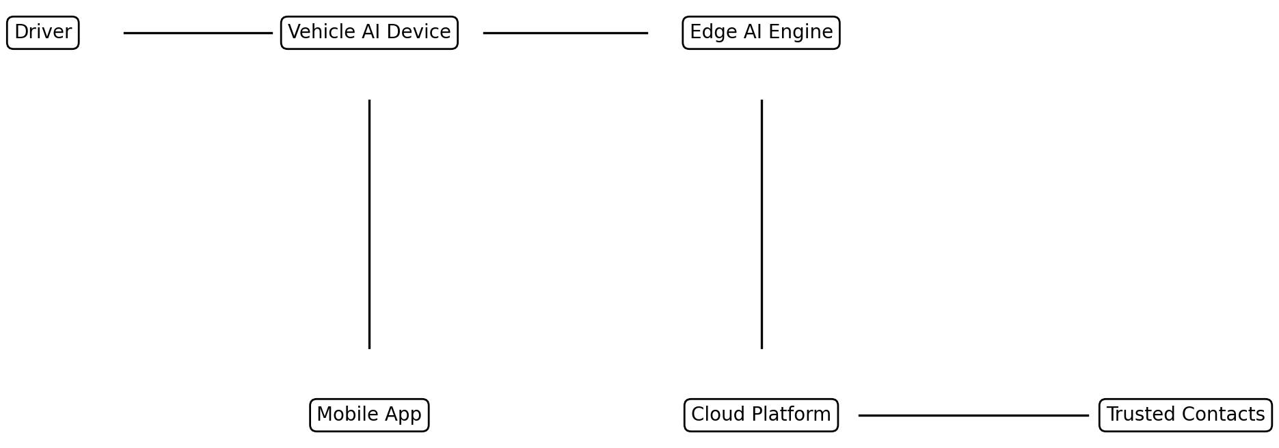

Figure 2 - Communication Architecture
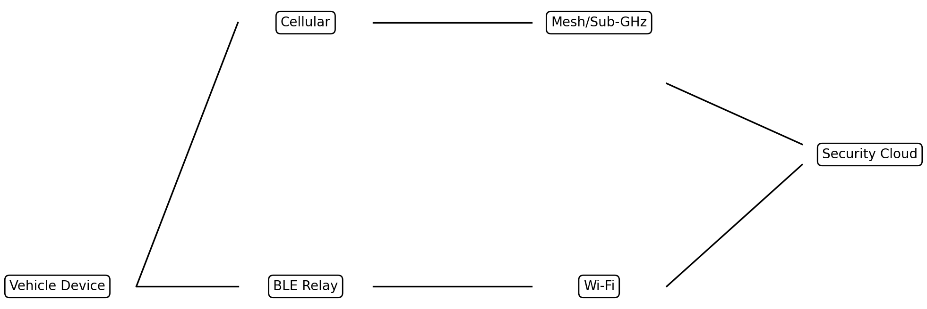

Figure 3 - AI Detection Pipeline
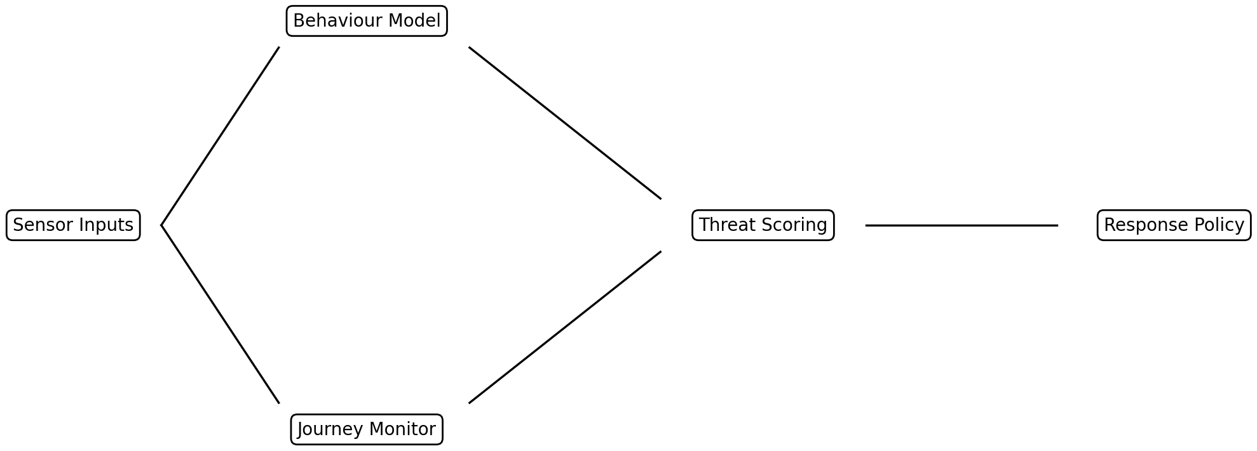

Figure 4 - Behaviour Learning Feedback Loop
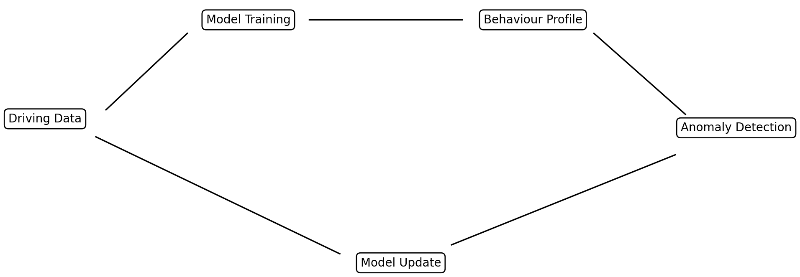

Figure 5 - In-Vehicle Device Hardware Architecture
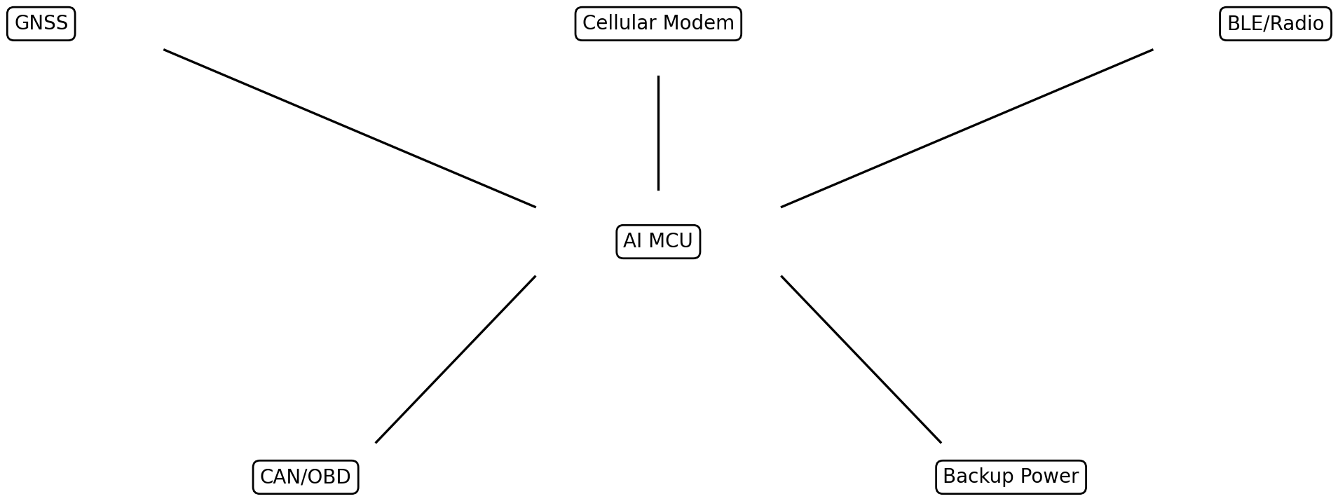

Figure 6 - Wearable, Phone, and Vehicle Correlation Engine
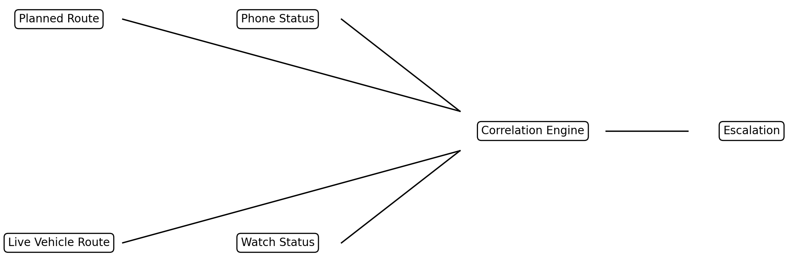

Figure 7 - Voice Trigger Emergency Workflow
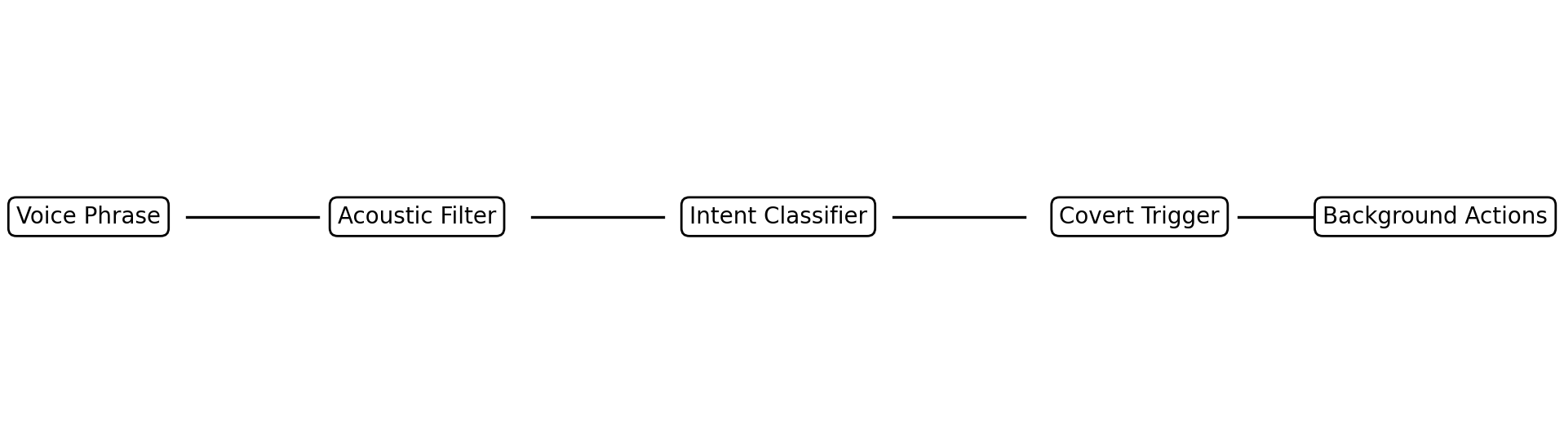

Figure 8 - Journey Monitoring and Risk Reclassification
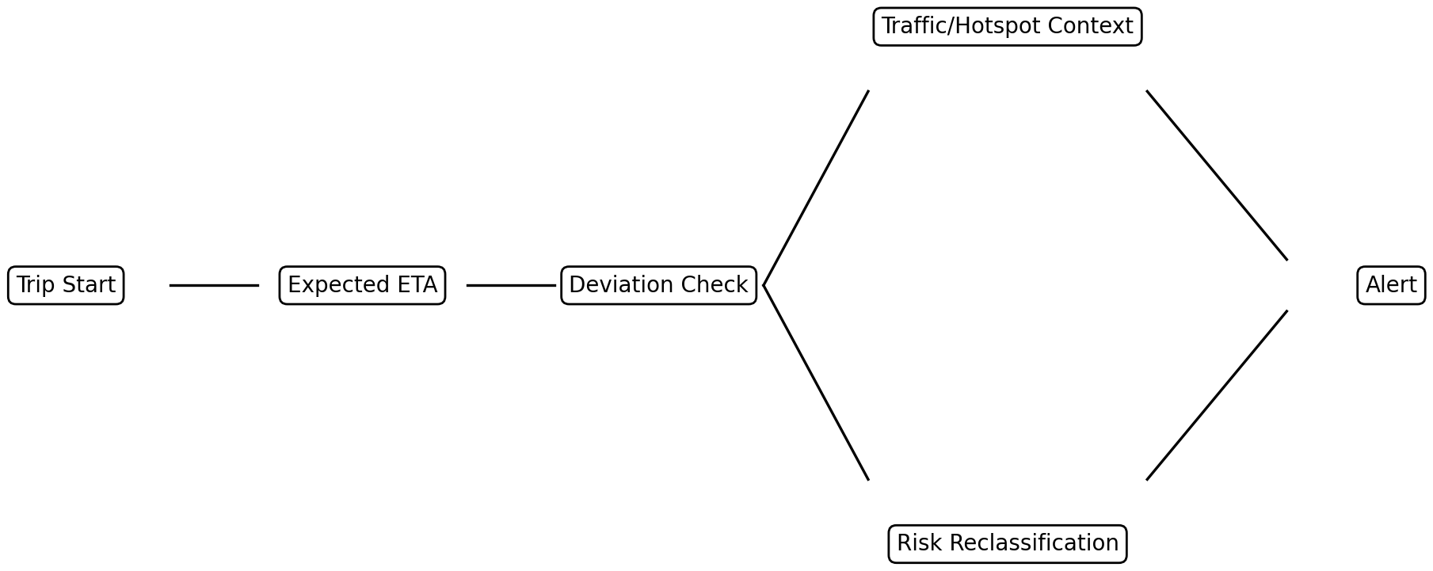

Figure 9 - Response Policy Escalation
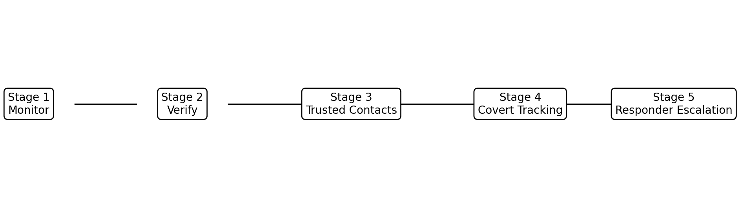

Figure 10 - Example Distress Scenario
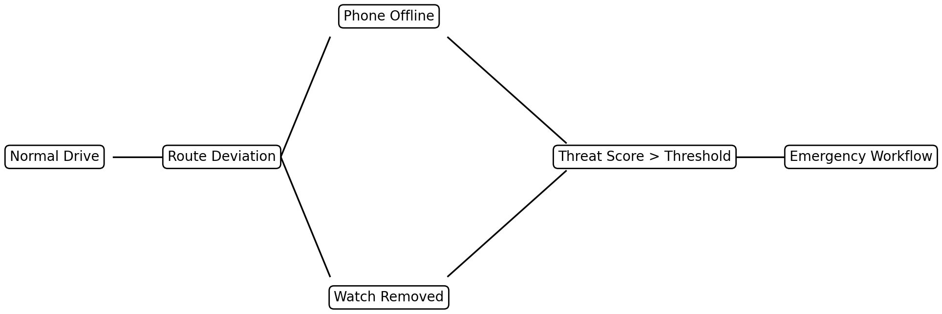

Figure 11 - Startup Authorization / Protected Lockout / Authenticated Reactivation
