Chapter 2,
Why Do We Have Queues?

Anything in magenta is notes to the author and editors. The table of contents and index are just for the author’s convenience.
The images are in their native size and the text is not wrapped, to avoid making it hard for your editorial designer. I provide them in full size in the Resources/* files for the various chapters
This table of contents is broken.
Table of Contents

2.1 Introduction
Everyone has had the experience of getting stuck in a queue, often in stores. It’s not enjoyable.

Multiple people want to buy something, are actually wanting to give the store money, but they can’t. So they queue up at the service desk and wait for the clerk to finish the previous person. The service desk is a bottleneck.
Computers, too, are full of queues, for the CPU, for I/O, for a page of memory and so on, ad infinitum. When things queue up, the machine gets slow. As a result, they have been extensively studied by computer scientists and mathematicians, in order to know how not to bottleneck, and to not have queues build up.
There are single line, single-server queues., as illustrated in Figure 1.
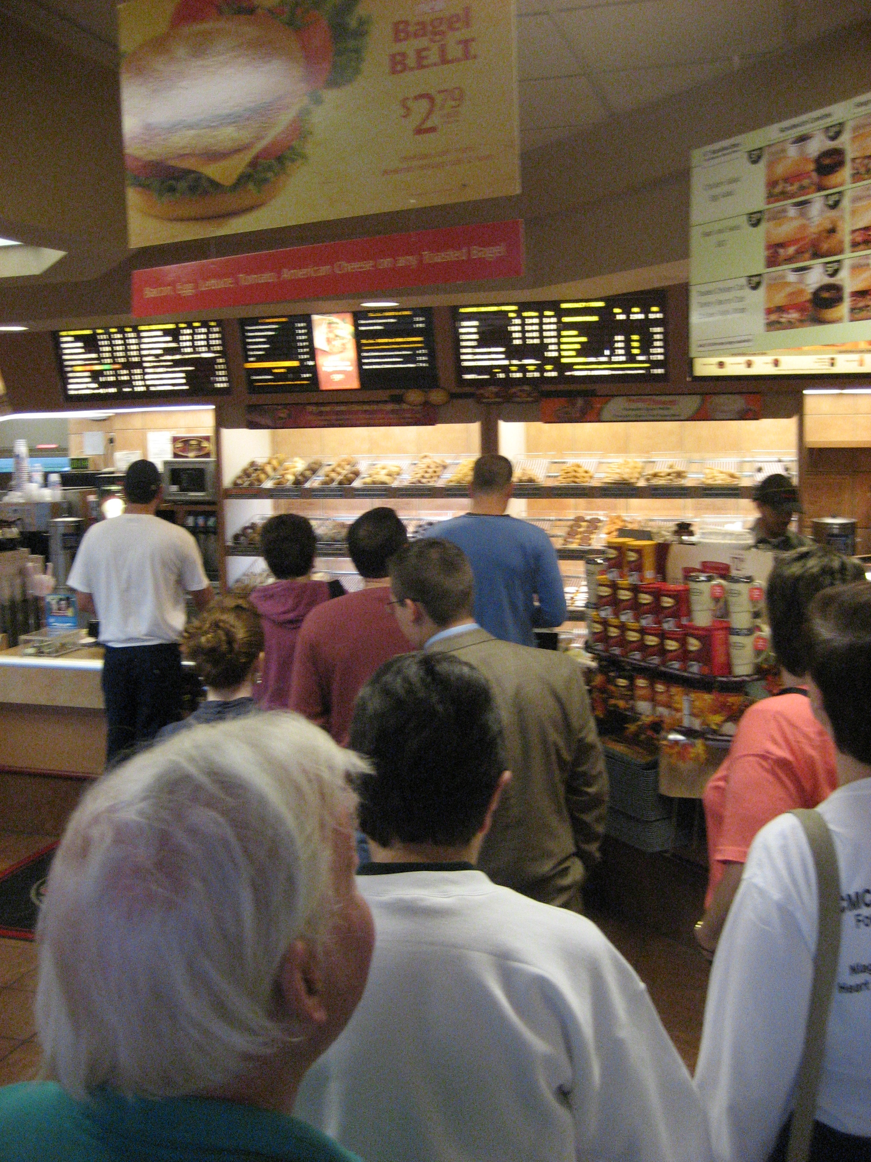
Figure 1: Customers queuing in a coffee-shop

And there are a host of others like:
- multi-queue multi-server in grocery stores with multiple lines for multiple clerks,
- single-queue multi-server, as in airports, with one interminable line but several clerks, and
- the hated single-server, multi-queue one, when one lane of a two-lane highway is blocked and everyone has to merge into the same lane.
All of them come from having more work than workers, like the clerks in Figure 1, so the checkout desk is a bottleneck.

2.2 Why Does Queuing Hurt?
It’s because queues are all a lot like a closed lane on a highway. Everyone has to wait while the cars at the head of the line squeeze themselves through a one-lane bottleneck.
If all the cars were lined up absolutely perfectly in two lanes, they could merge into a single lane without slowing down at all. We’d see something like Figure 2-2, a so-called “zipper” merge.
Figure 2-2: A "zipper" merge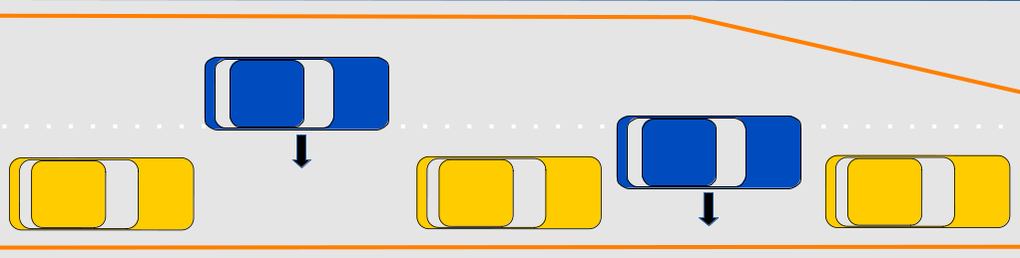
Of course, that’s terribly improbable. Unless traffic is very light, it’s arbitrarily hard to make everyone line up perfectly. So we get overlap. The more traffic, the more probability of overlap, until we get the merge in Figure 2-3.
Figure 2-3: An ordinary (or "crunch") merge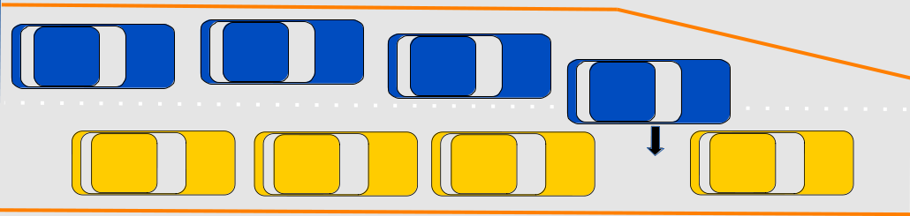
All images have been proofed in grayscale. So I plan to be able to always said dark and light or solid or dotted.
In heavy traffic, there is no room. The first dark-colored car has to slow down to get behind the first light-colored one. The second light-colored car has to brake to avoid an accident, and all the rest of the light-colored cars have to brake and make spaces for the dark-colored cars. Or run the dark ones off the road.
That slows everyone, and the queue behind the bottleneck gets longer and longer.

2.3 Queues in Computers
In computers, you hear queues mentioned when someone is trying to plot the performance of a component, for example, a CPU.

Throughput
In textbooks you often see a throughput diagram, like the one in Figure 2-4, along with a response time diagram, like Figure 2-5.
The throughput graph rises steadily until around 80% of the maximum, then starts to level off, and finally becomes a horizontal straight line, but not until it’s at almost 20 requests per second, long past 10 requests per second.
Figure 2-4: Textbook Graphs, Throughput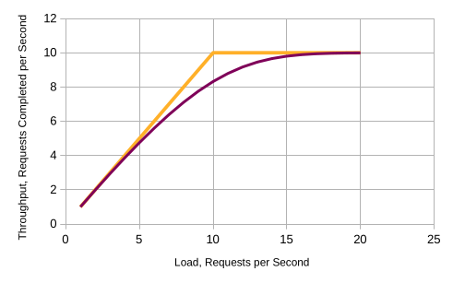
This is what you will see from a load test, even though you might expect the graph to follow the lighter line and deliver 10 completed transactions per second (TPS) at a load of ten requests per second.
Instead, you can see the slowdown: at 10 requests a second, the program is only completing eight. At 17, it’s almost completing 10. For every higher load, it’s doing 10.
That slowdown is the origin of the widely used “don’t go over 80% CPU” rule of thumb. The program quickly gets into diminishing returns, and performs poorly.

Response Time
Figure 2-5: Textbook Graphs, Response Time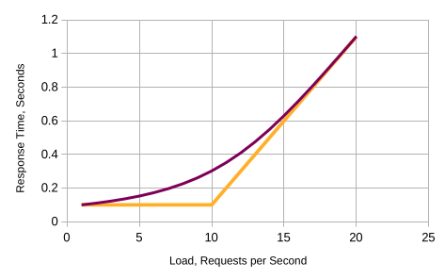
We can see the same thing in the second textbook graph, Figure 2-5. At low loads, the process takes 1/10 of a second. After about 80% load, the amount of time taken per transaction starts to rise rapidly in a “hockey-stick” or “_/” curve. With eight requests a second coming in, the machine is only completing 7.1 of them, because their response time is now averaging 0.022 seconds.
At 10 request per second, there are no resources left. The machine processes as much as it can in a given second and the excess load sits in a queue, waiting for a chance to be processed.
With ten requests/second, it takes 0.3 seconds to respond and 8.3 requests will be completed per second. We don’t get past 9.5 out of 10 until the offered rate is 14, and the response time that used to be 0.1 second is now almost a full second.
In this book we’ll look at the second curve a lot: its easier to measure and understand response time, but at the same time it is locked to the first, throughput, graph.
This too is what you’d see from a load test, even though you’d intuitively expect to see something like the bounds line.
Caveat: I never say why the throughput curve mirrors it
look at TPS versus requests and rephrase
So that’s how much queuing slows you down, but why does it slow you down in the first place?

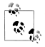
To keep things simple, I’ll always use a tenth of a second as the
service time of my examples, and report in transactions per
second. The data came from PDQ, which we’ll see more of later.

For now, the data comes from this table:

# Closed solution from PDQ, where service time = 0.1s,
# think time = 0.9s, dmax = 0, queues = 1
LoadThroughputUtilizationQueueLenResidenceResponse
11.0000000.1000000.1000000.1000000.100000
21.9801980.1980200.2178220.1100000.110000
32.9360470.2936050.3575580.1217820.121782
43.8619140.3861910.5242770.1357560.135756
54.7509200.4750920.7241720.1524280.152428
65.5948380.5594840.9646460.1724170.172417
76.3841550.6384151.2542610.1964650.196465
87.1084190.7108421.6024230.2254260.225426
97.7570000.7757002.0187000.2602420.260242
108.3203680.8320372.5116690.3018700.301870
118.7917930.8791793.0873870.3511670.351167
129.1691340.9169133.7477800.4087390.408739
139.4560730.9456074.4895350.4747780.474778
149.6621460.9662155.3040690.5489530.548953
159.8013150.9801326.1788160.6304070.630407
169.8894750.9889487.0994720.7178820.717882
179.9418270.9941838.0523560.8099470.809947
189.9709980.9971009.0261020.9052360.905236
199.9862810.99862810.0123471.0026101.002610
209.9938300.99938311.0055531.1012351.101235

Figure 2- 6: The Data We Used to draw Figure 2-4 and Figure 2-5
The data came from PDQ, which we’ll see more of, later. For now, the
data comes from this table. To keep things easy to calculate, I’ll be
using a tenth of a second as the service time of my examples, and
report in transactions per second.

Closed solution from PDQ, where service time = 0.1s and think time = 0.9s
LoadThroughputUtilizationQueueLenResidenceResponse
11.0000000.1000000.1000000.1000000.100000
21.9801980.1980200.2178220.1100000.110000
32.9360470.2936050.3575580.1217820.121782
43.8619140.3861910.5242770.1357560.135756
54.7509200.4750920.7241720.1524280.152428
65.5948380.5594840.9646460.1724170.172417
76.3841550.6384151.2542610.1964650.196465
87.1084190.7108421.6024230.2254260.225426
97.7570000.7757002.0187000.2602420.260242
108.3203680.8320372.5116690.3018700.301870
118.7917930.8791793.0873870.3511670.351167
129.1691340.9169133.7477800.4087390.408739
139.4560730.9456074.4895350.4747780.474778
149.6621460.9662155.3040690.5489530.548953
159.8013150.9801326.1788160.6304070.630407
169.8894750.9889487.0994720.7178820.717882
179.9418270.9941838.0523560.8099470.809947
189.9709980.9971009.0261020.9052360.905236
199.9862810.99862810.0123471.0026101.002610
209.9938300.99938311.0055531.1012351.101235

2.4 Computer Queue Behavior
When we look at why the curves don’t have square corners we’ll look at queues. Computers are full of queues, and they are a big part of why computers slow down under load: queues build up like the merge diagrams above. Fortunately, processes don’t crash into one another like cars. Instead, for each CPU core they stack up, like processes two and three do in Figure 2-7.

Figure 2-7: Computer queuing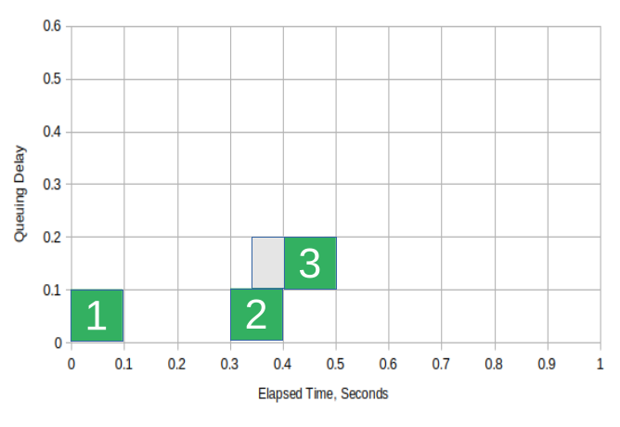
In this diagram, the X axis is elapsed time, measured in tenths. The Y axis is delay caused by queuing. The solid color (green) area is time processes spent actually running on the CPU. The shaded (gray) area is time spent waiting to run.
Here, request number 3 has arrived at the Linux dispatcher just a bit after request 2 and created process 3. That process, however, can’t be run until process 2 has finished. Each process still takes one tenth of a second to get through the bottleneck, but some have to wait before they can do so, and therefore their total time is a lot longer.
This is not a very busy system. That means there are usually more tenths of a second than there are requests. Only when two requests arrive in the same tenth of a second do we have two processes trying to run at the same time. Only then do we see contention and queuing. Consider quiet systems as a zipper merge with only a few cars on the road, so there are lots of spaces when the road narrows.

2.5 When Does Probability Come Into It?

When things get busier.
Just like increasing road traffic makes a zipper merge less probable. As the number of computer processes competing for a chance to run increases, we get more and more chances that two processes want to run at the same time.
For example, when I did an experiment and chose four random numbers between 0.0 and 0.99 for arrival times, I got 0.12. 0.40, 0.83, and 0.93. When we draw that in the first (upper left) box of Figure 2-8, the boxes fall on a horizontal straight line.
The request that created process 2 arrives well after process 1 has completed. No queue. As we add more processes competing for the CPU, though, we have a greater and greater chance they’ll show up at overlapping times.

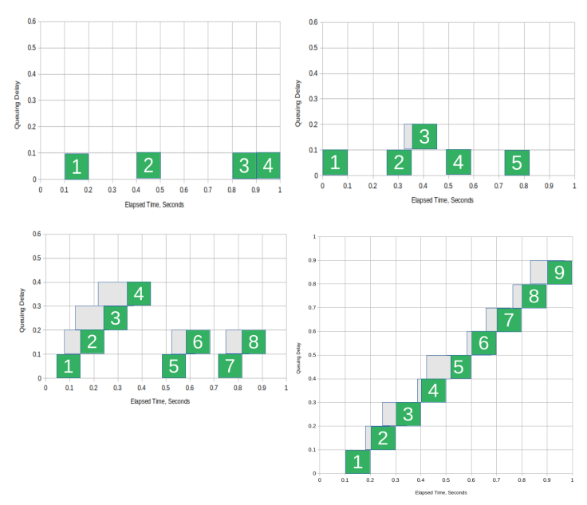Figure 2-8: Increasing interference with load

When I chose five random arrival times in the second (upper right) box, it looks a little busier. I got 0.00, 0.24, 0.33, 0.46 and 0.74. All but process 3 run immediately. Only it has to wait.
When I asked for eight random arrival times, however, I got the third box. There we see contention between all of the first four, the fifth and sixth, and the seventh and eighth. The time spent waiting in queue is much longer: instead of 0.01 second, we have spent 0.05 seconds for process four. The amount of time the processes spend running remains what you’d expect, 0.08 seconds, but the wait time rises to more than half that.
As the number of processes which arrive goes up, more conflict with each other, and the average time it takes for the processes to complete rises, until it’s approaching a straight line, shown in the last box. That’s what causes the dark (red) line in Figure 2-9 to curl upwards.
Figure 2-9: Response-time curve, copy of Figure 2-5

2.6 Why the Delay isn’t Infinite
Probability doesn't just make things worse, though. It also keep us from failing on the very first overload.
Consider what would happen if we got 11 requests per second steadily. In the first second, we would do 10 requests, and the 11th would sit in queue and be delayed a tenth of a second. In the next second, there would be two processes in queue, delayed two tenths of a second. After three seconds, three-tenths of a second queuing delay. Every other process would be delayed too.
After a minute, we observe 6 seconds of queuing delay, for something that normally completes in one tenth of a second. After 10 minutes, 60 seconds of delay, and so on. The machine would be running, the lights would be flashing, but each human user would have to wait for a minute before they got a response, and then another minute for the next. To them “the lights are on, but nobody’s home”.
Fortunately, though, probability keeps that from happening. Every second, a few requests come in after a delay, like requests 5 and 7 in Figure 2-10. The queue falls back to zero, and then start to build again.
This is enough that machines don’t build up ever-increasing queues. At individual times, the queue may be madly building or falling toward zero, but on average the delay will be finite. It will rise, as shown in Figure 2-10, but not just go straight up to infinity at 11 request per second.

2.7 Putting it all Together
Now we’ll start looking how these parts all fit together, by looking at averages. The boxes will not be individual requests, but instead the average of many.
As before, we’ll start with zipper merges and look at what happens as load increases, and then add probability back in.
At up to 10 requests per second, they all fit perfectly, with no crumpled fenders. At 11 requests per second, the 11th request will be delayed by a tenth of a second, on average. Some will be delayed more, some not at all, but general, they will be slowed by a tenth.
The 11th arrivals will all have to wait for the first request from the next second to complete, or vice versa. That time is shown here as light gray. In either case, the time taken will increase by a tenth of a second.
If we make the Y-axis total time taken, we get Figure 2-11, where the average time to service the request rises steadily in tenth of a second increments as the load passes 10 requests/second.
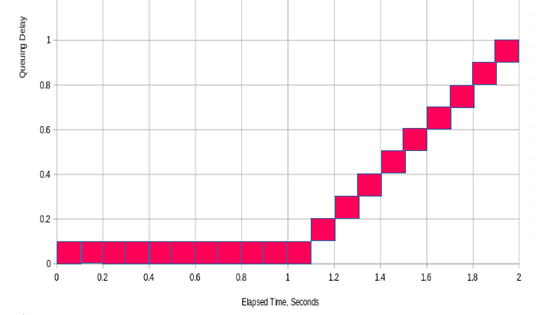Figure 2-10: Averages, Zipper Merge
These averages are exactly the two dotted lines we mentioned back in Figure 2-4. One is horizontal, at one tenth of a second, and the other slopes at a “rise over run” of 1 over 10, or one tenth. They meet at 10 requests per second, often called the “knee”.
These make up the “hockey stick” or “_/” lines. It is what you’d see if the requests were doing zipper merges and not having to wait.
Regrettably, we are doing ordinary merges, not zippers. As load rises, more and more requests will come in at overlapping times, and the non-zipper average response time will rise in a gentle curve as shown in Figure 2-13
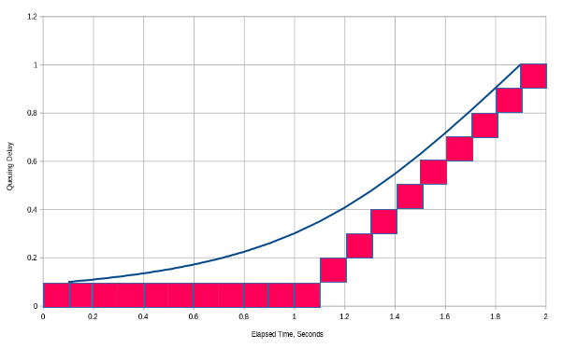Figure 2-11: Averages and Probability Line
As the number of requests keeps rising, the probability of multiple requests in the same second approaches 100%, and the curve approaches the sloping line of boxes.
A combination of simple mechanics and probability gives us the curved response-time lines, which are a hyperbola between the straight lines.

2.8 Drawing the Curves
Normally you’ll want to know the curve’s shape, so you use your understanding to keep the load below the point at which response time turns upwards.
To generate the curve, I use either the Java Modeling Tool suite, or more often, Neil Gunther’s PDQ (Pretty Darn Quick) queuing-network modeler. Specifically, I use Dr Gunther’s library via a little wrapper program that takes the service time, the sleep time and the range you want to report on.
For example, the curve above was created by running pdq -v -s 0.1 -z 0.9 1 20 1
where
-v is verbose
-s is the service time,
-z is the sleep time, and
the range is from 1 to 20, in 1 request-per-second units.
Notice that I didn’t say before why the sleep time was 0.9. The explanation, for now, is that having service and sleep times totaling one millisecond generates a good-looking hockey-stick curve. We’ll see more in chapter 6, in the section on Improving First-Principles Models, and Appendix B, Queuing Networks.

2.9 Using Your Knowledge

Let’s do a simple case which illustrated what we’re going to do in detail in subsequent chapters.
Consider a service that is normally takes or usual 100 milliseconds. We want to use it where we can’t afford it to take longer than 150 milliseconds. 150 milliseconds will be our “do not exceed” time.
With a model like the one from PDQ, the first part of calculation is easy. In Figure 2- 6, above, you can look up the number of requests per second from the line where the response time hits 0.15 seconds. If we look at just the first six rows of that table, as Figure 2-9, we can look at response times around 0.15 seconds

Load | Throughput | Utilization | QueueLen | Residence | Response
1 | 1 | 0.1 | 0.1 | 0.1 | 0.1
2 | 1.980198 | 0.19802 | 0.217822 | 0.11 | 0.11
3 | 2.936047 | 0.293605 | 0.357558 | 0.121782 | 0.121782
4 | 3.861914 | 0.386191 | 0.524277 | 0.135756 | 0.135756
5 | 4.75092 | 0.475092 | 0.724172 | 0.152428 | 0.152428
6 | 5.594838 | 0.559484 | 0.964646 | 0.172417 | 0.172417
Figure 2-12: Response time Under Load (Detail)

This shows that at 5 request a second, each will take 0.152 seconds. That is illustrated in Error: Reference source not found,
where the lighter (green) line is 100 milliseconds, and the darker (red) one is our do-not-exceed response time of 150 milliseconds.
As you see, the throughput of the 100 millisecond response time is higher that our do-not-exceed line, so we don’t want the throughput to fall below about seven completed requests per second, down from our current ten.

Figure 2-13: Comparative Performance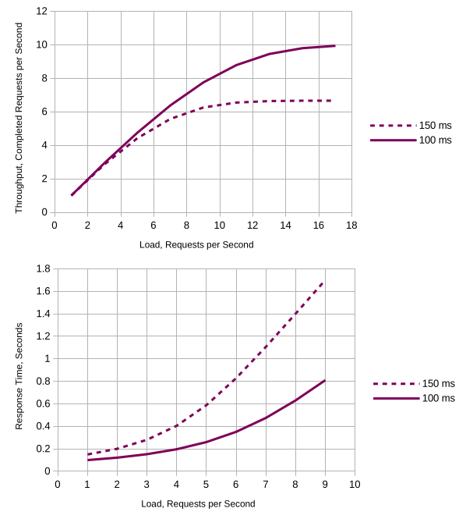
Looking at the data table, we see that a CPU core can deliver only 5 requests a second at or below 150 millisecond per transaction. That’s the bold-faced cell in Figure 2-12
That’s not very much. This is beginning to sound a little scary.
Now add that the customer needs 80 successful transactions a second (TPS). We need some headroom, so let’s add 20% to that and say we want to deliver 100 transactions per second. Now it definitely starts to sound scary...
Nope, it’s not!
At 5 request per second per core, we will need a 24-core machine for each 100 completed requests per second. We have lots of those in stock. Not scary at all.
Without a model, we would not have known, and we could have missed either high or low when we made a recommendation on how to fix the problem
- if we over-bought, we’d spend too much money but deliver the service, or
- if we under-bought, we could see the service fail in use.
With a model, you can make a decent prediction of how much you will need to spend. Without one, you’ve got a good chance of making a mistake.
This is a classic illustration of a queuing model, and also an illustration that one’s initial thoughts can mislead, if we lack intuition and understanding. We’ll use this kind or analysis all through the book. It allow us is be predictive in a very unpredictable industry.

2.10 Summary
If you think back to Chapter 1, you can see what we were doing with the model in performance analysis.
Because we knew the system had slowed down, we could use a model to see how much slowdown to expect. That started us looking for a bottleneck as soon as the model said the system would be slower than we wanted.
That same focus on slowdowns from bottlenecks will be use in planning and development in Part IV, chapters 7 through 11.
This paragraph was added by the Go editor.
But first we’ll stop talking about theory and jump straight to to the process of debugging problems using queues in Chapter 3, Diagnosis In the Heat of Battle.

Alphabetical Index
cars 3, 6 f.
closed lane 3
hockey-stick 5
service time 12
single-server, multi-queue 2
sleep time 12
think time 12
TPS 4
transactions per second ( 4
zipper merge 3

