**Project Title / Website Name: Korean Merchandise E-commerce Website**

**Proponents: Dave Charm B. Bulaquena– Project Manager (Block-3)**

**Dhan Mendoza – System Analyst**

**Janice Garcia -Researcher**

**Donna Bel Facun Macalanda– Document Writer**

**Project Statement**

This project aims to design and develop a Korean Merchandise E-Commerce Website for Unnies Company to facilitate and automate the Shopping and Selling Mechanism for both Customer and the Seller. The proponents believe that this project will benefit not just their company but also will improve their customer satisfaction and convenience because of e-commerce transaction. Unnies company is currently facing the following difficulties in running their Korean merchandise selling business:

Unnies’ Korean merchandise shop experience difficulties in displaying and updating their products manually thus inefficient in marketing and is time consuming.

* Unnies’ Korean merchandise shop have to manually lists and update who are the customers that ordered and bought products. It is really time consuming especially if there are many customers.
* Customers find difficult submit orders because they are only commenting to the product post thus have no assurance whether they got the deal or not.
* Unnies’ Korean merchandise shop sales report is mostly delayed and are not on time.

Having that as basis, the proponents of this project came up building an e-commerce website for Unnies Korean Merchandise Shop that will automate the buying, selling, and updating of their products through the website.

**Project Objectives**

The main goal of this project is to design and develop an e-commerce website for Unnies Korean Merchandise Shop that will handle and solve the inadequate and poor business transaction method they had with their current manual process.

Specifically, is aims to achieve the following:

* Make product information and prices up to date.
* Make customers buying and ordering experience convenient.
* To generate sales report for shipped/sold items.
* To solve the time consuming and inefficient handling of orders because of numerous customers.

**Project Scope and Limitation**

The E-commerce website coverage in terms of its modules are follows:

* Customer Registration Page – This module allows a customer to register for an account in order to use the website, this module also ask several necessary information to the user in order to use the website.
* Authentication/Login Page – This page secures the access of business information via providing a login or access form for authorized administrator of Unnies Korean merchandise and their registered customers.
* Profile Management Page- This is where the user can see his entered information and can edit and save that information.
* Accounts Management Page – This page allows an administrator of the website to create co-admins and accounts of authorize employees, they can also delete the accounts of users if necessary.
* Website Content Management Page – This is a dashboard on the Admin side that allows him to add, view, modify, and delete contents of the website such as texts, images, and prices of the products display.
* Unnies E-comerce Web Page – This is the highlight Page of the proposed website in which registered customers can view and order products. The customers can add item to their shopping cart and check out items they want to buy. They can also see their ordered products and can cancel it when the admin does not confirm it yet. The Admin of the website is also able to see all the orders and has the authority to approve the orders made by the customers.

However, the proposed E-commerce website does not cover real-time package tracking, however Unnies will update customers from via text-message or email. It also does not cover in-website messaging and in-website inquiries, they can contact Unnies Korean Merchandise Shop via provided contact number and several social media pages on the footer of the website. This website does not cover bank account payment, payment transactions is done through Credit card payments and Cash on Delivery Method. Furthermore, this E-commerce website is only intended for use by Unnies Merchandise Shop and follows its core business rules, terms and conditions.

**The Proposed system**

**UI of the Proposed System**

Home Page

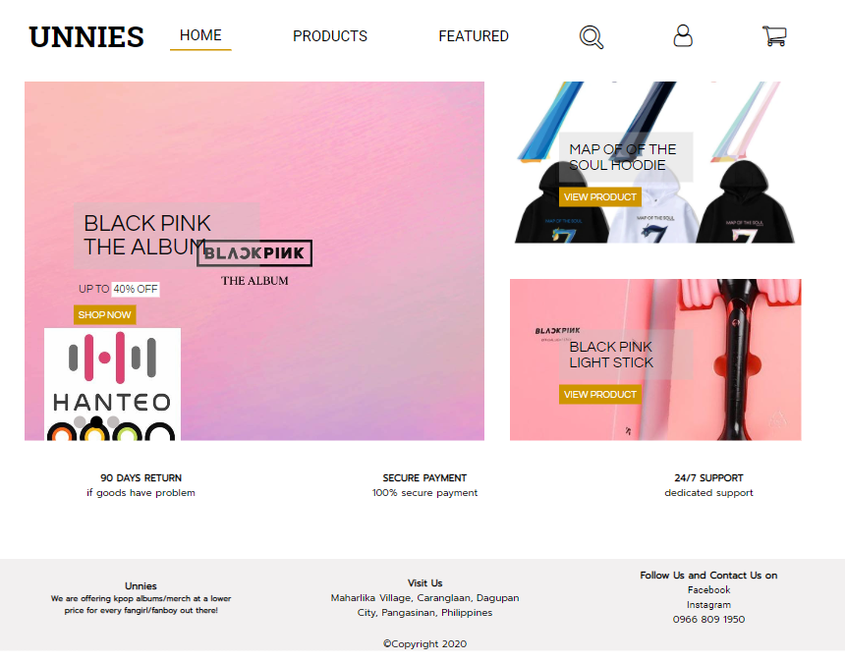

Fig 1. Home Page

Figure 1 shows the home page of Unnies E-commerce website, the homepage contains the featured images of the product that attracts the customers, the image on the left part is a carousel images of product with discounts.

Account Registration Page

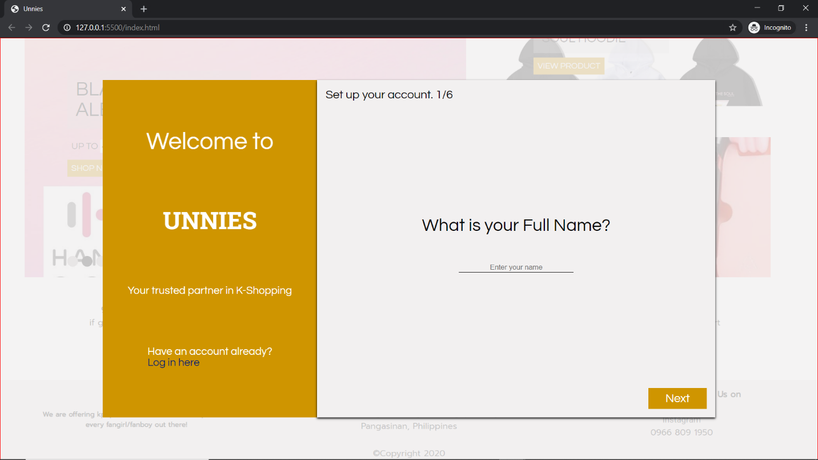

Fig 2. Account Registration Page

Figure 2 shows the account registration form, the left panel contains greeting to the user and 1 navigation button that tells if they have already an account then they should proceed to log in. The right panel contains questions that are necessary on setting up the account. It asks 6 information from the user namely their name, address, contact number, email, desired username, and password.

Account Verification Page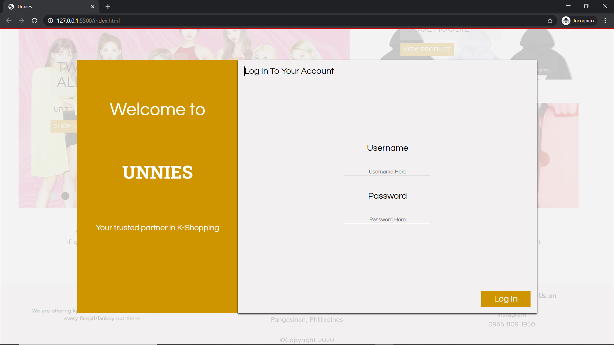

Fig 3. Account Verification Page

Figure 3 shows the log-in page for the customers. The left side of the panel shows the welcome message and on the right-side panel shows the input form for username and password as well as the log-in button on the lower right.

Products Page

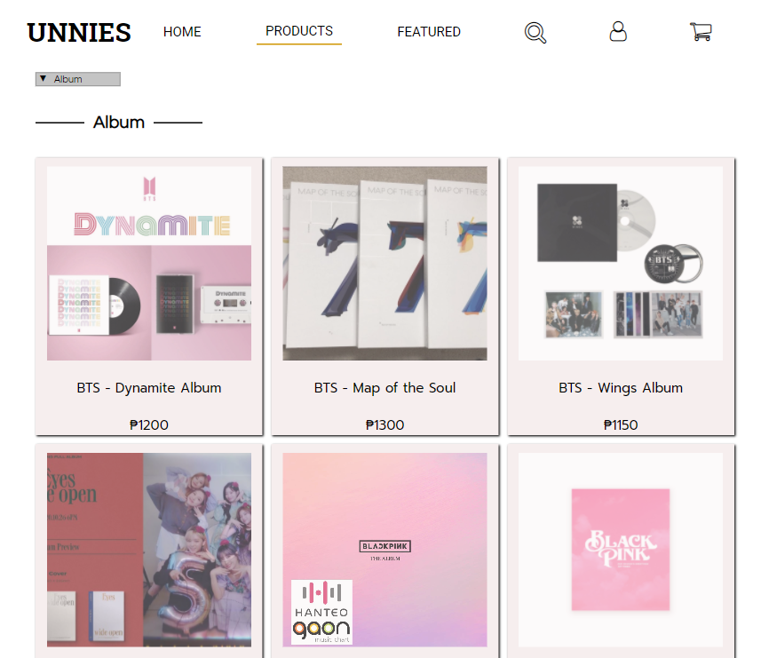

Fig 4. Products page

Figure 4 shows the products page. Product page contains the main navigation the top and the products displayed below it. The products is displayed in grid and has an the image, description and price on it. You can also see the selection tab for the type of products you want to browse.

Featured Page

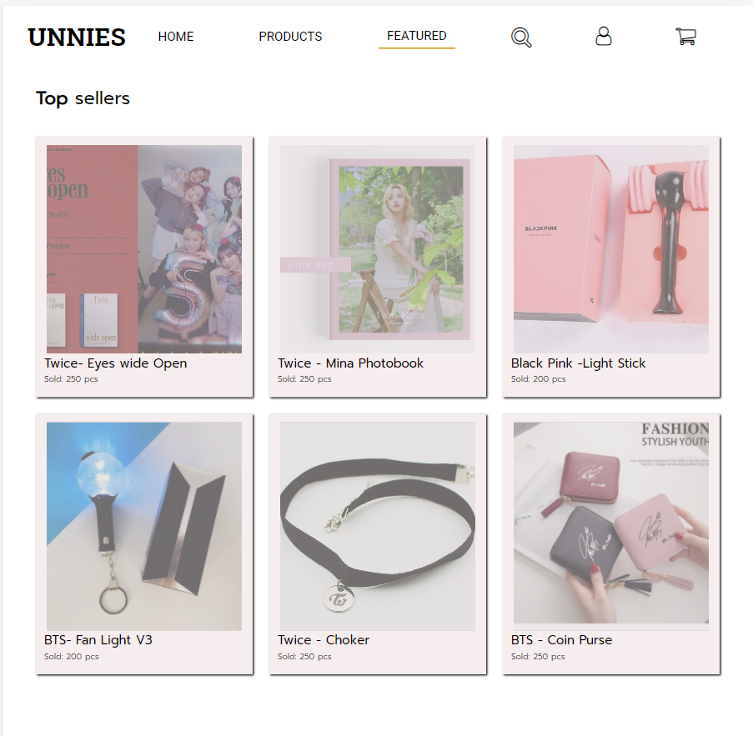

Fig 5. Products page

Figure 5 show the featured page, feature page contains navigation on top and products below it. The products that are displayed here have image and name as well as the number of the sold products.

Profile Page

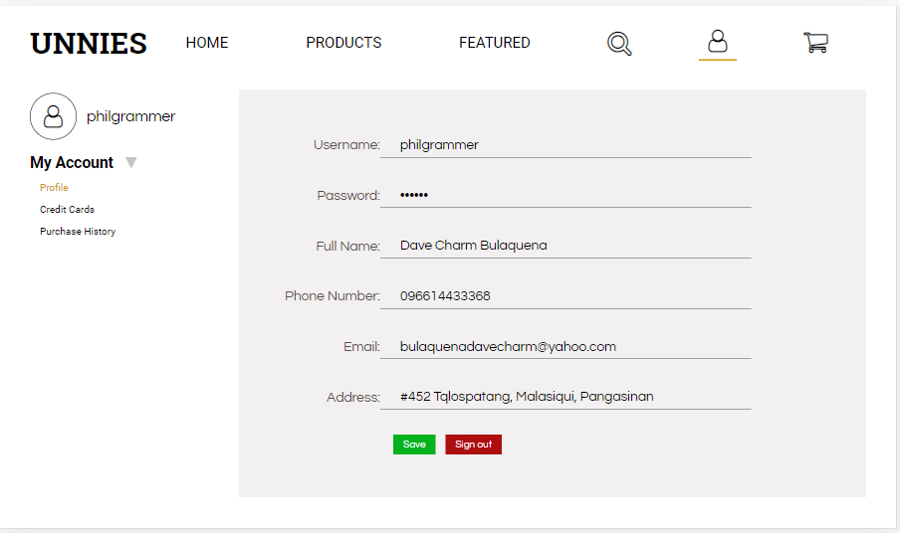

Fig 6. Profile Page

Figure 6 shows the profile page. The profile page has navigation bar on top. Profile page contains a side bar in which you can see the avatar icon, username and different navigation tabs below it. On the right-side panel, you can see the information and content that depends on the opened tab on side bar.

View Product Page

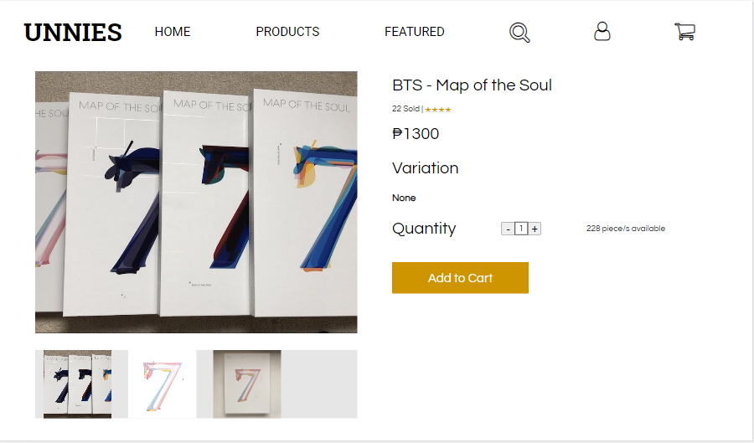

Fig 7. Product Page

Figure 7 shows the View Product Page. This page happens to open when you click on a product. The view product contains a navigation bar at the top. Below the navigation bar is the product overview. On the left side is the Image of the product and below it is the image gallery. On the right side you can see the name of the product, ratings, price, variation, quantity, stocks available and action button for adding the product on cart.

Shopping Cart Page

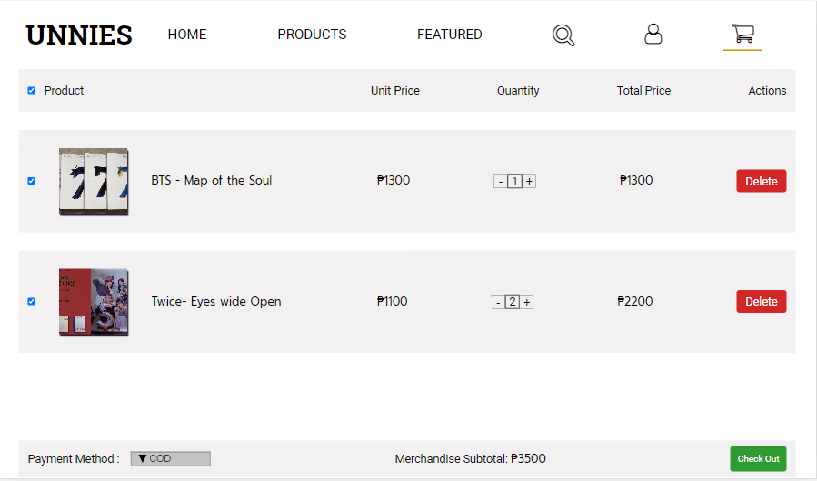

Fig 8. Shopping Cart Page

Figure 8 shows the Shopping Cart Page. The shopping cart page contains navigation bar on top. Below the navigation bar is the headings for the product items. Below the heading is the product items that’s been added to cart. The product item contains a check box indicator if the item is to be checked out, image of the product, name of the product, quantity, price, total price, and action button of delete. On the bottom you can see the payment method, merchandise subtotal and action button of check out.

Check Out Page

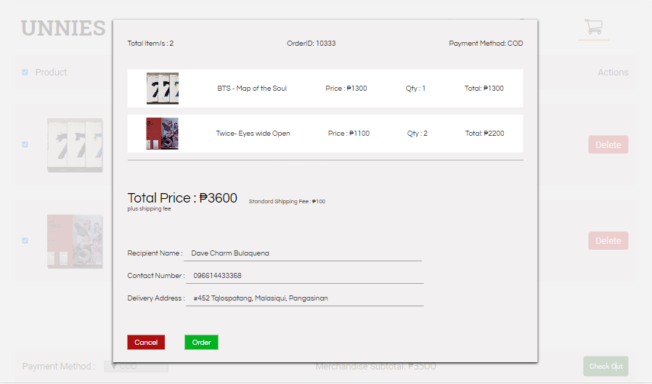

Fig 9. Check out Page

Figure 9 shows the Check out page. The check out page contains the information about the products that has been selected. On the top you can see the total items, order id, and payment method selected. You can also see the items selected. Below it, you can see the total price of the products plus the standard shipping fee. The check-out page also contains the recipient name, recipients address and the customers phone number. On the bottom, there are 2 action buttons cancel and save.

Admin Account Verification Page

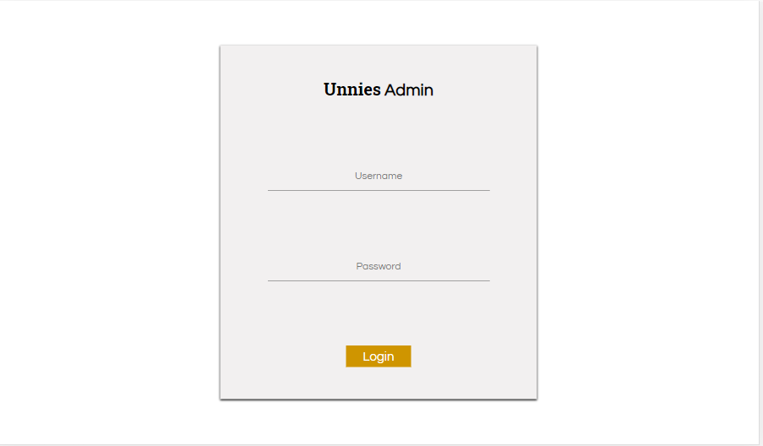

Fig 10. Admin Verification Page

Figure 10 shows the admin account verification page. On this page you can see a box panel containing input form for username and password. On the bottom of the box panel is the log-in action button.

Admin Page

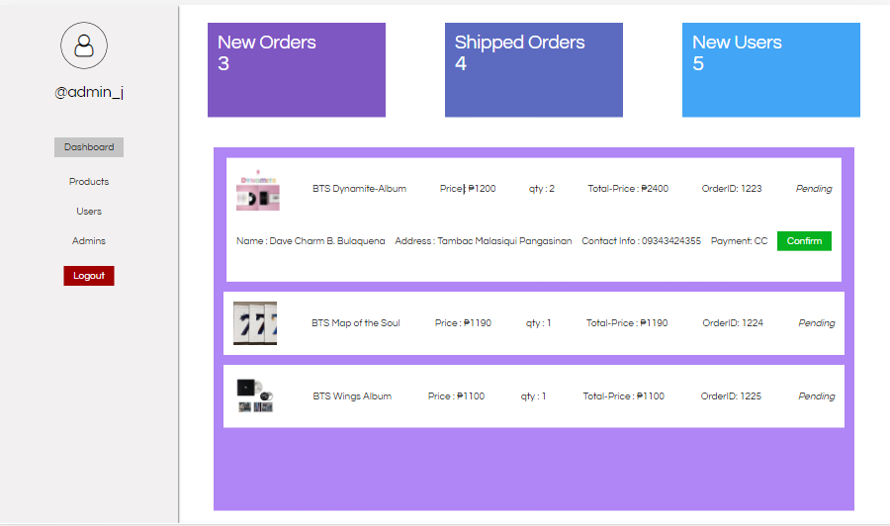

Fig 11. Admin Verification Page

Figure 11 shows the admin page. The admin page contains a dash board for new orders, shipped orders and, users. Admin page also contains a side bar navigation for product, user, and admin management. On the bottom of the side-bar is the logout action button.

**Proponents**

1. **Name:** Dave Charm B. Bulaquena

**Role:** Project Manager

**Responsibilities:** The one who monitors the progress of the project and ensures that it is completed on time and within the budget. He may also develop and maintains the project plan such as implementation, work plans, resources. Project manager is also responsible for collaborating with team members in order to determine the specifications of the project.

1. **Name:** Dhan Mendoza

**Role:** Systems Analyst

**Responsibilities:** The one who analyzes the data that could be possibly injected to the system. He may also responsible for giving technical solutions when problem occurs in the project. He is also responsible for evaluating procedures and processes.

1. **Name:** Janice B. Garcia

**Role:** Researcher

**Responsibilities:** Theone responsible in finding relevant and accurate topics that it is related to the system. She is responsible for most of the content of the website and the system.

1. **Name:** Donna Bhel Macalanda

**Role:** Document Writer

**Responsibilities:** The one responsible for documenting and writing for what is the project for. She is also responsible for producing factual information about the project, technical specification and reference manuals.