**Purpose:** To quantify how density of native large mammals respondS to human development.

**Approach**: Distance sampling of groups along linear transects AND at point transects radiating out from an urban center.

**Materials:**

* A phone or GPS unit capable of showing your latitude and longitude and the current time of day.
  + Some phone apps are capable of showing you your current latitude and longitude but not all of these apps work offline (you will be out of cell phone coverage).
* Rangefinder for measuring distance
* Compass for measuring bearings
  + You can download an app like ‘Compass’ for iPhone or Android for a compass that works on phones with a magnetometer (some phones or GPS units have a ‘compass’ app but it is actually showing your direction of movement. THIS WILL NOT WORK).
* Binoculars (or spotting scope or zoom camera) for counting group size.
* Pencil and instructions and data sheet and clipboard.
* Coffee or tea

**Safety:**

Always use one driver and one spotter for safety, the driver should be focused on the road, but if the driver happens to see a group, record those detections as well. **Immediately** pull out of the lane of traffic for any detection or supposed detection. Remain stopped by logging the observation.

Please do not combine this survey with something other activity (like hunting or traveling).

**Things to keep in mind:**

You will often detect one or two individuals in a group first, and then detect the rest of the members of the group. The detection of most group members is therefore dependent on the detection of the first individual(s). When you first detect only some of the individuals in the group, you will record your ‘detection’ variables as applying to only these individuals (such as their background at the time of detection). Other variables relate to the group as a whole (such as their total group size, activity, distance, bearing, etc). ‘Groups’ are difficult to unambiguously define but we will say individuals are part of the same group if they are on the same side a major road or structure (unless apparently in the act of crossing that structure) AND within 200 meters of each other AND in an unbroken chain of line-of-sight from one individual in the group to another (unless moving or in dense vegetation/high relief, in which case line-of-sight may be coming in and out). These rules can all be broken. In general, I tend to ‘lump’ rather than ‘split’ individuals into groups. A group can consist of more than one species, but the data are recorded one species at a time (except for the Total Group Size, which refers to all species in the group).

**General instructions:**

Try to conduct transects in the morning when animals are most active.

Stop and park at the Start and End of the transect to record the time, lat, long, odometer reading, sky conditions and snow conditions on the first and last rows of data. Record the same data at any Observation Points. Observations Points are any place you choose to stop (even if you don’t detect anything). While conducting the transect, i**mmediately** pull over for any detection or supposed detections of a native large mammal (pronghorn, mule deer, white-tailed deer, elk, moose, bighorn sheep, jackrabbit, coyote, fox, bobcat, black bear, mountain lion). Each species is a single row of data. Transect are only conducted one-way. If you need to end a transect prematurely, that is fine, just be sure to record your end location and time as the last row of data and make a note.

**Logging Observations:**

*Always be comfortable admitting you aren’t sure of what you see. False negatives and missing data are much easier to accommodate than false positives and errors!*

Every species in a group is a row of data. For every species, record the following:

1. **Species:** Any large native mammal species (no livestock or wild horses). ‘Unknown’ if unsure of species but certain it is native. ‘Unknown deer’ if unsure of species but certain it is mule deer or white-tailed deer. Record this as ‘Start’ or ‘End’ if at the start or end of the transect.Record this as ‘Obs Point’ if you are at a designated stopping point or if you stop for any reason (even if you detect nothing!).
2. **Latitude at Instant of Detection –**For detections, it is critical to record exactly where you were when you first detection any individuals in the group. It is okay, once you record your position at detection, to move to another location to get a better view, or better ranging, of the group. Also record your location here for Start, End, or Observation Points. Record your odometer reading if your GPS fails. Record in decimal degrees out to four decimal places (##.####) using a phone or GPS.
3. **Longitude at Instant of Detection.** For detections, it is critical to record exactly where you were when you first detection any individuals in the group. It is okay, once you record your position at detection, to move to another location to get a better view, or better ranging, of the group. Also record your location here for Start, End, or Observation Points. Record your odometer reading if your GPS fails. Record in decimal degrees out to four decimal places (##.####) using a phone or GPS.
4. **Time:** The time the first individuals in the group were detected. 24 hour time
5. **Observer State at 1st detection:**  Were you ‘moving’ or ‘parked’ at the instant of first detection.
6. **Method at 1st detection:** were the first individuals detected in the group seen with ‘Naked Eye’ or were they seen with a visual aid like ‘Binoculars’ while scanning the area or observing another group?
7. **Detection Shadow**: Classify the light conditions of the first individual detection in the group as “overcast”, “full sun”, or “shade” (as from a tree or mountain). Also record the generally sky conditions here when at Start, End, and Observation Points as ‘overcast (>90% cloud)’ ‘partly cloudy’ (5-90% cloud cover) or ‘sunny’ (<5%),
8. **Detection Background / Snow Cover:** Record the backdrop behind the 1st detected individuals at the instant of detection. The framing of individuals’ profiles often effects how conspicuous they are to the human eye. We are interested in what might be highlighting or hiding their profile such as sky, dirt, grass, shrubs, forest, fences, etc. Also not here whether snow contributed to the backdrop as ‘bare’ (<5% snow cover), ‘part snow’ (5-90%), or ‘full snow’ (if >90%).
9. **2nd Ranging Latitude (optional):** Often it is easier to record the distance and bearing to a group from a 2nd location, one different from the initial location at 1st detection particularly if it possible to approach closer to the group, after first detection. You must always record the lat and long at your location of 1st detection but you can also record your location at a second location, closer to the group for ranging purposes. Record in decimal degrees out to four decimal places (##.####) using a phone or GPS. If the GPS malfunctions, you can record the odometer.
10. **2nd Ranging Longitude (optional):** Often it is easier to record the distance and bearing to a group from a 2nd location, one different from the initial location at 1st detection particularly if it possible to approach closer to the group, after first detection. You must always record the lat and long at your location of 1st detection but you can also record your location at a second location, closer to the group for ranging purposes. Record in decimal degrees out to four decimal places (##.####) using a phone or GPS. If the GPS malfunctions, you can record the odometer.
11. **Ranging Distance:** The rangefinder distance, in meters, to every group detected. If your rangefinder works in yards, append ‘y’ to your distance. Use the distance to the first animal in the group you detected, if possible. If not, use other members of the group. If the rangefinder will not provide a distance, use the distance to a more reflective target that appears to be a similar distance away (hillside, tree, building, rock, bush, fencepost, prairie-dog hill). If you cannot get a range from the rangefinder, use a map or app (such as Google Earth) to approximate the distance between where you are and where you think the group is located in the map. You can also estimate the distance, but use tildas to indicate it is an estimate: “≈1000 m”.
12. **Ranging Angle and Equipment:** Record the compass bearing in degrees off of True North to the animal from your location (0 – 360). If you do not have a compass, or it is malfunctioning, approximate the angle if you can. Sometimes you can use a mapping application to see where North is then approximate the angle off North, to the group. Approximate angles are just fine. Most phone compass apps show angles off of True North, but some GPS units (and all non-corrected compasses) are set to use magnetic north. Please note if you are certain you used ‘mag’ or ‘true’ and if you are not sure just put ‘phone’, ‘GPS’, or ‘compass’.
13. **Detection Aid:** The visual aid used at the instant of detection (naked eye, binoculars, spotting scope, camera). Most often this will be your naked eye, but sometimes after stopping to record one group, we end up detecting a second group with binoculars.
14. **Group Size:** Record the total size of the entire group. Avoid overcounting at all costs. You can use a visual aid, such as binoculars, to confirm the size of the group. You can also move to another location to get a better view of the group. If some individuals moved off before they could be accurately counted use “<” to indicate a known undercount.
15. **Classification (one species per row):**  For the current species (identified in the first cell of the row), classify the age and sex breakdown of the species. Classification codes attached to the counts (4M/3F/3J/8B/2U) are used to identify our level of confidence in the sex and age class of each individual. Codes **M,** **F**, and **J** denote counts belonging to the highest level of confidence in identifying the number of adult **M**ales, adult **F**emales, and **J**uveniles (<12 months old). **A** and **B** denote a middle layer of confidence that indivuals of unknown sex are certainly at least **A**dults (and absolutely not juveniles) or **B**alds (adult females or juveniles but absolutely not adult male). **U** is reserved for the lowest level of confidence, for **U**nknown individuals of uncertain sex or age. You can use all of these codes in classifying a single group. The sum of these counts MUST equal the total number of individuals in the group (for the current species).
16. **Majority Activity:** What was the most common activity observed in the group (for the current species). Grazing, Resting, Standing (but not grazing), Running, or Walking.

Figure 1. The difference betwee a bearing off of north between an observer and her observation and a heading off of her direction of travel. If your compass fails, heading angles can be easily estimated. If you use heading angles instead of bearings, be sure to label the angle on the data sheet as a heading and not wether it is on the left or right side of the roadway, for example, “head 30° right”. Bearings do not need the side of the roadway indicated because they span a full 360° while headings only span 180.

**Transects**: Work in pairs, one driver, one spotter. If there are additional spotters in the vehicle, they must be identified at the top of the worksheet and they must be indicated as the ‘Detector’ if they spot a group first.

**Woods Landing Transect**

Wyoming 230, Laramie to Woods Landing. 25.2 Miles Head west on WY 230. Transect begins at the gas station at the junction of highway WY 230 and highway WY 130 in West Laramie. Transect ends at the junction of WY 230 and the turnoff to WY-10 Woods Landing – Jelm at the base of the Snowy Mountains.

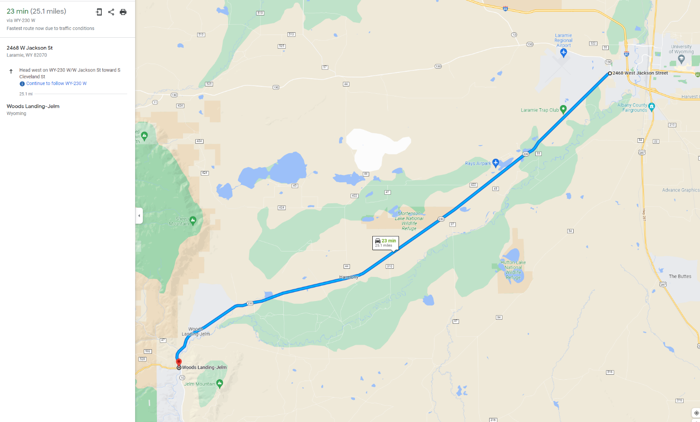

**Centennial Transect.**

Wyoming 130. Laramie to Centennial. 27.3 miles. Head west on WY 130. Transect begins at the Kiwanis Park in West Laramie. Transect ends at the ice-cream shop in Centennial.

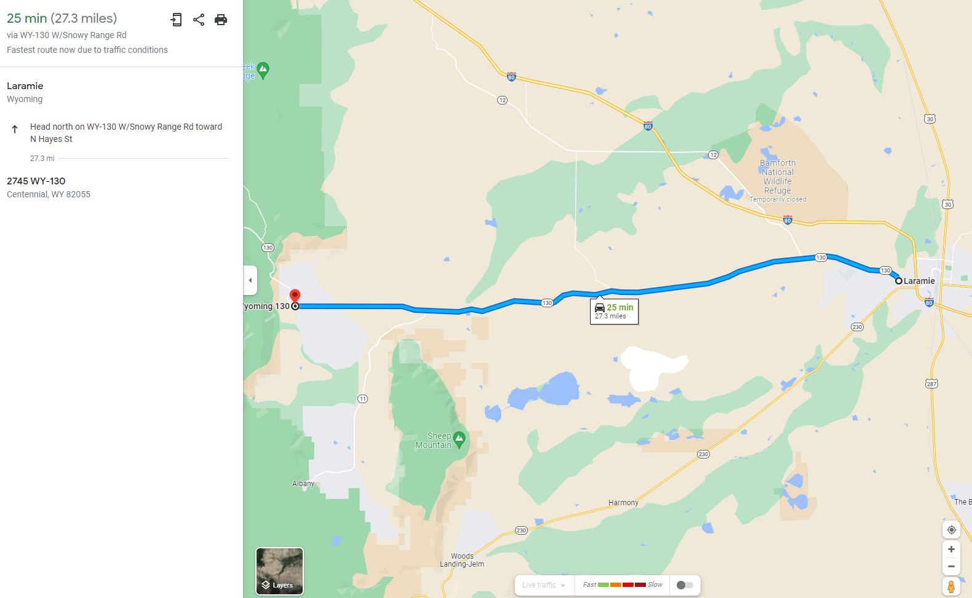

**Roger Canyon Transect.**

CR 17, Roger Canyon Road. Laramie to Horse Creek RD-Laramie County Fire District #2 Station 3. 26.7 miles. Transect Begins at the junction of Beaufort Street and 9th Street in Laramie. Transects ends 26.7 miles down the road on the east side of the Laramie Range where the road jopins Horse Creek Road/WY 211.

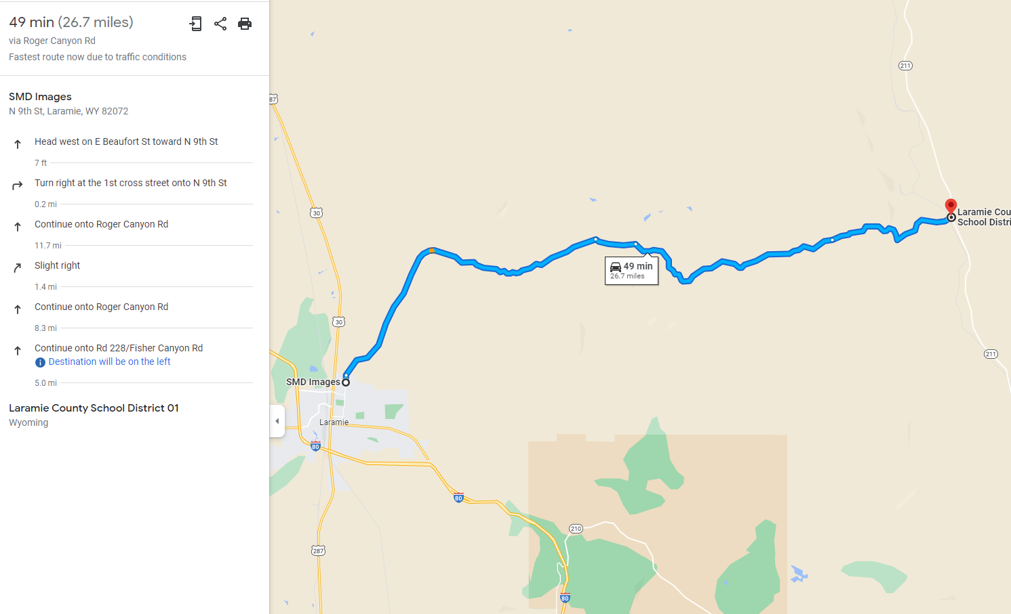

**Colorado Transect.**

US 287. Laramie to Wyoming/Colorado border. 23.4 miles. Head south on 287. Start at the Fairgrounds/Wyoming Port of Entry on the edge of town. Stope at the ‘Welcome to Colorful Colorado’ on the Wyoming/Colorado border.

**Bakery Transect**

WY 12 – CR 57 – I-80 on ramp 279 I-80. 26.9 miles. Golden Prairie Bakery to on-ramp 279 I-80. Transect Starts at on WY 12-Herrick Lane (just off of WY 130) where the B W J road to the Golden Prairie Bakery leaves the highway. Transect continues NW down WY 12, past Alsop Lake then west under the interstate at Bath Stone House, then continuing west, northwest when it becomes Dutton Creek Road, Stay on this road. You will go back under the instate, twice more endingbup on the southwest side of the interstate. Until you come to the I-80 on-ramp at mile marker 279. Transect ends at the on-ramp.

**Bosler Transect.**

US 30 Laramie to Sand Hills Road. Transects Starts at Peking Chinese Restaurant on US-30. Transect ends 26.7 miles north on US-30 at the turn-off for Sand Hills Road.

**Vedawoo Transect**

CR 124-WY 210-CR 700 Old US Hwy 30 and Happy Jack Road – Vedawoo Glen Road. 25.3 miles. Transect starts at Vedawoo exit 329 on I-80 towards Cheyenne. Turn right off the exit ramp and head NW on CR 124/Old US Hwy 30 (heading back towards Laramie, parallel to interstate). Cross over the interstate at the Lincoln monument and turn north onto WY 210/Happy Jack Road. Continue north, then east, then southeast down Happy Jack Road/WY 210 for 11 miles until you get to CR-700/Vedawoo Glen Rd (gravel road). Stay on this road for 7.3 miles until you come to the Interstate again. Transect ends at the I-80 Interstate on-ramp 329. This transect is one complete loop.

**Chimney Rock Transect.**

CR 34 Sand Creek Road to Wyoming Colorado border. 22.3 miles Transect Starts at the Mountain Cement Company on southwest side of town (over the tracks). CR-34/Sand Creek Road heads south/south west for 22.3 miles until you arrive at Chimney Rocks just on the other side of the Wyoming border.

**Bull Mountain Transect.**

Sportsmen Lake Road CR 316, Bull mountain road 322. 21 miles. To get to the transect start head down US-287 towards Fort Collins Transect starts about 0.75 miles west of US-287 where the road cross Grant Creek/Willow Creek. Head west down Sportsman Lake Road for 12.5 miles until you come to CR-34/ Sand Creek Road. Head southwest down Sand Creek Road for 0.5 miles until you cross Sand Creek. Take a right onto Bull Mountain Rd/CR 322. Stay on this road heading southwest until you come to the Wyoming Colorado border in 8 miles. Transect ends at the border.

**Sybille Creek Transect**

Transects starts on WY 34 at junction with US 30. Transect ends 19.0 miles down WY 34 at Keil Outdoor Adventures.

**Laramie River Transect**

CR 55/Welsh Lane – CR 51/Howell Road, Aspenwood Arena and Stables to Bosler, Wy. 19.1 miles. Transect starts at Junction of WY 130 and CR55/Welsh Lane. Transect ends at junction of CR 51/Howell Road and US 30/287.

**Lakes Transect**

CR 422 to Lake Hattie Reservoir. 11.3 miles. Transect starts at Juction of WY 230 and CR 422/Pahlow Lane. Transect ends on the edge of Lake Hattie Reservoir.

