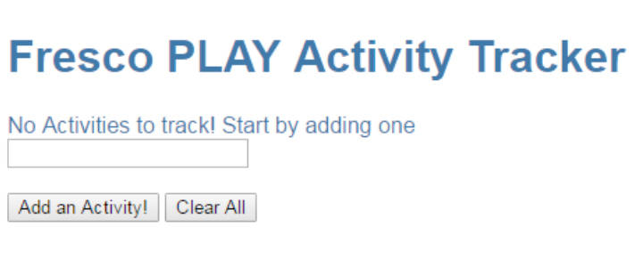
Now, it is time to build your own app with what you have learnt so far.
Create a page as shown in the picture. Have the following elements in your app.
- Header
- Label – Display ONLY IF there are no activities
- Text Input box
- Button 1 – To add an activity
- Button 2 – To clear all activities

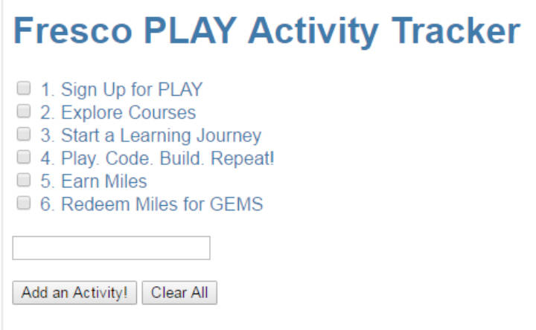

You should be able to add a list of activities, where the activities are displayed along side a checkbox.
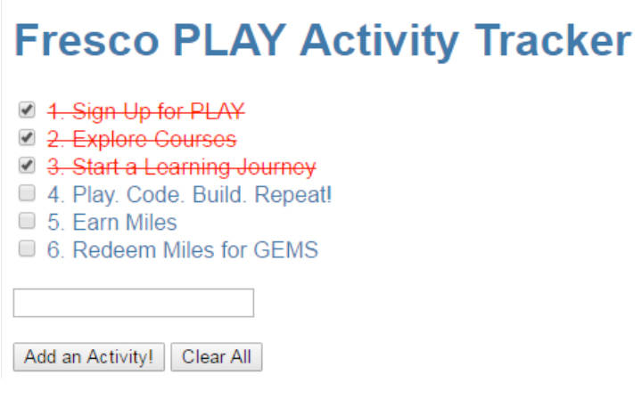
Once you check any activity, strike it out, with the font color changing to red.
It is time to build your own app with what you have learnt so far.

Create an Application as shown in the picture with the following elements:
- Header
- Label – Display ONLY IF there are no activities
- Text Input box
- Button 1 with a title Add an Activity– To add an activity
- Button 2 with a title Clear All– To clear all activities

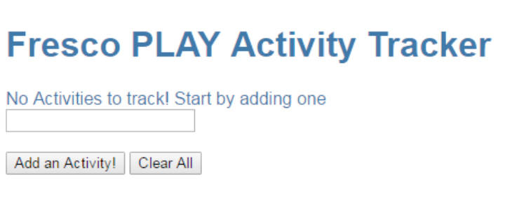

- You should be able to add a list of activities, where the activities are displayed along side a checkbox.

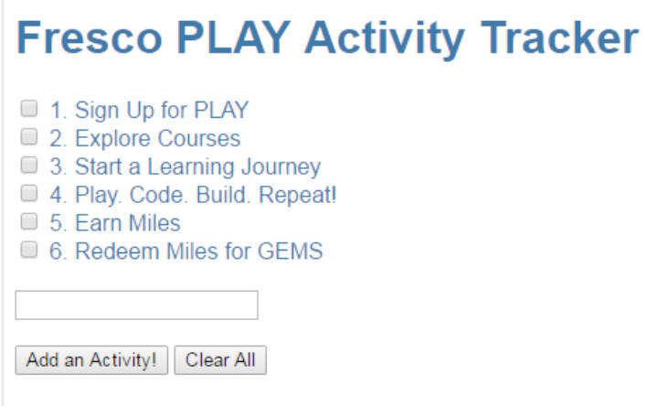

- Once you check any activity, strike it out, with the font color changing to red.

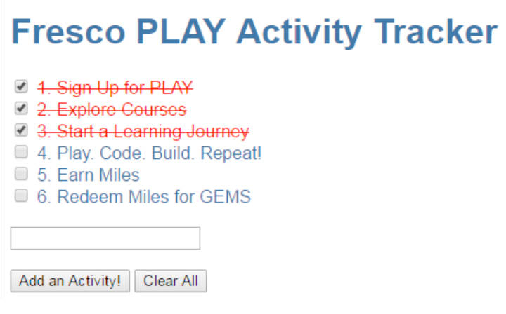
- By clicking Clear All button, all activities should be cleared.

Hints:

- Create a component with selector as app-root
- Use a templateUrl that refer to the app.component.html.
- Use a styleUrls thet refer to the app.component.css.
- Define the variables in AppComponent,
  - done as boolean
  - todos as any
  - newToDoas string
  - newToDoObjas any
  - erroras boolean
  - TODOS as array
- Define constructor with todos as [], newTODO as empty and error as false.
- Declare and define functions addMore() and clearAll() to perform the specific tasks.

