**Homework 4 – output based on test cases**

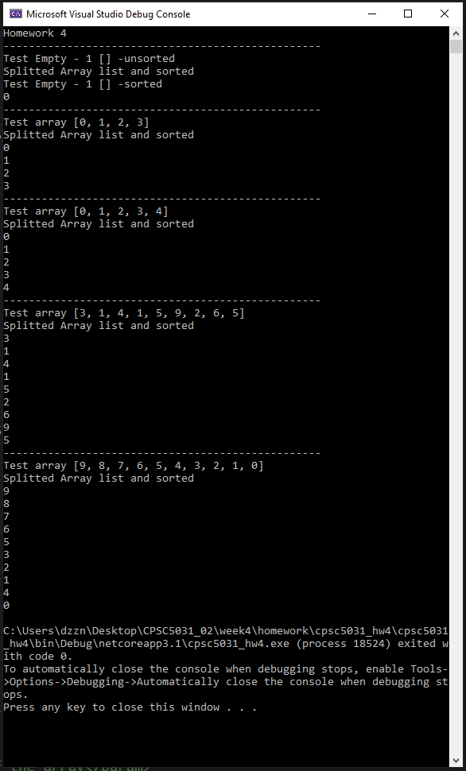

|  |  |  |
| --- | --- | --- |
| Test case | Expected result | Actual test result |
| [] | [] | passed |
| [0, 1, 2, 3] | [0, 1, 2, 3] | passed |
| [0, 1, 2, 3, 4] | [0, 1, 2, 3, 4] | passed |
| [3, 1, 4, 1, 5, 9, 2, 6, 5] | [1, 1, 2, 3, 4, 5, 5, 6, 9] | Failed [3, 1, 4, 1, 5, 2, 6, 9, 5] |
| [9, 8, 7, 6, 5, 4, 3, 2, 1, 0] | [0, 1, 2, 3, 4, 5, 6, 7, 8, 9] | Failed [9, 8, 7, 6, 5, 3, 2, 1, 4, 0] |

**Codes updated and second test run**

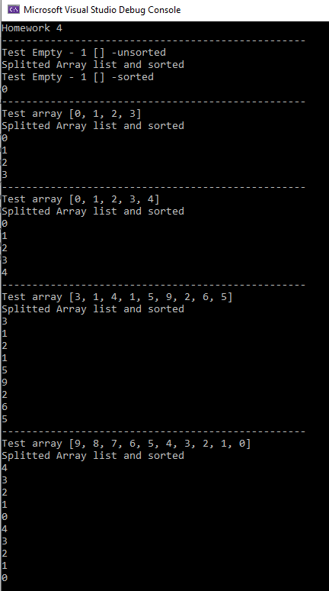

|  |  |  |
| --- | --- | --- |
| Test case | Expected result | Actual test result |
| [] | [] | passed |
| [0, 1, 2, 3] | [0, 1, 2, 3] | passed |
| [0, 1, 2, 3, 4] | [0, 1, 2, 3, 4] | passed |
| [3, 1, 4, 1, 5, 9, 2, 6, 5] | [1, 1, 2, 3, 4, 5, 5, 6, 9] | Failed [3, 1, 2, 1, 5,9, 2, 6, 5] |
| [9, 8, 7, 6, 5, 4, 3, 2, 1, 0] | [0, 1, 2, 3, 4, 5, 6, 7, 8, 9] | Failed [4, 3, 2, 1, 0, 4, 3, 2, 1, 0] |