Adar Readme for Version 1.2.1.1
How to Install Adar:
- Download the self extracting file to a temporary folder.
- From Explorer, double click the file you just downloaded. This will extract all the files into the same folder.
- Double click the SETUP.EXE icon in the temporary folder.
- Follow the instructions during the installation process.
Getting Started:
ADAR is extremely simple to use. All you need to do is make sure that your sound card is set up correctly for recording and that the signal is available to multimedia programs. You can use the Media Player program that comes with Windows to verify that your sound card is capable of recording.
Windows 95 and NT both have a speaker icon that is available on your desktop's start bar (or tray). Look for the speaker icon near the clock (if you have set the clock to be visible in your start bar properties).
The speaker icon allows you to control the volume levels for recording and listening.
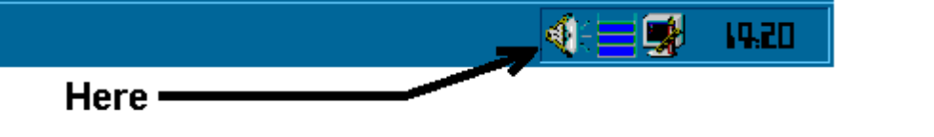
One click of the speaker icon reveals one slider volume control. If you double click this icon, you should see several volume control sliders. Each slider has a mute checkbox under it. If you see a muted volume slider, you should uncheck it if you think it could prevent audio from reaching the recorder.
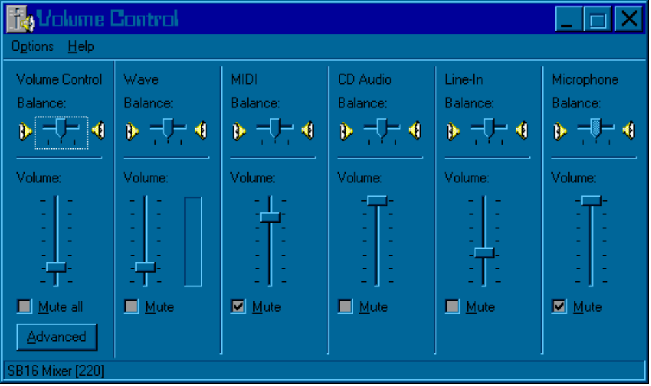Since I only have a SoundBlaster (AWE32) I don't know if these sliders are common to all Win95 and WinNT setups or not. I hope they are because they're great to have.
Most sound cards have both a mic and a line input. If you plan on using a scanner or other radio for recording, you should connect the radio's speaker or headphone jack to the sound card's line input jack. If you only have a mic input, you will probably notice that the signal from the radio's speaker jack is going to be too loud for the sound card, resulting in a low signal to noise ratio and high distortion. For a clearer signal in this situation, you should try to locate a passive line attenuator. If you don't know where to buy one, you can make one yourself if you're good with soldering and understand how to read a schematic diagram. Figure 1 shows a schematic drawing of how to build your own input attenuator.

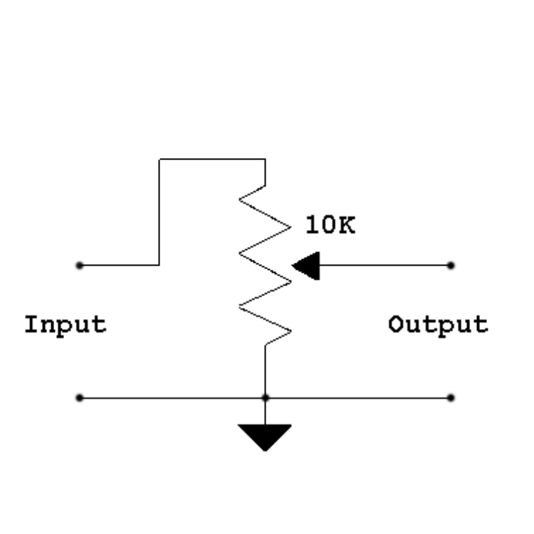
Figure 1.
Settings:
There is a file called ADAR.INI that is located in the Windows directory. This file looks like the example shown here:
[INIT]
SampleRate=8000
ScrollTime=80
Squelch=14
The SampleRate parameter can be changed to any valid sample rate. Soon this won't be necessary as there will be a dropdown list allowing you to choose the sample rate from a list.
The ScrollTime parameter is the delay in milliseconds of the update interval for the sweep marker display. The lower this number, the faster the marker will move and this can also increase how much CPU is being utilized by the program. The higher this number, the more condensed the display will appear and less CPU will be used.
The Squelch parameter represents the squelch threshold in percent. The range is 0 to 100. This value is maintained automatically by the squelch slider control.
NOTE: If you accidently mess up this file, you can recover by deleting the file and starting ADAR again. That will cause a default file to be generated.
Index file:
When a recording session is taking place, there are two output files. The .WAV file and the .IDX file. Currently, the IDX file is created in either the same path as the executable or the path specified in the Start In field of the shortcut's property page.
The index file contains a series of timing markers to indicate when each squelch-break event occured. Each record contains the following information:

- Date
- Time
- Offset to the current sample number
- Elapsed samples since the recoding session started.

The file is not used yet by the program but it is available if you want to extract the times out of it. In order to view the contents, you need to either use ADAR's "Display Index File" option or you need a program or script to extract the records from the IDX file. The SampleStoredCount field can be used to locate an event if your audio player application has the ability to locate by sample number.
Each record is fixed in length and is formatted as follows: (note - Integer representation is based on Intel's byte order).

- int Seconds
- int Minutes
- int Hour
- int Day
- int Month
- int Year
- int (reserved)
- int (reserved)
- int (reserved)
- Long Integer Sample Offset
- Long Integer Elapsed Samples

C Program Representation of the Index file record structure.

struct Index
{
SYSTEMTIME Time; // Time of first sample that broke squelch
long SampleStoredCount; // offset to the sample number in the file
long SampleCount; // Samples measured from start of recording
};

