
Minecraft Server Manager
User Guide
Version 1.0.0 · October 2026
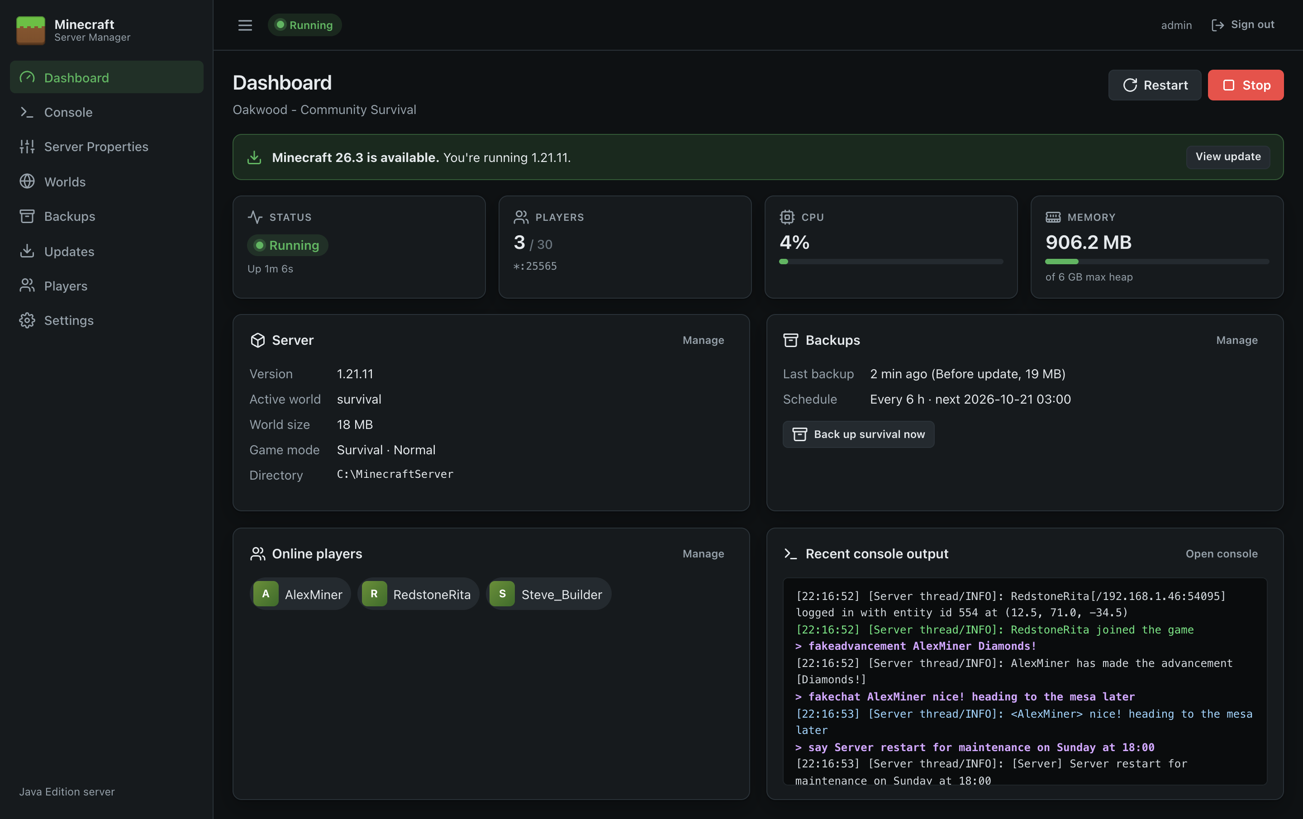
Web control panel for Minecraft: Java Edition dedicated servers on Windows Server.
Minecraft is a trademark of Mojang AB. This project is not affiliated with Mojang or Microsoft.
Contents
Introduction
What you can do with it
About this guide
Quick Start
Before you begin
Steps
What next?
Installation
Requirements
Download
Install with the setup wizard
First-run setup
Choose Java
Install Minecraft and accept the EULA
Start the server
Upgrading
Uninstalling
Unattended installation
Manual installation from the zip
Next steps
Getting Around the Panel
Signing in
Finding your way around
Pages in this guide
Dashboard
Server controls
Alerts
Status cards
Information panels
Tips
Console
Reading the output
Running commands
After a crash
Server Properties
How the page is laid out
Changing settings
Adding and removing settings
When the file doesn't exist yet
Good to know
Worlds
World cards
Creating a new world
Switching the active world
Importing a world
Deleting a world
Backups
Taking a backup now
Storage
Scheduled backups
Backup history
Restoring a backup
Backup file names
Updates
Status cards
Browsing versions
Installing or updating
Rolling back
Good to know
Players
How changes are applied
Online now
Operators
Whitelist
Banned players
Banned IPs
Settings
Server
Java
Memory and JVM
Account
Validation
Running as a Windows Service
The service
Managing the service
Logs
Installing the service by hand (zip)
Service account
Updating the panel
Running more than one Minecraft server
Remote Access and HTTPS
Option 1: Listen on the network (LAN)
Option 2: HTTPS directly in the panel
Option 3: Behind a reverse proxy
Access from the internet
Troubleshooting
Installing
The panel won't open in the browser
"Rejoining the server…" keeps appearing
The server won't start
The server is stuck on "Starting…"
Players can't connect
The server crashes
The server is slow / "Can't keep up!"
Backup problems
Update problems
Player list problems
Signing in
Collecting information for support
Frequently Asked Questions
Appendix A: Server Properties Reference
General
Gameplay
World
Players & Security
Performance
Resource Pack
RCON & Query
Advanced
Notes
Appendix B: Files and Folders
Panel program folder
Panel data folder
Zip installs
Windows registry
Server directory
Naming conventions
Editing files by hand

Introduction
Minecraft Server Manager is a web control panel for running a Minecraft: Java Edition dedicated server on Windows Server. It installs as a single program, runs in the background as a Windows service, and is managed from any web browser, on the server itself or (if you allow it) from another computer.
Figure 1: The dashboard

What you can do with it
Area | What it does
Run the server | Start, stop and restart with one click. Watch status, players, CPU and memory live. The server restarts itself after a crash and shuts down cleanly with Windows.
Console | See the live server log, colour-coded, and type commands without logging on to the server.
Configure | Edit every server.properties setting through a form with descriptions and validation.
Worlds | Generate new worlds (with seeds, world types and superflat presets), switch between worlds, and import singleplayer saves.
Backups | Take safe backups of a running world, schedule them, and restore or download them.
Updates | Install or update the official Minecraft server from Mojang, verified and with automatic backup and rollback.
Players | Manage operators, the whitelist and bans, and kick or ban players who are online.

About this guide
This guide is for the people who look after the Minecraft server: installing the panel, running the server day to day, and fixing problems. No programming knowledge is needed; some familiarity with Windows Server (PowerShell, Services, Windows Firewall) helps for installation.
Chapter | Covers
Quick Start and Installation | Getting from the download to a running server
User Guide to Settings | Each page of the panel, in the order they appear in the menu
Running as a Windows Service, Remote Access and HTTPS | Setting the panel up for everyday, unattended use
Troubleshooting and FAQ | Solving common problems
Appendices | Every server setting, and where the panel keeps its files

Conventions. Names of buttons, fields and pages are shown in bold. File names, settings keys and commands are shown in code style. Screenshots come from a demonstration server, so names, sizes and dates will differ from yours.
This guide is also available online in the project wiki, which includes additional technical reference material for developers.

Quick Start
This gets you from the download to a running Minecraft server in about ten minutes. The rest of the guide covers each step in more detail.

Before you begin
You need:
- A Windows Server 2016+ or Windows 10/11 (x64) machine with administrator access.
- Internet access from the server (to download Minecraft and Java).

Steps
- Install Java. Download and install a 64-bit JDK from Eclipse Temurin. Choose Java 21 for Minecraft 1.20.5 to 1.21.x, or Java 25 for Minecraft 26.x. Tick Set JAVA_HOME during setup.
- Download MinecraftServerManager-<version>-Setup.exe from the Releases page.
- Run the setup wizard. Keep the defaults (panel port 8080, Minecraft players allowed through the firewall) and click Install. If SmartScreen warns about the download, click More info → Run anyway.
- Click Finish. The panel opens in your browser at http://localhost:8080.
- Create your admin account and confirm the server directory (default C:\MinecraftServer). See Installation.
- Select Java. Go to Settings → Java, click Detect installed Java, choose the version you installed, then Save settings.
- Install Minecraft. Go to Updates and click Install next to the latest release your Java supports.
- Accept the EULA. Read the Minecraft EULA and click I agree on the Dashboard or Updates page.
- Start the server with the Start button on the Dashboard. The first start generates the world; watch progress on the Console.
- Connect from Minecraft: Multiplayer → Add Server with the server's IP address (port 25565 is the default).

What next?
- Turn on Start the Minecraft server when the manager starts in Settings so the server comes back after a reboot.
- Turn on scheduled backups on the Backups page.
- Review Server Properties: set the MOTD, difficulty and whitelist.
- To manage the panel from your own PC, see Remote Access and HTTPS.

Installation
This page covers system requirements, installing the panel with the setup wizard, first-run setup, Java, unattended installation, and upgrading or removing the panel.

Requirements
Item | Requirement
Operating system | Windows Server 2016, 2019, 2022 or 2025, or Windows 10/11, 64-bit (x64)
.NET | Not required. The panel is self-contained.
Java | A 64-bit Java runtime matching your Minecraft version (see below)
Memory | Enough for Windows plus the Minecraft heap. 8 GB total is a sensible minimum for a small server.
Disk | About 120 MB for the panel, plus worlds and backups (allow several GB)
Network | Internet access to download Minecraft and check for updates. TCP port 25565 open for players.
Browser | Any current browser (Edge, Chrome, Firefox, Safari)

Which Java do I need?
The panel checks this for you before installing a version, and the Updates page shows the requirement for the latest release.
Minecraft version | Minimum Java
26.1 and later | Java 25
1.20.5 – 1.21.x | Java 21
1.18 – 1.20.4 | Java 17
1.17.x | Java 16
1.16.5 and earlier | Java 8

Install a JDK or JRE from Eclipse Temurin (recommended), Microsoft Build of OpenJDK, Azul Zulu or Amazon Corretto. You can install several versions side by side and choose one in Settings.

Download
Download the latest release from the Releases page:
File | Use it if…
MinecraftServerManager-<version>-Setup.exe | You want the simplest install. Start here.
MinecraftServerManager-<version>-x64.msi | You deploy software with Group Policy, Intune or similar, or want an unattended install (details).
MinecraftServerManager-<version>-win-x64.zip | You'd rather install by hand (details).
SHA256SUMS.txt | Checksums to verify the downloads: Get-FileHash <file> in PowerShell.

Install with the setup wizard
- Run MinecraftServerManager-<version>-Setup.exe and approve the administrator prompt.
"Windows protected your PC"? The installers aren't code-signed yet, so Microsoft Defender SmartScreen may show this for a new download. Check the file's SHA-256 against SHA256SUMS.txt, then click More info → Run anyway.
- Select Destination Location. The default C:\Program Files\Minecraft Server Manager is fine.
- Web panel. Choose the port the panel uses (default 8080). Change it only if another program already uses 8080.
- Network access. Choose which Windows Firewall rules to add:
Option | Default | Effect
Allow Minecraft players to connect | On | Opens TCP 25565 so players can join.
Allow other computers to open the web panel | Off | Makes the panel listen on the network and opens its port. Read Remote Access and HTTPS first.

- Ready to Install summarises your choices. Click Install.
- Click Finish. Open Minecraft Server Manager in your web browser is ticked, so the panel opens at http://localhost:8080.
The panel now runs in the background as a Windows service and starts with Windows. A Minecraft Server Manager shortcut in the Start menu opens it again later.

What the setup wizard installs
Item | Location / name
Program files | C:\Program Files\Minecraft Server Manager\
Panel settings, sign-in and keys | C:\ProgramData\Minecraft Server Manager\ (appsettings.json and data\)
Windows service | Minecraft Server Manager (MinecraftServerManager): automatic start, Local System, restarts if it fails
Firewall rules | Minecraft Server (TCP 25565) and, if chosen, Minecraft Server Manager (TCP <port>)
Start menu | Minecraft Server Manager (opens the panel in your browser)
Uninstaller | Settings → Apps → Installed apps → Minecraft Server Manager

Your Minecraft server files and worlds go in a separate folder that you choose during first-run setup (default C:\MinecraftServer). See Files and Folders.

First-run setup
The first time the panel opens, you're asked to create the administrator account.
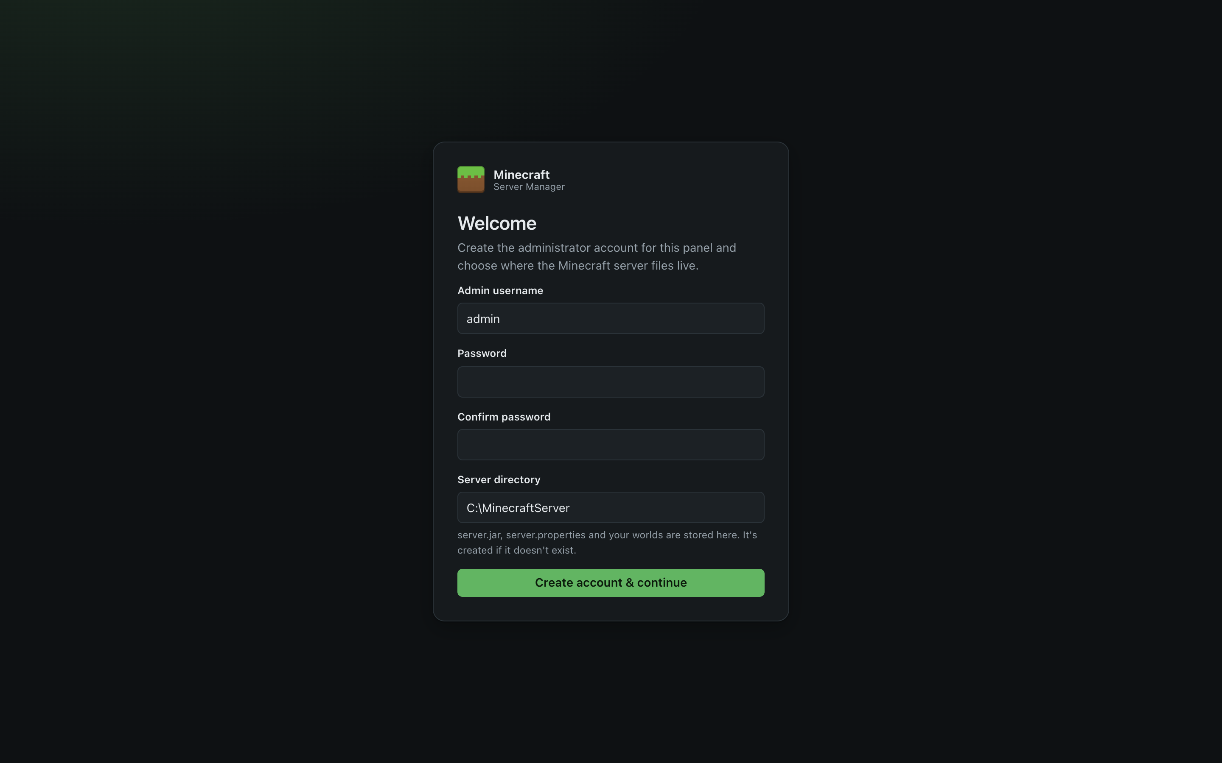
Figure 2: First-run setup
Field | What to enter
Admin username | The name you'll sign in with (letters, numbers, ., -, _).
Password / Confirm password | At least 8 characters. Use a strong, unique password, especially if the panel will be reachable from other machines.
Server directory | A full path where server.jar, server.properties and worlds are kept, e.g. C:\MinecraftServer. It's created if it doesn't exist.

Click Create account & continue. You're signed in and taken to the Dashboard, which shows what's still needed:
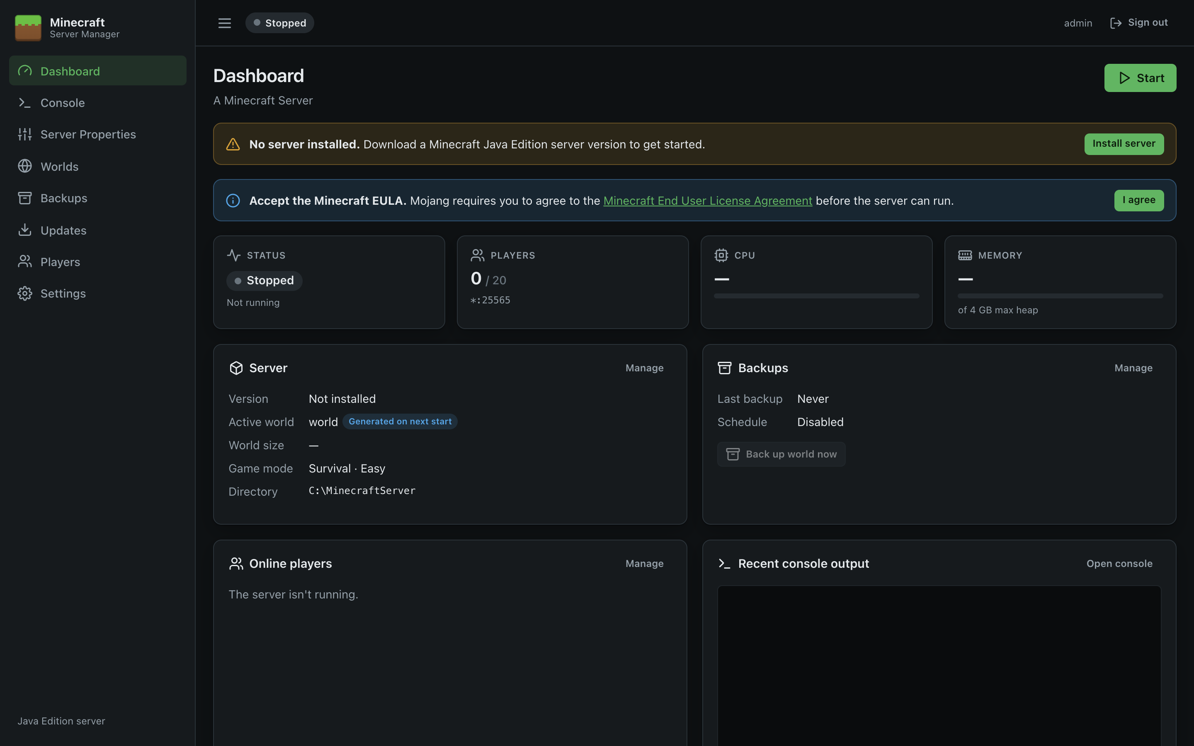
Figure 3: Dashboard on first run
Note: There is a single administrator account. Anyone who can reach the setup page before it's completed could claim it, so complete setup straight after installing. By default the panel only listens on localhost, so this is only possible from the server itself.

Choose Java
- Go to Settings.
- Under Java, click Detect installed Java. The panel searches JAVA_HOME, the PATH, and the usual install folders (C:\Program Files\Eclipse Adoptium, Java, Microsoft, Zulu, Amazon Corretto, BellSoft, Semeru and others).
- Click the runtime you want. Its full path is filled in.
- Click Test to confirm it runs, then Save settings.
See Settings for details.

Install Minecraft and accept the EULA
- Go to Updates.
- Click Install on the version you want (usually the latest release your Java supports). The download comes from Mojang and is verified.
- Read the Minecraft End User License Agreement. If you agree, click I agree in the blue banner. This writes eula=true to eula.txt; the server won't start without it.
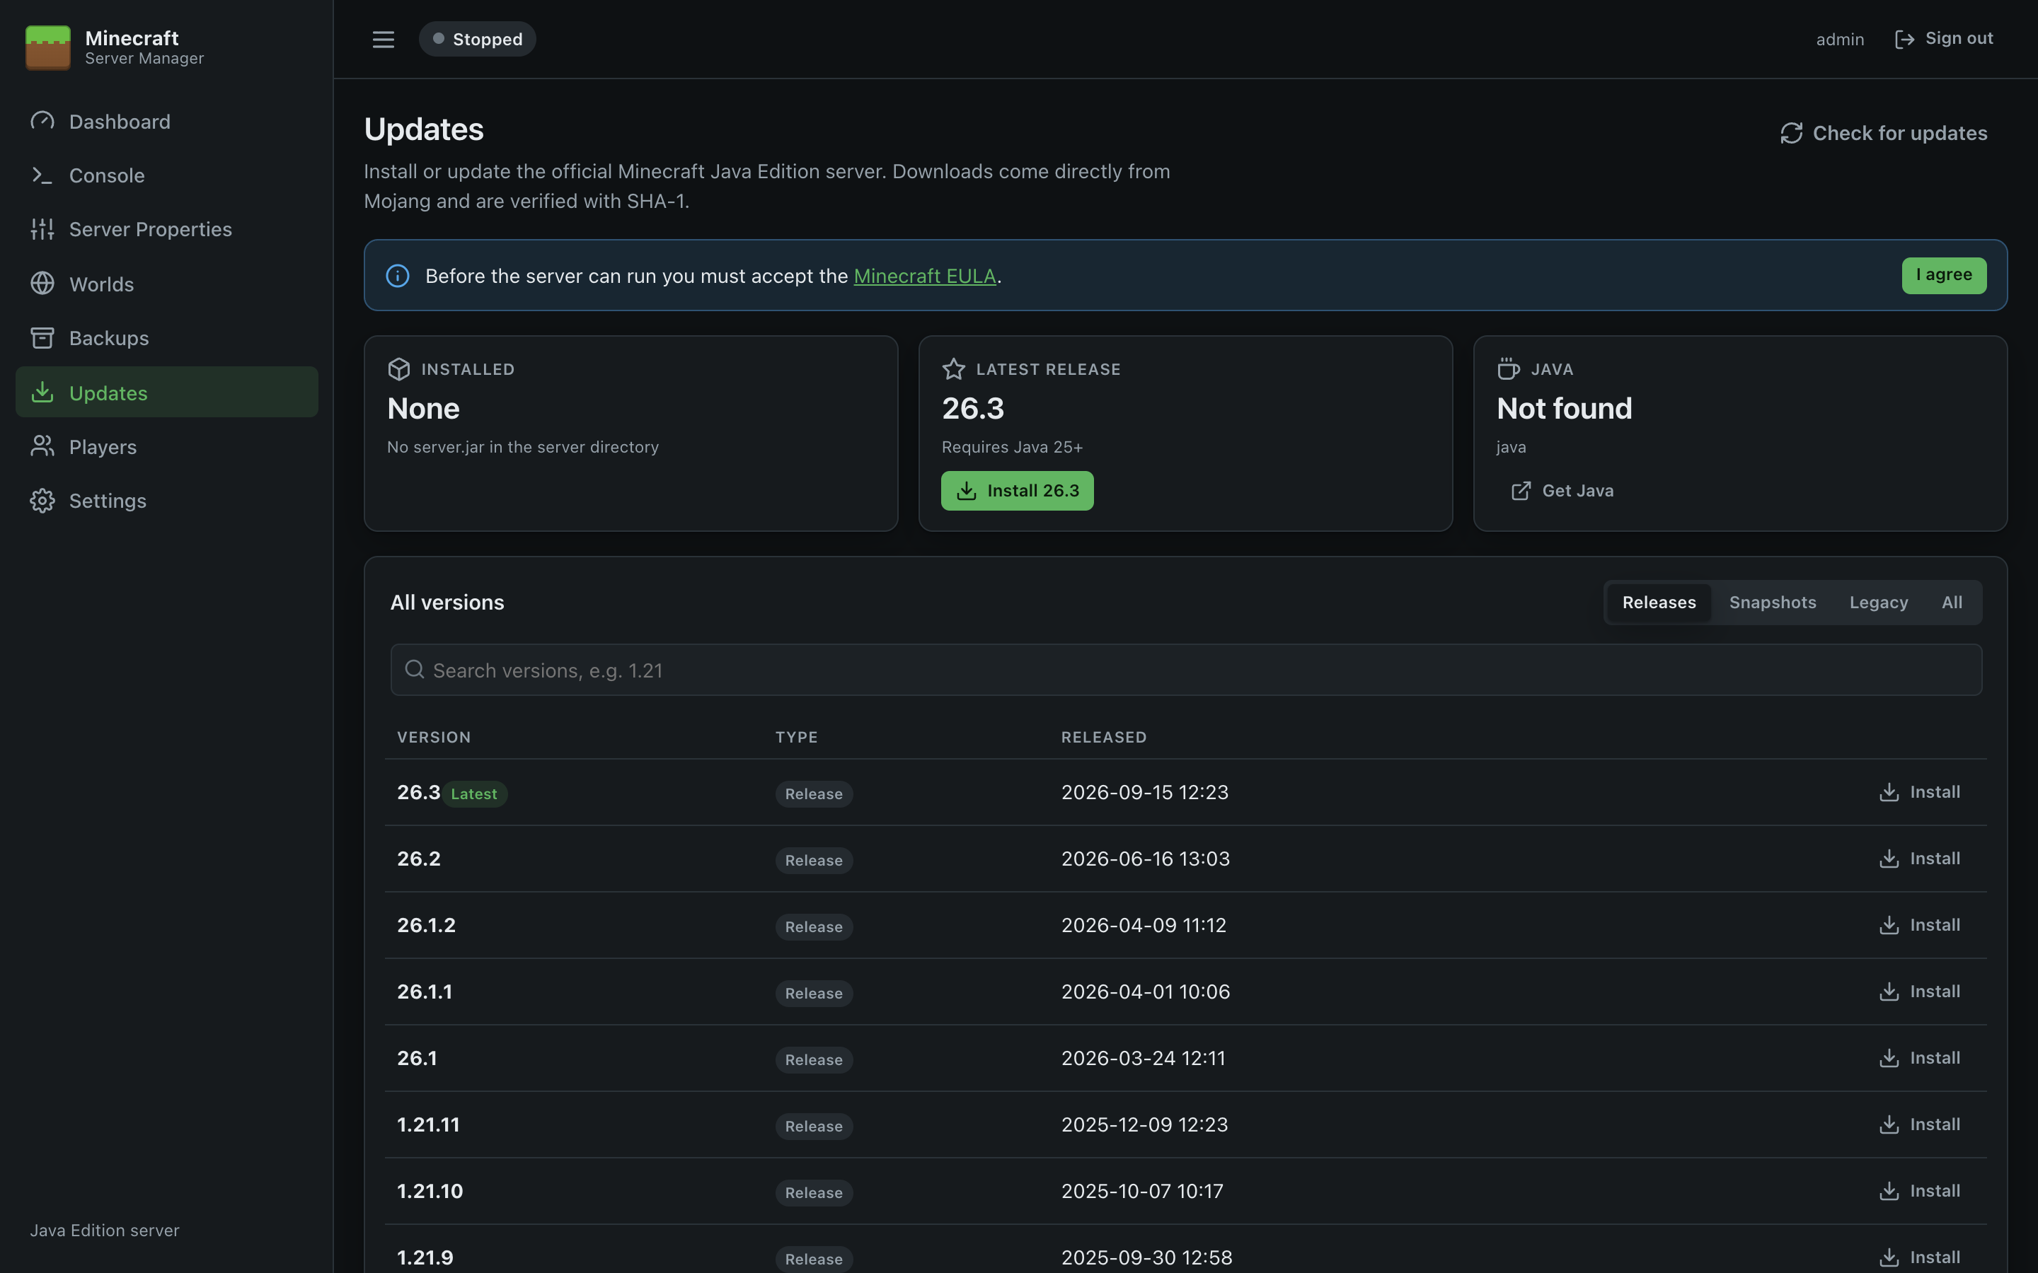
Figure 4: Updates page before anything is installed

Start the server
Click Start on the Dashboard. The first start downloads libraries and generates the world, which can take a minute or two. The status changes from Starting… to Running when Minecraft reports it's ready.

Open the firewall for players
The installers add the Minecraft Server (TCP 25565) rule unless you unticked it. To add it yourself, or for a different server-port, run this in an administrator PowerShell window:
New-NetFirewallRule -DisplayName "Minecraft Server (TCP 25565)" -Direction Inbound -Protocol TCP -LocalPort 25565 -Action Allow
For players outside your network, also forward TCP 25565 on your router or firewall to this server.

Upgrading
Run the setup wizard for the new version. It detects the existing installation, skips the option pages, stops the service (which shuts the Minecraft server down cleanly), replaces the program files, and starts the service again. Your panel settings, sign-in, worlds and backups are kept, as are your port and firewall choices.
The MSI upgrades the same way: install the newer .msi over the old one.

Uninstalling
Use Settings → Apps → Installed apps → Minecraft Server Manager → Uninstall (or Programs and Features). The uninstaller stops and removes the service, the firewall rules, the Start menu shortcut and the program files. It then asks whether to delete the panel's settings and sign-in details. Your Minecraft server directory, worlds and backups are never removed; delete them yourself if you no longer need them.

Unattended installation

Setup wizard switches
MinecraftServerManager-<version>-Setup.exe /VERYSILENT /SUPPRESSMSGBOXES /NORESTART [/PORT=8080] [/OPENMINECRAFTPORT=1] [/REMOTEACCESS=0] [/LOG="setup.log"]
"C:\Program Files\Minecraft Server Manager\unins000.exe" /VERYSILENT /SUPPRESSMSGBOXES /NORESTART
/SILENT shows progress without asking questions; /DIR="D:\Apps\Minecraft Server Manager" changes the install folder. A silent uninstall keeps the panel settings.

MSI properties
msiexec /i MinecraftServerManager-<version>-x64.msi /qn [PANELPORT=8080] [OPENMINECRAFTPORT=1] [REMOTEACCESS=0] [/l*v install.log]
msiexec /x MinecraftServerManager-<version>-x64.msi /qn
Property | Default | Meaning
PANELPORT | 8080 | Port for the web panel.
OPENMINECRAFTPORT | 1 | 1 adds the Minecraft Server (TCP 25565) firewall rule.
REMOTEACCESS | 0 | 1 makes the panel listen on the network and adds a firewall rule for PANELPORT.

The MSI has no wizard; double-clicking it installs with the defaults. On an upgrade or uninstall, properties you don't specify keep their previous values. The panel's port is only applied on a first install; to change it later use configure.

Manual installation from the zip
- Right-click the zip, choose Properties, tick Unblock if shown, then Extract All… to a permanent folder such as C:\MinecraftManager.
- Either double-click MinecraftServerManager.exe for a quick test (a console window shows Now listening on: http://localhost:8080; closing it stops the panel and the Minecraft server), or install it as a service from an administrator PowerShell window in that folder:
.\install-service.ps1 -OpenMinecraftPort
With the zip, panel settings are kept in a data folder next to the executable and the address is set in the appsettings.json beside it. See Running as a Windows Service and Configuration Reference.

Next steps
- Backups: turn on the schedule
- Remote Access and HTTPS: manage the panel from another PC
- Running as a Windows Service: service management and logs

Getting Around the Panel
This guide explains how to use every part of Minecraft Server Manager day to day. It assumes the panel is installed and set up (see Installation).

Signing in
Open the panel's address in a browser (by default http://localhost:8080 on the server itself) and sign in with the administrator account created during setup.
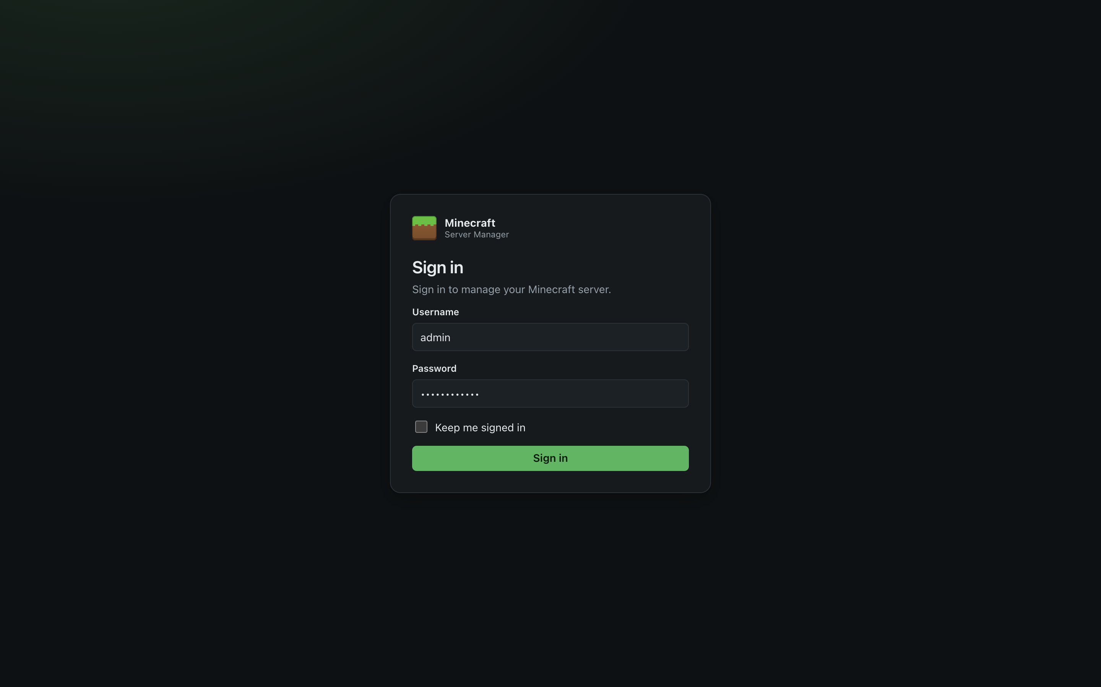
Figure 5: Sign-in page
- Tick Keep me signed in to stay signed in for 14 days on this browser (the period renews while you use the panel). Leave it unticked on shared computers; you'll be signed out when the browser closes.
- After 5 wrong passwords from the same address, sign-in is blocked for 5 minutes.
- Changing the password (in Settings) signs out every browser.

Finding your way around
The panel has three areas:
Area | What's there
Sidebar (left) | Links to each page: Dashboard, Console, Server Properties, Worlds, Backups, Updates, Players and Settings.
Top bar | The live server status, your username, and Sign out.
Page | The page you're on. Most pages have a title, a short explanation, and action buttons at the top right.

Server status
The coloured status in the top bar (and on the Dashboard) is always live:
Status | Meaning
Stopped (grey) | No server process is running.
Starting… (amber, pulsing) | Java is running and Minecraft is loading or generating the world. Players can't join yet.
Running (green) | Minecraft reported Done and is accepting players.
Stopping… (amber, pulsing) | The stop command was sent and the world is being saved.
Crashed (red) | The server exited unexpectedly. Check the Console. If automatic restart is on it restarts itself after 10 seconds.

Notifications and confirmations
- Short messages pop up at the top of the page after actions. They disappear after a few seconds (errors stay a little longer), or click × to close them.
- Anything destructive asks for confirmation first. Deleting a world also asks you to type its name.
- Everything updates live: if another person starts the server or a backup finishes, your page updates without reloading.

On a phone or tablet
The panel works on small screens. Tap the ☰ button at the top left to open the menu.
Dashboard on a phone | Menu open
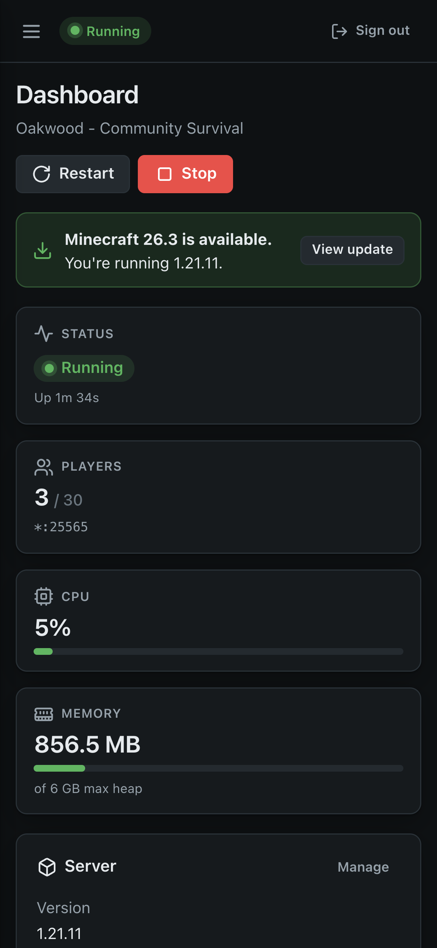 | 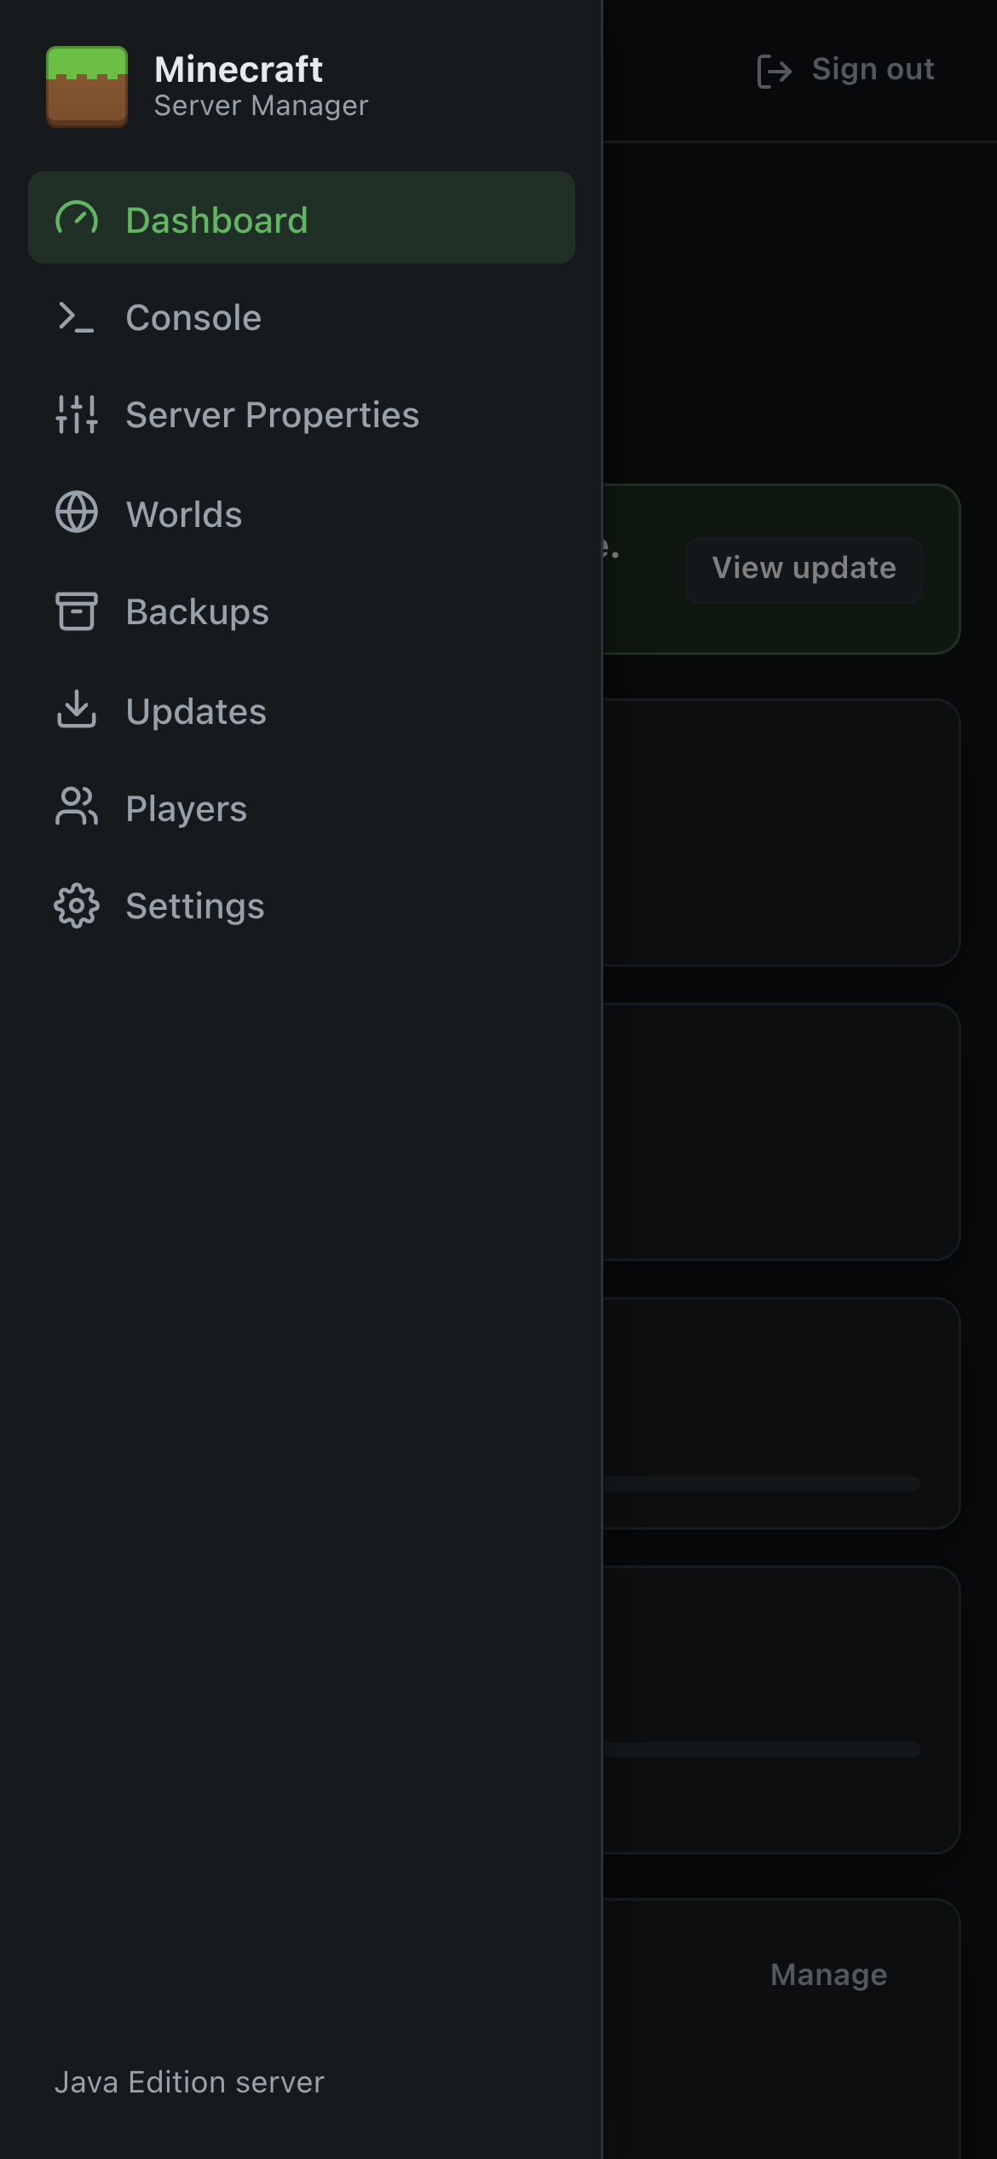

Light and dark appearance
The panel follows your device's light/dark setting automatically.
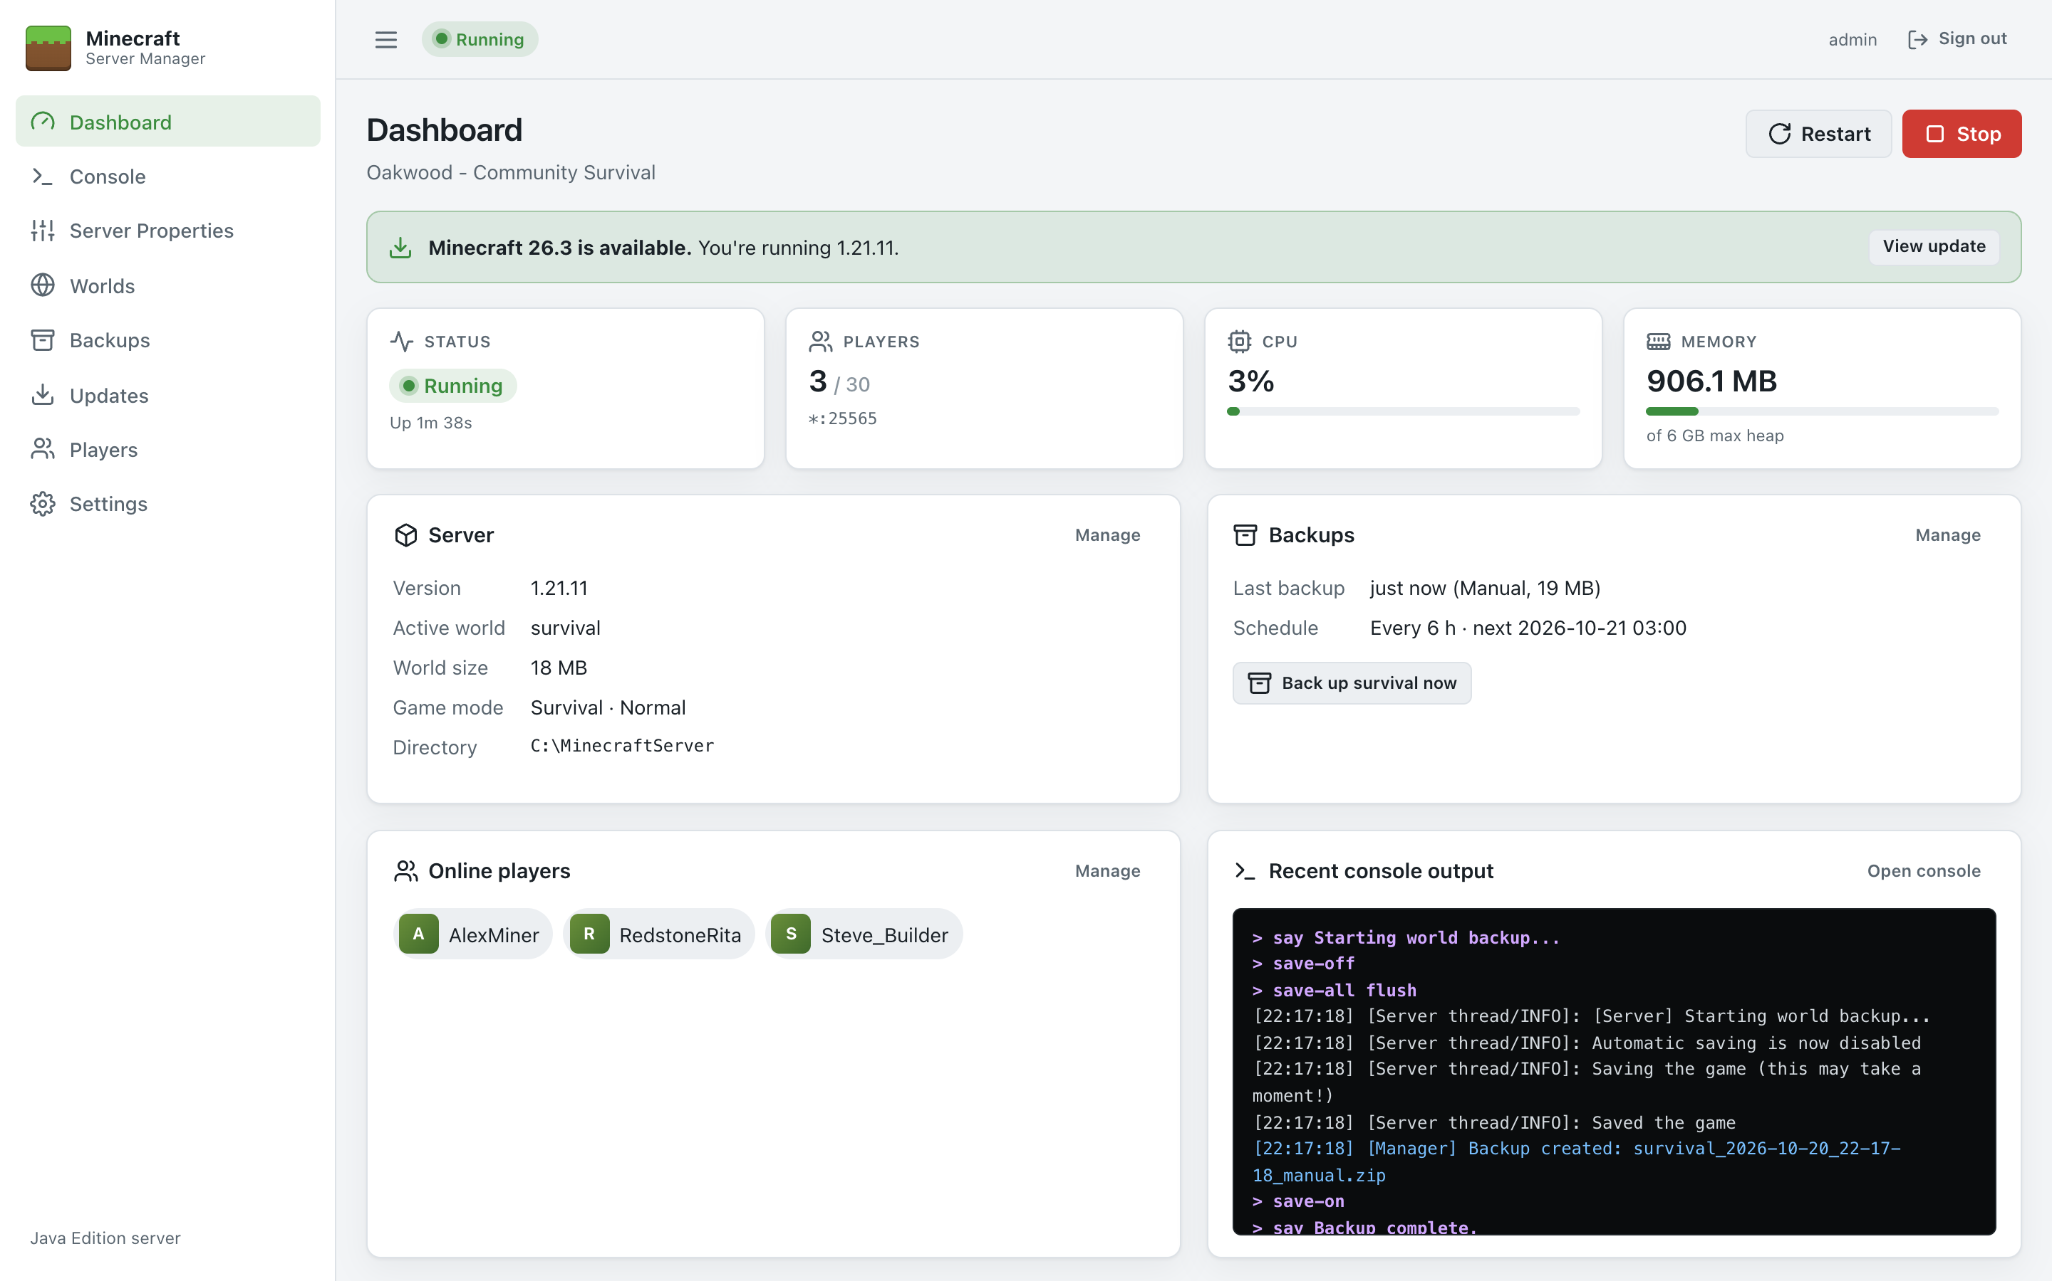
Figure 6: Light appearance

If the connection drops
The panel keeps a live connection to the server. If it's interrupted (for example while the panel service restarts) a Rejoining the server… message appears and the page reconnects on its own. If it can't, click Retry or reload the page.

Pages in this guide
Page | Use it to
Dashboard | See the server at a glance and start, stop or restart it
Console | Read the live log and run commands
Server Properties | Change server settings such as MOTD, difficulty, whitelist and view distance
Worlds | Create, switch, import and delete worlds
Backups | Back up, schedule, restore and download worlds
Updates | Install, update or roll back the Minecraft server
Players | Manage operators, the whitelist and bans
Settings | Configure Java, memory, folders, automatic start and your password

Dashboard
The Dashboard is the home page. It shows the server's state at a glance and has the main Start / Stop / Restart controls.
Figure 7: Dashboard

Server controls
The buttons at the top right change with the server's state:
Button | When it appears | What it does
Start | Server stopped or crashed | Launches Java with your Settings. Fails with a clear message if there's no server jar, the EULA hasn't been accepted, or Java can't be found.
Restart | Server running | Stops the server cleanly, then starts it again.
Stop | Server running | Sends stop, waits for the world to save and the process to exit (up to the Graceful stop timeout, 60 seconds by default), then kills it if it's still running.
Kill | While starting or stopping | Ends the Java process immediately, after confirmation. Anything not yet saved is lost. Use it only if the server is stuck.

The same controls are on the Console page.

Alerts
Banners appear at the top when something needs attention:
Banner | Meaning and action
No server installed | There's no server.jar yet. Click Install server to go to Updates.
Accept the Minecraft EULA | Mojang requires agreement to the EULA before the server can run. Click I agree if you accept it.
The server stopped unexpectedly | The server crashed (the exit code is shown). Click Open console to see why. See Troubleshooting.
Minecraft x.y is available | A newer release than the one installed exists. Click View update.

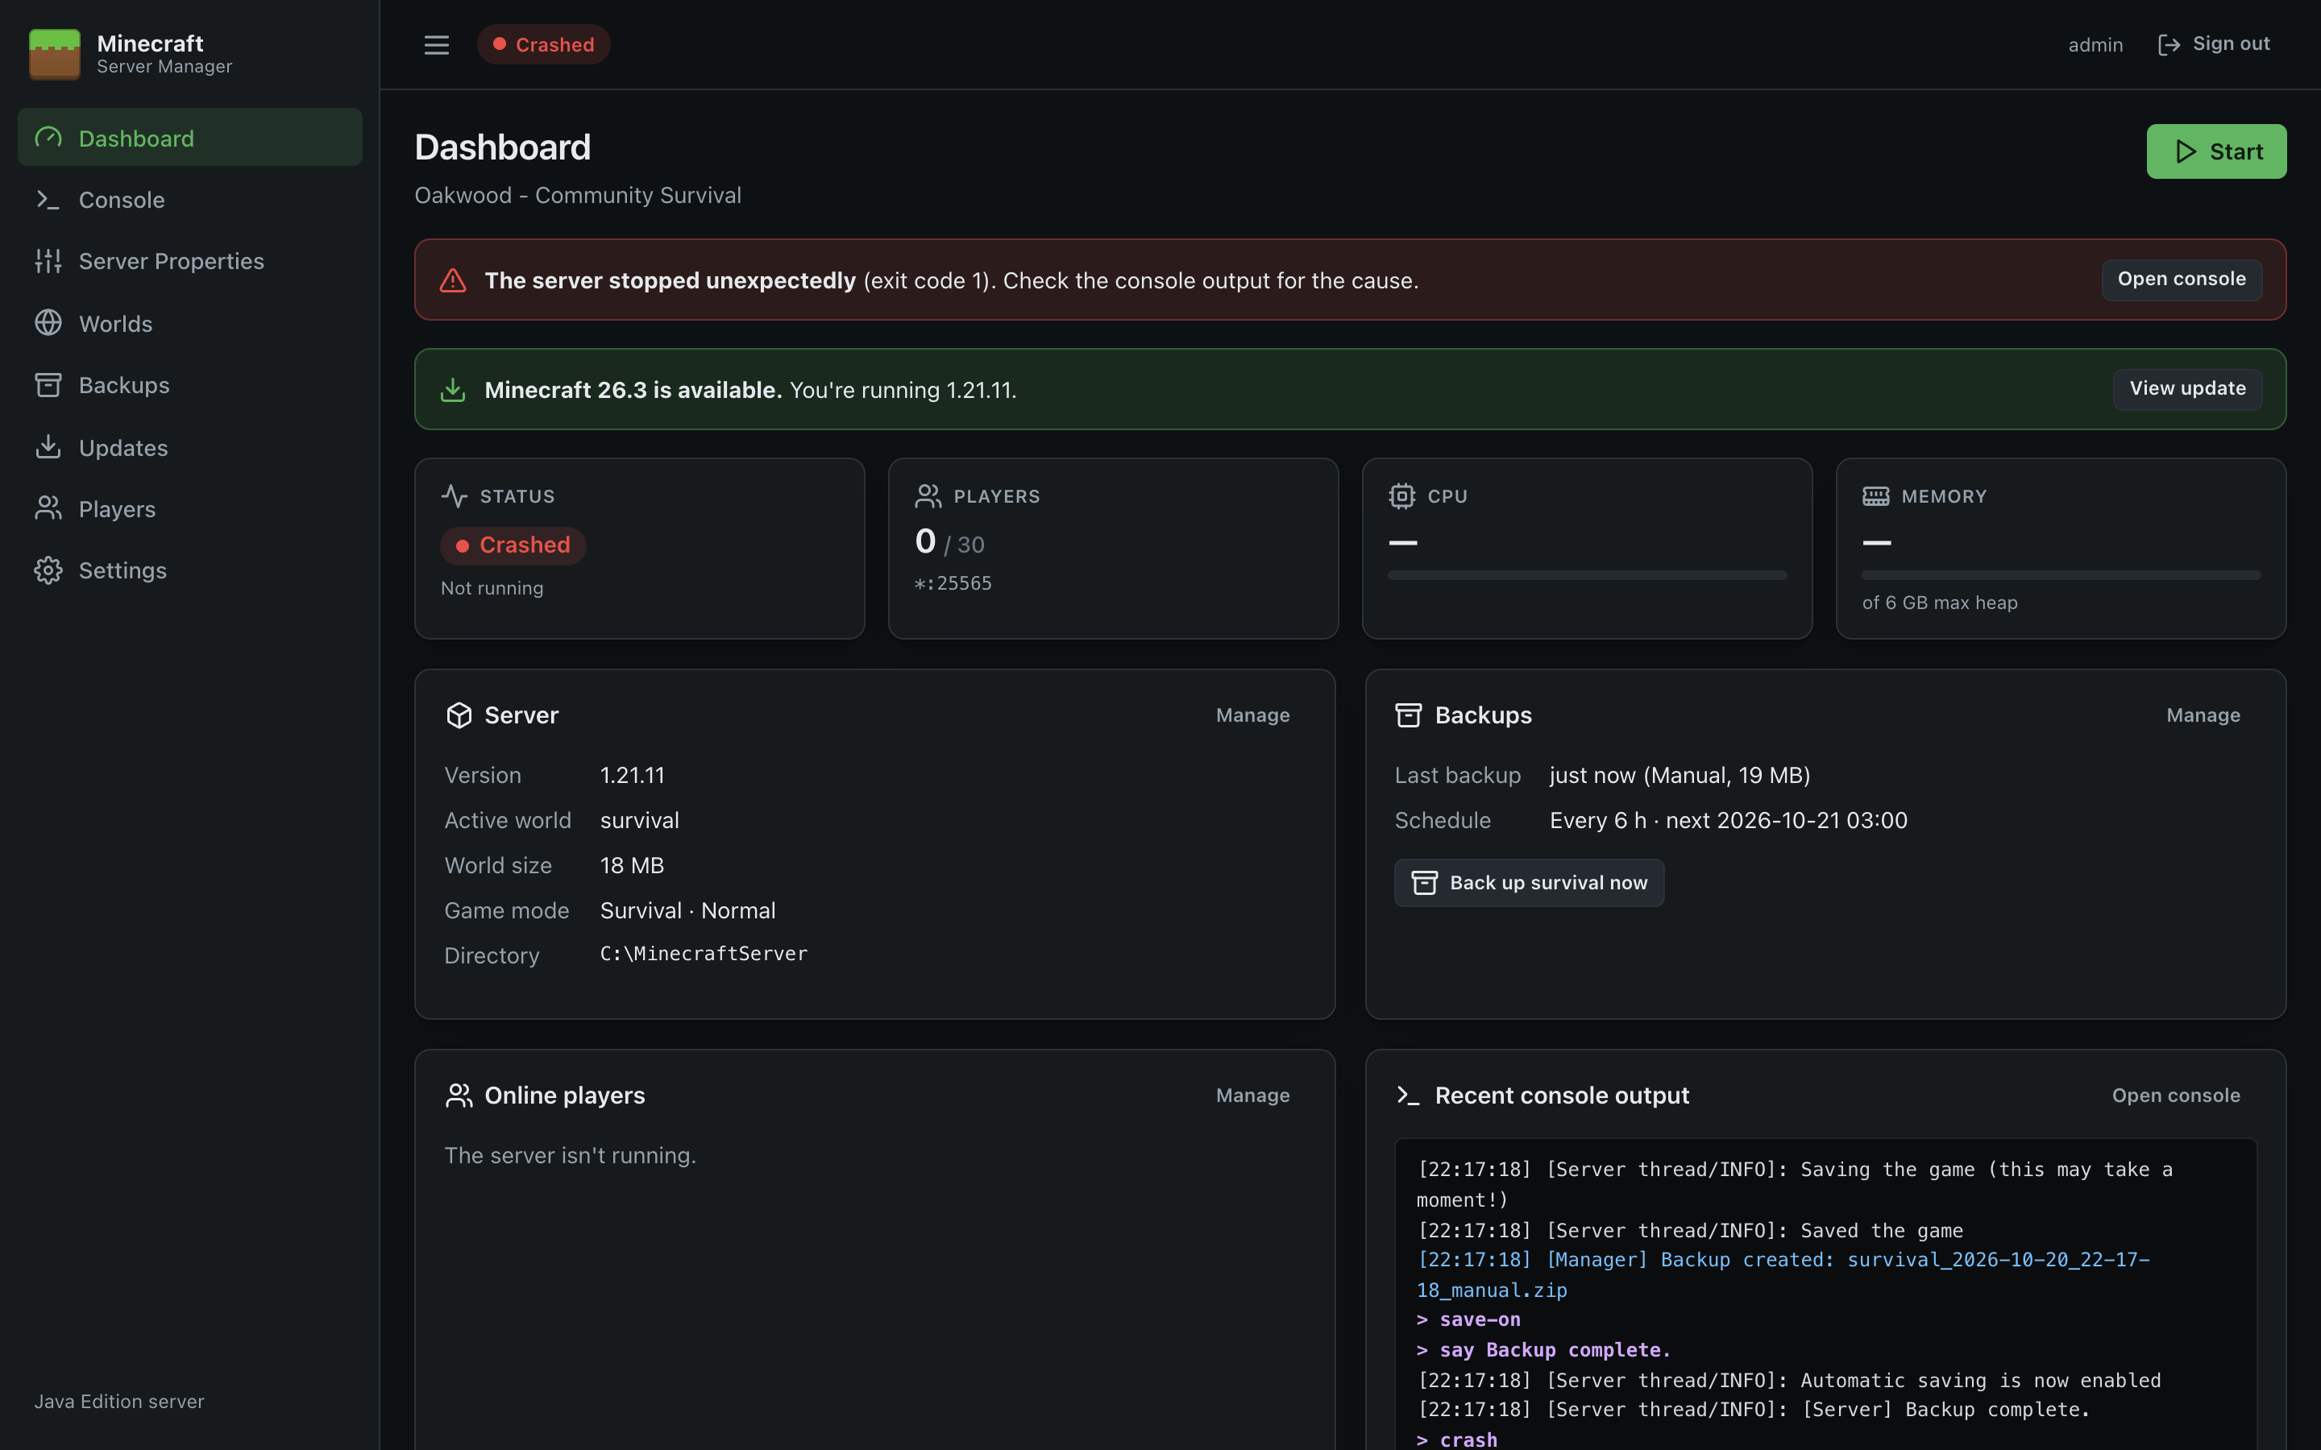
Figure 8: Dashboard after a crash

Status cards
Card | Shows
Status | Current state and how long the server has been up.
Players | Players online / max-players, and the address and port the server listens on (* means all network interfaces).
CPU | The Minecraft process's share of the whole machine's CPU (all cores), updated every 2 seconds.
Memory | Memory used by the Java process, compared with the maximum heap set in Settings. Java reserves memory up front, so a steady high figure is normal.

Information panels
- Server: installed Minecraft version, the active world (with a Generated on next start badge if it doesn't exist yet), world size on disk, game mode and difficulty, and the server directory. Manage opens Updates.
- Backups: when the last backup was taken (and its type and size) and the backup schedule. Back up world now takes an immediate backup of the active world, with a progress bar. Manage opens Backups.
- Online players: everyone currently connected. Manage opens Players.
- Recent console output: the last dozen console lines. Open console opens the full Console.

Tips
- The player list is built from join/leave messages in the log. Clicking Refresh on the Players page (which runs list) resynchronises it.
- The subtitle under Dashboard is the server's MOTD with colour codes removed.

Console
The Console shows the Minecraft server's output live and lets you run server commands as if you were typing into the server window.
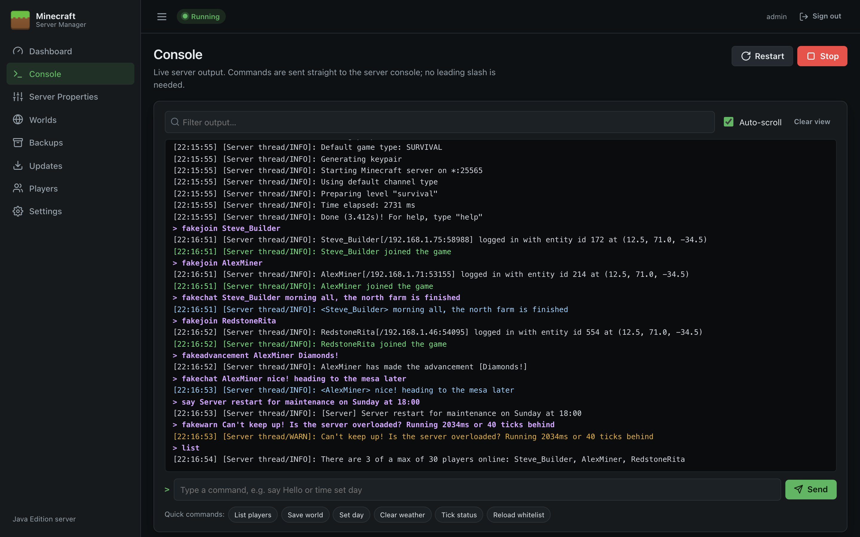
Figure 9: Console

Reading the output
Lines are coloured so important events stand out:
Colour | Lines
White | Normal server messages
Yellow | Warnings (WARN), e.g. Can't keep up! Is the server overloaded?
Red | Errors (ERROR/FATAL) and anything written to the error stream
Green | Players joining and leaving
Light blue | Player chat
Purple (bold) | Commands you or the panel sent, shown as > command
Blue | Messages from the panel itself, tagged [Manager]: start/stop, backups, updates, restarts

- Filter output… shows only lines containing the text you type (not case-sensitive).
- Auto-scroll keeps the newest line in view. Untick it to scroll back without being pulled down.
- Clear view hides everything currently shown. It doesn't delete anything; it only clears your screen.
- The panel keeps the last 3,000 lines in memory since it started, and the page shows up to the last 1,000. The server's complete log is always in logs\latest.log in the server directory.

Running commands
Type a command in the box at the bottom and press Enter (or click Send).
- No leading slash is needed (time set day, not /time set day); a leading slash is removed if you type one.
- The command box is only available while the server is running.
- Press ↑ and ↓ to go back through commands you've sent on this page.
- The response appears in the output like any other line.
- Typing stop stops the server cleanly. The panel treats it as an intentional stop, not a crash, so it won't restart automatically.

Quick commands
The buttons under the command box send common commands with one click (available while the server is Running):
Button | Command | Does
List players | list | Shows who's online and resynchronises the panel's player list
Save world | save-all | Saves the world to disk now
Set day | time set day | Sets the time to morning
Clear weather | weather clear | Stops rain and thunder
Tick status | tick query | Shows the server's tick rate and performance
Reload whitelist | whitelist reload | Re-reads whitelist.json

Useful commands
Command | Purpose
say <message> | Broadcast a message to everyone as [Server]
op <player> / deop <player> | Grant or remove operator status (also on Players)
kick <player> [reason] | Disconnect a player
gamerule <rule> <value> | Change a game rule, e.g. gamerule keepInventory true
difficulty <peaceful|easy|normal|hard> | Change difficulty until the next restart
tp <player> <x> <y> <z> | Teleport a player
weather <clear|rain|thunder> | Change the weather
whitelist add <player> | Add to the whitelist (also on Players)

After a crash
When the server crashes, the error is shown in red followed by the panel's own messages. If Restart automatically after a crash is on (see Settings), the panel restarts the server after 10 seconds, up to 3 times in 10 minutes.
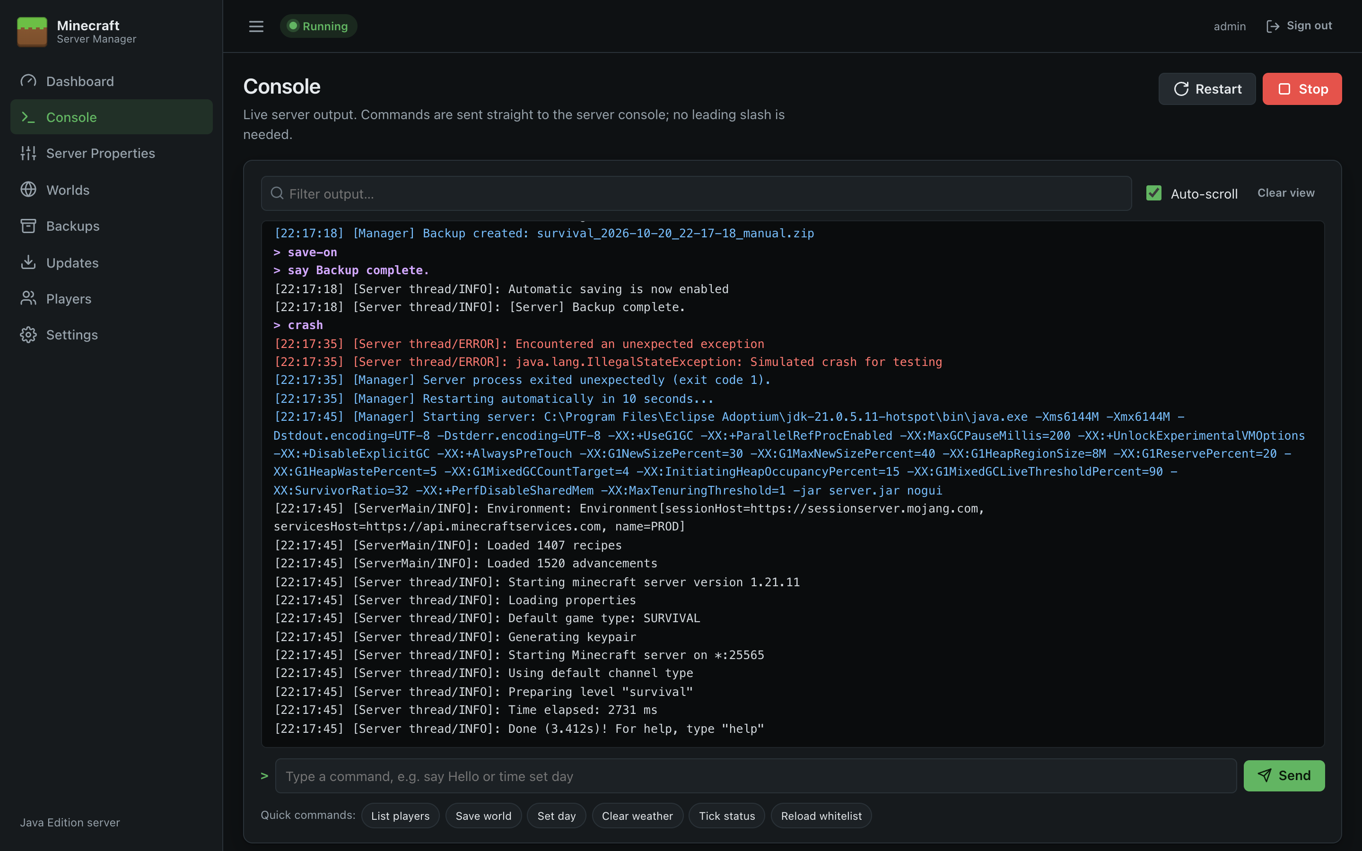
Figure 10: Console after a crash and automatic restart

Server Properties
This page edits server.properties, Minecraft's main configuration file, with proper controls instead of a text editor.
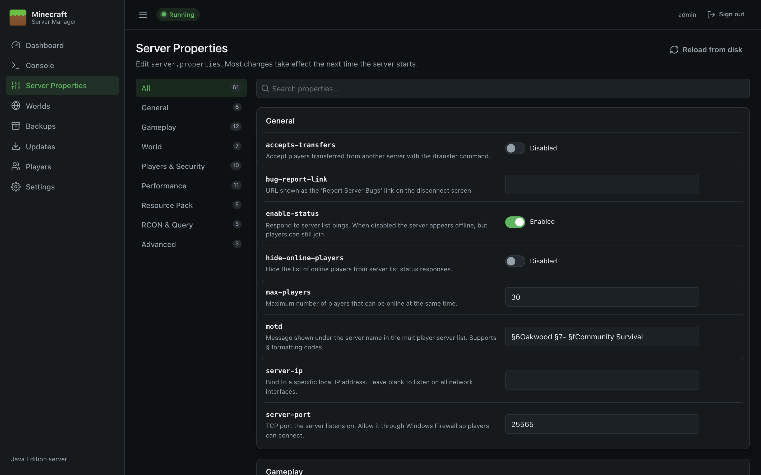
Figure 11: Server Properties

How the page is laid out
- Categories on the left: All, General, Gameplay, World, Players & Security, Performance, Resource Pack, RCON & Query, Advanced, and Other for keys the panel doesn't recognise. The number shows how many settings are in each.
- Search properties… filters by name or description.
- Each setting shows its key (the name in the file), a description, and an input suited to its type:
Type | Control
On/off | A switch showing Enabled or Disabled
Number | A number box with limits, e.g. view-distance 3–32
Choice | A drop-down, e.g. difficulty: peaceful, easy, normal, hard
Text | A text box, e.g. motd
Secret | A password box with Show/Hide, e.g. rcon.password
JSON | A multi-line box, e.g. generator-settings

The full list of settings, with defaults and descriptions, is in the Server Properties Reference.
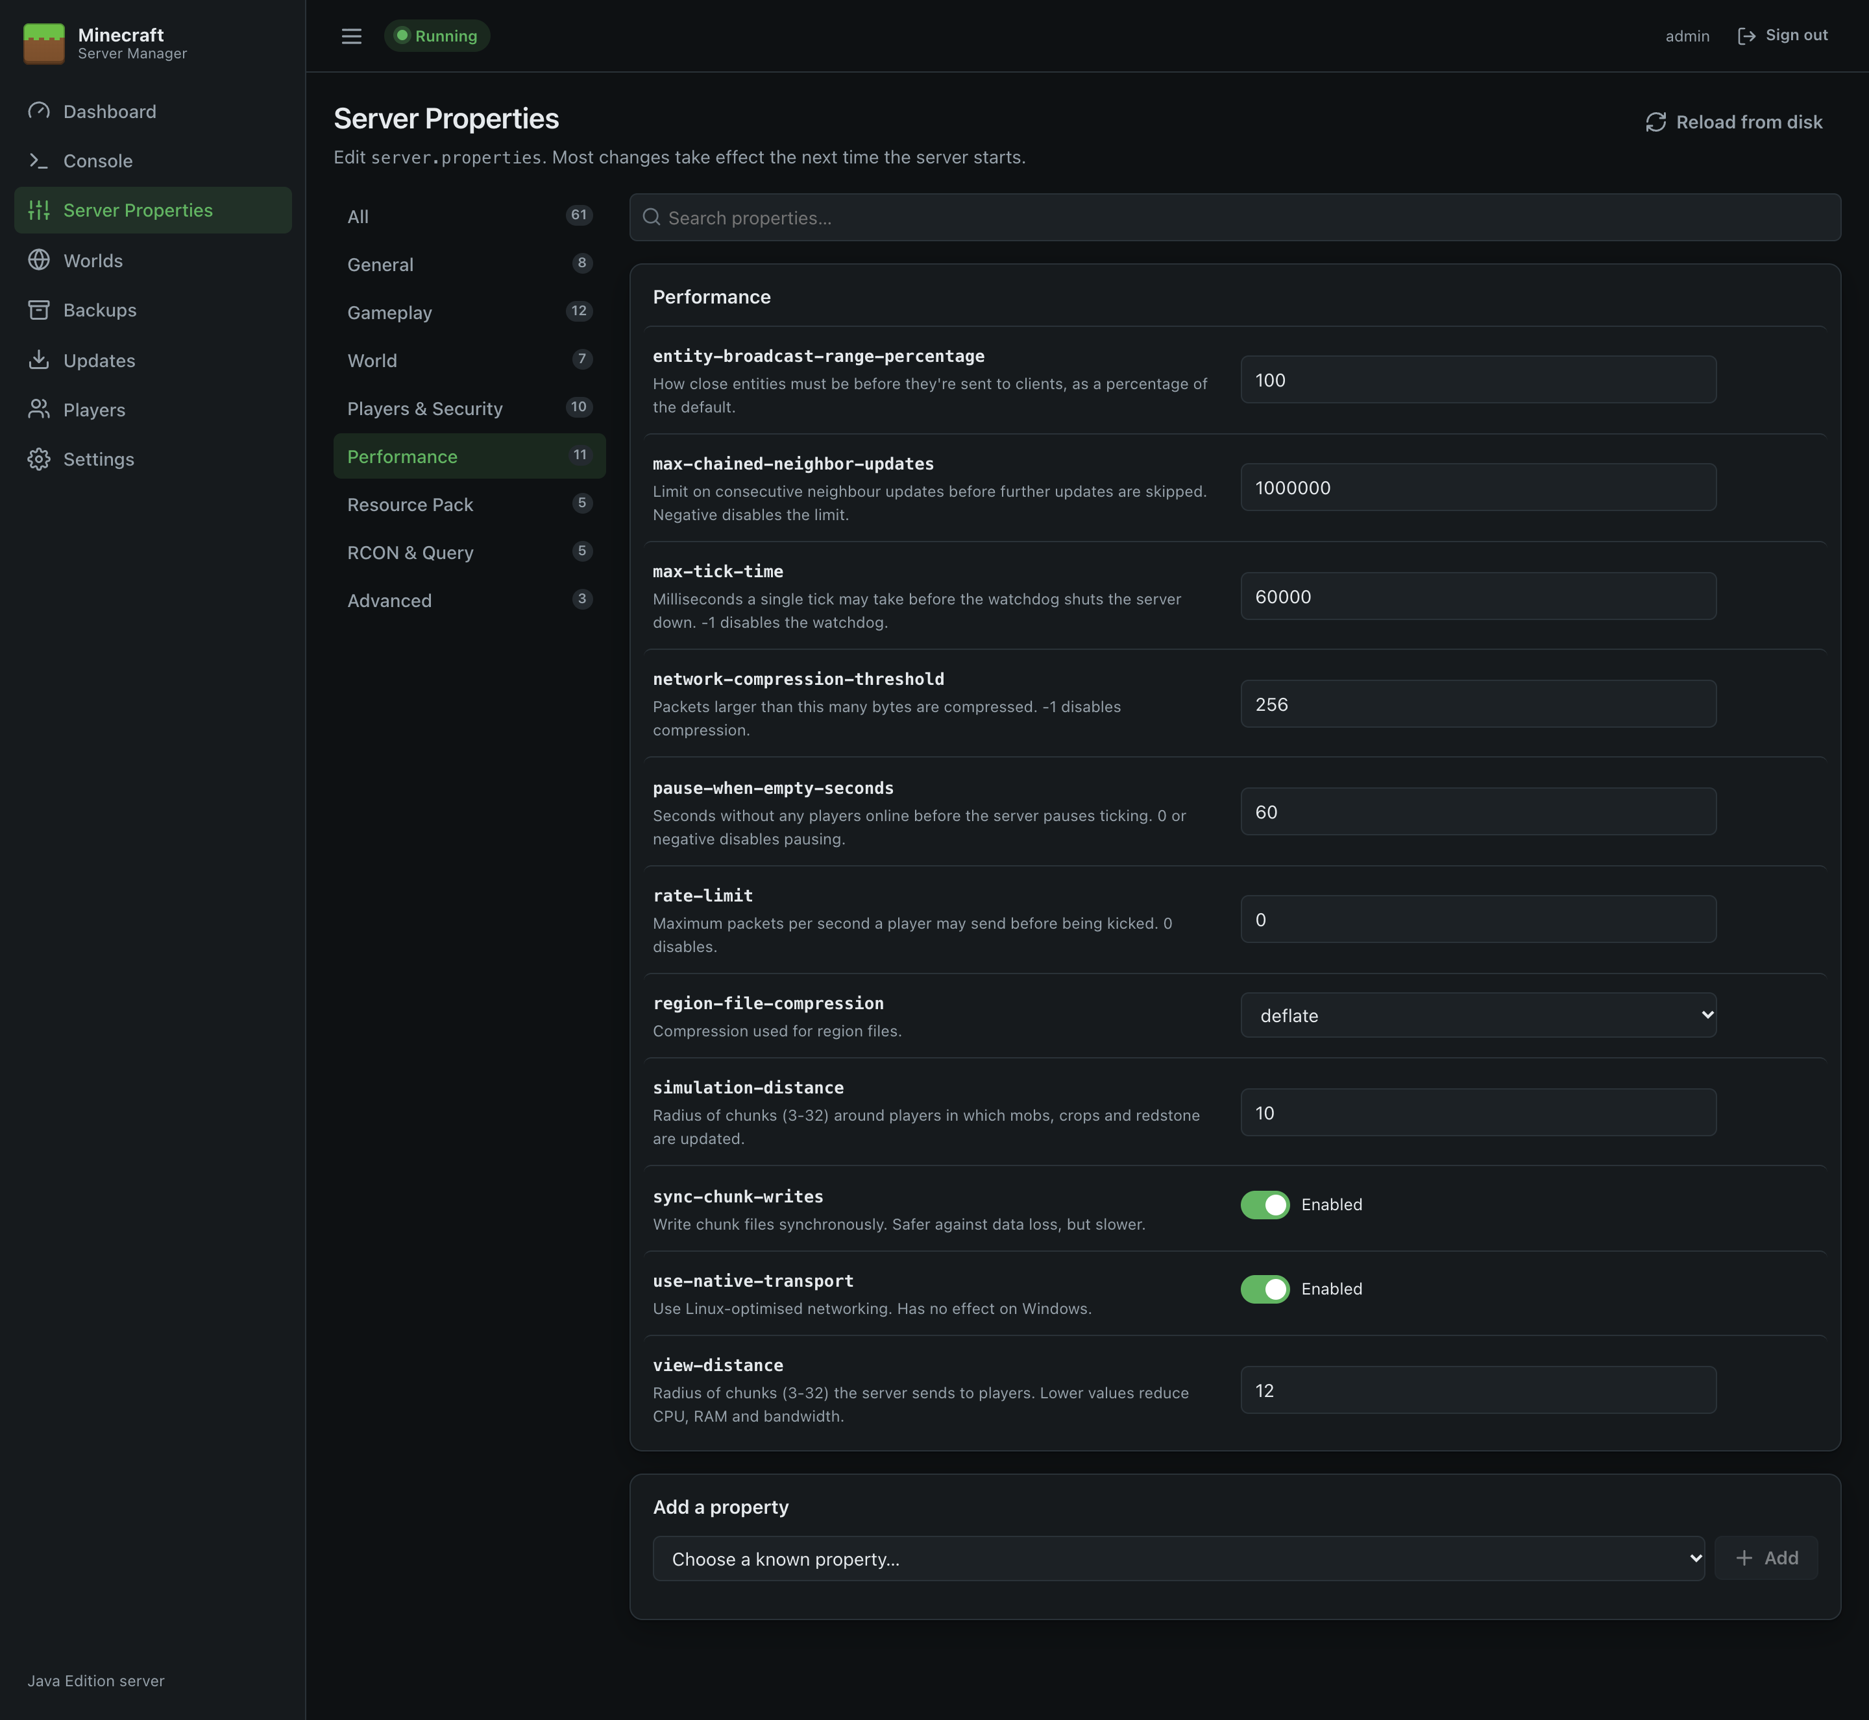
Figure 12: Performance settings

Changing settings
- Change one or more values. Changed rows are highlighted in amber, and a bar appears at the bottom showing how many unsaved changes there are.
- Invalid values are flagged in red (for example a number outside its range), and saving is blocked until they're fixed.
- Use the ↶ button on a row to undo that change, or Discard to undo everything.
- Click Save. If the server is running, you can click Save & restart instead to apply the changes straight away.
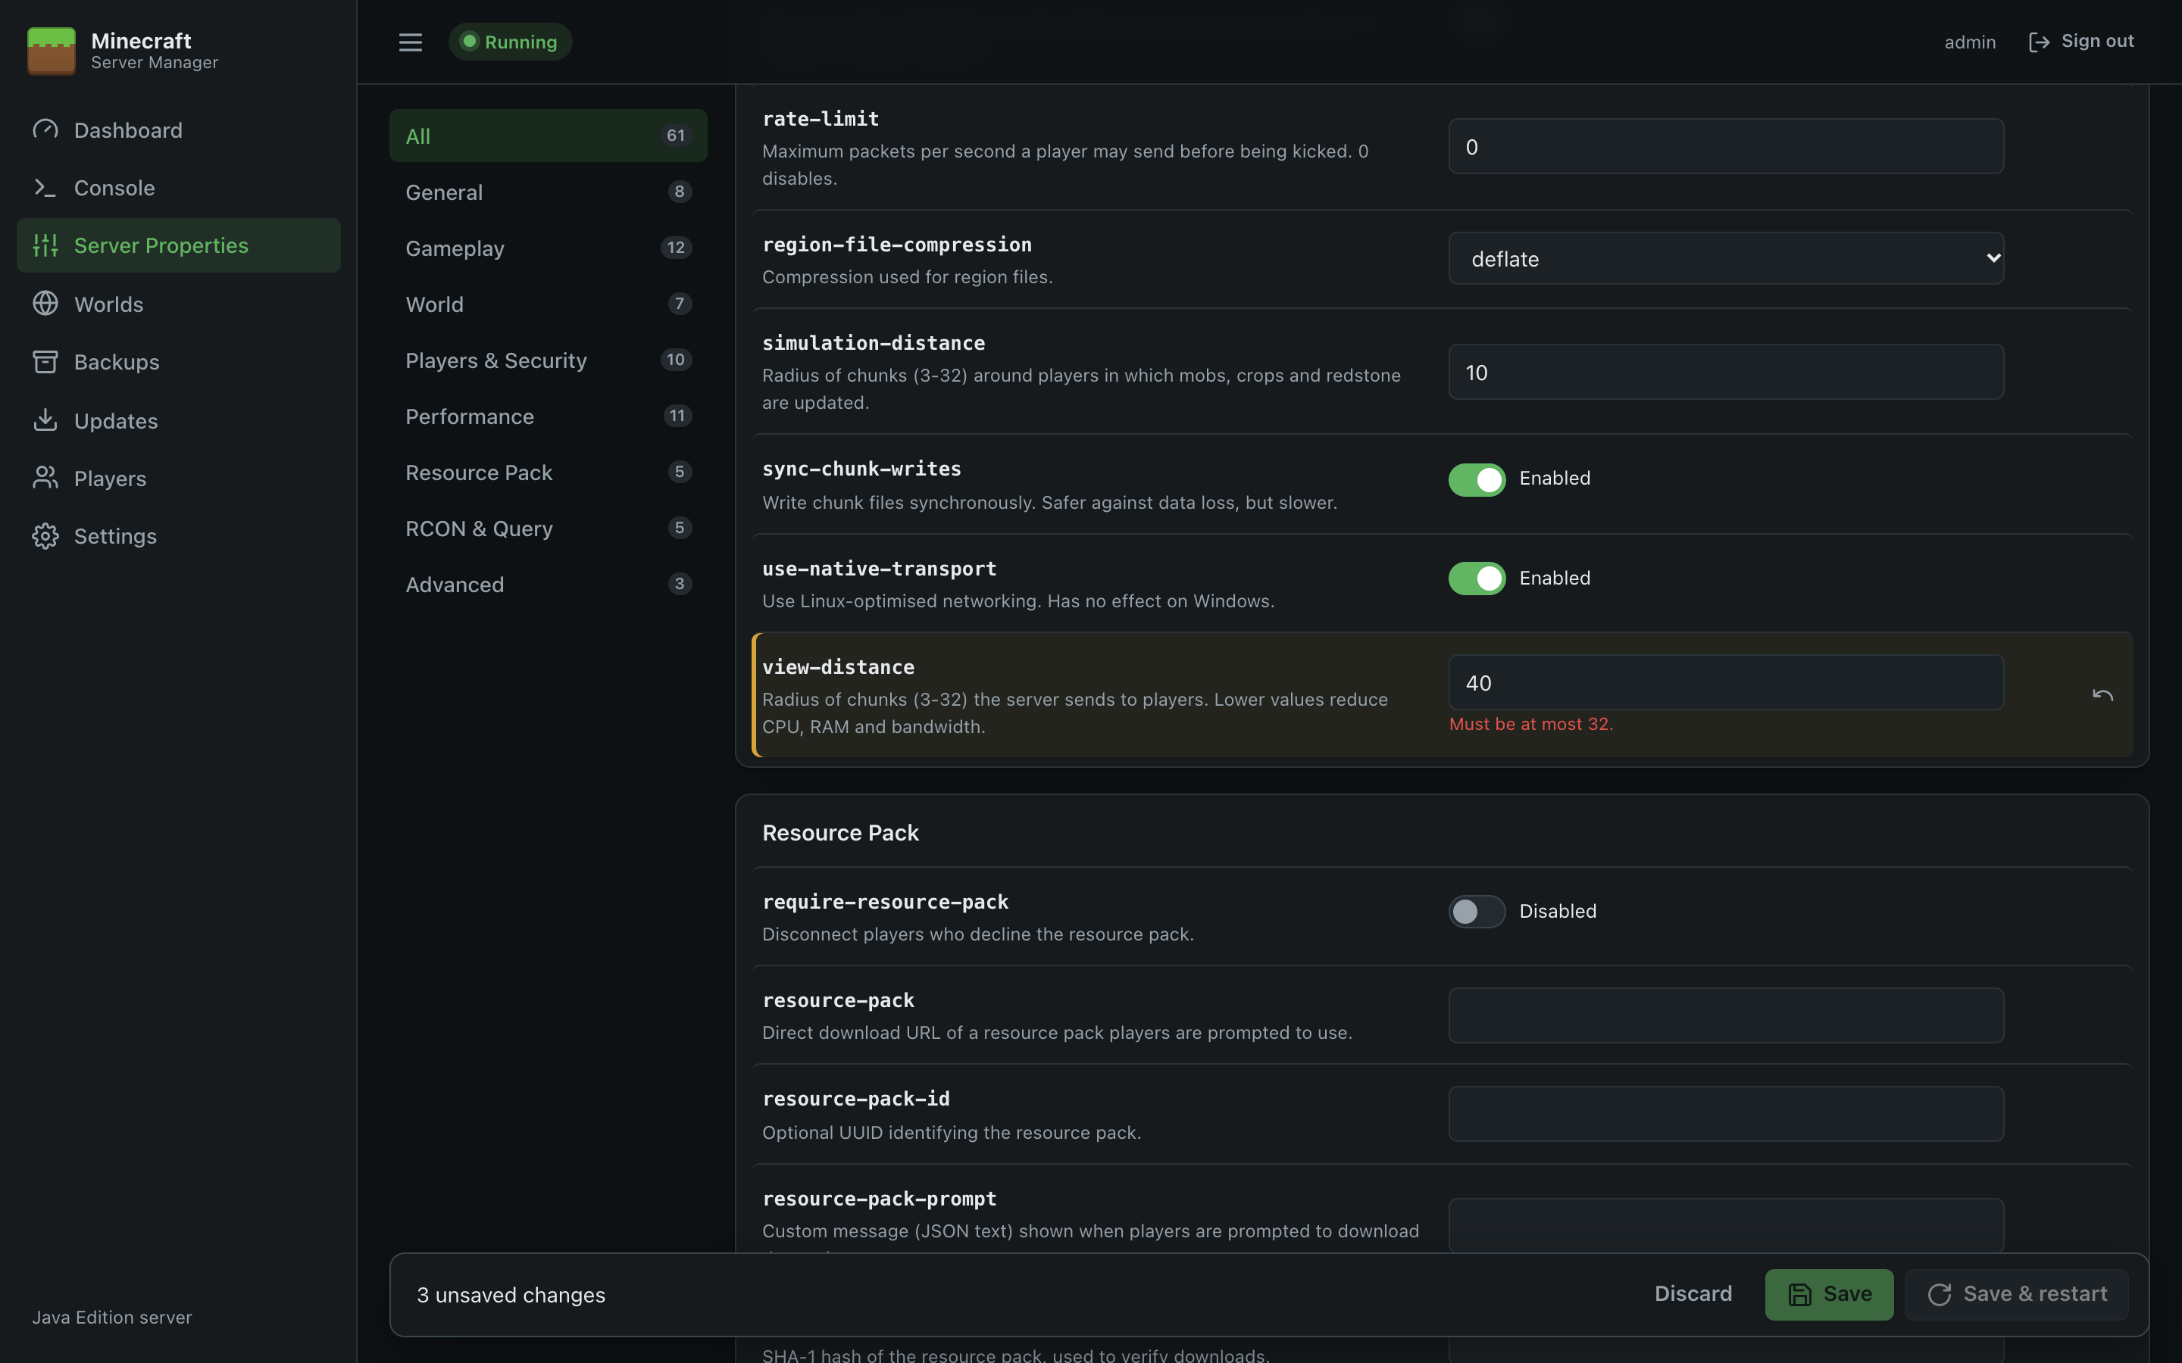
Figure 13: Editing with unsaved changes and a validation error
Most settings take effect the next time the server starts. Minecraft reads server.properties at start-up, so after Save you'll see a reminder to restart.

Adding and removing settings
- Add a property at the bottom lists known settings that aren't in your file. Pick one and click Add. Choose Custom key… to add any other key (for example one used by a mod).
- Settings the panel doesn't recognise, and ones you've just added, have a 🗑 button to remove them.
- Reload from disk re-reads the file, for example after editing it by hand.

When the file doesn't exist yet
Before the server has run for the first time there's no server.properties. The page shows Minecraft's defaults instead; click Save to create the file with them, or just start the server and it creates one.

Good to know
- Switching or creating worlds: use the Worlds page rather than editing level-name here. It handles restarts and new-world settings for you.
- Seeds and world type (level-seed, level-type, generator-settings) only affect newly generated worlds.
- Whitelist: the switch on the Players page sets white-list and applies it immediately on a running server.
- Colour codes in the MOTD: use § codes, e.g. §6Gold §fWhite. The panel saves them in the escaped form Minecraft expects (§).
- Comments and order are preserved. The panel only changes the lines you edit. Minecraft itself rewrites the file each time it starts.
- RCON isn't needed. The panel controls the server directly. Only enable RCON if another tool needs it, and never expose its port to the internet.

Worlds
The Worlds page lists every world in the server directory and lets you generate new worlds, choose which world the server runs, import existing worlds and delete old ones.
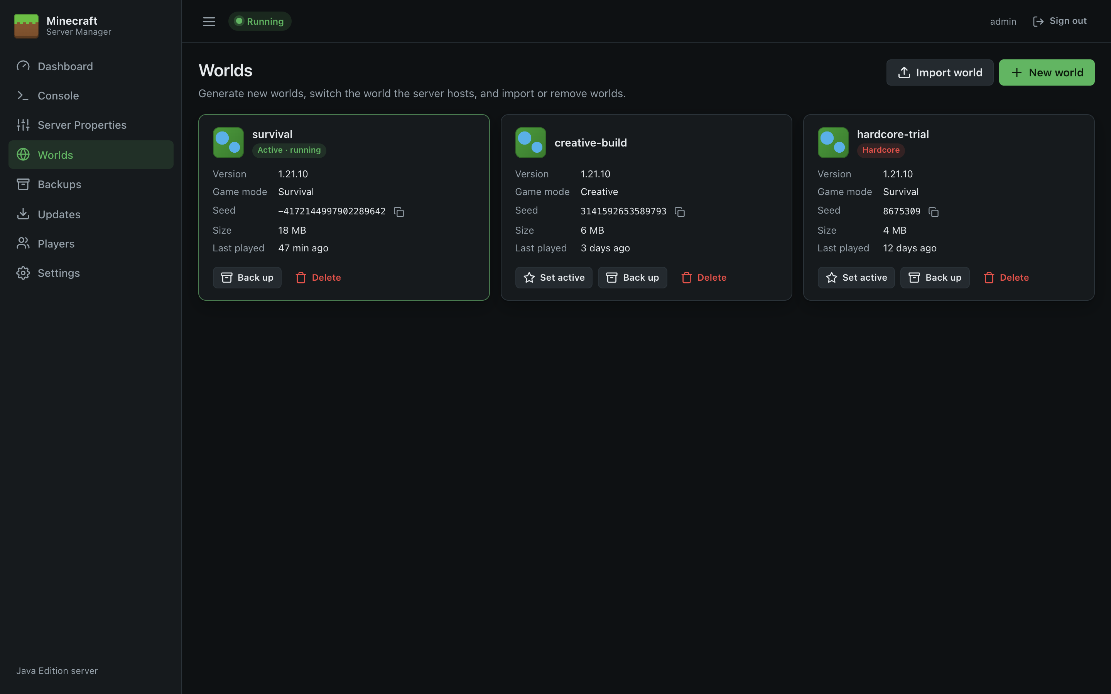
Figure 14: Worlds

World cards
Each world is shown as a card:
Item | Meaning
Name | The world's folder name in the server directory.
Active badge | The world the server loads (level-name). Shows · running while the server is up.
Hardcore badge | The world was created in hardcore mode.
Version | The Minecraft version that last saved the world.
Game mode | The world's default game mode.
Seed | The world seed. Click the copy icon to copy it.
Size | Space used on disk, including world_nether / world_the_end folders if the world uses that layout (Paper/Spigot style).
Last played | When the world was last saved by the server.

Buttons on each card:
- Set active: make this the world the server runs (not shown on the active world).
- Back up: take an immediate backup of this world (see Backups).
- Delete: remove the world (see Deleting a world).
If the active world hasn't been generated yet, a banner says so, with a Start & generate button.

Creating a new world
Minecraft generates a world the first time the server starts with a new world name. The panel therefore writes the new world's settings to server.properties, makes it the active world, and (optionally) restarts the server so it's generated straight away.
- Click New world.
- Fill in the form:
Field | Notes
World name | Becomes the folder name. Letters, numbers, spaces, -, _ and . only, up to 64 characters, and it must not already exist.
Seed | Optional. Leave blank for a random seed, type any number or text, or click Random to generate one now (so you can note it).
World type | Default, Large Biomes, Amplified, Superflat or Single Biome.
Game mode | Default game mode for new players.
Difficulty | Locked to Hard when Hardcore is ticked.
Generate structures | Villages, temples, strongholds and so on.
Hardcore | Players become spectators when they die.
Generator settings | Shown for Superflat and Single Biome: JSON describing the layers or biome. For Superflat, the Classic Flat, Redstone Ready and The Void buttons fill in a preset.
Restart/Start the server now | Ticked by default. Untick to configure the world now and generate it at the next start.

- Click Create world. Watch the generation on the Console; the server shows Running when it's done.
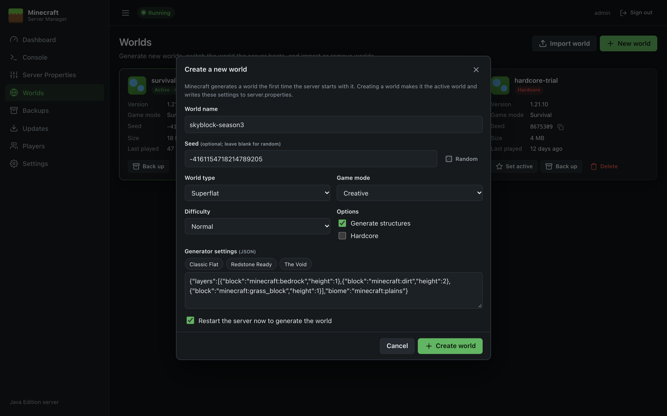
Figure 15: Create a new world
Note: Difficulty, Game mode and Hardcore are server-wide settings in server.properties, so they also apply when you switch back to another world. Adjust them on Server Properties if needed.

Switching the active world
Click Set active on a world. If the server is running you'll be asked whether to restart it now (ticked by default). If you don't restart, the server keeps running the current world and loads the new one at the next start.
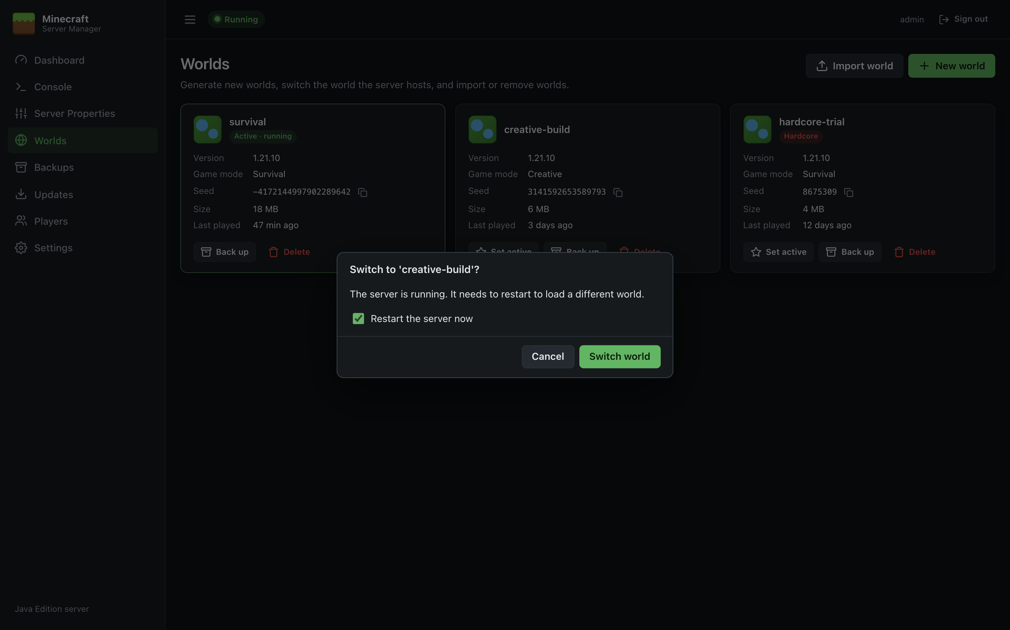
Figure 16: Switch world

Importing a world
You can upload an existing Java Edition world, such as a singleplayer save from %APPDATA%\.minecraft\saves.
- Zip the world folder (the folder that contains level.dat). Right-click it and choose Send to → Compressed (zipped) folder.
- Click Import world, choose the .zip, and optionally:
  - enter a World name (otherwise the zip's file name is used), and
  - tick Make this the active world.
- Click Upload & import.
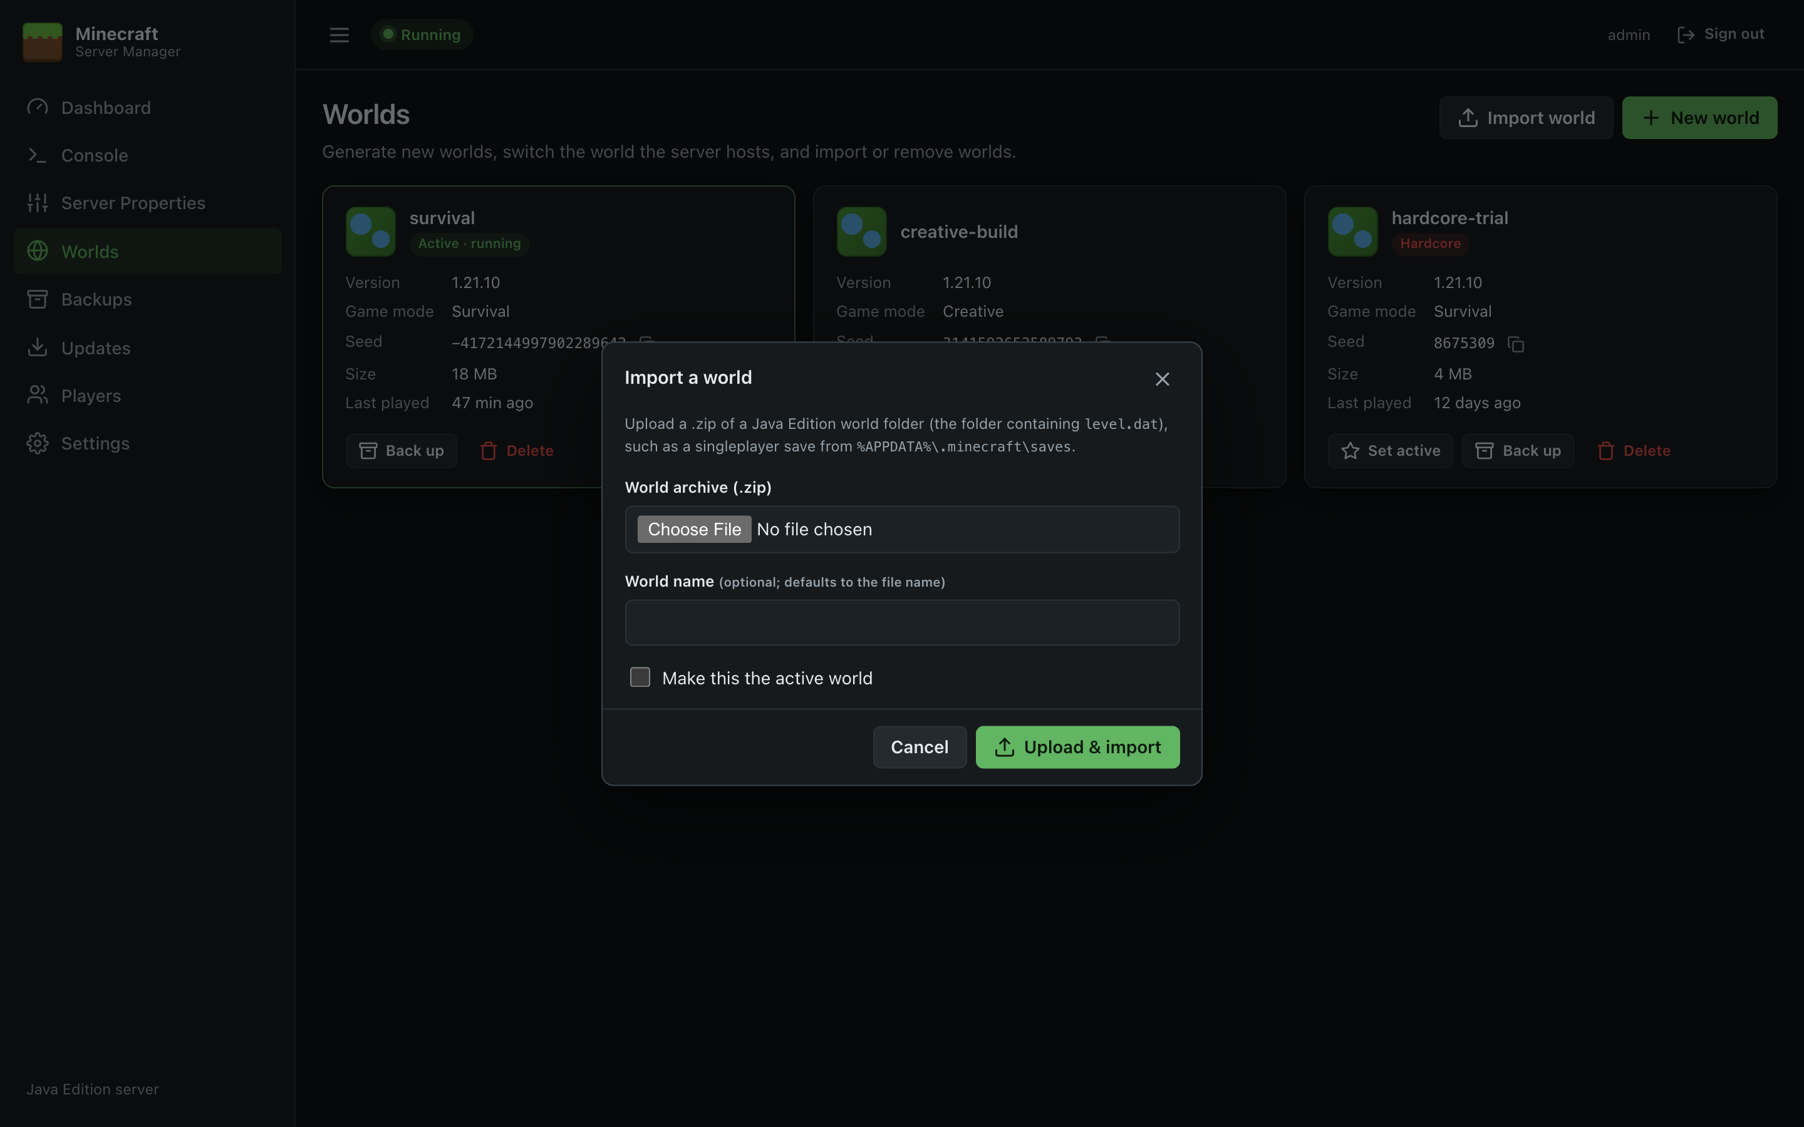
Figure 17: Import a world
The panel finds the folder containing level.dat anywhere in the zip, so it doesn't matter whether you zipped the folder or its contents. Uploads of up to 8 GB are accepted. Archives containing unsafe paths are rejected. If you made the imported world active while the server was running, restart the server to load it.
Bedrock Edition worlds (.mcworld) are a different format and can't be imported.

Deleting a world
- Click Delete on the world's card.
- Leave Take a backup first ticked unless you're sure. The backup is kept on the Backups page as Before delete.
- Type the world's name to confirm, then click Delete world.
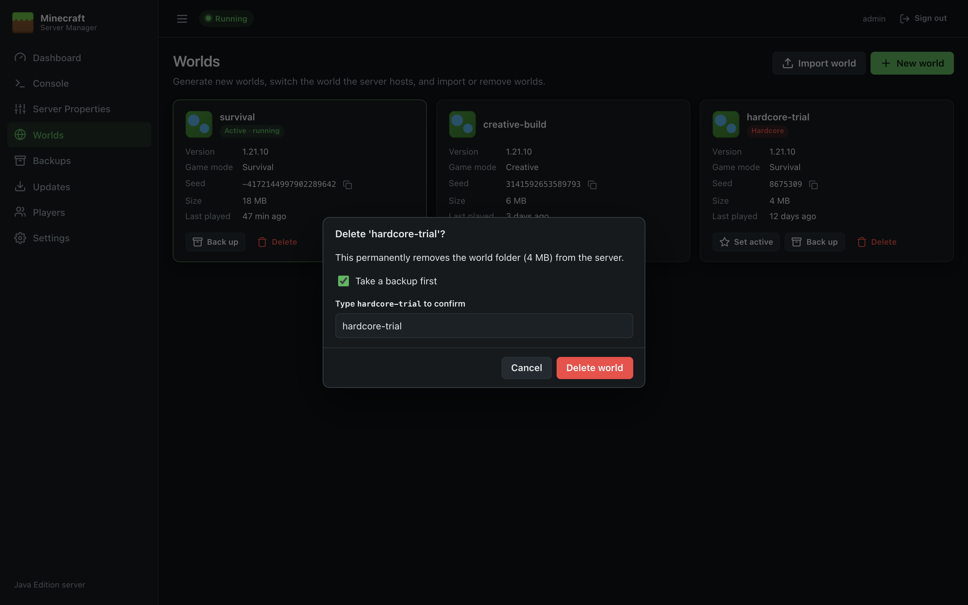
Figure 18: Delete a world
You can't delete the world the server is currently running; stop the server first.

Backups
The Backups page takes zip backups of your worlds, runs them on a schedule, and lets you restore, download or delete them.
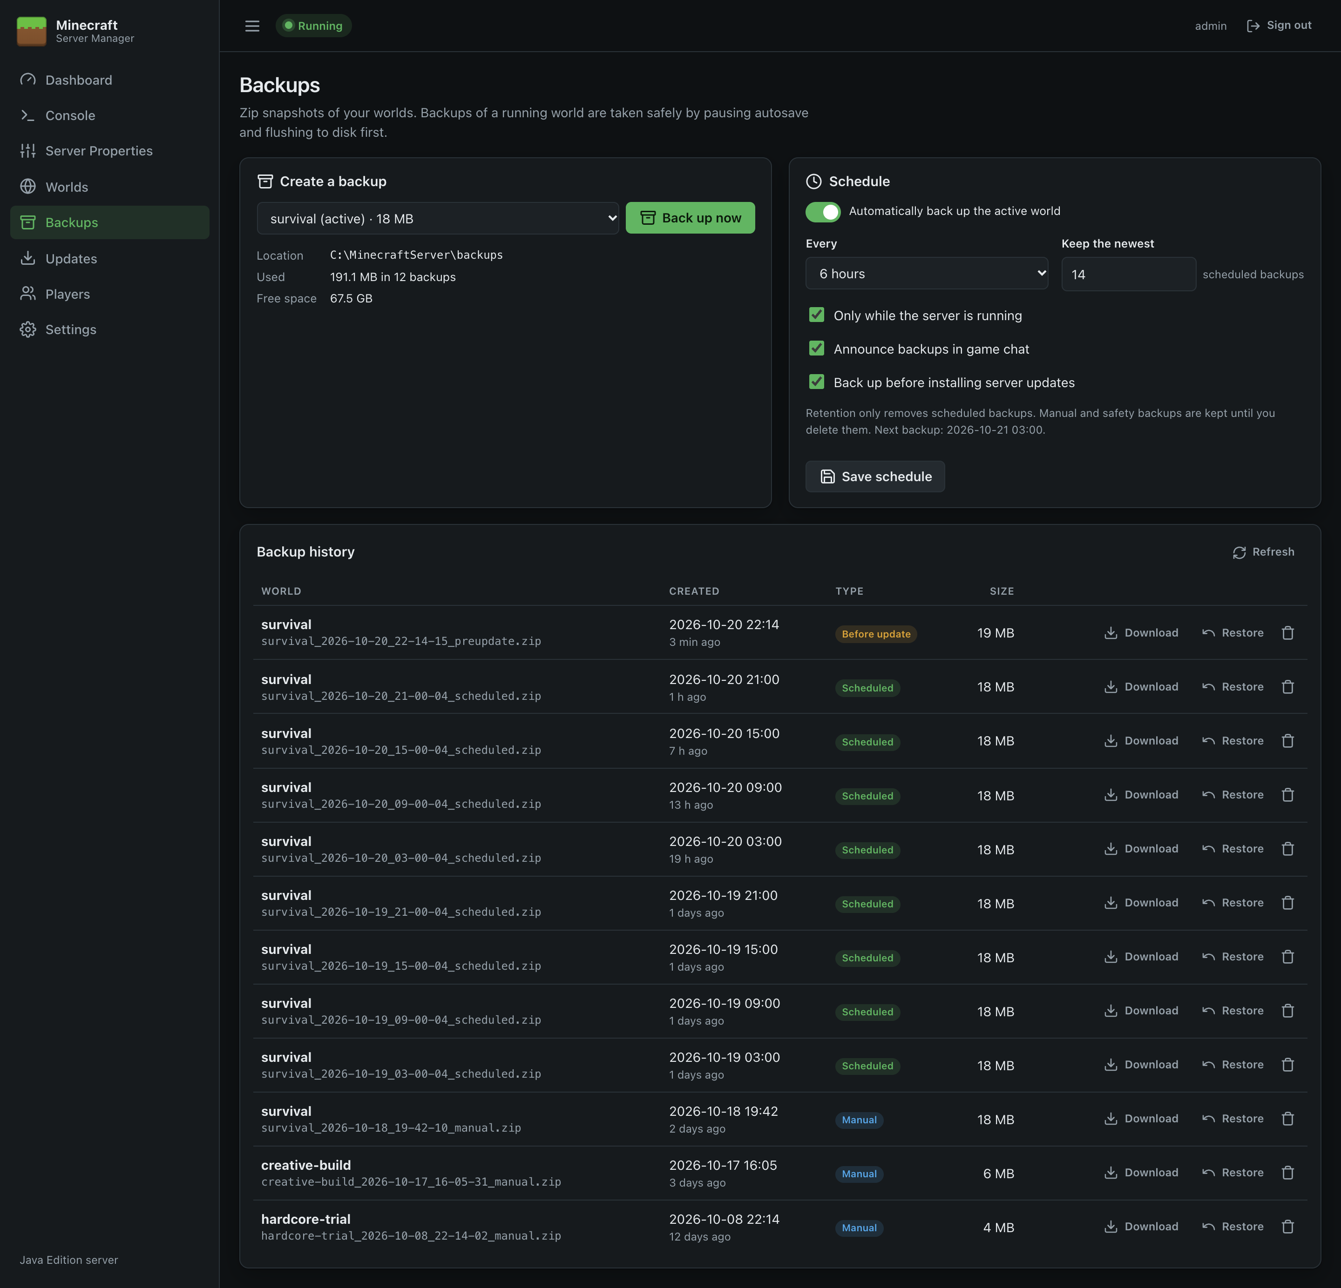
Figure 19: Backups

Taking a backup now
- Under Create a backup, choose the world (the active one is selected by default).
- Click Back up now. A progress bar shows each stage and how much has been copied.
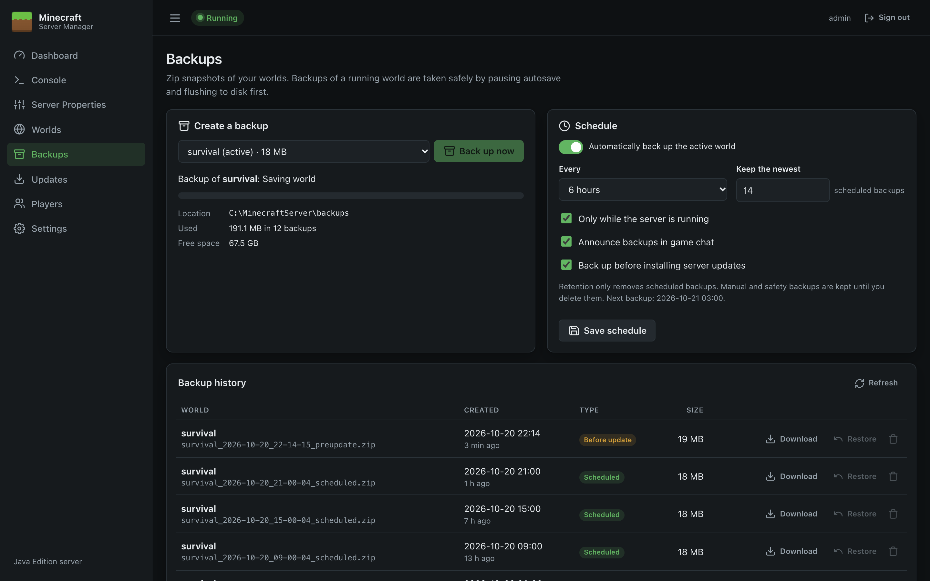
Figure 20: Backup in progress
You can also back up from the Dashboard (active world) or from any world card on Worlds.

Backing up a running world safely
Copying a world while Minecraft is writing to it can produce a damaged backup. When the world being backed up is the one the server is running, the panel does this automatically:
- Announces Starting world backup... in chat (if Announce backups in game chat is on).
- Runs save-off so Minecraft stops writing to the world files.
- Runs save-all flush and waits (up to 2 minutes) for Minecraft to confirm Saved the game.
- Compresses the world into a zip.
- Runs save-on and announces Backup complete. Autosave is turned back on even if the backup fails.
Players can keep playing throughout. Their changes are held in memory and saved once autosave is back on.
If the server is still Starting… or Stopping…, the backup is refused with a message. Try again in a moment.

What's in a backup
- The world folder, plus <world>_nether and <world>_the_end if they exist (Paper/Spigot layout).
- Not session.lock, which Minecraft keeps locked while running and doesn't need restoring.
- Files are stored under the world's folder name inside the zip, e.g. survival/region/r.0.0.mca.
Before starting, the panel checks there's enough free space on the backup drive.

Storage
The Location, Used and Free space lines show where backups are kept and how much room is left. By default backups go in backups inside the server directory. You can choose another folder (ideally another drive) in Settings.
Keep a copy somewhere else. Backups on the same disk don't protect against disk failure. Copy the backup folder to another machine or cloud storage regularly, or download important backups.

Scheduled backups
Setting | Meaning
Automatically back up the active world | Turns the schedule on. The first backup runs within a minute of saving.
Every | 30 minutes, 1, 2, 3, 6 or 12 hours, a day or a week.
Keep the newest … scheduled backups | Older scheduled backups beyond this number are deleted automatically after each scheduled backup.
Only while the server is running | Skip backups while the server is stopped (the world can't change then).
Announce backups in game chat | Tell players when a backup starts and finishes.
Back up before installing server updates | Take a Before update backup automatically before Updates replaces the server jar.

Click Save schedule to apply. The time of the next backup is shown under the settings, and on the Dashboard.
Retention only removes scheduled backups. Manual backups and the automatic safety backups (Before update, Before restore, Before delete) are kept until you delete them.

Backup history
Every backup is listed, newest first, with the world, date, type, and size.
Type | Created by
Manual | You, with Back up now or a Back up button
Scheduled | The schedule
Before update | Installing a server version
Before restore | Restoring a backup, if Back up the current world first was ticked
Before delete | Deleting a world, if Take a backup first was ticked

Actions:
- Download saves the zip to your computer.
- Restore replaces the world with the backup (see below).
- 🗑 deletes the backup permanently, after confirmation.

Restoring a backup
- Click Restore on the backup.
- Leave Back up the current world first ticked (recommended) so you can undo the restore.
- Click Restore backup.
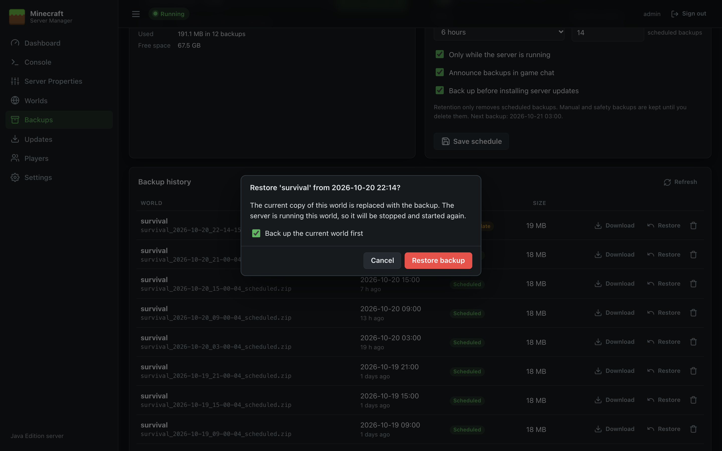
Figure 21: Restore a backup
What happens:
- If the backup is of the world the server is running, the server is stopped, the world restored, and the server started again.
- The current world folder is set aside and only deleted once the backup has been fully extracted. If anything goes wrong the original is put back, so a failed restore never leaves you without a world.
- Restoring a world that isn't active doesn't affect the running server. Use Set active on Worlds if you want to play it.

Backup file names
Backups are named <world>_<yyyy-MM-dd_HH-mm-ss>_<type>.zip, for example survival_2026-10-20_21-00-04_scheduled.zip. Zips you copy into the backup folder by hand also appear in the list (shown as Manual). To restore those, the zip must contain the world folder at its top level.

Updates
The Updates page installs the official Minecraft Java Edition server, updates it to new versions, and rolls back if needed. Versions come from Mojang's version list, and every download is verified with SHA-1 before it's used.
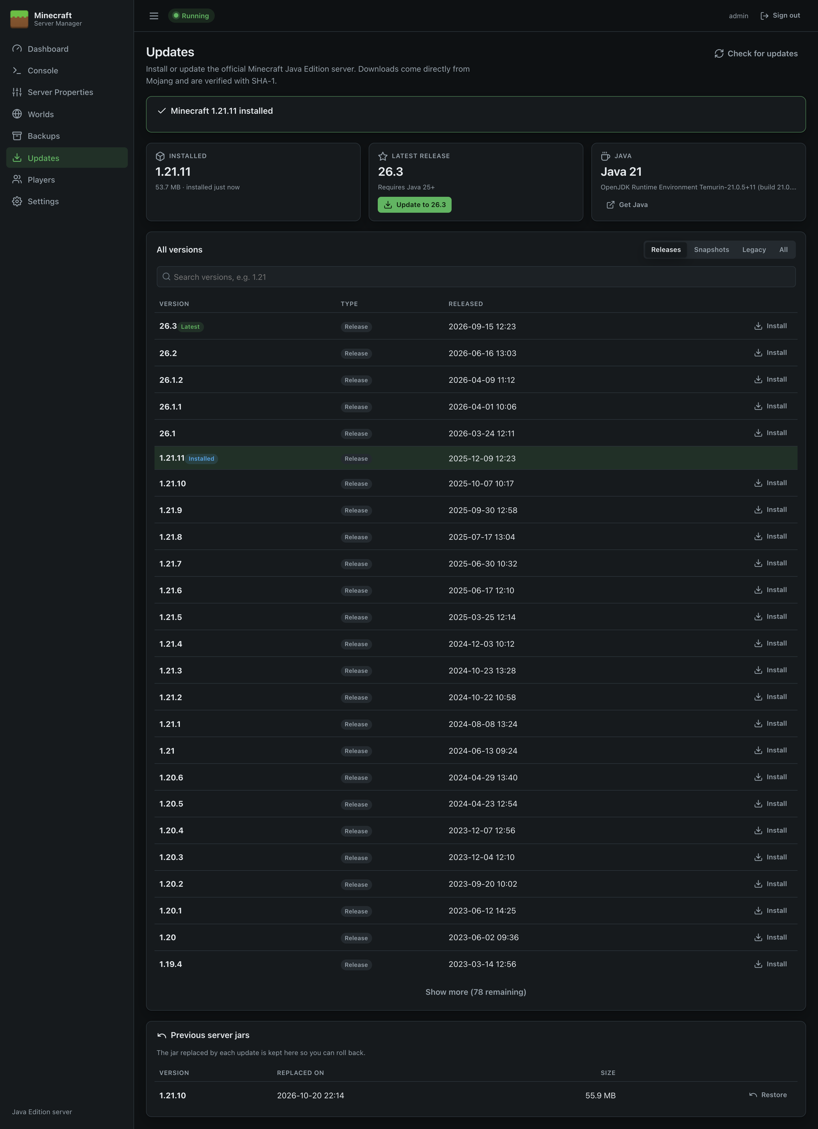
Figure 22: Updates

Status cards
Card | Shows
Installed | The version of server.jar, read from the jar itself, with its size and install date.
Latest release | Mojang's newest release, the Java version it needs, and an Install / Update to button, or Up to date.
Java | The Java version the panel is configured to use (see Settings). A Get Java link appears if Java is missing or too old for the latest release.

If the EULA hasn't been accepted yet, a banner with I agree appears at the top.

Browsing versions
- Use Releases, Snapshots, Legacy (old alpha and beta versions) or All to filter, and the search box to find a version (e.g. 1.21).
- The list shows 25 versions at a time; Show more loads more.
- The installed version is highlighted, and the newest release is marked Latest.
- Check for updates refreshes the list from Mojang (it's otherwise cached for 15 minutes).

Installing or updating
- Click Install next to a version (or the button on the Latest release card).
- Read the confirmation. It tells you if the server will be restarted, if a backup will be taken, and warns about snapshots and older versions.
- Click Install update.
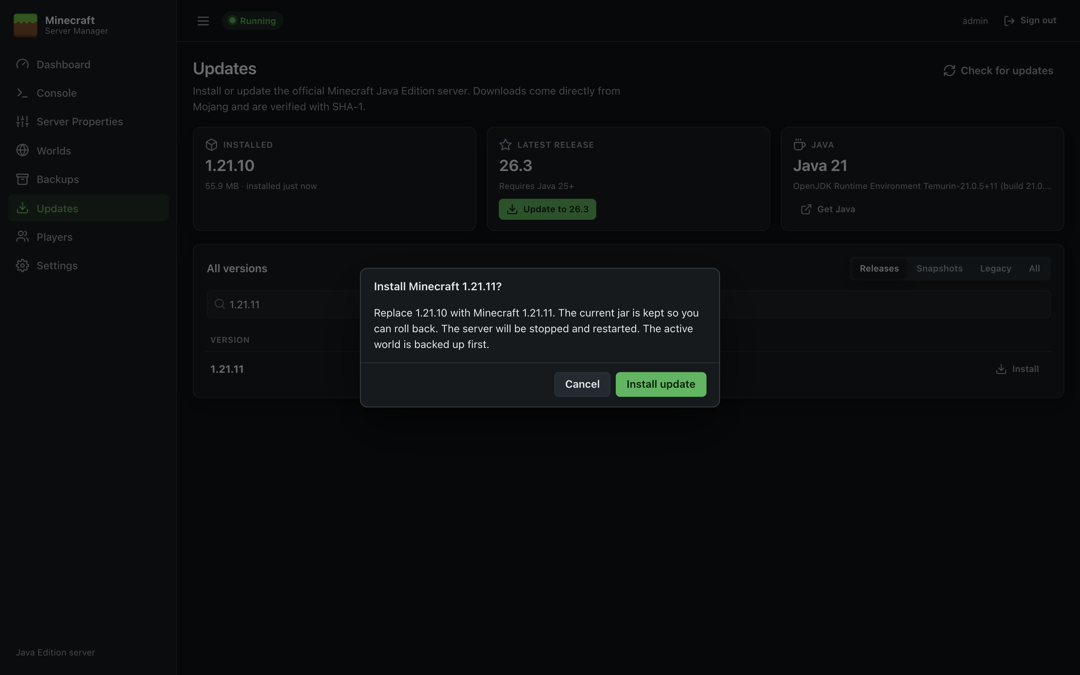
Figure 23: Confirm installation
The panel then:
- Checks Java. If the configured Java is older than the version needs, it stops here and explains what to install. Nothing is changed.
- Downloads the server jar from Mojang with a progress bar, and verifies its SHA-1 checksum.
- Backs up the active world (if Back up before installing server updates is on in Backups).
- Stops the server, if it was running.
- Installs the new jar, keeping the old one for rollback.
- Starts the server again, if it was running before.
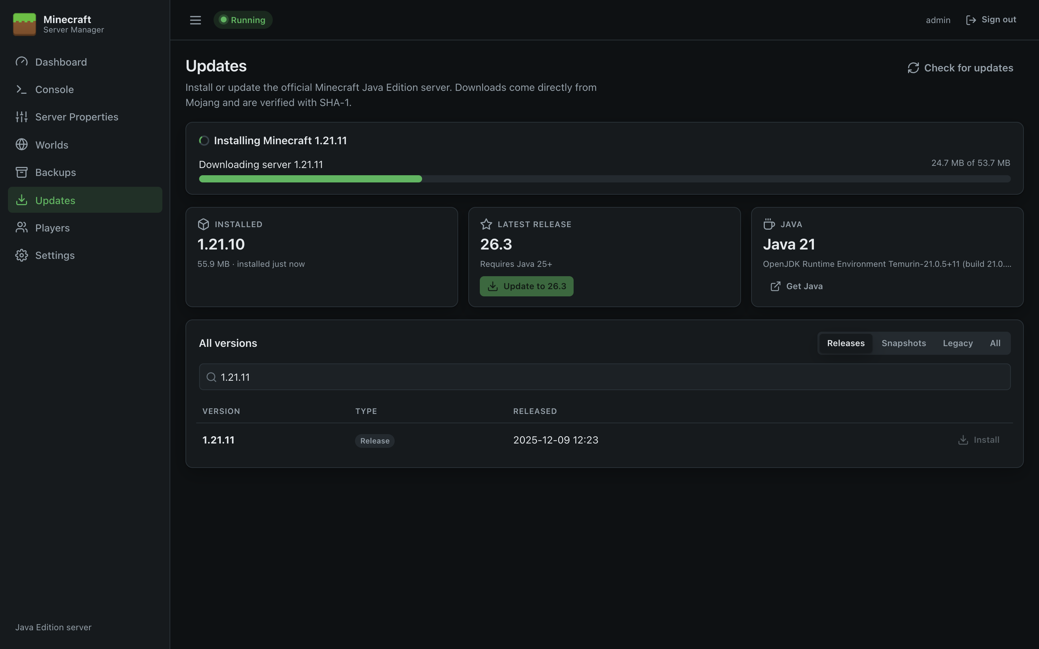
Figure 24: Download in progress
The progress card stays visible for ten minutes afterwards, showing the result or any error. You can leave the page while it runs; the installation continues in the background.
First start after an update: Minecraft upgrades the world to the new version the first time it loads it. This can take a while for big worlds; watch the Console.

When Java is too old
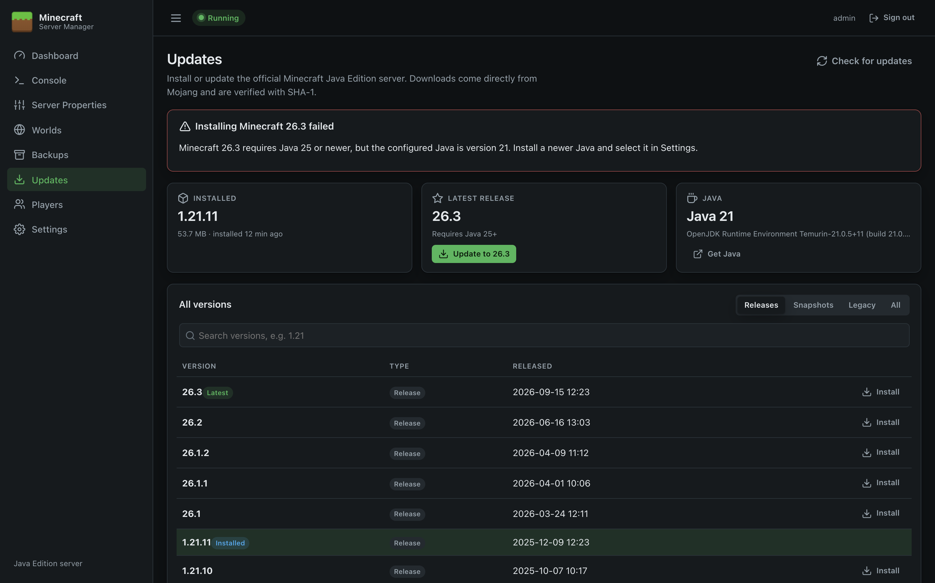
Figure 25: Java requirement
Install the required Java (see Installation), select it in Settings, and try again.

Rolling back
Each time a jar is replaced, the old one is kept. The last five are listed under Previous server jars at the bottom of the page. Click Restore to switch back to one. The current jar is kept in its place, and the server is stopped and restarted if it was running.
Downgrading is risky. A world opened by a newer Minecraft version may not load, or may be damaged, in an older version. The panel warns you before installing an older version. To roll back properly, restore the jar and the Before update world backup from Backups.

Good to know
- Snapshots are test versions. Use them on a copy of your world, not your main one.
- Only the vanilla (Mojang) server is installed. To run Paper, Fabric or Forge, place their jar in the server directory and set its name in Settings; updates for those must be done by hand.
- The Dashboard shows a banner when a newer release than the installed one is available.

Players
The Players page manages who's online, operators, the whitelist and bans.
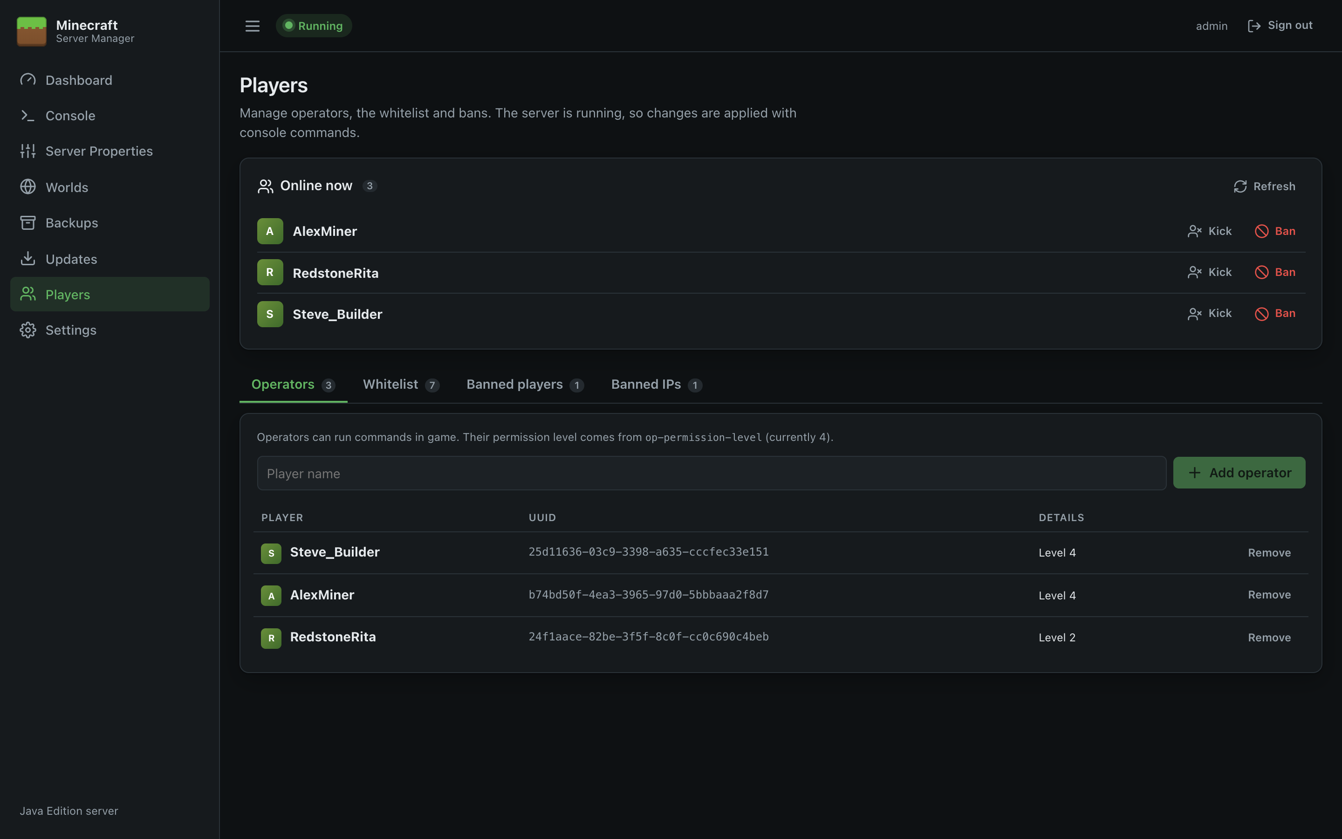
Figure 26: Players: operators

How changes are applied
- While the server is running, the panel sends the matching console command (op, whitelist add, ban, …). The change takes effect immediately and the server updates its own files.
- While the server is stopped, the panel edits ops.json, whitelist.json, banned-players.json and banned-ips.json directly. To get the player's unique ID it asks Mojang's account service (so the name must be a real Minecraft account), or calculates the offline ID if online-mode is false.
A line under the page title tells you which mode is in use. Player names must be 1–16 characters: letters, numbers and underscores.

Online now
Lists everyone currently connected, with buttons to:
- Op: make them an operator (shown if they aren't one).
- Kick: disconnect them (they can rejoin).
- Ban: ban and disconnect them, after confirmation.
Refresh runs list to resynchronise the list with the server.

Operators
Operators can use commands in game. Their permission level comes from op-permission-level in Server Properties (4 = all commands). Enter a name and click Add operator; click Remove to take it away.

Whitelist
When the whitelist is on, only listed players can join.
- The switch at the top turns the whitelist on or off. It updates white-list in server.properties and, if the server is running, applies it immediately with whitelist on / whitelist off.
- Add to whitelist and Remove manage the list.
- To also remove players who are already online but not on the list, turn on enforce-whitelist in Server Properties.
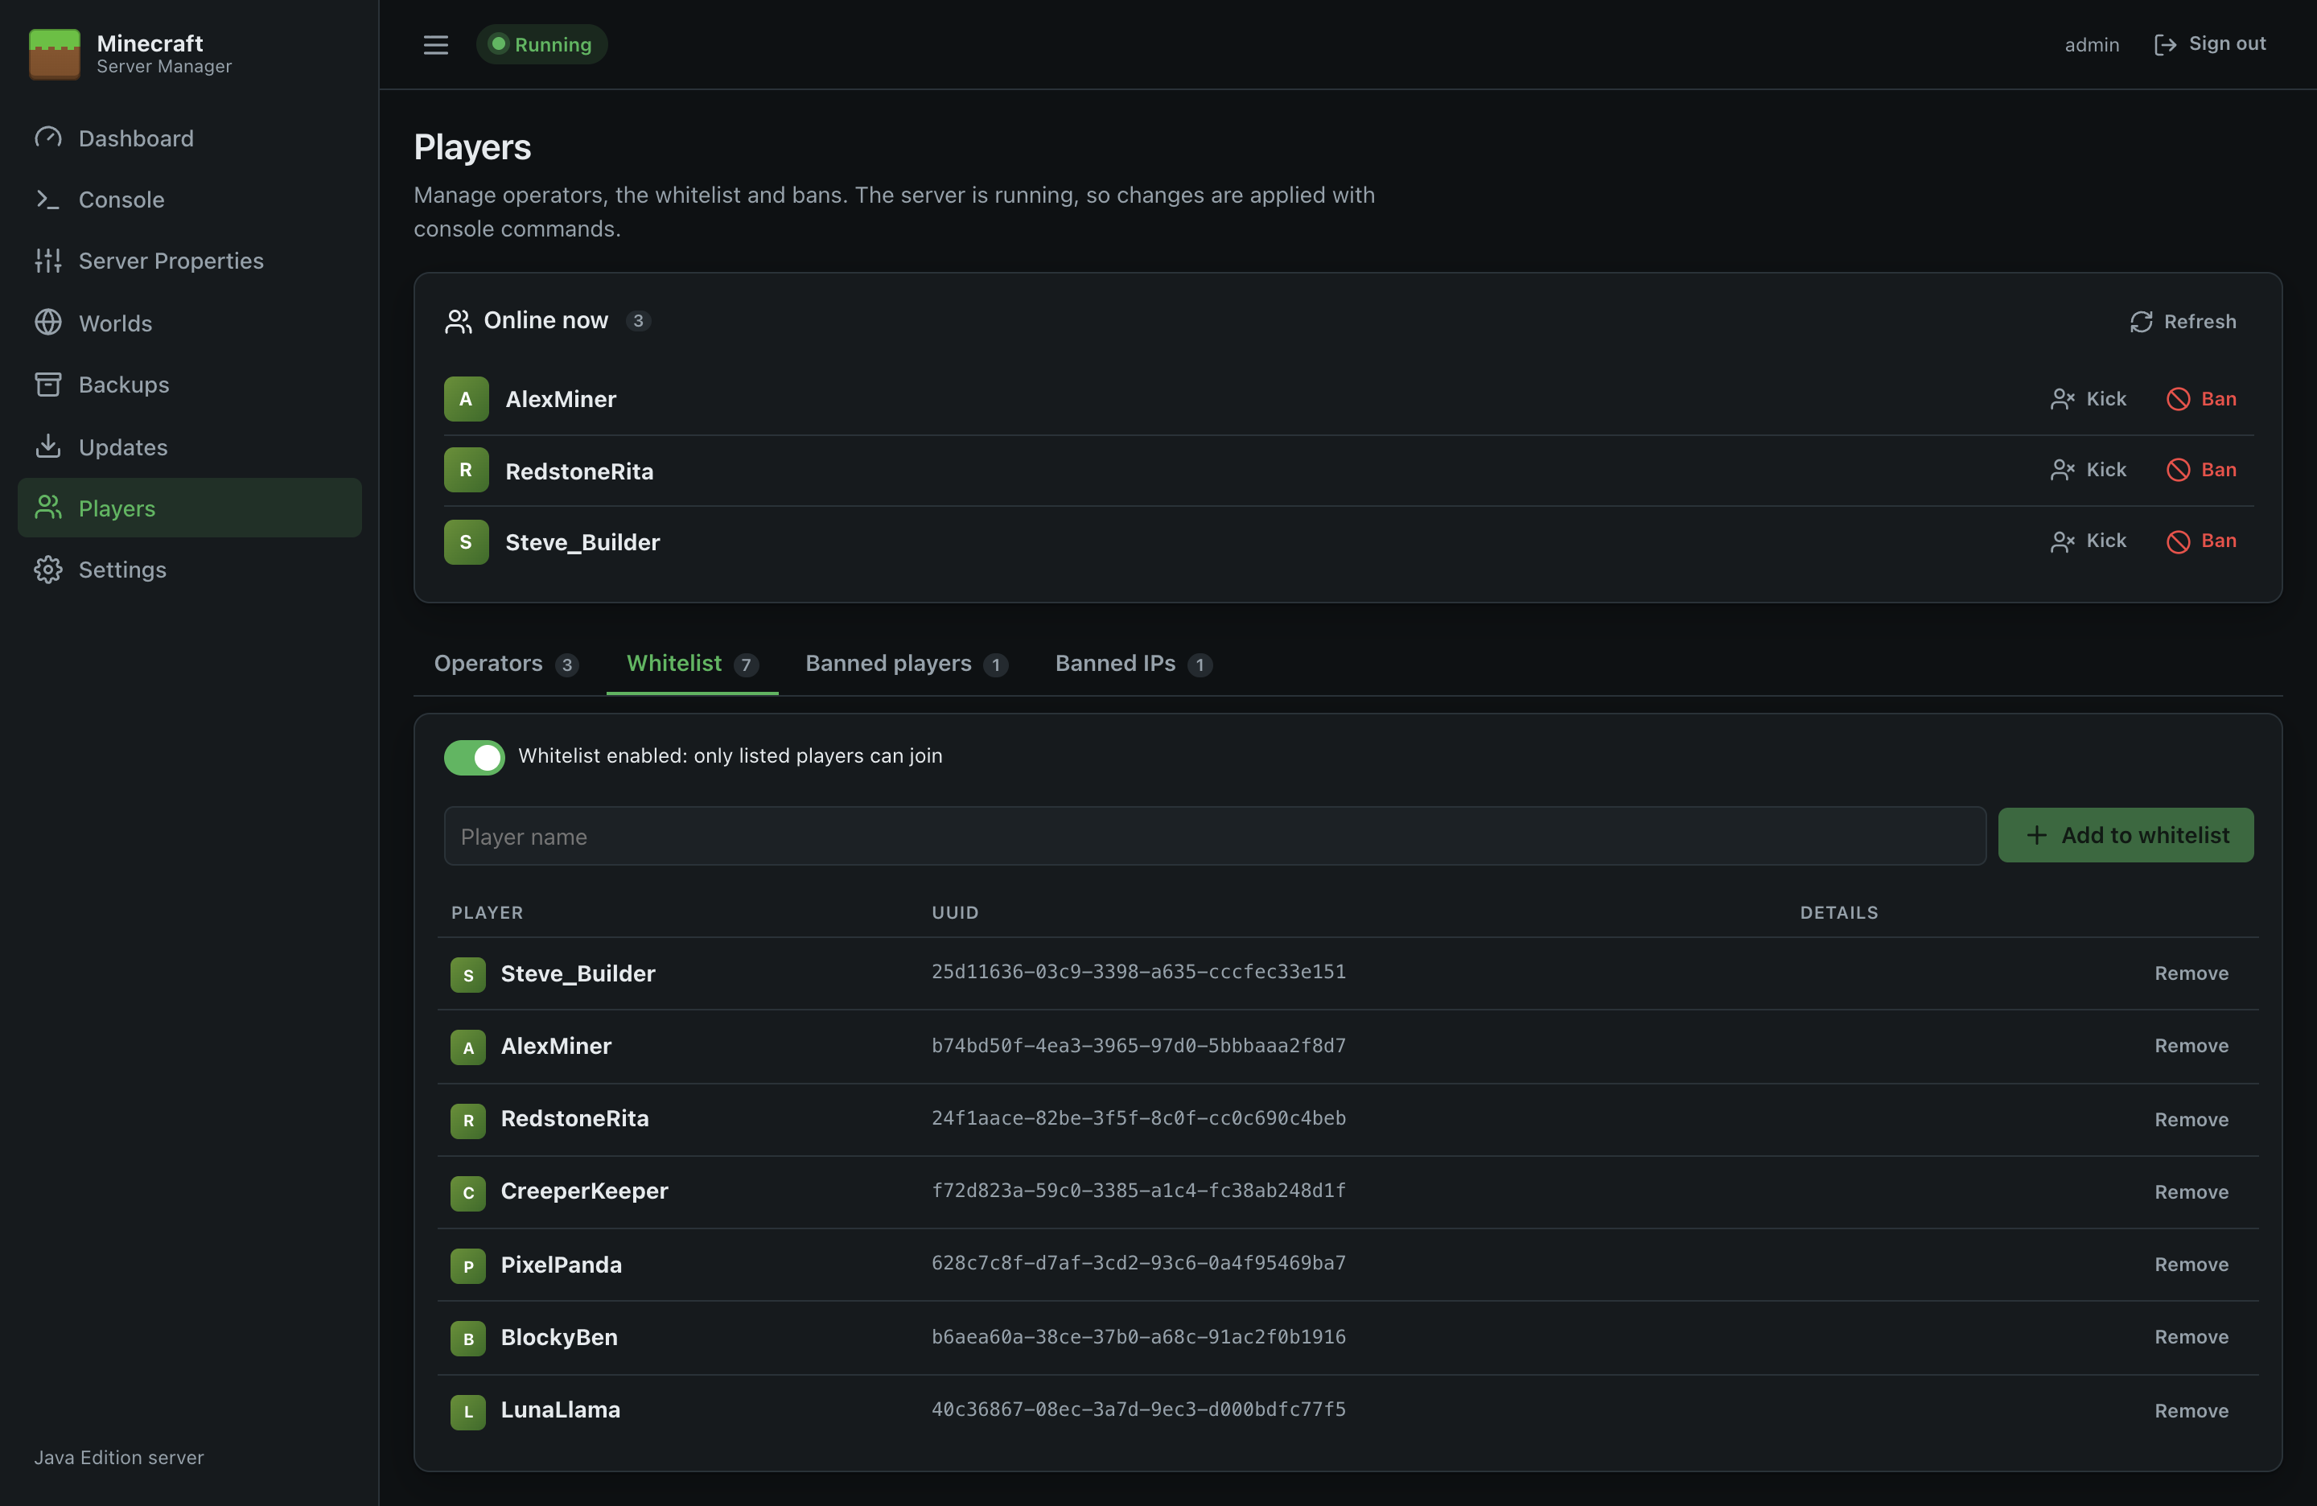
Figure 27: Whitelist

Banned players
Enter a name and an optional Reason (shown to the player) and click Ban player. Pardon lifts the ban.
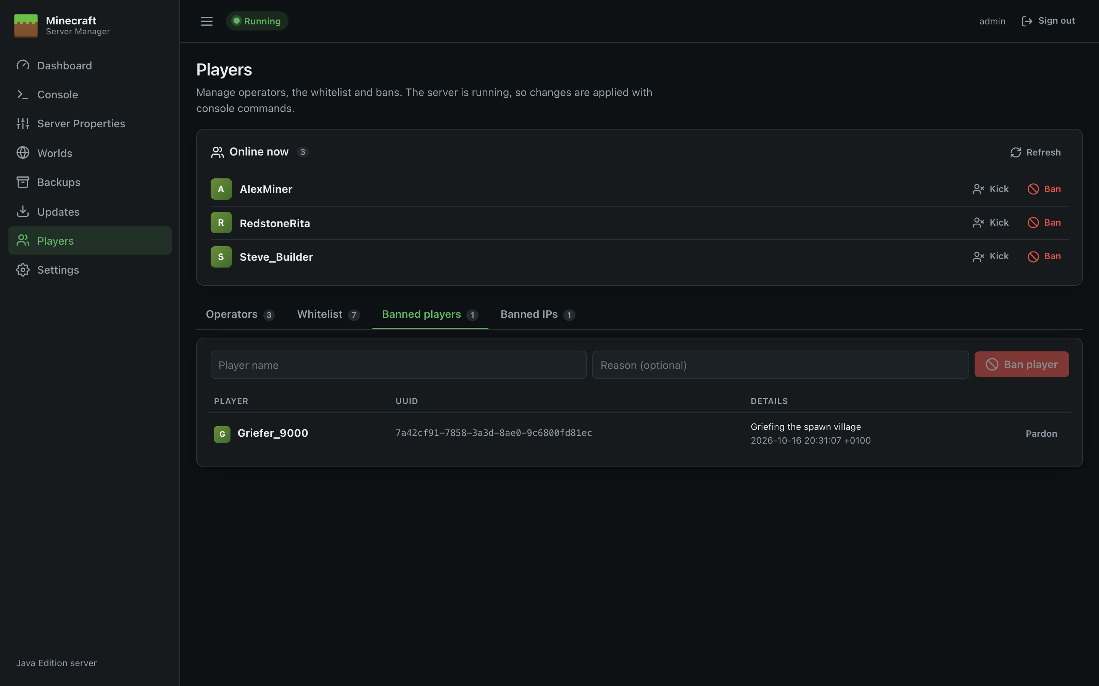
Figure 28: Banned players

Banned IPs
Bans an IP address, so nobody can join from it. Enter the address and optional reason and click Ban IP; Unban removes it.
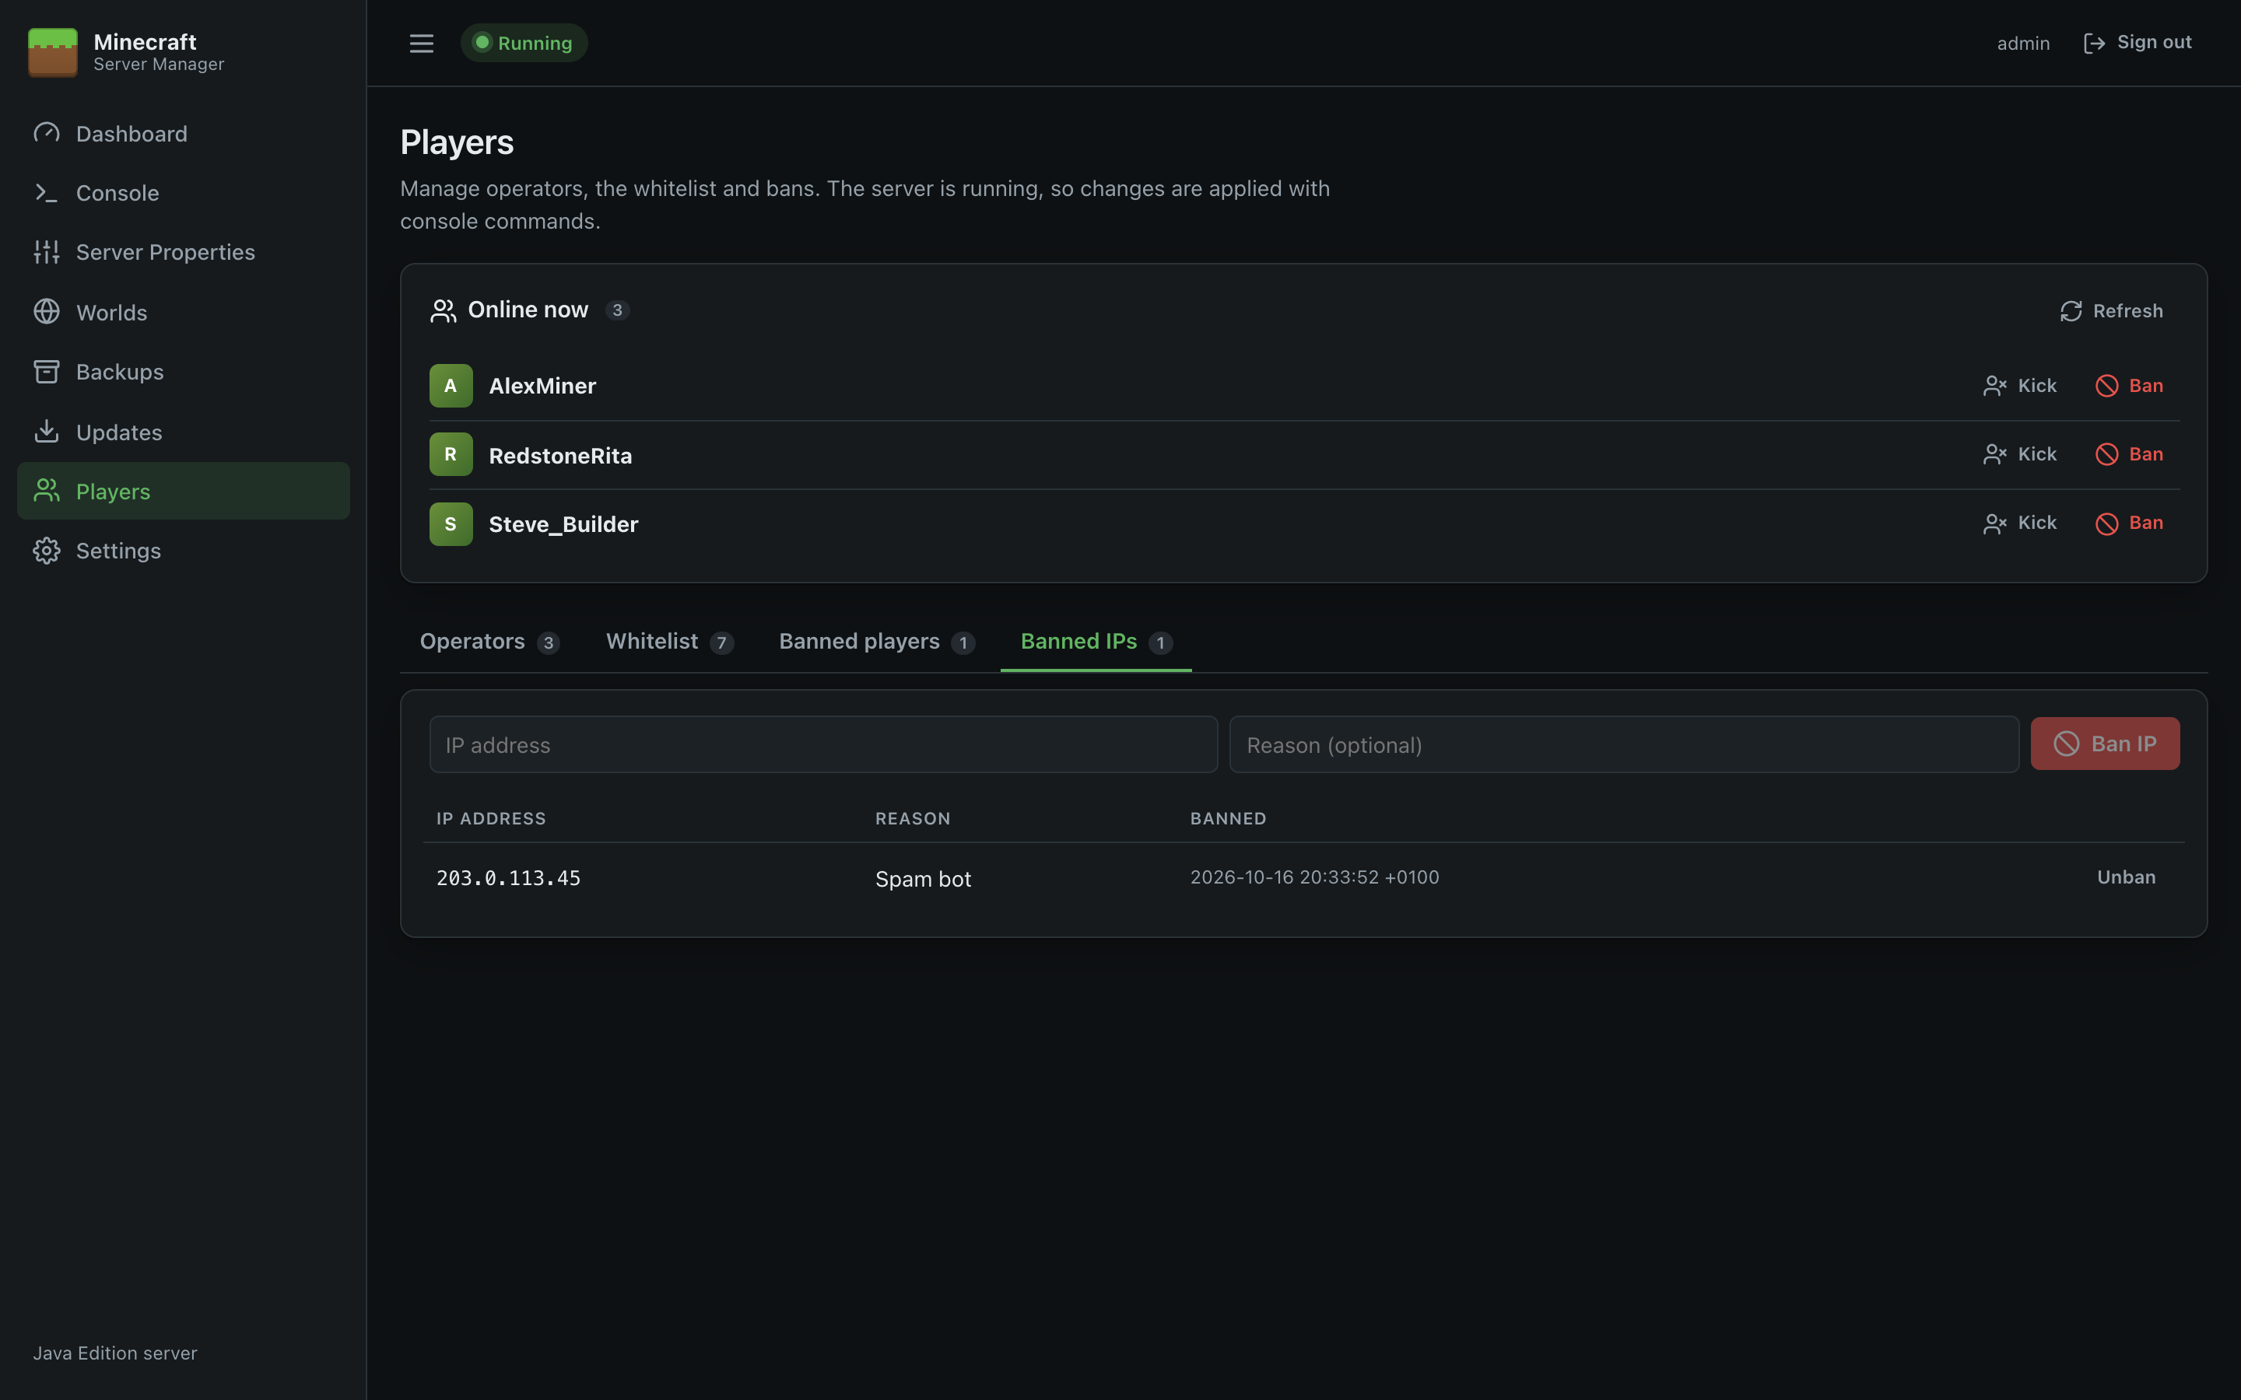
Figure 29: Banned IPs
Tip: Changes made in game (for example an operator typing /ban) appear here too, because the page reads the same files.

Settings
Settings controls how the panel launches and supervises Minecraft: folders, Java, memory, automatic start and restart, and your password. Click Save settings at the bottom to apply changes. Launch settings take effect the next time the server starts.
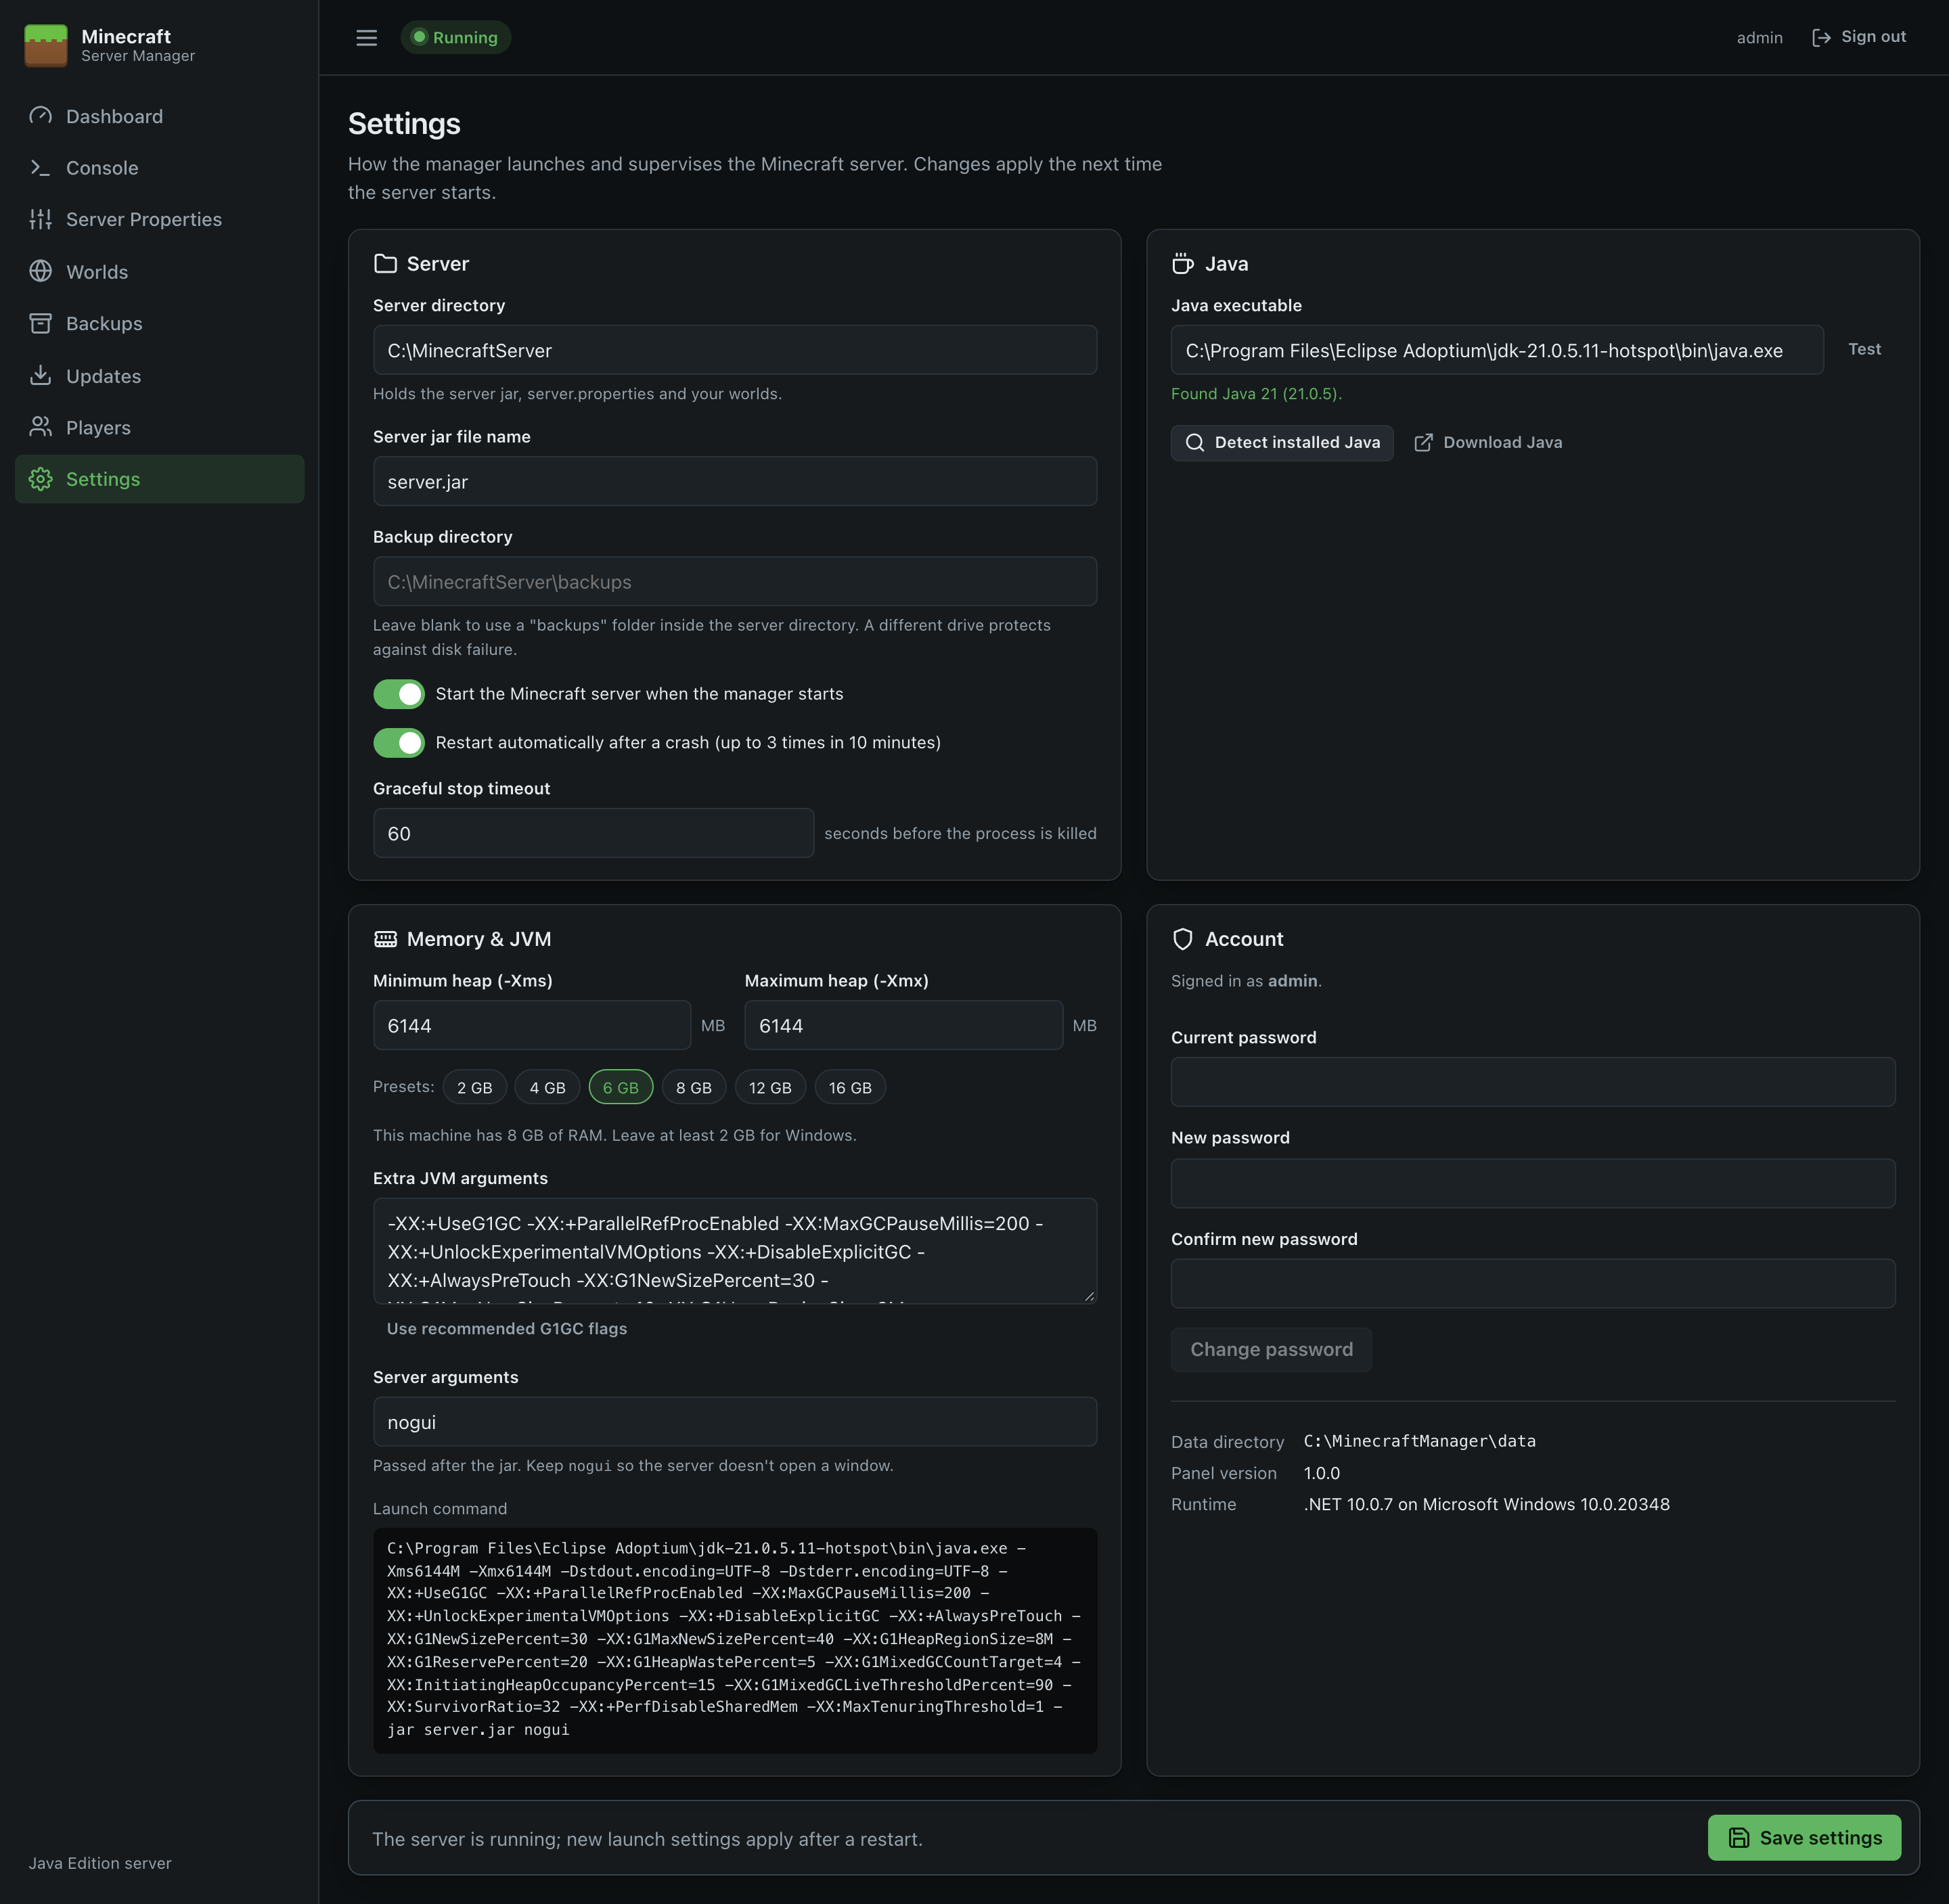
Figure 30: Settings

Server
Setting | Default | Notes
Server directory | C:\MinecraftServer | Holds the server jar, server.properties, eula.txt, the player lists and worlds. Must be a full path; it's created if missing. Changing it doesn't move files.
Server jar file name | server.jar | The jar to launch. Change it to run a different jar (e.g. Paper). Must end in .jar.
Backup directory | (blank: backups inside the server directory) | Where Backups are written. A different drive is recommended.
Start the Minecraft server when the manager starts | Off | Turn on to start Minecraft automatically when the panel (or Windows) starts.
Restart automatically after a crash | On | Restarts the server 10 seconds after a crash, up to 3 times in 10 minutes. After that it waits for you to start it, so a broken configuration doesn't loop forever.
Graceful stop timeout | 60 seconds | How long Stop waits for Minecraft to save and exit before killing the process (5–600). Increase it for very large worlds.

Java
Setting | Notes
Java executable | Full path to java.exe (or just java to use the PATH).
Test | Runs java -version and shows the version found, or an error.
Detect installed Java | Searches JAVA_HOME, the PATH and standard install folders, and lists every runtime found. Click one to select it.
Download Java | Opens the Eclipse Temurin download page.

When the panel runs as a Windows service it uses the service account's PATH. Selecting a full path with Detect avoids "Java not found" problems.

Memory and JVM
Setting | Notes
Minimum heap (-Xms) / Maximum heap (-Xmx) | Memory given to Minecraft, in MB. The presets (2–16 GB) set the maximum. The page shows the machine's total RAM; leave at least 2 GB for Windows. A typical small server needs 4–6 GB.
Extra JVM arguments | Additional Java options. Use recommended G1GC flags fills in garbage-collector tuning widely used for Minecraft servers and sets the minimum heap equal to the maximum.
Server arguments | Passed to Minecraft after the jar. Keep nogui so no window opens.
Launch command | A live preview of the full command the panel will run.

The panel always adds -Dstdout.encoding=UTF-8 -Dstderr.encoding=UTF-8 so console text displays correctly.

Account
- Change password: enter the current password and the new one twice (at least 8 characters). Changing it signs you out everywhere; sign in again with the new password.
- Data directory, Panel version, Runtime: information for troubleshooting.

Validation
Settings won't save if:
- a folder isn't a full path (such as C:\…),
- the jar name isn't a plain file name ending in .jar,
- the maximum heap is under 512 MB or smaller than the minimum,
- the stop timeout is outside 5–600 seconds.
The error is shown at the top of the page.

Running as a Windows Service
The panel runs as a Windows service, so it starts with Windows, keeps running when nobody is signed in, and shuts the Minecraft server down cleanly when Windows shuts down.
If you used the setup wizard or the MSI, this is already done. The installer registers the service, sets it to start automatically and restart after a failure, and adds the firewall rules you chose. This page explains how to manage the service, and how to install it by hand from the zip.

The service
Property | Value
Name | MinecraftServerManager
Display name | Minecraft Server Manager
Startup type | Automatic
Log on as | Local System
Recovery | Restart after 1 minute (failure count resets daily)

Start Minecraft with Windows
The service starts the panel with Windows. To have the Minecraft server start too, turn on Start the Minecraft server when the manager starts in Settings.

Managing the service
Use Services (services.msc) or PowerShell:
Get-Service MinecraftServerManager # status
Restart-Service MinecraftServerManager # restart the panel (Minecraft is stopped cleanly and started again if auto-start is on)
Stop-Service MinecraftServerManager # stop the panel and the Minecraft server
Start-Service MinecraftServerManager
Stopping the service sends stop to Minecraft and waits for the world to save. The panel allows up to 90 seconds for this.

Logs
- Panel events (start-up, errors, backups, updates, crashes) go to the Windows Event Viewer → Windows Logs → Application, source MinecraftServerManager. By default warnings and errors are logged, plus information from the panel itself. Change this in C:\ProgramData\Minecraft Server Manager\appsettings.json (reference).
- Minecraft's own log is in the server directory: logs\latest.log (older logs are zipped alongside), with crash reports in crash-reports\.

Installing the service by hand (zip)
Open PowerShell as administrator in the folder containing MinecraftServerManager.exe and run:
.\install-service.ps1 -OpenMinecraftPort
The script registers the service (or updates it if it already exists), sets the recovery options, adds any firewall rules you ask for, and starts it.
Parameter | Default | Purpose
-ServiceName | MinecraftServerManager | Service name, if you run more than one panel.
-DisplayName | Minecraft Server Manager | Name shown in Services.
-OpenMinecraftPort | off | Adds an inbound rule for TCP -MinecraftPort so players can connect.
-MinecraftPort | 25565 | Port for the rule above. Match server-port.
-OpenPanelPort | off | Adds an inbound rule for TCP -PanelPort, for remote access to the panel (details).
-PanelPort | 8080 | Port for the rule above.
-WaitForPanel | off | Waits until the panel answers before finishing.

If PowerShell refuses to run the script, allow it for this session with Set-ExecutionPolicy -Scope Process Bypass, or unblock the file (Properties → Unblock).
To remove it: .\uninstall-service.ps1 (add -RemoveFirewallRules to remove the firewall rules too). Worlds, backups and settings are kept.

Service account
The service runs as Local System, which can read and write anywhere on the machine. That's the simplest setup. For tighter security you can run it as a dedicated local account:
- Create a standard user, e.g. mcservice.
- Give it Modify permission on C:\ProgramData\Minecraft Server Manager (or the zip folder), the server directory and the backup directory, and Read & execute on the program folder.
- Make sure it can run Java (select a full Java path in Settings).
- Change the service's log-on account:
sc.exe config MinecraftServerManager obj= ".\mcservice" password= "<password>"
Restart-Service MinecraftServerManager
The panel's process (and therefore Minecraft) then only has that account's rights. Upgrading with the setup wizard keeps the service's log-on account.

Updating the panel
- Setup wizard / MSI: run the new version's installer. See Installation → Upgrading.
- Zip: stop the service, copy the new files over the old ones except appsettings.json and the data folder, run .\install-service.ps1 again, and it starts the service.
Your panel settings, password and sign-in keys are in the data folder; worlds and backups are in the server directory. Neither is touched by updating.

Running more than one Minecraft server
Each panel manages one Minecraft server. To run several side by side, use the zip:
- Extract the panel into a separate folder for each (e.g. C:\MinecraftManager-Survival, C:\MinecraftManager-Creative).
- In each copy's appsettings.json, give Urls a different port.
- Install each with a different -ServiceName.
- In each panel, choose a different server directory and give each Minecraft server a different server-port.
The setup wizard and MSI install a single instance.

Remote Access and HTTPS
Out of the box the panel only accepts connections from the server itself (http://localhost:8080). This page explains how to manage it from other computers, and how to protect it with HTTPS.
Security first. The panel can run commands on your server and replace files. Only expose it to networks you trust, use a strong password, and use HTTPS for anything beyond a trusted LAN. Plain HTTP sends your password unencrypted.

Option 1: Listen on the network (LAN)
If you ticked Allow other computers to open the web panel in the setup wizard, this is already done. Otherwise:
- From an administrator PowerShell window, tell the panel to listen on all network interfaces:
& "C:\Program Files\Minecraft Server Manager\MinecraftServerManager.exe" configure --remote-access
This sets "Urls": "http://0.0.0.0:8080" in C:\ProgramData\Minecraft Server Manager\appsettings.json (keeping the current port). --local-only undoes it. With the zip, edit Urls in the appsettings.json next to the executable instead. To listen on one interface only, set Urls to that address, e.g. http://192.168.1.20:8080.
- Allow the port through Windows Firewall:
New-NetFirewallRule -DisplayName "Minecraft Server Manager (TCP 8080)" -Direction Inbound -Protocol TCP -LocalPort 8080 -Action Allow -Profile Domain,Private
Limiting the rule to the Domain and Private profiles keeps it closed on public networks. You can also restrict it with -RemoteAddress 192.168.1.0/24.
- Restart the service: Restart-Service MinecraftServerManager.
- Browse to http://<server-name-or-ip>:8080 from another PC.

Option 2: HTTPS directly in the panel
The panel's web server (Kestrel) can serve HTTPS with a certificate in PFX format.
- Get a certificate for the name you'll use (e.g. mc-panel.example.local): from your internal certificate authority, or from a public CA if the name is public. Export it as a .pfx with its private key.
- Copy it to the server, e.g. C:\certs\panel.pfx.
- Open C:\ProgramData\Minecraft Server Manager\appsettings.json (or, with the zip, the appsettings.json next to the executable) and replace its "Urls" line with:
"Kestrel": {
"Endpoints": {
"Https": {
"Url": "https://0.0.0.0:8443",
"Certificate": {
"Path": "C:\\certs\\panel.pfx",
"Password": "<pfx password>"
}
}
}
},
Note the doubled backslashes in JSON paths.
- Open TCP 8443 in the firewall and restart the service.
- Browse to https://mc-panel.example.local:8443.
Don't put this in C:\Program Files\Minecraft Server Manager\appsettings.json: that file is replaced when you upgrade. Protect the file if it contains the certificate password; only administrators and the service account should be able to read it. Alternatively load the certificate from the Windows certificate store; see Microsoft's Kestrel endpoint configuration documentation.

Option 3: Behind a reverse proxy
You can leave the panel on http://localhost:8080 and publish it through a reverse proxy that handles HTTPS, such as IIS with Application Request Routing, Caddy, nginx or Traefik.
Requirements for the proxy:
- WebSockets must be allowed. The panel's pages use a live WebSocket connection (path /_blazor). In IIS, install the WebSocket Protocol feature; in nginx, pass the Upgrade and Connection headers.
- Keep the connection timeout generous (a few minutes), because the live connection stays open.
- Serve the panel at the root of a host name (e.g. https://mc.example.com/), not in a sub-folder.
Example (Caddy):
mc.example.com {
reverse_proxy localhost:8080
}
Example (nginx):
location / {
proxy_pass http://127.0.0.1:8080;
proxy_http_version 1.1;
proxy_set_header Upgrade $http_upgrade;
proxy_set_header Connection "upgrade";
proxy_set_header Host $host;
proxy_read_timeout 300s;
}
Behind a proxy, every sign-in attempt appears to come from the proxy's address, so the sign-in lockout (5 failures → 5 minutes) applies to everyone at once. Use the proxy's own rate limiting if this matters.

Access from the internet
Avoid exposing the panel directly to the internet. Better options, in order of preference:
- A VPN (WireGuard, Tailscale, your firewall's VPN) and access it as if on the LAN.
- A reverse proxy with HTTPS and an extra sign-in layer (for example your proxy's authentication or an identity-aware proxy).
The Minecraft server's own port (25565) is separate and is what players need; see Installation.

Troubleshooting
Start with the Console: most problems are explained there, either by Minecraft or by a blue [Manager] message. For the panel itself, check Event Viewer → Windows Logs → Application (source MinecraftServerManager).

Installing
Symptom | Fix
Windows protected your PC (SmartScreen) | The installers aren't code-signed yet. Check the file's SHA-256 (Get-FileHash <file>) against SHA256SUMS.txt from the release, then click More info → Run anyway.
Setting up the Windows service failed (exit code N) | The files were installed but the service didn't start. Usually the panel's port is taken: see Port already in use? below, then run .\install-service.ps1 -PanelPort <port> from C:\Program Files\Minecraft Server Manager in an administrator PowerShell window. Check Event Viewer for the panel's own error.
Saving the panel settings failed | C:\ProgramData\Minecraft Server Manager\appsettings.json couldn't be written; it may contain invalid JSON. Fix or delete it and run the installer again.
Need a log | Setup wizard: run it with /LOG="setup.log". MSI: msiexec /i <file>.msi /l*v install.log.

The panel won't open in the browser
Check | How
Is the service running? | Get-Service MinecraftServerManager. Start it with Start-Service MinecraftServerManager.
Right address? | Use the Start menu shortcut, or check Urls in C:\ProgramData\Minecraft Server Manager\appsettings.json (default http://localhost:8080, which only works on the server itself).
Port already in use? | If the service stops straight away, check Event Viewer for "address already in use" (or run netstat -ano | findstr :8080). Move the panel with configure --port 9090 and restart the service.
Remote access blocked? | See Remote Access and HTTPS: listen on 0.0.0.0 (configure --remote-access) and open the firewall.
Run it interactively | Stop the service and run MinecraftServerManager.exe from an administrator PowerShell window to see start-up messages and errors.

"Rejoining the server…" keeps appearing
The page lost its live connection, usually because the panel restarted or the network dropped. It reconnects automatically; if not, click Retry or reload. Behind a reverse proxy, make sure WebSockets are enabled (details).

The server won't start
Message | Fix
No server jar was found | Install a version on Updates, or fix Server jar file name in Settings.
The Minecraft EULA has not been accepted | Click I agree on the Dashboard or Updates page after reading the EULA.
Could not launch Java using '…' | The Java path is wrong. Use Detect installed Java in Settings.
The server directory '…' does not exist | Fix the path in Settings.
Console: UnsupportedClassVersionError … class file version 65.0 | Java is too old: 65 = Java 21, 69 = Java 25, 61 = Java 17. Install the right Java and select it.
Console: Invalid maximum heap size / Could not reserve enough space | The memory setting is too large for the machine. Lower Maximum heap.
Console: Unrecognized VM option | Remove the bad option from Extra JVM arguments.

The server is stuck on "Starting…"
The panel shows Running when Minecraft logs Done (…)! For help, type "help". Generating a new world or upgrading a big world after an update can take several minutes. Watch the console for progress. If nothing has happened for a long time, click Kill and check logs\latest.log.

Players can't connect
- Firewall: TCP 25565 (or your server-port) must be allowed inbound. The installers add this rule unless you unticked it; see Installation.
- Router: players outside your network need TCP 25565 forwarded to the server.
- Port conflict: the console shows **** FAILED TO BIND TO PORT! if something else uses the port. Change server-port or stop the other program.
- Whitelist: if white-list is on, add the player on Players.
- Version mismatch: the player's game version must match the server's (see Installed on Updates).
- "Failed to verify username": the player isn't signed in to a genuine Minecraft account while online-mode=true.

The server crashes
- The Dashboard shows The server stopped unexpectedly with the exit code. Check the red lines in the Console and the newest file in crash-reports\.
- If Restart automatically after a crash is on, the panel restarts the server after 10 seconds. After 3 crashes within 10 minutes it stops retrying (the console says so) so a broken setup doesn't loop. Fix the cause and click Start.
- Out of memory (java.lang.OutOfMemoryError): increase Maximum heap in Settings, or reduce view-distance/simulation-distance.
- Mods or plugins (non-vanilla jars): remove recently added ones to find the culprit.

The server is slow / "Can't keep up!"
- Lower view-distance (e.g. 8–10) and simulation-distance (e.g. 6–8) in Server Properties.
- Give Java enough memory, and try Use recommended G1GC flags in Settings.
- Check the CPU and Memory cards on the Dashboard, and run tick query on the Console.
- Pre-generated or very large worlds need fast disks; avoid network drives for the server directory.

Backup problems
Symptom | Cause and fix
The server is starting or stopping. Try the backup again in a moment. | Backups of the running world need the server fully started. Wait for Running.
Not enough free disk space for the backup | Free space, delete old backups, or move backups to another drive in Settings.
Event log: Timed out waiting for the server to confirm the save | Minecraft didn't confirm the save within 2 minutes (very busy server). The backup still completed; check it, and consider backing up at a quieter time.
Event log: skipped … locked file(s) | A file was locked by another program (often antivirus or a sync tool). Exclude the server directory from real-time scanning.
Scheduled backups don't run | Check the schedule is on and saved. With Only while the server is running, nothing happens while the server is stopped.
Restore fails | The original world is put back automatically. Check the error; the zip must contain the world folder at its top level.

Update problems
Symptom | Fix
Couldn't reach Mojang's version service | The server has no internet access, or a proxy/firewall blocks piston-meta.mojang.com.
requires Java N or newer | Install that Java and select it in Settings.
failed SHA-1 verification | The download was corrupted or altered in transit. Try again; if it persists, check for a proxy rewriting downloads. The existing jar is untouched.
The world won't load after a downgrade | Restore the Before update backup from Backups and the matching jar from Previous server jars.

Player list problems
Symptom | Fix
No Minecraft account named '…' exists | Check the spelling. With the server stopped and online-mode=true, names are checked against Mojang's account service.
Change didn't stick | While the server runs, changes are made with console commands; check the console for the response (for example That player does not exist).
Online list looks wrong | Click Refresh on Players (runs list).

Signing in
Symptom | Fix
Too many failed attempts | Wait 5 minutes.
Forgot the password | See Security → Resetting a forgotten password.
Signed out unexpectedly | The password was changed, data\keys\ was removed, or Keep me signed in wasn't ticked and the browser was closed.

Collecting information for support
- The Minecraft version (Updates), Java version (Settings → Test), and panel version (Settings → Account).
- The relevant Console lines, logs\latest.log, and any file in crash-reports\.
- Panel errors from Event Viewer (Application log, source MinecraftServerManager).

Frequently Asked Questions

Does closing the browser stop the server?
No. The browser is only a window onto the panel. The server keeps running for as long as the panel (normally a Windows service) runs.

What happens when Windows restarts?
The service stops the Minecraft server cleanly during shutdown. After the restart the panel starts automatically, and so does Minecraft if Start the Minecraft server when the manager starts is on in Settings.

Can I run Paper, Spigot, Fabric or Forge?
The panel can launch any server jar: place it in the server directory and set Server jar file name in Settings. Fabric and Forge need their installer run first. Updates only installs and updates the vanilla Mojang server, so update other jars by hand. The Worlds and Backups pages understand Paper's separate world_nether / world_the_end folders.

Does it support Bedrock Edition?
No. It manages the Java Edition dedicated server only.

Can I manage several Minecraft servers?
One panel manages one Minecraft server. Run one panel per server, each with its own folder, port and service name. See Running as a Windows Service.

Can more than one person use the panel?
There's a single admin account, which several people can share. Everyone sees the same live state, so two people can have it open at once. Give the password only to people you'd trust with administrator access to the server.

How much memory should I give the server?
For a small vanilla server (up to ~10 players) 4–6 GB is plenty; larger or modded servers may need 8–12 GB. Leave at least 2 GB for Windows. Setting minimum and maximum heap equal (the recommended-flags button does this) gives the most predictable performance.

Where are my worlds and backups?
Worlds are folders in the server directory (default C:\MinecraftServer); backups are in backups inside it unless you moved them. See Files and Folders.

Can I edit files by hand?
Yes, but preferably while the server is stopped. See Files and Folders → Editing files by hand.

How do I change game rules (keepInventory etc.)?
Game rules are stored in each world, not in server.properties. Use the Console: gamerule keepInventory true.

Do I need RCON?
No. The panel talks to the server directly. Leave enable-rcon=false unless another tool needs it.

Is my world safe while a backup runs?
Yes. Autosave is paused and everything is flushed to disk first, then turned back on afterwards, and players can keep playing. See Backups.

How do I move to a new server machine?
Install the panel on the new machine and stop both services. Copy the server directory across to the same path, and optionally C:\ProgramData\Minecraft Server Manager\data (your account and panel settings), then start the service, select Java in Settings and start Minecraft. If you don't copy data, run first-run setup and point it at the server directory.

How do I update the panel itself?
Download the new version's setup wizard (or MSI) and run it. It stops the service, upgrades, and starts it again, keeping your settings, worlds and backups. See Installation → Upgrading.

Why does Windows warn about the installer?
The installers aren't code-signed yet, so SmartScreen may say Windows protected your PC for a new download. Check the file against SHA256SUMS.txt from the release, then choose More info → Run anyway.

Can I use it on Linux or macOS?
It's built for Windows, but the panel is cross-platform .NET, and it can be built and run on Linux or macOS for testing (see Development). Windows-specific features (the service and the job object) only apply on Windows.

Appendix A: Server Properties Reference
Every server.properties key the panel recognises, grouped the way the Server Properties page groups them. This table is generated from the panel's property schema (Services/PropertySchema.cs).
Keys that aren't listed here (added by newer Minecraft versions or by mods) still appear in the editor under Other and can be edited as plain text. Most changes take effect the next time the server starts.

General
Key | Type | Default | Description
motd | Text | A Minecraft Server | Message shown under the server name in the multiplayer server list. Supports § formatting codes.
server-port | Number (1 to 65535) | 25565 | TCP port the server listens on. Allow it through Windows Firewall so players can connect.
server-ip | Text | (blank) | Bind to a specific local IP address. Leave blank to listen on all network interfaces.
max-players | Number (0 to 2147483647) | 20 | Maximum number of players that can be online at the same time.
enable-status | true / false | true | Respond to server list pings. When disabled the server appears offline, but players can still join.
hide-online-players | true / false | false | Hide the list of online players from server list status responses.
bug-report-link | Text | (blank) | URL shown as the 'Report Server Bugs' link on the disconnect screen.
accepts-transfers | true / false | false | Accept players transferred from another server with the /transfer command.

Gameplay
Key | Type | Default | Description
gamemode | One of: survival, creative, adventure, spectator | survival | Default game mode for players joining for the first time.
force-gamemode | true / false | false | Put players into the default game mode every time they join.
difficulty | One of: peaceful, easy, normal, hard | easy | Difficulty of the world: affects mob damage, hunger and more.
hardcore | true / false | false | Players are switched to spectator mode when they die, and difficulty is locked to hard.
pvp | true / false | true | Allow players to damage each other.
allow-flight | true / false | false | Allow flight in survival mode (e.g. with mods). When false, players airborne for 5 seconds are kicked.
allow-nether | true / false | true | Allow players to travel to the Nether.
spawn-monsters | true / false | true | Spawn hostile mobs.
spawn-protection | Number (0 to 2147483647) | 16 | Radius in blocks around world spawn that only operators can change. 0 disables protection.
enable-command-block | true / false | false | Allow command blocks to run commands.
player-idle-timeout | Number (0 to 2147483647) | 0 | Minutes a player can be idle before being kicked. 0 disables.
max-world-size | Number (1 to 29999984) | 29999984 | Maximum radius of the world border, in blocks.

World
Key | Type | Default | Description
level-name | Text | world | Folder name of the world the server loads. Use the Worlds page to switch or create worlds.
level-seed | Text | (blank) | Seed used when a new world is generated. Blank means random. Has no effect on existing worlds.
generator-settings | JSON | {} | JSON settings used to customise newly generated worlds, such as superflat layers.
generate-structures | true / false | true | Generate structures such as villages, temples and strongholds in new chunks.
initial-enabled-packs | Text | vanilla | Comma-separated data packs enabled when a new world is created.
initial-disabled-packs | Text | (blank) | Comma-separated data packs that are not enabled automatically when a new world is created.

Players & Security
Key | Type | Default | Description
online-mode | true / false | true | Verify that players own a Minecraft account. Only disable on private LANs or behind a proxy, because anyone can then join with any name.
white-list | true / false | false | Only allow players on the whitelist to join.
enforce-whitelist | true / false | false | Kick online players who are not on the whitelist when it is reloaded.
enforce-secure-profile | true / false | true | Require players to have a Mojang-signed public key in order to join.
prevent-proxy-connections | true / false | false | Kick players whose connection appears to come through a proxy or VPN.
op-permission-level | Number (0 to 4) | 4 | Default permission level given by /op (1 = bypass spawn protection, 4 = all commands).
function-permission-level | Number (1 to 4) | 2 | Permission level that data pack functions run with.
broadcast-console-to-ops | true / false | true | Show console command output to online operators.
broadcast-rcon-to-ops | true / false | true | Show RCON command output to online operators.
log-ips | true / false | true | Write player IP addresses to the server log when they connect.

Performance
Key | Type | Default | Description
view-distance | Number (3 to 32) | 10 | Radius of chunks (3-32) the server sends to players. Lower values reduce CPU, RAM and bandwidth.
simulation-distance | Number (3 to 32) | 10 | Radius of chunks (3-32) around players in which mobs, crops and redstone are updated.
entity-broadcast-range-percentage | Number (10 to 1000) | 100 | How close entities must be before they're sent to clients, as a percentage of the default.
network-compression-threshold | Number (-1 to 2147483647) | 256 | Packets larger than this many bytes are compressed. -1 disables compression.
max-tick-time | Number (-1 or more) | 60000 | Milliseconds a single tick may take before the watchdog shuts the server down. -1 disables the watchdog.
sync-chunk-writes | true / false | true | Write chunk files synchronously. Safer against data loss, but slower.
region-file-compression | One of: deflate, lz4, none | deflate | Compression used for region files.
rate-limit | Number (0 to 2147483647) | 0 | Maximum packets per second a player may send before being kicked. 0 disables.
max-chained-neighbor-updates | Number | 1000000 | Limit on consecutive neighbour updates before further updates are skipped. Negative disables the limit.
pause-when-empty-seconds | Number | 60 | Seconds without any players online before the server pauses ticking. 0 or negative disables pausing.
use-native-transport | true / false | true | Use Linux-optimised networking. Has no effect on Windows.

Resource Pack
Key | Type | Default | Description
resource-pack | Text | (blank) | Direct download URL of a resource pack players are prompted to use.
resource-pack-sha1 | Text | (blank) | SHA-1 hash of the resource pack, used to verify downloads.
resource-pack-id | Text | (blank) | Optional UUID identifying the resource pack.
resource-pack-prompt | Text | (blank) | Custom message (JSON text) shown when players are prompted to download the pack.
require-resource-pack | true / false | false | Disconnect players who decline the resource pack.

RCON & Query
Key | Type | Default | Description
enable-rcon | true / false | false | Enable remote console access over the RCON protocol. Do not expose RCON to the internet.
rcon.port | Number (1 to 65535) | 25575 | TCP port for RCON.
rcon.password | Secret text | (blank) | Password for RCON. Use a long, random value.
enable-query | true / false | false | Enable the GameSpy4 query protocol used by server listing sites.
query.port | Number (1 to 65535) | 25565 | UDP port for the query protocol.

Advanced
Key | Type | Default | Description
enable-jmx-monitoring | true / false | false | Expose tick time metrics through JMX (requires extra JVM flags).
text-filtering-config | Text | (blank) | Configuration for an external chat text filtering service.
text-filtering-version | Number (0 to 2147483647) | 0 | Version of the text filtering configuration format.

Notes
- Escaping. The panel writes the file the way Java does: : = # ! are escaped with \, and non-ASCII characters (such as the § colour sign in a MOTD) are written as \uXXXX escapes. Minecraft reads these back correctly.
- World settings (level-seed, level-type, generator-settings, generate-structures) only apply when a world is first generated. Use Worlds to create a new world with different settings.
- Version differences. Mojang occasionally adds, renames or removes keys between versions. The server rewrites server.properties on start-up with the keys it supports.

Appendix B: Files and Folders
Where the panel and the Minecraft server keep everything, assuming the defaults (C:\MinecraftServer for Minecraft).

Panel program folder
Installed by the setup wizard or MSI. Everything here is replaced when you upgrade, so don't keep your own files in it.
C:\Program Files\Minecraft Server Manager\
├── MinecraftServerManager.exe The panel (self-contained; includes the .NET runtime)
├── appsettings.json Default settings (don't edit; see below)
├── MinecraftServerManager.staticwebassets.endpoints.json
├── wwwroot\ Web assets (styles, scripts, icons)
├── install-service.ps1 / uninstall-service.ps1
└── web.config Only used when hosted under IIS

Panel data folder
Created by the installer and on first run. Kept when you upgrade or uninstall (the setup wizard asks whether to delete it when uninstalling).
C:\ProgramData\Minecraft Server Manager\
├── appsettings.json Your start-up settings: address, port, HTTPS (see Configuration Reference)
└── data\
├── settings.json Panel settings and the admin password hash
└── keys\ Keys that protect sign-in cookies
C:\ProgramData is hidden by default; type the path into File Explorer's address bar to open it.
Back up this folder along with your worlds. If keys\ is lost, everyone simply has to sign in again; if settings.json is lost, you'll go through setup again (your worlds are unaffected).

Zip installs
With the zip, everything is in the folder you extracted it to (for example C:\MinecraftManager): edit the appsettings.json there, and the panel data is in data\ next to the executable.

Windows registry
The installers record their choices under HKEY_LOCAL_MACHINE\Software\Minecraft Server Manager (install folder, version, panel port, which firewall rules they added) so upgrades and uninstalls can reuse them. The key is removed on uninstall.

Server directory
C:\MinecraftServer\
├── server.jar The Minecraft server installed by the Updates page
├── server.properties Server settings (Server Properties page)
├── eula.txt eula=true once you've accepted the EULA
├── ops.json Operators ┐
├── whitelist.json Whitelist │ Players page
├── banned-players.json Banned players │
├── banned-ips.json Banned IPs ┘
├── usercache.json Name/UUID cache kept by Minecraft
├── <world>\ One folder per world (e.g. survival\, creative-build\)
│ ├── level.dat World settings: seed, version, game mode
│ ├── region\ The terrain
│ ├── playerdata\ Player inventories and positions
│ └── session.lock Held by the running server
├── logs\ Minecraft logs (latest.log, older .log.gz)
├── crash-reports\ Created when Minecraft crashes
├── libraries\ versions\ Unpacked by the server jar on first start
├── backups\ World backups (unless moved in Settings)
└── .manager\ Panel working files
├── jars\ The last 5 replaced server jars, for rollback
└── tmp\ Temporary files during world imports

Naming conventions
Item | Pattern | Example
Backup | <world>_<yyyy-MM-dd_HH-mm-ss>_<type>.zip | survival_2026-10-20_21-00-04_scheduled.zip
Backup types | manual, scheduled, preupdate, prerestore, predelete
Duplicate backup in the same second | …_<type>_2.zip | survival_2026-10-20_21-00-04_manual_2.zip
Archived jar | <version>__<yyyyMMdd-HHmmss>.jar (time it was replaced) | 1.21.10__20261020-221152.jar
Restore in progress | <world>.restore-old-<timestamp> | Removed automatically when a restore succeeds

Times are in the server's local time zone.

Editing files by hand
- While the server is stopped you can edit server.properties and the JSON player lists by hand; the panel reads them fresh each time.
- While the server is running, Minecraft owns the player lists and will overwrite hand edits. Use the panel or console commands instead.
- After editing server.properties by hand while the page is open, click Reload from disk on Server Properties.
- You can copy a world folder into the server directory yourself. It appears on Worlds as long as it contains level.dat.

