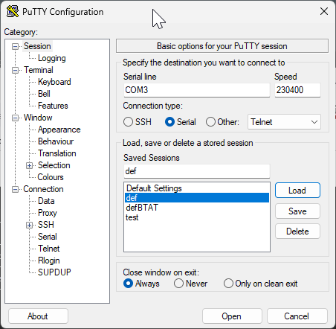
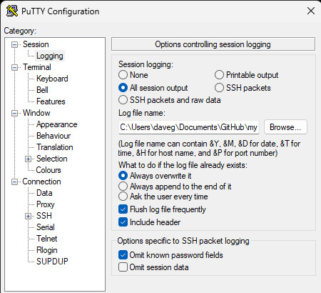
Windows puTTY setup to interact with SOC_Particle serial port

/dev/ttyACM0 for linux

/dev/tty.usbmodem14202 for Darwin
/home/daveg/.local/putty_def.csv (Linux)
Or
/Users/daveg/.local/putty_def.csv (Darwin)
or
C:\Users\daveg\AppData\Local\Temp\putty_def.csv (Windows)
