Windows puTTY setup to interact with SOC_Particle serial port for SOC_Test.py

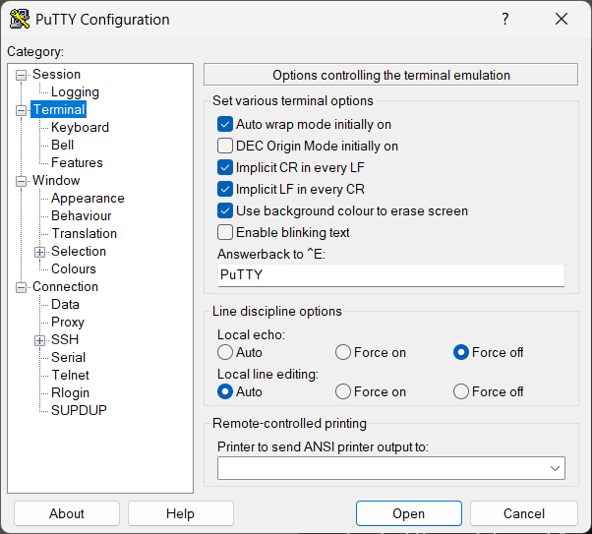
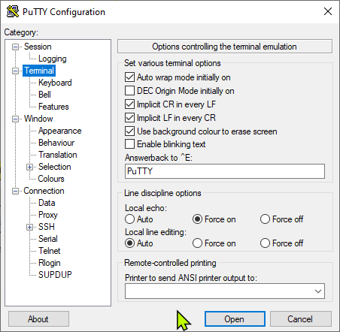
Same as ‘def’ except log file location and terminal
/home/daveg/.local/putty_test.csv (Linux)
Or
/Users/daveg/.local/putty_test.csv (Darwin)
or
C:\Users\daveg\AppData\Local\Temp\putty_test.csv (Windows
open ‘PuTTY’ gui on test computer
save a session for each test article, e.g.
> Load ‘test’ in tab Session
> change ‘Serial line’ from ‘COMx’ to whatever test article shows up as
> type ‘testpro0p’ in the ‘Saved Sessions’ box. This must correspond to ‘putty_connection’ at the top of py/GUI_TestSOC.py. Change things until they match
> press ‘Save’

